Milan Mangukiya
2243784
Module Leader – Vasilos

Importance of influencer marketing and social media marketing in restaurant industry.

Index
Contents
1. Index 1
1. Introduction 1
1) Background 1
2) Problem Statement 2
3) Research Aim 2
4) Research Objectives 2
5) Research Question 3
6) Significance / Relevance of Study 3
7) Methodology 4
Risk Factors 5
Conclusion 5
Gantt Chart 6
References 6

Introduction

Background
The restaurant industry in the UK is highly competitive, with establishments vying for consumer attention and loyalty in a crowded marketplace. In recent years, the emergence of influencer marketing and social media marketing (SMM) has revolutionized how restaurants promote their offerings, engage with customers, and drive foot traffic. Influencer marketing involves collaborating with social media personalities who have significant followings to promote a restaurant's products or services, while SMM encompasses the use of various social media platforms to create and share content, interact with customers, and build brand presence. This type of advertising depends on product mentions and recommendations from influencers—people with a large following on social media who are seen as experts. Influencers who enjoy a significant amount of trust from their followers are valuable sources of social proof for prospective buyers, which is why influencer marketing works very well. Influencer marketing has shown to be an effective tool for restaurant marketing's return on investment, producing remarkable outcomes and engaging customer interaction. Over 70% of consumers are more inclined to buy something if an influencer recommends it, according to recent studies. The benefits of collaborating with restaurant influencers include more brand exposure and social media presence, focused marketing to a particular age group, and the social proof they offer, which can influence customer decisions.

Problem Statement
Despite the increasing prevalence of influencer marketing and SMM in the restaurant industry, there exists a gap in understanding their precise impact on consumer behaviour, brand perception, and business performance. Additionally, restaurants face challenges in effectively leveraging influencer partnerships and social media platforms to achieve their marketing objectives, such as attracting new customers, increasing sales, and enhancing brand loyalty. Therefore, there is a need for comprehensive research that examines the importance of influencer marketing and SMM in the restaurant industry, particularly within the context of the UK market.

Research Aim
The primary objective of this investigation is to investigate and understand the effects and efficacy of social media marketing and influencer marketing tactics in the restaurant business. The goal of the study is to figure out how these digital marketing strategies affect consumer behaviour, brand recognition, and ultimately restaurant profitability. Additionally, the study will look for best practices and offer restaurants strategic advice on how to maximize their influencer and social media marketing campaigns. To inquire into how influencer marketing affects consumer decisions and perceptions in the restaurant business. Assess the performance of different social media marketing tactics used by eateries. Evaluate social media and influencer marketing's return on investment (ROI) in the restaurant business. Find best practices and case studies that demonstrate influencer and social media marketing in the food business. Offer restaurants strategic advice on how to get the most out of their influencer and social media marketing initiatives.

Research Objectives
- To assess the current landscape of influencer marketing and SMM practices within the UK restaurant industry.
- To examine the effectiveness of influencer marketing in driving consumer engagement and increasing brand awareness for restaurants.
- To evaluate the impact of SMM strategies on customer perceptions, attitudes, and behaviors towards restaurants.
- To identify key challenges and opportunities associated with implementing influencer marketing and SMM initiatives in the UK restaurant sector.
- To provide practical recommendations for restaurants to optimize their influencer partnerships and SMM efforts, thereby enhancing their marketing effectiveness and overall business performance.

Research Question
1 Most effective social media marketing strategies employed by restaurants.
2 Influencer marketing impacts customer perceptions and decisions in the restaurant industry
3 CRM and Loyalty in the Restaurant Industry

Significance / Relevance of Study
Consumer Behaviour- As digital media has grown, so too has consumer behaviour, with a notable shift towards online platforms. Researching this subject can assist in comprehending how consumers rely on internet effects while making dining judgments. The research and investigation of consumer behaviour focuses on the purchasing habits of consumers. It is part of the definition. "The psychological, emotional, and physical activities that people engage in when choosing, buying, using, and disposing of products and services to satisfy needs and wants" is the exact meaning of consumer behaviour It includes the buying and other consumption-related activities that participants in the exchange process engage place in (Hoyer & Macinnis, 2009).

Making Strategic Decisions - Restaurant owners and marketers can use the study's findings to help them decide where to focus their marketing budgets to get the most impact. Operational decision-making aims to establish new dining reservations and seating plans that are based on standard net revenue capacity control techniques. More specifically, policies based on revenue are established for deciding either to approve or reject a reservation request from a specific party size (Bertsimas and Shioda, 2003).

Competitive Advantage - Making good use of social media and influencer marketing can give a restaurant, which is a highly competitive industry, a major advantage. This study can be used to showcase effective approaches and methods. Product, pricing, distribution, and advertising are only a few of the many factors that influence the creation of new products and the happiness of consumers with new menus. Customers take into factors such as food safety, attractive packaging, and food taste when developing new products. Food quantity also plays a role in purchasing decisions. Price perspectives include the following: food quantity is a worthy purchase; food quality is at an affordable cost; and price is acceptable. Price is a factor in making a purchase decision (Suvittawat, Maneenuam and Bunliang, 2019). The distribution opinions include the following: the restaurant is lovely, has internet access, is conveniently located for travel, and offers a relaxing atmosphere. From a promotion point of view, a restaurant can advertise online, run frequent deals, offer assistance to customers while they are using it, and create a positive customer experience.

Industry Trends - Just as the restaurant business is always changing, so too are marketing tactics. This research can shed light on present trends and forecast new ones. Technological advancements made digitalization possible on the technological level, but they also greatly impacted the application level by changing business models and processes (Alt 2018). They take the form of digital services, which are application systems that are offered by service providers on third-party infrastructure (the cloud), and they are usually licensed locally but priced on a per-use basis. Cloud computing systems have numerous benefits for consumers (Zysman & Kenney 2018). Restaurant operators are saved from the burden of acquiring and managing their system infrastructure in this instance. Instead, all they require is an internet connection and suitable consumer equipment, which is frequently common (e.g., affordable tablets and mobile devices in place of brand-name cash registers).

Cost-Effectiveness - social media and influencer marketing may be more affordable than traditional marketing avenues, offering a larger return on investment. This study can assist in calculating this benefit. With the help of social media and influencers nowadays any restaurant (small, medium, or large) can reach a larger audience via different social media platforms. Assume that I have a small-sized restaurant in Birmingham but with the help of social media platforms, I can target and reach an audience in other cities like London, Leicester, and Cambridge.

Global Reach - Restaurants can draw clients from beyond their local area thanks to social media and influencers' global reach. This research can aid in comprehending these marketing tactics' potential for international growth.

Methodology
Methods - I’m selecting Systematic Literature Review the justification for the topic, reason, pros & cons are described below with enhanced details.
I am going to use literature research methods in this research. In this research method, I will collect data from the existing 50 articles and examine data, literature, and material related to this research issue. I will collect data from Google Scholar and examine data from the already available research related to my research dissertation topic. This is perfect for examining the effects of digital marketing strategies and tactics on consumer behaviour and brand awareness in the UK food industry. As well as I will also research and examine the data from the 50 articles to better understand about Importance of influencer marketing and social media marketing in the restaurant industry.

Justification
Increased consumer engagement and brand recognition - SMM and IM provide effective methods for reaching a larger audience, developing relationships with potential customers, and raising brand awareness through engaging content and influencer collaborations.
Enhanced brand image and reputation - Using encouraging testimonials from influential people and displaying user-generated material may increase confidence and reliability, resulting in a better brand image and repute. Researchers advise that service quality and brand image are linked, meaning that a device's ability to communicate a positive or negative reputation can be indicated by its service quality.

Risk Factors
- Reputation Risks: Engaging with influencers and marketing the restaurant on social media channels could create reputation issues. Negative reviews, remarks, or conflicts involving influencers or social media campaigns might harm the restaurant's brand image and credibility (Schultz, Schwepker Jr, & Good, 2015).
- Authenticity Risks: Maintaining authenticity and credibility in influencer marketing efforts is vital for establishing trust with customers. When influencers promote an eatery, followers may become suspicious or react negatively (Abidin, 2016).
- Competitive Risks: Intense rivalry in the restaurant business might pose hazards to influencer and social media marketing initiatives. Competitors may use similar techniques or defeat influencer collaborations, resulting in lower returns or market saturation (Pavlov et al., 2017).

Conclusion
In conclusion, it is impossible to exaggerate the significance of social media and influencer marketing in the restaurant business. These new marketing techniques have a big influence on revenue, brand awareness, and consumer behaviour.
Influencer marketing uses the popularity and trust of well-known people to promote items, offering a type of social proof that has a significant impact on consumer choice. However, social media marketing enables eateries to communicate with customers directly, increasing both customer engagement and brand visibility. These tactics provide affordable marketing through product placement, increased website traffic, and targeted advertising. Examining these marketing tactics is extremely pertinent since it tackles a significant and contemporary facet of restaurant sector marketing. A wide range of stakeholders, including customers, policy officials, marketers, and restaurant owners, may find value in the information collected. To help restaurants maximize their marketing efforts, this research will uncover successful case studies and best practices, investigate and comprehend the impact and efficacy of various digital marketing tactics, and offer strategic advice. The developed research questions look into a number of these marketing tactics' facets, from their impact on customer perceptions to their return on investment. Overall, by offering insightful analysis and helpful suggestions that could support restaurants in thriving in the digital era, this research may make a substantial contribution to the field of marketing within the restaurant business.

Gantt Chart
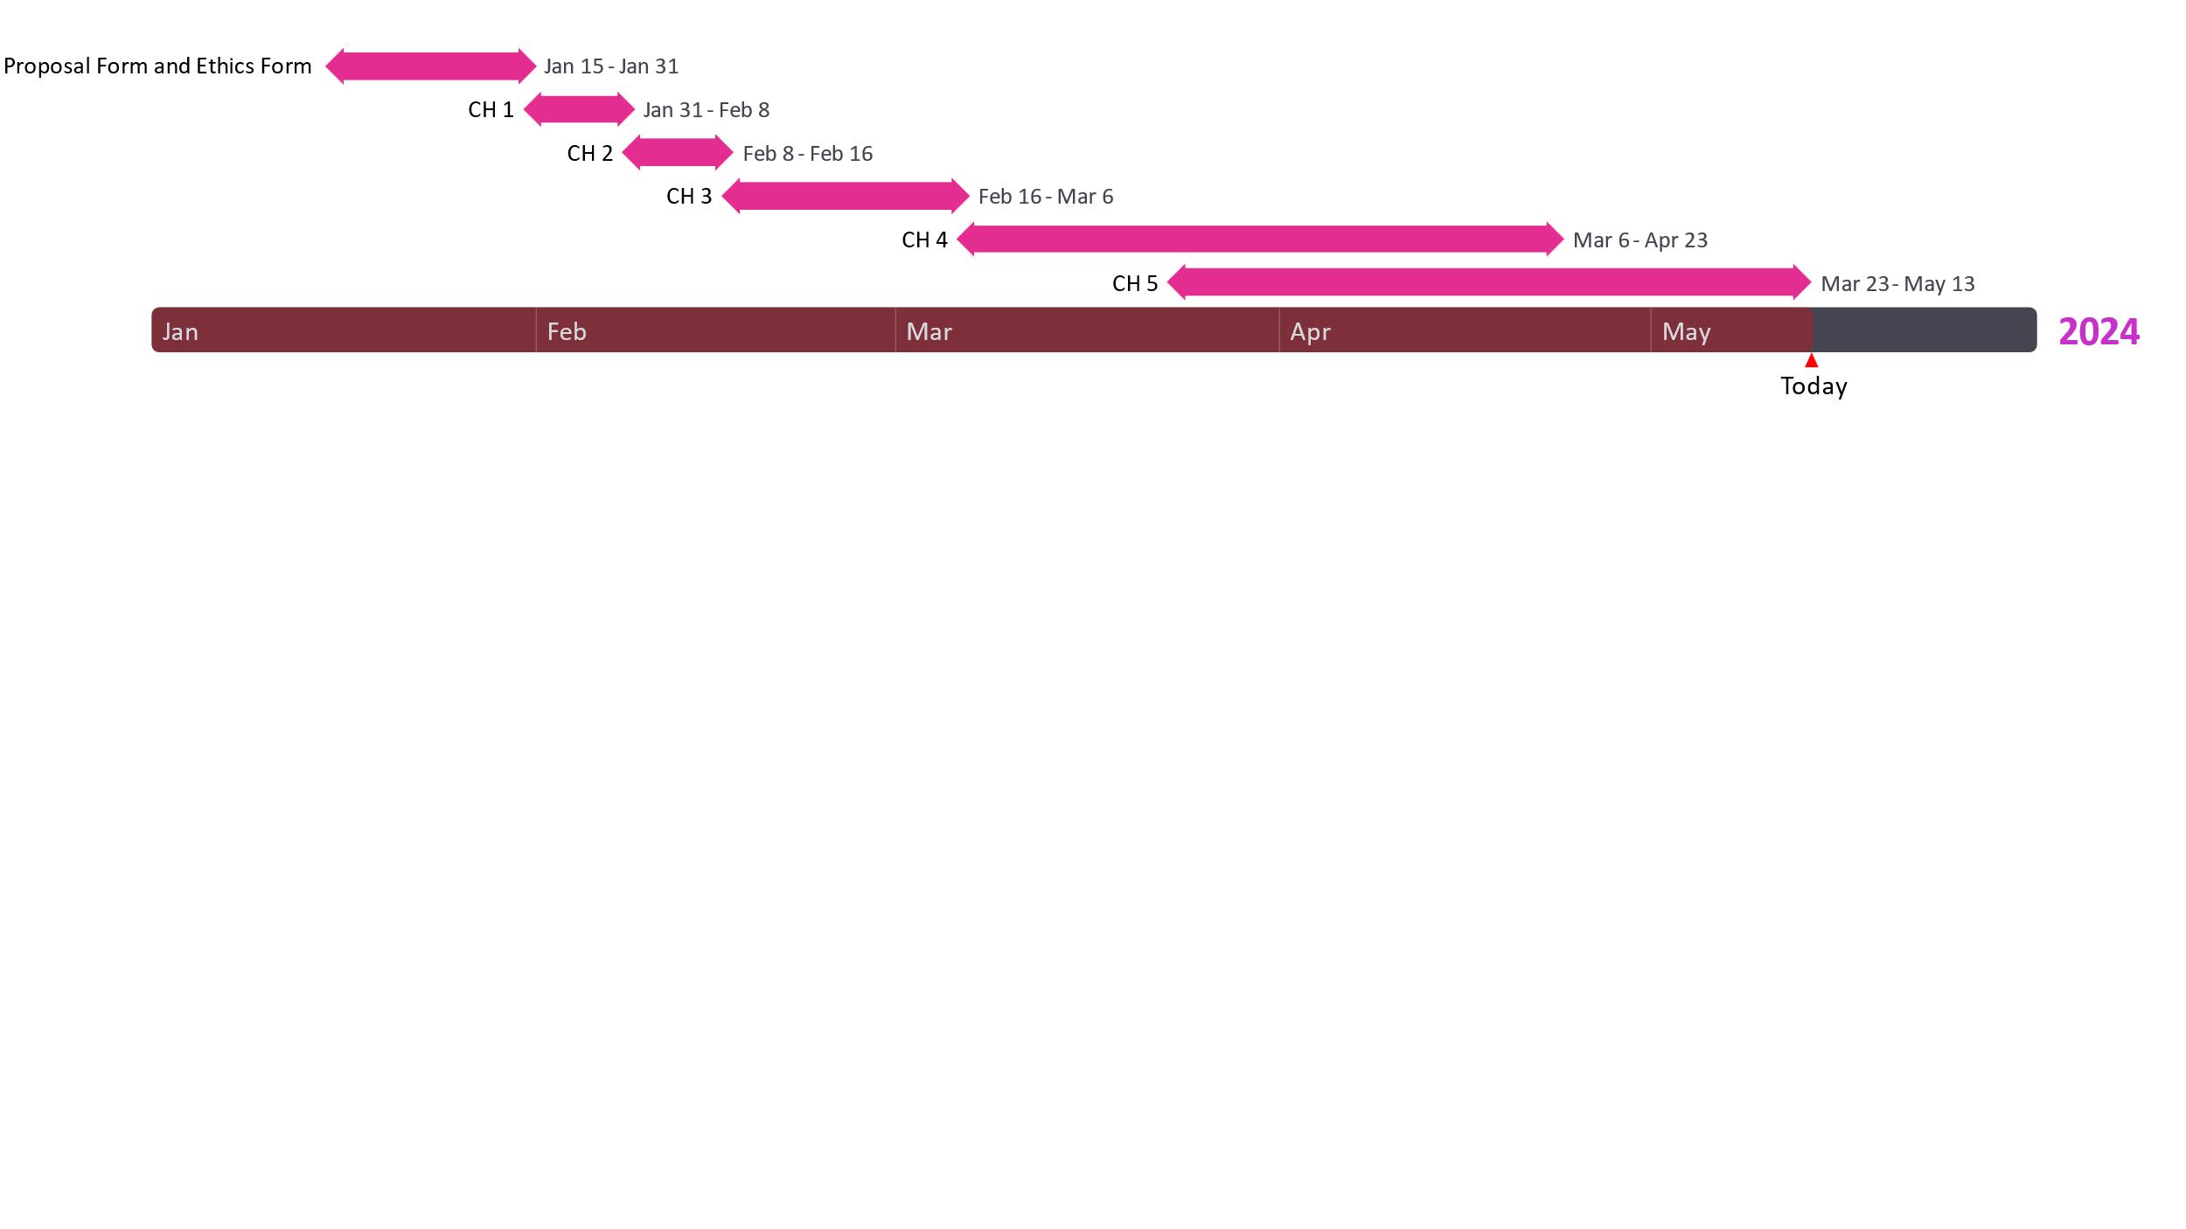

References
- Bertsimas, D. and Shioda, R., 2003. Restaurant revenue management. Operations research, 51(3), pp.472-486.
- Hoyer and Macnnis 2010. Consumer behavior and retailing. Journal of Retailing, 85(3), p.239.
- Samoggia, A., Bertazzoli, A. and Ruggeri, A., 2019. Food retailing marketing management: social media communication for healthy food. International Journal of Retail & Distribution Management, 47(9), pp.928-956.
- Alt, R. (2018). Electronic Markets on digitalization. Electronic Markets, 28(4), 397-402.
- Zysman, J., & Kenney, M. (2018). The next phase in the digital revolution: Intelligent tools, platforms, growth, employment. Communications of the ACM, 61(2), 54-63.

