Understanding and Engaging in the Customer Experience

Student Name: Iulian-Alexandru Dinu

Student Id: 1909113

Lecturer Name: Mary March

Module Name: Understanding and Engaging
in the Customers Experience

Module Code: BMSW5103_LON

Table of Contents
Background of Company. 3

Introduction 4

Government support. 4

Methods used by Coppa club to gather information n from the customers. 5

Marketing Strategy. 7

Customer Relationship Management. 10

Conclusion 17

Reference 18

Coppa Club (Bar and Restaurant)

Background of Company.

In the year 2015, the first Coppa Club was open in Berkshire countryside village on Sonning-on-Thames offering their customers a bit of everything from a nice family vibe to a warm welcoming in our sofa lounge where you can meet your friends and have a relaxing evening, enjoying a wide range of wines, spirits, cocktails, and food.
Providing an excellent and warm welcoming for our customers making them feel like they are visiting a friend, not a restaurant.
The Owner of Coppa Club Is looking for an expansion after securing 25 million Ponds, which on this day we have seven restaurants open across England, with the vision to open more in the future.

Introduction.
This company was chosen because the author has a clear understanding of how the company runs from the Head Office to the restaurants themselves.
In this academic report we will identify the Marketing and CRM Coppa Club it’s using to attract and satisfy its customers needs what types of theories/theory they are using to gather this information and how to use this to their benefit, how to apply and how to put in practice the information gathers from their customers and how to improve their service and the customer’s needs.
With the coronavirus pandemic, this report will show and explain how that affected the customer's relationship with the Company and what the company did to improve that.
What regulation was implemented by the government and how the company respected them and implement them.
What application it’s using for gathering the information from the customers.
To receive clear information from our customers we always provide in our menu clear explanation with details about the product, example from where the product comes which country, how it's prepared, and what contains.

Government support.
With the pandemic in place all over England, the government implemented support for the companies providing them extra capital which helped to keep the staff members and pay them through the government scheme called furlough which was implemented at the beginning of the pandemic.
This scheme had a huge success for the company which allows them to keep paying the staff without losing the business capital supporting and helping the business.

Methods used by Coppa club to gather information n from the customers.
Online review Systems: such as Trip Advisor or Google Review. Individual for every Site

- One of the methods used it's Online rating and review system such as Google maps and Review, Trip Advisor, Booking.com where you can find all the information about what the Restaurant offers and many others.

- Google maps and reviews show the address and locations of all the Coppa Club Restaurants across London and nearby London.
Shows the opening and closing hours, as well the busy times and quieter time allowing you to choose when to visit the restaurant depends on your preferences, allowing you to access the website straight for the application without the need to explore the vast internet.

- Trip Advisor is a worldwide website and application showing you the best restaurant and hotels you can book a room in a hotel or a table in one of the restaurants chosen making the experience worth travelling here.
Where all the customers can write about their experience when visiting Coppa Club.

- Booking.com some of the Coppa club brunches offers hotel or rooms to rent they are more (Inn) style with few rooms and providing breakfast included in the price.

All the branches are using this application and website to collect information which will help develop the restaurants and expand their vision further, by improving, and creating what is missing to provide the best service ever for the customers.
By putting and comparing the reviews for all the websites mentioned above, Coppa club can see what is going wrong by reading all the reviews and compare with the other branches reviews allows them to grow like a Company and upgrade the facilities and equipment for a smooth operation and functionality.

By taking all the bad reviews the company can make four categories which are:

- Waiters/waitresses: reading and separating all the negative comments about waiters/waitresses’ service allow the Company to identify the problem why the customers are unhappy with their visit, giving them information's of what its wrong and the step they need to take make it better.
For example, if a waiter/waitress who is serving the customers is rude or inattentive with the people at the table will create discomfort for the customer which will have a huge impact on the experience the customer has, which can have an impact on the future reference of that customer for the restaurant and the review which will sure fallow after the departure of the customer for the restaurant.
If one or more negative comment is made for the same server that means the fallow action it’s to understand where the issue is and how it can be solved.

- Kitchen Food: The main key for a successful restaurant it's the food they serve, all the customers come to the restaurant to eat and to have an amazing experience if something its missing in those steps can create a gap in the customers experience a which will lead to a bad experience which will make the customers not to return or recommend the restaurant.
The information about the food served will come from the customer's reviews showing the quality of the products and dishes. What needs to stay or what can be improved.

When spoken about the restaurant the food it's the essential and the main key to the success of the company if the quality of the food is poor the disses will taste way much different than the rest of the dissed from other places which will leave a negative impact on the customer making the chose different place to go in the future while the company lose sales and income.

- Bar: Always important another main key to a restaurant every customer it’s looking to have a great wine or cocktail while enjoying a delightful meal, making their experience far much better and giving an amazing boost to the customer's experience.
For a successful restaurant, the owner needs to be sure that he can provide good quality products which will be transformed into amazing dishes, best service from the kitchen to the bar team which will serve quality drinks and cocktails that will satisfy the customers.

In a busy time, everyone can make mistakes for the bar can be adding a wrong ingredient to the cocktail of mix the drinks, which will lead to a complaint from the customer creating dissatisfaction in the service provided.
Creating a negative impression from the customer point of view on the experience, the only solution for these situations it’s to act fast and in the best interest of the customers providing choices of drinks, or a complimentary discount for the dissatisfaction created.

Host/Reception: They are the first person getting in contact with customers when they arrive at the restaurant it’s very important to have a great personality, positive attitude and always a smile on your face for the guests.
That’s why the first impression of the guests about the restaurant starts from the host/reception team which welcomes them into the restaurant.

The job of the host team it's to welcome the customers in the restaurant but it's very important to know how to express yourself in a way that will not disturb the customer, from the body language, tone of voice, to the facial expression it's very important for them to make a good or bad impression on the customer.
After separating all the negative or positive reviews the company can make plans and find a solution how to improve the sections explained above.
What needs to change or improve can be determinate from the review by looking at what the customers need and what they expect from the restaurant.

The reviews with a very bad negative impact on the Company will be separated from the other and dealt with in emergencies ways which will make the priority to the for solving.
Analysed very deep and carefully to identify the main factor of this customers dissatisfaction, identify the main problem and solved as soon as possible with a plan which will last for a longer period.

Marketing Strategy.
Coppa club it's using different sites and markets to promote their product and make publicity for the restaurant some are Facebook, Instagram, influencers, and the main website where all the company history and information are displayed.
- Facebook and Instagram where we can promote our menu and our available space.
Facebook is the most used social media by all the people that's why it's the best way to promote and advertise the restaurant and the products that are sold in it.
Used by millions of people from all around the world they form special groups which promote different places, restaurants, hotels, and many others.
Coppa Club has its page on Facebook showing the people what we are about, where all the people visiting the restaurant can post and advertise the restaurant, by uploading pictures with the surroundings, food dishes, drinks, and all the beauty of the restaurant.
Which it’s the best way to advertise a place when the people are enjoying and recommending the place to their friends, relative, and many other people that are visiting the page and ask for recommendations.
Influencer’s Coppa club has many influencers coming and visiting especially the igloos which are quite rare in London, having a deal they will promote the products that Coppa club are selling buy having premium access to the igloos with a complimentary meal and drink offered by the Company for their help to promote the Restaurant via social media channels.
Instagram is another very popular social media site used by many people where you can follow different persons and see what they are doing, visiting, and what they are writing about their experience in different places, making the fallowers try and see by themselves the experience that they will get from the visited places and the advice from the other people they visit before.
- The website where you can check what Coppa Club means and what we are doing including menu, reservation, promotion, events.
Like all the other Restaurants Coppa club has its website where you can book tables make requests, see the menu and what type of food we are selling, have a glimpse of the cocktail and wine menu, as well as the spirits and soft beverages the restaurant it's offering for the customers.
On the website are listed all the privacy policies which will provide all the necessary information when you reserve a table what are the steps to follow if any issues occur in the process of making a reservation or other issues that may occur.
The company plan it's to remain active on this social media updating always all the new promotion and new dishes, providing extra information for the people around the world, always on top of the others when it comes to view, uploading amazing pictures with the restaurant from different angles capturing all the view.
Promote each food dish and cocktail with explicit detail where the people can see exactly what it’s in the dish. Post new dishes and drinks as soon as the restaurant it’s selling them, and they are added to the menu.
Using these facilities, it's limited to the use of the internet if people don't have an internet connection, they can’t use the social media websites

Customer Relationship Management.
What is CRM the technology with gives the Company the ability to manage all the relationships gather over the years and future new relationships of the customers and potential customers? The whole goal of the CRM it's to improve the business relationship helps keep connected with the customers which will increase profitability.
There is 3 type of CRM systems:
- Collaborative.
- Analytical.
- Operational.
Each company chose the best type suited for their business.
- Collaborative:
Collaborative CRM it's a bit different from the others more toward the communication of the team, as well with the external stakeholders, suppliers and distributors.
Coppa club Type of CRM is Collaborative where the company collaborate with the supplier and the customers to improve the business and make it more profitable more stable and more productive, with better efficiency.
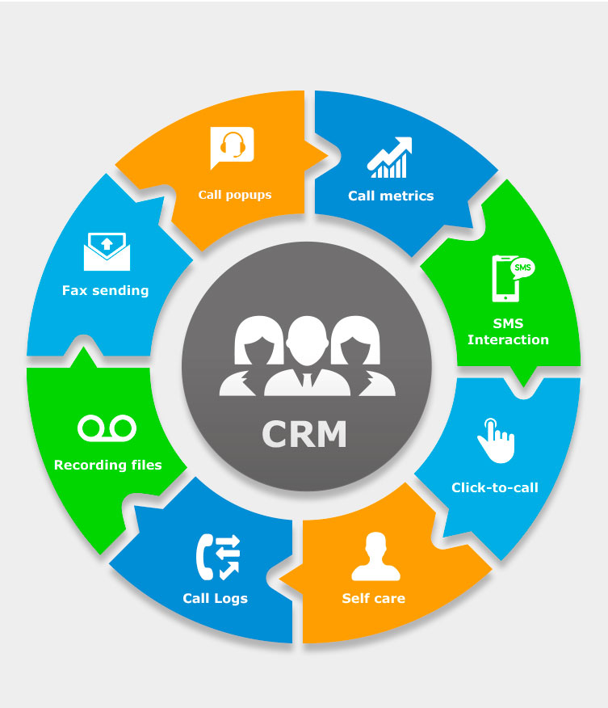
This Photo by Unknown Author is licensed under CC BY-NC-ND
Coppa club Customer Relationship Management (CRM).
Coppa club it's using the website and social media just like a connection string between the Company and customers, where the customers can use a different type of communication channel to get in touch with the restaurant and vice versa for the company to get in touch with the customers.
Using channels like email, telephone, SMS interaction where the company can get information, verbally and written from the customers, also provide information and promotion through the channel back to the customers.
Another type of interaction with the customers it’s the physical one where the customers can speak face to face with someone from the reception asking and for the necessary information as well as making a complaint or a compliment.
The most common way of communication preferred by all people it's email, telephone or SMS interaction, with these methods the time is cut for more efficiency and better productivity. The company being able to respond and communicate with a larger number of customers in a shorter time providing a better and more consistent service than before.
Implementing new technology in the restaurant giving opportunities for the customers to make specific requests when they book a table such a special events birthdays, anniversaries, proposals which will increase the and boost positively the customer service provided by the company.
For some people which are a bit behind with the technology there still ways to communicate with the Company by providing telephone enquires and information without putting so much pressure on the customers understanding, clear information on what option to got when they call depends on what they want and require from the restaurant.
All the application where we promote and share the information about the restaurant, they are equipped with click to call which it’s easier to use then look on the website or internet for the telephone number, all the customers that want to get in touch with the restaurant just visit Google or trip advisor and just click on call and the phone number will automatically go on speed dial without any complication, fast and easy to call.
All the calls are recorded for quality purpose after each call the recording it listens again to hear how the employers speak and how the information required from the customers it's explained in which manner and tone that determine the way the customers think about the enquires service which needs to be specific, clear and on customer demands.
The restaurant has a call log which will store all the missed call allowing the reception team to call back all the customers who haven't been able to connect with the restaurant, and listen and ask for the customers enquires, another boost on service quality most of the people fells appreciated when they try to call for a booking and nobody answer, after few minutes to be called back and one of the reception member to ask about the enquiries of the customer.
Each month the receiving call analyses and gather creating a matrix which shows a daily basis per cent of calls, separating the negative from the positive ones making a calculation, and after this analysing the improvement or what still needs to be improved.
When the coronavirus (COVID-19) pandemic started the customers, the relationship became harder, when all the restrictions took place and all the restaurants including Coppa club needed to change the way they are working making sure that all the conditions are met to operate and follow the new government regulations.
Following the new regulation, the restaurant needed to leave the specific space between tables, which was one meter and half, limiting and decreasing the capacity of the restaurant which affected the customer relations with the restaurant.
Forcing the company to move reservation from day to another one because of the limited space available at the same time cancel some of the reservation because being unable to provide a table, which left a huge disappointment for the customers.
With an imminent national lockdown coming the Company needed to shut the restaurant and start to think of an alternative to satisfy the existing customers by transforming into a takeaway restaurant with the possibility of home delivery using Delivero all the people which head of Coppa club can have a taste and try what the restaurant it's selling and make the customers happy and with a desire to come when the doors are open again, to fully experience the Coppa club vibe and what it means.
With the pandemic all over the world, the customers change their behaviour becoming scared to go out of the house isolating themselves without having any contact with the outside world with the restaurant transformed into taking away helped us maintaining the relationship with the customers.
The company decided to be more focused on telephone and emails to the customers inform them about the new regulation in place when the doors will open again, giving them a full explanation and apology why some of their bookings were moved or cancel, something the company can't control. Some decisions were made by the higher management and Owners to ensure the Company can still open and operate normally just with the restriction in place and limited seating's available for the customers.
The company needs to think first that the law is respected and there is no problem whatsoever, thinking about the customers it's the second thing in the company protocol after all the customers are the one providing capital for the restaurant allowing us to stay open to grow and develop further.
The strategy was placed by the owner thinking about the future of the company and ensuring that the company will gain capital in these hard times, anyway the company owners after the referendum of the Brexit they started to create a saving account from where they can withdraw a certain amount of money for different occasions and emergencies.
After the first wave of coronavirus, the Company took advantage of the situation when so many businesses go bankrupt without having the necessary capital to keep the business going. With the pandemic in place, the prices decreased which give an advantage for the big companies with extra capital. The owner took advantage and started to acquire new sites by buying them at low market prices which allow them to invest, redecorate and equip the new site with new furniture and equipment.
After the second wave of the pandemic which happened very fast Coppa club having enough capital to survive they just close the doors waiting for the pandemic to pass, working just with the takeaway for extra incomes, and waiting to reopen the doors again.
After the second wave, the doors were opened and the company slowly started to change their policy and the prices boosting them with a very small amount, implementing new rules and for the people that are booking for the igloo's creating a minimum spend and ensuring a steady and sure income per day from that, while satisfying the customers with a premium view experience and service.
Making them forget about the minimum spent and enjoy their reservation with a wonderful view, meal and drinks.
After the pandemic, the company started to improve the customer's relationship, with the restaurant fully set to reopen the focus of Coppa club to become their customers. Because so many things happened with the coronavirus and the lockdown the company neglected the customers for a short period focusing on the restaurant renovation and fully prepared for the opening.
With the focus back on the customers, the company started to provide extra importance for the existing customers with a reservation made before the impact of coronavirus by offering them promotions, discounts, and gift cards which help boost the morale and the experience at the restaurant.
Ensuring that with the opening all the new regulation which was presented by the government were in place and all the safety precautions were implemented, by providing sanitizing stations across the restaurant for staff members as well as for the customers, gloves if required from the customers and staff as well, face mask for customers and staff. Ensuring that the staff follows the twenty minutes rule where they need to wash their hands regularly every twenty minutes, as well as sanitising all the common touch places such as door handles, tills and all the surfaces touch by more than one person.
For the customers and their safety, a two-meter distance between person was placed allowing them to feel safe and taken care of, providing a one-way entrance and exit trying to avoid for the people to get very close one to another, and inform them what rules they need to follow within the restaurant.

When the company become steady and everything was ready for opening the main attention was change to the customers, making sure that all the existing customers were fully informed about the situation and the new regulation, without creating confusion and disappointment, each customer was informed individually by e-mail or telephone informing them when the restaurant it's open and what is the new regulation, what they need to know and how to proceed with the restriction implemented by the government.
To ensure that the customers feel safe on the walls of the restaurant the company implemented the rapid-flow test for all the staff members which they were obligated to take the test two times per week at home before going to work failed to take the test at home the employers were to take the test on-site at the restaurant before their shift starts, depending on the result the employer was allowed to work if tested negative or sent home in the situation if tested positive with the obligation to register the result on NHS and self-isolate for 10 or 14 days depends on the following coronavirus test.
An application was placed where all the employers were to take and respect which allows the employee to monitor all the symptoms of the employers before started to work with the customers, ensuring that none of the staff has any symptoms before engaging with the customers.

Conclusion.
After finalizing the report, we will have a better understanding of how the company works, and how they build the customers relationship based on the information, and the strategy that they use to gather the information.
As well as the action is taken with all the coronavirus pandemic and new regulations in place, how they acted and what they make different to ensure the safety of the customers as well the employer's safety and well-being.
What were the steps to provide extra capital for the company what changes did they make and how they adapted to the current situation?
Showing how the company separate the issues in buy sections mentioned above and how to deal with them in a proper manner and with the solution which will last for a long period.
A better understanding of how the company market strategy work and how they promote their products, with which channel they promote and how good and fast are these channels.
How the government affected the business by implementing restrictions to ensure the safety of the customers and employers.
Those are few things that will help in the future, allowing to have the best understanding on how external factors can affect the business, something that it's uncontrollable just to adapt and use the best of the knowledge gathered from all the situation encountered by other Companies.

Reference

1951, D. B., 2017. Hospitality marketing. third edition ed. London; New York: Routledge, Taylor & Francis Group.
1958, I. L., 2018. Diverse methods in customer relationship marketing and management. Hershey: IGI Global.
Anon., 2021. Coppa Club. [Online]
Available at: https://coppaclub.co.uk/our-story/
Anon., 2021. Creatio. [Online]
Available at: https://www.creatio.com/page/what-is-crm
[Accessed 31 08 2021].
Anon., 2021. CRM.org. [Online]
Available at: https://crm.org/crmland/collaborative-crm
[Accessed 2021 09 01].
Bergeron, B. P., 2002. Essentials of CRM a guide to customer relationship management. New York: Wiley.
Buttle, F., 2012. Customer relationship management: concepts and technologies. 2nd ed. London; New York: Routledge.
Peel, J., 2002. CRM: redefining customer relationship management. 1st ed. Amsterdam; Boston: Digital Press.
Reinartz, W. J. & Kumar, V., 2006. Customer relationship management: a database approach. Hoboken, N.J.: Wiley.

