William Scott (1703620)
1703620@student.uwtsd.ac.uk
Contextual Practices
Ways of Perceiving
M4X01559
14/05/2018

My imagined exhibition would involve producing an artwork and musical concert simultaneously in real time. A synchronised development of shapes, light, shade, colour and sound. A bringing together of multiple artistic disciplines.
John Cage and Merce Cunningham would work in isolation then bring their music and choreography together just before a performance rejecting the idea of a united, singular purpose in the creative process. This was a conscious, artistic decision to remove the influence of one upon the other. Laura Kuhn, of the John Cage Trust said that John Cage “liked the idea of independence and wondered if there were another way we could work separately to produce a work of music and dance’’ (Weinstein, 2011)
It could be argued music and movement are inextricably linked. As the quote commonly attributed to Fredrich Nietzsche says, ‘’those who were seen dancing were thought to be insane by those who could not hear the music’.
From involuntary dilations of pupils to the writing of a score, the waving of a conductor’s baton to the fingers of virtuoso or the whirling of a dervish, movement is essential. Physical art forms require movement of some description, at some level, in their creation. Though interdisciplinary inspiration is common place, forming a direct link between art creation and music has been performed mainly in the realm of dance.
It is natural to respond to music.
‘After birth, sound is to the nervous system what food is to our physical bodies: Food provides nourishment at the cellular level of the organism, and sound feeds us the electrical impulses that charge the neocortex.’ (Leeds. J. 2010)

It is natural for musical performers to react to their audience and even their own performance. It follows that an artist would respond to sounds created in parallel to their movements executed whilst making their art. Elaborate and flamboyant or small and delicate movements replicated in sound. A cycle of brush or pen strokes resulting in an interactive graphic score.
‘I love to have music playing in the background while I paint. Fast, upbeat music sometimes inspires me to be very expressive with my brush. I typically listen to this type of music at the outset of a painting… since I like to fill the canvas as fast as I can. For the second half of the creation process I usually turn to slower, mellow music. This type of music helps me to be more precise and technical in my brush strokes.’ (Matthews. G. 14 January 2013)

Art can be the inspiration for music. In 1874 Modest Petrovich Mussorgsky’s wrote a piano piece, Pictures at an exhibition, which was inspired by ten drawings and water colours by his friend Victor-Edouard Hartmann.
It can also be said that music influences art.
‘’Listening to music while creating art is like escaping into a dream and emerging with a souvenir. Music and art-making are undeniably intertwined, passionate partners who enrich, even define one another.’’ (Znerold. R. 2010)
An early connection between graphics and music was the Oramics Machine invented by Daphne Oram who is also credited with setting up the BBC Radiophonic Workshop in 1957. Her invention was an early type of sequencer. It used what were a kind of graphic score, drawn on 35mm film, which could be read by the machine and directly transformed into sounds.

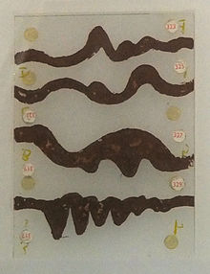
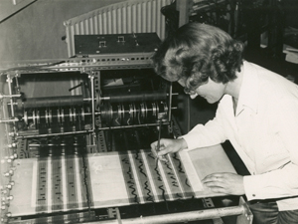
An Oramics Machine score. (1965-80)
Figure 1An Oramics Macine score.
Oram draws timbres on the Oramics machine (Credit: Fred Wood/Daphne Oram)
Our ability to interact with sequencers has moved on.
Linking the physicality of art creation with sound can give an audible depiction of an art work. We are visually and aurally responsive creatures. Combining art creation with music creation is a logical step. The tools are available, curiosity and experimentation will lead the way.
Until the invention the of audio recording, music has always been a performance art.
In the 1960s when the recording studio suddenly really took off as a tool, it was the kids from art school who knew how to use it, not the kids from music school. Music students were all stuck in the notion of music as performance, ephemeral. Whereas for art students, music as painting? They knew how to do that. (Eno, date cited in Priestley, 2014: 129)
Music and sounds can stimulate feelings and emotions. Music makes us feel and therefore respond in a physical manner. According to Mark Changizi (2009) ‘’Human movement has been conjectured to underlie music as far back as the Greeks.’’
Music underpins many visual art forms particularly film, theatre, dance and animation. Using tracking systems, it is possible to apply a soundscape to static images as they are formed.
Rather than a retro-active tie, pieces inspired by works performed previously such as Picasso’s Three Musicians or Kandinky’s Composition 8, art and music can be made concurrently, forming a live, real time graphic score. It can be stored, edited and exhibited at any time. It may be better to use the term ‘sound’ as opposed to ‘music’. There is no reason why the sounds triggered by the artist should be ‘musical’. In the same way film and animations use soundtracks and foley, an artwork depicting a city could use road-like noises or a seascape use ocean-like noises or indeed, something more abstract that denotes the image.
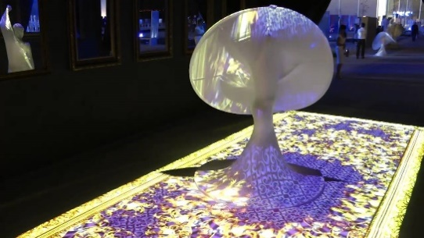
There are many examples of dance and visual interactivity using various tracking devices.
Interactive installation for the opening of the National Theatre of Bahrain. www.vertigo-systems.com

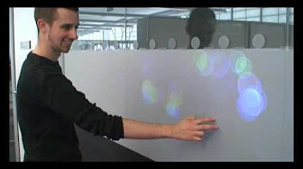
‘Vie’, is an interactive tactile illuminated screen. Art installation created by Giuseppe Paul Davies.

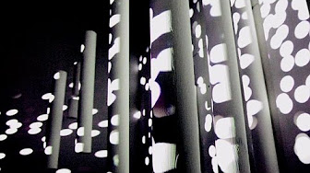
‘Delusion’ uses static tubes, interactive light, projectors and sound. delusion.yuluo.de

Due to the simplicity of such tracking systems and sensors, afforded by current technology, it is easy to involve not only the artist but the passer-by, audience or spectator actively in the production.
Graphic scores began to appear around the 1950s to extend notational possibilities, introduce random interpretation and improvisation. ‘’Although the graphic score must remain an intriguing byway in music history it helped redefine the possibilities of ordered sound.’’ (Phillips. T. 2013).

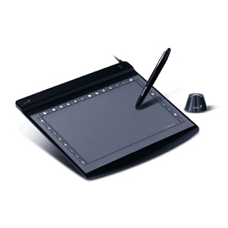
The idea behind the event would be along the lines of the Oramics Machine but using a computer sketch pad linked to music software. Whilst the drawings were being created the sounds could respond to the movement across the computer screen. I say ‘could’ because there is no reason why the sound should not track the movements retrospectively assuming each stroke was stored in a computer history or MIDI piano roll.
This Photo by Unknown Author is licensed under CC BY-SA

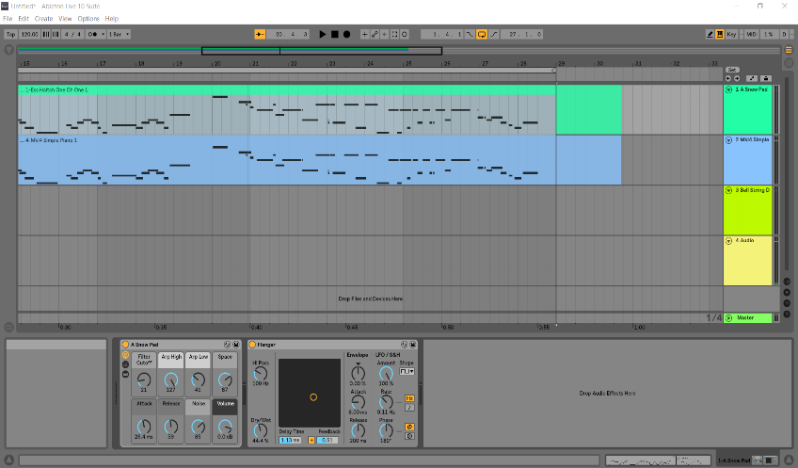

MIDI piano roll on a digital audio workstation (DAW).

Storing the score as MIDI would make it possible to re-interpret the sound and images in many ways, exchanging the instruments, sounds, lines, colours, hues, shapes, sizes and effects, at will, on a later occasion. It could be shared on the internet. It could be sampled or used as foley for many other projects.
For a live event it would be wise to pre-program limits to the scales and sounds produced particularly if the event was to be open to public participation. The intention would be to encourage active involvement. Without limits the noises could be very off putting, dissonant and counterproductive. Random noises can be an acquired taste. Hopefully, the result would be two bodies of work, independently valid, neither subordinate to the other, yet intimately related.
From a practical, logistical point of view, although the venue for a live event could be an indoor or outdoor space provided it had the facility to display the graphics on a large screen visible to spectators and would also allow sound to be produced at an adequate volume level, an indoor location would be the simplest option. Using an indoor location, the sound is contained, the environment is more controllable, the weather (unless it is extreme) is not an issue and there are places available that regularly put on events of a similar nature.
Selecting an existing venue which has refreshment facilities in place would eliminate the need for food and drinks stalls to be arranged as would be the case at an outdoor event.
Technicians would need to be on hand to set up and assist where and when required.
Artists would be needed to get things started, give advice and keep thing going.
Relevant licences and official approval would need to be obtained.
Public welfare, health and safety issues should be anticipated, and any necessary insurances obtained.
Support staff such as door personnel, bar staff and stewards would also be required.
As this is, thus far, simply an idea, rehearsals would need to be arranged and preparation made to ensure all the components would work as expected. A working knowledge and practical experience of the hardware and software would be essential. Building a library of usable sounds and effects would be prerequisite. Preconceived ideas of the artists subjects may well be worth exploring. Although this event would improvisational on many levels, having a fall-back position would be a good plan. The aim is, as with most events, to be entertaining.

References
Online Articles and Journals
Changizi. M. (2009) ‘’ Why Does Music Make Us Feel’, Scientific American, [Online]. Available at: https://www.scientificamerican.com/article/why-does-music-make-us-fe/ (Accessed 12 May 2020)
Leeds. J. (2001, 2010) ‘Psychoacoustics’, The Power of Sound, [Online]. Available at: http://thepowerofsound.net/psychoacoustics-defined/ (Accessed: 12 May 2018)
Matthews. G. (2013) ‘10 Artists and the Music They Listen to While Painting’, Artpromotive, [Online]. Available at: http://www.artpromotivate.com/2013/01/artists-listen-music-while-painting.html (Accessed 11 May 2018)

Phillips. T. (2013) ‘Playing pictures: the wonder of graphic scores’, The Guardian,
[Online]. Available at: https://www.theguardian.com/music/2013/oct/07/graphic-music-scores-playing-pictures-tom-phillips. (Accessed: 10 May 2018)

Weinstein, B. (2011) ‘The Collaborative Legacy of Merce Cunningham’ Places Journal, March 2011. [online]. Available at: https://placesjournal.org/article/the-collaborative-legacy-of-merce-cunningham/ (Accessed 11 May 2018)
Williams. H. (2017) ‘The Woman Who Could Draw Music’ BBC. Available at: http://www.bbc.com/culture/story/20170522-daphne-oram-pioneered-electronic-music (Accessed: 9 May 2018)
Znerold. R. (2010) ‘Top Ten Albums of 2009: Music to Make Art To!’, Elephant Journal [Online] Available at: https://www.elephantjournal.com/2010/02/top-ten-albums-of-2009-music-to-make-art-to/ (Accessed 12 May 2018)

You Tube Videos
Eeky2008 (2009) Vie - Interactive Art Installation. Available at: https://www.youtube.com/watch?v=nvoVTEJZ_Dk (Accessed: 7 May 2018)
goandsee123. (2011) DELUSION - an interactive light installation. Available at: https://www.youtube.com/watch?v=t-T74im_r8g (Accessed: 10 May 2018)

vertigosystems (2012) Interactive installation for the opening of the National Theatre of Bahrain. Available at: https://www.youtube.com/watch?v=iM5NIQs9DP8 (Accessed 8 May 2018)

Online Photographs
Wood. F. (N.D) Fred Wood/Daphne Oram [Online]. Available at: http://www.bbc.com/culture/story/20170522-daphne-oram-pioneered-electronic-music (accessed: 9 May 2018)

Online Screen Shots
vertigosystems (2012) Interactive installation for the opening of the National Theatre of Bahrain. Available at: https://www.youtube.com/watch?v=iM5NIQs9DP8 (Accessed 8 May 2018)
Eeky2008 (2009) Vie - Interactive Art Installation. Available at: https://www.youtube.com/watch?v=nvoVTEJZ_Dk (Accessed: 7 May 2018)
goandsee123. (2011) DELUSION - an interactive light installation. Available at: https://www.youtube.com/watch?v=t-T74im_r8g (Accessed: 10 May 2018)

Additional Reading
Online Articles and Journals
http://petermedhurst.com/study-days/music-inspired-by-paintings/
http://www.hse.gov.uk/event-safety/
http://zbikowski.uchicago.edu/pdfs/Zbikowski_Music_and_movement_draft.pdf
https://group.sciencemuseum.org.uk/our-work/research-public-history/research-projects/past-research-projects/oramics-to-electronica/
https://www.gov.uk/government/publications/can-do-guide-for-organisers-of-voluntary-events/the-can-do-guide-to-organising-and-running-voluntary-and-community-events

https://www.gov.uk/government/publications/can-do-guide-for-organisers-of-voluntary-events/the-can-do-guide-to-organising-and-running-voluntary-and-community-events
https://www.wqxr.org/story/200394-top-five-musically-inspired-paintings-new-york/

Online Videos
https://www.bing.com/videos/search?q=glade+electronic+music&&view=detail&mid=3BAFFDE446EE4701D6A43BAFFDE446EE4701D6A4&&FORM=VDRVRV
https://www.bing.com/videos/search?q=john+cage+merce+cunningham&&view=detail&mid=EE2E372637011F775D15EE2E372637011F775D15&rvsmid=6FFB5B06E4EC212449F66FFB5B06E4EC212449F6&FORM=VDQVAP

