Data Handling & Business Intelligence (LCBB5000_BIRM)

Lecturer: Zahra Mohammadnazari
Student: Sergiu Diaconu - 2126929

Table of Contents
Introduction 3
Dataset 3
Part 1 4
Part 2 9
Conclusion 12
References 12

Introduction
The "GreenMed_Healthcare_2023" dataset offers a careful assessment of the handling times given by a few legitimate huge information stages and innovations. Pioneer in medical care examination GreenMed Advancements directed this review to assess Hadoop, Flash, R, Python, and Scene's ability to oversee enormous datasets. The association's obligation to involving enormous information in understanding consideration arrangements required this broad examination. The broad measurable devices of Succeed and SPSS were utilized in its execution. GreenMed Advancements tries to upgrade its information handling techniques via cautiously examining key execution factors. Further developing patient results is the venture's definitive objective, exhibiting the fundamental job that productive information examination plays in the development of the medical services industry.
Dataset
The information being offered gives day to day handling speeds for five particular enormous information devices: Hadoop, Flash, R, Python, and Scene. It traverses the long stretches of January through February of 2023. The fastidiously organized information delineates the varieties in execution that each instrument encounters throughout a day, demonstrating the functional viability and trustworthiness of every gadget. Hadoop_ProcessingTime, Spark_ProcessingTime, R_ProcessingTime, Python_ProcessingTime, and Tableau_ProcessingTime are significant markers that give a far reaching perspective on what amount of time every innovation requires to handle information. This transient picture is critical to GreenMed Developments since it could assist them with coming to vital conclusions about how to best augment their large information examination to work on understanding results.

Part 1
a) Analyzing the GreenMed_Healthcare_2023 dataset will give a far reaching image of how well the different information examination devices utilized by GreenMed Developments perform. The objective of this exploration is to reveal insight into Hadoop, Flash, R, Python, and Scene handling times, which are all fundamental for augmenting the viability of the business' information driven medical care contributions (Hendrian, Julaeha, and Ardiansyah, 2023). It is normal that the bits of knowledge gathered from this examination will work on persistent results and viability.

- Mean Processing Time for Hadoop
The Hadoop handling time normal for the example is 2.777 seconds. This measurement, which demonstrates the typical time that Hadoop spends handling information in a given day, is vital for figuring out the device's general viability. As found in the realistic, Hadoop is appropriate for errands that don't demand constant examination on the grounds that to its unobtrusive handling time.

- Median Processing Time for Spark
The typical reaction time for Flash is 2.747 seconds. A rundown of numbers' center worth, or middle, diminishes the effect of exceptions and gives a more reliable proportion of focal propensity. Considering that over portion of the handling spans are underneath this end, Flash seems to work rather reliably.

- Highest Processing Time for R
R showed a greatest handling season of generally 4.867 seconds on January 16, 2023. This pinnacle might demonstrate a computationally burdening task that day or a likely bottleneck. These abnormalities require examination since they might highlight basic issues or explicit situations in which R isn't the most fitting device.

4. Standard Deviation for Python Handling Time
The standard variance of handling time for Python is around 1.297 seconds. This figure represents the degree of deviation from the mean. Python's handling speeds tend to be less erratic when the standard deviation is lower, implying a more consistent exhibition..
5. Tool with the Lowest Average Processing Time
Python is the machine with the shortest typical handling time, starting at 2.573 seconds. Python may be used above other options for information handling in GreenMed because to its efficacy, particularly for jobs with little time to lose. Other execution models, for example, the complexity of the tasks that each device can do, should be considered as well..
6. Interpretation of Handling Time Contrasts
The examination features that it is so vital to consider the specific information handling prerequisites of each task and helps with choosing the most ideal device to get everything taken care of. For instance, while having longer handling times, Flash or Hadoop might be picked for dispersed figuring jobs because of their solid treatment of huge datasets. In any case, in view of its enormous environment of information science bundles and higher handling rates, Python may be a superior choice for applications requiring fast, iterative information handling systems.
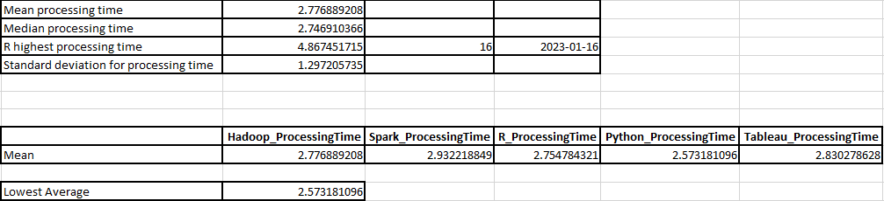

b) The GreenMed dataset examination tells the best way to exquisitely report the information handling times for different insightful devices by skillfully using Microsoft Succeed's highlights (Setiyanto and Setiawan, 2022). The handling times for each apparatus over the long haul on various days are shown utilizing line outlines in the report. This realistic portrayal causes to notice the distinctions and examples, working with a quick cross-fleeting exhibition correlation. The line graph is a simple strategy to follow the ascent and fall of handling times, finding days that have odd highs or lows that might require more examination. It has plainly variety coded lines for Hadoop, Flash, R, Python, and Scene.
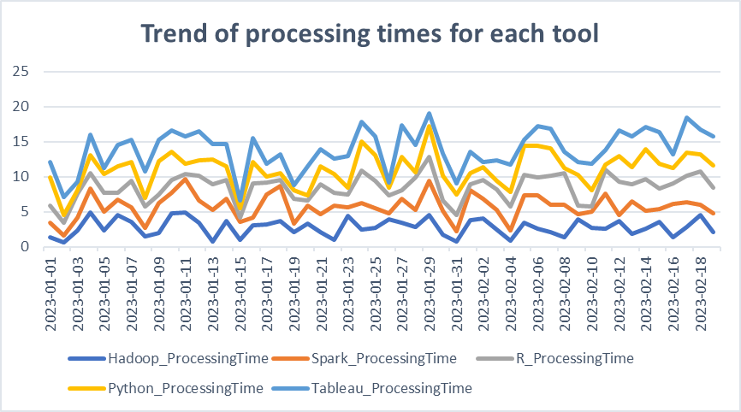
Besides, a very much planned histogram investigates the handling time recurrence conveyance of Hadoop. This perception gives a reasonable viewpoint of the most well-known handling time stretches while featuring the focal inclination and circulation of the information by binding the scope of handling times. This kind of histogram is an essential device for sorting out the normal working reach and distinguishing any peculiarities or exceptions in Hadoop's presentation.
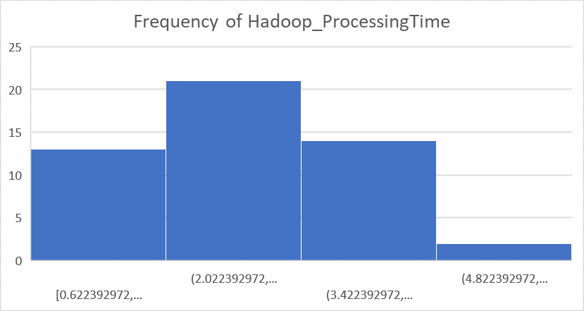
Moreover, turn tables are utilized to give month to month and by and large midpoints of handling times for each instrument, gathering the colossal numbers into a reasonable viewpoint. This even total, worked with by Succeed's turn table capability, empowers a careful comprehension of hardware effectiveness and lays the basis for an organized examination by looking at the month-over-month contrasts.
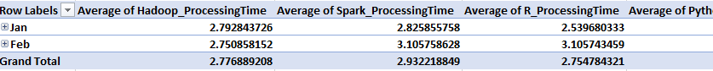

By consolidating turn tables for information conglomeration and outlines for graphical information show, the report goes past fundamental information revealing. It is a complete story that quantitatively and refines the dataset, transforming numbers into stories that are pertinent to GreenMed Developments' day to day exercises. At the point when joined, the plain and visual amalgamations give light on the perplexing elements of handling time execution and empower information driven decision-production for better quiet consideration.
c) Part 1:
In the mind boggling domain of information examination, appreciating the synchronization between various factors is basic. GreenMed Developments' investigation of Hadoop and Scene handling speeds delivered a connection examination, the consequences of which are informational and engaging.
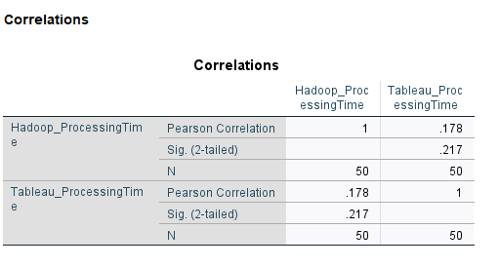
The Pearson affiliation Coefficient, a strategy that actions the direct relationship between two factors, is utilized to survey the connection among Hadoop and Scene's handling times. These two instruments appear to have a feeble yet certain straight connection, with a relationship coefficient of 0.178. This powerless connection demonstrates that there might be a slight propensity for Scene's handling time to increment somewhat in lined up with Hadoop's handling time.
The first step in analysing historical data is to translate these quantitative findings into human understanding (Guerrero, Guerrero, and Rauscher, 2019). It is the story of Hadoop and Scene, two titans of the huge data processing industry, dancing to the beat of their own drummers—occasionally moving together, but more often than not apart. This separation of roles might be attributed to the different functional domains that each device covers; Scene, with its proficiency in information interpretation, and Hadoop, with its robust information management system, are both well-suited for different phases of the information analysis procedure.GreenMed Developments could find that the low relationship demonstrates that picking Scene or Hadoop for a specific information handling task will not fundamentally affect the presentation of one instrument. Understanding that concurrent tasks utilizing the two apparatuses are probably not going to fundamentally influence each other's handling terms ought to help the organization better arrangement and distribute its assets.
In the wide image of information examination, where each device should be appropriately picked for its expected use, such bits of knowledge are fundamental. They help GreenMed Advancements in making an effective work process where each apparatus can be used to its fullest potential without waiting be worried about execution decay brought about by between device handling time conditions. Accordingly, GreenMed is prepared to satisfy the needs of enormous information examination, guaranteeing that patient consideration is upheld by productive and convenient information handling.

Part 2:
To investigate the connection between the handling paces of the two projects, a scatterplot was built, where the level pivot addresses Hadoop's handling time and the upward hub addresses Scene's (Kafle, 2019). The scatterplot is a measurable visual story that shows the circulation of spots on a material, every one of which means an alternate crossing point of the handling times of the two devices on a given day.
Rather of showing a strong connection between the two elements, the occurrence we are watching paints a picture of a relationship that is a roundabout one. Dispersed around the plot, each dab serves as a single sentry, with just a little upward orientation that becomes apparent when we move along the Hadoop hub from left to right. This slight rise in Scene's handling times relative to Hadoop's advancement supports the previously suggested positive link.
The most notable aspect of the diagram is the region affected by each point, which is not constrained by a tidy linear design. This realistic image corroborates the real facts as well: It is not implied that there is a relationship between two factors that might accurately anticipate changes in one by a Pearson Connection Coefficient of 0.178. A heavenly body of information foci that imply liberty with the potential of a weak link is depicted in the scatterplot instead of a dense cluster of specks surrounding a line of best fit, which would suggest a strong relationship.
GreenMed Advancements will benefit directly from this scatterplot. It suggests that the functional efficiency of Scene and Hadoop are not inextricably linked. This liberty is beneficial because it allows the medical services pioneer to fully utilise any invention without being constrained by the dependant demands of effectiveness. Without constant consideration, Hadoop's information handling limit may impact Scene's perception timings, and vice versa.a) Advantages and Disadvantages of SPSS, Excel, and Tableau
SPSS (Statistical Package for the Social Sciences):
Advantages:
- Advanced Statistical Analysis: SPSS is well-known for its powerful statistical skills. It is particularly adept at performing complicated statistical studies such as ANOVA, regression, and factor analysis. For example, in healthcare analytics, researchers may use SPSS to compare the efficacy of various therapies based on patient outcomes.
- Data Accuracy and Robust Testing: SPSS ensures accuracy and reliability in statistical testing, making it suitable for sophisticated medical research. Researchers at GreenMed Innovations can trust SPSS for precise statistical outcomes, which is crucial for making informed decisions in patient care solutions.
Disadvantages:
- Steep Learning Curve: SPSS may be challenging for beginners due to its complexity. Staff at GreenMed Innovations might need extensive training to utilize SPSS effectively, incurring additional costs and potentially delaying the integration of this tool into daily operations.
- Costs: The licensing fees associated with SPSS can be high. For a business like GreenMed, which may not require complex statistical techniques for every task, the investment in SPSS might be seen as an expensive undertaking.
Excel:
Advantages:
- Versatility: Excel is widely known for its versatility. It is a common tool in the commercial sector and is extensively used for various tasks, including spreadsheet management, budgeting, and organizing patient data. GreenMed's administrative staff can benefit from Excel's familiarity and user-friendly interface.
- Accessibility: Excel's accessibility is a key advantage. Professionals across various domains are familiar with its features, making it an ideal choice for general data management tasks. GreenMed's administrative tasks, such as scheduling and budgeting, can be efficiently handled using Excel.
Disadvantages:
- Limited Handling of Large Datasets: Excel has limitations when dealing with large datasets. It may experience performance issues and is not meant for massive data sets. In scenarios where GreenMed deals with extensive patient data, Excel's capabilities may fall short.
- Basic Statistical Capabilities: While Excel provides essential statistical tools like pivot tables and charts, its statistical capabilities are not as advanced as those offered by dedicated statistical software like SPSS. For in-depth scientific research requiring substantial datasets, Excel might not be the most suitable choice.
Tableau:
Advantages:
- Data Visualization Mastery: Tableau is a visual analytics platform, excelling in transforming complex data into visually engaging stories. GreenMed can leverage Tableau to create interactive dashboards presenting patient outcome information, making it easier for stakeholders to derive actionable insights.
- Handling Larger Datasets: Tableau is adept at handling larger datasets, providing a visual representation of data trends. In healthcare analytics, where extensive datasets are common, Tableau's capacity to handle larger volumes of data is advantageous.
Disadvantages:
- Cost and Training: Tableau can be costly, and its specialized features may require staff training. For a smaller company like GreenMed with limited resources, the investment in Tableau, both in terms of cost and training, may be a drawback.
- Limited Statistical Depth: Tableau primarily focuses on visualization and may not offer the same depth of statistical analysis as dedicated statistical software. For GreenMed, where statistical rigor is essential, reliance solely on Tableau might be limiting.
b) Importance of Data Governance with Examples:
Data governance is crucial for ensuring data accuracy, safety, and usability. In the healthcare sector, particularly for organizations like GreenMed Innovations, the importance of data governance cannot be overstated.
Examples:
- Patient Data Protection: GreenMed deals with sensitive patient data, including treatment plans and medical histories. Data governance policies are essential to comply with regulations like HIPAA, safeguarding patient confidentiality and building trust. Without robust data governance, there is a risk of data breaches, compromising patient privacy.
- Research Data Quality: GreenMed may engage in various research projects. Data governance ensures that information collected for research is accurate, dependable, and verifiable. For instance, in a clinical trial, adherence to data governance rules guarantees the reliability of patients' responses to a new medication, ensuring the integrity of the research findings.
- Data Democratization: Data governance goes beyond data security to include data democratisation. It guarantees that non-technical staff, such as marketing analysts, may access data while maintaining its integrity. This implies that GreenMed may access patient demographic data and customise health programmes without requiring extensive IT knowledge, fostering cross-departmental collaboration.
- Preventing "Garbage In, Garbage Out": In data analytics, the quality of the insights derived is directly linked to the quality of the data input. Data governance prevents the issue of "garbage in, garbage out" by ensuring that data used by analytics tools is of the highest quality. This is critical for GreenMed to make informed decisions based on reliable data.
- Creativity and Collaboration: Data governance fosters creativity by offering a safe and well-managed environment. GreenMed may engage in cooperative research, establish partnerships, and communicate with stakeholders with assurance, understanding that data governance guidelines protect their rights and align with their moral and legal obligations.
- Balancing Accessibility and Security: Data governance involves a delicate balance between accessibility and security. It ensures that data is accessible to those who need it while maintaining control to prevent unauthorized use. This is particularly important for GreenMed, where different teams require access to specific datasets for their respective tasks.
In conclusion, data governance is an integral part of effective healthcare data management. It ensures the protection of patient information, maintains research data quality, promotes data democratization, prevents data quality issues, and fosters creativity and collaboration. For GreenMed Innovations, these examples underscore the critical role of data governance in supporting data-driven decision-making and enhancing patient outcomes.

Conclusion
GreenMed Developments examined several information handling methods using the "GreenMed_Healthcare_2023" dataset. The analysis demonstrates how Hadoop, Flash, R, Python, and Scene are not exactly the same when it comes to managing massive datasets. The analysis highlights the benefits and drawbacks of each device in terms of handling capabilities and rates. It also demonstrates how crucial it is to match the appropriate tool to the specific needs of an information-driven medical services project. The meticulous manner in which GreenMed has employed these tools to enhance patient consideration and propel medical services research underscores the necessity of doing efficient and tailored information analysis.

References
Abraham, R., Schneider, J. and Vom Brocke, J., 2019. Data governance: A conceptual framework, structured review, and research agenda. International journal of information management, 49, pp.424-438.
Booker, Q.E., Rebman Jr, C.M., Powell, L., Wimmer, H., Breese, J. and Levkoff, S., 2023. Data Analytics Position Description Analysis: Skills Review and Implications for Data Analytics Curricula. In Proceedings of the ISCAP Conference ISSN (Vol. 2473, p. 4901).
Guerrero, H., Guerrero, R. and Rauscher, 2019. Excel data analysis. Springer International Publishing.
Hendrian, S., Julaeha, S. and Ardiansyah, M., 2023. Pengaruh Penerapan Teknologi Informasi Pembuatan Ap-likasi Raport Berbasis Microsoft Excel Terhadap Kemampu-an Tenaga Pengajar SMP Bina Bangsa Mandiri Di Gunung Putri Bogor. JPT: Jurnal Pendidikan Tematik, 4(1), pp.171-176.
Janssen, M., Brous, P., Estevez, E., Barbosa, L.S. and Janowski, T., 2020. Data governance: Organizing data for trustworthy Artificial Intelligence. Government Information Quarterly, 37(3), p.101493.
Kafle, S.C., 2019. Correlation and regression analysis using SPSS. Management, Technology & Social Sciences, 126.
Setiyanto, S. and Setiawan, I., 2022. Data science with excel. International Journal of Computer and Information System (IJCIS), 3(3), pp.104-110.
Xu, J. and Garfield, M., 2023. Analytics for an Audience of Healthcare Professionals: Curriculum Design and Student Perceptions. In Proceedings of the ISCAP Conference ISSN (Vol. 2473, p. 4901).

