

Architecture in your Home Town.

School of Architecture, Built and Natural Environment

Course: BSc Architecture

Name: Riham Ghaleb
Student Number: 2204330
Module code: ACAA4003
Word count: 1,083
Date: 15/01/2024
Contents
Architecture in your home town 1
School of Architecture, Built and Natural Environment 1
Course: BSc Architecture 1
Introduction 3
Chapter 1: Context and History. 3
Chapter 2: Plan and Section 5
Chapter 3: Materials and Light 8
Chapter 4: Uses 9
Conclusion 9
Reference List 10

List of Figures Arial 16 Bold [Heading 1 style]
Figure 1: Image of Bab-Al-Yemen, Sana’a. |  | 3
Figure 2: Image of The Buqshan Hotel, Hadhramaut. |  | 4
Figure 3: Typical Façade of Tower House (Left) and Cross-Section of Tower House Building (Right), Sana’a |  | 5
Figure 4: Sketch of Bab-Al-Yemen. |  | 6
Figure 5: Buqshan Hotel Ground Plan |  | 6
Figure 6: Buqshan Hotel Section Plan |  | 7

Introduction
Yemen is an extremely old country with extensive history that is heavily reflected in its architecture, both traditional and modern. This essay will compare an ancient entryway structure to a modern hotel, explaining both structures importance and position in the country of Yemen.

Chapter 1: Context and History.
The first building is Bab-Al-Yemen, situated in Sana'a, Yemen. The name of the grand structure translates to 'Gate of Yemen', as it is the entrance to the city of Old Sana'a, an iconic ancient city in Yemen.
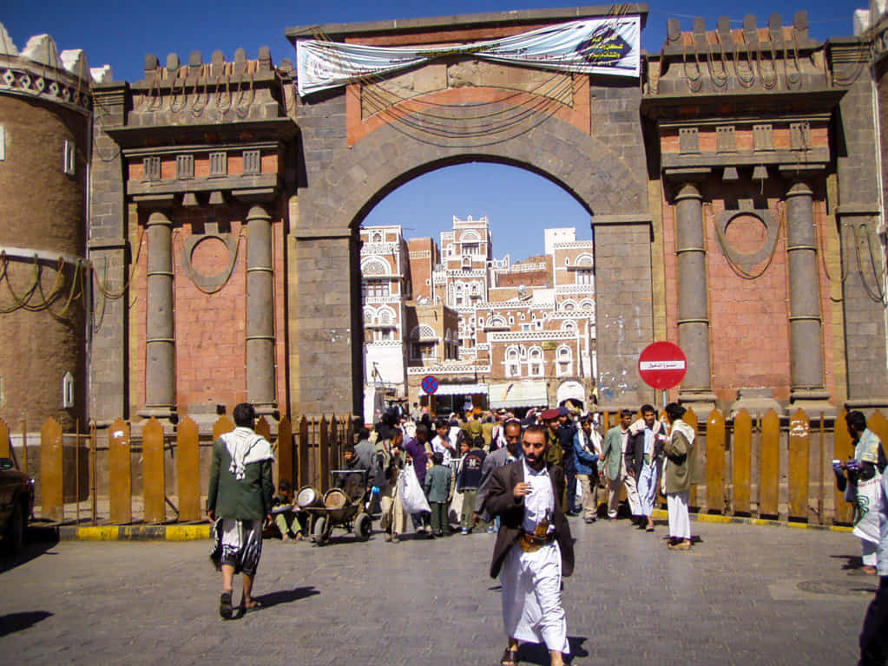
Figure 1, Image of Bab-Al-Yemen, Sana’a. (Adapted from AtlasIslamica, 2023).

The gate also follows the traditional Arabian architectural style as an ancient Yemeni building itself, built over 1,000 years ago. Bab-Al-Yemen is the only remaining gate out of 7 gates built in ancient Yemen, furthering its importance in Yemeni architecture (2023). The structure was renovated in the 17th century, however solely for preservation purposes, and the original aesthetics remained the same, making it an incredible piece of ancient architectural history. The second building is the Buqshan Hotel located in Hadhramaut, which is an entirely different building in comparison to Bab-Al-Yemen.
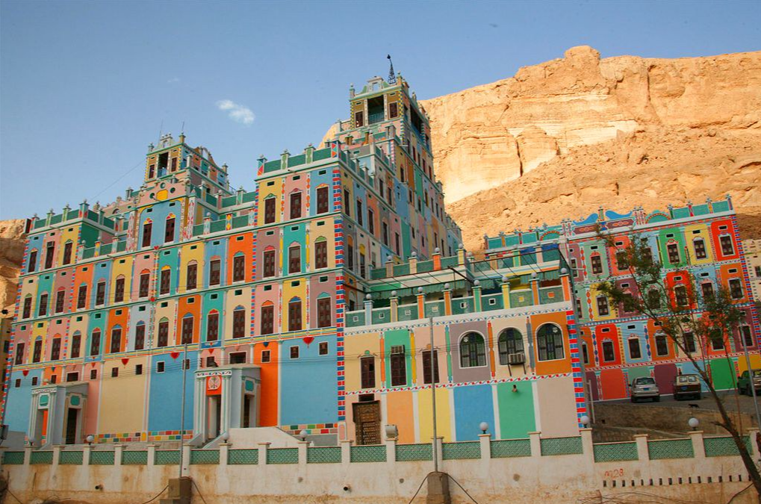
Figure 2, Image of The Buqshan Hotel, Hadhramaut. (Adapted from Laffrogue, 2006).

To begin, the Buqshan Hotel is a much more modern piece of architecture, shown through the colours on the building, the materials used, and the intricate patterns painted across the structure. The Buqshan Hotel was originally built in the 1950’s as a house, however the Buqshan family left it unused and untouched for 46 years before it was renovated in 2003 (2021). This is when the iconic colourful facades and painted details were added to the structure, making it one of the most famous tourist attractions in the country. Both buildings are standing in similar climates due to the entirety of Yemen being consistently hot and dry, and therefore both use the same techniques as essentially every building in Yemen does in order to stay in maximised quality, which is to be constructed in strong materials such as stone and bricks to combat the heat and coated in a lime wash for sun protection and to remain waterproof (2023).

Chapter 2: Plan and Section.
To begin, there are no known plans or original architectural sketches of Bab-Al-Yemen, due to its extremely ancient construction, however there are some plans of houses situated around the gate in Old Sana’a (2023), as shown below.
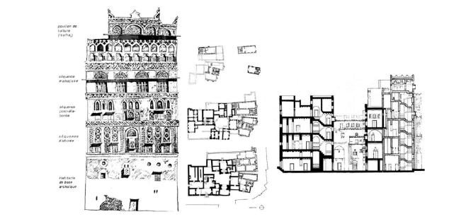
Figure 3, Typical Façade of Tower House (Left) and Cross-Section of Tower House Building (Right), Sana’a. (Adapted from Lewcock, R. 1986).

Therefore, from what is known based off visual assessments and the surrounding buildings, Bab-Al-Yemen was constructed using heavy bricks at its foundation to remain firmly planted on the ground.
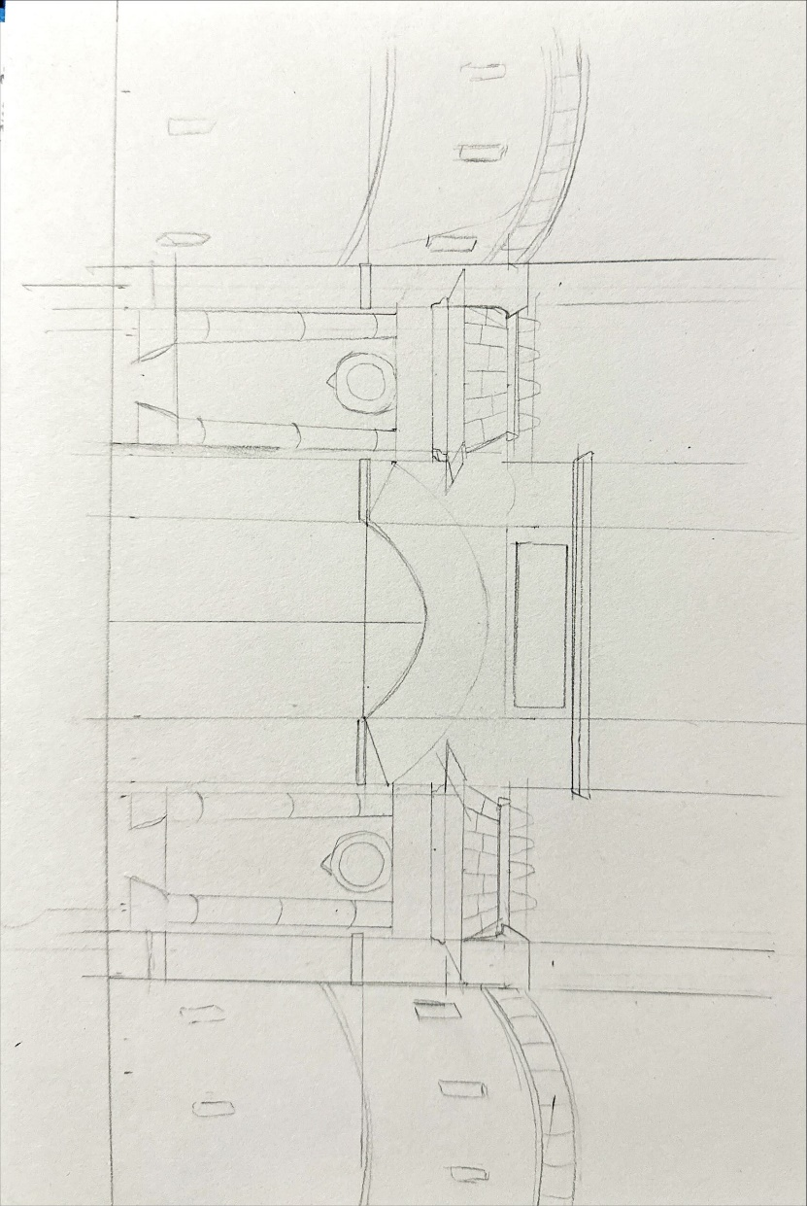
Figure 4, Sketch of Bab-Al-Yemen. (Adapted from Author, 2024).

The towers on either side of the gate are large and circular, juxtaposing the rectangular facade in the centre and balancing the entire structure. On the other hand, the Buqshan Hotel has documented plans as shown below.
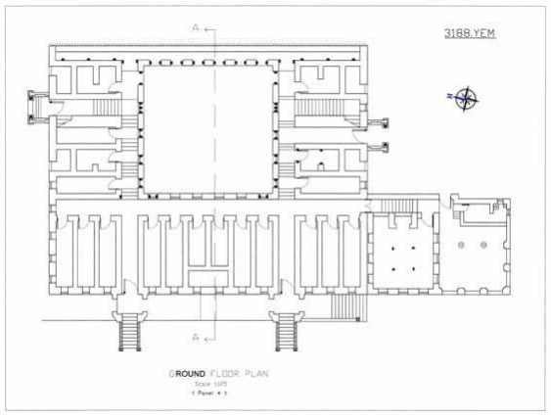
Figure 5, Buqshan Hotel Ground Plan, (Adapted from Barfid, H. 2007).

These drawings explain the structure of the building and the intricacies of the structure. The ground floor plan shows the symmetrical style present throughout the entire building, with equally spaced doors separated by equally sized walls. These doors are the entries to the available rooms on the ground floor, while the large square in the middle is the communal area. Moreover, the section drawing clearly shows the large stairway leading up to the building, which is blended nicely with the staircase-like structure of the mountain the hotel is placed on.
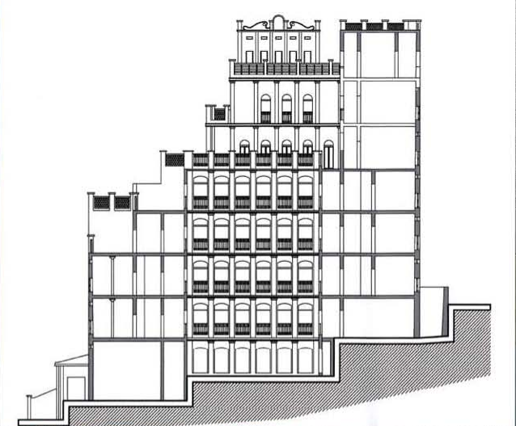
Figure 6, Buqshan Hotel Section Plan, (Adapted from Barfid, H. 2007).

The first few floors are equally spaced and even, until it gets to the sixth floor that is brought backwards. This choice was made as the mountain the hotel is situated on gradually goes higher, therefore the structure following the natural elevation of the location allows the hotel to still look appealing and in place, while standing out due to its colours and size, rather than its shape.

Chapter 3: Materials and Light.
The 1,000-year-old Gate of Yemen is a vernacular structure made of baked bricks and painted with lime plaster to remain waterproof in the event of rain (2023). The structure also being made of natural materials found in the country allows the gate to perfectly suit the hot and dry climate of Yemen, while also aesthetically harmonising with the surrounding area. The entire gate follows a consistent colour scheme of muted beiges, oranges and browns, with some white highlights and detailing to bring out certain aspects of the structure, such as windows, parapets and decorative banded string courses that wrap around the gate. In comparison, the Buqshan Hotel was originally constructed using sun dried mud bricks held together using mud mortar and libin, a type of Arabic glue (2007). The ceiling was traditionally crafted using wooden beams and a layer of mud above to keep the ceiling extremely sturdy. Both structures used similar materials as their base construction, however the Buqshan hotel had some minor additions during renovation. Although most of the materials had only been enhanced or polished, a new kitchen was installed as an extension using steel beams and cement blocks as a base and covered with industrial tiles. The entire outer building was then covered in industrial paint in a tile-like pattern and polished using an Arabic gloss called nurah. Unlike Bab-Al-Yemen, the hotel is a habitable building and thus requires appropriate lighting. The inside of the hotel uses warm-toned light bulbs to light the inside during nighttime, however due to the extremely sunny climate of Yemen, these are not turned on frequently and instead the large windows on every room lets in a huge amount of natural sunlight for the majority of the day instead, lighting up the entire structure.

Chapter 4: Uses.
Bab-Al-Yemen is a gate to Old Sana’a, and its purpose is to serve as a grand entrance to such an iconic and respected city in Yemen. Moreover, the structure has since become the biggest tourist attraction and important building of the country, holding extreme significance due to its history and preservation. This is completely different to the use of the Buqshan Hotel, which became a place for tourists to spend while at Yemen. The first 3 floors are hotel rooms, while the floor above is an office for a Development Committee centre which encourages support and funding of the building, specifically since it is the first hotel in the area and thus has a huge volume of visitors annually (2007). Overall, the Buqshan hotel holds multiple uses, the primary usage being a hotel.

Conclusion.

In conclusion, both structures hold some similarities, such as the construction, materials, and in demonstrating the importance of preservation. However, the two also have differences, especially in colour and usage. With Bab-Al-Yemen remaining extremely traditional and portrayed exactly as it was originally built 1,000 years ago, while the Buqshan hotel expresses the positives of renovation and modern architecture, while still maintaining a sense of place and fitting beautifully with the surrounding location.

References List.
Alluring World. (2023). BAB-AL-YAMAN. https://www.alluringworld.com/bab-al-yaman/ (Accessed 28/12/2023).
ARCHNET. (2021). Palace of the Buqshan Family. https://www.archnet.org/sites/6286 (Accessed 31/12/2023).
AtlasIslamica (2023). Bab-El-Yemen. https://atlasislamica.com/bab-al-yemen/ (Accessed 28/12/2023).
Barfid, H. (2007). Rehabilitation of the Palace of the Buqshan Family. https://s3.us-east-1.amazonaws.com/media.archnet.org/system/publications/contents/1643/original/FLS1887.pdf?1384750968 (Accessed 31/12/2023).
Lafforgue, E. (2006). Buqshan hotel in Khaila Wadi Do’an – Yemen. https://www.flickr.com/photos/mytripsmypics/149781674 (Accessed 31/12/2023).
Lemmin-Woolfrey, U. BBC. (2021). Yemen’s Ancient Soaring Skyscraper Cities. https://www.bbc.com/travel/article/20211004-yemens-ancient-soaring-skyscraper-cities (Accessed 28/12/2023).

Research Gate. Hamid, AB., Ismail, M. (2023). The Yemeni Architecture Influenced The Culture In The Tower House In Bab Al Yemen. https://www.researchgate.net/publication/372187682_The_Yemeni_Architecture_Influenced_The_Culture_In_The_Tower_House_In_Bab_Al_Yemen (Accessed 31/12/2023).

