Children, Young People and Families
Assessment 1
Case study - Supporting Paper

Student name: Sevzhiha Hasanova
Student ID:2020999

Module name: Children, Young People and Families
Module code: (BMHP5004_LON)
Lecturer name: Bianca Sanfilippo

CASE STUDY-Stockport Family
1 Introduction
In this supporting paper, I will discuss a case study of a Stockport family facing adversity, which presents factors of vulnerability. The primary issue in this family is parental substance abuse. This factor's effects on children will be explored. It also describes the social services' intervention and the consequences of their work. Included are policies and legislation that help children and families have a normal life.
2 Presentation of case study: The case is about Stockport Family.
The case study: Stockport Family
The family: Single mum with 2 children
The situation: Mum was an alcoholic (Parental substance missus). Also, Anti-social behaviour
The children were not attending school regularly and their behaviour in school was disruptive
Parental substance misuses. All family vulnerable because they need help.
3 Adversity in the family: The Vulnerability Risk Factors
Using alcohol, drugs, or other emotional state substances not only affects the user but also those around them, especially their children. According to several experts, parental substance misuse is one of the variables that put children in danger.
This family is distinct from other families because the children are vulnerable and in need because of these conditions. Vulnerable means more vulnerable to danger, health and safety risks, abuse, and neglect. According to the Children Act 1989, being a kid in need arises when the child would not be able to have a high quality of life without the assistance of social services. The major source of vulnerability in this case study is parental substance misuse, specifically alcohol addiction.
According to the NSPCC (2019), "the largest risk posed to children is that parents who are under the influence of drugs or alcohol are unable to keep their kids safe." Life in a family where one or both parents abuse substances can be unpredictable and chaotic, with domestic violence, unemployment, and mental health issues more prevalent. Children might be confused and scared by their parents'
4 The effect of these substances on the health and well-being of children
In this section I will explain how it effects children's Children of alcoholics and drug addicts are at high risk for mental, physical, and health issues, including stress, anxiety, eating disorders, and suicidal thoughts. Isolation: Young children may lack social engagement. School-aged children are ashamed of their homes. They may avoid taking classmates home and skip parties and after-school events to avoid detection. Home issues might make it hard for kids to focus on schoolwork (and the lack of sleep). They may fall behind, miss school, or misbehave. Others may use school and friends to compensate for home life. When parents are focused on drugs and alcohol, neglect is a big concern. A child's life may be hungry, unclean, without clothing, housing, medical treatment, or supervision. Most child maltreatment is neglect. It can harm a child's growth and well-being. Neglect kills children. Sexual and physical abuse—Children are at danger from parents and other adults in families where a parent abuses drugs or alcohol. Domestic Abuse: Substance abusers' children are more likely to witness domestic violence.
Young children may miss immunizations or be malnourished. Bed-wetting, stomach bugs, headaches, and asthma are stress-related health concerns. Everyone must keep children safe.
Increased criminal behaviour and domestic violence have been linked to alcohol use. Mental and physical health issues are becoming more common. (National Institute for Health and Care Excellence, 2011)
5 The procedure through which relevant health and social care organisations get involved in the situation.
Referral (One working one to decide).
Assessment. The social services after the referral, carried an assessment based on the policy Working Together to Safeguard Children (2018).
The assessment framework was based on parental capacity, children developmental needs and family environmental factors. Parental capacity in this case was poor because of alcohol dependent.
Action. On this case Working in multi-agency: The family worker, health care provider, school, specialist Troubled Families Job Centre Plus worker.
Refer the mother to a detoxification program. Following an exhaustive evaluation, the family worker swiftly arranged for her to join a detox programme. She was able to help her break her alcohol addiction and win her trust to confront her about her terrible parenting via consistent and consistent contact.
Support the mother in starting to set routines and boundaries for the children. The family worker phoned school to inform them of what was going on at home. She also advised the mother to begin establishing routines and limits for her children. Children's attendance at school greatly increased through the encouragement they received from both their parents and teachers.
Provide counselling. It was also suggested that Mom get professional help to investigate the factors that lie behind her drinking problem. As her condition continued to improve, the family worker made the necessary arrangements for her to speak with a Troubled Families Job Centre Plus worker, who was able to provide her with immediate assistance. Her mother has tried to quit drinking and is keeping a record of everything that sets off her addiction, which is helping her get her life back under control. Her home is a lot quieter now that it is no longer being used as a gathering spot for those who drink because of this change.
Results and outcomes: The children’s attendance at school improved significantly. improved behaviour and happier children. The mother is a recovering alcoholic. She is now looking for employment.
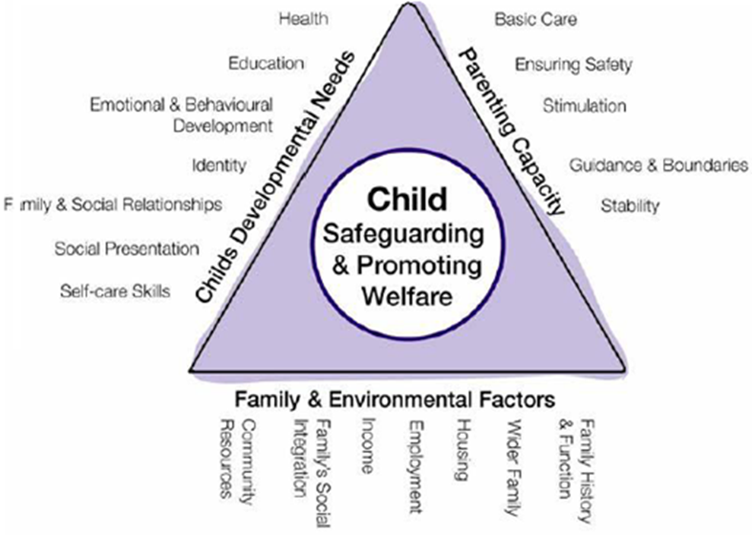

6 The laws and the actions of the relevant agencies
(HM Government, 2018) Working Together to Safeguard Children A guide to inter-agency working to safeguard and promote the welfare of children (POLICY).
The (Children Act, 2004). The Children Act 2004 is a development from the 1989 Act. It served as a reminder that everyone who works with children has a duty to do their part to keep them safe and support their well-being. Anyone who works with children, whether in a formal educational context or a non-formal one, can benefit from the rules laid out in this regulation.
The (Children Act, 1989). The keep family together.
(Equality Act, 2010) was applied in the case study as the social services worked with the family without discrimination, providing care, etc. All children should receive same care and protection…
United Nations Convention on the Rights of the Child (UNCRC, 1989) for example article 19 that places a duty on Government to protect children from abuse and 27 foods, clothing, a safe home that child basic need.
The rights of all children should be protected free from any form of discrimination; the best interests of children should always take precedence in any decision or action that affects them; the right to life and development of children should be ensured for all children; and the right to be heard should be guaranteed for all children (UNCRC, 1989).
The effectiveness of the work of the social services is justified by theories, such as (Maslow’s hierarchy of Needs, 1954).

REFERENCE LIST
Children Act 2004, c. 31. Available at: http://www.legislation.gov.uk/ukpga/2004/31/contents (accessed: 26 July 2022).
Children Act 1989. Available at: Children Act 1989 (legislation.gov.uk) (accessed: 28 July 2022).
HM Government (2018) Working Together to Safeguard Children A guide to inter-agency working to safeguard and promote the welfare of children. Available at: https://assets.publishing.service.gov.uk/government/uploads/system/uploads/attachment_data/file/942454/Working_together_to_safeguard_children_inter_agency_guidance.pdf (accessed: 22 July 2022).
(NSPCC, 2018) How Safe Are Our Children. Available at: http://mandyparrytraining.co.uk/how-safe-are-our-children-nspcc-report-2018/#:~:text=Following%20the%20Government's%20commitment%20to,how%20they%20keep%20children%20safe(accessed:28 July 2022).
NSPCC (2019) Children living in families facing adversity. Available at: https://learning.nspcc.org.uk/media/1432/nspcc-families-facing-adversity-helplines-report.pdf (accessed: 21 July 2022).
Maslow, A.H. (1954) Motivation and personality. New York, NY: Harper & Row Publishers.
United Nations (1989) The United Nations Convention on the Rights of the Child. Available at: Layout 1 (unicef.org.uk) (accessed: 26 July 2022).

Appendix: Power Point Presentation for debate WEEK 9


