n
Jason Paul Evans
1706645

University of Wales Trinity Saint David
School of Engineering
Mechanical Engineering

A study into cooling fins
  - Advanced Thermofluid Mechanics

Date 03/12/2023

Contents
2 Fins and Extended Surfaces 3
2.1 Fins in automotive design 3
2.2 Extended Surfaces in micro-processors 4
2.3 Recent Advances 5
3 Finite Fin Length With Adiabatic Tip 6
4 Example of Problems That Can Be Extrapolated Using Given Information 7
5 References 11

Introduction
The purpose of this technical report is to Have a brief look into cooling fins. Firstly there will be a brief look into the history of fins, in the automotive industry as well as in the computing world with a look into the different methods that have been used to assist the cooling methods. There is also a brief look into what advances have been made and are still being made.
There is also an analysis of of a hypothetical fin

Fins and Extended Surfaces

Fins in automotive design

A fin or an extended surface is method of increasing the surface area of a component with a thermally conductive material like copper or aluminium to allow for an increase in the heat transfer rate through convection and conduction therefore allowing the area to cool more quickly than would otherwise be possible (Pandya and Karia, 2023).
Air cooled engines came about as almost a necessity to combat overheating water-cooled engines. Prior to World War Two the overheating was such an issue that a lot of mountain roads had garages to repair the overheating issue (Kayal and Sur, 2021).
There were many manufacturers that had taken up the task of creating air cooled engines over the years but there are two that may stand out in the car manufacturing industry those are Volkswagen and Porsche. Both engines set up in what is known as a “boxer” configuration, where a piston sits opposite another piston using a reciprocating motion to power the engine, the air would flow over the pistons through the fins cooling the engine. This configuration was a flat four in the Volkswagen Beetle (Accelerator, no date), and a flat six in the Porsche 911 (Flat Sixy: The Evolution of the Porsche 911 in the U.S., 2013).
The production of cars with air cooled engines seemed to ease back a fair bit with a small amount of cars being manufactured with this in mind, motorcycles however are a different matter. The vast majority, nearly all, motorcycles manufactured at one point were air cooled engines (YOSHIDA et al., 2004). The reason for this is because of the simplicity of the design, being that there is no pump to move the fluid around the system as it relies on the airflow over and through the fins which is more reliable with less opportunity for failure and even if a fin does break it still provides an extended surface to aid with the cooling (Thornhill et al., 2003)
Fins in the cooling system of the engine are critical to the air cooled system therefore the material selection for the fin is crucial to maintain the highest level of heat transfer possible. There are numerous materials that can be selected with copper being the best material for heat transfer which could be quite expensive. The next best material for thermal transfer is Aluminium and this is the material that can be seen in most air cooled components in motorcycles and car engine (Abbood, Azziz and Farhoud, 2021).
Fins cool the engine however to increase the rate of convection there is a process called forced convection. This uses a fan to increase the amount of air flowing over and between the fins therefore increasing the amount of heat transfer (C. L. et al., 2020).
In the automotive industry, newer vehicles are made with a liquid cooling system and some with a combined air and liquid cooling system this is due to the specific heat capacity of air being so low compared to something like water. However the air cooled engine is still being used for many different applications, for instance unmanned aerial vehicles (UAV’s) use a Wankel rotary engine due to its power-to-weight ratio its efficiency is much higher than a conventional engine, these engines use air cooled engines with fins to aid in the heat transfer thus prolonging their operational life and due to the simplicity in the air cooled engine maintenance is much easier than a more conventional engine (Sagar et al., 2017)

Extended Surfaces in micro-processors

Extended surfaces in computing, also known as heat sinks, are an important part of the computer and in particular microprocessors being used to dissipate the heat they generate during their operation. The microprocessors have increased in usage over the years and their performance has had to increase in terms of what they are capable of accomplishing this has also had a knock on effect to the cooling system. Cooing fins in the heat sink have been crucial in maintaining the appropriate operating temperatures of these microprocessors (Singh, Akbarzadeh and Mochizuki, 2009)
The reason that the correct operating temperature is important is due to the fact during the microprocessors normal working life the processes that they complete increases their temperature therefore affecting their ability to complete the process that they are tasked with Increased temperatures can cause degradation in the work that they are able to complete causing the processors to slow down their processes or even stop working altogether (Kong, Chung and Skadron, 2012).
As with extended surfaces in engines the material selection is crucial, therefore typical heat sinks would most likely be made of aluminium or copper. The type of extended surface that is typically used in this process can vary depending on the dimensions of the area the processor is in. The extended surface will be place onto the microprocessor to increase the overall surface area of the heat sink therefore expediting the extraction of the heat therefore preventing the processor from overheating and expiring and increasing the operational efficiency of the microprocessor (Zhao and Mercier, 2022)
The heat transfer works in the similar way to the air cooled engine with the heat generated within the processor being conducted into the base of the heat sink this then travels to the fin through conduction. Convection then takes over as the air travels over and between the fins, as the air flows through the fins it absorbs the heat and removes it. To help increase the heat transfer rate it may be helpful to increase the airflow rate or perhaps the difference in the ambient temperature and the temperature of the heat sink (Ahmed et al., 2018)
Over the years there have been numerous advancements in microprocessor technology. This has lead to an increase in their power consumption which has in turn lead to several advancements in how the heat sink works to ensure that the microprocessor continues working at an optimal temperature. With the increase in the power consumption for the microprocessors the heat sink design has had to evolve and include more innovative improvements to assist in the heat dissipation like changing or creating advanced materials or heat pipes to aid in the heat exchange (Singh, Akbarzadeh and Mochizuki, 2009)

Recent Advances

Due to the increased amount of computers in the daily lives of the average person and the use of fins and extended surfaces within the computer industry there are numerous approaches being undertaken to increase the heat transfer from the computer itself. As anyone may see there are numerous fans on a computer to promote forced convection and aid with cooling however with the increase in the processing power of computers adding more fans will only be able to assist so far therefore other approaches are being researched.
It has been known for quite some time that there is or will be an issue with removing heat from processors to prevent any damaging effects or decreased effectiveness in the processors abilities (Garimella et al., 2002). This has led to many researching alternative methods to cool systems in a similar way for instance (Ladekar et al., 2023), integrated a vapour chamber into the heat sink with acetone vapour as the vapour in the chamber. This increased the heat transfer through creating a uniform heat distribution therefore increasing the amount of heat transferred through the fins.
Another approach proposed by (Li et al., 2024) is by removing the thermal resistivity of the contact area by using a more conductive medium. This was achieved by using a three dimensional vapour chamber and liquid fins, this seems like a promising approach with a reduction in thermal resistivity of between 44 and 67%.
An approach using combined phase change material (PCM) and vapour chamber by (Ghanbarpour et al., 2021) had somewhat interesting results with their approach with an increase in the heat transfer until forced convection is used in conjunction with the PCM. This affected the heat transfer adversely and just using forced convection without the PCM gave better results.
These are just an example of the numerous approaches many researchers are taking to combat the increasing heat around processors to enable them to function correctly.

Finite Fin Length With Adiabatic Tip

Typically fin design can take many shapes and forms but one thing may remain constant in the design of a finite length fin and that is a parameter of mL with L being the length of the fin and m being a variable of $\frac{hP}{kA_{c}}$ ($h$=surface convective transfer coefficient, $P$=Perimeter of the fin, $k$=Thermal conductivity and $A_{c}$=cross sectional area). In increasing values of mL there is negligible difference after a value of roughly 2.65 as will be shown in the graph below:-
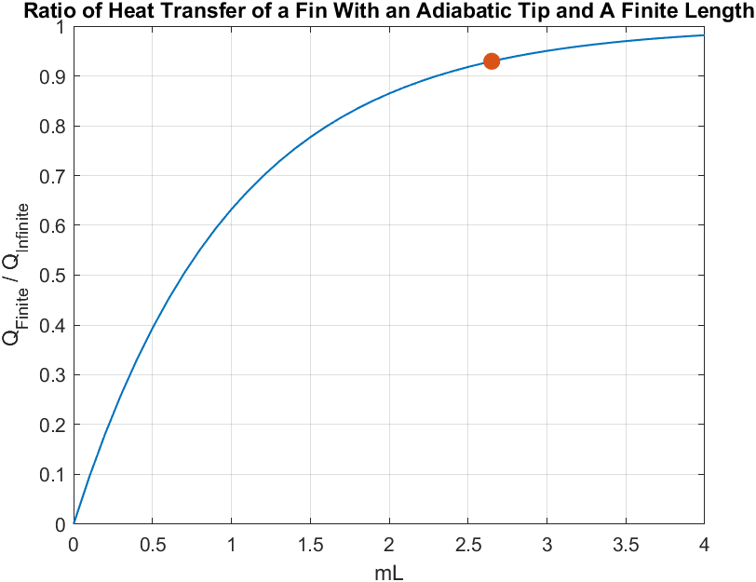

Example of Problems That Can Be Extrapolated Using Given Information
(1)
What follows is a graph showing the temperature disstribution for each of the materials listed followed by equations showing how it was calculated:-
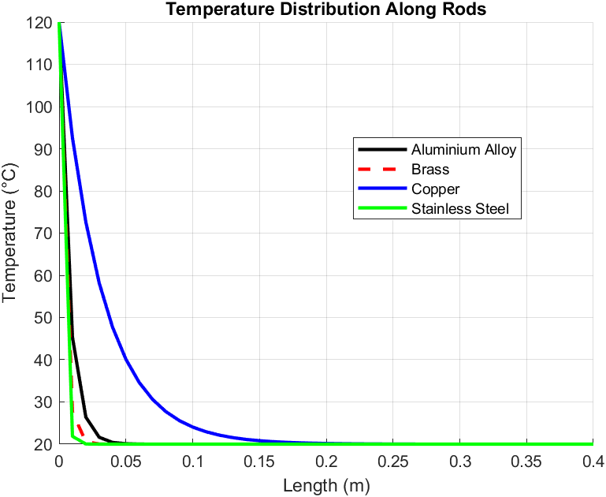
Aluminium Alloy with a surface convection coefficient of 30W/$m^{2}K$ and a Thermal conductivity of 186W/mK using the equation $T\left(x\right)=T∞+(T_{b}-T_{∞})\frac{cosh⁡[m\left(L-x\right)]}{cosh⁡(mL)}$
By selecting an arbitrary length of 200mm this would give a result of
$$T\left(x\right)=20+(120-20)\frac{cosh⁡[11.64216022\left(0.4-0.2\right)]}{cosh⁡(11.64216022*0.4)}$$
$$T\left(x\right)=29.84°C$$
Similarly with the other materials this equation will show the temperature at a given location along the rod.

(2)
It is also possible to calculate the values of heat loss for each tip of the materials fins using the equation:-
$\dot{Q}$ =$\sqrt{hPkA_{c}}∙\left(T_{b}-T_{∞}\right)∙tanh⁡(mL)$
Using this equation the heat loss for each material is as follows:-
2024 Aluminium Alloy
$\dot{Q}= \sqrt{30}∙0.01495398103∙186∙0.000017795$ $∙$ (120-20) $∙\tanh\left(11.64216022∙0.4\right)$
$\dot{Q}=3.852708765$ Therefore aluminium will lose 3.85W of heat energy

Brass (70 Cu/30 zn)
Using the same equation with parts changed for the specifics for brass:-
$\dot{Q}= \sqrt{30}∙0.01495398103∙99∙0.000017795$ $∙$ (120-20) $∙\tanh\left(0.5046259143∙0.4\right)$
$\dot{Q}=$0.5598766783 Therefore Brass would lose 0.56W of heat energy
Copper
Using the same equation with copper will give:-
$\dot{Q}= \sqrt{15}∙0.01495398103∙398∙0.000017795$ $∙$ (120-20) $∙\tanh\left(0.1779633665∙0.4\right)$
$\dot{Q}$ =0.2832516641 Therefore Copper would lose 0.28W of heat energy.
304 Stainless Steel
Finally the equation is used with the stsainless steel specifications:-
$\dot{Q}= \sqrt{7.5}∙0.01495398103∙16∙0.000017795$ $∙$ (120-20) $∙\tanh\left(0.6276205565∙0.4\right)$
$\dot{Q}=$ 0.02802209566 Therefore stainless steel would lose 0.028W of heat energy.

(3)
Using an equation from the graph plotted against mL an extrapolation can be made for each optimum length of the materials as follows:-
$$mL≥2.65$$
And if that equation is rearranged it gives:
$$L=\frac{2.65}{m}$$
With each material having its own “m” value the optimum length can be calculated, they are as follows:-
Aluminium:- $L=\frac{2.65}{11.64216022}$ , The optimum length being 0.227620987m ,
Brass:- $L=\frac{2.65}{15.95777901},$The optimum length being 0.1660632096m,
Copper:- $L=\frac{2.65}{5.627733327}$, The optimum length being 0.4708822977m
Stainless steel:- $L=\frac{2.65}{19.84723705},$The optimum length being 0.1335198443m
(4)
All the lengths apart from the Copper seem to fall short of the maximum 400mm of the graph suggesting that copper would be able to conduct the heat along the length of a rod that length suggesting that it is a good conductor. With the aluminium alloy following behind at just over half the maximum given length suggesting that it is still able to conduct but not as good as the copper. With brass and stainless steel falling way short of the mark suggesting that in comparison they are poorer heat conductors than the other two.
(5)
To get a more accurate length estimation of the materials the use of the equation $e^{-ml}<0.01$
Is necessary but not as it is it would need to be rearranged to give this:-
$$l>-\frac{ln⁡(0.01)}{m}$$
Therefore if that equation is used with the metals :
Aluminium:- 0.3955597672m
Brass:-0.2885846572m
Copper:-0.81829929m
Stainless Steel:-0.2320307947m
As a comparison this appears quite different from the plots on the graph in the initial analysis and and the previous parts examples seem to differ quite a large amount from the plotted graph which suggests there is perhaps an error in the matlab script or perhaps in the calculations. The lengths using the log method above seem to show nearly double the length of the previous part.

References
Abbood, M.H., Azziz, H.N. and Farhoud, E.K. (2021) ‘Investigating the effects of fin geometry on motorcycle cylinder cooling’, IOP Conference Series: Materials Science and Engineering, 1067(1), p. 012102. Available at: https://doi.org/10.1088/1757-899X/1067/1/012102.
Accelerator, A. (no date) Volkswagen Air Cooled Engine: Most Up-to-Date Encyclopedia, News & Reviews, Academic Accelerator. Available at: https://academic-accelerator.com/encyclopedia/volkswagen-air-cooled-engine (Accessed: 16 December 2023).
Ahmed, H.E. et al. (2018) ‘Optimization of thermal design of heat sinks: A review’, International Journal of Heat and Mass Transfer, 118, pp. 129–153. Available at: https://doi.org/10.1016/j.ijheatmasstransfer.2017.10.099.
Flat Sixy: The Evolution of the Porsche 911 in the U.S. (2013) Car and Driver. Available at: https://www.caranddriver.com/news/a15366914/flat-sixy-the-evolution-of-porsche-911-engine-size-technology-and-output-in-the-u-s/ (Accessed: 16 December 2023).
Ghanbarpour, A. et al. (2021) ‘Evaluation of heat sink performance using PCM and vapor chamber/heat pipe’, Renewable Energy, 163, pp. 698–719. Available at: https://doi.org/10.1016/j.renene.2020.08.154.
Kayal, A. and Sur, A. (2021) ‘Design and Analysis of Cooling Fins of Engine’, International Journal of Engineering Research, 9(11).
Li, C. et al. (2024) ‘Experimental and numerical investigation on thermal characteristics of the heat sink integrating 3D vapor chamber heat spreader and liquid cooling fins’, Applied Thermal Engineering, 236, p. 121609. Available at: https://doi.org/10.1016/j.applthermaleng.2023.121609.
Pandya, B. and Karia, M. (2023) ‘A BRIEF OVERVIEW OF APPLICATION OF EXTENDED SURFACES (FINS) FOR ENHANCEMENT OF HEAT TRANSFER’, Global Journal of Engineering Science and Researches [Preprint].
Sagar, P. et al. (2017) ‘Heat transfer analysis and optimization of engine fins of varying geometry’, Materials Today: Proceedings, 4(8), pp. 8558–8564. Available at: https://doi.org/10.1016/j.matpr.2017.07.202.
Singh, R., Akbarzadeh, A. and Mochizuki, M. (2009) ‘Sintered porous heat sink for cooling of high-powered microprocessors for server applications’, International Journal of Heat and Mass Transfer, 52(9–10), pp. 2289–2299. Available at: https://doi.org/10.1016/j.ijheatmasstransfer.2008.11.016.
Thornhill, D. et al. (2003) ‘Experimental Investigation into the Free Air-Cooling of Air-Cooled Cylinders’, SAE Transactions, 112, pp. 2046–2057.
Zhao, W. and Mercier, D. (2022) ‘Materials Selection for a Heat Sink’.

