Systems Engineering
BAE Systems/UWTSD
For classification reasons, images of the product in question are only available on request and subject to approval.
Development and evaluation of a test, trial project using systems engineering approaches
Joshua Martin | 1810346
2020
Contents
1 Introduction 2
1.1 Systems engineering 2
2 Needs analysis 2
2.1 Current process 2
2.2 Stakeholder Engagement 3
2.3 The problems 3
2.3.1 Operational time 3
2.3.2 Repetitive strain injury 3
2.3.3 Product Quality 3
3 Developing options 4
3.1 Function/Means 4
3.2 Option 1 4
3.3 Option 2 4
4 Chosen option 5
4.1 Identifying constraints 5
4.1.1 Explosive sensitivity 5
4.1.2 Explosive licensing 5
4.1.3 Pneumatic control 5
5 Assessing and managing risk 6
5.1 PMFEA 6
5.2 Commissioning 7
6 Conclusion 7
7 References 8

Figure 1 Stakeholder map 3
Figure 2 Function means table 4
Figure 3 FANUC Robot [9] 4
Figure 4 Pneumatic press *product classified 5
Figure 5 Kitting tray 5
Figure 6 Process FMEA [8] 6
Figure 7 Commissioning plan 7

Introduction
This report is going to use systems engineering techniques and tools to investigate, discuss and evaluate a range of options for developing a manufacturing improvement trial on behalf of BAE Systems. This will include a test procedure to ensure the safe and effective operation of the system before full scale implementation.
During the manufacture of one of BAE Systems lethal mechanisms, the product travels through a number of buildings during its manufacture. Although the process of moving the product is not particularly lean in itself, this cannot be avoided due to explosive licensing. This report is going to pick on one process in particular that has potential for a significant improvement to the production rate and quality of these products.

Systems engineering
Systems engineering is a field quite dissimilar to the specific and well known disciplines such as mechanical, civil, electrical etc... It is in fact an interdisciplinary from of engineering and engineering management, designed to look at the whole system, rather than being problem focused as can frequently be the case in the engineering industry [1]. A range of tools can be used throughout the process to ensure that the analysis of the system is done as thoroughly as possible. These tools include SIMILAR, FMEA, Process Flow, Function/Means analysis and stakeholder maps.

Needs analysis
To decide whether a process is justified in having an improvement made to it, a needs analysis must be performed. Below is a summary of the needs analysis that has been performed for this pressing process, to discover whether there is a valid operational need for the new process and if there is a feasible way to fulfil the need. [2]

Current process
The process in question is simple in itself however it is very time consuming, it requires two components to be secured together using three screws, the two components are however separated by a number of springs, therefore the components must be pushed down against the force of the springs before being secured. One component is filled with explosives and the other is bare metal, therefore movements to secure the assembly must be slow and controlled. The springs used in the assembly are also too strong to be compressed by human strength, here lies the problem. The process currently uses 3 tie bars to hold the two components in place, and the three nuts must be tightened to travel 20mm of the tie bars length. This operation must be done by tightening one nut ¼ of a turn before moving to the next nut in a circular pattern to ensure the components are tightened down equally. This is because if the components are not perfectly straight when secured then it may cause performance issues for the lethal package.
The aim for this report is to develop a method of tightening down the two components in a fraction of the time while still ensuring that the required quality and safety is achieved.

Stakeholder Engagement
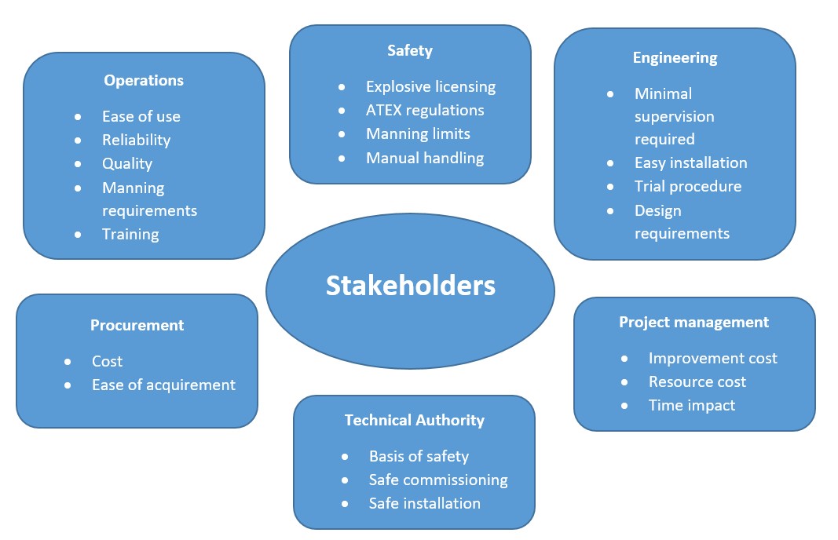
Early stakeholder engagement is key to the success of a project, particularly when taking a systems engineering approach. By meeting with stakeholders early, you can get everyone’s views and concerns written down, and ensure that the project meets any requirements set by the stakeholders. When choosing stakeholders, it’s important to consider the whole lifecycle of the project, a team of engineers may be able to give requirements on the how the process must operate, however may not take into consideration what someone from procurement may say. This could be something as crucial as ensuring the project know where certain equipment can and can’t be purchased from, this could put a stop to a project if not considered at the early stages. [3]
Figure 1 Stakeholder map

Above is a stakeholder map that has been put together after a meeting was held to discuss the problems of the existing process, then the scope and requirements of the new process. The stakeholders were chosen as they will have a direct impact on the planning and implementation of a new process. It shows a range of points that were brought up,

The problems
A meeting was held with the lethal mechanisms operational team to determine what the main failures are of the current process. The general consensus was the process is painfully slow, they can only get 4 products completed each shift, and the ¼ turn at a time is causing wrist pain for some of the employees due to the need for hundreds of repetitions of the action on each product. One product may take up to two hours to tighten down properly, as the ¼ turn cannot be increased due to safety and quality requirements from the customer.

Operational time
The time it takes to complete one product is roughly one hour, this means a maximum of 8 products can be completed per day. The labour cost to complete a contract amount of 40 products would consume 5 days of infrastructure costs and the cost of wages for a team of 4 staff. This is one of the main problems that need rectifying in the new process.

Repetitive strain injury
A few operators have complained that the current process can cause aching in the wrists, as each employee has to repeat the same ¼ rotation with a spanner, hundreds of times throughout the day. Although this has not got to the point of becoming a documented injury, reducing the risk of injury is something extremely important to the company.

Product Quality
The quality of the product is essential, both to ensure safety throughout the product lifecycle, and to ensure the customers performance requirements are met. The equal tightening down of the three nuts is critical to quality, an angled assembly will mean the shaped charge does not function correctly.

Developing options

Function/Means
A function means analysis chart is a good way of generating a range of ideas to complete the main function. This allows a team of people to look at what the possibilities are, and down select certain ‘means’ to create a path through the chart, and eventually create a concept from them. In this chart, the pressing process has been split into its functions on the left, with a variety of means to complete the function on the right. From this, three different concepts will be taken forward for consideration. [4]
Function | Means
Gather components | Automated iCart trolley | Pallet from stores | Organised kitting tray
Load base | Robot | Manual lift | Pulley chain | Pneumatic lift
Load weir discs | Robot | Manual | Suction pen | Pre-assembled
Load springs | Robot | Manual | Magnetic lift | Pre-assembled
Load cover | Robot | Manual | Pneumatic lift
Press assembly | Robot | Operator manual press | Mechanically assisted | Pneumatic press | Remotely operated
Insert bolts | Robot | Manual
Tighten bolts | Robot | Manual
Figure 2 Function means table

Option 1
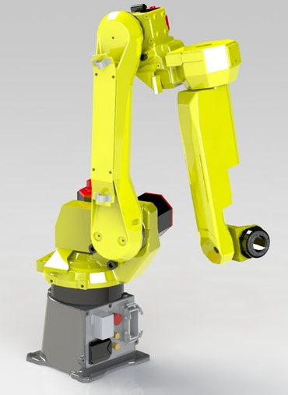
Option 1 will be the most expensive to implement, but it will also cut down the most labour cost. Firstly, an iCart trolley will automatically bring the components into the assembly area, ensuring that the correct amount of components are available for assembly, this makes quality control at the end of the process much easier, if all the components are gone, then they have all made it into the assembly. Then a FANUC robot will pick up each component in the correct order, and install it onto the assembly. Each component will need a different tool for the operation to work properly and safely, tools listed below:
Figure 3 FANUC Robot [9]
Pick up & move main body – Large grip claw
Pick up & insert weir discs – Small electromagnet
Pick up & insert springs – Small grip claw
Pick up & insert tie bars – Small rotating grip claw
Pick up and lower cover plate – Large grip claw
Compress assembly – Rubberised pressing attachment
Pick up & install nuts – Small rotating grip claw
Tighten nuts – Socket attachment
The above list shows that a minimum of 5 tools are required to complete the operation, to save cost on a robot, each tool would have to be manually changed. [5]

Option 2
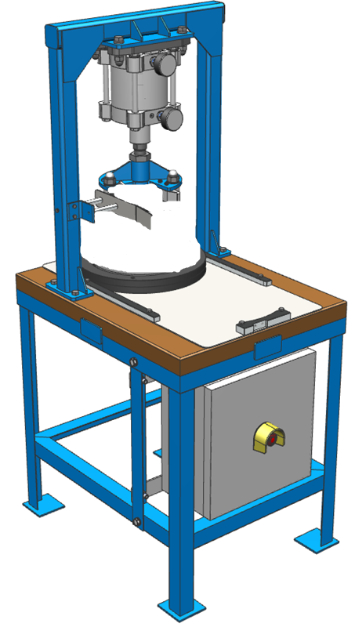
This option is to install a pneumatic press within the building, this is a more labour orientated solution however the main problem of the pressing speed and tightening the assembly is drastically improved upon. The assembly will be built by hand, the operator will load the main body onto the assembly table, install the weir discs, tie bars and springs, then lower the cover plate. Then the assembly will be slid into the pressing area, and the operator can turn on the switch to lower the pneumatic press. While the press ram is fully extended, the operator can insert the nuts, and tighten all three down fully, this will guarantee an equal compression around the product. The pneumatic press will have to be custom made for this operation, however it is something that can be designed by in-house designers and manufactured on site by the fitters.

Chosen option
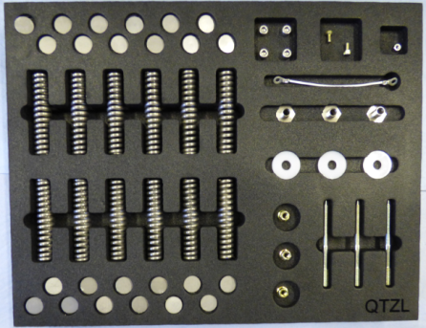
The option that will be going forward is option 2, this is mainly due to the intricacy of the operation, a robot will be physically unable to effectively insert all of the components, especially with the added complication of having to change the tools manually for each operation, more time would be spent changing tools for the robot than the robot would be operating. The capital investment required for this process is also very large in comparison to option 2, with labour cost still incurred. As a result of this, the whole system lifecycle cost is far too great to consider as an option going forward.
Figure 4 Pneumatic press *product classified
Figure 5 Kitting tray
To improve the quality control of the process, inspiration will be taken from the iCart method from option 1 however will be manually operated, stores will distribute a set of stocked kitting trays, so the operators can pick up the exact quantity of materials required for each assembly. [6]

Identifying constraints

Explosive sensitivity
Due to the high sensitivity of the explosives used in this product, the pressing operation must be conducted slowly and smoothly, there must be no sudden movements and the press must stop before it is able to over compress and come into contact with any explosives if any components failed. To meet this constraint, the press must first be designed so the air flow restricts the speed of descent. Secondly, the press must be designed so that the assembly can only be pressed in the correct orientation. A stopper must also be put in place to prevent the press travelling too far. [7]

Explosive licensing
Explosive licensing on the process building requires the building to be empty of personnel when explosive processing is taking place. As the pneumatic press is not a manual operation, this means the operators cannot be present when the component is being pressed. A separate processing operation already occurs in this building and uses remote operation from a nearby control room. The infrastructure is already in place for the control system and with some minor software changes done by the engineers, the press can be remotely operated from the control room as well.

Pneumatic control
The pneumatic control for the building will be reasonably easy to install, there are already permanent air lines running through the building for a separate process, so the installation of the press will be relatively cheap and easy. A flow control valve will be installed into the press to ensure the ram descends at a safe speed, in addition to this, a ‘proof of position’ switch will be installed so the press cannot operate unless the component is safely in the correct position.
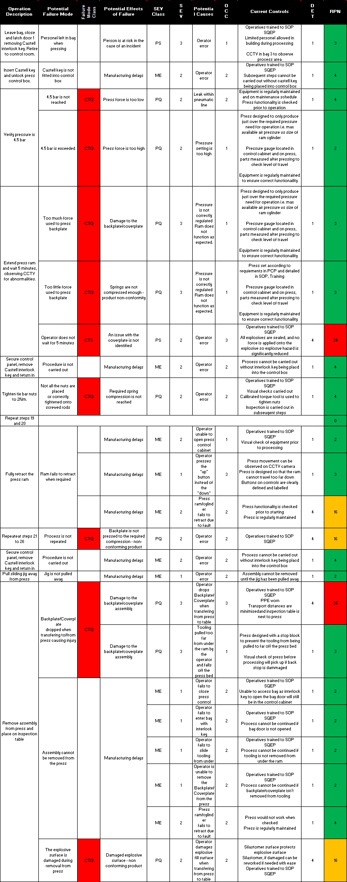
Figure 6 Process FMEA [8]

Assessing and managing risk

PMFEA
A PFMEA must be completed before the pressing operation commences, this will be done as a group, with engineering, safety and operations in attendance as each team will have something different to offer. This is a systems engineering tool that allows a full view of the process, helping to discover where the highest risk is in the process, each operation undergoes a particular scoring system, to categorise into green, orange and red. Processes highlighted in red need extra attention, either an extra control to bring it into orange, or extra precautions to ensure the operation is as safe as possible.

Commissioning
To ensure safe operation of the remotely operated pneumatic press during production, a commissioning procedure must be completed first. Below is a procedure that will ensure each aspect of the operation works safely, before any explosive filled components are processed. If this commissioning trial is completely successfully, then full scale manufacture can commence.
Step | Check | Comments
Perform building start up and engage the interlocks | Ensure all of the required lighting and barriers are working | Yes, all castell interlocks work as intended, lights and sirens sound during operation
Perform a functional test on the press, with no assembly components | The press has operated in both directions without any issues | Yes, press works in both directions
Attempt to operate the press without engaging the ‘proof of position air switch’ | The press should not be able to function at all | Yes, press unable to function if proof of position is not made
Perform a second functional test, this time operating the emergency stop on the control panel | The movement of the press should stop immediately | Yes, pressing stopped immediately, and air pressure was removed
Attempt the operation of the press once the interlock has been removed | The press should be unable to operate | Yes, press was unable to operate without the correct castell key in place
Re-engage the interlocks and perform an inert operation (assembly as per the SOP, with non-filled components) | The press has operated in both directions without any issues,  Reference the QA document to ensure the pressing operation has completed successfully within spec limits. | Yes, Coverplate/backplate assembly was pressed with no issues.
All tests completed successfully? | Circle:  Yes / No | Signature:  Josh Martin: ____J Martin_____  Date: _____03/04/20________
Figure 7 Commissioning plan

Conclusion
The commissioning trial was undertaken without fault, the control system worked as it should, the safety procedures worked as they should, and the operators found it much easier to assemble the product.
Operational time has been greatly reduced, it now takes 5 minutes to load the components into the main body and 10 minutes to complete the pressing and securing operation due to the need to lock the building and walk back and forth to the control room. The operators have said the process is now much easier and less stressful.
The potential for a repetitive strain injury has also been completely removed, the press pushes down the components and allows the operators to use a pneumatically powered socket to wind down the nuts, and will use a single motion to torque it with a calibrated spanner.
The quality issue with an uneven assembly has also been removed, the press is physically unable to push down in an uneven manner, then with the nuts torqued with the calibrated tools, each component will be tightened down as it should be and even.
A POKE-YOKE has also been installed to ensure the product cannot be inserted incorrectly, there is only one way the product fits into the press and it cannot cause a safety issue when operated.

References

[1] | S. Ramo, The systems approach: Fresh solutions to complex problems through combining science and pratical common sense, Anaheim, 1998.
[2] | R. Morgan, Needs Analysis, Swansea: UWTSD, 2019.
[3] | D. Holley, Design for manufacture, Glascoed: BAE Systems, 2019.
[4] | S. Burge, The systems engineering tool box, Rugby: Burge Hughes Walsh, 2006.
[5] | FANUC, Robot Brochure, Coventry, 2020.
[6] | K. Kosuge, iCART: Intelligent Cooperative Autonomous Robot Transporters, Guangzhou: IEEE, 2012.
[7] | B. Systems, Explosives Hazard Data Sheet - Explosive classified, Glascoed: BAE Systems, 2019.
[8] | B. Systems, FMEA Training, Glascoed: BAE Systems, 2018.
[9] | FANUC, “Products,” 2020. [Online]. Available: www.fanuc.eu.

