Academic and Industry Skills
(M4X02101)
Report
Steffan Treharne
1705128

Executive summary

The report will talk about the different type of skills needed to be a teacher / lecturer. It will go into depth of each skills and how vital each one will be in the career of a lecturer or teacher. It will define each one and see how each one can be used in every day life and what a is expected of a teacher also students. There several skills needed such as communication, patience organisational, planning and adaptability. The skills in this report will define the teacher but also the skills needed are skills that can be developed and improved on through out the teacher or lecturers career, and whether a person has the capacity to do the profession.

Table of Contents
Executive summary 2
Introduction 3
Main body 5
Communication 5
Patience 5
Organisational and planning 5
Adaptability 6
Team Work 6
Leadership 7
Conclusion 8
Appendices 9
1.1 9
Referencing 10
Bibliography 11

Introduction
The report will be looking at in depth information about key skills needed for the required job which is a teacher or a lecturer role. Certain key skills will be spoken more in depth than others, as some will be more crucial than others. It will also determine other skills that are needed and are they dependant on whether it defines an individual. Information given by UCAS. (2018), “The teaching profession looks for the highest quality candidates”. This in turn would also look at the key skills that this report will be looking at, not only educational grades.

Main body

Communication

The first key skill the report will be looking at is communication. This skill is one of the key skills desired to become a teacher or lecturer, according to teachercertification.org. (2018) “No teacher will succeed if they don't have good communication skills. Clear, concise, and to the point”. This shows that to be considered for the profession it is vital to have very good communication skills, as a teacher or lecturer this skill will be used every day throughout the career time, by developing the children of today and the future through the skill of communication. Without this skill the information passing through if not clear and concise will not be effective and therefore wasteful.

Patience

Patience is also a very key skill to have and gained experience for a teaching or lecturer role some may even suggest it is the most important such as teachercertification.org. (2018) “This is likely the single most important skill.” This determines that patience is vital as a teacher or lecturer would have to present and explain work several times for students this information is also mentioned on thebalancecareers.com, (2018) “They often have to explain concepts multiple times and have to manage students who might act up or have a difficult time in class”. This shows that a teacher must demonstrate professionalism through being patient with all students through challenging times in their career. The skill required is not formed overnight, it is a skilled that will be gained over previous and future experience.

Organisational and planning

This is another skill that is very important to have, maintain and develop and by information from nationalcareersservice.direct.gov.uk, (2018) “IT, organisational and planning skills”. This skill is listed as required not many on this website has been shown has required. Having this skill is very important as a primary teacher as every day you will need to plan and organise at least 4 lessons for each day. this skill ties into imagination which is part of this key skill, imagination is the skill that gives you that creativity to make those ideas for lessons according to teachercertification.org, (2018) “imagination to create new and interesting ways for your students to learn”. This in time will develop the minds of the children that are being taught and will have a positive impact on their lives.

Adaptability

this is another skill that teachers will need to thrive in the chosen field of work, there are several reasons for this being a skill needed for teachers as every day is different and every situation is different. According to information given by teachercertification.org (2018) “Different kids learn in different ways, and some lessons need unique teaching tools”. This is just two examples of adapting to a scenario but there are several other types, being a teacher is to give the best information that is translated through different methods for the pupils to be able to grasp what is the information. If a student has difficulty spelling according to readingrockets.org (2018) “Have students make flashcards and highlight the difficult spots on the word”. This is just one example that could help pupils but not all, using coloured flash cards will make them remember words form linking them to the colour. “Becoming actively involved in your profession provides for both personal and professional growth”, this information is from Burke, L, M. (2015). The information given is explaining to become a good teacher by adapting in profession gives a career growth and adapt new ways of learning for pupils.

Team Work
According to businessdictionary.com (2018) “The process of working collaboratively with a group of people in order to achieve a goal”. In this instance teachers don’t only work with pupils, but also, they work with other teachers and lecturers, but they also work with parents in some cases to benefit the pupil in special cases. According to Burke, L, M. (2018) “As a teacher, you are bombarded with information. You may not find a lot of this information useful, but someone else might. Pass the information along. It could help another teacher solve a problem”. This explains by working as a team whether it is as staff or pupils that working as a team has its benefits.

Leadership
According to teachercertification.org (2018) “One of the other most important skills each teacher must have (besides patience) is leadership”. This information is important as being a leader in front of a class room or lecture room then showing leadership is profound and is vital to know that the teacher is in charge. There is information that in every day school life teachers are good leaders there is information by Rogers, B., (2002) “in less than 4% to any school or teacher factors (including previous schools or teachers)” this information shows that only 4% of teachers either can’t take control of the classroom, or are not born leaders, this is a skill that can be developed.

Conclusion
To conclude there are several key skills teachers need and on a whole they are all important for the success that defines the capability of a teacher or lecturer. Using each skill such as team work, adaptability and so forth can either come naturally or can be developed to become a good teacher. Each skill in its own way will shows strength and weakness, for the best in the pupil’s teachers must be willing to take the challenge of developing or adapting themselves to become a better person and teacher.

Appendices

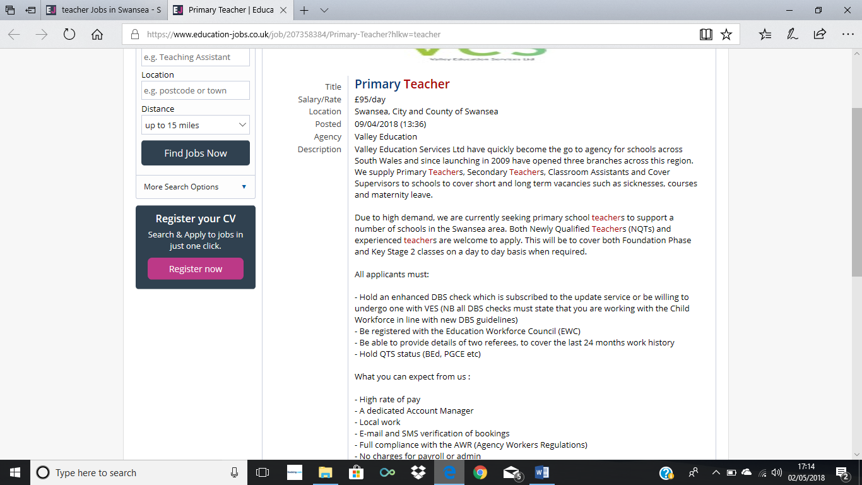

https://www.education-jobs.co.uk/job/207358384/Primary-Teacher?hlkw=teacher

Referencing

- Burke, L.M., 2015. Teacher's Ultimate Planning Guide : How to Achieve a Successful School Year and Thriving Teaching Career
- Businessdictionary.com, (2018), http://www.businessdictionary.com/definition/teamwork.html
- nationalcareersservice, (2018) https://nationalcareersservice.direct.gov.uk/job-profiles/primary-school-teacher#skills-required
- Readingrockets.org (2018) http://www.readingrockets.org/article/how-adapt-your-teaching-strategies-student-needs
- Rogers, B., 2002. Teacher leadership and behaviour management, London: PCP.
- teachercertification, (2018) http://www.teachercertification.org/a/9-useful-skills-for-teachers.html
- Thebalancecareers, (2018),https://www.thebalancecareers.com/teaching-skills-list-2062488
- Ucas (2018) https://www.ucas.com/teacher-training-entry-requirements-england

Bibliography

- Burke, L.M., 2015. Teacher's Ultimate Planning Guide : How to Achieve a Successful School Year and Thriving Teaching Career
- Businessdictionary.com, (2018), http://www.businessdictionary.com/definition/teamwork.html
- nationalcareersservice, (2018) https://nationalcareersservice.direct.gov.uk/job-profiles/primary-school-teacher#skills-required
- Readingrockets.org (2018) http://www.readingrockets.org/article/how-adapt-your-teaching-strategies-student-needs
- Rogers, B., 2002. Teacher leadership and behaviour management, London: PCP.
- teachercertification, (2018) http://www.teachercertification.org/a/9-useful-skills-for-teachers.html
- Thebalancecareers, (2018),https://www.thebalancecareers.com/teaching-skills-list-2062488
- Ucas (2018) https://www.ucas.com/teacher-training-entry-requirements-england
- KARA, H. Gözde ERTÜRK, 2017. AN ANALYSIS OF CHILDREN'S BEHAVIORAL PROBLEMS IN THE CONTEXT OF SOCIAL SKILLS AND TEACHER CHILD RELATIONSHIPS. Electronic Turkish Studies, 12(17), pp.195–213.
- Stephens, P., 1996. Essential mentoring skills: a practical handbook for school-based teacher educators, Cheltenham: Stanley Thornes (Publishers) Ltd.
- Wu, Zhongling, 2018. The associations between social skills and teacher-child relationships: A longitudinal study among Chinese preschool children. Children & Youth Services Review, 88, pp.582–591.
- Teaching.org, (2018),http://teaching.org/resources/top-10-qualities-of-a-great-teacher
- Skillsyouneed.com (2018), teaching skills, https://www.skillsyouneed.com/learn/teaching-skills.html
- The telegraph, (2015), what really makes a good teacher?, https://www.telegraph.co.uk/education/educationopinion/11347131/You-dont-need-a-qualification-to-be-a-good-teacher.html

Edutopia, (2015), The Heart of Teaching: What It Means to Be a Great Teacher, https://www.edutopia.org/discussion/heart-teaching-what-it-means-be-great-teacher

