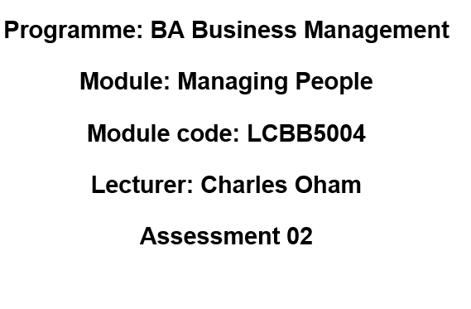
Student name : Andreea Gina Tabacaru
Student Id: 1914595

Table of Contents
Report Title 1
Background of the report 1
Objectives of the report 1
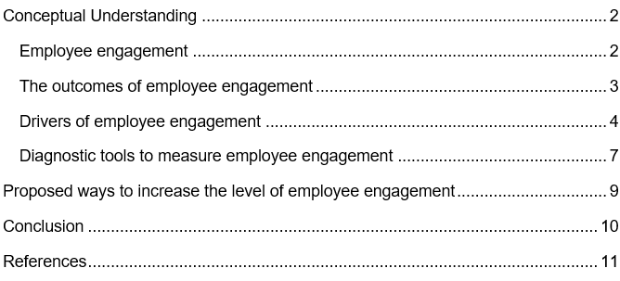

Report Title
The title of the report is “Ensuring employee engagement to attain improved employee performance and wellbeing in the workplace”.

Background of the report
Most recently the Chief Executive Officer (CEO) of XYZ Ltd. has participated in an online conference. The conference was rich with new concepts and information for change. One of the concepts that has been discussed in the conference was “Employee engagement”. According to the facilitators of the conference, the drivers that increase employee engagement of an organization help to attain increased performance as well as employee wellbeing. XYZ Ltd. did not measure the level of engagement previously in the traditional office settings. But the situation has vigorously changed because of the global outbreak of COVID-19. The organization has recently introduced flexible work culture that includes Work from home, flexible working time, restructured job responsibilities and workplace that is safe etc. after the spread of COVID-19.
Based on the learning gathered in the conference, the CEO is now looking for measures to ensure higher employee engagement to make sure a viable organization. The report is important to the CEO as this report will provide with necessary information to adapt employee engagement techniques as well as measure the employee engagement level in XYZ Ltd. which will eventually help the organization ensuring better performance from the employees.

Objectives of the report
The objectives that will be attained through the generation of this report are:
- To provide the CEO with related conceptual development information on employee engagement,
- To find out the employee engagement drivers,
- To evaluate the diagnostic tools of measuring employee engagement,
- To propose employee values from new ideas and previously covered analyses and propose strategies to increase the employee engagement level.

Conceptual Understanding
This section of the report includes research-based theories, models and information on employee engagement to help the readers in developing better understanding of the employee engagement process. The information depicted in this section are being extracted from peer reviewed journals, and internet reliable reports.

Employee engagement
The word “employee engagement” is still to be given any accurate or universally received explanation. For this reason, three familiar research organizations have given an understandable form of definition of the word, allowing only single researchers. The definitions are discussed below:
According to Perrin (2003), the word employee engagement is used to refer to “the eagerness and aptitude to be useful for the success of the company, mostly through executing unrestricted effort on a justifiable basis”. In accordance with the research, there are several factors including both emotional and logical factors that have an effect on engagement which are mainly related to work and the gathered experience from the work. According to the Gallup organization, engagement is the participation in the work with eagerness. According to Gallup, employee engagement can be defined as a positive attitude and emotional inclusion and commitment of employees towards the organisation. In accordance to Robinson et al. (2004), employee engagement refers to “the employees carried a bright outlook toward the business organization and its worth.” An employee who is engaged understands the business environment of the organization and works together with co-workers to develop the job performance for the welfare of the organization. The company must encourage employees to improve and develop engagement which will create a two-way sustainable relationship among the employer and the employee.” The Institute of Employment Studies has given the definition as employee engagement is the result of the two-way connection of employee and employer, the connection emphasizes on the equal responsibilities of both parties. Many researchers consider job satisfaction as the crucial segment of engagement, but it can simply review a transactional relationship which is only a match for the organization’s most recent rounds of perks and rewards; Engagement is considered to be the total involvement and attachment which refers the eagerness to give oneself and enlarge an individual's high levels of effort to aid the employer flourish, which goes beyond the simple job satisfaction toward the employment adaptation and the employer's loyalty ( Erickson, 2005; Macey and Schnieder, 2008; BlessingWhite, 2008). As a result, the alignment of the maximum job satisfaction and greater job contribution yields the whole engagement equation. According to the executive administrator of Towers Perrin, Stephen Young, the differences between employee engagement and employees’ job satisfaction claim that the engagement of the employees (not satisfaction) is more powerful medium than any other medium for ensuring better organizational performance ( Human Resources, 2007).

The outcomes of employee engagement
Different researches have been conducted by academicians and scholars to assess the positive outcomes that employee engagement generate from time to time. In 2013, Gallup, a global analytics and advice firm, conducted a research. The research examined 1.4 million employees of 49928 business units of 192 business organisations from 49 industries of 34 countries. The research revealed that the businesses that was in the top half in terms of employee engagement performed better and were achieving doubled more success in terms of employee absenteeism, finance, safety and quality and customer retention metrics than the businesses in the bottom half. Besides, those businesses from top half were experiencing 25% lower turnover in the organisations with high turnover rate and 65% lower turnover in the organisations with low-turnover. Furthermore, 37% lower absenteeism, 21% productivity, 22% higher profitability and 10% higher customer retention metrics was being recorded (Popli and Rizvi, 2016).
In another research done by Witemeyer (2013) mentioned that the organisations that engage their employees experiences positive impacts like proactiveness, cooperation, collaboration, knowledge sharing, better creativity, speaking highly of the organisation etc. Besides, researchers have also found better performance and productivity, higher profitability, enhanced safety and quality and better customer retention rates in organisations where employee engagement is being practiced.

Drivers of employee engagement
Researchers from time to time tried to find out the actual drivers that initiate employee engagement properly in business organisations. By conducting researches following different methods, different researchers have identified different employee engagement drivers. Those are depicted below:
- Employee involvement and commitment have been identified as engagement driver by Britt et al. (2001),
- According to IES (2005), communication and co-operation, the feeling of being valued and involved, equality, health and safety, length of service and job satisfaction are the employee engagement drivers that have been mentioned in another study (Bedarkar and Pandita, 2014),
- According to Wallace et al. (2006) mentioned in Bedarkar and Pandita (2014), contributions, connections and growth opportunities are the three employee engagements drivers,
- Seijit (2006) mentioned 10 Cs as the drivers of employee engagement. These include Career, Connect, Clarity, Convey, Congratulate, Contribute, Control, Collaborate, and Credibility & Confidence.
Apart from the above-mentioned drivers that have been identified through different studies, two more recognised driver hierarchies can be mentioned. One is from the study of Penna (2007). The study revealed a hierarchical order of the drivers of employee engagement which is aligned to Maslow’s hierarchy of needs. According to Penna (2007), pay, working hours and working conditions are the basic needs of an employee. After that learning and development scope works as a driver.
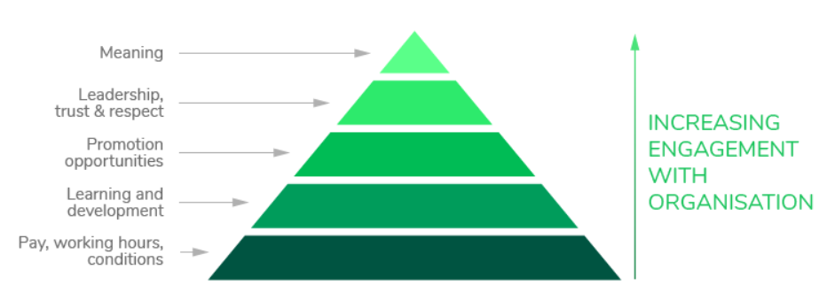
Graph 1: Penna’s hierarchy of employee engagement
At the third stage, promotion opportunities work as the form of motivation and helps the organisation to engage target employees. At fourth stage, leadership opportunities, trust and respect help an employee to be more engaged by fulfilling his/her esteem needs. At the last stage, meaning of doing something works as a driving force in engaging an employee.
Another study of Gallup (2013) has identified four key areas of employee engagement. Those are basic needs, individual contribution, teamwork and growth. In each area, different questions have been raised to understand the level of engagement of an employee with his/her organisation. Total 12 questions are being asked in this employee engagement hierarchical method to assess the level of employee engagement.
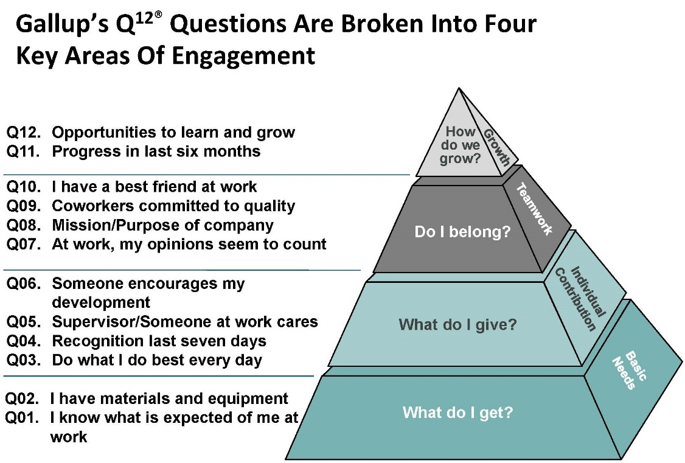
Graph 2: Gallup’s hierarchy of engagement
The discussion above has been prepared by accessing different journals to ensure better understanding of the employee engagement drivers.

Diagnostic tools to measure employee engagement
Human resources professionals of an organisation are responsible for the assessment and assurance of the performance of an employee. To make this complex task possible, an HR professional is required to make use of different tools and metrics. The necessity and the drivers of employee engagement has been already discussed. Now after the successful implementation of engagement tactics, one needs to track the level of employee engagement. The key metrics or diagnostic tools to measure employee engagement are mentioned and briefly discussed below:
- One-on-One meeting: HR professionals should arrange one to one meeting with every employee from time to time. It would help the HR professionals to understand what an employee might think of his/her job, how engaged the/she feels in this organisation and what is going to his/her next move (Engagedly, 2021). Besides, as the meetings are face to face and no other persons are not hearing, a person feels safe in expressing himself/herself which will help HR professionals to understand the level of employee engagement in the organisation.
- Conducting exit and stay interview: HR professionals can conduct interviews and also ask the employees about the status of the employee engagement that they feel (Engagedly, 2021). In these interviews, HR professional can ask employees what employees think they lack in the organisation and what should be done to improve the situation.
- Annual Surveys: The HR department can also arrange surveys to understand the employee engagement situations in the organisation.
- Employee turnover rate: Employee engagement can also be determined by measuring employee turnover rate in a specific period (Abdi, 2022). The greater number of employee turnover may indicate the lower level of engagement. Turnover can be determined by dividing the number of shoved off employees by the total number of employees and making the percentage of the number.
- Employee absenteeism rate: Greater number of employee absenteeism indicates the greater rate of employee disengagement. The HR professional can also make use of this metrics to understand the level of engagement in the organisation (Engagedly, 2021). To determine the absenteeism rate, the number of absent days will be divided by total workdays for a specific period and the percentage of the result should be determined.

Proposed ways to enhance the level of employee engagement
In above discussions, different concepts and theories of employee engagement has been depicted. By considering all the drivers and tools, it can be proposed to the CEO of XYZ Ltd. that to ensure the better performance and wellbeing of the employee, employee engagement tactics should be adopted. To do so, Penna’s hierarchy of engagement and Gallup’s hierarchy of engagement can be considered and made sure that all these driving forces are being generated in different levels of employee performance. Besides, annual surveys and exit interviews should be arranged and absenteeism rate and employee turnover rate should be determined to understand the lacking of the organisation in ensuring employee engagement.

Conclusion
The information provided from different researches shows how important the employee engagement in an organisation is for the further betterment of the process. Employee engagement helps an organisation to increase productivity, improve the operations, improve safety and quality, enhance employee performance and increase the rate of customer satisfaction and retention. This report shows how important employee engagement is for an organisation and how it can cut the cost and make the process effective and efficient at a time.

References
Abdi, N. (2022). Employee Engagement: How to Measure It and It’s Top Benefits (Updated 2021). [online] Sparkbay. Available at: https://sparkbay.com/en/culture-blog/measure-employee-engagement-8 [Accessed 4 Apr. 2022].
Bedarkar, M. and Pandita, D., 2014. A study on the drivers of employee engagement impacting employee performance. Procedia-Social and Behavioral Sciences, 133, pp.106-115.
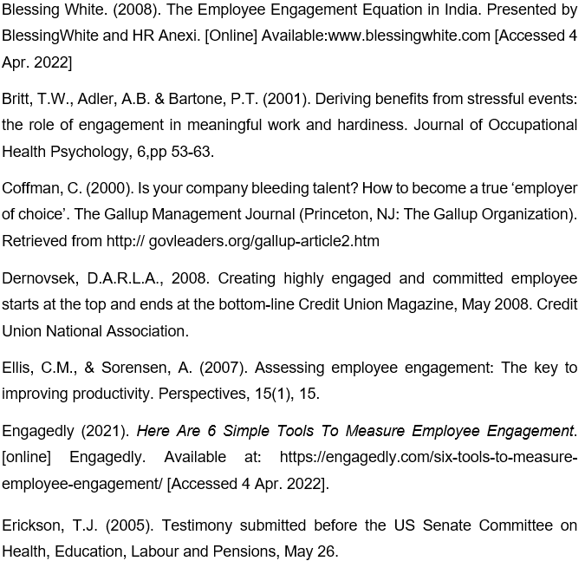Gallup (2013). State of the global workplace: Employee engagement insights for business leaders. Gallup. Retrieved 28 June 2015, from http://www.gallup.com/services/178517/state-global-workplace.aspx?utm_source=EMPLOYEE_ENGAGEMENT&utm_medium=topic&utm_campaign=tiles [Accessed 4 Apr. 2022]
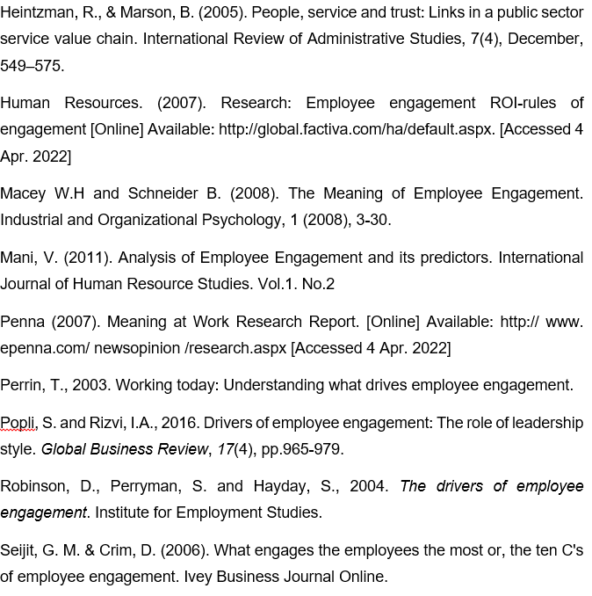Witemeyer, H.A. (2013). Employee engagement construct and instrument Validation, Dissertation. Georgia State University. Retrieved from http://scholarworks.gsu.edu/cgi/viewcontent.cgi?article=1018& context=bus_admin_diss [Accessed 4 Apr. 2022]

