Assignment Title: Data Analysis & Visualisation

Module: DATA HANDLING & BUSINESS INTELLIGENCE
Module number: LCBB5000
Lecturer’s name: Dr. Anupam Mazumdar

Executive Summary
The present report depicts the use of software i.e., Excel and SPSS for finding the outcomes or results of the data set. In this report, it has been depicted that the excel software has been used to find out the results of the data set by using the LOOKUP and PIVOT table. Hence, from the outcomes, it has also been found that the sales have been decreased over the years. On the other hand, SPSS software has also been used for segregating the male and female candidates associated in the survey has also been presented. The use of SPSS has been helpful in developing statistical analysis in this regard.

Table of Contents
Part 1: 4
Introduction 4
Body 4
1.1 Identification of the superstore data set for finding profit or sales declining 4
1.2 Evaluation of the excel used for data pre-processing and examining the data visualization 7
Conclusion 9
Part 2: 10
Introduction 10
Body 10
2.1 How many students like ice cream with vanilla flavor? 10
2.2 How many students are female and male? 11
2.3 What are the participant’s mean and median who likes strawberry and chocolate flavor ice cream? 11
2.4 K-means 13
2.5 Critical explain the text and data mining methods 13
2.6 Discuss the SPSS and excel using advantages and disadvantages 14
Conclusion 15
Reference list 16
Bibliography 18

Part 1:

Introduction
“Business intelligence (BI)” is important for the users for drawing better data analysis. The data scientist breaks up into the data specific and also forecast analytics, and utilizes advanced statistics. Along with that, it assists to search for patterns and forecast patterns for the future. It gives organizations data for needing in the way of making decisions like products to the market store to proceed. This report mainly aims at managing the finding sales or profit declining data, using pre-processing of data, and also analysing the data, there is also needed to determine the statistical analysis with the help of using SPSS software.

Body

1.1 Identification of the superstore data set for finding profit or sales declining
The profit and sales are most major parts to know the product’s commercial success. It is mainly based on recognition which is stated as per the basic requirements mentioned in the below table. According to Gruner et al. (2019, p.8), new product success can be indicated by the profit levels and sales volume as they acts as the main indicator for commercial success. Moreover, the profit and loss attained by a company is the indicator of their success in the market and it would bring higher transparency in the business as well. Hence, the profit or sales of superstore can be judged by the relative earning capability of the company in different segments of their business. Moreover, the optimum level of sales is the required value by which the profit of the store can be improved in the future since it has been decreased in the current year in comparison to the previous year. Along with that the information is mainly based on the dataset shows in the 4209896 for the year 2009, decreased in the year 2010 i.e., 3560087, again decreased in 2011 i.e., 3429944.98, slightly increased as compared to the year 2011 but reduced as compared to the year 2009 i.e., 3715671.95. Therefore, with the effect of that, it can be seen that the value of sales decreased from 2009 to 2012 and it can be clearly seen in the chart and table.
Years | Sum of Sales
2009 | 4209896.846
2010 | 3560087.045
2011 | 3429944.981
2012 | 3715671.953
Grand Total | 14915600.82
Table 1: Data table for Pivot table
(Source: self-developed)
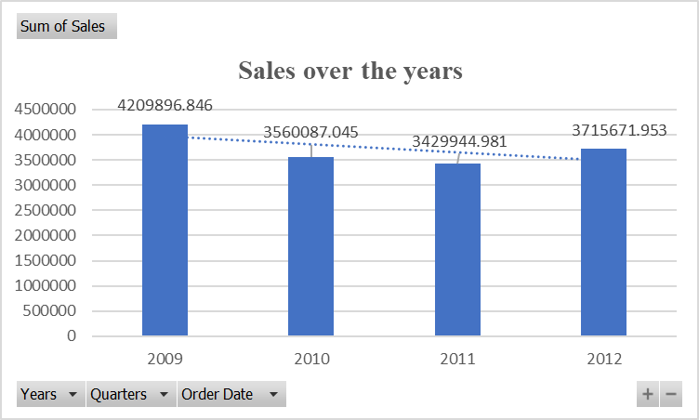
Figure 1: Sales declined over the years
(Source: Self-developed)
As per the above-given image, there has been mentioned PIVOT table as per the basis of the given data set of superstore sales. As per the view of Paradza and Daramola (2021, p.1), in order to retain long term sustainability and profitability understanding the relationship with the business values and intelligence is very important. It can be done by utilizing the Pivot table and also analysing the numerical data in-depth detail. The pivot table is mainly designed related to querying the huge data set amount in many ways user-friendly. It can be seen that the sales value decreasing in every year from 2009 to 2012. Thus, with the effect of that, the company is facing losses every year. Thus, it is easy to determine the value with the help of analysing the given data on the basis of the Pivot table.
Pivot table is important because it permits anyone to extract and filter the importance related to the data amount set with working. Along with that, it permits to look at its data the way of various numbers and also perspectives. It's one of the biggest benefits related to the pivot table that it is easy to manage and also lower to intimidating. Therefore, with the effect that it reduces the thousands of cells burden on the individuals so just a small table, the individual can able to calculate its requirements, and it also it makes easy to analyse huge information. Moreover, the best use of excel spreadsheet in the business is to show the financial situation of the company based on the revenue or profit data. The spreadsheet is the best way to use the information for decision-making purposes and improving the business performance by improving the profit or revenue of the store. Moreover, the PIVOT function of excel has been used to depict the to present decision related information (Jansen and Hermans, 2018, p.1).Profit or revenue data of the company that are the best way to perform the decision making based on the information. Moreover, the PIVOT table requires a number of tables and data for providing the relevant information which the individual has tried to achieve for the decision-making.
It can be explained with the help of summarizing and also identifying the chosen column and also data rows in the mentioned database and spreadsheet to take the desired report. The tools are not actually altered on the basis of database and spreadsheet which is generally shown in the pivots in turns of data to see the divergent perspectives.
As per the above-given information, it can be easily determined that the value of sales decreased in the next years such as 2009, 2010, 2011, and 2012. Thus, with the effect of that it can be said that the decreasing value of superstore sales means the company is facing issues in their inventories and also losing their customers. It affects the financial position of the company and also affects the company’s financial health. The company needs to increase its sales value by increasing its advertising. It can be easily determined with the help of easily analysingthe above-mentioned graphs. Along with that, it has been managing the data which is much easier with the features of user-friendly, gets more valuable insights without hassles, and also examines the data easier with the pivot tables.
It is required to make recommendations on the basis of a company facing issues of reducing sales margin value. Thus, it can be recommended that the company may increase its productivity and manufacturing area by reducing expenses. In addition, it is also required to manage the inventory of the company because it also affects the company’s sales value. Therefore, it is also required to add new products or services, enlarge the new domestic markets, increase the revenue channels, alter the price, be aware of the competition, and also improve community relationships. It can be recommended that the organization may also be able to increase the number of consumers by issuing offers, and discount rates, enhancing the average transaction size, enhancing the per consumer frequency, and also able to increase the prices. As suggested by Sunarsiet al. 2019, p.1), good service quality and price accuracy depending on the confidence of the customers helps in enhancing sales. Hence, the store can apply the sales enhancement system for gathering the relevant data and information about the different segments of their business for achieving higher sales in the store. With the application of sales enhancement system, the company would enable to generate higher sales in business by offering the discounts and other offers on the products. This creates the higher demand of the product in the market and for which the acquisition process of the product would be increased significantly. Lastly, the sales enhancement system will also be helpful for the company in enhancement of consumer frequency by which the products would be sold rapidly in the market and it will create a higher income base in business.
Therefore, with the effect of that, it makes able to increase the value of sales for the next year. Thus, the company may need to follow the recommendations for increasing the value of revenue.
The company also needs to attract customers towards the company. This is another issue that is faced by the company so it can be done only by issuing various offers, and discount rates, updating the company’s website, taking advantage related to the review sites, and also online ratings, promoting the expertise, and also asking for referrals. These are the necessary points which are related to the increasing the number of customers towards the company. It will also assist the company to increase the value of sales. The company may able to attract new customers and also keep existing or old customers by tending to keep in touch with the market can be offered. Therefore, if the company reduces behind even loyal customers won’t come back. It is adding the new consumer who is significant for the just revenue terms. Therefore, with the effect of that, the company may need to follow the mentioned strategies and also the recommendation so it will assist the company to attract the customer and also able to increase the sales value. It is more useful for comparable extracting data points for the analysis of comparative. For example, the median is often utilized as a central tendency to measure the income contributors for the highly skewed.
All aspects have been shown are reasons for using the Pivot charts and tables which are the major tools in excel. Along with that, it is more extremely important related to data science. It has been used in complex and time-consuming tasks which are rapidly and easily done. Thus, with the effect of that, it can be utilized with managers to get revenue breakdown from the individual each of the athlete's departments related to the revenues. Pivot charts permits the data scientists to indicate their client's information which they want to search the other numbers.

1.2 Evaluation of the excel used for data pre-processing and examining the data visualization
Products | Earliest Sales | Latest sales | Formula
Office Supplies | 392.57 | 261.54 | =LOOKUP(2,1/($A$2:$A$8400=E4),$C$2:$C$8400)
Technology | 469.84 | 4965.76 | =LOOKUP(2,1/($A$2:$A$8400=E5),$C$2:$C$8400)
Furniture | 2026.01 | 146.69 | =LOOKUP(2,1/($A$2:$A$8400=E6),$C$2:$C$8400)
Table 2: Calculation of Lookup
(Source: Self-created)
As per the above-given table, there has been done the calculation of Lookup value for determining the earliest sales and also latest sales. Thus, it can be seen that there is determined the product value with the help of analysing the Lookup values such as office supplies, technology, and also furniture. The higher latest sales value is mentioned in the furniture and the higher earliest sales value is mentioned in the technology. Additionally, there has been also given the lowest value of office supplies that are 261.54, and also the furniture’s value is given 1465.69. The value of lookup searches as per the basis of the given direction or array which is mentioned in the formula area.
The value of earliest sales in office supplies is given 392.57 which is decreased in latest sales i.e., 261.54. On the other hand, the technology’s earliest sales also decreased in the latest sales increased that is 4965.76. However, the furniture’s earliest sales value decreased in the latest sales i.e., 146.69. Thus, this statement proves that the sales value of the company is decreased in the latest sales value as compared to the earliest value. It can be easily determined with the help of a lookup value. It assists the individual to know the lowest value from the huge data set and it is possible only by the following formula lookup value. As per the information taken from Draganaet al.(2019, p.2), by the help of operating profit margin performance of the business gets determined that helps in taking financial decisions. It has been done with the help of single formula to lookup the values, speedily determine the correlated data, and also perform rough and extract matches. It assists the organization to determine the information from the large amount of data mentioned in the spreadsheet. The company needs to increase its sales value because it has decreased from the year 2009 to 2012. Furthermore, it can also be depicted from this evaluation of lookup function presented in the above table it has been identified that trend of sales has been significantly affected over the years. In addition, the basis of this presentation has been done by data validation function through which the product category can be selected specifically a based on that information is taken.
The argument of lookup value can be shown in the text, number, and also the logical value for the reference and name. It is mainly referred to as the value which can be determined with the lookup value and is also easy to show in the huge value. Therefore, with the effect of that, the function of Lookup permits the users to make better searches for the data piece. It can be done on the basis of mentioned column or row for the corresponding return on the data piece for another column or row. As per the view of Setianingrum(2021, p.16), the benchmark is mainly a liquid, transparent and non manipulative method that is considered for ensuring the financial market based efficiency. LOOKUP Value is one of the capabilities of the intelligence, which is used to demonstrated the overall changes in the sales and profit of business. In addition, it permits one to look into the information and analyse them more effectively. The classifications have been used to designate the huge groups inside the demographic, and target audiences. It is the most measurable central tendency related to the most informative for skewed contribution or also the outliers.

Conclusion
It can be concluded that the sale declined from the year 2009 to 2012. It is the major factors related to the organization that assists to recognize profitability more effectively. This report has recognized that the superstore has faced the challenges of declining sales value. It has been determined with the help of calculating the Pivot table and also lookup value on the basis of the study. The main findings of the report are showing that the company has faced the challenges of decreased sales value. However, the company needs to increase its sales value by managing its inventory and decreasing the cash outflow and expenses value.

Part 2:

Introduction
This part mainly aims at using and calculating the total female and male data in the statistical data. In addition, it has been sorted in ascending order from the highest number value to the lowest numerical value. This report mainly aims the determine the numbers of male and female who likes vanilla flavour ice cream, the total numbers of male and female, and also determine the value of the mean and median mode related to the participants who likes chocolate and strawberry flavour ice cream.

Body

2.1 How many students like ice cream with vanilla flavour?

Statistics
 |  | ice_cream | Gender
N | Valid | 200 | 200
N | Missing | 0 | 0

Frequency Table

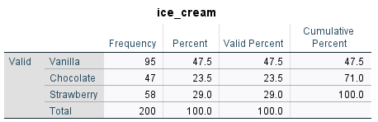

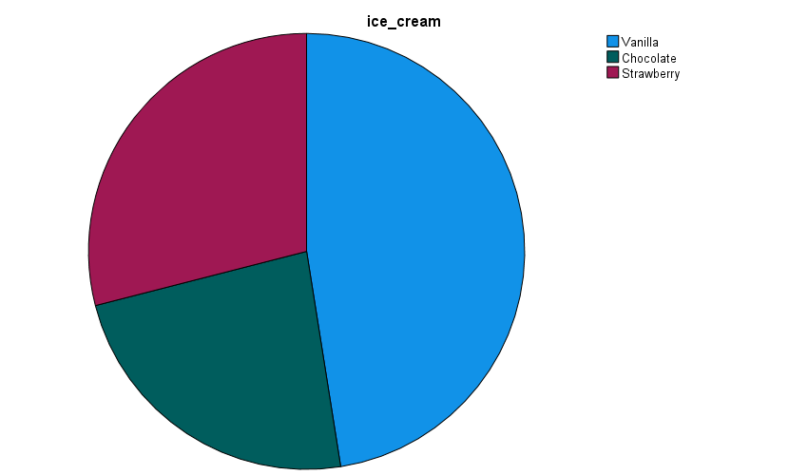

Figure 2: Students like Vanilla flavour
(Source: self-developed)
This research has represented female as 1 while male is considered 0. In addition to this, vanilla is referred as 1, chocolate is considered 2, and strawberry is presented as 3. On the basis of the above figure, it can be stated that a total of 95 males and females like Vanilla flavour ice cream. Along with that, it can be seen that it is the highest value as compared to the rest of the ice cream flavours. The valid percentage is given 47.5% which is also higher as compared to the rest of the valid percentage of ice cream flavours. The total number of males and females has taken participated in the program i.e., 200. Therefore, from this outcome, the total number of vanilla flavour ice cream lovers is mentioned as 95 out of 200, i.e., 47.5%.This analysis helps to identify that the maximum number of students likes vanilla flavour in ice cream. Therefore, the sale of ice cream with vanilla flavour can is helpful in increasing revenue that can lead to increased profitability of the company.

2.2 How many students are female and male?
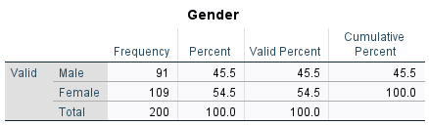

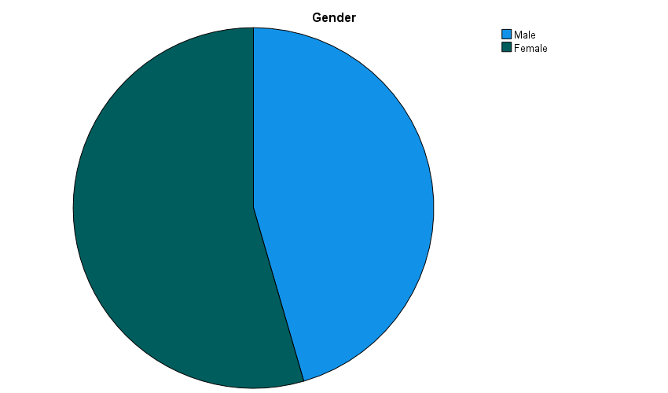

Figure 3: The numbers of students
(Source: self-developed)
As per the above discussion female and male are presented as 1 and 0 respectively in the determination of number of students. Figure 3, it is mainly showing the total number of females and males who have taken participated. Thus, it can be determined that the total number is given 200 which included both males and females. Thus, adding with the missing system stands at 0.However, in the percentage value, it can be seen that the valid percentage is given as 45.5% in the context of male while on the other hand, valid percent of female stands at 54.4% and also the total is given as 100%. It can be determined with the help of SPSS descriptive data’s frequency value so it makes it easy to find a better value for total participants. It is observed from the determination of frequencies of this data that the total number of female students stands at 109 while in contrast, the total number of male students stands at 91.This analysis helps to identify that there are maximum number of female students as compared to males students.

2.3 What are the participant’s mean and median who likes strawberry and chocolate flavour ice cream?
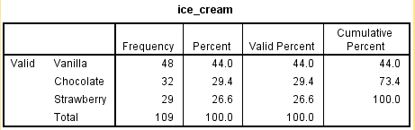
Figure 4: The participants like chocolate and strawberry
(Source: self-developed)
As per the above-given image, it can be stated that the value of total participants mainly likes strawberries and chocolate. Thus, the total number of strawberry participants is mentioned at 29, and the chocolate value is mentioned at 32. In these values, it included both male and female values, and the percent value is given for chocolate i.e., 29.4%, and strawberry i.e., 26.6%. It can be determined with the help of analysing SPSS
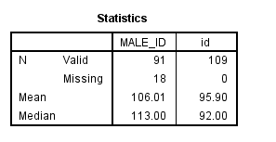
Figure 4: Determine the value of Mean and Median
(Source: self-developed)
It can be seen that the mean value is given 106.01 for Male and 95.90 for females. The mean is the provided average value as per the basis of mentioned numbers which is calculated by dividing the total numbers provided. On the other hand, the total number of the median is mentioned as 113 for the Male and 92 for the female.
The median is the simple and middle number which is sorted from the mentioned number list. Along with that, it has been determined as the median value in the sequence number. The median is mainly showing the middle value which is shown in the list in order from the smallest to the largest.

2.4 K-means
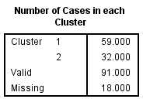
Figure 5: Initial cluster
(Source: self-developed)
K-Means is a process to intercept data of two or more variables through the use of vector quantization originally from a huge population of data, its main aim is a partition of observation in K clusters. By the help of SPSS probability of the events through K- means can be determined The SPSS software is also important in deriving the cluster, missing, valid valued of the experiments along with the graphical representation of the same (Muqri et al.2018,p.5). The value of cluster 1 has been evaluated at 59.00 whereas the value of cluster 2 has been evaluated at 32.00. Thus, it has been executed that male consumer are more consuming ice create as compared to female consumers. Besides that. Among the data population, 91 data on ice cream consumption are more valid and affected sales and demand for ice cream in the market. On the other hand, 18 data on male as well as female consumers are missing due to inappropriate data as well as missed in cluster 1.

2.5 Critical explain the text and data mining methods
Data mining is the process of statistical techniques related to the raw data in the framework form. Along with that text, mining is the data part that is related to mining and participating with the document text form. On the other hand, pre-existing databases and also spreadsheets are utilized for the collected information. In data mining, it is classified thought about the clustering form.
It is quite evident that the big data technologies are important in different industries for the successful application of data mining and text mining in business. Both the mining process is important for different companies since it provides different usefulness to the business by improving their efficacy and performance of business. As per Pejić-Bach et al. (2019, p.2), the text mining process is helpful in analysing the textual documents of the business for gathering the relevant data from the documents. Text mining has been done by using the advance technologies like machine learnings that encompasses through the exchange of languages for attaining the relevant data from the text documents.
Logistics regressions: It is the attempts of algorithms to show the specific profitability result inside the two possible outcomes of the data. For example, the service of email can be used in the regression of logistics to forecast email spam.
Decision trees: At first the data is classified, follows up with the questions that can be asked, and also the outcome is diagrammed in the chart called the decision tree. Decision trees are a strategy- making approach is the process of patterns that are identified for helping in prediction (Pasha, 2022, p.4). For example, if the computer organization wants to forecast the buying laptop likelihood, it may ask, “Is the potential buyer a student?” the data is systematized into the NO and Yes decision trees.

2.6 Discuss the SPSS and excel using advantages and disadvantages
Advantages
SPSS | EXCEL
It assists the research to determine an accurate value of statistical data and also reduces the possibility of errors occurring which is minimum with the help of using SPSS. | It has been used mathematic analyse and summarize the financial and statistical data.
The users can able to select the data freely type that can match the data contribution needs. | It utilized the examination returns in the stock market that developed the organization plan.
It can generate new variables from the already given information. | It created the budget plan for maintaining the monthly living expenses.
It can give many divergent kinds of statistical analysis operations that are not available in the other package program. | It can save divergent document versions and also easily sort them. Thus, with the effect of that, it can go behind the same document’s previous version.
Table 1: Advantages of SPSS and EXCEL
(Source: self-developed)
Disadvantages
SPSS | EXCEL
There are available a lot of options so it is needed to know the process of selecting accurate options for doing analysis. | Data can be lost sometimes because of data corruption.
It has capabilities of limited data visualizations | It consumes so much time at the time of entering data manually.
Its default storage formats for the output and data log file are “Software-dependent”. | The viruses can be attached by the way of macros which are mini-programs written into the excel sheet.
Table 2: Disadvantages of SPSS and EXCEL
(Source: self-developed)

Conclusion
It can be recommended that the study is based on the use of SPSS and excel for the analysis of mentioned data. In addition, with, the K-means cluster has been calculated as also text mining and data mining which has been explained in the depth. In addition, the study has discussed the use of SPSS’s advantages and limitations as same as excel. The calculation of mean and median are the most major central measures of tendency. The complete data set is represented with these values and is also not essential for the mean and median which have the same values. The mean builds and creates a better sense to draw a better conclusion.

Reference list
Dragana, V.K., Radojko, L., Gordana, G. and Milan, G., 2019. The operative profit margin and interest cost in retail food. EkonomikaPoljoprivrede (1979).
Gruner, R.L., Vomberg, A., Homburg, C. and Lukas, B.A., 2019. Supporting new product launches with social media communication and online advertising: sales volume and profit implications. Journal of Product Innovation Management, 36(2), pp.172-195.
Jansen, B. and Hermans, F., 2018. The use of charts, pivot tables, and array formulas in two popular spreadsheet corpora. arXiv preprint arXiv:1808.10642.
Muqri, M.R., Harper, N., Muqri, H. and Wesr, B.K., 2018, June. Leveraging the power of Matlab, SPSS, EXCEL, and Minitab for Statistical Analysis and Inference. In 2018 ASEE Annual Conference & Exposition, pp 05-19.
Paradza, D. and Daramola, O., 2021. Business Intelligence and Business Value in Organisations: A Systematic Literature Review. Sustainability, 13(20), p.11382.
Pasha, F.M., 2022. From Experimental Results To Business Strategies: Harnessing The Power Of Decision Trees And Rule-Learners, pp.1-24
Setianingrum, A., 2021. ISLAMIC BENCHMARK IN BANKING PRICING TO OVERCOME BUSINESS CYCLE IN NEW NORMAL. International Journal of Economics and Finance Studies, 13(2), pp.1-23.
Sunarsi, D., Baharuddin, A., Afni, N. and Patak, A.A., 2019. The Effect of Service Quality and Price Accuracy on Consumer Confidence and Implications for Sales Increase. PINISI Discretion Review, 3(2), pp.01-10.

Bibliography
Azzedin, F. and Ghaleb, M., 2019. Towards an architecture for handling big data in oil and gas industries: Service-oriented approach. International Journal of Advanced Computer Science and Applications, 10(2).
Kadirhodjaev, A., Rezaie, F., Lee, M.J. and Lee, S., 2020. Landslide susceptibility assessment using an optimized group method of data handling model. ISPRS International Journal of Geo-Information, 9(10), p.566.
Li, Z., 2020. Geospatial big data handling with high performance computing: Current approaches and future directions. High Performance Computing for Geospatial Applications, pp.53-76..
Souibgui, M., Atigui, F., Zammali, S., Cherfi, S. and Yahia, S.B., 2019. Data quality in ETL process: A preliminary study. Procedia Computer Science, 159, pp.676-687.
Sun, S., Zheng, X., Villalba-Díez, J. and Ordieres-Meré, J., 2020. Data handling in industry 4.0: Interoperability based on distributed ledger technology. Sensors, 20(11), p.3046.
Trakadas, P., Simoens, P., Gkonis, P., Sarakis, L., Angelopoulos, A., Ramallo-González, A.P., Skarmeta, A., Trochoutsos, C., Calvο, D., Pariente, T. and Chintamani, K., 2020. An artificial intelligence-based collaboration approach in industrial iot manufacturing: Key concepts, architectural extensions and potential applications. Sensors, 20(19), p.5480.
Yahya, N.A., Samsudin, R., Darmawan, I., Shabri, A. and Kasim, S., 2018. Group Method of Data Handling with Artificial Bee Colony in Combining Forecasts. International Journal of Integrated Engineering, 10(6).

