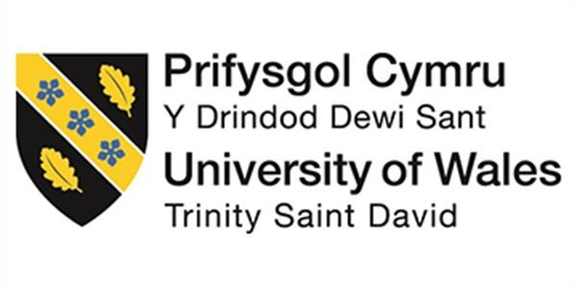

Programme: Master of Business Administration
Module: Marketing Management
Module code: LCMB7024
Student name: Hiren Kishorbhai Adroja
Student ID number: 2527939

Table of Contents
Introduction 3
Element 1: Sustainable Brand Extension Poster Presentation 4
Element 2: Segmentation, Targeting, Differentiation, and Positioning (STDP) Analysis 5
1. Market Segmentation 5
2. Target Market 5
3. Differentiation 6
4. Positioning 7
Element 3: Marketing Mix (7Ps) Analysis 8
1. Product 9
2. Price 9
3. Place 10
4. Promotion 10
5. People 10
6. Process 11
7. Physical Evidence 11
Element 4: Reflection 12
4.1 Reflection on Developing the Nike Circular Collection 12
Developing the Brand Extension 12
Learning and Future Improvement 12
4.2 Reflection on the Poster Presentation and Professional Development 13
Poster Presentation Experience 13
Professional Development and Future Learning 13
References 14

Introduction
The global sportswear sector is undergoing a shift towards a circular economy, where businesses must strike a balance between sustainability and profitability. In spite of its reported FY2025 revenue of US$46.3 billion and presence in over 190 countries, Nike's financial results declined, signaling the importance of exploring new growth avenues (Nike, 2025).
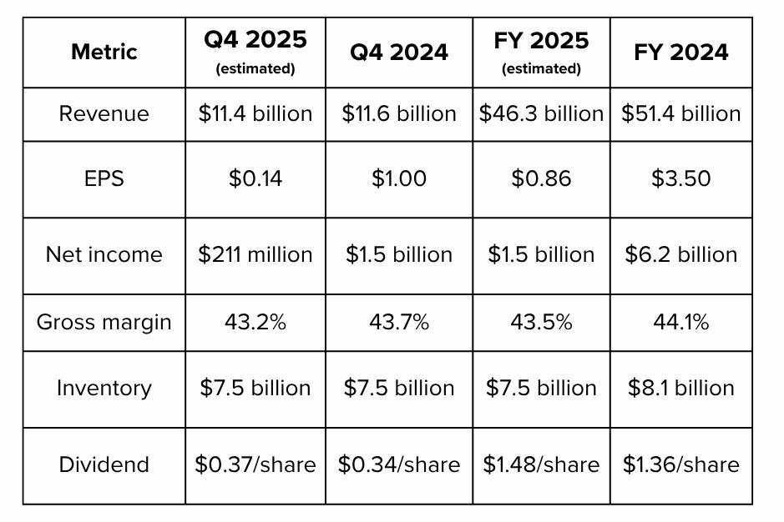
Figure 1. Nike FY2025 Financial Performance Indicators Compared with FY2024.
Source: Adapted from Nike, Inc. (2025) FY2025 Annual Report.

The following statistics are adapted from Nike, Inc. (2025) Annual Report. This report aims to suggest the Nike Circular Collection as a sustainable brand extension, and critically assess its strategic feasibility with the Segmentation, Targeting, Differentiation and Positioning (STDP) framework and the Extended Marketing Mix (7Ps), and reflect on the development process.

Element 1: Sustainable Brand Extension Poster Presentation

Nike Circular Collection is a brand extension that builds on the principles of circular design, recyclable materials and responsible consumption to help Nike's competitive edge.

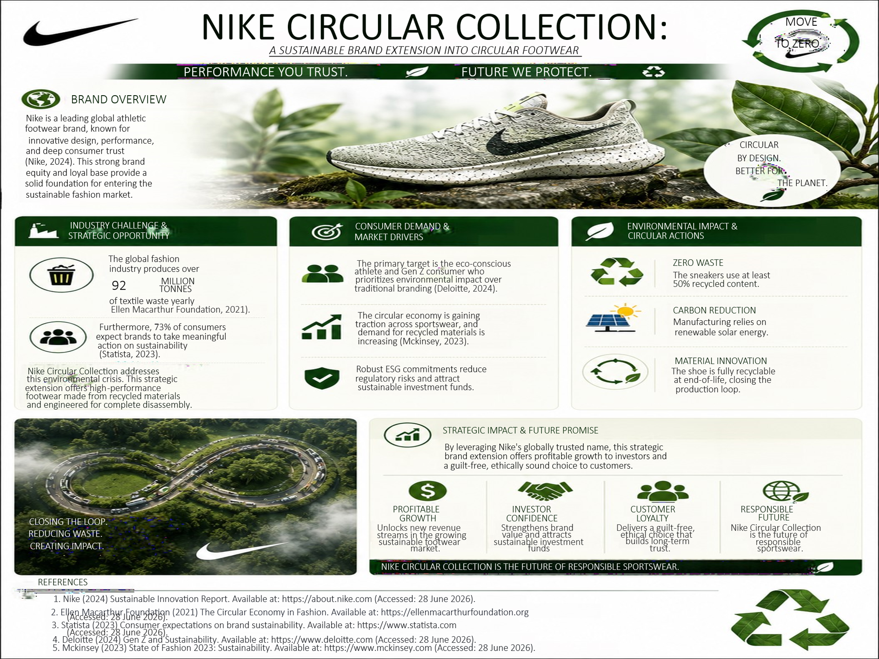

Element 2: Segmentation, Targeting, Differentiation, and Positioning (STDP) Analysis

Segmentation, targeting and positioning (STP) is a three-step process that involves identification and profiling of segments of buyer groups, choosing the segment(s) most suited for the company and developing an offer in the minds of the target group (Cozma and Cosma 2023). The Nike Circular Collection could be used as a roadmap to market for Nike's footwear extension into the world of circular and recycled sportswear.

1. Market Segmentation

The Nike Circular Collection is segmented geographically, demographically, psychographic ally and behaviourally to target consumers. The collection will start in the United States, the United Kingdom and Western Europe where recycling infrastructure, environmental policies and sustainable consumption are highly developed and will be rolled out to major Asia-Pacific cities in the future. In terms of demographics, the main consumer target group is people aged 16 to 35 years, with a higher percentage of Gen Z and younger Millennials willing to pay a higher price for sustainable products (Gomes et al. 2023). Psychographically, the group is made up of people who are environmentally aware and are seeking to make their lifestyle and buying decisions a sustainable one. As consumer expectations shift (Branca et al., 2025), these consumers appreciate companies that are transparent and socially responsible, exhibiting ethical practices. The collection is targeted at the Nike loyalists and eco-conscious consumers who are often buying athletic footwear and are keen to engage in recycling and take-back initiatives, aligning with Nike's circular economy approach (Nike,2024).

2. Target Market

Given that Simkin & Dibb(1998), argued that companies would need to consider the attractiveness of the segment in relation to their own organisational capability, Nike is ideally positioned to capitalise on the ‘Move to Zero' sustainability platform, supply chain for recycled materials, and international distribution network (Nike, 2024).A differentiated targeting approach is recommended in the case of the Circular Collection compared to the large mass market, where the Nike Collection is sold to customers who are aware of the environmental issue, whereas the rest of the Nike range sells its core products to general consumers. This is similar to the targeting logic of Nathaniel (2026), which meant that marketing resources and messaging would not be spread out among incompatible audiences.
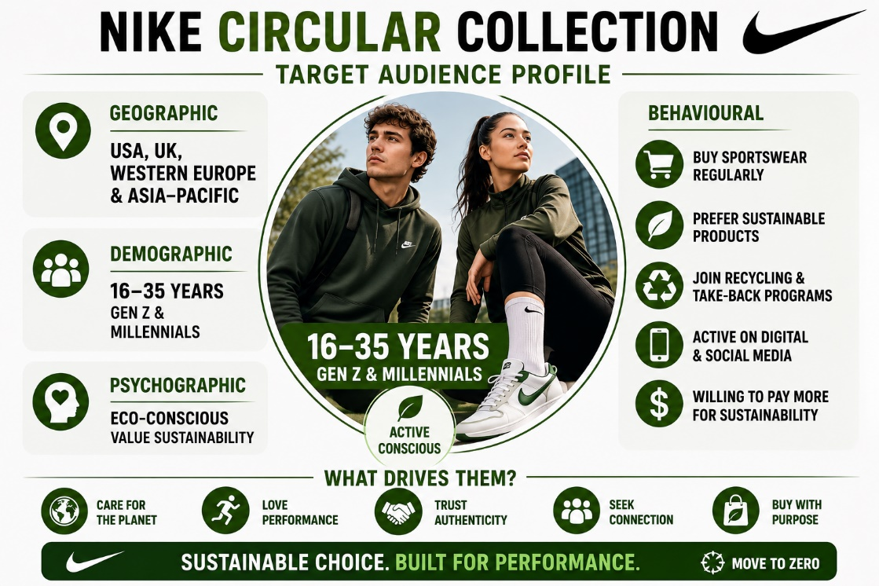

Figure 2. Target Audience Profile for the Nike Circular Collection.
Source: Author's own illustration (2026), developed from Gomes et al. (2023), Branca et al. (2025) and Nike (2024).

3. Differentiation

The Nike Circular Collection stands out in its incorporation of circular product design principles alongside Nike's longstanding legacy of athletic performance (Ulziibadrakh et al., 2025). Nike’s mono-material construction, design for disassembly and high-performance innovations all in one shoe are in contrast to brands that focus solely on sustainability and comfort, like Allbirds, or those whose recycled footwear has been called into question about being recyclable at the end of its life, such as Adidas. While competitors may develop similar sustainability initiatives programs over time, its extensive research capability, global brand recognition and existing athlete partnerships give the company a better platform to continue to maintain its competitive edge. This comprehensive approach will allow the Circular Collection to offer environmental benefit and function, thus providing a more defensible market position (Cicinionyte, 2026).

4. Positioning

Positioning involves creating a clear and unique position in the minds of target customers compared to the competing offers (Prasetya et al., 2025). The Nike Circular Collection positioning statement is: For everyday athletes who care about the environment, but don't want to sacrifice performance, the Nike Circular Collection is the sustainable footwear collection designed to close the loop on athletic waste, without sacrificing the innovation known for Nike. This alignment puts the Circular Collection one step closer to the traditional sportswear brands and sustainability-driven footwear brands. Instead of being only an environmental brand or a sports brand, Nike is a unique type of brand that offers both attributes to its sporty market, making it a very special brand that attracts both sporty and environmental consumers. Competitors keep working on sustainable innovation but with Nike's circular design combined with its successful product performance, there's a greater value proposition for the long term for the brand, and it's meeting evolving consumer expectations Ulziibadrakh et al., 2025).
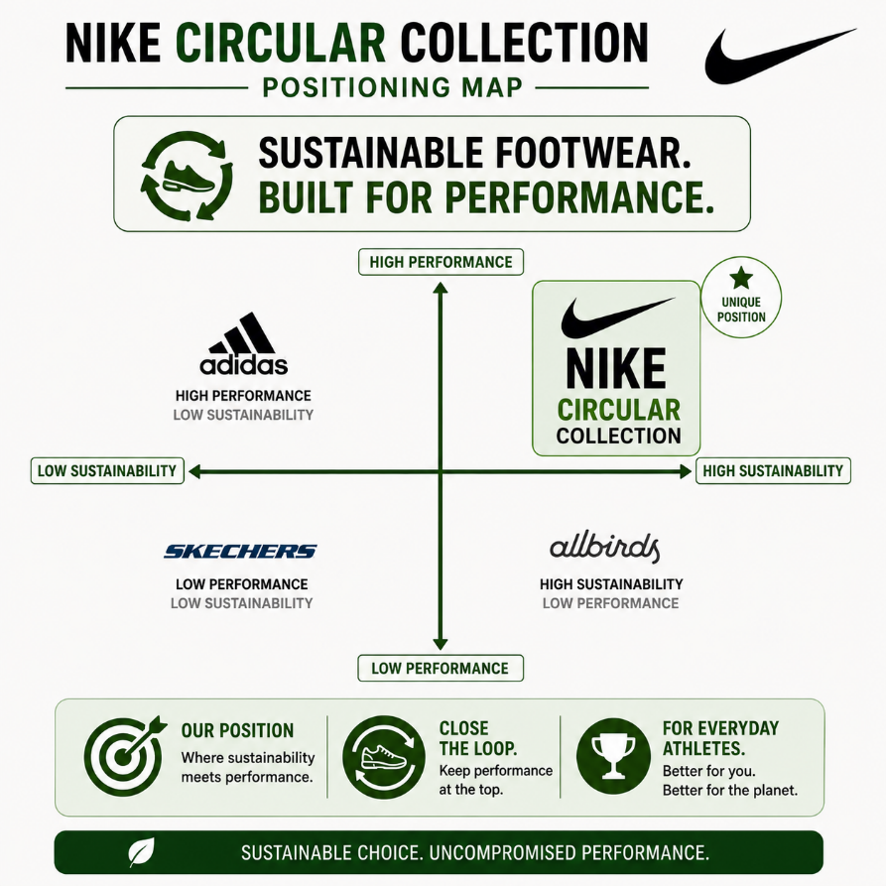
Figure 3. Positioning Map of the Nike Circular Collection in the Sustainable Sportswear Market.
Source: Author's own illustration (2026), developed from Prasetya et al. (2025), Nike (2024), and Bocken et al. (2016).

Element 3: Marketing Mix (7Ps) Analysis

The Nike Circular Collection has a product (as well as a service aspect in terms of take-back and recycling initiatives) and uses the 7Ps marketing mix. The 7Ps framework developed by Ko (2024) encapsulates the jobs of individual, process and physical evidence that enables the sustainable brand extension strategy.

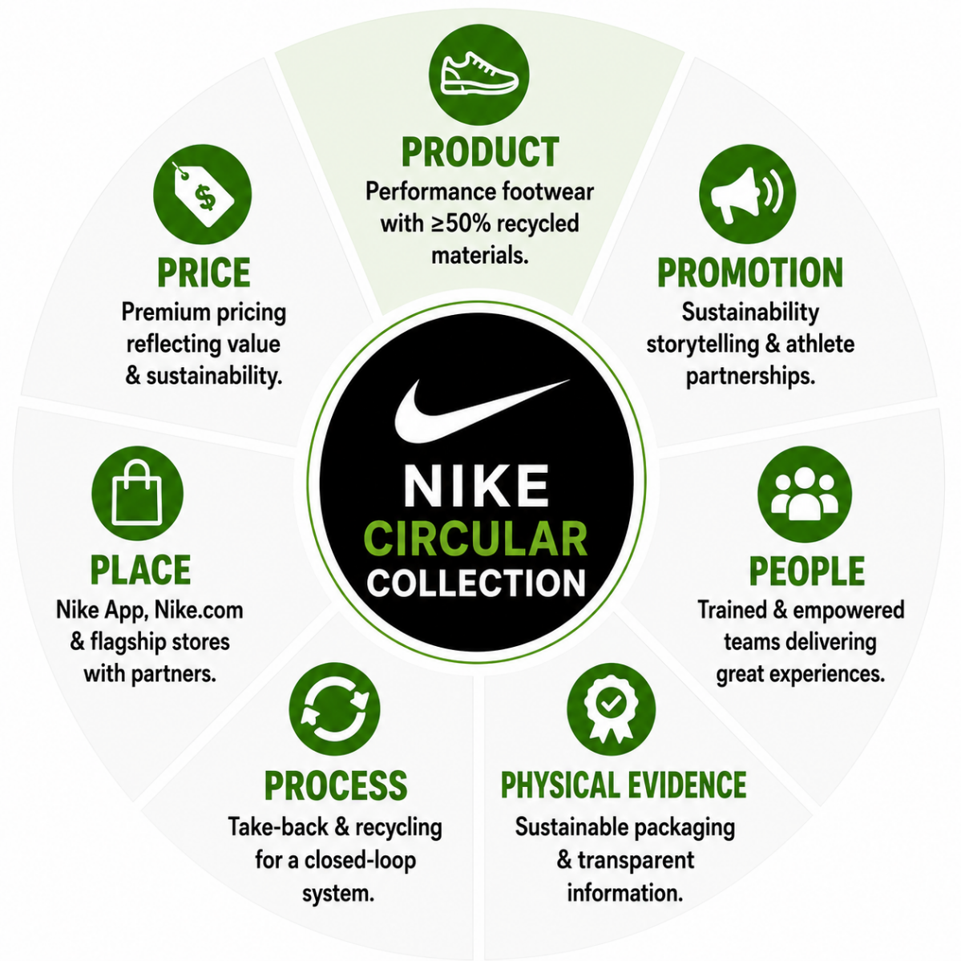

Figure 3. The Extended Marketing Mix (7Ps) Applied to the Nike Circular Collection
Source: Author’s own illustration (2026)

1. Product

The core product is a mono-material, fully-dissemblable and recyclable running shoe with at least 50% recycled content (Mhatre et al., 2021). This directly helps the brand extension strategy because it turns a generic sustainability message into something that consumers can actually see, touch, and feel a verifiable product attribute, something that is helping to quell criticism that greenwashing is not leading to consumer trust (Cicilionytė, 2026). The design for disassembly is also a significant advantage for other brands, which is often overlooked, as their recycled-content sneakers may not be able to be recycled either (Bocken et al., 2016). But mono-material footwear can have certain performance and design limitations when compared to traditional multi-material footwear. However, as long as there are limitations, Nike can keep investing in material innovation, thus improving the functionality of their products while still following the principles of circular design. This is a well-balanced approach, which reinforces the credibility of the Circular Collection, as sustainability and sport performance do not have to significantly impact on the product quality.

2. Price

The premium pricing strategy is recommended for the Nike Circular Collection, as it is slightly higher than Nike's regular running shoes, but still within the consumers' willingness to pay for a sustainable product. The average willingness to pay for a truly sustainable product is 12% according to Rampazzo (2024). Thus, a moderate premium is supportive of value-based pricing, which is based on the customer's perceived value of the product or service, rather than the costs of production (Loutraris, 2025). Premium pricing further establishes the sustainable and innovative brand image of the Circular Collection and contributes to the recovery of the higher production costs of recycled materials. A lower pricing model may lead to higher market penetration in the short term, but may have a negative impact on product quality and exclusivity in the short to medium term. So, premium pricing makes better strategic sense, as it captures consumers' perception of sustainable innovation value, and works in favour of Nike's brand positioning.

3. Place

Distributed channels should focus on Nike's own direct to consumer (DTC) points of sale, primarily its Nike app, Nike.com, and flagship stores, which accounted for around 42% of company revenue by 2024, and allow Nike to have direct influence on customer data, storytelling and brand experience (Gunz, 2023). This is ideal for the Circular Collection, since this would enable Nike to deliver the circularity story without any dilution via third parties for retail. Nike's recent pivot to a more balanced omnichannel marketing strategy, which has been challenged by too much focus on DTC and the impacts it has had on wholesale relationships, should be complemented by a more limited and curate wholesale strategy to gain further reach without diluting brand positioning (Alves, 2021). But it is not without tension: Nike's earlier wholesale push introduced some tension in partnership channels like Foot Locker, so any wholesale footprint for the Circular Collection would need to be carefully managed – while bringing the advantages of wholesale channels to consumers that aren't shopping Nike's owned channels.

4. Promotion

The emphasis of promotion should be on a real and honest story rather than on advertising. Nike should work together with the athletes and sustainability activists to make sure that individuals are educated about the company's sustainability efforts and the use of recycled materials in its products (Mainjot, 2025). The credibility of the Circular Collection will be reinforced if its claims are clear, measurable and backed by credible and independent evidence (Cicinionyte, 2026).

5. People

In service influenced offers, credibility is a key factor that relies on employees and brand representatives (Ulziibadrakh et al., 2025). All in-store and customer service personnel should be trained to accurately discuss the Circular Collection's disassembly design and take-back process because inaccurate or exaggerated staff communications will detract from the trust the promotional messaging is trying to establish with consumers. Nike has built a solid platform in its athlete partnerships and Nike stores' training infrastructure that serves as a practical basis to integrate it throughout the markets (Nike, 2024).

6. Process

The take-back and recycling services is the most transparent element of the offer and should be designed as a low-friction reverse logistics system, where the customer is able to return the used shoe in the store or by post, and it will be recycled into new material inputs (Fashion for Good, 2025). The Efficient reverse logistics infrastructure is said to be the critical link that make a circular product design a closed material loop, not just a marketing promise (Govindan & Bouzon, 2018). Rewarding participation, like store credit for returned pairs, can help achieve repeat participation and generate first party data that can be used to support the Nike DTC strategy. However, the real success of the reverse logistics depends on customers' continuing involvement. Take-back programmes might not be as effective as they could be if they had a convenient collection system and meaningful incentives, as their participation might be limited. Hence, Nike has a constant need for continuous improvement of their reverse logistics to turn circularity into a reality and not merely a marketing statement.

7. Physical Evidence

Physical proof is very important in demonstrating the sustainability credentials of the Circular Collection. Nike's circular economy actions are seen in recycled content labelling, in-store displays to educate on Nike disassembly and the limited sustainable packaging. These can be physical indicators that differentiate between genuine sustainability and greenwashing claims (Gomes et al., 2023). While Nike can add consumer trust by the use of independent verification of its circularity claims, other brands like Allbirds are using third-party certifications to add credibility. In combination with reverse logistics and direct to consumer methods, these all contribute to the positioning and customer trust in the collection in the long term.

Element 4: Reflection

4.1 Reflection on Developing the Nike Circular Collection

Developing the Brand Extension

The Nike Circular Collection proved to be more than a new, innovative product idea, it was a successful brand extension. The project involved the practical application of marketing concepts in a realistic business context and the use of academic research and industry data to inform business decisions (Cozma and Cosma, 2023). I found this stage of market segmentation and the selection of a target market to be relatively easy as it fits with the knowledge acquired in the module. It was only when they were brought together in a unified marketing plan that some deeper thinking was needed, though. By researching Nike's sustainability efforts (and that of the competition), I realized that sustainability is not about pushing the message out, it's about providing a real competitive edge. Comparing options and making recommendations with evidence instead of assumptions was enhanced by evaluating various strategic options. In addition, the process of creating the marketing mix increased my awareness of the need to consider the various components of the marketing mix in relation to each other to support the overall positioning of the brand. This experience proved sustainability should be part of the marketing mix from the product design to the communication to the customers and value delivery in the long run (Ko, 2024).

Learning and Future Improvement

This project was a great learning experience for me as it was a way to bring out my strengths and also focus on areas I needed to work on. I gained more confidence as a user of marketing tools like STDP and the 7Ps, but pricing and financial justification were more difficult due to the need to balance commercial goals with sustainability goals. This experience proved to be a valuable expression of the need to combine theory with business acumen. For future projects, I will continue to improve my commercial awareness by using the knowledge and skills acquired in this course to increase my understanding of pricing strategies and financial evaluation and evidence-based decision making to enable more balanced marketing recommendations to be made.

4.2 Reflection on the Poster Presentation and Professional Development

Poster Presentation Experience

Writing the report took a different style of approach to preparing the poster. It required the communication of the main elements of the Nike Circular Collection in a succinct, organized and logical way with text. This helped me to be clearer in separating facts from supporting details and to keep a strong message. The presentation rehearsal also helped me to build my communication skills as it made me more confident in explaining the concept of marketing in a limited time.

Professional Development and Future Learning

In conclusion, this portfolio reinforced my grasp of sustainable marketing and strategic brand development and evidence-based decision making. It made it easier for me to understand how theories from the academic field could be used in business; and it helped me build my research, communication and critical thinking skills. It has also been a learning experience to reflect on this project as I learned there is a need for continuous learning for professionals. On future assignments I will try to get feedback at an earlier stage, improve my skills of commercial analysis, and spend more time on preparing written assignments, presentations, which will further increase the quality of my commercial practice.

References

Alves, H.A. (2021) Making it in e-luxury: How can luxury niche brands leverage from (and break into) luxury e-tailing titans. Master's thesis. Universidade NOVA de Lisboa, Portugal.
Bocken, N.M.P., de Pauw, I., Bakker, C. and van der Grinten, B. (2016) 'Product design and business model strategies for a circular economy', Journal of Industrial and Production Engineering, 33(5), pp. 308–320. Available at: https://doi.org/10.1080/21681015.2016.1172124
Branca, G., D'Arco, M., Marino, V. and Resciniti, R. (2025) 'Beyond sustainability narratives: Exploring Generation Z's shopping motivations in vintage fashion', Journal of Consumer Behaviour, 24(6), pp. 3082–3103. Available at: https://doi.org/10.1002/cb.70050
Cicilionytė, J. (2026) Who sells sustainability better? The effect of model gender stereotypes, green skepticism and message type on willingness to buy green products. Doctoral dissertation. ISM University of Management and Economics. Available at: https://gs.elaba.lt/object/elaba:302171384/ (Accessed: 7 July 2026).
Cozma, A.T. and Cosma, S.A. (2023) 'B2C market segmentation: A systematic literature review', The USV Annals of Economics and Public Administration, 23(1), pp. 25–45. Available at: http://www.annals.seap.usv.ro/index.php/annals/article/viewArticle/1448 (Accessed: 7 July 2026).
Fashion for Good (2025) Closing the loop: Scaling circularity in the fashion industry. Available at: https://fashionforgood.com (Accessed: 7 July 2026).
Gomes, S., Lopes, J.M. and Braga, V. (2023) 'Willingness to pay more for green products: A critical challenge for Generation Z', Journal of Cleaner Production, 390, 136114. Available at: https://doi.org/10.1016/j.jclepro.2023.136114
Govindan, K. and Bouzon, M. (2018) 'From a literature review to a multi-perspective framework for reverse logistics barriers and drivers', Journal of Cleaner Production, 187, pp. 318–337. Available at: https://doi.org/10.1016/j.jclepro.2018.03.040
Gunz, C. (2023) Key success factors for direct-to-consumer (D2C) business models in e-commerce. Doctoral dissertation. FH Vorarlberg. Available at: https://opus.fhv.at/frontdoor/deliver/index/docId/5085/file/Master_Thesis_Cedric_Gunz.pdf (Accessed: 7 July 2026).
Ko, W.Y. (2024) The analysis of 7Ps service marketing mix affecting customer intention in Thailand's cosmetic industry. Doctoral dissertation. SIAM University. Available at: https://e-research.siam.edu/wp-content/uploads/2025/04/MBA-2024-IS-Wai-Yan-Ko-6517190009-The-Analysis-of-7Ps-Service-Marketing.pdf (Accessed: 7 July 2026).
Loutraris, P. (2025) Quantifying product/service value: A framework for modeling perceived value to pricing. SSRN Working Paper No. 5449996. Available at: https://papers.ssrn.com/sol3/papers.cfm?abstract_id=5449996 (Accessed: 7 July 2026).
Mainjot, M. (2025) How do Gen Z consumers perceive social media influencers in promoting sustainable fashion consumption? [Unpublished dissertation].
Mhatre, P., Panchal, R., Singh, A. and Bibyan, S. (2021) 'A systematic literature review on the circular economy initiatives in the European Union', Sustainable Production and Consumption, 26, pp. 187–202. Available at: https://doi.org/10.1016/j.spc.2020.09.008
Nathaniel, S. (2026) The role of integrated marketing communication in the digital era in building brand consistency and consumer engagement. [Unpublished manuscript].
Nike (2024) Circular solutions: Move to Zero. Available at: https://www.nike.com/sustainability/services (Accessed: 7 July 2026).
Nike, Inc. (2024) FY2024 annual report. Beaverton, OR: Nike, Inc. Available at: https://investors.nike.com/investors/financials/annual-reports/default.aspx (Accessed: 7 July 2026).
Pham, H. (2025) The influence of corporate social responsibility (CSR) on brand equity: From sustainable marketing perspectives. Available at: https://www.theseus.fi/handle/10024/892153 (Accessed: 7 July 2026).
Prasetya, F.A., Soetjipto, B.E. and Wardhana, L.W. (2025) 'Brand positioning analysis in enhancing customer loyalty: A systematic literature review', Economics and Business Journal (ECBIS), 3(4), pp. 357–370. Available at: https://doi.org/10.47353/ecbis.v3i4.209
Rampazzo, F. (2024) Willingness to pay for sustainable luxury: An empirical inquiry into the alchemy with individual personality profiles. Available at: https://unitesi.unive.it/handle/20.500.14247/22977 (Accessed: 7 July 2026).
Simkin, L. and Dibb, S. (1998) 'Prioritising target markets', Marketing Intelligence & Planning, 16(7), pp. 407–417. Available at: https://doi.org/10.1108/02634509810244417
The University of Edinburgh (2024) Gibbs' Reflective Cycle. Reflection Toolkit. Available at: https://reflection.ed.ac.uk/reflectors-toolkit/reflecting-on-experience/gibbs-reflective-cycle (Accessed: 7 July 2026).
Ulziibadrakh, Z., Sándor, K. and Szakály, Z. (2025) 'Influence of the service marketing mix on audience decision-making in Mongolian performing arts', Humanities and Social Sciences Communications, 12(1), pp. 1–12. Available at: https://www.nature.com/articles/s41599-025-05167-2 (Accessed: 7 July 2026).

