Dylan Evans (1701153)
1701153@student.uwtsd.ac.uk
Internet of things – Smart cities applications
BSc Software Engineering

Contents
Introduction 2
1.0 How can cities leverage the benefits of digitalization to relieve stress on overstretched services and resources? 2
1.1 What is IOT? 2
1.1.1 History of IOT 2
1.1.2 Costs and efficiencies of IOT within the industry 3
1.2 Wireless Sensor Networks 4
1.3 Protocols 4
1.3.1 WiFi 4
1.3.2 Zigbee 4
1.4 Security 5
1.5 Ethics of IOT (Mini Literature Review) 5
2.0 Problem statement for a Smart Campus 6
3.0 What is required to develop a smart campus? 6
3.1 Hardware 6
3.2 Cost 6
4.0 Implementation 7
4.1 Description of smart campus solution 7
4.2 Sensors and Hardware used 7
4.3 How does the system work? 8
4.4 Blynk 8
4.5 Code explained 9
5.0 Conclusion 11
5.1 Future work 11
6.0 References 12

Table of Figures
Figure 1: Average costs of industrial Internet of Things (IoT) sensors from 2004 to 2020 (in U.S. dollars) 3
Figure 2:Wirless Sensor Network Protocol Stack 4
Figure 3: Cost of sensors 6
Figure 4: Blynk App 8
Figure 5: Motion Sensor Code 9
Figure 6: Light Sensor Code 9
Figure 7: Temperature and Humidity Code 10
Figure 8: Gas and Fire Detection Code 10

Introduction
This report will cover IOT (Internet of Things) within the industry and how it can be utilised to make buildings smarter. The report will cover the authors findings on IOT and how it benefits the industry. Smart campuses can benefit university’s as they can see all of information about their university in one place via a web portal.
Smart campuses can utilise water monitoring and temperature monitoring, this information can then be used to automate the heating by switching the heating on when the building is cold and turning it back off once it is warm, this can save the universities money allowing them to use the budget elsewhere.

How can cities leverage the benefits of digitalization to relieve stress on overstretched services and resources?

What is IOT?
“The Internet of Things (IoT) describes the network of physical objects—“things”—that are embedded with sensors, software, and other technologies for the purpose of connecting and exchanging data with other devices and systems over the internet”[1]. This quote is taken from the oracle website a company which is well known for its cloud applications and recent implementation of IOT. The definition of IOT isn’t set in stone and there are many different opinions on how to define it. The authors definition of IOT is: IOT can be made up of sensors and any device capable of connecting to a network, these devices and sensors can then share data and it can then be brought together and used to the end users’ requirements.

History of IOT
IOT has been called many different things through the years like “pervasive computing” and “embedded internet” the technologies for IOT have been around since the 1970s but the term Internet of Things originated from Kevin Ashton in 1999 at his time working at Proctor & Gamble. Kevin came up with the term “Internet of Things” when presenting a new technology to the company RFID [2].
In 1990 John Romkey created a device which was said to be the first internet connected IOT device. The device was a toaster which John could control via a web portal it took the tech world by storm but also raised a lot of questions regarding security. What’s stopping someone from going on his web portal and turning his toaster on while he is out or what if John didn’t want anyone to know how much toast he was making? All these issues would need to be addressed if his toaster was made available on the market [3].

Costs and efficiencies of IOT within the industry
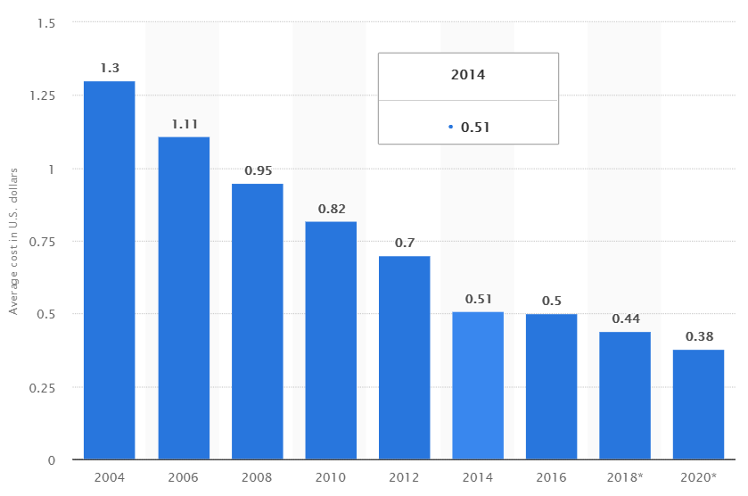
Figure 1: Average costs of industrial Internet of Things (IoT) sensors from 2004 to 2020 (in U.S. dollars)[4]
As shown from the figure above the average costs of IoT sensors has been decreasing over the years and becoming much cheaper. This makes IoT sensor networks very cost efficient you can pick up an IoT senor on average for $0.38 if a sensor network had 100 sensors this would cost $38 for all the sensors. For example, currently being implemented across the UK are “smart meters” if the average cost to employ someone to go home to home checking peoples meter readings is £17,753 per year whereas a smart meter costs on average £100 per household [5], if one meter reader employee checks 100 meters in his area it would cost £10,000 to install the smart meters saving electric and gas companies an estimated £7,753 per year per area. From these findings the author sees the IoT industry very cost effective and if implemented correctly could save companies thousands.

Wireless Sensor Networks
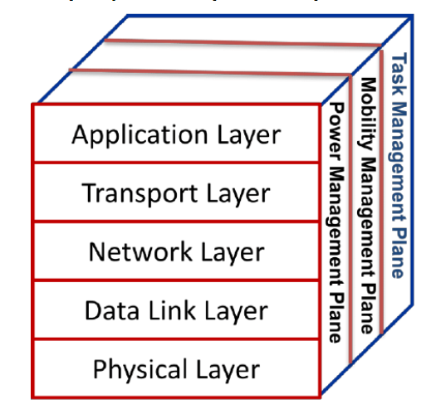
Wireless sensor networks can be configured to monitor physical or environmental conditions using sensors such as temperature, light, sound, water leak sensors, gas and smoke detectors. These sensors can be brought together in a network and then the information could be fed to something such as a web server or database.
Figure 2:Wirless Sensor Network Protocol Stack [6]
A sensor network can be made up of hundreds or thousands of sensors, as many as required. Each sensor within a wireless sensor network needs something called a sink node this is a gateway for all the sensors. The sink node interfaces between all the sensors and acts as the destination for all the data being recorded by the sensors.
Figure 2 shows the protocol stack for wirless sensor networks the top layer being the application layer this layer is where all the sofware is loaded for the sensors to communicate with the sink. The second layer is the transport layer on this layer error detection takes place. The third layer is the network layer this is where the communication between sensors and the sink takes place this layer will also check for quality of service and congestion to maximise the connection speeds between devices. On the fourth layer this is where collison detection takes place. On the final layer transmission, receiving signals and robost modulation takes place [6] .

Protocols

WiFi
WiFi is a wireless protocol used to transmit data across a network. WiFi uses multiple IEEE 802.11 protocols [7]. The benefits of WiFi that its affordable and can be extended throughout a building with ease. Using WiFi for wireless sensor networks makes it easier for the sensors to connect to a network. With WiFi it’s easy to connect access points together in a mesh network in order to get wider network coverage and for large campuses this is a must.

Zigbee
Zigbee is a combined language and mesh network which IOT devices can utilise. The main advantage for ZigBee compatible devices is that if the IOT device supports it then all the Zigbee devices use the same language so it’s easier to integrate them together. The disadvantage of using Zigbee over WiFi is that the range isn’t as good as WiFi so if implementing on a larger scale you would need to install more Zigbee hubs for this reason the author has chosen to use WiFi for his project [8].

Security
Security is a very important part when it comes to IOT. Going back to a previous example made by the author where John Romkey made his smart toaster if released to the public as is anyone could just go to John’s webserver see how much toast he makes a day and even turn on his toaster while he’s not at home. There are plenty of other malicious attacks that hackers could use against your IOT devices therefore security is needed.
Simple things like changing the interfaces default password or adding anti-virus or a firewall will increase the security of an IOT device [9]. Some devices are only made for one purpose for example a smoke detector is made only to detect smoke therefore it wouldn’t be able to handle encryption this makes it an easy target for an attacker to gain access to a network and this is why companies should have security in their design [10]. In a recent press release from the FBI it is recommended to keep all IOT devices on a separate network and make sure that all IOT device’s software is up to date with all of the latest security patches [11].
In a recent study by Ayush Kumar and Teng Joon Lim they designed a machine learning system using raspberry pi’s to detect malware within the IOT network. To the authors understanding the system scans the network packets being transported by IOT devices on a network and scans them for known malware execution scripts and notifies the user of possible malware on the network. Their system was pretrained using for a total of 60 sessions running at 15 minutes with a 70:30 split of training data and test data [12].

Ethics of IOT (Mini Literature Review)
IOT Ethics is an area which is not spoken about much but an area which needs to be focused upon. Ideas such as access to personal information and the privacy of said information are issues in the IOT industry. How much data is too much data? Users of IOT devices should be given the ability to decide what data the IOT devices can record and wat data the devices don’t have access to [13].
For example the author spoke to an Alexa and asked it a few questions about a random product as a test the product he chose something which he normally wouldn’t search for; microwaves and a couple of minutes later amazon and other websites on the internet were displaying ads for microwaves to Dylan. This information should be kept private, yet it is shared with marketing companies. In the authors opinion this is a very big ethical issue.
The author compared his findings with an author called Nancy Davis Kho. The report entitled AI, the IoT, and Content: ETHICS AND OPPORTUNITY Nancy says “I decided to ask Alexa a few precisely worded and detailed queries, asking it multiple times and in multiple ways. That’s why it’s likely that my brother and his wife were served up advertisements for bedbug abatement, rash cream, and adult bed-wetting support in their internet sidebars for the next few weeks.” [14]. These findings are very similar to the authors findings with the microwave product test, this shows that ethics is an area which needs to be investigated within the IOT industry.
In the authors opinion IOT devices should have the ability to:
- Manage what data is collected by the IOT devices.
- Manage how the data should be shared or if it should be.
- How often the data can be collected.
- Verification needs to take place before the information can be shared.

Problem statement for a Smart Campus
Campuses are usually large buildings and can be increasingly hard to manage. The use of IOT within campuses can automate a lot of the facilities within the building like heating, lighting, disaster management (Fires, gas leaks, water leaks) and access control. The problem the author is facing is to implement a system which covers all of this. The system must make the building smart.

3.0 What is required to develop a smart campus?

3.1 Hardware
A smart campus will consist of many sensors scattered across the buildings. These sensors would need to be connected to a network so access points would also need to be implemented throughout the buildings. Some example sensors which can be used are listed below:
- Temperature/Humidity sensors
- Gas detectors
- Smoke detectors
- Water leak sensors
- Light sensors
- Motion detectors
- RFID sensors for access control
All these sensors would also need a server or sink node to communicate with. This could be something like a raspberry pi or Arduino. £36.93

3.2 Cost
Figure 3: Cost of sensors
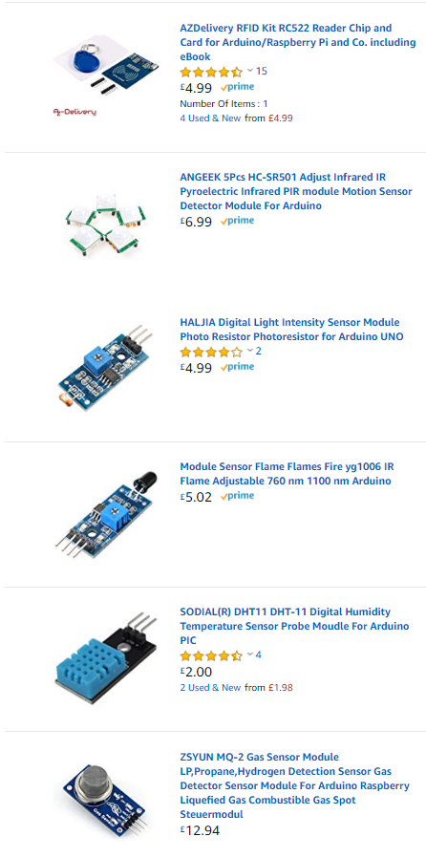
The sensors mentioned above by the author at the time of writing this report the average cost was around £6.15 based upon some searches on amazon [15]. If a smart campus required 1000 sensors this would accumulate an estimated cost of £6155 for all the required sensors.
The figure to the right shows the average cost of sensors available for the Arduino/Raspberry pi.

4.0 Implementation

4.1 Description of smart campus solution
The system implemented by the author is a small physical implementation in the form of an IOT kit usually used for homes, but the author has put this kit into the perspective of a smart campus. The idea is that there would be one of the authors kits in every room of the campus. This kit monitors for fires, gas leaks, detects light levels, motion detection, has relays which can be used to connect appliances like lighting and when the lighting drops below a defined level then the relays can switch on.

4.2 Sensors and Hardware used
- Osoyoo Mega 2560 – This is the main device and brains of the kit it’s the Arduino board used to gather all the information from the sensors.
- Yun Shield – The Yun Shield is a hat for the Arduino this gives the Arduino internet access via the form of WiFi.
- 4x4 Keypad – The 4x4 keypad is used for access control
- Alphanumeric I2C Liquid Crystal Display – The liquid display is used to display information when using the keypad and can also be improved to show when a sensor triggered.
- RGB LED Module – This is used as a visualisation for when sensors have activated. There is a total of 2 LEDs in the kit.
- SG90 Micro Servo – The micro servo is used to virtualise a door when the servo is at 0◦
- PIR Motion Sensor – This sensor is used to detect motion
- Photoresistor module – This sensor detects the current light level.
- Positive buzzer module – This buzzer activates when a fire or gas is detected.
- MQ2 Gas Module – This module detects gas and then activates the buzzer to show that gas is present.
- Flame Sensor Module – The flame sensor detects flames and then activates the buzzer to show that flames have been detected.
- 2 Channel Relay Module - This 2-channel relay is used to virtualise lights these relays can be activated remotely, or some code can be implemented to activate the relays when the light level drops below a predefined value.
- DHT11 Sensor Module – This module monitors the temperature and humidity of the room and could be linked to the campuses heating system in order to regulate the temperature.
Sensors and Arduino purchased as part of a kit [16].

4.3 How does the system work?
The system is scalable, and more sensors can be added as necessary with the only limit being the power. If the total voltage goes above the Arduino’s maximum 5V output, then an external power supply will need to be added.
The system also utilises a pin pad which can be used for access control into rooms, the idea is that this keypad would be on the outside of every room and each user will have their own key code and if they have access to the room then the door will open.
The system checks for motion and when motion is detected the front LED will light up to show that motion has been detected. If an alarm system was integrated and armed this could also trigger the alarm and contact the police and duty manager of the campus.

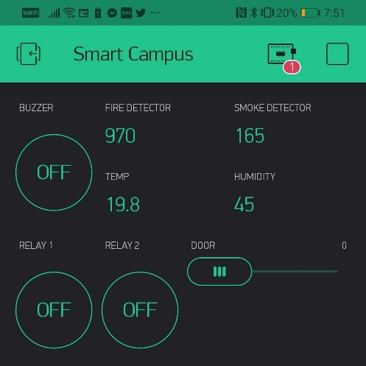
4.4 Blynk
Figure 4: Blynk App
Blynk is an IOT service in which you can output sensor data over the internet to the app to be viewed and modules like servos and LEDs can be controlled from within the app on this service [17]. The author has implemented the use of this app to make the device smart and controllable over the internet from wherever you are in the world.
To the right is a screenshot of the Blynk app which shows the authors smart campus system.

4.5 Code explained
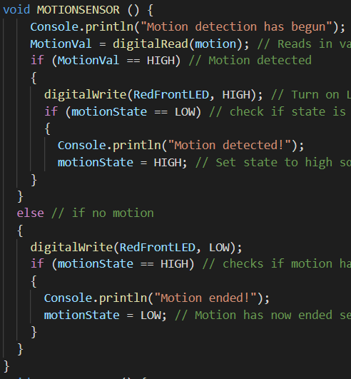
Figure 5: Motion Sensor Code
This code works by reading the value the motion sensor is outputting if this value is HIGH then motion has been detected it then sets the motion state to HIGH if the motion sensor value is LOW then there is no motion detected the motion state will then be set to LOW.
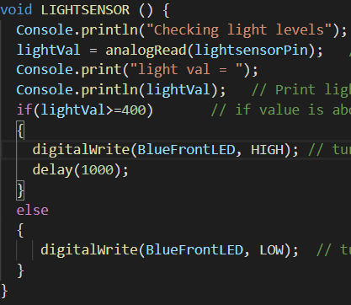
Figure 6: Light Sensor Code
The above code checks to see if the light sensor value is above 400(the room is dark) then it turns on the LED otherwise the room is light and isn’t required for the lights to be on.

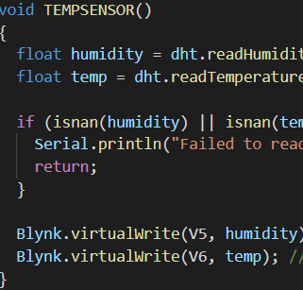
Figure 7: Temperature and Humidity Code
The above code reads in the temperature and humidity values from the sensor and then sends them to Blynk to be viewed on your smartphone.
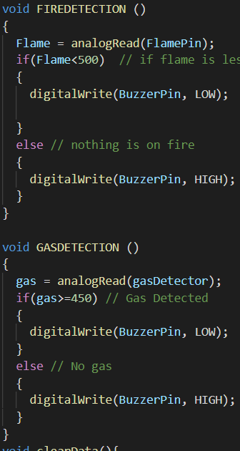
Figure 8: Gas and Fire Detection Code
The gas and fire detection code are very similar it reads in the values from the sensors if the flame detector is outputting less than 500 somethings on fire and if the gas detector is outputting more than 450 then gas is detected.

5.0 Conclusion
To conclude this report has covered smart cities and how they work in relation to IOT and Wireless sensor networks. The report covered how IOT can be implemented within campuses and covered the security aspect and the dangers of how leaving your IOT devices unsecured can infect your networks with malware.
The report also covers the authors implementation of the smart campus system in which he showed a scaled down system which could be used within every room within a campus to make the entire building smart.

5.1 Future work
If given more time in the future for this project the author would like to implement this project on a larger scale throughout an entire campus. The author would then take this data and extend the report with his findings.

6.0 References
[1] “What Is the Internet of Things (IoT)? | Oracle United Kingdom.” [Online]. Available: https://www.oracle.com/uk/internet-of-things/what-is-iot.html. [Accessed: 05-Dec-2019].
[2] “Why it is called Internet of Things: Definition, history, disambiguation.” [Online]. Available: https://iot-analytics.com/internet-of-things-definition/. [Accessed: 05-Dec-2019].
[3] Jeff Elder, “The Internet’s First Smart Device | Avast.” [Online]. Available: https://blog.avast.com/the-internets-first-smart-device. [Accessed: 10-Dec-2019].
[4] “• IoT average sensor costs 2004-2020 | Statista.” [Online]. Available: https://www.statista.com/statistics/682846/vr-tethered-hmd-average-selling-price/. [Accessed: 10-Dec-2019].
[5] “Smart Meters | Gas & Electric Smart Meters | UKPower.” [Online]. Available: https://www.ukpower.co.uk/home_energy/smart_meters. [Accessed: 10-Dec-2019].
[6] K. IqbalMalik and M. Mateen Yaqoob, “An Analytical Survey on Routing Protocols for Wireless Sensor Network (WSN),” Int. J. Comput. Appl., vol. 107, no. 18, pp. 40–45, Dec. 2014.
[7] “What is 802.11 Wireless LAN Standards? Webopedia Definition.” [Online]. Available: https://www.webopedia.com/TERM/8/802_11.html. [Accessed: 11-Dec-2019].
[8] “Benefits of Zigbee - Zigbee Alliance.” [Online]. Available: https://zigbeealliance.org/why-zigbee/. [Accessed: 12-Dec-2019].
[9] S. Ijaz, M. Ali, A. Khan, and M. Ahmed, “Smart Cities: A Survey on Security Concerns,” Int. J. Adv. Comput. Sci. Appl., vol. 7, no. 2, 2016.
[10] “The Importance of Security by Design for IoT Devices - IoTSecurity SBD TrustModel SecureDevelopment IoT.” [Online]. Available: https://www.redalertlabs.com/blog/the-importance-of-security-by-design-for-iot-devices. [Accessed: 12-Dec-2019].
[11] “Tech Tuesday: Internet of Things (IoT) — FBI.” [Online]. Available: https://www.fbi.gov/contact-us/field-offices/portland/news/press-releases/tech-tuesday-internet-of-things-iot. [Accessed: 11-Dec-2019].
[12] A. Kumar and T. J. Lim, “EDIMA: Early Detection of IoT Malware Network Activity Using Machine Learning Techniques,” in IEEE 5th World Forum on Internet of Things, WF-IoT 2019 - Conference Proceedings, 2019, pp. 289–294.
[13] H. F. Atlam and G. B. Wills, “IoT Security, Privacy, Safety and Ethics,” 2020, pp. 123–149.
[14] N. D. Kho, “AI, the IoT, and Content: ETHICS AND OPPORTUNITY.,” EContent, vol. 42, no. 3, pp. 22–27, 2019.
[15] “Sensors on amazon.” [Online]. Available: https://www.amazon.co.uk/hz/wishlist/ls/187CQ01PJFM1I?ref_=wl_share. [Accessed: 11-Dec-2019].
[16] “OSOYOO Yun IoT Smart Home Kit « osoyoo.com.” [Online]. Available: https://osoyoo.com/2018/03/11/osoyoo-smarthome-yun-iot-kit/. [Accessed: 11-Dec-2019].
[17] “Blynk IoT platform.” [Online]. Available: https://blynk.io/. [Accessed: 12-Dec-2019].

