Student Name: Rhys Alexander Davies

Student Number: 1803152

Module Code: ACCA5014

Lecturer: Kemi Ademoye

Module Name: Database Manager Systems

Table of Contents
Introduction 3
Performance Tuning 3
What is an index? 3
What is a clustered and non-clustered index? 4
Clustered: 4
Non-Clustered: 4
Suggested indexes used for shape up gym: 4
Package Name Index: 4
Gym Name Index: 5
Customer Name Index: 5
Distributed Databases 6
What is a distributed database? 6
What is a homogeneous and heterogeneous database? 6
Homogeneous Database: 6
Heterogeneous Database: 6
What is fragmentation? 7
Horizontal – 7
Vertical – 7
Mixed – 7
Suggested fragmentation schema: 8
Region Table 8
City Table 8
Gym Table 8
Membership Type Table 8
Membership Price Table 9
Customer Table 9
Membership Purchase Table 10
Conclusion 10
Bibliography 11

Introduction
The following report will look into performance tuning and why performance tuning is important in a distributed database and the benefits to using performance tuning indexes. In addition, suggested indexes will be documented for the case study of shape up gym. The report will also log what a distributed database is and the different types of distributed databases along with answering what fragmentation is and he different types of fragmentation available. The report will conclude with suggestions to the case study, shape up gym, on the fragmentation schema they should follow on the company’s database.

Performance Tuning

What is an index?
An index is a distinct database structure that is used to improve the performance of queries. They improve performance by using the indexed field to point towards the data associated with that field, an example of this is the index of a book which points toward specific data within the book references the page number it belongs to, figure 1 below demonstrates a similar example with where an employee field index points towards employee data. When an index query is run it has its own space in the database in which the pointer data is kept and cached therefore able to refer to every time the index is run resulting in faster querying times The performance increase is more noticeable in larger databases where a query returns thousands of results however in a small database index wouldn’t make a noticeable difference on the returning speed [1] [2]. Indexes are ideally used on tables where the data isn’t updated that frequently as every time the data is updated, or new insert statements are used the index can become fragmented and will need to be updated. This can be done in two ways ‘reorganize’ or ‘rebuild’. Microsoft recommend doing nothing if the fragmentation is less that 10 percent, reorganising the index if the fragmentation is between 10 and 30 percent and rebuilding if anything more than 30 percent [3].
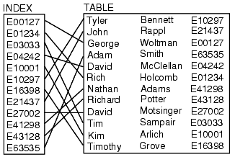

Figure 1, Employee index points towards specific employee data within table [2].

What is a clustered and non-clustered index?

Clustered:
A clustered index sorts and stores data rows based on the primary key values. Tables can only have one clustered index per table and data rows within a clustered index are sorted [4].

Non-Clustered:
A Non-Clustered index doesn’t use the primary key as a pointer, instead uses a field or non-clustered index key in which the value has a pointer which contains the non-clustered key value [4].

Suggested indexes used for shape up gym:
Using the research above the suggested secondary indexes used for shape up gym would be:
> A non-clustered index on package name column in the membership type table.
> A non-clustered index on the gym name column within the gym table.
> A non-clustered index on first and last names columns within customers table.

Package Name Index:
This is a query that will be frequently used by shape up gym as at customer request it is highly possible they will want a list of the packages available to them, depending on the variety of packages shape up gym offers an index for this would be ideal as packages, assumed, wouldn’t be added that often therefore the index would be low maintenance and work ideally in this situation.
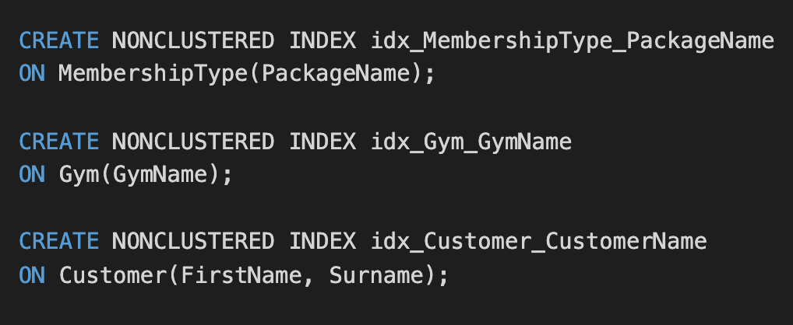
Figure 2, shows code to create package name index.

Gym Name Index:
This index is one that will useful for shape up gym as if a customer knows the name of the gym but needs more details about the gym in question such as phone number then indexing the gym name field would point to the row in which that data is kept. It is more often than not that customers know the names of businesses therefore making it an appropriate column to index.
Figure 3, shows code to create Gym Name index.

Customer Name Index:
A customer name index is the most useful to shape up gyms as the clients is what give the company custom. Customer name index will be a composite index that takes the first and last name columns from the customer table as these are the most relevant towards them, from there many actions can be taken such as updating bank details for customers, changing phone numbers and so on. The first and last name columns are the least likely to be changed therefore being ideal indexed columns.
Figure 4, shows code to create customer name index.

Distributed Databases

What is a distributed database?
A distributed database is when a database is spread over a network of computers that can be located on many different sites without sharing the same physical components. Although appearing as one database to the user there is multiple ways in which the database can be managed through the backend, these methods of management called homogeneous database and heterogeneous database [5]. Distributed databases offer more reliability given that having data spread over multiple sites allows for less impact from the failure of a single site. Distributed database also helps improve performance with the indexing and queries and increased the reliability of transactions with [6].

What is a homogeneous and heterogeneous database?
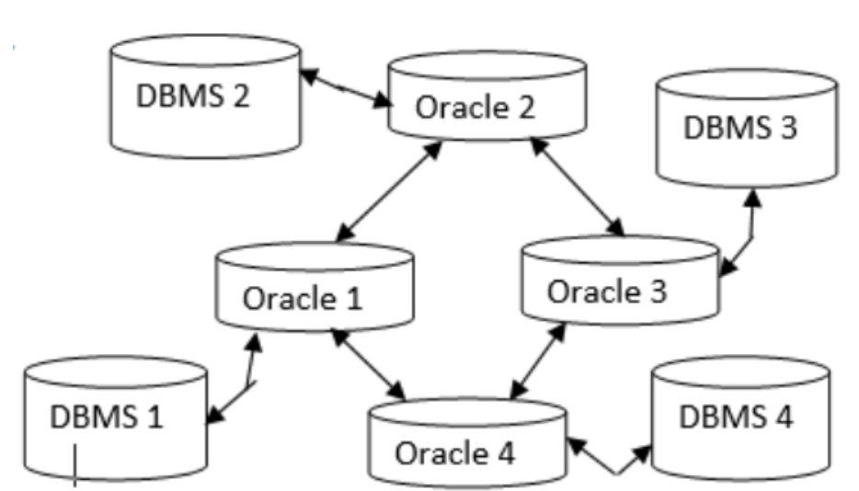
Figure 5, Homogeneous distributed database system [6]

Homogeneous Database:
A homogeneous database This type of database management system stores the database identically across all the different sites therefore making it easier to design and manage due to all sites being the same and adding new sites allows for easy integration with other sites [7].

Heterogeneous Database:
A heterogeneous database is a more dynamic distributed database system in which different sites can use different software to access the database and can be completely unaware of other sites that are using the database [5].

What is fragmentation?
Data fragmentation is the breaking of data into smaller fragments or segments that can be stored at any given site over a computer network, there are three different types of fragmentation that derive how the data is broken down into segments these are Horizontal, Vertical and Mixed [8]. Data fragmentation stores data to the nearest to where it is most frequently used for increased performance [9].

Horizontal –
This type of fragmentation is splitting of data based on tuples, otherwise known as rows, in accordance to the values of one or more fields. Horizontal fragmentation must confirm the rule of having each of the columns from the original table for reconstruction [10].

Vertical –
Vertical fragmentation is the process of segmenting a table based on their columns. For reconstruction it is important that each segment has the primary key of the original table [10].

Mixed –
Also known as hybrid fragmentation is a combination of both horizontal and vertical fragmentation. This type of fragmentation generates segments with minimal extraneous information which is very good for data privacy. Mixed fragmentation is also flexible as it can be performed in two ways. The first way is to horizontally fragment the table in to segments then vertically fragment the already fragmented segment or vice versa by doing vertical first followed by horizontal. The reconstruction of data with this fragmentation method is highly cost-effective task to perform [10].

Suggested fragmentation schema:

Region Table
The region table will have no fragmentation applied to it and will be replicated due to other sites needing access to this table throughout the database.

City Table
The recommendation for the city table would be to perform a horizontal fragmentation. This is suggested as by fragmenting the table by region ID which allows for clear distinction of cities within a certain region, shown in figure 6. To reconstruct this table a union would be used on the Region ID primary key.
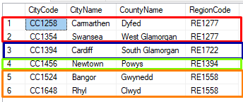
Figure 6, shows the horizontal fragmentation of the city table.

Gym Table
The fragmentation recommendation for the gym table would be to horizontally fragment based on the city code. By doing this the table will be fragmented to show gyms in each city code, shown in figure 7. The segments of each gym would be stored to the gym in question for quick and easy access for that gym. Reconstruction on this table would take place with a union on the city code primary key.
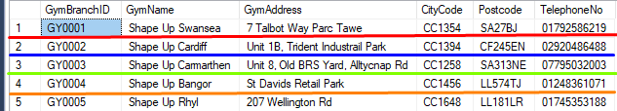
Figure 7, shows the horizontal fragmentation of the Gym table.

Membership Type Table
There is no fragmentation recommended for this table as each membership type should be able to be implemented to each gym and each gym should have access all the membership types.

Membership Price Table
This table is recommended to be fragmented horizontally by Gym ID, shown in figure 8. This is to allow for only the relevant membership prices and packages that apply to that gym and that will be accessed frequently. This is highly useful if the there are certain packages that don’t apply to a certain gym or packages that are exclusive to certain gyms. As this is a horizontal fragmented table the suggested reconstruction would be to use a union on the Gym ID primary key.
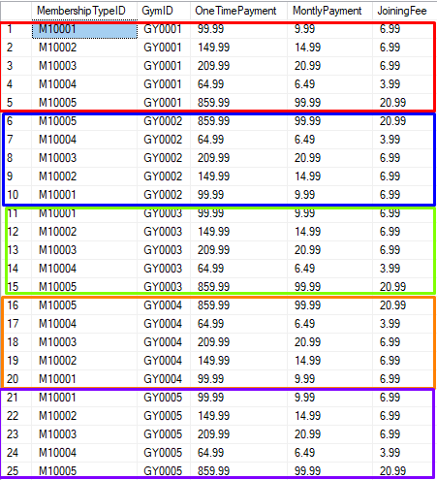
Figure 8, shows the horizontal fragmentation of the Membership Price Table.

Customer Table
The customer table will use the fragmentation method of mixed, or hybrid due to the sensitive data within customer by fragmenting it into two tables it makes the data more secure. The approach taken will be to first vertically fragment followed by horizontally fragmenting. The vertical segment will be split into two, as shown in figure 9, by the customer payment details and general customer details. The horizontal segment will be fragmented by home city code so that all customers are segregated by region. Reconstruction of this table would use a Join to initially re-join the vertically split table, then a union to connect the horizontally fragmented segments by home city code primary key.
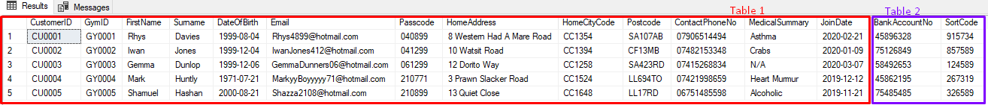
Figure 9, shows the vertical fragmentation of the customer table.

Membership Purchase Table
Due to clear instructions set out by shape up gym that all financial records are to remain in head office in Swansea, no fragmentation will take place on this table. The finance department will deal with all expired memberships financing issues therefore there is no need for the gyms to have access to this table.

Conclusion
In conclusion the research of distributed databases and performance tuning outlines well what the case study, shape up gym, should include in the company’s database. The report has covered and answered many aspects of what a distributed database is using sources to back up the information. A database was also created for the case study in SQL to improve efficiency as well as using the database created to demonstrate how the suggested fragmentation schema is implemented.

Bibliography

[1] | M. Winand, “Anatomy of an SQL Index,” [Online]. Available: https://use-the-index-luke.com/sql/anatomy. [Accessed 12 03 2020].
[2] | “Using Database Indexes,” [Online]. Available: https://www.progress.com/tutorials/odbc/using-indexes. [Accessed 12 03 2020].
[3] | B. Snaidero, “Types of SQL Server Indexes,” 24 12 2019. [Online]. Available: https://www.mssqltips.com/sqlservertip/6274/types-of-sql-server-indexes/. [Accessed 12 03 2020].
[4] | Microsoft, “Clustered and Nonclustered Indexes Described,” [Online]. Available: https://docs.microsoft.com/en-us/sql/relational-databases/indexes/clustered-and-nonclustered-indexes-described?view=sql-server-ver15. [Accessed 12 03 2020].
[5] | “Distributed Database System,” [Online]. Available: https://www.geeksforgeeks.org/distributed-database-system/. [Accessed 13 03 2020].
[6] | S. B. S. S. Nitesh Kumar, An Overview of Transparency in Homogeneous Distributed Database System, vol. 2, no. 10, 2013.
[7] | D. THAKUR, “What is the difference between Homogeneous and Heterogeneous Distributed DBMSs,” [Online]. Available: http://ecomputernotes.com/database-system/adv-database/homogeneous-and-heterogeneous-distributed-dbmss. [Accessed 13 03 2020].
[8] | “DISTRIBUTED DATABASE DESIGN,” [Online]. Available: http://www.uobabylon.edu.iq/eprints/publication_4_2259_1575.pdf. [Accessed 20 03 2020].
[9] | A. Bhardwaj, “Role of Fragmentation in Distributed database system,” International Journal of Networking & Parallel Computing, vol. 1, no. 1, 2012.
[10] | “Distributed DBMS - Design Strategies,” [Online]. Available: https://www.tutorialspoint.com/distributed_dbms/distributed_dbms_design_strategies.htm. [Accessed 20 03 2020].

