Pathway Project 2 Skill for Self Employment
Lecturer: Dr Husam Helmi
Student ID: 1605850
Mahmuder Rahaman
Submission Date : 02-05-2018

Table of Contents
Introduction: 1
Aims and objectives: 2
Mission and vision: 2
The legal issues of Burger King: 3
Management procedure: (Finance, marketing, HR and operation) 3
PESTEL analysis on Burger King: 5
SWOT analysis on Burger King: 7
Conclusion: 9
References: 10

Introduction:
In this competitive business world, nowadays every organization requires thinking differently in accordance with the change made in the market and the frequent change of the customer and the stakeholders of the underlying firm. There is no hard and fast rule in the strategic analysis in the long endure as the situation is changing so frequently worldwide. In this report, there will be a discussion on a multinational franchise company where there are many ups and downs considering success in the world. On the basis of the perspectives of a new business named Burger King, there will be an overview of aims, objectives, mission, vision and managerial procedures. Other legal procedure and strategic analysis will be discussed here as well. The main line of this report is to define different business development concept and idea in the light of managerial perspective.

Aims and objectives:
Aims of Burger King: Aim indicates what the organizers hope for. As a fast food company, Burger King aims to be the best food brand throughout the country. There is a huge opportunity to be the leader in the market if they can introduce new idea and knowledge in the later working period to create some extra value for the customer (Beard, 2012).
Objectives of Burger King: Objectives are the action to be taken to reach the aim. The general objective of Burger King is to find out an innovative idea and hold the existing position in the long run. The other objectives are to develop brand value, creating more outlets and going for franchising for further growth. To beat the market and to be a leader in the market, Burger King requires creating something new to make sure competitive advantages accompanied by maximizing profit and maximizing value for Burger King.

Mission and vision:
The mission of Burger King: mission raises a question, what is the business? It is the mission of Burger King to ensure the best quality for the customer and running the business effectively and efficiently. Literally, a business may have different considering the time span and different leading party of the underlying company. Burger King should ensure a fresh and youthful environment for the stakeholders of the company. Burger King has a mission to expand more everywhere in the UK through reinvestment and consistent innovation tools and techniques.
The vision of Burger King: vision statement raises the question, what do Burger King want to be? Ensuring best service quality and customer-oriented circumstances for the customers are two fundamental vision of this firm. If the customer is satisfied, any mission or vision will be successful. Burger King wants to be a public limited company to collect more funds and to expand the business by issuing more shares in the stock market in the UK. At this level, their vision is to be the leader in the UK market and capture a maximum number of customer.

The legal issues of Burger King:
Burger King in the UK is a private limited corporation having two divisions of financing that are 60% of personal and friends and family and 40% of banks and financial institutions. There are a few legal aspects and lawsuits related to fast food service network. After the foundation of Burger King, they would have plaintiff and defendant to face different operational challenges relating tactics and negative issues (Pearce and Correa, 2010). Fast food is harmful in many cases that’s why people for the ethical treatment of animals (PETA) accompanied by social agencies and human health groups raised the question but the majority did not get the outcome in lawsuits (Galbraith, 2014). The firm would be given some restrictions such as restriction of promotional activities to below twelve children, promoting healthy issues in advertising, restricting advertising in school etc. The firm would go for a franchise which brings more successful result in the larger sense. When Burger King involves in the middle east as Israel led territories business activities were a breach of contract between Israel franchise and Burger King. Arab league also joined in the dispute. Amid all these, Burger King has more than four-billion-dollar revenue in the USA market during the fiscal year of 2015 (Burger King Corporation, 2015). Restaurant Brand International is the parent company of Burger King and it is now a global served company having more than fifteen thousand locations in the world. The firm is worldwide popular retailers having business in more than 80 countries. After franchising of the firm, the profitability and risk increase but finally it brings the huge margin of growth for the later period.

Management procedure: (Finance, marketing, HR and operation)
Finance of Burger King: the financial franchise is fixed by Burger King’s franchising which is minimum and pound to 250000 from personal resources without borrowing. Three lacs are the standard requirement on the basis of every restaurant cost and franchise fees. 75% should be from a bank loan and the rest are from the franchise besides above requirements (Pearce and Correa, 2010).
Marketing of the Burger King: Burger King is a well-recognized brand in the world focusing on customer viewpoint. The brand logo used by Burger King is worldwide familiar when it comes marketing promotion and advertising success which is rare in the business of franchising. The fast-food industry is highly competitive as its major competitors are Mc Donald, Subway, Star Bucks, KFC etc. Among the huge competition, Burger King maintains loyal customer by identifying and meeting the customer requirement in a better way that the competitors can do. Whopper and Big Mac are the basic difference between Burger King and Mc Donald by concentrating customer health and demand (Pearce and Correa, 2010).

Human resources of Burger King: Burger King desires for recruiting a higher experienced workforce to join its bandwagon. To ensure customer service at a standard level, the efficient workforce in managing and operating body is highly needed. Not focusing only on central employee development, Burger King should run program worldwide at each level of operations. Cooking, baking, cleaning, serving should be controlled in a specific direction. The marketing and managing departments are quite organized but now is the time to develop the service department and the operation department.

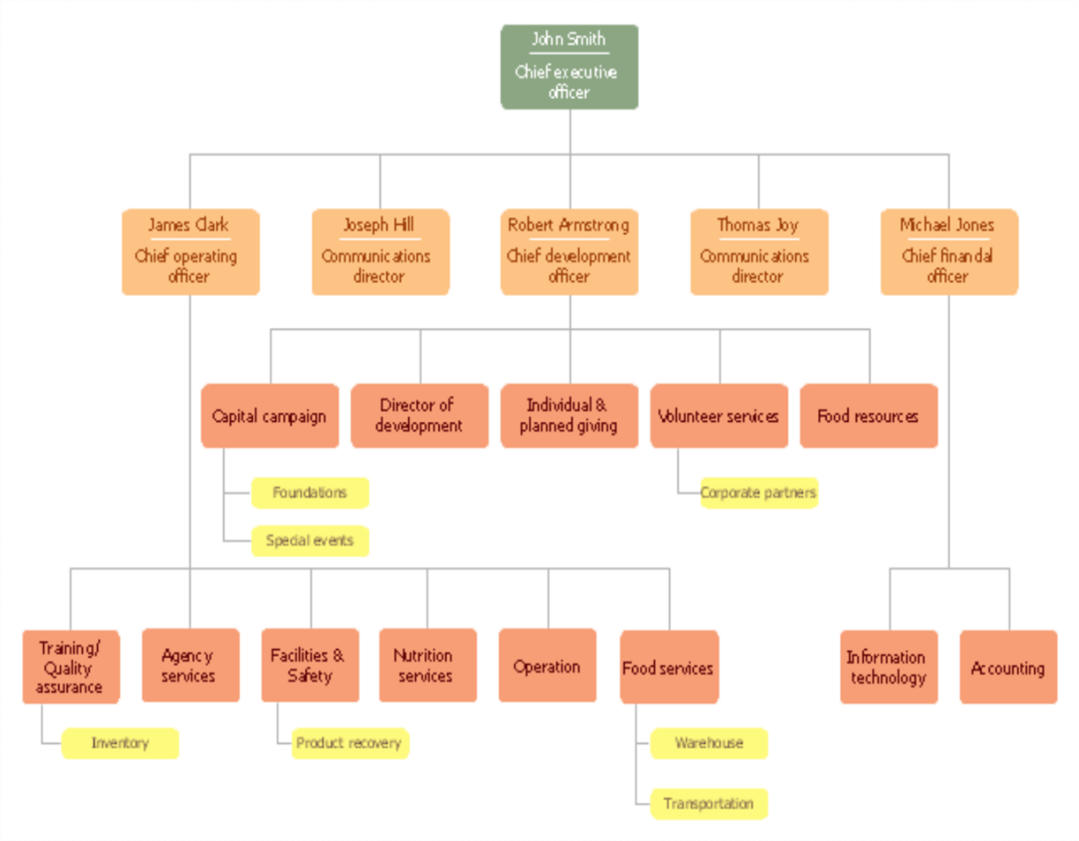
Figure one: Burger King operational structure
Source: (Galbraith, 2014).
Operations of Burger King: Burger King is presently having its operation in more than hundred countries. The hierarchy of the management is thus like that of a larger organization. The immediate decision of the management might change the hierarchy of the management. The reported management body is just a sample here (Galbraith, 2014).

PESTEL analysis on Burger King:
Political factors: Nowadays government is the main party in creating pollical influence Burger King positively. Recent decades every ruling party is interested in globalization and e-commerce. Burger King should utilize the support appropriately. Political stability where it exists can be another political aspect of Burger King (Roper, 2012).
Economic factors: the major economic positive aspects are the economic stability in the USA and the UK market, excessive expansion of international trade agreement, higher economic growth and profit in the developing market in the world. Supply chain development can be another economic factor potential source for Burger King using developing economies.
Social factors: increasing customer variability and diversity is the only positive social factor for Burger King. There are increasing support from animal rights agencies and other related groups as well as more active health consciousness which can be positive or negative on the basis of the condition, Burger King will ensure the product quality in the favor of the good health and nutrition (Pearce and Correa, 2010).
Technological factors: now things have been quite easier for Burger King if the technological factors are taken into action. Now there is excessive adequacy of automation technology and research and development activity is comparatively lower in rapid service providers in this field. On the other hand, mobile technology is much more popular (Roper, 2012).
Ecological factors: the major ecological or environmental aspects are climate change worldwide, focusing business sustainability, ever-growing publicity of low carbon lifecycles and so on. Climate change may hamper the business of Burger King though it has the possibility of utilizing business stability and inspiring consumers in lower carbon lifestyle (Polisciano, and Farina, 2010).
Legal factors: earlier it had been somehow threat for Burger King but now the situation has changed a bit. Import and export restriction has been reduced a lot in this global market in the line with globalization. Environment protection regulations and GMO regulation are two positive and negative aspect respectively for Burger King. The health and nutrition agencies and researchers are the main threat in this factor for any fast food organization including Burger King.
From above PESTEL analysis, some recommendations can be found like emphasizing growth and expansion activities much more in the developing economies, utilizing mobile transactions and e-commerce, comprehending business and political sustainability. Moreover, the health and nutrition factors must be overviewed time to time (Roper, 2012).

SWOT analysis on Burger King:
The strength of Burger King: there are a variety of products, quick service providing and some innovative food like whopper and set an item as well. The strong market situation, greater franchise mix and robust financial performance are the strong sides of Burger King.
The weakness of Burger King: Scattered marketing design and market concentration problem are two major week zone of Burger King in line with the inconsistent and poor managing operations in ensuring quality and standard food (Moran, 2009).

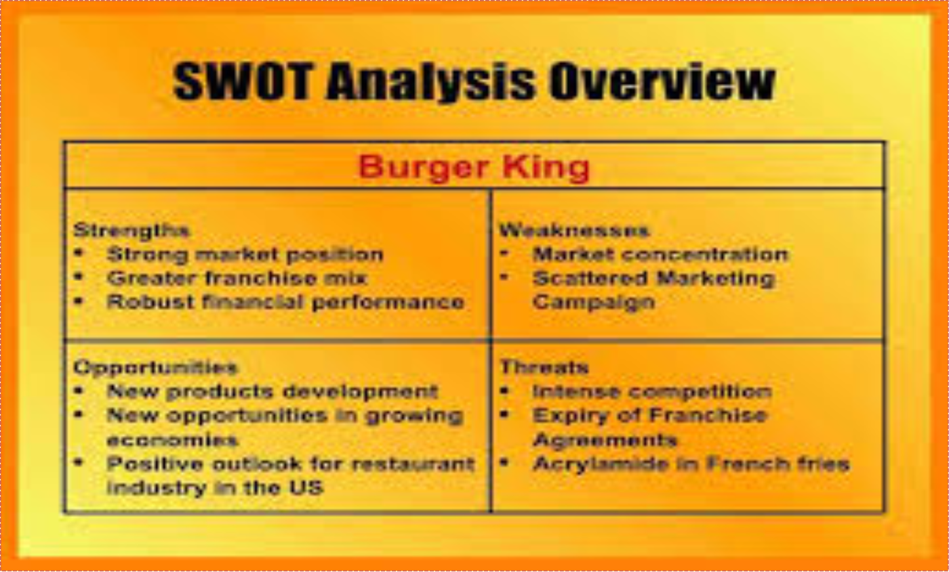
Figure two: SWOT analysis on Burger King
Source: (Beard, 2012)
The opportunity of Burger King: There is a huge possibility of growth in the developing economies for Burger King. In the USA and UK, there is a positive and growing market for the restaurant industry. The market is expanding and creating more chances for the investor as the production cycle and working capital turnover are comparatively higher and less risky.
The threat of Burger King: The fast food industry is highly competitive and there are strong alternative food and firms. The expiry of franchise and development of French fries are other two threat in this industry. Moreover, the frequent change of attention to these kinds of foods has accelerated more threats for Burger King (Moran, 2009).

In the critical situation, Burger King should spend more in R&D service for further development in line with the reinvesting more in promotional activities. The introduction of new idea and product can change the game of fast food industry is facing strong competitors like McDonald, Wendy and others. To attract more customer and remain in the competition, there is no alternative to improve the new product to add suddenly increased value for the customer in the market. The middle east can be used as another target zone for this business accompanied by improving the managing and operating issues there (Polisciano, and Farina, 2010). To have a competitive advantage, differentiating strategy might be fruitful. In the developing economies, Burger King will get a recognition of fashionable goods provider so there are many things to do in the promotional and development sectors through launching new idea and knowledge.

Conclusion:
it's all about the business plan is creating effective business plan and strategy. The market variables should be utilized properly at the best level of management. But the end of the day, what Burger King needs to make sure is customer satisfaction. No customer behind to take advantage of Burger King should be the business motto. The factors related to public health and nutrition can no way be ignored to build up a long-term customer relationship. The PESTEL analysis and SWOT analysis show the way for Burger King what it is right now and what it should be done. Now is the time to find out how to achieve those through the proper business plan and strategy implementation. The idea for a developed country and the idea for developing country should not be same. Burger King requires being ready for the market change where the choice, custom and demand may vary from area to area. So, differentiating strategy on the basis of customer preferences and needs must be made sure in order to add more value to the target customer groups.

References:
Beard, C. (2012). Economic Interpretation of the Constitution of the United States. Dover Publications.
Delinsky, B. (2012). Threats and promises. Sutton, Surrey, England: Severn House.
Galbraith, J. (2014). Designing organizations. San Francisco, California: Jossey-Bass.
Gillespie, A. (2007). PESTEL analysis of the macro-environment. Foundations of Economics, Oxford University Press, USA.
Moran, T. (2009). Three threats. Washington, DC: Peterson Institute for International Economics.
Naylor, T. (2009). Maritime tankers. New York: Nova Science Publishers.
Pearce, A. and Correa, L. (2010). Dolphins. New York: Nova Science Publishers.
Polisciano, G. and Farina, O. (2010). National parks. New York: Nova Science Publishers.
Roper, K. (2012, November). BIM Implementation: PESTEL Drivers and Barriers (Cross-national Analysis). In World Workplace 2012. IFMA.

