Portfolio part 2: Image (9th November) Scene from the Bayeux Tapestry; Harold swears an oath to William

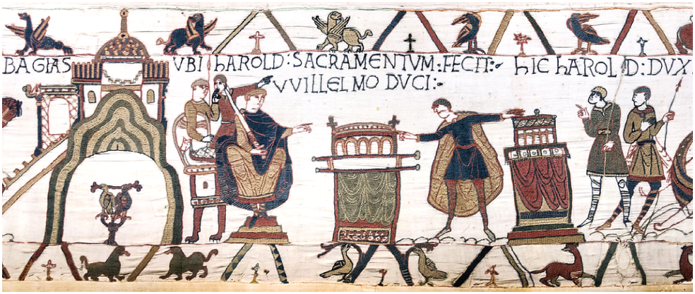

The Bayeux Tapestry is the retelling of William of Normandy's rise to the English throne and becoming William the Conqueror. William of Normandy’s claim to the English throne that was held by Edward the Confessor, was an important detail in history. Portrayed as a noble figure against the usurper Harold Godwinson who broke his oath to the Norman promising the English throne, leading to the Battle of Hastings. The Bayeux Tapestry commissioned around the 1070s, potentially for William’s half brother Odo bishop of Bayeux, favored Norman views in portraying William as the heroic conqueror while his rival Harold Godwinson as a fallen villain. This specific scene from the Bayeux Tapestry depicts Harold swearing an oath to William on a handle potentially a shrine, adding to the Norman’s claim to the English throne, swearing on holy ground, leading to multiple debates through history.
The chronicler Wace indicated a degree of trickery similar to other Norman schemes. “so help him God and the holy relics there! Many cried "God grant it!" and when Harold had kissed the saints, and had risen upon his feet, the duke led him up to the chest, and made him stand near it; and took off the chest the pall that had covered it, and shewed Harold upon what holy relics he had sworn; and he was sorely alarmed at the sight.” Despite the intention behind the Tapestry, subtext analysis suggests William was no better than Harold, hiding relics underneath his rival possibly to justify his planned invasion of England if Harold were to succeed Edward the Confessor. Wace’s writing “so help him God and the holy relics there!" implies William was threatening Harold, believing he was acting on God’s will to rule over England, against the ‘oath breaker’ who stole what was rightfully his and so William's invasion will be justified further.

Today with modern historians able to access multiple sources throughout history expanding on Norman historiography, views on the Tapestry’s reliability may have changed, criticizing the art piece.
Commissioning of the tapestry could add to the reliability of the scene between William and Harold. Beech in a conference presented Was the Bayeux Tapestry made in France, theorizing that William himself commissioned the piece in the Loire valley. The claim is supported by various factors including Baudri of Bourgueil who had a verse describing the campaign from geography to architecture. “The fact that the Tapestry establishes Norman supremacy in Brittany, an account not particularly pertinent to the story of the Norman conquest but that indeeds celebrates William's domain in the region.” William may have commissioned the Tapestry to potentially tarnish Godwinson’s reputation, drawing the Norman in history as a dominating force, conquering and humiliating his opponent through drawing their defeat, immortalizing it for all.
Historians could potentially view the Bayeux Tapestry as a form of propaganda considering most of the population was illiterate, many would understand historical events through art, allowing details to be written in another’s favour and would not know the difference. Adding to Beech’s theory that William himself commissioned the tapestry, his half brother could detail specific details that favoured the new English king in respect or future favour. Furthermore the tapestry is Anglo Saxon styled, with the Normans establishing dominance over their conquered opponent, immortalizing Saxon defeat for future generations. “This mixed origin or perhaps the simple brevity of its textual style mean that the text provides little clarity in a number of controversial areas.” Walker understands that the tapestry is unreliable, having little text leading to various interpretations, leaving no concrete state on its meaning. ‘a number of controversial areas’ summaries the debate of the Bayeux Tapestry, with multiple historians attempting to develop a clear stance on its reliability yet not much has changed.
The meeting with William and Harold has been commentated on its meaning. David Bates’s Normandy before London stated that the designers of the tapestry were “not as certain as their Norman patrons would have wanted them to have been” about the reason for Harold’s mission in France. He notes that the scene depicting Harold and William's meeting suggests knighting which there are no references too, as some historians claim that wooden fortifications atop mounds did not belong in pre 1066 Normandy. With the potential commissioner being William himself, most arguable his half brother, knighting seems unlikely to have occurred if the tapestry was propaganda, the most established broken oath would feed into said agenda of striking Godwinson’s reputation .

William could have personally taken advantage of Godwinson pushing through with the oath. “William calculated that he had now achieved a moral ascendancy over Harold which could be useful later, both to undermine Harold’s position and to justify his own.” The Tapestry being a form of Norman propaganda becomes more evident with analysis such as this quotation, William being a schemer with the oath and history presenting him with a “moral ascendancy over Harold”. Harold being imagined as an oath breaker allows William to strike at his rival’s prestige, justifying his actions with future Norman propaganda illustrating the conqueror as a virtuous leader, presenting William's deceitful tendencies. However considering the work is centered around Harold Godwinson, Walker can be seen as a Godwinson supporter against William, portraying him as an antagonist creating further divide in the debate on the Tapestry’s reliability.
The scene must be portraying Harold swearing an ‘oath,’ he would later break justifying Norman invasion of England, putting the ‘true’ king on the throne which could make William appear as a more religious leader, failing to uphold an oath which was seen as a unforgivable crime if it was to be broken. Harold as an oath breaker is seen as weakness of his character, seen as unfaithful in the Tapestry. “However if as we have seen Harold found himself in a position where swearing this oath was the only way to extricate himself from William's custody then it is likely that he regarded his action as fully justified.” Walker presents Harold in an avoidable state of conflict, only way to escape William's custody was to swear an oath, yet he will be damned when becoming king, becoming a fallen hero in history. Thus Harold would be justified in taking the oath, in order to return home and run England which the tapestry subtext could be implying being made through sympathetic Saxon craftsmanship.
The Tapestry itself has little writing leaving it to interpretation, creating various views that conflict with each other and making it difficult to establish correct facts and the reliability of the work. With interpretations that see William as a deceiver, manipulating Harold as a means of pushing English invasion, Harold being in an unavoidable situation, historiography of the Tapestry will always be obscured from clearness. As a means of expanding Norman historiography, no doubt the Tapestry is useful, accounting Godwinson and William meeting and their battle becoming an iconic part of Norman history, taught to the illiterate on how the Normans viewed themselves and their invasion.
To conclude this segment of the Bayeux Tapestry, historiography of Normans has expanded with their own portrayal as heroic conquerors. Alongside multiple interpretations concerning it as propaganda, William possessing deceitful traits for example, leaving the debate open for further analysis and for individuals to form their own opinion.

Word count: 1210

Bibliography

- 1: Ian W.Walker Harold the Last Anglo Saxon King published by The History Press; New Ed edition (1 April 2010) Page 105
- 2: Master Wace The Chronicle of the Norman Conquest from the Roman de Rou translated with notes and illustrations by Edgar Taylorm, published by Library of Alexandria (29 July 2009) Page85
- 3: John F. Szabo, Nicholas E. Kuefler of The Bayeux Tapestry: A Critically Annotated Bibliography Published by Rowman & Littlefield Publishers (18 June 2015) Page 43
- 4: Ian W.Walker Harold the Last Anglo Saxon King published by The History Press; New Ed edition (1 April 2010) Page 106
- 5: John F. Szabo, Nicholas E. Kuefler of The Bayeux Tapestry: A Critically Annotated Bibliography Published by Rowman & Littlefield Publishers (18 June 2015) Page 36
- 6: Ian W.Walker Harold the Last Anglo Saxon King published by The History Press; New Ed edition (1 April 2010 Page 113
- 7: Ian W.Walker Harold the Last Anglo Saxon King published by The History Press; New Ed edition (1 April 2010) Page.142

Ian W.Walker Harold the Last Anglo Saxon King published by The History Press; New Ed edition (1 April 2010) Page 105
Master Wace The Chronicle of the Norman Conquest from the Roman de Rou translated with notes and illustrations by Edgar Taylorm, published by Library of Alexandria (29 July 2009) Page.85
John F. Szabo, Nicholas E. Kuefler The Bayeux Tapestry: A Critically Annotated Bibliography Published by Rowman & Littlefield Publishers (18 June 2015) Page 43
Ian W.Walker Harold the Last Anglo Saxon King Published by The History Press; New Ed edition (1 April 2010) Page 106
John F. Szabo, Nicholas E. Kuefler The Bayeux Tapestry: A Critically Annotated Bibliography Published by Rowman &Littlefield Publishers (18 Jun. 2015) Page 36
Ian W.Walker Harold the Last Anglo Saxon King published by The History Press; New Ed edition (1 April 2010 Page 113
Ian W.Walker Harold the Last Anglo Saxon King published by The History Press; New Ed edition (1 April 2010) Page.142

