Thareque Immon
Student No. 1706493
Tutor name: Dr Greogory Cowan
Course Code: BMSK4002

EFFECTIVE TEAM WORKING AND COMMUNICATION

Executive Summary
This assignment has written in a report format, which depicts about the core factors related with the communication process applicable to the organizations function. Different relevant models of communication have presented here by underpinned with the theoretical perspectives of this entire assignment. In any workplace how the entire managerial functions have been operating by implementing the effective communication process has been portrayed here.

Table of Contents
Introduction 4
Definition of effective communication 4
Verbal and non-verbal communication with examples 4
Theories of workplace communication 5
Improvement in productivity through effective communication in workplace 8
Advantages of maintaining effective workplace communication 300 10
Conclusion 10
Reference List 12
Appendix: 14

Introduction
Communication is a process to convey any kind of message to any individual or to a group of people. Communicators can use communication as their necessary tool to sending their encoded messages to its target receiver (Ang and Van Dyne, 2015). An effective communication strategy brings the positive results with its intended purpose designed by the message encoder. In the present globalized world, business firms are facing numerous challenges in the context of revenue earning, enhance the productivity level and to get the competitive advantage from the open market. In this report, an effective communication process will be discussed by underpinning with some relevant theory of communication.

Definition of effective communication
Effective communication is a process of depicting a message to a targeted audience. The messages sender needs to design his or her message in that way by how it can be easily understand by its receiver. Every communication process generally consisted with three components that are, message sender, channel and message receiver. A communication process will be successful when the intended purpose of the message sender became fulfill means it is easily decoded by the message receiver by understanding the essence of the message of the sender (Beebe and Masterson, 2014). This type of communication can be referring as the effective communication.

Verbal and non-verbal communication with examples
In the communication process, there are different types of communication, such as interpersonal communication, interpersonal communication, group communication and the mass communication. In the type of interpersonal and intrapersonal communication process there are two divinations that are, verbal and nonverbal communication. Verbal and nonverbal communication also incorporated with the mass communication but generally in a workplace verbal and nonverbal communication linked up with inter and intra personal communication (Grunig, 2013). Verbal communication is an oral communication by any person and nonverbal communication is without producing any kinds of sound of larynx and depicting through gesture and postures; For instance in any workplace if any employee aims to convey his or her message through oral communication then it will be considered as the verbal communication. Sometime because of different organizational situation a person has forced to depict his or her message through applying the gestures and postures, then this kind of communication will be considered as the non- verbal communication. Non-verbal communication also need to be known by individuals as because to communicate with the disabled persons who are not able to hear a messages passed by the communicator.
In order to work in a team both the verbal and nonverbal communication are necessary in order to communicate with the team members (Holmes and Stubbe, 2015). This traits needs to be expertise by the team leader. Moreover, this technique also required to exercise by the team member. This aspect will help the team members to make a smooth communication among them and it helps to omit any misunderstanding among the team members. An effective communication depends both on these two factors. A communicator either must have to adopt the techniques to communicate in verbal or in non-verbal way of communication based on the occurred situation. In order to do proper negotiation and to develop any plans for achieving any goals, the business organizations need to depend on the appropriate ways of communication.

Theories of workplace communication
In any workplace, different kinds of agendas have been performed by the authority and by the staffs. In this part two relevant theories of communication will be discussed which are appropriate for the workplace communication. In order to do the discussion Marks and Spencer, United Kingdom's one of the largest retailing company has been chosen. In that organization how they carry, their all functions by doing an effective communication will be mentioned here. Some relevant theories of communication they have used to manage their communication process. In this order, Belbin theory of team structure and Shannon-Weaver's communication model will present the concept about the appropriate communication system of this organization. Moreover, group dynamic theory will also be discussed to shed light over the workplace communication.
Group Dynamic theory: This theory refers to the interactive nature of individual within the context of a group. It is an important theory that enables the members of any organization to take the appropriate approach for communication. In any workplace, people work in different situation by formulating either any team or individually (Maund et al. 2017). This theory generally emphasized over human interaction; therefore Marks and Spencer Company uses this theory to interact with its internal and external stakeholders. Group dynamic theory has been used by different companies to influence their message receivers as well as by the Marks and
Spencer Company.
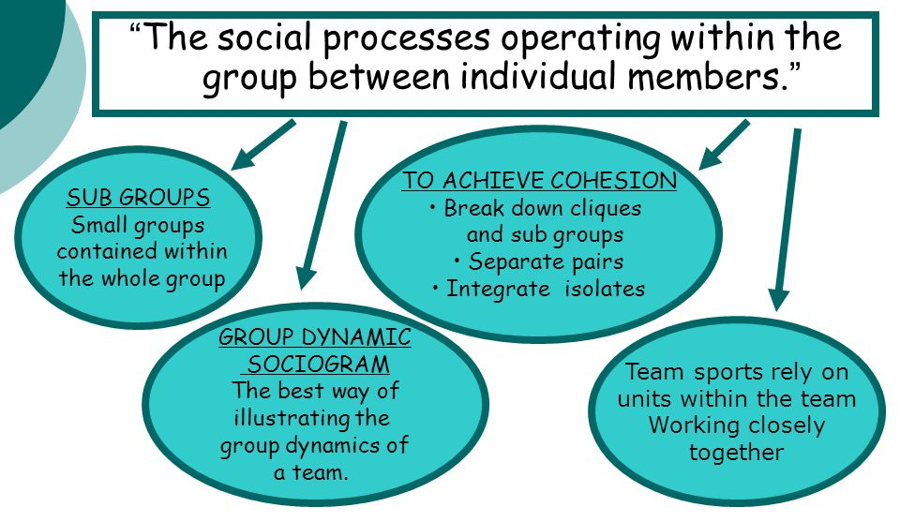
Figure 1: Group dynamic theory
(Sources: Morgan, 2016)

Belbin's theory of team structure:
The essence of this theory is to provide the way of communication a team leader will play a proper role to manage their all kinds of agendas. In any workplace, team formulation and negotiation among them is very much important to achieve the business objectives. Belbin tried to highlight the factor that if all the team members are well known about their roles and responsibilities then they perform in best manner. Marks and Spencer used the belbin theory to carry their communication process in the organizational domain. In order to get the best outcome from those formulated teams, the team leaders are responsible to inform their team members about their work responsibilities.
Belbin suggested that, by understanding the role of their works agendas team members will be able to know about their strengths and weakness. After recognizing the strengths and weaknesses, team members can achieve their goals in uncompleted ways. The basic elements of Belbin’s theories are Thinking, Action and action. These three elements are work as a core component to manage the teamwork. In the thinking, factors there are some sub-factors that are Monitor evaluator, plant and species. In the action factor, implementer, shaver and finisher and co-coordinator, resource investigator and team worker are incorporated with the people. All these parameters are practiced by the Marks and Spencer Company to handle their team works and performances.

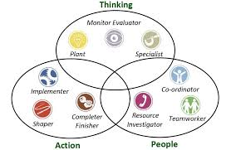
Figure 2: Belbin's theory of team structure
(Source : Wates, 2014)

Shannon-weaver's models of communication:
Shannon and weaver model of communication is an appropriate tool of communication applicable for any kind workplace. This model has some basic components such as information source, message, transmitter, signals, noise sources, receiver and final destination of message. If any organization practices this theory for their workplace communication then they can easily get the feedback from their targeted message receivers. The messages sender will be able to manipulate the source of noises. In this model, Shannon and weavers stated that if any kinds of noises have incorporated with the communication process then there has a chance of detoriation of sent messages.
In order to communicate any information communicators needs to select appropriate media, which will be convenient for the message receiver. In this phase, there has a chance of inject of the noises in the communication system. The communicator is responsible to understand about the possible noise in advance, by how they will be succeed to design their messages effectively. The noise injection may change the essence of the communication and it do not portray about the actual intention of the message encoder. Thus the message entirely perceived by the receivers in different meaning. The marks and Spencer Company used this model of communication in order to maintain effective communication with their stakeholders.
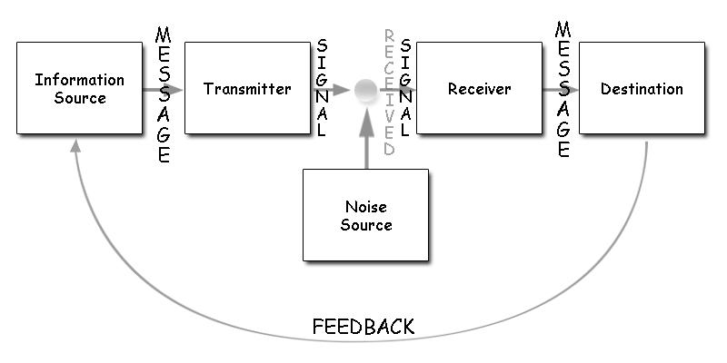
Figure 3: Shannon Weaver Model of Communication, 1948
(Source: Weller et al. 2014)
Barlo’s model of communication:
This communication model depicts about main four components of communication process. Those four components are the Source, medium, channel, and receiver. This model is valuable for maintaining the effective communication process in any workplace.

Improvement in productivity through effective communication in workplace
A company can change their level of productivity and other condition by applying effective communication strategies. Effective communication is helpful to abide any kinds of misunderstanding among employees. In any organization, various kinds of department are existed, among them good and strong communication process must have to be maintained. Companies are generally practice the appropriate tools of communication for their employees, which also used to motivate their employees (Ang and Van 2015). Communication strategy needs to exercise for informing about the duties and responsibilities of the worker, this process operated by the expert communicator of any organization. Production level of a company can be improved by maintaining different kinds of agendas, like doing the market research, gathering relevant information, maintain collaboration among the departments and finally produce the product for service users. Effective communication in workplace depends over the psychological perspectives of the employee.
In this context, example of Marks and Spencer will be appropriate for emphasizing the importance of communication in workplace for their large amount of production. The Marks and Spencers have performed above-mentioned tasks in order to enhance their productivity level. Enhancement of production depends on the collaboration among department. The marketing department needs to make connection with the public relation and sales department. Reason behind this strategy is to get the relevant information of previous sales records that can be used by the marketing manager of this company for setting the next market strategies. Public relation department is responsible to make promotional activities of any manufacturing product or service. Therefore, if the marketing department and the public relation department function coordinating then it will be more effective for the organization in the perspective to reach over to their target consumers. All these actions will be successful if the appropriate communication system is existed in the functional system.

Advantages of maintaining effective workplace communication
Effective communication can help the business organisations in various ways so that they can enhance their overall productivity. Advantages of maintaining an effective communication process enhances the revenue earning, strong collaboration among employees, responsive to their consumers in easy and comfortable ways, taking quick actions for strategy formulation. A company can adopt the communication strategies for abiding all kinds miscommunication from their operation management. The process of maintaining the strong communication depends over the capabilities of the communicator (Weller et al. 2014). How they are playing their role for give the organizational information the employees. There are various kinds of positive results a company can owns if they set up any effective communication strategy in their functional system, such as grab the market by producing various kinds of products and services, get the competitive advantage from the open market, addressing the demands of the customers.
Marks and Spencer tries to maintain an effective communication process in their functional system to gain the above-mentioned benefits. The authority of this company has instructed their all department to maintain a smooth communication among there all departments. This initiative helps them to operate their work non-systematic and effective ways. One department cannot be success in their core operation until they get support from the other department. They are a large company in the retail sector, so they needs to performs various kinds of task starting from the administrative department to sales departments. Lacking of communication generates various kinds of issues within the workplace, the staffs are well known about their responsibility with accurate information then they will be able to perform in best way. The main aim is to provide the accurate knowledge about the organizational rules and regulations with maintaining the quality of the service to all the employee of this trading unite. The information regarding the public demand need to be addressed by the company in order to create or maintain the brand image. Brand image is helpful for any organization to gain the positive results.

Conclusion
As a conclusion, it can be stated that the process for managing any teamwork in successful way depends on the process of communication. All this factors will be emphasized here. The aim of the study is to provide the knowledge regarding the communication process for managing the workplace agendas.
This overall assignment is based over the appropriate communication strategies which can be used an important tool for managing the teamwork. All this information will be useful for the future researchers related with this specific topic. All part of this assignment has successfully completed by using relevant theories and model of communication.

Reference List
Ang, S. and Van Dyne, L., 2015. Handbook of cultural intelligence. Routledge.
Austin, E.W. and Pinkleton, B.E., 2015. Strategic public relations management: Planning and managing effective communication campaigns (Vol. 10). Routledge.
Beebe, S.A. and Masterson, J.T., 2014. Communicating in small groups: Principles and practices. Pearson Higher Ed.
Bolman, L.G. and Deal, T.E., 2017. Reframing organizations: Artistry, choice, and leadership. John Wiley & Sons.
Boud, D., Cohen, R. and Sampson, J. eds., 2014. Peer learning in higher education: Learning from and with each other. Routledge.
Brock, D., Abu-Rish, E., Chiu, C.R., Hammer, D., Wilson, S., Vorvick, L., Blondon, K., Schaad, D., Liner, D. and Zierler, B., 2013. Interprofessional education in team communication: working together to improve patient safety. BMJ Qual Saf, 22(5), pp.414-423.
Cummings, T.G. and Worley, C.G., 2014. Organization development and change. Cengage learning.
Dozier, D.M., Grunig, L.A. and Grunig, J.E., 2013. Manager's guide to excellence in public relations and communication management. Routledge.
Goetsch, D.L. and Davis, S.B., 2014. Quality management for organizational excellence. Upper Saddle River, NJ: pearson.
Grunig, J.E. ed., 2013. Excellence in public relations and communication management. Routledge.
Holmes, J. and Stubbe, M., 2015. Power and politeness in the workplace: A sociolinguistic analysis of talk at work. Routledge.
Marsick, V.J. and Watkins, K., 2015. Informal and Incidental Learning in the Workplace (Routledge Revivals). Routledge.
Maund, A. Schriek, M. and Tinkler, P. (2017). Certificate in Higher Education: Skills for the Workplace Student Yearbook. Sage Publications
Morgan, P. (2016). The Business Student’s Guide to Study and Employability. Sage Publications
Nancarrow, S.A., Booth, A., Ariss, S., Smith, T., Enderby, P. and Roots, A., 2013. Ten principles of good interdisciplinary team work. Human resources for Health, 11(1), p.19.
Shockley-Zalabak, P., 2014. Fundamentals of organizational communication. Pearson.
Ulmer, R.R., Sellnow, T.L. and Seeger, M.W., 2017. Effective crisis communication: Moving from crisis to opportunity. Sage Publications.
Wates, N., 2014. The Community Planning Handbook: How people can shape their cities, towns & villages in any part of the world. Routledge.
Weller, J., Boyd, M. and Cumin, D., 2014. Teams, tribes and patient safety: overcoming barriers to effective teamwork in healthcare. Postgraduate medical journal, 90(1061), pp.149-154.
Woodcock, M., 2017. Team development manual. Routledge.

Appendix:


