

Applied Leadership and Management in the Workplace
Module Assignment Submission

Student Name: | Darlington Gima
Student Number: | 2327712
Module No: | BMSK4013
Module Title: | Management Communication

Statement of Confirmation of Authenticity
By the act of making this submission, the student declares that this is the work of the student named above. The work has not, in whole or in part, been knowingly presented elsewhere for assessment, or where assessment has been built on a previous assessment, this has been identified. Where materials have been used from other sources it has been properly acknowledged. If this statement is untrue, the student acknowledges that an assessment offence has been committed.
Attention is drawn to the plagiarism and unfair practice policies of both the University and of IL
COMMUNICATION

Communication is the process of exchanging information, ideas, and feelings between one another through various means like speaking. Writing and understanding each other.
Communication is an essential aspect of human interaction, allowing individuals to exchange information, ideas, and emotions. It serves as the foundation for building relationships, resolving conflicts, and expressing thoughts. In this paper, we will explore the various forms of communication, its significance in different contexts, and the factors that influence its effectiveness. By delving into the intricacies of communication, we can gain a deeper understanding of how it shapes our personal and professional lives.

COMMUNICATION MODELS

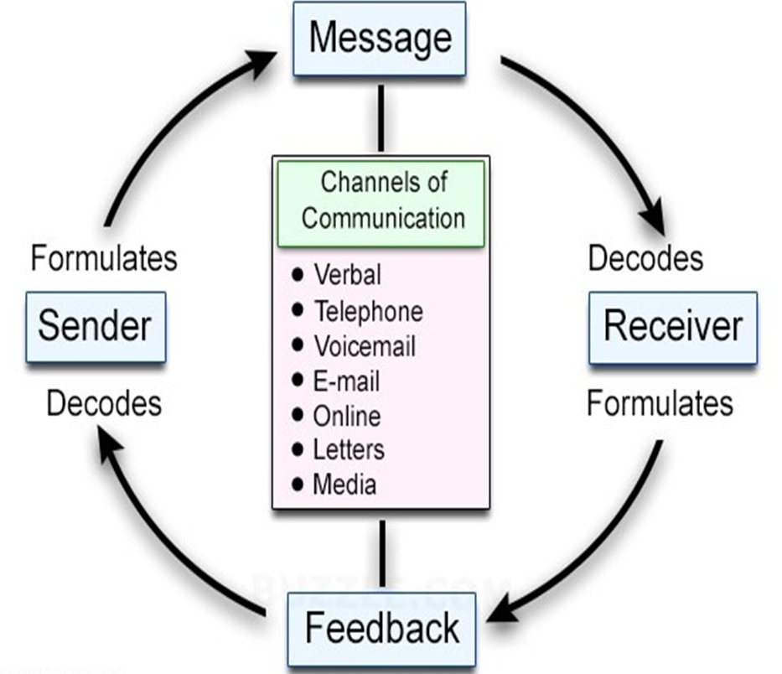

The image you provided shows how communication works, highlighting the key parts and how they interact. Here’s a simplified explanation:

1.Sender the sender is the person who starts the conversation.
For example, the sender thinks about what they want to say and then puts those thoughts into words, gestures, or symbols. They need to think about the receiver to make sure the message is clear.

2. Message: The message is what the sender wants to share.
The message can be spoken, written, or shown through body language or signals. It must be clear for the receiver to understand it properly.

3.Channels of Communication: Channels are the ways the message is sent.
Common ways include talking face-to-face, phone calls, emails, letters, and online messages. The choice of channel can affect how well the message is understood.

4. Receiver: The receiver is the person who gets the message.
The receiver interprets the message based on their own knowledge and experiences. They try to understand what the sender means.

5. Feedback: Feedback is the receiver’s response to the message.
Feedback helps the sender know if the message was understood correctly. It can be a reply, a reaction, or a gesture. Feedback is important to ensure both sides understand each other.

The communication cycle in the image shows that communication is an ongoing process where both the sender and receiver actively exchange information and feedback to understand each other.

Sure, here's a simplified breakdown of the strengths and weaknesses of the communication cycle using bullet points and layman terms:

Strengths:
clear Messages
strength Makes sure messages are easy to understand.
- It helps avoid confusion by making sure what you say is clear and easy to get.

Feedback Loop: Lets you know if the other person understood.
It's like asking, "Did you get it?" to make sure they understood, and if not, you can explain better.

Spotting Problems; Helps notice when something makes it hard to talk.
Like when there's loud music while you're on the phone, it's harder to hear. The cycle helps notice and fix that.

Works Everywhere
Works for talking in person, writing, or using technology.
Whether you're talking face-to-face or sending a text, the same rules help make sure you understand each other.

-talking Together

Shows that talking is like a game where both people need to play.
Instead of one person talking and the other just listening, it's like playing catch - you throw the message, and they throw it back.

- TOO SIMPLE
Sometimes, it's too simple for real conversations.
; Real talks can get complicated with lots of people, but the cycle is like using a simple rule for a hard game.

Assumes
Thinks everyone talks perfectly and understands perfectly, which isn't always true.
People don't always say exactly what they mean, or others don't get it because of different backgrounds.

straight Line Thinking
Thinks talking is like a straight line, but it's more like a messy tangle.
Sometimes both people talk at once, or there are interruptions, which the cycle doesn't cover.

Doesn't think about how where or when you talk might change things.
Talking to your friend is different from talking to your boss, but the cycle doesn't think about that.

- Needs Good Feedback
If the feedback isn't good, the talk might not work well.
If you ask if they understood and they say yes, but they didn't, the whole talk might go wrong because you didn't get good feedback.

This breakdown simplifies the strengths and weaknesses of the communication cycle into easy-to-understand points, making it clear how it helps with talking but also where it might fall short in real-life conversations.

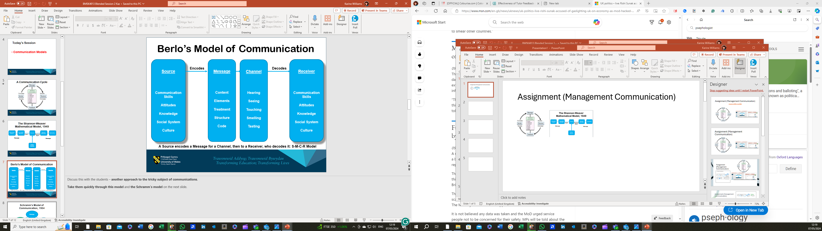

Berlo's communication model, developed by David Berlo in 1960, is a classic framework that helps us understand the various elements involved in the communication process. This model also known as (SMCR MODEL)

The model includes four main components: The (S)ender, The (M)essage, the (C)channel, and the (R)eceiver. Here’s a breakdown of each component:

1. Sender: This is the individual who initiates the communication. They encode their thoughts, ideas, or information into a message they wish to convey.

2. Message: The message is the content or information being transmitted by the sender. It can be conveyed through words, gestures, visuals, or other forms of communication.

3. Channel: The channel is the medium used to transmit the message. This can include face-to-face conversations, phone calls, emails, social media, or any other communication platform.

4. Receiver: The receiver is the individual or audience who receives the message. They decode the message and try to understand its meaning.

Additionally, the model considers two factors that can influence the communication process:

Feedback: Feedback is the response or reaction of the receiver to the message. It helps the sender understand whether the message was interpreted as intended.

Noise refers to any interference or barriers that can disrupt the communication process. This can include external noise (such as a loud environment) or internal noise (such as distractions or biases).

Overall, Berlo's communication model highlights the importance of effective encoding and decoding, selecting the appropriate channel, and ensuring clear feedback to enhance the communication process.

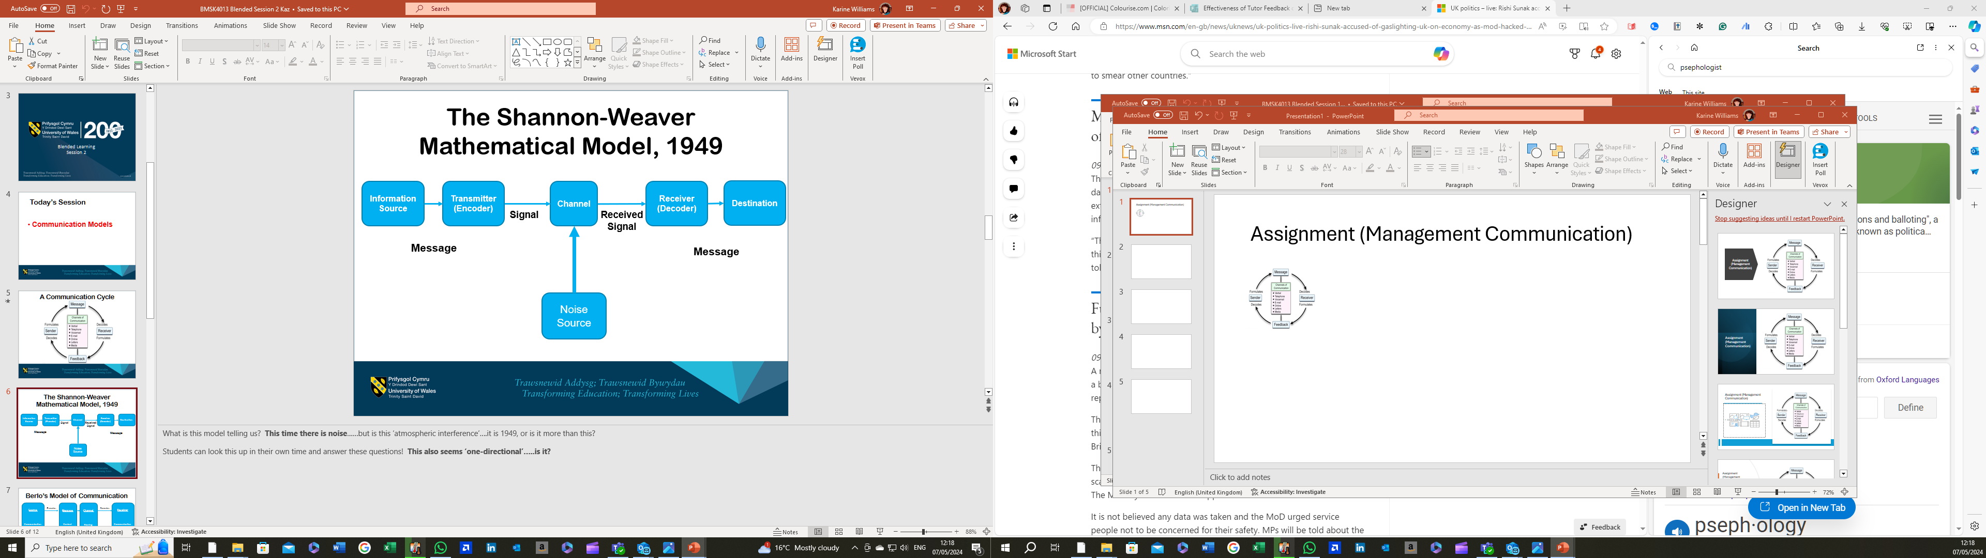

The Shannon-Weaver communication model, also known as the information theory model, focuses on the technical aspects of communication and views it as a linear process. It includes the following elements:

1.Sender: The individual who initiates the communication by creating a message to be transmitted.

2. Encoding
The sender converts the message into a form suitable for transmission through the chosen communication channel.

3.Channel The medium or method used to transmit the message from the sender to the receiver. This can be face-to-face conversation, a phone call, an email, or any other means of communication.

4. Noise. Any interference or disturbances that can affect the transmission of the message. This includes external noise, such as background sounds, or internal noise, such as distractions or language barriers.

5. Receiver. The individual who receives the message from the sender. They decode the message, interpreting and understanding its meaning.

6. Decoding: The process by which the receiver interprets and understands the message.

7. Feedback: The response or reaction of the receiver to the message, which helps the sender determine if the message was understood correctly.

The Shannon-Weaver model underscores the importance of clear encoding and decoding and the need to minimize noise for effective communication.

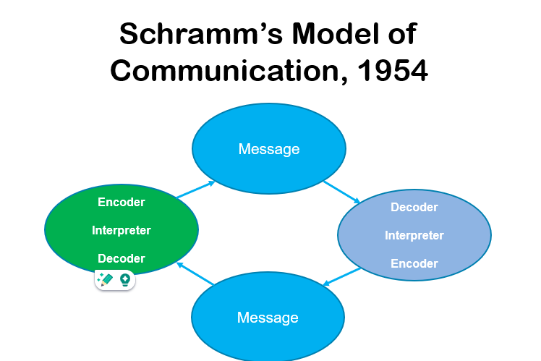

Examining Schramm's model of communication provides another perspective on how people exchange information.

In Schramm's model, communication is viewed as a process of sharing meaning between a sender and a receiver. Here are the main components:

1. field of Experience Both the sender and receiver bring their own backgrounds, knowledge, and experiences, which influence how they interpret messages.

2. Encoder: The sender translates their thoughts or ideas into a message using language, gestures, or other forms of communication.

3. Message The content the sender wishes to convey, which can be in the form of spoken words, written text, body language, or other expressions.

4. Channel The medium through which the message is transmitted, such as face-to-face conversation, phone calls, emails, or social media.

5. Decoder: The receiver interprets and understands the message based on their own field of experience.

6. Feedback: The receiver's response or reaction to the message, indicating whether the message was understood as intended.

7. Noise: Any interference or distractions that can affect the communication process, including physical noise, psychological noise, or cultural differences.

Schramm's model highlights communication as a dynamic and interactive process, where both the sender and receiver actively participate in creating and interpreting meaning.

TONE, LANGUAGE ANG FORMALITY

In a workplace, tone, language, and formality are key components that influence communication, relationships, and overall productivity. Here’s a detailed explanation of each.

Tone.
Tone refers to the attitude or feeling conveyed through the way something is said or written. In the workplace, tone can be.

Tone

Tone refers to the attitude or feeling conveyed through the way something is said or written. In the workplace, tone can be:
- Professional: Respectful, polite, and focused on business-related topics.
- Friendly: Warm, approachable, and encouraging positive relationships.
- Formal: Structured and serious, often used in official communications.
- Informal: Casual and conversational, suitable for everyday interactions.

Importance:
Clarity: Ensures the message is clear and understood as intended.
- Relationships: Builds and maintains positive relationships among colleagues.
- Motivation: Encourages and motivates employees by creating a supportive environment.
- Conflict Prevention: Reduces misunderstandings and potential conflicts.

Language

Language in the workplace includes the choice of words, phrases, and style of communication. This can range from technical jargon to plain language depending on the context.
Importance:
- Professionalism: Reflects the level of professionalism and competence.
- Accessibility: Makes information accessible and understandable to all employees.
- Efficiency: Facilitates efficient communication, reducing the time needed for explanations.
- Inclusivity: Ensures all employees feel included and respected regardless of their background.

Formality

Formality refers to the adherence to conventional standards of behaviour and communication. This can be:
- High Formality: Adhering strictly to professional protocols, dress codes, and formal language.
- Moderate Formality: Balancing professional standards with a relaxed approach.
- Low Formality: Casual interactions and a relaxed dress code.
Importance:
- Consistency: Provides a consistent framework for behaviours and communication.
- Expectations: Sets clear expectations for how employees should conduct themselves.
- Respect: Demonstrates respect for the workplace and its norms.
- Trust: Builds trust and confidence in the workplace structure and culture.

Overall Importance in the Workplace
Maintaining appropriate tone, language, and formality is crucial for several reasons:

- Effective Communication: Ensures messages are delivered clearly and effectively, minimizing misunderstandings.
- Professionalism: Upholds a standard of professionalism that reflects well on the organization.
- Culture: Shapes the workplace culture, influencing employee satisfaction and engagement.
- Productivity: Enhances productivity by fostering an environment where communication flows smoothly and efficiently.
- Conflict Resolution: Helps in managing and resolving conflicts amicably through respectful and clear communication.

In summary, tone, language, and formality are integral to creating a positive and productive workplace environment. They influence how employees interact, collaborate, and perceive the organizational culture. Adapting these elements appropriately based on the context and audience is essential for maintaining effective and professional workplace communication.

Motivation in the workplace refers to the intrinsic and extrinsic factors that stimulate an employee's enthusiasm, energy, commitment, and persistence towards achieving their work goals and the overall objectives of the organisation.

Explanation of Motivation in the Workplace

Intrinsic Motivation

Intrinsic motivation comes from within the individual and is driven by personal satisfaction and the inherent enjoyment of the task itself. Examples include:
- Passion for Work: Employees are genuinely interested and engaged in their work.
- Personal Growth: The desire to learn new skills and improve oneself.
- Sense of Achievement: Satisfaction from accomplishing challenging tasks or goal

- Extrinsic Motivation

Extrinsic motivation comes from external rewards or pressures. Examples include:
- Financial Rewards: Salary, bonuses, and other monetary benefits.
- Recognition: Praise, awards, and other forms of acknowledgment from colleagues and superiors.
- Career Advancement: Opportunities for promotions, new responsibilities, and professional development.

Importance of Motivation in the Workplace
- Increased Productivity:
Motivated employees tend to be more productive and efficient, contributing to higher overall performance and output.

2 Enhanced Employee Engagement:
Motivation boosts employee engagement, leading to higher levels of enthusiasm, commitment, and involvement in their work.

Better Quality of Work:
Employees who are motivated are more likely to take pride in their work, leading to higher quality outcomes and fewer errors.

Higher Retention Rates:

A motivated workforce is less likely to experience high turnover rates, saving the organization costs associated with recruiting and training new employees.

Positive Work Environment:
Motivation contributes to a positive and dynamic workplace culture, where employees feel valued and motivated to contribute their best efforts.

Innovation and Creativity:
Motivated employees are more likely to think creatively and come up with innovative solutions to problems, driving the organisation forward.

Customer Satisfaction:
Motivated employees provide better customer service, which enhances customer satisfaction and loyalty.

Factors Influencing Motivation in the Workplace
1.Leadership Style:
  - Supportive and inspiring leadership can significantly boost employee motivation.
- Work Environment:
  - A positive, safe, and conducive work environment fosters motivation.
- Job Design:
  - Roles that are well-defined, challenging, and allow for autonomy and creativity can enhance motivation.
- Rewards and Recognition:
  - Regular and meaningful recognition and reward systems can drive motivation.
- Opportunities for Growth:
  - Providing opportunities for career advancement and professional development motivates employees to perform better.
- Work-Life Balance:
  - Supporting a healthy work-life balance helps maintain employee motivation and prevent burnout.

Here we look at 4 Motivational Theories
Maslow's Motivation Theory

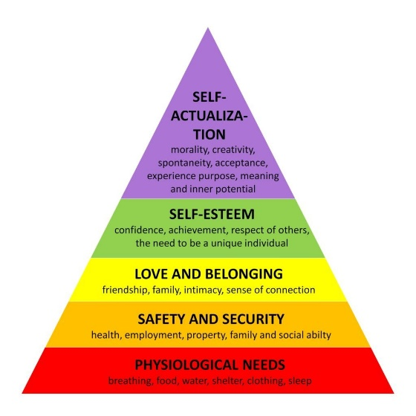

Maslow's Motivation Theory, also known as Maslow's Hierarchy of Needs, explains that people have different types of needs that must be met in a specific order. Imagine it like going up a set of stairs where you need to step on the lower Stairs before you can reach the higher ones. The hierarchy includes five levels:

- Basic Needs
- Safety Needs
- Social Needs
- Esteem Needs
- Self-Actualisation Needs

Explanation of Each Level
1. Basic Needs
These are the essential things you need to stay alive and function.
- Food and Water: Making sure you have enough to eat and drink.
- Rest: Getting enough sleep and taking breaks.

2. Safety Needs
These needs are about feeling safe and secure in your environment.
- Job Security: Knowing you won’t lose your job unexpectedly.
- Safe Workplace: Being in a place free from danger or harm.

3. Social Needs
These are about having relationships and feeling part of a group.
- Friendships: Building connections with others.
- Teamwork: Feeling like you belong and are accepted by a group.

4. Esteem Needs
These involve feeling good about yourself and being respected by others.
- Recognition: Being praised and acknowledged for your work.
- Responsibility: Being given important tasks that make you feel valued.

Douglas McGregor, a management professor, introduced two contrasting theories about how managers view and treat their employees. These are known as Theory X and Theory Y. Each theory represents a different set of assumptions about worker motivation and behaviour.

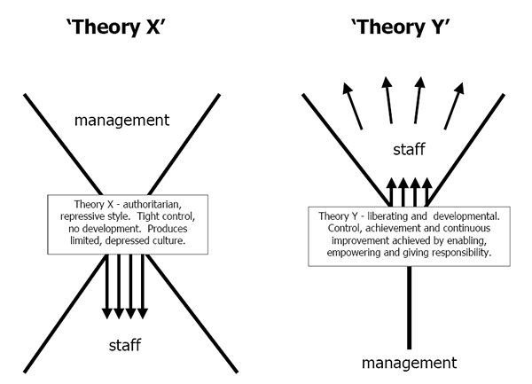

Theory X
Definition: Theory X assumes that employees are naturally unmotivated and dislike work. Because of this, managers believe they need to closely supervise their workers and use strict controls and punishments to ensure productivity.
Explanation in Simple Words:
- Negative View: Managers think that workers don’t like their jobs and will avoid work if they can.
- Control and Coerce: Managers believe they need to control workers closely, give lots of orders, and use punishment or threats to make them work.
- Lack of Ambition: Managers assume that workers avoid responsibility and have little ambition.

Theory Y
Definition: Theory Y assumes that employees are self-motivated and enjoy the challenge of work. Managers believe that if given the right conditions, workers will be enthusiastic and take initiative.
Explanation in Simple Words:
- Positive View: Managers think that workers find their jobs satisfying and will seek out responsibility.
- Trust and Freedom: Managers believe in giving workers more freedom and trust, which leads to higher motivation and better performance.
- Encourage Development: Managers assume that workers will be motivated by opportunities for growth and development.

Comparison and Implications

Theory X Managers:

- Strict Supervision: Use tight controls and closely monitor their employees.
- Authoritarian Style: Tend to give orders and expect obedience without questioning.
- Motivation through Fear: Rely on threats and punishment to get work done.
Theory Y Managers:
- Empowerment: Give employees more responsibility and trust them to do their jobs well.
- Participative Style: Involve employees in decision-making and value their input.
- Motivation through Opportunities: Use opportunities for growth, development, and recognition to motivate employees.

Application
- Theory X in examples

  - Strict Workplaces: Factories or call centres where tasks are repetitive and closely monitored.
  - Heavy Supervision: Environments where tight control and supervision are considered necessary to maintain productivity.

- Theory Y in Examples

  - Innovative Companies: Tech firms or creative industries where innovation and initiative are highly valued.
  - Autonomy: Workplaces where employees are given freedom to make decisions, work independently, and pursue personal growth.

Herzberg's Two-Factor Theory, also known as the Motivation-Hygiene Theory, was developed by psychologist Frederick Herzberg. It suggests that there are two sets of factors in the workplace that influence employee satisfaction and motivation: Hygiene Factors and Motivators.

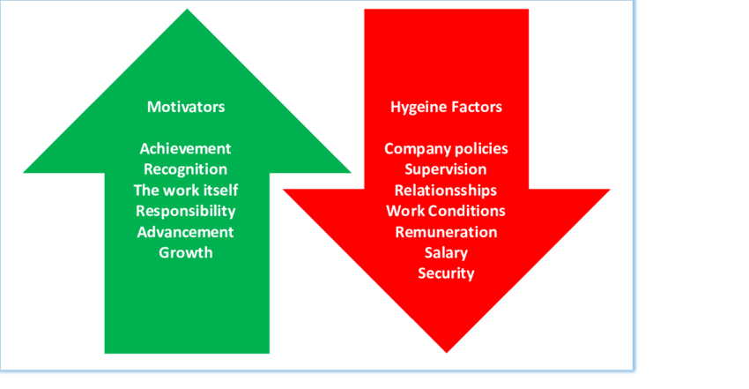
Definition

Hygiene Factors: These are factors that can cause dissatisfaction if they are missing or inadequate, but do not necessarily motivate employees if they are present.

Motivators: These are factors that truly motivate employees and lead to higher satisfaction and performance.

Hygiene Factors
These are the basic needs that, if not met, can make employees unhappy. However, having these factors doesn't necessarily make employees motivated or satisfied with their job; they just prevent dissatisfaction.
Examples of Hygiene Factors:
- Salary: Getting paid fairly.
- Work Conditions: Having a safe and comfortable work environment.
- Company Policies: Clear and fair rules and procedures.
- Job Security: Feeling secure in your job.
- Relationship with Supervisors and Peers: Having a good relationship with your boss and coworkers.

Imagine you have a leaky roof. Fixing the leak won't make you happy, but if you don't fix it, you'll be very unhappy. Hygiene factors work the same way: they prevent problems but don't create happiness.

Motivators

These are the aspects of the job that actually make employees feel satisfied and motivated to do their best work. These factors are related to the nature of the work itself and the opportunities it provides.

Motivators:
- Achievement: Accomplishing something important.
- Recognition: Getting praise and acknowledgment for your work.
- Work Itself: Finding the work interesting and enjoyable.
- Responsibility: Having control over your work and being trusted to do a good job.
- Advancement: Opportunities for promotion and personal growth.

These are the factors that truly make you enjoy your job and want to do better. Think of these as the exciting features of a house, like a beautiful garden or a cosy fireplace, that make you love living there.

How It Works Together

- Preventing Dissatisfaction:
  - Ensure all hygiene factors are adequately addressed. This means providing fair pay, safe working conditions, and good relationships at work.
- Creating Satisfaction:
  - Focus on motivators to truly engage and inspire employees. This means giving recognition, providing opportunities for growth, and making the work itself interesting.
Real-World Application
- Improving Work Environment:
  - Hygiene Factors: Make sure the office is clean, safe, and comfortable.
  - Motivators: Provide challenging projects and recognise achievements.
- Employee Benefits:
  - Hygiene Factors: Offer competitive salaries and job security.
  - Motivators: Provide opportunities for training and career advancement.

