Level 4 Assignment 2.

Title: Managing Health, Safety and Welfare in Construction.

Name: Gethin Griffiths.

Student No: 1910877.

Module Code: ACBA4003.

Tutor: Dr Deborah Hughes.

Completion Date: 05/05/2020.

Contents Page.
Contents. Page.
- Introduction. 3.
- Course of Action. 3.
- Research. 3.
3.1 Construction Phase Plan. 3, 4.
3.2 Scope of Works. 4.
3.3 Programme of Works. 4.
3.4 Project Team Responsibilities. 4, 5, 6.
3.5 Health and Safety Procedures. 6, 7, 8, 9.
3.6 Health Risks. 9, 10.
3.7 Security of the Site. 10.
4.0 Method Statements 10.
5.0 Risk Assessments. 11.
6.0 Conclusion. 12.
7.0 References. 13, 14, 15.
8.0 Appendices. 16.
8.1 Appendix 1. Site Plan and Location. 16.
8.2 Appendix 2. Location of the Nearest Hospitals. 17.
8.3 Appendix 3. Unexploded Ordnance Assessment. 18.
8.4 Appendix 4. PPE. 19, 20.
8.5 Appendix 5. Programme of Works. 21.
8.6 Appendix 6. Site Rules. 22, 23, 24.
8.7 Appendix 7. Method Statement Excavation. 25, 26.
8.8 Appendix 8. Risk Assessment Excavation. 27, 28.
  - Appendix 9. Method Statement Blockwork. 29, 30.
8.10 Appendix 10. Blockwork. 31, 32.
8.11 Appendix 11. Method Statement Roof Structure. 33, 34.
8.12 Appendix 12. Risk Assessment Roof Structure. 35, 36.

- Introduction.
The point of this assignment is to demonstrate a constructive phase plan all of the main operations, method statements, risk assess situations and relate this to the correct legislation as guidance for the development of a low- rise building; work commencing on 6th May 2020. The areas for the method statements and risk assessments will be focused on how to improve the welfare of the site; This will demonstrate management strategies to overcome and provide a safe environment for the client, staff, visitors and the public.
- Course of Action.

To discuss areas focused on and research used.

  - Evidence on management of site constructive phase plan, method plans, risk assessments and to follow the legislation as guidance towards the project’s operations.

  - Notes from lectures and PowerPoint presentations for background information.

  - References from published text books, videos and IHS website on legislations on focused areas.

  - Research.

  - Construction Phase Plan.
The pre-CPP operations will improve the health and safety procedures of the site, at (Kings Roads, Swansea) (refer to Appendices: Appendix 1) for the location and layout of the working site.
A pre-contingency plan must be put in place before the start of a project; which is produced by three main parties; including the Principle Designer, Principle Contractor (builder); who will present the plan to the Client for approval (CDM Regulations 2015, p 8, 9).
In the CPP it must contain the following:
  - Scope of Works:

    - Work involved relates to developing a two-storey building with a loft room (refer to the brief for further details).

  - Programme of works:

    - Start 6th May 2020 programme of works illustrating the sequence of works example (refer to Appendix 5) 12 weeks Estimated providing that there are no delays with materials being delivered and waste removal.

  - Project Team and Responsibilities:

    - Client: Organises and arranges appropriate solutions for the management of a construction project which has to be notified if the project last over 30 days, including,
- Must notify the HSE authority before the designs are developed
- Appoint additional duty holders.
- Adequate resources and periods are assigned.
- Designer and contractor achieve the proposals promise.
- Prepare the correct details of the project to further professionals.
- Funding for welfare on site is of standard.
(HSE, 2015, p. 6, paragraphs 23-52) for further details.
In relation to the CPP, indicates the client must have all Health and safety procedures in place and filed; alongside with the site rules, method statements and risk assessment for all major activities in accordance to, ‘Schedule 3 of CDM 2015’ (HSE, 2015, p. 19).
‘Regulations 7’ in guidance for domestic clients with duties that comes under (CDM 2015); which the majority of responsibilities must be passed over to various duty holders and not done through a business.
3.4.2. Principle Designer: Organises the planning procedures, including:
- Health and safety before the construction phase takes place.
- Recognizes the possible risks.
- Illustrates vital information or changes to other professionals.
- Demonstrates the appropriate data to the principle contractor to mange the health and safety throughout the project.
(HSE, 2015, p. 6, paragraphs 94-115) for further details.
    - Principle Contractor: Organises and plans the health and safety within the period of the project, Including:
- Communication and regular meetings with the client, principle designer and sub-contractors to notify the schedules of works.
- Produce preparation for the CCP under the health and safety guidance, reducing the risks.
- Site inductions explaining all major activities.
- Provide regular tool box talks (PUWER, 1998).
- Provide acting site safety measures towards the working professionals, visitors and public.
- Operational welfare on site is provided.
(HSE, 2015, p. 6, paragraphs 110-146) for further details.

    - Contractor: Arranges the constructive work within the contract under the health and safety regulations with various contractors on site when needed, (HSE, 2015, p. 6, paragraphs 147-179) for further details.

    - Skilled Professional and labourers: must comply with:
- Any raised risks.
- Maintain their personal health and safety measures.
- Close call or report any near misses on site.
- Communicate with other professional on site for updates within the stages of the project.
All exchange of design information should be made available and any amendments made will be discussed notifying the projects team. (HSE, 2015, p. 6 & 7).
  - Health and Safety Procedures.

    - Drawings of the main project, schedules, specifications, temporary works and the major dangers are pre-risk assessed to reduce the risk within the project, containing:

    - All temporary works, collapsing structure use of supports, scaffolding or stabilisers for cranes must be notified and must have valid information explaining why it is being carried out, complying with; ‘BS 5975’ (British Standards, 2019):

    - Wear full PPE at all times on site, extra precautions must be considered for. specific task taking place ‘Personal Protection at Work Regulations (PPE) 1992’ (CITB, 2012, p. 1-5, B2, Section B). (refer to appendix 4) for PPE that must be warn onsite at all times (CDM, 2015).

    - Excavations for foundations (trench support); which should be sectioned off as an exclusion zones; due to operating plant, safety of pedestrians, working professionals and the risk of collapsing occurring, complying with (HSE, 2009, p. 6, 26 & 27) refer to method statements and risk assessments for further details.

    - Unexploded ordnance assessment has been filed in the near area, produced by, ‘BACTEC for Atkins Limited’; which is highlighted. (Refer to Appendix 3). Knowing there is a history of bombings within the area (digging with caution) is a must; Stop digging if there is any sign of a suspected object, (Construction Health and Safety Manual, 2014, p. 5).

    - Temporary scaffolding for roof access, kickboards preventing falling objects, use of harnesses or walking through fragile surfaces; in compliance with (Working at Heights Regulations 2005, p. 2-3) and refer to the method statement and risk assessments for further information preventing falls.

    - Crane management (safe system of work) lifting operations of roof structure in accordance to, BS 7121-5:2019 (British Standards, Tower Cranes, 2019, p, 5).

    - Over headline protection in correspondence with plant operations; which must comply with (HSE, 2009, p.9) ‘The Electrical at Work Regulations 1989’ BS 7375 (British Standards, 2010, p. 17 & 18) all electrical feeds in the area must be isolated by the electric board when permitted to dig.

    - Waste must be controlled with allocated skips under the, ‘The Waste (England and Wales) Regulations 2011’ and, ‘The Environmental Protection (Duty of Care) Regulations 1991’. Waste permits must be filed within the waste management procedures for removals, in relation to ‘The Site Waste Management Plan Regulations 2008’ (CITB, 2012, p. 4, 5 and 11, G4, Section G).

    - Make sure all hazardous chemicals are stored and locked away in the correct areas, in accordance with ‘COSHH, 2012’ (CITB, 2012, B3, Section B).

    - Maintaining the safety of the working professionals, visitors and public complying with, ‘Management of Health and Safety at Work Regulations 1999 amended’ (CITB, 2012, p. 2, D1, Section D). Preventing further risk to the public, operatives and visitors by sectioning off the perimeter of the site and exclusion zones within the site.

    - All fire extinguishers are located around the site with a fire alarm attached.

    - Working in confined spaces under the ‘CDM 2015’ has to be assessed before the work is carried out.

    - Emergency fire evacuation is through the main access points across to the assembly destination (Technium 2) refer to Appendix 1.

    - A qualified professional will Cat Scan the area before digging, removing or excavations takes place; detecting water, gas or electrical supplies within the grounds.

    - First Aiders will be presented on the notice boards within the site office, mentioned in the inductions, task briefs and tool box talks.

    - Use of walk ways must be separate to traffic routes, which relates to (HSE, 2009, p.7).

    - Nearest A & E (refer to appendix 2).

    - Maintenance of plant and equipment will be inspected daily before use and recorded.

    - Working near water (preventing the risk of drowning).

    - Signs will be illustrated around the site to demonstrate the dangers, hazards, first aid boxes, fire exits, fire alarms/ extinguishers and hazardous chemicals.

    - Drying room for overalls to be placed after shift blue container.

    - Canteen has fresh drinking water, microwave and toilets ‘Technium 2’

The CPP, programme of works, induction, task briefs, health and safety file, emergency plan, first aiders/ box, power tools manuals, PPE and (site rules are demonstrated in Appendix 6): are located within the site office.

  - Health risks:

    - Asbestos awareness checks within the site berried materials due to the land being reclaimed, Control of Asbestos at Work Regulations (2012) (HSE, 2012, Regulations 10, p. 53-62) workers must have awareness training.

    - Dealing with contaminated land and the correct procedures are put in place to avoid further risk.

    - Increased levels of dust, light and air pollution from building works can be controlled through dust extractors, water controlled and face fitted masks, with reference to the, ‘Clean Air Act 1993’ (CITB, 2012, p. 5, G2 Section G).

    - Vibration control measures must be recorded (HAVS), ‘Vibration at Work Regulations 2005’ (CITB, 2012, p. 8, D1, Section D) and major work vibration to disrupt to other buildings in the area.

    - Noise control must be contained within allocated time periods, under the ‘Nuisance Act, The Control of Pollution Act 1974, BS 5228’ (CITB, 2012, p. 3, G2, section G).
    - Sun protection, hand sanitisers, hand creams will be provided in the site office.

    - Correct lifting techniques and lifting devices must be used to prevent injuries and accidents in accordance to, ‘Manual Handling Operations Regulations, 1992’ (Sutherland, Canwell & Brooks, 2013, p. 4, 22 & 23).

    - All accidents, close calls, near misses and injuries are to reported to you supervisor, recorded and filed, ‘RIDDOR 1995’.

  - Security of the site:
3.7.1. A security guards will be at the access points for delivers, banksman of traffic, monitor car park to prevent congestion and to stop the public from entering the site.

    - Signs will be present around the site, to warn the public to stay out.

    - The site will be closed off with barriers/ fencing and the gates will be locked after every shift.

    - Cabins and storage containers are to be locked after shift.

- Method Statements:
4.1. Method Statements analyses a sequence of tasks and to support reducing the risk in relation to risk assessment data, calculations and investigate other information concerning the health safety of the planned site; refer to:
- Appendix 7: Method Statement: Excavation Strip Foundation procedure.
- Appendix 9: Method statement: Blockwork, Sills and Lintels procedure
- Appendix 11: Method statement: Roof Structure and Coverings Procedure.
- Risk assessments:

  - Risk Assessments Indicates hazards that can affect an individual’s health, which safety measures are put in place to reduce the risk of it happening within the construction project. From close examination there are measures demonstrating potential hazards relating to the project and how the risk can be reduced; refer to:
- Appendix 8: Risk Assessments (Excavation Strip Foundation).
- Appendix 10: Risk Assessment Blockwork, Sills and Lintels procedure.
- Appendix 12: Risk Assessment Roof Structure and Coverings.

- Conclusion.
From close examination of the site plans, programme of works and health and safety procedures put in place; this will reduce the risk of any accidents happening, delays within the schedules and materials being delivered. Providing that the plan is followed and will be reinforced in regular meetings, inductions, toolbox talks and daily task briefs by the project’s management team.
In relation to the current situation of ‘COVID-19’ the project development will have to be delayed due to the NHS guide lines set out to maintain everyone’s safety within the work place:
- Keeping a distance of 2 metres apart.
- Wash hands regular.
- Cover your mouth when coughing.
- Wear gloves and face mask to prevent anyone catching the virus.
- Any cold like symptoms self-isolate for 2-14 days.
- If well after coming into contact with someone who has the virus stay home and self-isolate for 14 days.
- Stay home and keep everyone safe.
(NHS, COVID-19, 2020).
For further guidance research ‘NHS Website (COVID 19)’. This will have complications on the project’s development at present work commencing, ‘6th May 2020’.
Once the project has been completed the health and safety file must be handed over to the client either by the principle designer or principle contractor (CDM, 2015).

- References.

BACTEC International Limited. (2014) Explosive OrdnancesThreat assessment in respect of Swansea Docks to Baglan Burrows for Atkins Limited. Available at: http://www.tidallagoonpower.com/wp-content/uploads/2016/11/Appendix-B-TLSB-ATK-00-RP-Y-0001.pdf. (Accessed: 15th April 2020).

British Standards. (2019) BS 5975: 2019 Code of practice for temporary works procedures and the permissible stress design of falsework. IHS. Web. Available at: https://www-ihsti-com.ezproxy.uwtsd.ac.uk/tempimg/18022FC-CIS888614800326221.pdf. (Accessed: 26th April 2020).

British Standards. (2010) BS 7375:2010, Distribution of Electricity on Construction and Demolition Sites-Code of Practice. British Standards Institution. Available at: https://www-ihsti-com.ezproxy.uwtsd.ac.uk/tempimg/B1E922-CIS888614800294489.pdf. (Accessed: 29th April 2020).

British Standards, Tower Cranes. (2019) BS 7121-5:2019, Code of Practice for Safe Use of Cranes. Part 5: Tower Cranes. IHS. Web. Available at: https://www-ihsti-com.ezproxy.uwtsd.ac.uk/tempimg/10A0BF5-CIS888614800327534.pdf. (Accessed: 22nd April 2020).

CDM, (2015). Construction Design and Management Regulations 2015. IHS. Web. Legislation UK. Available at: https://www-ihsti-com.ezproxy.uwtsd.ac.uk/tempimg/4C5D72B-CIS888614800309569.pdf. (Accessed: 2nd April 2020).

CITB. (2012) Construction Site safety. (Volume 1 & 2). CITB ConstructionSkills.

Construction Health and Safety (2019) PPE, Volume E, Section 17. Available at: https://www-ihsti-com.ezproxy.uwtsd.ac.uk/tempimg/43224B5-CIS888614800326648.pdf. (Accessed 18th April 2020).

Construction Health and Safety Manual. (2014) Excavation Section 7. Construction Industry Publications Ltd. Available at: https://www-ihsti-com.ezproxy.uwtsd.ac.uk/tempimg/50DCA65-CIS888614800315093.pdf. (Accessed: 29th April 2020).

Google Maps. (2020). NHS Wales Information, 2 Technium, Kings road, Swansea. Available at: https://www.google.co.uk/maps/place/NHS+Wales+Informatics+Service/@51.6209523,-3.9331593,21z/data=!4m8!1m2!2m1!1skings+road+nhs+service+centre,+swansea!3m4!1s0x0:0xde0f2e939d92e40d!8m2!3d51.6211109!4d-3.9331104. (Accessed: 28th March 2020).

Google Chrome Maps. (2020). Neath Port Talbot Hospital. Available at: https://www.google.com/maps/place/Neath+Port+Talbot+Hospital/@51.599213,-3.802544,17z/data=!4m5!3m4!1s0x486e5df5e5a86b1f:0xe1106c5d372e0262!8m2!3d51.599213!4d-3.80035. (Accessed: 28th April 2020).

Google Chrome Maps. (2020). Singleton General Hospital. Available at: https://www.google.com/maps/place/Singleton+Hospital/@51.6093656,-3.9873673,17z/data=!4m5!3m4!1s0x486e8b31474baa2b:0xfbd3c43eda72b04e!8m2!3d51.6093656!4d-3.9851733. (Accessed 28th April 2020).

Google Chrome Maps. (2020). Morriston Hospital Accident and Emergency. Available at: https://www.google.com/maps/place/Morriston+Hospital+Accident+and+Emergency/@51.6690279,-3.9632444,12z/data=!4m5!3m4!1s0x486ef5f3c0d2b765:0x3e6491b364b3d35b!8m2!3d51.6850982!4d-3.9355272. (Accessed 27th April 2020).

HSE. (2015) Managing Health and Safety in Construction. Construction (Design and Management) Regulations 2015 Guidance on Regulations. (Regulations 2015 came into force 6th April 2015, replacing CDM 2007) IHS. Web. HSE. Available at: https://www-ihsti-com.ezproxy.uwtsd.ac.uk/tempimg/D72BBA-CIS888614800310090.pdf. (Accessed: 21st April 2020).

HSE. (2012) Managing and Working with Asbestos. Control of Asbestos Regulations 2012. HSE. (First published 2006 and 2nd Edition 2013). IHS Web. Available at: https://www-ihsti-com.ezproxy.uwtsd.ac.uk/tempimg/126EAEE-CIS888614800305559.pdf. (Accessed: 21st April 2020).

HSE. (2009) The Safe Use of Vehicles on Construction Sites. A Guide for Clients, Designers, Contractors, Managers and Workers involved with Construction Transport. IHS. Web. Available at: https://www-ihsti-com.ezproxy.uwtsd.ac.uk/tempimg/494348B-CIS888614800305095.pdf. (Accessed: 15th April).

NHS, COVID-19. (2020) Coronavirus (COVID-19). Available at: https://www.nhs.uk/conditions/coronavirus-covid-19/. (Accessed: 27th April 2020).

Strip Foundation-Excavation & Reinforcement. (2017) Available at: https://www.youtube.com/watch?v=a5LfHmaH8O0. (Accessed: 29th April 2020).

Sutherland, J. Canwell, D. Brooks, A. (2013) Site Carpentry Level 3 Diploma. Nelson Thornes.

Working at Height. Brief Guide. HSE. Available at: https://www.hse.gov.uk/pubns/indg401.pdf. (Accessed 25th April 2020).

Working at Heights Regulations. (2005) London Hazards Centre. IHS. Web. Available at: https://www-ihsti-com.ezproxy.uwtsd.ac.uk/tempimg/126EAEE-CIS888614800278884.pdf. (Accessed: 29th April 2020).

- Appendices.

  - Appendix 1: Site Plan and Location (not drawn to scale):
Rubbish and Recycling skips.
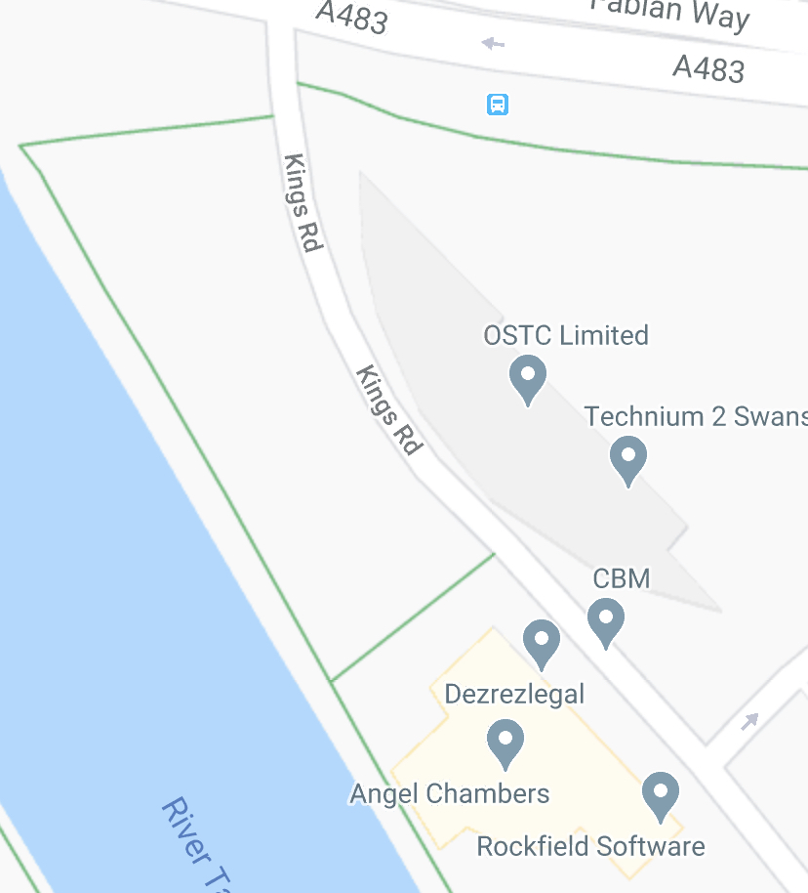
Car Park and plant lock up.
Access point to site, deliveries for larger materials: trusses and fire exit.

Footprint of the building.
Welfare site, Tech 2. Canteen, Toilets and assembly destination.
Smoking area.
Foot path around working area.
Storage for materials and power tools.

Deliveries access/ fire exit.
Office for signing in, inductions, health and safety file, emergency plan, method statements, risk assessments, first aid box, close call cards etc.

(Google Maps, 2020).

  - Appendix 2: Locations of the Nearest Hospitals:

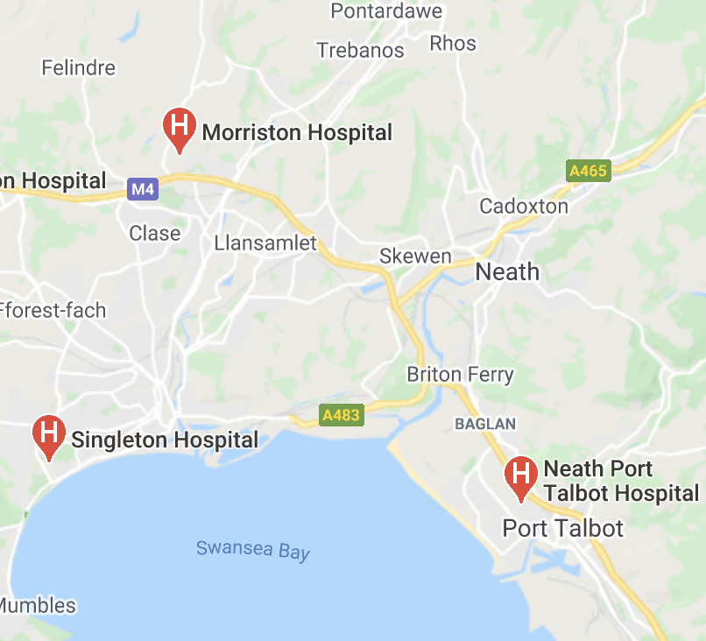

(Google Maps, 2020).
Address:
Neath Port Talbot Hospital, Baglan Way, Port Talbot, SA12 7BX.
Tel: 01639 862000.
Singleton General Hospital, Sketty Ln, Sketty, Swansea SA2 8QA.
Tel: 01792 205666.
Morriston Hospital Accident and Emergency, Heol Maes Eglwys, Cwmrhydyceirw, Morriston SA6 6NL.
Tel: 01792 702222.
(Google Maps, 2020).

  - Appendix 3: Unexploded Ordnance Assessment:

Highlighted in red; high risk.
Highlighted in green low risk.
Swansea docks:
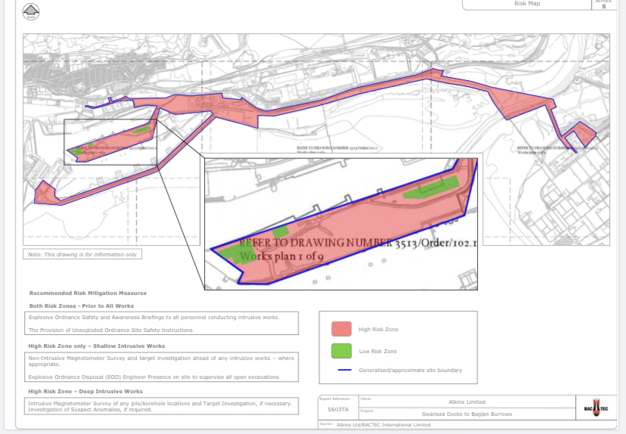

(BACTEC International Limited. 2014, p.60).

  - Appendix 4: Personal Protective Equipment CDM 2015 requirements:
Head Protection: BS EN 812.  Construction Health and Safety, 2019, p. 18 & 19). | Hard Hat, chin straps, ear defenders and face shields can be attached.  Black: Supervisor.  Orange: Signaller or slinger.  White: Site manager, operative,  Blue: Visitors.  Green cross sticker: First Aider.  Red cross sticker: Fire Marshall.  BS EN 397/ EN12492.  Construction Health and Safety, 2019, p. 19).
Eye Protection: BS EN 166. Construction Health and Safety, 2019, p. 4 & 5). | Glasses, goggles or face shield.
Hearing Protection: BS EN 352.  Construction Health and Safety, 2019, p. 5 & 6). | Ear plugs and defenders with helmet attachments.
Foot Protection:  BS EN 345, 346, 347.  Construction Health and Safety, 2019, p. 7). | Steel composite toe cap boots high & low rise.
Hand Protection: EN 388 & BS 697  Construction Health and Safety, 2019, p. 7 & 8). | Gloves specific to the job.
Hi Vis: BS 6629 & BS EN 471.  Construction Health and Safety, 2019, p. 8 & 9). | High visibility Clothing.  Overalls fire resistant or waterproof.
Respiratory: CE marked.  Construction Health and Safety, 2019, p. 9, 10 & 11). | Face masks-FFP, FFP1 & FFP 3.  Half mask.  Full face respirators.  Breathing apparatus attached to face mask.  Construction Health and Safety, 2019, p. 9, 10 & 11).
Safety Harness: BS EN 361.  Construction Health and Safety, 2019, p. 12, 13, 14 & 15). | Harness, rope and restraints (must be competent to carryout procedures).

Construction Health and Safety (2019)

  - Appendix 5: Programme of Works:
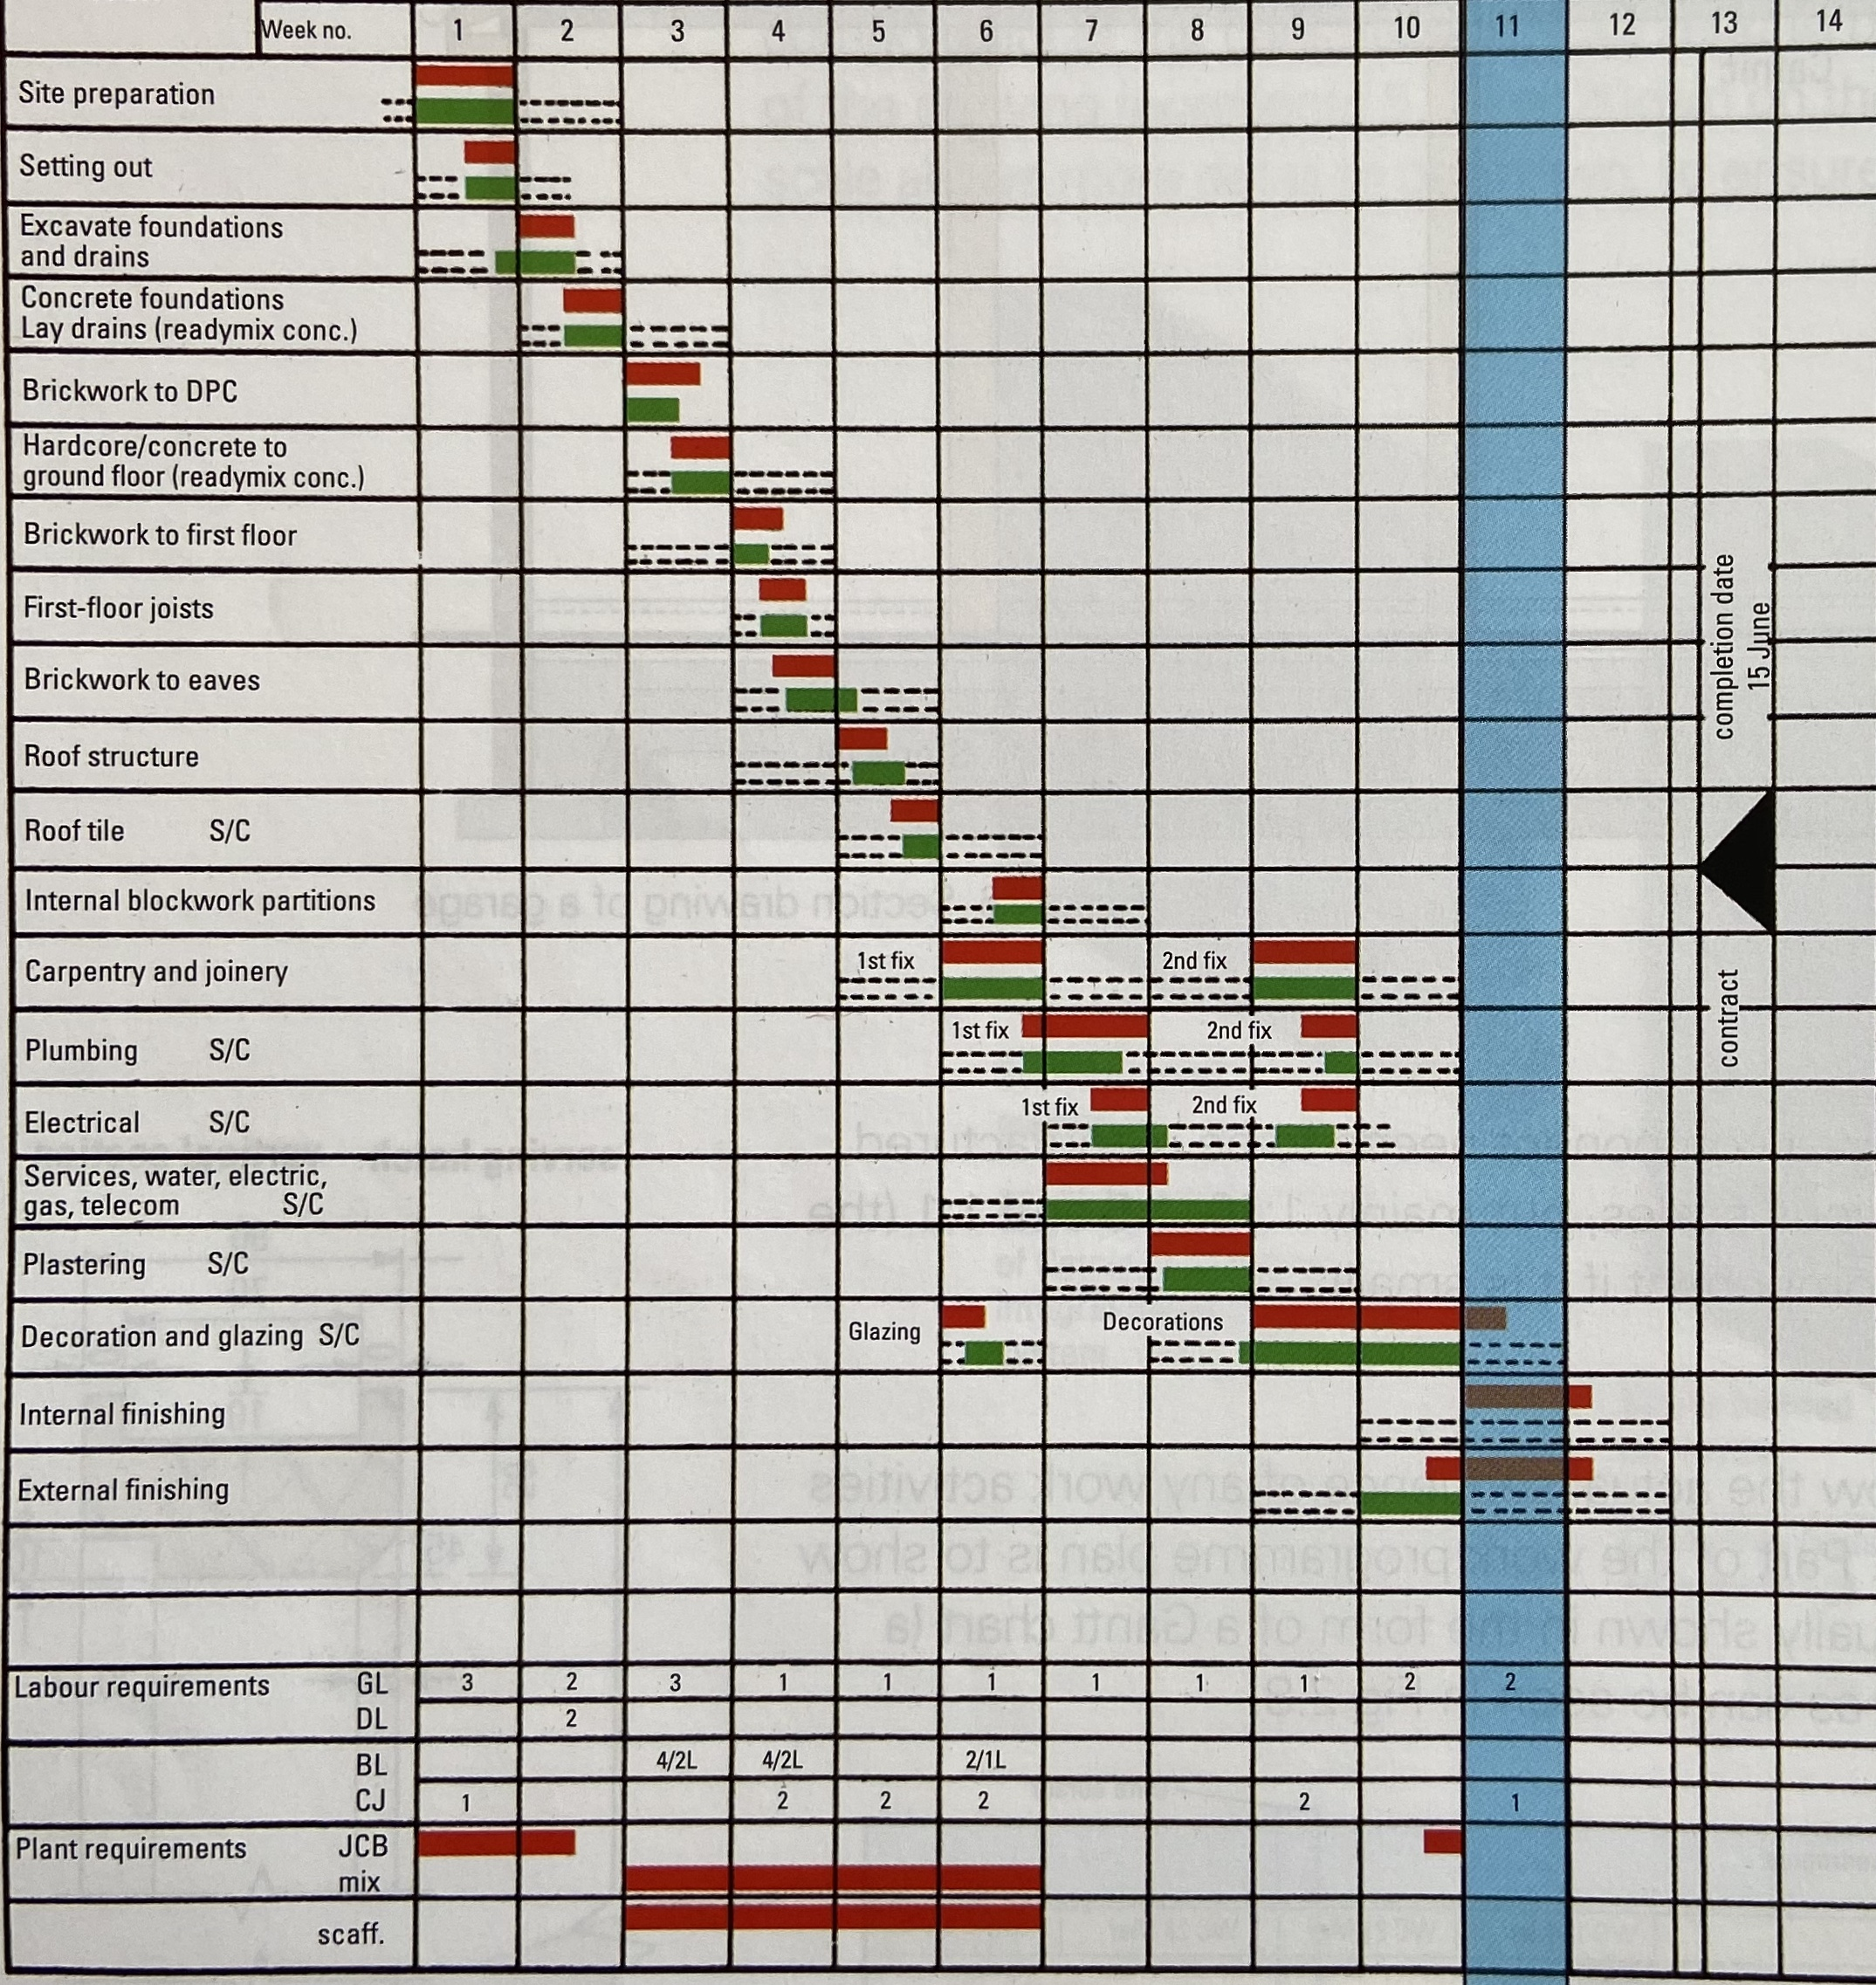

(Sutherland, Canwell & Brooks, 2013, p. 46).

  - Appendix 6: Site Rules:

- Sign in on site.

- Participate in a site induction (brief, first aiders, nearest hospital etc) (Refer to Appendix 2 for Nearest Hospital).

- Analyse the risk assessment and method statements; ask any questions if anyone has a query.

- Wear full PPE at all times on site and to sign in.

- Carry CSCS card at all times or other competencies relating to the project.

- All plant, tools and materials must be stored away in a safe place.

- Food or drink only to be ingested in the canteen.

- Canteen and Toilets in the, ‘Technium 2’ building.

- Nobody should be under the influence of drugs or alcohol when on site.

- Notify the supervisor if prescribed medication.

- Follow the health and safety procedures put in place, if unsure then ask your supervisor.

- Use of walk ways must be separate to traffic routes, which relates to (HSE, 2009, p.7).

- Do not attempt to adjust a scaffolding, notify your supervisor if you need it to be altered.

- Maintain a tidy work site (avoid trips or falls).

- Report any hazards to your supervisor.

- Report any near misses, close calls or accidents, ‘RIDDOR, 1995’ (Sutherland, Canwell & Brooks, 2013, p. 2, 8, 9, 10, 11 & 12). The accident book or close call cards are maintained within the site office.

- First Aid Box, ‘BS 8599’ is maintained within the site office.

- Follow protocol when discovering an accident or emergency (call 999).

- Make sure all hazardous chemicals are stored and locked away in the correct areas, in accordance with ‘COSHH, 2012’ (CITB, 2012, B3, Section B).

- Familiarize and comply with the fire emergency plan (Fire extinguishers, fire exits and assembly destinations) (Refer to Appendix 1).

- Smoking only in designated areas.

- Only reverse parking and drive forward when permitted.

- Deliveries are only to be delivered at the correct loading and storage areas, with the correct information supplied and layout (Refer to Appendix 1) and comply with the (HSE, 2009, p. 10-27).

- Correct lifting techniques and lifting devices must be used to prevent injuries and accidents in accordance to, ‘Manual Handling Operations Regulations, 1992’ (Sutherland, Canwell & Brooks, 2013, p. 4, 22 & 23).

- Banksman to be used for cranes, dumpers or deliveries at all times, ‘Signals to drivers’ (HSE, 2009, p.23).

- Reverse parking only (HSE, 2009, p.18-19).

  - Appendix 7: Method Statements:
Excavation Strip Foundation procedure:
Hazards (reduce risk):
- Banksman in place Keep clear from moving plant.
- Competent professionals supervising the project.
- Exclusion zones sectioned off with warning signs in place.
- Wearing appropriate PPE at all times (head, eye, hands, foot, respiratory equipment & overalls).
- Risk assessments carried out for excavation and concrete task.
- Leptospirosis (wash hands).
- Incorrect lifting (lift as correctly instructed).
- Trench collapsing (supports in place).
- Utilities undetected (dig with caution) explosions.
- Working restrictions 8am-9pm.
- Follow emergency plan (call 999).
- CSCS, SSSTS cards are carried with professionals at all times.

Plant, tools and materials required:
- Plant (360 digger) with stabiliser attachments.
- Dumper.
- Cat Scan.
- Levelling system (surveying).
- Poker.
- Hand tools.
- Concrete/ Rebar Cage/ stilts.
Task stages:
- Exclusion zones, banksman in place to sustain a clear area.
- All plant equipment, tools and materials will be located in a safe location on site away from the working area.
- Contractor will mark out the strips for the foundation to be located.
- The use of a Cat Scan to detect any gas pipes, water pipes or electric cables before digging and to sign the dig permit.
- The trench will be dug at a depth of 1m in relation to the design shape (plant ‘360’ stabilisers in place).
- The top level of concrete will be levelled out using a level or laser, with (shuttering-supports, if needed) sustain the excavated area.
- A wagon will pour the Portland cement aggregates (concrete) over the raised reinforced bar evenly.
- The poker will be placed into the concrete to reduce the air throughout.
- Constant levelling will be carried out to specification, using a straight edge to flatten out the high and low spots.
- Tolerance test will be carried out once complete.
- On completion all materials and equipment are stored away safely, or put waste into the correct skips.

(Strip Foundation-Excavation & Reinforcement, 2017).

  - Appendix 8: Risk Assessments (Excavation Strip Foundation):
Activity to be Assessed |  |  |  |  |  |  |  |  |  |  |  |  |  |  |  |  | Assessment Number
Excavation for a Strip Foundation 1m depth.  Kings Road, Swansea. |  |  |  |  |  |  |  |  |  |  |  |  |  |  |  |  | 01
Persons undertaking or affected by the activity
 |  | x | Employees |  | x | Contractor |  |  | x | Public |  |  |  | x | Service User
 |  |  | Other …………………………………………………………………………………………….
Identified Hazards and Associated Risks |  |  |  |  |  |  |  |  |  |  | Likelihood |  |  |  |  |  | Severity |  |  |  |  | Risk Level
1 | Moving plant colliding with an individual. |  |  |  |  |  |  |  |  |  | 3 |  |  |  |  |  | 5 |  |  |  |  | 15
2 | Trench collapsing. |  |  |  |  |  |  |  |  |  | 2 |  |  |  |  |  | 2 |  |  |  |  | 4
3 | Incorrect lifting technique. |  |  |  |  |  |  |  |  |  | 3 |  |  |  |  |  | 2 |  |  |  |  | 6
4 | Gas explosion. |  |  |  |  |  |  |  |  |  | 3 |  |  |  |  |  | 5 |  |  |  |  | 15
5 | Electric cables. |  |  |  |  |  |  |  |  |  | 3 |  |  |  |  |  | 5 |  |  |  |  | 15
6 | Power tools. |  |  |  |  |  |  |  |  |  | 2 |  |  |  |  |  | 4 |  |  |  |  | 8
7 | Hazardous substances (Petrol, Concrete). |  |  |  |  |  |  |  |  |  | 4 |  |  |  |  |  | 3 |  |  |  |  | 12
8 | Leptospirosis. |  |  |  |  |  |  |  |  |  | 2 |  |  |  |  |  | 3 |  |  |  |  | 6
9 | Unexploded objects. |  |  |  |  |  |  |  |  |  | 3 |  |  |  |  |  | 5 |  |  |  |  | 15
10 | Materials, equipment and hand tools. |  |  |  |  |  |  |  |  |  | 2 |  |  |  |  |  | 2 |  |  |  |  | 4
Existing Control Measures / Additional Control Measures Required
1 | Exclusion zones sectioned off around the working area, stabilisers attached to plant and banksman in place.
2 | Trench supports put in place (shuttering and raised rebar).
3 | Following correct lifting technique as per training course (if you do not feel comfortable lifting the object, do not lift it).
4 | Cat scan the area before digging, insulated handles, thick cloves and fire-resistant overalls.
5 | Cat scan the area before digging, insulated handles, thick gloves and fire-resistant overalls.
6 | Use as per manufacturing instructions, check before use, make sure guards are in place and wear full PPE before use.
7 | Where full PPE and Store correctly COSHH regulations (use of spill mat for generators etc), warning signs in place.
8 | Wear gloves, do not smoke unless you wash your hands, make sure you wash your hands regularly and keep hands away from your mouth.
9 | An unexploded ordnance assessment to be carried out, to detect the working area. Signed off for safe working for strip foundation.
10 | All materials, equipment and tools are put to one side, stacked correctly and locked away after use.
Reassessment of Activity Hazards |  |  |  |  |  |  |  |  |  |  | Likelihood |  |  |  |  |  | Severity |  |  |  |  | Risk Level
1 | Moving plant colliding with an individual. |  |  |  |  |  |  |  |  |  | 1 |  |  |  |  |  | 5 |  |  |  |  | 5
2 | Trench collapsing. |  |  |  |  |  |  |  |  |  | 1 |  |  |  |  |  | 2 |  |  |  |  | 2
3 | Incorrect lifting technique. |  |  |  |  |  |  |  |  |  | 1 |  |  |  |  |  | 2 |  |  |  |  | 2
4 | Gas explosion. |  |  |  |  |  |  |  |  |  | 1 |  |  |  |  |  | 5 |  |  |  |  | 5
5 | Electric cables. |  |  |  |  |  |  |  |  |  | 1 |  |  |  |  |  | 5 |  |  |  |  | 5
6 | Power tools. |  |  |  |  |  |  |  |  |  | 1 |  |  |  |  |  | 4 |  |  |  |  | 4
7 | Hazardous substances (Petrol, Concrete). |  |  |  |  |  |  |  |  |  | 1 |  |  |  |  |  | 3 |  |  |  |  | 3
8 | Leptospirosis. |  |  |  |  |  |  |  |  |  | 1 |  |  |  |  |  | 3 |  |  |  |  | 3
9 | Unexploded objects. |  |  |  |  |  |  |  |  |  | 1 |  |  |  |  |  | 5 |  |  |  |  | 5
10 | Materials, equipment and hand tools stored. |  |  |  |  |  |  |  |  |  | 1 |  |  |  |  |  | 3 |  |  |  |  | 3
Name: Gethin Griffiths.  Position: Trainee Construction Manager. |  |  |  |  |  |  | Signed: G. Griiffiths. |  |  |  |  |  |  |  |  |  | Date of Completion:  5th May 2020.
Reviews |  |  |  | Key
Review Date: |  |  |  | Likelihood |  |  |  | Severity |  |  | Severity of Injury |  | 5 | 5Y |  |  |  | 10R |  | 15 |  |  | 20 |  | 25
Reviewed by: |  |  |  | 1 very unlikely  2 unlikely  3 likely  4 very likely  5 certainty |  |  |  | 1 nuisance  2 minor  3 medical treatment  4 major  5 fatal |  |  |  |  | 4 | 4 |  |  |  | 8 |  | 12 |  |  | 16 |  | 20
Review Date: |  |  |  |  |  |  |  |  |  |  |  |  | 3 | 3 |  |  |  | 6G |  | 9 |  |  | 12 |  | 15
Reviewed by: |  |  |  |  |  |  |  |  |  |  |  |  | 2 | 2 |  |  |  | 4 |  | 6Y |  |  | 8 |  | 10Y
Review Date: |  |  |  |  |  |  |  |  |  |  |  |  | 1 | 1 |  |  |  | 2 |  | 3 |  |  | 4 |  | 5G
Reviewed by: |  |  |  |  |  |  |  |  |  |  |  |  | 0 | 1 |  |  |  | 2 |  | 3 |  |  | 4 |  | 5
Review Date: |  |  |  |  |  |  |  |  |  |  |  |  |  | Likelihood of Injury
Reviewed by: |  |  |  |  |  |  |  |  |  |  |  | Low Risk |  |  |  |  |  |  | Medium Risk |  |  |  |  | High Risk

  - Appendix 9: Method Statement:
Blockwork, Sills and Lintels procedure, (Manual Handling Operations Regulations, 1992) (Working at Heights Regulations 2005) (Working at Height. Brief Guide), (‘Clean Air Act 1993’ silica dust ‘‘COSHH, 2012’):
Hazards (reduce risk):
- Comply with site rules.
- Working at height and overhead objects and secure working platforms.
- Full PPE to be warn at all times, hard hat, harness, gloves etc.
- Respirators to be warn due to silica dust.
- Manual handling (correct technique).
- Barriers and warning signs in place.
- Moving plant (banksman) delivery of materials.
- Scaffolding, ladders and catch nets in place.
- Power tools and equipment to be checked before use.
- Follow emergency plan (call 999).
- Working restrictions (8am-9pm).
- CSCS, SSSTS cards are carried with professionals at all times.
- lights for more effective visibility.

Plant, tools and materials required:
- Folk lift to off load blocks and cement (banksman signalling driver).
- Wheel barrow.
- Mixer.
- Angle Grinder battery 110v, generator 240v transformer.
- Block Cutter.
- Hand tools and levels.
- Trestle and Scaffolding (working platforms).

Task Stages:
- Follow the drawing plans and safety regulations provided by the principle designer.
- Delivered materials to site (lack of room) Banksman signal driver.
- Blocks, mortar, membrane, wall ties, insulation, cavity drainage and vapour sheets will be stored safely on site.
- Datum points marked out.
- Safely stack block close to the working area.
- Wall ties, membrane, insulation, block and lintel; details in relations to the specifications.
- All materials will be supplied to a competent professional by an experienced workman into position (reduce manual handling).
- Apply mortar to specification details.
- Mix mortar on site.
- Trestle and scaffolding will be assembled when required at various stages of the project.
- Secure working platforms will be put in place (stack materials safely).
- Joist openings will be measured within the block work for suspended ground and first floor.
- Correct sills and lintels will be installed over opens to the correct specifications.
- Constantly levelling each course.
- Course around gable end ladders of roof structure.
- Completion of works, safely store equipment and materials in a container or put waste into the correct skips.

  - Appendix 10: Risk Assessment Blockwork, Sills and Lintels procedure:
Activity to be Assessed |  |  |  |  |  |  |  |  |  |  |  |  |  |  |  |  | Assessment Number
Blockwork, Sills and Lintels procedure, (Manual Handling Operations Regulations, 1992) (Working at Heights Regulations 2005) (Working at Height. Brief Guide), (‘Clean Air Act 1993’ silica dust ‘‘COSHH, 2012’): |  |  |  |  |  |  |  |  |  |  |  |  |  |  |  |  | 02
Persons undertaking or affected by the activity
 |  | x | Employees |  | x | Contractor |  |  | x | Public |  |  |  | x | Service User
 |  |  | Other …………………………………………………………………………………………….
Identified Hazards and Associated Risks |  |  |  |  |  |  |  |  |  |  | Likelihood |  |  |  |  |  | Severity |  |  |  |  | Risk Level
1 | Moving plant colliding with an individual. |  |  |  |  |  |  |  |  |  | 3 |  |  |  |  |  | 5 |  |  |  |  | 15
2 | Overhead objects being lifted. |  |  |  |  |  |  |  |  |  | 3 |  |  |  |  |  | 4 |  |  |  |  | 12
3 | Overhead lines and moving plant. |  |  |  |  |  |  |  |  |  | 3 |  |  |  |  |  | 5 |  |  |  |  | 15
4 | Power tools (disc cutter). |  |  |  |  |  |  |  |  |  | 3 |  |  |  |  |  | 4 |  |  |  |  | 12
5 | Materials, equipment and hand tools. |  |  |  |  |  |  |  |  |  | 2 |  |  |  |  |  | 2 |  |  |  |  | 4
6 | Hazardous substances (Petrol, mortar). |  |  |  |  |  |  |  |  |  | 4 |  |  |  |  |  | 3 |  |  |  |  | 12
7 | Falling from scaffolding. |  |  |  |  |  |  |  |  |  | 3 |  |  |  |  |  | 5 |  |  |  |  | 15
8 | Incorrect lifting technique. |  |  |  |  |  |  |  |  |  | 3 |  |  |  |  |  | 2 |  |  |  |  | 6
9 | Falling objects. |  |  |  |  |  |  |  |  |  | 3 |  |  |  |  |  | 4 |  |  |  |  | 12
10 | Cement or silica dust. |  |  |  |  |  |  |  |  |  | 5 |  |  |  |  |  | 4 |  |  |  |  | 20
Existing Control Measures / Additional Control Measures Required
1 | Exclusion zones sectioned off around the working area, stabilisers attached to plant (crane) banksman and warning signs in place.
2 | Check slingers and restraints before use, keep the lifting area clear, section off exclusion zones (use of banksman).
3 | Place temporary barriers in place to reduce the risk of a crane hitting the overhead lines, notify the electric board to isolate the overhead lines, use of a banksman and use insulated PPE.
4 | Use as per manufacturing instructions, check before use, make sure guards are in place and wear full PPE before use (eye and face mask protection).
5 | All materials, equipment and hand tools are put to one side, stacked correctly and locked away after use to reduce trips and falls.
6 | Where full PPE and Store correctly, COSHH regulations (use of spill mats for generators etc), warning signs.
7 | Handrails, kick boards, catch nets and harnesses/ ropes are in place before working at heights.
8 | Following correct lifting technique as per training courses, (if you do not feel comfortable lifting the object, do not lift it).
9 | Kick boards, catch nets, Crane slingers are secure and keep the working area below clear.
10 | Respiratory equipment to be used when cutting blockwork, water aided equipment and extractors to reduce breathing in harmful dusts.
Reassessment of Activity Hazards |  |  |  |  |  |  |  |  |  |  | Likelihood |  |  |  |  |  | Severity |  |  |  |  | Risk Level
1 | Moving plant colliding with an individual. |  |  |  |  |  |  |  |  |  | 1 |  |  |  |  |  | 5 |  |  |  |  | 5
2 | Overhead objects being lifted. |  |  |  |  |  |  |  |  |  | 1 |  |  |  |  |  | 4 |  |  |  |  | 4
3 | Overhead lines and moving plant. |  |  |  |  |  |  |  |  |  | 1 |  |  |  |  |  | 5 |  |  |  |  | 5
4 | Power tools (disc cutter). |  |  |  |  |  |  |  |  |  | 1 |  |  |  |  |  | 4 |  |  |  |  | 4
5 | Materials, equipment and hand tools. |  |  |  |  |  |  |  |  |  | 1 |  |  |  |  |  | 2 |  |  |  |  | 2
6 | Hazardous substances (Petrol, mortar). |  |  |  |  |  |  |  |  |  | 1 |  |  |  |  |  | 3 |  |  |  |  | 3
7 | Falling from scaffolding. |  |  |  |  |  |  |  |  |  | 2 |  |  |  |  |  | 5 |  |  |  |  | 10
8 | Incorrect lifting technique. |  |  |  |  |  |  |  |  |  | 1 |  |  |  |  |  | 2 |  |  |  |  | 2
9 | Falling objects. |  |  |  |  |  |  |  |  |  | 1 |  |  |  |  |  | 4 |  |  |  |  | 4
10 | Cement or silica dust. |  |  |  |  |  |  |  |  |  | 3 |  |  |  |  |  | 4 |  |  |  |  | 12
Name: Gethin Griffiths  Position: Trainee Construction Manager. |  |  |  |  |  |  | Signed: G. Griffiths |  |  |  |  |  |  |  |  |  | Date of Completion: 5th May 2020.
Reviews |  |  |  | Key
Review Date: |  |  |  | Likelihood |  |  |  | Severity |  |  | Severity of Injury |  | 5 | 5Y |  |  |  | 10R |  | 15 |  |  | 20 |  | 25
Reviewed by: |  |  |  | 1 very unlikely  2 unlikely  3 likely  4 very likely  5 certainty |  |  |  | 1 nuisance  2 minor  3 medical treatment  4 major  5 fatal |  |  |  |  | 4 | 4 |  |  |  | 8 |  | 12 |  |  | 16 |  | 20
Review Date : |  |  |  |  |  |  |  |  |  |  |  |  | 3 | 3 |  |  |  | 6G |  | 9 |  |  | 12 |  | 15
Reviewed by: |  |  |  |  |  |  |  |  |  |  |  |  | 2 | 2 |  |  |  | 4 |  | 6Y |  |  | 8 |  | 10Y
Review Date : |  |  |  |  |  |  |  |  |  |  |  |  | 1 | 1 |  |  |  | 2 |  | 3 |  |  | 4 |  | 5G
Reviewed by: |  |  |  |  |  |  |  |  |  |  |  |  | 0 | 1 |  |  |  | 2 |  | 3 |  |  | 4 |  | 5
Review Date : |  |  |  |  |  |  |  |  |  |  |  |  |  | Likelihood of Injury
Reviewed by: |  |  |  |  |  |  |  |  |  |  |  | Low Risk |  |  |  |  |  |  | Medium Risk |  |  |  |  | High Risk

  - Appendix 11: Method Statement:
Roof Structure and Coverings Procedure (Working at Heights Regulations 2005):
Hazards (reduce risk):
- Comply with site rules.
- Working at height and overhead objects.
- Full PPE to be warn at all times, hard hat, harness etc.
- Manual handling (correct technique).
- Barriers and warning signs in place.
- Moving plant (banksman).
- Scaffolding, ladders and catch nets in place.
- Power tools and equipment to be checked before use.
- Follow emergency plan (call 999).
- Working restrictions (8am-9pm).
- CSCS, SSSTS cards are carried with professionals at all times.
- lights for more effective visibility.

Plant, tools and materials required:
- Crane to install roof structure (catch nets and harness with attachments).
- Fixed scaffolding (kick boards).
- Access to roof
- Tile elevator (conveyor belt)
- Fixed Ladders to scaffolding.
- Trusses, ceiling joists, purlins, felt eaves guards, batten, slates, ridge tiles fixings, insulation and euro board.
- Cement / mortar.
- Nail gun, power, hand tools and generator.

Task stages:
- Erect the scaffolding around the perimeter of the external leaf to the wall plate height.
- Fall protection in place and ladder in place for roof access.
- Trusses are delivered to site (lack of room) Banksman signal driver, stored safely on site.
- Crane in lifting position (supervised).
- Trusses lifted individually in to position.
- Trusses fixed into position on to the wall plate with temporary bracing.
- Trusses and purlins fixed into place and fixed into the gable ends of the inner leaf.
- Gable ladder fixed to trusses with timber bargeboards, fascia and soffits in place (closed eaves).
- Blockwork to be coursed around the gable ladder (inner & outer leaf).
- Felt, batten, slates, ridge tiles, fixings, flashing, euro board for soffits, fascia, bargeboards, Insulation, gutter and down pipes to be delivered to site.
- Insulation to be installed between trusses (50mm ventilation gap).
- Conveyor put into a safe position and stabilised.
- Felt laid and over lapped across trusses.
- Batten fixed to trusses at specific centres.
- Eaves guards fixed into position.
- Slates elevated to the scaffolding platform and stored safely.
- Slates fixed to the roof batten (eaves course overlapped).
- Slate process repeated up to the apex.
- Ridge tiles installed with mortar.
- Gable ends to be fixed with slate edging,
- Euro board (UPVC) fixed to the bargeboards, fascia and soffits.
- Gutters installed with down pipes.
- Job completion, plant, equipment and materials will be safely removed (stored safely) or put waste into the correct skips.

  - Appendix 12: Risk Assessment Roof Structure and Coverings:
Activity to be Assessed |  |  |  |  |  |  |  |  |  |  |  |  |  |  |  |  | Assessment Number
Roofing structure and Covering Procedure (Working at Heights Regulations 2005) Kings Road, Swansea. |  |  |  |  |  |  |  |  |  |  |  |  |  |  |  |  | 03
Persons undertaking or affected by the activity
 |  | x | Employees |  | x | Contractor |  |  | x | Public |  |  |  | x | Service User
 |  |  | Other …………………………………………………………………………………………….
Identified Hazards and Associated Risks |  |  |  |  |  |  |  |  |  |  | Likelihood |  |  |  |  |  | Severity |  |  |  |  | Risk Level
1 | Moving plant colliding with an individual. |  |  |  |  |  |  |  |  |  | 3 |  |  |  |  |  | 5 |  |  |  |  | 15
2 | Overhead objects being lifted. |  |  |  |  |  |  |  |  |  | 3 |  |  |  |  |  | 4 |  |  |  |  | 12
3 | Overhead lines and moving plant. |  |  |  |  |  |  |  |  |  | 3 |  |  |  |  |  | 5 |  |  |  |  | 15
4 | Power tools. |  |  |  |  |  |  |  |  |  | 2 |  |  |  |  |  | 4 |  |  |  |  | 8
5 | Hazardous substances (Petrol, mortar). |  |  |  |  |  |  |  |  |  | 4 |  |  |  |  |  | 3 |  |  |  |  | 12
6 | Falling from scaffolding. |  |  |  |  |  |  |  |  |  | 3 |  |  |  |  |  | 5 |  |  |  |  | 15
7 | Falling objects. |  |  |  |  |  |  |  |  |  | 3 |  |  |  |  |  | 4 |  |  |  |  | 12
8 | Materials, equipment and hand tools. |  |  |  |  |  |  |  |  |  | 2 |  |  |  |  |  | 2 |  |  |  |  | 4
9 | Incorrect lifting technique. |  |  |  |  |  |  |  |  |  | 3 |  |  |  |  |  | 2 |  |  |  |  | 6
Existing Control Measures / Additional Control Measures Required
1 | Exclusion zones sectioned off around the working area, stabilisers attached to plant (crane) banksman and warning signs in place.
2 | Check slingers and restraints before use, keep the lifting area clear, section off exclusion zones (use of banksman).
3 | Place temporary barriers in place to reduce the risk of a crane hitting the overhead lines, notify the electric board to isolate the overhead lines, use of a banksman and use insulated PPE.
4 | Use as per manufacturing instructions, check before use, make sure guards are in place and wear full PPE before use (eye and face protection).
5 | Where full PPE and Store correctly, COSHH regulations (use of spill mats for generators etc), warning signs.
6 | Handrails, kick boards, catch nets and harnesses/ ropes are in place before working at heights.
7 | Kick boards, catch nets, Crane slingers are secure and keep the working area below clear.
8 | All materials, equipment and hand tools are put to one side, stacked correctly and locked away after use to reduce trips and falls.
9 | Following correct lifting technique as per training course (if you do not feel comfortable lifting the object, do not lift it).
Reassessment of Activity Hazards |  |  |  |  |  |  |  |  |  |  | Likelihood |  |  |  |  |  | Severity |  |  |  |  | Risk Level
1 | Moving plant colliding with an individual. |  |  |  |  |  |  |  |  |  | 1 |  |  |  |  |  | 5 |  |  |  |  | 5
2 | Overhead objects being lifted. |  |  |  |  |  |  |  |  |  | 1 |  |  |  |  |  | 4 |  |  |  |  | 4
3 | Overhead lines and moving plant. |  |  |  |  |  |  |  |  |  | 1 |  |  |  |  |  | 5 |  |  |  |  | 5
4 | Power tools. |  |  |  |  |  |  |  |  |  | 1 |  |  |  |  |  | 4 |  |  |  |  | 4
5 | Hazardous substances (Petrol, mortar). |  |  |  |  |  |  |  |  |  | 2 |  |  |  |  |  | 3 |  |  |  |  | 6
6 | Falling from heights (scaffolding). |  |  |  |  |  |  |  |  |  | 1 |  |  |  |  |  | 5 |  |  |  |  | 5
7 | Falling objects. |  |  |  |  |  |  |  |  |  | 1 |  |  |  |  |  | 4 |  |  |  |  | 4
8 | Materials, equipment and hand tools stored. |  |  |  |  |  |  |  |  |  | 1 |  |  |  |  |  | 3 |  |  |  |  | 3
9 | Incorrect lifting technique. |  |  |  |  |  |  |  |  |  | 1 |  |  |  |  |  | 2 |  |  |  |  | 2
Name: Gethin Griffiths  Position: Trainee Construction Manager. |  |  |  |  |  |  | Signed: G. Griffiths. |  |  |  |  |  |  |  |  |  | Date of Completion: 5th May 2020.
Reviews |  |  |  | Key
Review Date: |  |  |  | Likelihood |  |  |  | Severity |  |  | Severity of Injury |  | 5 | 5Y |  |  |  | 10R |  | 15 |  |  | 20 |  | 25
Reviewed by: |  |  |  | 1 very unlikely  2 unlikely  3 likely  4 very likely  5 certainty |  |  |  | 1 nuisance  2 minor  3 medical treatment  4 major  5 fatal |  |  |  |  | 4 | 4 |  |  |  | 8 |  | 12 |  |  | 16 |  | 20
Review Date: |  |  |  |  |  |  |  |  |  |  |  |  | 3 | 3 |  |  |  | 6G |  | 9 |  |  | 12 |  | 15
Reviewed by: |  |  |  |  |  |  |  |  |  |  |  |  | 2 | 2 |  |  |  | 4 |  | 6Y |  |  | 8 |  | 10Y
Review Date: |  |  |  |  |  |  |  |  |  |  |  |  | 1 | 1 |  |  |  | 2 |  | 3 |  |  | 4 |  | 5G
Reviewed by: |  |  |  |  |  |  |  |  |  |  |  |  | 0 | 1 |  |  |  | 2 |  | 3 |  |  | 4 |  | 5
Review Date: |  |  |  |  |  |  |  |  |  |  |  |  |  | Likelihood of Injury
Reviewed by: |  |  |  |  |  |  |  |  |  |  |  | Low Risk |  |  |  |  |  |  | Medium Risk |  |  |  |  | High Risk

