Skills for Success

To succeed in the field of creative computing, graduates must build two essential skillsets that will allow them to work proficiently and have an advantage in the industry: academic and employability skills. The first skillset, academic skills, cover the abilities student use to study effectively, and they also develop graduates’ expertise in the workplace for the future. One of the most transferable academic skills graduates can build for the field is critical analysis. Critical analysis involves objectively engaging with a text by assessing the intended message/point, reading other sources on the topic and using judgement to form a conclusion [1, p. 250]. Other important academic skills that graduates should develop further include:
- managing time for studying
- planning and organisation
- self-motivation and discipline
- digital skills and using online tools [2].

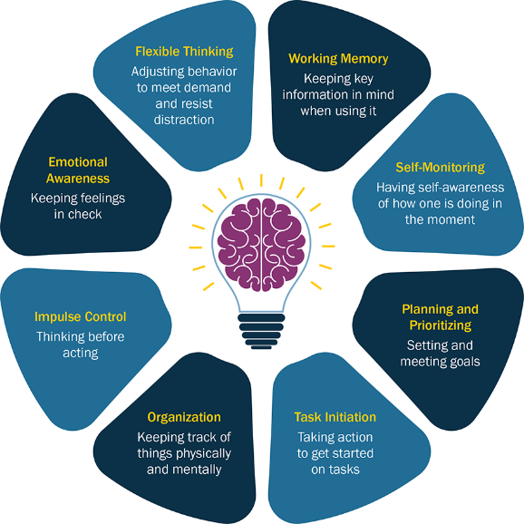
Figure 1, [3], Graph showing several examples of academic skills and how they're used

The secondary set of skills, which are employability skills, are the transferable attributes that will help graduates find jobs and secure their place in the industry. For creative computing and other fields, these skills are divided into hard and soft skills, which differ in some respects but are both important. Hard skills are the technical abilities required to complete a task, such as expertise in software or managing projects. Soft skills cover the personal skills individuals have that allow them to work effectively in the workplace, such as communication with colleagues, adapting to changing conditions, and creative thinking [4]. Employability skills also overlap with academic skills, but both are important to develop as the industry continues to look for graduates with these skills. In particular, Sharland and Slesser’s research [5] shows that creative thinking is becoming one of the most valued skills in the workforce, so students/graduates should use their time to build skills sought after in the industry to make strides in their career.

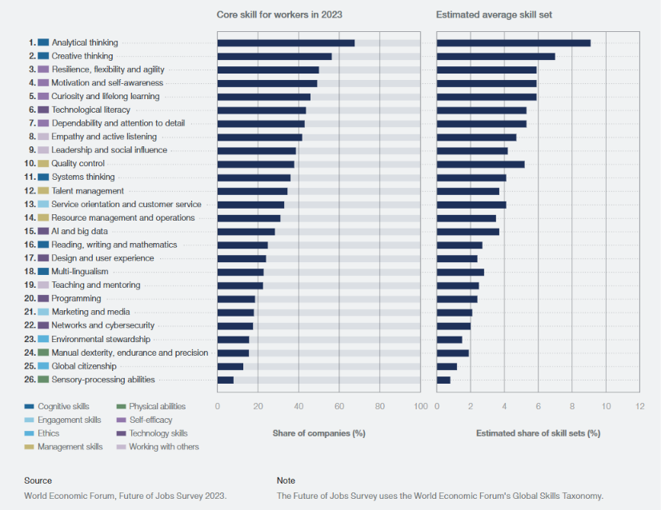
Figure 2, [6], Organisations were surveyed in the graph on which skills were the most important to them

Making use of AI

The AI boom has made effectively using its tools essential for professionals in the modern computer industry [7, p. 3]. As it can help accelerate development and strengthen cybersecurity, it’s important to choose the right AI assistant for the appropriate field and tasks. Different AI assistants have strengths in certain areas. ChatGPT, one of the most used AI chatbots [8, p. 8], is best for general use as it uses various features such as web searches and agent modes. Google Gemini also performs well across many areas, but its standout features are its integration with Google Drive and free access to advanced models. Claude is particularly well-received in coding and long-form writing, and Copilot’s main strength is integration with Microsoft Office and Windows. Lastly, Perplexity is best used for research and information as it primarily functions as an AI search engine.
For creative computing, an assistant that’s able to do coding/other technical tasks, along for general logic and brainstorming is key, which makes Claude a strong choice for the field. For instance, Claude can directly integrate with Sketch to create interactive interfaces to demonstrate concepts, such as Perlin noise, or generate concept ideas for your projects.

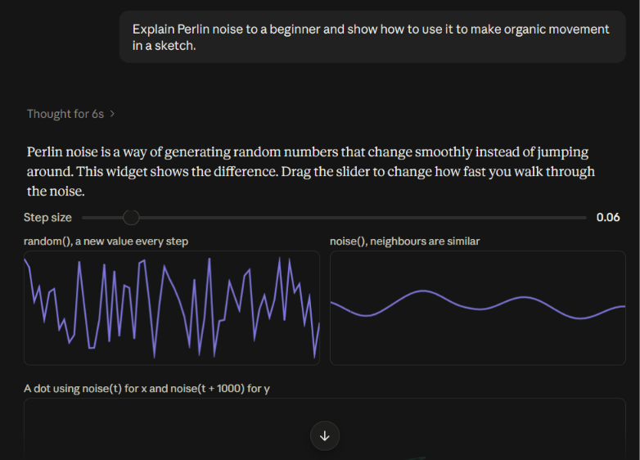
Figure 3, [9], Claude can explain different concepts to the user in an interactive way

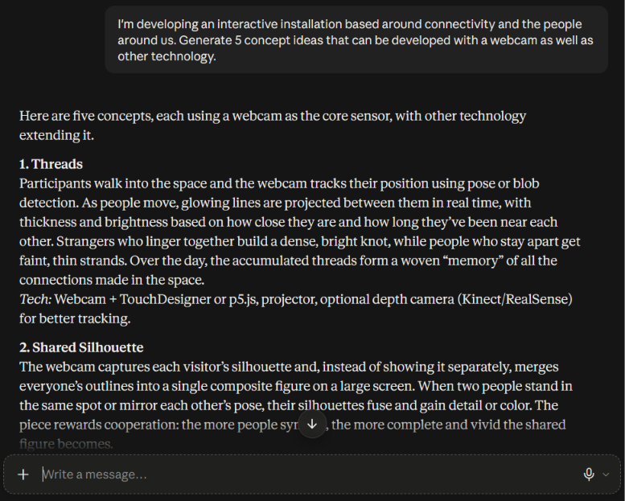
Figure 4, [9], Creative assistance with Claude is a useful application in creative computing

Bibliography

[1] | G. Price and P. Maier, Effective Study Skills: Essential Skills for Academic and Career Success, Harlow, Essex, United Kingdom: Pearson, 2007.
[2] | University for the Creative Arts, “Academic Skills,” [Online]. Available: https://mylibrary.uca.ac.uk/academicskills. [Accessed 7 October 2026].
[3] | “Design Principles for Schools,” [Online]. Available: https://k12.designprinciples.org/integrated-support-systems. [Accessed 02 October 2026].
[4] | A. Needham, “Soft Skills vs Hard Skills,” University of Salford, 21 October 2024. [Online]. Available: https://www.salford.ac.uk/spd/soft-skills-vs-hard-skills. [Accessed 7 October 2026].
[5] | L. Sharland and C. Slesser, “The workforce of tomorrow needs creative thinking now,” British Educational Research Association, 31 July 2024. [Online]. Available: https://www.bera.ac.uk/blog/the-workforce-of-tomorrow-needs-creative-thinking-now. [Accessed 08 October 2026].
[6] | World Economic Forum, “Future of Jobs Report 2023,” World Economic Forum, Geneva, Switzerland, 2023.
[7] | Organisation for Economic Co-operation and Development, “Using AI in the workplace,” OECD Publishing, Paris, France, 2024.
[8] | J. Gottfried, W. Bishop, M. Anderson, M. Faverio, E. Park and C. McClain, “Americans and AI 2026: Chatbots, Smart Devices, and Views on Impact,” Pew Research Center, Washington D.C., United States, 2026.
[9] | Anthropic's Claude, private communication, 2026.

