
Skills for the Workplace
Module Assignment Submission
Student Name: | Tracey Hughes
Student Number: | 20008698
Module No: | BMSK4002
Module Title: | Effective Team Working and Communication  Part 2

Statement of Confirmation of Authenticity
By the act of making this submission, the student declares that this is the work of the student named above. The work has not, in whole or in part, been knowingly presented elsewhere for assessment, or where assessment has been built on a previous assessment, this has been identified. Where materials have been used from other sources it has been properly acknowledged. If this statement is untrue, the student acknowledges that an assessment offence has been committed.
Attention is drawn to the plagiarism and unfair practice policies of both the University and of ILM.

Table of Contents
Part 2 Communication 3
1.0 3
Communication Cycle 3
2.0 7
Assessing Own Communication Skills as a Manager 7
Gap Analysis 7
PDP 8
Personal Development Plan to Improve own Communication Skills 8
References 9
Appendix A 10

Part 2 Communication

1.0

Communication Cycle

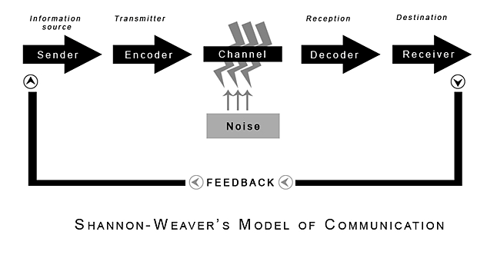
(Shannon and Weaver, 1949)
In 1948, Shannon an electronical engineer and Weaver an American scientist joined together to write an article in the ‘Bell System Technical journal ‘called a mathematical theory of communication ‘also called “Shannon and Weaver model of communication". (Chandler, 2011)
This model was specifically designed to develop effective communication between sender and receiver. This model describes communication as a linear process as shown above.
This model deals with five elements, these are an information source where the message begins, a transmitter which encodes the message into signals, a channel where signals are adapted for transmission, a receiver that decodes the message and a destination where the message finally arrives.
It is extremely important when a message is being delivered there is no miscommunication, and it is clear and simple.
A sixth element would be noise which can interfere with the message being sent. Noise can come from many forms such as static from a phone.

As both Shannon and Weaver were mathematics and both worked for “Bells Telephone Laboratories” it was deemed valuable for communication engineers when dealing with issues such as static and interference and because of this, this model is very information based so may be limited as a human communication model.
While this model was influential its disadvantages are easy to see as this model assumes communication only goes one way, such as a speech, tv advert or sending an email. This can cause problems as there is no conversation, no feedback to make sure the message was relayed properly or gain an understanding. (Munday,2011)
Another major disadvantage of this mode is it can isolate people from lines of communication, miss out on vital information and being able to contribute any ideas. (Dipilato, 2019)

The three well known models for communication are Linear, interactional, and transactional. Each model shows the development and the difference in communication. (West & Turner, 2007)

Interactional models deal with messages that goes both ways in which communication and feedback flow between sender and receiver. This helps with understanding the message and been able to give feedback, it uses different components for communication to work and proposes that a person behaviour is determined by their personality and environment. This model also has noise, such as language and social barriers. (Corey, M)
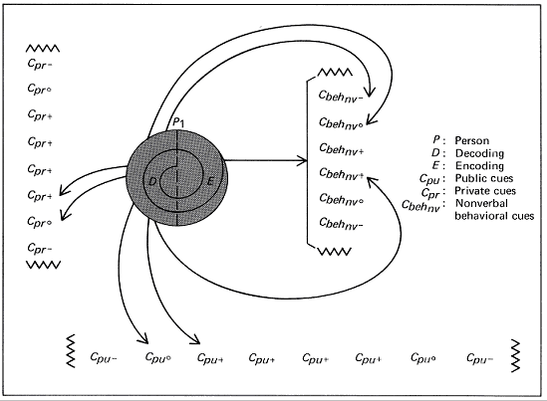
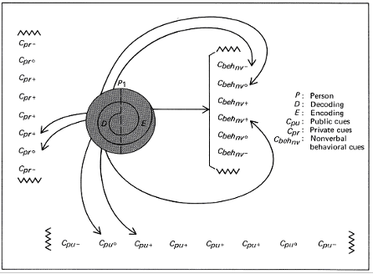
Barnlund Transactional Model (2008)

As models of communication have evolved one of the most useful models would be Barnlund’s transactional model. (2008) this is used as an interdependent process sending and receiving messages simultaneously and uses constant feedback, it happens in real time-and generally all parties are present. Examples are face to face meetings or a team meeting using a platform such as Skype or teams. (Businesstopia, 2018).
Communication or interpersonal skills is the act of sharing information from one person to another or a group of people. Communication is used in one form or another in every workplace and is necessary to build relationships, share ideas and delegating responsibilities when managing a team.
There are four types of communication people use daily, verbal, nonverbal, written, and visual. They are all as important as each other and if used satisfactory can improve your business. (Indeed, 2021)
Verbal means using speech to share information with each other, it can be face to face over the phone. Skype, , zoom etc. you need strong verbal skills to be able to get your point across clearly and have productive meetings. By having a strong confident speaking voice, speaking loud and clear makes it easier for others to understand.

Non- verbal communication includes smiling, eye contact hand gestures and posture, it also helps get a sense of how others are feeling, whether they are using closed body language making them seem anxious or nervous, or open body language making them feel confident and at ease. It is important to display positive body language to gain confidence so it sits aside with what you are saying, being too closed off can come across as arrogant and not open to another's point of view or idea.
Written communication is an especially useful tool which should be kept simple and clear, always kept to the point, jargon and technical terms are kept to a minimum, setting aside time to identify any mistakes as this creates a record for future reference.
Last but not least is visual communication, which uses charts and graphs to communicate information. It is important that the information is straightforward and relates to what is spoken. As we are a visual society and advertisers use imagery to sell products its extremely important to remember not everything is as its shown and it can become misleading.

In a hierarchy organisation such as a large retail company, communication is in the form of a top down method from Management, giving orders and allocating task to staff. even though Communication between staff members is frowned upon because staff are expected to get on with their own tasks without distraction.
Team members are willing to help each other if they are able to do so and if a different sort of leadership were to be implemented using a flatter management style and being more open to two-way communication, there would be less dissatisfaction in h workforce, resulting in absences and a high staff turnover.

Communication theories talk about the sender, the receiver, the message, and the noise. Noise has become the most significant sound in our lives, this noise includes physical noise, such as cars and appliances and psychological noise including what is going on in the person’s mind while others are speaking.
To actively listen to someone, it is important to use social cues such as a nod of the head, raising eyebrows and showing interest because while many people look as if they are listening, they are not really and are thinking of something ese or possibly day dreaming. This can often be seen as disrespectful to he person who is speaking. It is important to make the speaker feel that what they are saying is valid and engaging, as listening is a form of nonverbal communication (Weger et al, 2010).
Listening enables the listener to be aware of what the person speaking might be experiencing by observing both the words used and emotions being displayed. Practising being non-judgemental and mindful will make the speaker more comfortable speaking out, (Mindtools, 2012). Giving people the chance to speak without interrupting, this sometimes gives the speaker chance to reflect on what they are saying. Paraphrasing is often an effective way to let the speaker know you have been interested in their conversation as it does not necessarily make people feel understood, but it does create a sense of closeness and intimacy in a conversation(Ohlin, 2020).
In addition, a good listener does not interrupt before the speaker has finished as this can show a sign of arrogance and self-importance making the speaker feel that their views are not valid. This can then cause the speaker to feel unheard and unimportant and will make them feel uneasy and reluctant to speak up in the future.
An article by Peter Blenkinsop (2010) states that its extremely important when giving out messages that they are concise and easily understood using the 7 Cs of communication. If messages are difficult to understand they can cause confusion.
In a retail setting, it is imperative that memos are sent in plenty of time so that actions can be completed quickly and efficiently. If not, it can cause disputes between customers and staff if they are not kept up to date. Problems can be avoided if the person sending the messages was more thorough and made sure that all persons in the group had access to the new directions and were used in a straightforward manner. To bypass these problems, when the message is received by higher management it is cut down specifically for each department and deliverables set out and any question and misunderstandings are dealt with as quickly as possible, so all parties are working from the ‘same song sheet’, so to speak.

2.0

Assessing Own Communication Skills as a Manager

By assessing my own communication skills as a manager, I feel that I do come across as a very empathetic person and am proud to say that I know my team very well. Working up from a weekend job to management over several years. I feel because I have done the basic mundane jobs and have a lot of experience, I am better thought of than new managers that just join the business. I admit I do work against the business code of practice of not socialising with anyone underneath you , which I find very disrespectful, I feel it's important to know all my team personally , and often have one to one conversations in a more relaxed atmosphere where someone will be more open , I never hide my personal life and am open with what I have had to deal with as a person, hoping others will see this as a strength , and can easily open up if they have any issues whether that in work or at home . The rule of do not bring your home life to work is a very outdated way of working.
In my self-assessment findings, based on answers I gave my score was average, this was disappointing and has made me realize I need to improve or at least get rid of unhealthy habits I might have picked up. With listening I need to try to concentrate on one thing at a time, so I am given the person all my attention. My emotional intelligence is based on past experiences where I have been made to feel not good enough and came across as that to others, I need to work on this as I did not realise that by understanding others more will help me with my own personal development.
I do struggle with verbal communication again is due to being self-critical and need to work on my self-esteem and confidence. Because I sometimes get flustered, and find it difficult to get my point across, although in my presentation my feedback showed I came over as being quite knowledgeable this is because spent a lot of time on it and practised speaking and was comfortable in my group. This has given me confidence knowing even though I was extremely nervous I didn’t portray that to others. I need to work at my self-confidence as this lets me down in all areas of my life especially in work-based environments. Due to events that have happened in the past, this is an area I struggle with but since doing this course and having more knowledge I believe, I am improving.

Gap Analysis

Objective | Current Position | Deficiency | Action
What do I want to do? | What can I already do? | What am I lacking? | How do I fix this?
Public speaking | Clear speaking, read well, | Confidence  Self esteem | Try to have more practise, the more I do it more confident I feel.
Be confident in my own abilities. | I am knowledgeable.  Experienced | Confidence  Self esteem  Get up and go. | Try harder to push myself out of my comfort zone.
Interpersonal skills | Friendly  Easy going  Dependable  Good listener  empathetic | Confidence  Self esteem  Belief in my own strengths | Push myself to get to know people of all ages and backgrounds.  Push myself out of comfort zone.

PDP

Personal Development Plan to Improve own Communication Skills

Objectives | Tasks | Success Criteria | Time Frame | Resources
List your Goals | What do you need to do to achieve these goals? | How will you identify your success? | When do they need to be done by? | Who or what do you need to help you?
Dealing with conflict | Learn some new skills to help with this. | By feeling I can get my feelings and thoughts out without being nervous. | As soon as possible | Mentor help or reading material.
Listening skills | Learn to really listen without interrupting. | By having more respect from my team | As soon as possible | Practising using effective listening tools.
Being more open and honest with others about my feelings | Try not to hide my feelings for the benefit of others. | When I feel as I have been heard and acknowledged | As soon as possible | Start talking to people I trust first.

References

Blenkinsop, P. (2010) The Communication Cycle. [online] Available at: http://manyana-education.blogspot.com/2010/10/communication-cycle.html Accessed: 22.04.21
Businesstopia (2018) Barlund’s Transactional Model of Communication [online] available at: https://www.businesstopia.net/communication/barnlund-transactional-model-communication. Accessed 21.05.21.
Chandler, D. & Munday R. (2011) A Dictionary of Media and Communication. (1 ed). [online] available at: https://www.oxfordreference.com/view/10.1093/acref/9780199568758.001.001/acref-9780199568758. Accessed 24.05.21.
Corey, A. M.(2018) The evolution of human communication: from theory to practice. [online] available at: https://ecampusontario.pressbooks.pub/evolutionhumancommunication/chapter/chapter-1. . accessed 24.05.21
Dipilato, K.A. (2018) What is the disadvantage of the linear model of communication? [online] available at: https://www.quora.com/what-is-the-disadvantage-of-the-linear-model-of-communication. accessed 25.05.21.
Indeed (2021) 4 types of communication [online] available at: https://uk.indeed.com/career-advice/career-development/types-of-communication. Accessed 25.05.21.
Ohlin, B (2020) Active listening: The art of empathetic conversation [online] available at: https://positivepsychology.com/active-listening/
MindTools (2021) How good are your communication skills? [online] Available at: https://www.mindtools.com/pages/article/newCS_99.htm Accessed: 22.04.21
Mind tools. Active listening: Hear what people are really saying. [online] Available at: https://www.mindtools.com/commskll/ActiveListening.htm. Accessed 23.05.21.
Shannon, C. and Weaver, W. (1949) The Mathematical Theory of Communication. Urbana: University of Illinois Press.
Skills You Need (2021) Interpersonal Skills Self-Assessment. [online] Available at: https://www.skillsyouneed.com/ls/index.php/343479 Accessed: 22.04.21

Appendix A

Presentation Feedback and Evaluation.

Presentation Evaluation Sheet
Module: BMSK4002
Topic: Effective Team working
Date 23.05.21 | Name of Presenter: Tracey Hughes
 | Feedback
 | Weak | Fair | Good | Excellent
Prepared for Presentation |  |  | x | xx
Presented in an interesting way |  |  | x | xx
Objectives of the presentation are clear |  |  | xx | x
Used visual aids effectively |  |  | xx | x
Organised the presentation logically |  |  | xx | x
Spoke loudly enough |  |  | xx | x
Spoke slowly and clearly |  |  | xx | x
Presented within appropriate time |  |  | xx | x
Responded to questions accurately |  |  | xx | x
What can I do better next time?  Have more practice speaking in front of others. | What went well?  Everyone enjoyed my presentation I came across as confident and well prepared.

Appendix B
Self-Assessment Test Results



