In the name of Allah (SWT), the most Gracious, the most Merciful.

Effective TEAM-WORKING AND COMMUNICATION
Component 2

July 10, 2020
University of Wales Trinity Saint David

Mr Soyful Islam Miah
BMSW4002
1709512
Lecturer: Melanie Squires

Executive Summary

In this report, one will examine and analyse both theories by Tuckman and Belbin regarding effective teamworking and how the main theories and practices can be applied to this case study. The case study in question being a busy café in Swansea city centre, which has undergone a very recent and rapid expansion. One will investigate how current staffing is structured and organised and what improvements can be made regarding the smooth running of the business. One will also examine both cost effectiveness and profitability and how both can be increased by reducing staff members and streamlining the business more effectively. Roles of staff members will also be investigated to see how they can be more clearly defined, and Belbin’s questionnaire will support this to understand and define each employees’ various traits and characteristics. As it stands currently the busines has a group structure, which is very ad hoc, and changes will need to be made to ensure that the business is run more efficiently.
Effective methods of communication will also be examined through various models, such as Shannon-Weaver, Schramm and Berlo in order that communication in this workplace can be improved. In particular how the issue both verbal and non-verbal communication will be tackled and greatly enhanced upon, thus both improving customer service and professional working relationships between staff members. Both passive and active communication skills will be studied in depth as they are vital skills to build a more positive and productive working environment.

Table of Contents
Executive Summary 1
Terms of Reference 3
Procedure 3
Introduction 3
Findings 3
Tuckman’s Theory 3
Belbin Team Characteristic 4
Two Way Communication 7
Berlo’s - Source, Message, Channel and Receiver (SMCR) Model 7
Shannon and Weaver Model of Communication 9
Schramm’s Model of Communication 10
Conclusion 11
Recommendations 11
Appendices 12
Acknowledgements 12
Reference List 13
Communication Theory. Berlo’s SMCR Model of Communication. Available at:https://www.communicationtheory.org/berlos-smcr-model-of-communication/ (Accessed 08th July 2020) 13
Communication Theory. Shannon and Weaver Model of Communication. Available at:https://www.communicationtheory.org/shannon-and-weaver-model-of-communication/ (Accessed 09th July 2020) 13
UPDATE TABLE FREQUENTLY – CHECK IT HAS BEEN UPDATED PRIOR TO SUBMISSION

Terms of Reference
This report was requested by my lecturer Melanie Squires to be submitted by Mr Soyful Islam Miah through Turnitin links on the 10th July 2020, due to having been granted an extension by Ruth Cook. The report will discuss a case study of a recently expanded business in Swansea city centre. The purpose of this report is to implement the vast number of different theories and models that will help the business to improve and become more productive with the use of effective team-working and communication strategies.

Procedure
I have used online websites and lecture slides from Moodle as well as academic journals and through knowledge gained from remote lectures.

Introduction
I will be looking at the case study and addressing the key issues within the said business. the Tuckman and Belbin theories will show how effective the teams can become by working and communicating amongst each other in a team rather than in a group. How conflict can be avoided and erased in a team. One will show how teamworking theories will improve the businesses structure and productivity. I will also be investigating various communication models, such as Berlo, Schramm and Shannon-Weaver and how these principles can be applied in practice to the said business.

Findings

Tuckman’s Theory
The Tuckman theory has four key stages which will be explained below:

Forming Stage – is when team members will meet for the first time and get to know each other in order to build a working relationship by inducing to one another which one can get a feeling of the of judging each other characters by analysing each other’s behaviour and pointing out which has the dominate personality and leadership skills.

The business has 21 employees who variety in age and experience, due having a high number of employees there will be a forming stage were one feels that all employees should meet and get to know each other, this can be monitored by the general managers by Karen and Simon by holding a team meeting. One can offer Belbin’s questionnaire to all employees for identify which individuals what personality types.

Storming Stage – at this stage team members are vying and wanting their voices heard to become the stronger personality who are willing to push for leadership skills within the team. The emotional levels are at an utmost high and conflict may occur at any time. Team members may resist the task at an emotional level which therefore leads to further conflict within the team. Naturally, conflict is a phenomenon within any sort of teams, it can occur mostly during the storming stage when developing a team and when sorting out roles and responsibilities.

As we have found during this stage conflict is at its highest and personalities will clash for the higher positions within the team. If the teams are formed from the results of the Belbin’s questionnaire then one can find who holds which strength and weakness to delegates, the correct roles, and responsibilities within the business.

Norming Stage – This is when team members’ roles have been developed and conflicts are settled by exchanging views. This leads to co-operation between team members.

We have seen at the norming stage many employees tend to settle into their role and which place they stand in. the business has three cooks, one pot washer and two supervisors that have a established role. One feels respect has been achieved at this stage, the business has many employees working at different hours and days, and this now can be compromised amongst each employee as co-operation has now been developed between teams.

Performing Stage – The performing stage is when the teams have been established and their roles have been developed. They can function without being micromanaged and have become self-sufficient in achieving their shared goals and objectives. Solutions are now found and implemented which leads to an excellent standard of working.

This is the place where every employee is now communicating amongst with each other and teams are working to reach their common goal of making a profit for the business. the teams will be working more effectively and more smoothly to make sure that they have their rewards and incentives. One feels that rewards are the best way for team members to work to their fullest as they are acknowledged and appreciated within the organisation. If trust is the ethos of the team culture, then conflict will be minimised

Belbin Team Characteristic
Belbin’s theory examines different characteristics that employees possess, which will in turn help them to form a successful team within their organisation. This structure is vital to success as each individual has an important contribution to make and the team will then work together as a collective with each member performing their own individual tasks but everyone working together in order to achieve common goals and objectives.
Benefits of the Theories
Presently the café employs 21 staff of various ages and experience. The business currently has no formal team structure in place which has led to working patterns becoming very ad hoc. One might suggest that implementing a formal team structure may lead to a vast improvement in both productivity and working relations. As the current structure of the business is a group structure which is a very individualistic approach, employees are not working as a collective and therefore may not always be working towards a common goal. Whereas by contrast in a team structure they would be. If Belbin’s theory were to come into play as previously stated, it would take into account that there are a variety of people with different characteristics working in the business and individuals could therefore be identified for possessing different traits which will in turn enable the formation of highly successful teams. This will also help to define clearer roles for staff working in the business. That said there are several staff within the business who do have distinctly specific roles, which include Simon and Karen the general managers, two shift supervisors, three cooks and one pot washer. However, the waiting staff undertake a variety of different duties such as serving customers, taking payments, barista duties and dealing with takeaway orders. One concludes from this that all the waiting staff do not have clearly defined roles within the business, and this may cause some confusion and possible conflict. This in turn may have a negative impact upon the business. One has observed that in organisational terms the current structure is very management heavy and thus by initiating a team structured approach costs and overheads would be reduced. Neuman, J. (1975) Certainly, this approach is cost effective and will maximise profit and improve customer service.
By implementing Belbin’s theory to the business one can identify everyone’s characteristics. The Belbin questionnaire will directly point out one’s traits and what strengths they uphold. This can create a positive team that works and gels together to bring about a constructive working environment. It also helps to identify strengths and weaknesses within a team. One feels that Belbin’s questionnaire should be completed first as then the business will have identified whom will work better together. The Tuckman theory can be applied to this business as soon as teams are combined, there will be the four key stages that team members will come across but having completed these stages the end results become productive and will lead to effective team working. There are currently 21 employees working for the business however, this can be reduced to 18 and the structure can be made up by completing Belbin’s questionnaire in the first instance. This will find how to build teams as you can identify who has which characteristics. There should be a mixture of different personality types in each team. The 18 employees should be split into two groups by a mixture of different personality types and different traits. Karen and Simon will assume the role of the co-ordinator within their respective teams as in this role one delegates various tasks and responsibilities to other team members (Belbin.com). The two teams should be managed individually by Simon and Karen, by having the first team working from 8am to 2:30 pm with a team of 9 employees in each team. The second team would start their shifts from 2:30 pm to 7pm. Then the Tuckman theory will come into effect and help Karen and Simon identify who should have which role within the team.
The long-term sick employee will need to be replaced or made redundant best according to their contract of employment, by a new member of waiting staff. One stresses that there is a high need of a second pot washer in the kitchen on either the morning or the afternoon shift. The two shift supervisors could be offered redundancy best according to their contract. One should consider however that Part time employees are entitled by law to receive the same treatment as full-time employees (Gov.uk) By constructing a staff rota, everyone should have two days off per week including a Sunday and work a total of thirty-two and a half hours per week (Gov.uk). Assuming that staff who are less experienced fall into the age category of between sixteen and eighteen years of age, they could be employed on Fridays and Saturdays as these would be the café’s busiest times. This again would arguably more cost effective due to the current structure of the national living wage (Gov.uk)

Team 1 (Morning Shift) – 8am – 2:30pm  Karen – General Manager/ Shift Supervisor/ Serving Role  Monday -Thursday  4 waiting staff  - 1 staff/ Karen -Serving  - 1 staff – Payments  - 1 staff – Barista duties  - 1 staff – Takeaway orders  1 Cook  1 Cleaner  1 Pot washer  Friday - Saturday  5 waiting staff  - 2 staff/ Karen – Serving  - 1 staff – Payments  - 1 staff – Barista duties  - 1 staff – Takeaway orders  1 Cook  1 Cleaner  1 Pot washer | Team 2 (Afternoon Shift) – 2:30pm – 7pm  Simon – General Manager/ Shift Supervisor/ Serving Role  Monday -Thursday  4 waiting staff  - 1 staff/ Simon -Serving  - 1 staff – Payments  - 1 staff – Barista duties  - 1 staff – Takeaway orders  1 Cook  1 Cleaner  1 Pot washer  Friday - Saturday  5 waiting staff  - 2 staff/ Simon – Serving  - 1 staff – Payments  - 1 staff – Barista duties  - 1 staff – Takeaway orders  1 Cook  1 Cleaner  1 Pot washer

Two Way Communication

Berlo’s - Source, Message, Channel and Receiver (SMCR) Model
The Berlo’s communication model (www.communicationtheory.org/berlos-smcr-model-of-communication/) will be explained and shown how it can be practically applied to this case study. One will now demonstrate how the business can use this model in theory.

S - Sender/Source
Accounting to Businesstopia in Communication (2018) The sender is the person or source who forms or creates the message in the first instants. The message is then sent by the source or the person to the receiver.

Karen and Simon will need to possess excellent communication skills, as without clarity with their team members information may be misinterpreted. If the employers have good communication skills, they can save time and effort as things are understood in the first instance and that misunderstandings and conflicts are reduced significantly. With poor communication skills there are more confusion in the business as clear instructions are vital to the smooth running of the business. There must be clear verbal communication with the waiting staff who are serving the consumers in the establishment. The nonverbal communication will be a good indication as to how the staff present themselves with the skills or positive body language by smiling and keeping eye contact and a good posture as this will help to portray the business in a positive light. Friendly staff with a confident attitude will encourage customers to return, so therefore increasing profitability and maintaining the profile of the business
The staff will always have to use the correct register of language towards the customer and speak in professional and courteous manner. They must execute excellent listening skills to process the correct information regarding customer orders as reading communication is essential and demonstrates sound knowledge of the menu. Staff can clarify any order or question that a customer may request. The writing would have to be clear and understandable for the customer to read the final bill. One must stress that the writing will impact the kitchen staff and must be written in a clear and legible manner to avoid confusion and mis interpterion
These are the most important aspects of communication for employees and employers at the business as if the receiver cannot process the information correctly then there will be a breakdown in the chain of communication.
One might also suggest that because the customer base of the business may form a wide and varied demographic, that Simon and Karen should offer training in cultural differences to their teams. According to Businesstopia in Communication (2018) with in different spectrums of culture some forms of communications maybe considered offensive, whereas in other cultures they would be accepted. This would be an extremely prudent step for Karen and Simon to take as by widening their customer base they further maximise profitability.

M – Message

The message will be the information that sender will send to the recipient. It will be appearing in the form of verbal, aural, written, visual or through other media platforms.
Businesstopia in Communication (2018)

The content in the message that employees and employers should be clear and professional from the beginning to the very end of the message, as well using eye-contact the movement of hand gestures and the tone of voice as well as the gesture of the head movement. One states that high emotions should always be controlled amongst employees, as this may lead to conflict. The treatment should always mutual and respectful as this improves working relations between team members. If a message is conveyed in an emotional way to the receiver this may cause negative feedback and impact the surrounding environment. Team members should structure their message so that it can be more effective but to a certain limit as many have different characteristics and may inadvertently cause offense. There can always be messages that are not understood due to them being remotely received via a device. As body language and gestures are something that we use in our society to express our feelings and execute our message in a clear and polite manner. One should be careful of how messages are conveyed and how it may be received and interpreted by the receiver.

C -Channel

Channels are used to communicate to connect and interact with the other end which maybe the receiver by use of a device such as the use of the internet and telephone which are both electrical devices that we use in the 21 century to communicate on a day to day basis.

The employees and employers should be required to improve their listening skills, as if a customer orders a takeaway using the channel of the telephone and the background noise is at a high level the receiver will be unable to process all the information. There is always the great need of hearing as channels may also become problematic where the message is not clear due to electronical faults or satellite speeds. One recommends the use of electronic mail to take reservations and orders as it will be time effective not to say that there will not be problems that will occur with this method. Non-verbal communication can be the tap on the shoulder from a team member to another for their attention. Customers may taste their food and communicate by gestures of their hand such as lifting a thumb up to indicate that the food had been of a high quality.

R -Receiver

According to Janse, B. (2019) The receiver is the one who will obtain the message sent in the process. The Berlo’s model of communication refers to all the above factors must be in sync and have the same level of attitudes, communication skills, knowledge, social system, and culture for the communication to be effective. The sender and receiver would have to mirror each other in similarity for the message to be effective. The receiver would need to have good listening skills so that they could process and understand the message that has been sent from the sender or the source


Shannon and Weaver Model of Communication
The Shannon and Weaver model shares some similarities with Berlo’s model of communication, one may say that it lacks the depth of Berlo’s model as it is a simpler model but can be less effect as to run a business Berlo’s model is far more comprehensive model of communication as the factors cover many different attributes that are essential for effective communication in today’s working environment (Communicationtheory.org)

- Sender – Karen or Simon
- Encoder – Who the message originates from
- Channel – Verbal/ Non-verbal communication
- Nosie – Background noise in the business will hinder communication
- Decoder – Who receives the message
- Receiver – The team member


Schramm’s Model of Communication

The Schramm model of communication is rooted in the Shannon-Weaver model, in that it places a great desal of importance upon encoding and decoding. Encoding shows an extremely essential role as it instigates the process of communication by translating the thought into content. According to Schramm a person’s knowledge and experience as well as their cultural heritage will play an important role in their way of communication. Many individuals from different cultures, religions or backgrounds will interpret messages in different ways. Juneja, P. (2015) This shares similarities with Berlo’s model of communication. From this one may conclude that methods of effective communication have indeed progressed and evolved over the decades.
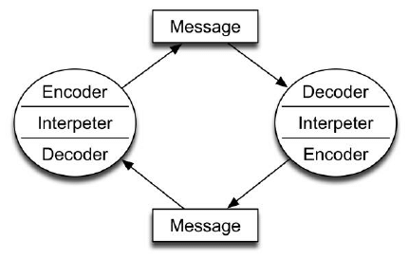

Conclusion
Our findings are that we have used Belbin’s questionnaire and Tuckman’s theory to find that teams will be far more effective in helping the business to run more smoothly. By implementing Belbin’s questionnaire, the varying personality traits and characteristics of the employees can be discovered, which will identify how to place them into appropriate teams. Then by referring to Tuckman’s theory one will be able to understand the various stages that each team will undergo. Initially the teams will have to get to know each other and start to form positive working relationships as well as familiarising themselves with their roles within the team. This will be particularly vital during the storming stage, as by also putting into practice effective communication strategies such as those in Berlo’s model of communication, conflict and disputes between employees will be minimised, thus ensuring a positive and co-operative working environment. This is undeniably important because both job satisfaction and motivation will increase. Both productivity and profitability will also rise because the business will be more streamlined and not management heavy, due to the team approach being a horizontal structure.

Recommendations
Staff working in the business should be organised into two teams. Karen and Simon should each assume overall responsibility for one of the teams.
The staffing structure should change for example by employing an extra pot washer so that there is one per shift. Staff numbers can be reduced from 21 to 18 to cut down on overall costs and overheads. Inexperienced and younger staff can be employed on Friday’s and Saturdays, this will cut costs further.
Effective communication strategies will be implemented, this will also include staff training.

Appendices
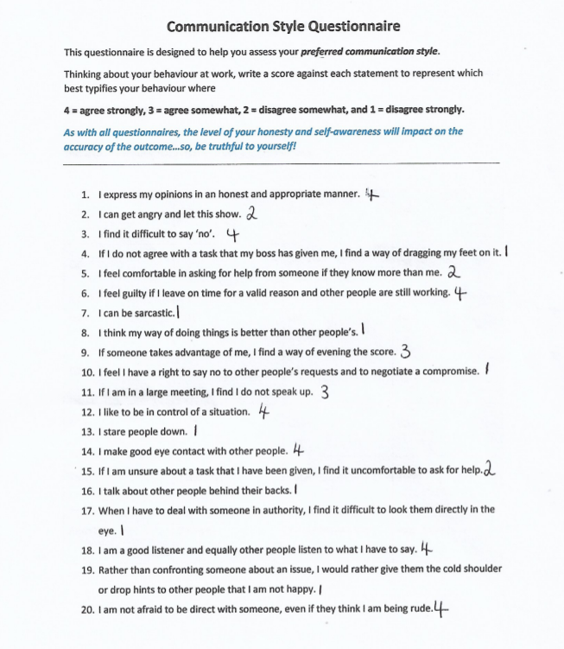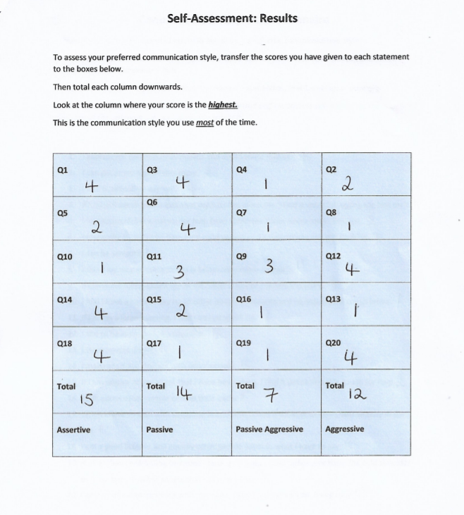
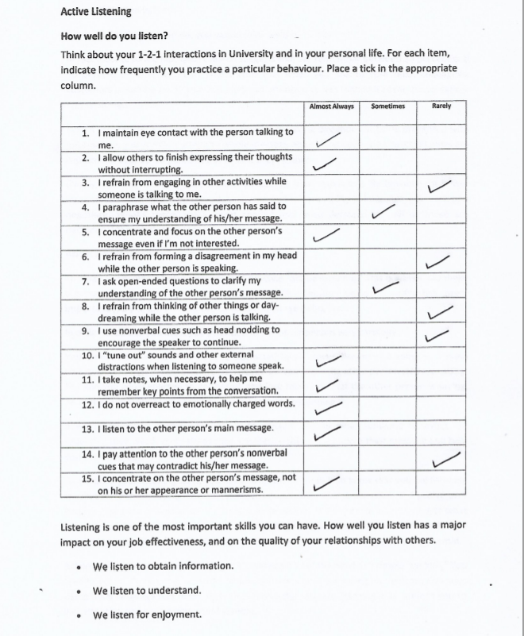

Acknowledgements

I would firstly like to thank Allah (SWT), my partner - Ms Hayley Alonso, my lecturer - Melanie Squires and the University of Wales Trinity Saint David for giving me this opportunity and for showing me a great deal of support and Ruth Cook for providing me with a submission extension.

Reference List

Belbin (2020). The Nine Belbin Team Roles. Available at: https://www.belbin.com/about/belbin-team-roles/ (Accessed 07th July 2020)

Businesstopia in Communication (2018). Berlo’s SMCR Model of Communication. Available at:https://www.businesstopia.net/communication/berlo-model-communication (Accessed 08th July 2020)

Communication Theory. Berlo’s SMCR Model of Communication. Available at:https://www.communicationtheory.org/berlos-smcr-model-of-communication/ (Accessed 08th July 2020)

Communication Theory. Shannon and Weaver Model of Communication. Available at:https://www.communicationtheory.org/shannon-and-weaver-model-of-communication/ (Accessed 09th July 2020)

Gov.uk (2020). National Minimum Wage and National Living Wage rates. Available at: https://www.gov.uk/national-minimum-wage-rates (Accessed 08th July 2020)

Gov.uk (2020) Part-time workers’ rights. Available at: https://www.gov.uk/part-time-worker-rights (Accessed 09th July 2020)

Janse, B. (2019) Berlo’s SMCR Model of Communication. Available at:https://www.toolshero.com/communication-skills/berlos-smcr-model-of-communication/ (Accessed 09th July 2020)

Juneja, P. (2015). Schramm’s Model of Communication. Available at:https://www.managementstudyguide.com/schramm-model-of-communication.htm (Accessed 09th July 2020)

Neuman, L.J. (1975 May Issue) The Harvard Business Review. Make Overheads Cuts That Last. Available at: https://hbr.org/1975/05/make-overhead-cuts-that-last (Accessed 08th July 2020)

