
Effective Teamwork within the workplace
BMSW4002

June 12, 2020
University of Wales Trinity Saint David

Alexandru-George Ghita
1912879

Executive Summary

This is a brief summary of the areas covered in the report.
How to use teamwork theories to improve the performance of a team in the workplace?
Teamwork theories are useful tools for individuals and for teams aiming for better teamwork in the workplace. They help to identify the abilities and vulnerabilities of the people working beside you. They help to create successful groups (teams and organizations), maximize work performance, develop trust and relationships and develop self-awareness.
Benefits of effective teamwork with improved performance using teamwork theories: better business outcomes, efficiency of work and financial savings for companies, effective problem solving, mutual support and sense of accomplishment.
The report covers the difference between groups and teams, why there is a need for effective team working in organizations, the characteristics of effective teams, group dynamics, as well as effective conflict handling and delegation including workplace and relevant industry examples.
And also covers the group dynamics and the types of groups.

Table of Contents
Executive Summary 1
Terms of Reference 2
Introduction 3
Findings 5
Conclusion 8
Bibliography/References 9
Appendices 11

Terms of Reference
The report was requested by the manager of Sytner BMW Cardiff on 12 of June 2020.
The purpose of the report is to explain how teamwork theories can improve the performance of a team in the workplace and also to demonstrate my knowledge and understanding of the theories and models developed by Tuckman and Belbin.
The report was compiled by Alexandru-George Ghita, student at University of Wales Trinity Saint David in Cardiff.
The report covers the following: the difference between groups and teams, why there is a need for effective team working in organisations, the characteristics of effective teams, group dynamics, as well as effective conflict handling and delegation including workplace and relevant industry examples.

Introduction

Why teamwork theories are useful tools and what benefits are for employees and business?
Using teamwork theories can improve the team performance at the workplace.
Effective teamwork and good communication are important at workplace because it is beneficial for both employees and the business.
From the employees point of view, teamwork is beneficial because promotes creativity and learning, blends complementary strength, builds trust, teaches conflict resolution skills, improves morale and provide flexibility, encourages healthy risk-taking allows employees to think outside the box.
From a business point of view, teamwork can increase efficiency, boost productivity, a better service, financial savings.
Every teamwork theory has advantages and disadvantages.
This report will include theories and models demonstrating the importance of teamwork, as well as how they can be used to maximize team performance and what are the differences between teams and groups.

Findings

This report is based on Tuckman and Belbin theories.
Teamwork are individuals working together to improve efficiency and reach a common goal as Belbin (2010) said, "Teams are a question of balance. What is needed is not well balanced individuals but individuals that balance well together."
An example of teamwork can be found at car manufacturers when designing automobiles. Rather than using separate areas, like design, engineering and parts supply when designing new cars, the car manufacturers will form a team including workers from those domains to design every model.
In this way, if an employee encounter complications, the whole team can help, and the task can be done quicker and more enjoyable.

There are differences between teams and groups.
Teams have: Interdependent relationships, mutual accountability and a common goal.

In essence the both theories Tuckman and Belbin are useful tools for individuals and for teams aiming for better teamwork in the workplace. They help to identify the abilities and vulnerabilities of the people working beside you. They help to create successful groups (teams and organizations), maximize work performance, develop trust and relationships and develop self-awareness.
Tuckman's theory focuses on how a team handles a task from the initial formation of the team to the completion of the project and comprises five stages.
The five stages are:
- Forming - when team members meet for the first time, relationships are not yet formed, communications are formal, they think about what is expected of them and how to behave, the roles are not clear making them dependent on the leader for supervision.
- Storming - group members fight for places, conflict arise as they sort roles and responsibilities, the certainty of the object rises but doubts perseverethe team can be diverted by relations and frustrating complications, compromises are made in order to progress.
- Norming - conflicts are settled, views are exchanged, positions and accountabilities are clear, understanding and co-operation develops within the team.
- Performing - the team knows clearly what to do, the team share the same vision, usage of leadership is minimised because the team can self-manage.
- Adjourning - personal relationships formed, break-up of the team, giving them a sense of fulfilment.

Belbin’s technic is based on group roles. Belbin assumes that everyone holds a pattern of comportment that distinguish one person’s comportment in a way to communicate with other person making possible the development of a team.
Belbin (2003) describes a team part as: “A tendency to behave, contribute and interrelate with others in a particular way.”
Everybody tends to perform distinctly when working among other people, that is not necessary, that they will all the time perform like that.

Belbin Team Role technique can support the development of originality and revolutionise within the organisation. Belbin is utilised in this inquiry to study how the Team Roles of the team members can help to distinguish how restructuring teams could be built in the most suitable mode applying the best variety of Team Roles.
Belbin Team Role technique begins with a personal behavioural online questionnaire, resulting in a team overview that aims to identify who represents which team positions in a team. A Team Role reveals you what manner team members act when operating in a team. Belbin's technique is composed of nine roles. Every Team Role possesses its distinct abilities and vulnerabilities, and everyone has a significant addition to bring to a team. Team members fill the questionnaire and obtain their report. These reports catalogue Team Role choices to let a person comprehend their abilities and which comportments should be polished for the interest of the group, for personal and professional progress.
The description of the nine roles of Belbin's technique:
- The Plants are very imaginative and skilled at resolving challenges using unorthodox methods. They tend to be introverted and react strongly to criticism and praise, they are independent, clever, and original but may be weak in communicating with other people.
- The Monitor Evaluator is demanded to provide a rational perception, offering disinterested analyses wherever needed and weighing the team’s choices in a relaxed manner, they possess great critical thinking capability.
- The Coordinators are required to concentrate on the team’s goals, keep team members concentrated and to transmit the work properly, a disciplined person in communication and approach.
- The Resource Investigators contribute internal information on the competition and ensure that the team's plan will be known to the world.
- The Implementers are needed to design a realistic, functional plan and to be accomplished efficiently as possible.
- The Completing finishers are used when a task is completed and to examine the work for inaccuracies through high-quality control.
- The Teamworkers support the group, identifying the work necessary and finishing in the name of the group.
- The Shapers, give the necessary impetus to ensure that the group continues to move and concentrate on the task.
- The Specialist has advanced information about an essential field, self-starting and dedicated.

The potential appliance of Belbin's technique:
- The technique helps to recognise how the Group Roles and management methods influence groups, it operates as a tool for groups and individuals that strives, improving work within the group.
- Managers use Belbin at the beginning of the task for the team members to get to know each other.
- Managers use Belbin during the task to know and review abilities and vulnerabilities in the team, in the event, there is something unclear that could be explained by the technique.
- Managers use Belbin to know how to properly manage the group and teach individual group members customized requirements and comportment.
- Managers use Belbin to select which applicant would match with the Group Roles that already exist in the group.
- Managers and H.R use Belbin for advising employees who would like to have guidance on career development.
- H.R uses Belbin to hire employees that suit the necessities of the organization.
- Belbin technique is a useful tool that helps individual group members to boost self-consciousness.

Having effective teamwork in organizations:
- Greater Results: Teamwork can provide greater business results because can be more resourceful to stand facing challenges.
- More efficient: When a team can operate properly collectively, they accomplish more than working individually, saving money for the company.
- Innovative thinking: Combining different skills from different individuals on the same task, they can provide an out of the box solution..
- Joint effort: When a team can operate properly collectively, they are encouraging each other, achieving goals hard to reach.
- Achieving the goal: By working together with other individuals in a team and achieving the goal gives you a feeling of fulfilment.

Group dynamics is a set of comportment and psychical methods occurring inside a group or groups and applied as methods for problem-solving, becoming productive and original for organizations.

There are different types and structures of groups: Command, Task, Functional, Interest, Friendship, Reference, Size, Roles, Norms, Cohesiveness.

Why conflict resolution is important?
Conflict resolution operates as an essential role in your workplace. Handling internal conflicts competently provides productive solutions, creating an adequate and prosperous environment for work, reducing tension and discomfort in the team.
For a balanced work environment, tasks and roles must be divided accordingly.

Why Delegation is important in organizations:
Delegation means empowerment to assign responsibilities and authority to someone else to complete the task.

Why Delegation is beneficial: provides you with the opportunity and capability to concentrate on bigger tasks, by encouraging employees to accept other roles in which they have more responsibilities and authority, they can improve their qualities but also acquire new skills.

Conclusion

As Steve Jobs (2011) said, “Great things in business are never done by one person; they are done by a team of people.”
In conclusion both theories Tuckman and Belbin are useful tools for individuals and for teams aiming for better teamwork in the workplace. They help to identify the abilities and vulnerabilities of the people working beside you. They help to create successful groups (teams and organizations), maximize work performance, develop trust and relationships and develop self-awareness.

Having effective teamwork in organizations:

- Greater Results: Teamwork can provide greater business results because can be more resourceful to stand facing challenges.
- More efficient: When a team can operate properly collectively, they accomplish more than working individually, saving money for the company.
- Innovative thinking: Combining different skills from different individuals on the same task, they can provide an out of the box solution..
- Joint effort: When a team can operate properly collectively, they are encouraging each other, achieving goals hard to reach.
- Achieving the goal: By working together with other individuals in a team and achieving the goal gives you a feeling of fulfilment.

Bibliography/References

- Belbin,R. Meredith, Management Teams: Why They Succed or Fail. Butterworth Heinemann, 3rd ed., 2010
- Cohen, L., Manion, L. and Morrison, K., 2013. Research methods in education. routledge.
- Easterby-Smith, M., Thorpe, R. and Jackson, P.R., 2012. Management research. Sage.
- Belbin, R.M., 2012. Team roles at work. Routledge.
- Cassidy, K., 2007. Tuckman revisited: Proposing a new model of group development for practitioners.
- Senior, C., Cubbidge, R., Riebe, L., Roepen, D., Santarelli, B. and Marchioro, G., 2010. Teamwork: effectively teaching an employability skill. Education+ Training.
- Stuart, F.I., 1991. Purchasing in an R&D environment: effective teamwork in busines. International Journal of Purchasing and Materials Management, 27(4), pp.29-34.
- Tuckman, B. W. (1965). Developmental sequence in small groups. Psychological Bulletin, 63(6), 384–399. https://doi.org/10.1037/h0022100
- Belbin,R. Meredith, Management Teams: Why They Succed or Fail, second edition 2003
- Steve Jobs: His Own Words and Wisdom,2010.
- https://blog.proofhub.com/top-11-benefits-of-teamwork-in-workplace-24a55b8ab46e
- https://www.businesscoaching.co.uk/files/belbin_team_role_theories.pdf
- https://smallbusiness.chron.com/benefits-teamwork-business-3250.html
- https://www.sandler.com/blog/6-benefits-of-teamwork-in-the-workplace/

Appendices
Belbin questionnaire.
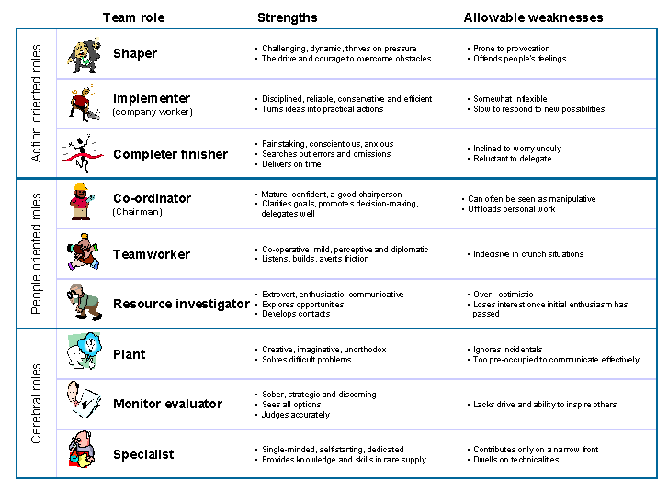

Tuckman theory



