

Name: Nilima Begum
Student ID:2027887

Lecturer: Alfred Mensah

Module: BMSW4003

Module title: Digital Skills and Research Methods
Assignment 1

Nilima Begum (2027887)

Contents Page:

Introduction……………………………………………………………………………………………2

Main body …………………………………………………………………………3,4,5,

Technology and Techniques……………………………………………………………………………………5,6

Conclusion………………………………………………………….7

References………………………………………………………8

INTRODUCTION:

Digital skills is very important for our present and for our future in employment as it is important that we are properly skilled and prepared with the knowledge of the digital skills, the majority of the public will always be in need to keep updating our technology skills to keep up with the modern society, the demand for digital skills has always been necessary in our life and should be implemented in our jobs , digital skill is required for any jobs, technology has changed to in many aspects, in addition adapting to the pace of digital technology changes, these skills can bring efficiency in our career, as there is in need for more communication online, Some basic platforms are emails, WhatsApp, Facebook,
digital skills are needed in our daily work and individual life, with the recent coronavirus pandemic we can see the world has accelerated the needs for digital skills, it is essential that we adapt to furthermore digital tools,

Αχχορδινγ το Μορρισον, Χ., (2021) αλλ ηεαλτηχαρε professionals are required to have IT skills and communication skills, also able to show data investigation skills, awareness of PC literateness, able to use medical devices, and to use the internet, in addition required to have the ability to study and analyse and forward data, all workers acquire skills in information safety and security, design and implementation of tools to collect data, awareness for software development ,should possess skills in project management,

MAIN BODY:

THE USE OF MODERN-DAY TECHNOLOGY IN HEALTHCARE

Digital technologies has greatly improved operational efficiency with respect to quality to medical needs, some parts where digital technologies has made outstanding results in healthcare, Use of contemporary technologies are impacting many lives and improving and providing greater accessible to new treatment, improving our health and social care, there is significant improvement in health and disease control, digital technologies has improved massively patients and doctors can access patients’ data from anywhere around the world. Technologies has improved making direct communications to patients through emails, smartphone, text messaging.

With the rapid growing of population, the healthcare industry and healthcare services are considered one of the priorities in the modern society to deliver better health to patients all facilities use data for check-up and record laboratory test , medical experiments and generation rate in the healthcare facilities is greater than any other business, paper files and medical reports were used as a source information about patients and were assessed by several healthcare professions for different purposes . source Ullah, H., et al (2021)

Among all these technologies, blockchain technology has a remarkable impact to provide more safe and secure healthcare structure including healthcare data, medical supply chain management, telemedicine, and e-health data sharing services blockchain , and this technology gradually supply chain logistics in healthcare organisation, blockchain provides massive opportunities to lead the digital changes of medical records, medicines resource and smart deals for expense delivery and other methods to impact this technology in the healthcare services, as one of the most important features of a hospital is the health record of patients and electronic health records are the support of every contemporary healthcare centre, medical reports of patients raise lengthier alongside every visit to the GP all doctor and hospital have different approaches to store these records, but this is not easy for healthcare workers to acquire them. Ullah et al (2021)
It is expected that the effect of digital marketing has three main key points that are Changing the techniques for data collection Fixing and editing for digital display and advertising Ownership and security of the digital assets, for the establishment.

USE OF TECHNOLOGY THROUGHOUT COVID

Digital technologies can provide a cheaper and faster and more effective solution for disease, in addition digital technologies could win us the fight against the serious conditions like cancer, AIDS, Ebola, and the recent covid-19.

The COVID-19 pandemic has been one of the largest global crises in social history, causing record health and financial loss in many nations however at the same period, this new situation is preferring the transition to digital solutions in many society, from public schools to universities and workplace, this has developed new methods for education remotely, shifting from lectures in schoolrooms to live conferencing or online courses, similarly health care groups have replied to the Corona virus outbreak through the rapid adoption of digital solutions and advanced technology tools resources. During a pandemic, digital technology can alleviate or even solve many challenges, thus improving health care delivery. Digital tools have been applied to tackle critical needs that have surfaced as a direct result of the pandemic. Source Golineli, D., et at (2020)

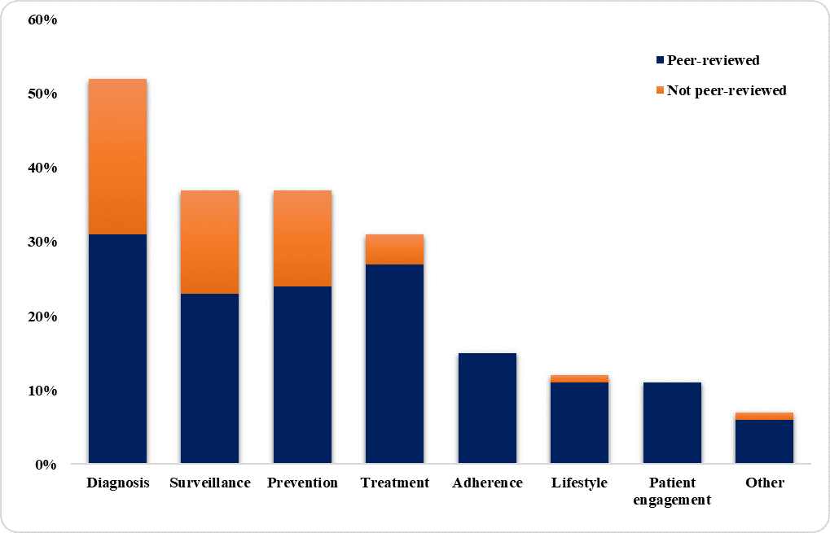

Source: Golineli, D., et al (2020)

According to Golineli, D., et al (2020) The COVID-19 pandemic is favouring the implementation of digital resolutions with unique quickness and effect. It is consequently suggested to keep track of the ideas and resolutions being planned today to implement best practices and models of care tomorrow and to be prepared for future national and international crises. It is worth taking advantage of the inspiration provided by the crisis we are currently experiencing to apply at least some of the explanations planned in the scientific literature, especially in national health systems, which in recent years have proved to be particularly resistant to the digital transition.

TECHNOLOGY AND TECHNIQUES:

THE USE OF DIGITAL INTERACTION, CO-OPERATION, AND CONTRIBUTION

Digital communication, collaboration, and participation, looks in the way we communicate and interacts with others, in focus of how we work with people, join, and connect through digital means, this motivations on how we join and connect throughout digital means, it is important to recognise that communication and collaboration are one and same, the functioning of those relationships allow collaboration to not only occur but to be productive.
some examples when using variety of digital too ls, Emails, Photo shooting, social media, Presentation, Video links, even blogs are considered digital communications.

Digital technology can be used for different communications, this can be used to encouraged others, or inform of new information, also to give support to others, this also can be used online to work with everyone, share files when needed, send emails, and work on documents ,many advantages of digital technology are, to be are able to take part in meetings, and importantly be able to build a online public to communicate and build relation with others.

In general, digital communications can be managed for promoting organisations for their products to the public, using latest digital advertising strategies, to reach to the wider audience and the world, collaboration in workplace involves group of people sharing their ideas and skills to achieve a mutual goal, this helps improve productivity in the working workplace.

DIGITAL INDIVIDUALITY

Digital identity and security safety is managing your online presence also keeping a healthy relation using digital technology, understand and managing your online presence, keeping it tidy and healthy, some examples are Managing online different profile, keeping it professional Maintaining and managing privacy on your account, can also keep record of your health and physical activities.

DIGITAL LITERACY

Digital literacy suggests to a person's ability to find and evaluate and clearly communicate knowledge throughout various digital platforms, it is evaluated by an individual.

The development of information and communication technologies and their combination in all ranges of people’s life and work gave for the first time a possibility for a steadfast and limitless access to massive data which is continuously developed, new model of society and people who will acquire the necessary skills and capabilities to use in your advantage of the possiblitys of new technologies and take active part in the economic additionally community and social life. Source Shopvat T, (2014)

CONCLUSION

Digital skills are important for all healthcare professions as it is highly required, research shows digital skills like computer skills and be able to operate advanced technology tools is very crucial for the healthcare professions.

The digital technology played a important part during covid pandemic , many services had to be taken like online , doctors consultation are done virtually and other patientcare and beyond ,all services had to be done online, doctors are still undertaking face to face consultations, all this experience are showing that healthcare industry can provide patient care virtual and can be managed virtually, doctors are able to prescribe prescriptions online , healthcare staff are able to assess high risk patients and provide swifter services, many will say there are positive outcome, but with all technology’s there will be challenges such as security threats.

References

Golinelli, D., Boetto, E., Carullo, G., Nuzzolese, A., Landini, M. and Fantini, M., 2021. Adoption of Digital Technologies in Health Care During the COVID-19 Pandemic: Systematic Review of Early Scientific Literature

Morrison, c., 2021. DIGITAL SKILLS FOR HEALTH PROFESSIONALS - European Health Parliament. [online] European Health Parliament. Available at: <https://www.healthparliament.eu/digital-skills-health-professionals/> [Accessed 6 September 2021].

Shopvat, T., (2014)
Eriesjournal.com. 2021. [online] Available at: <https://www.eriesjournal.com/index.php/eries/article/download/100/103/190> [Accessed 23 August 2021].

Ullah, H., Aslam, S. and Arjomand, N., 2021. Blockchain in Healthcare and Medicine: A Contemporary Research of Applications, Challenges, and Future Perspectives. [online] arXiv.org. Available at: <https://arxiv.org/abs/2004.06795> [Accessed 9 August 2021].

