I confirm that I have not used any AI tools in the research and creation of this assignment. I confirm that I have not presented any AI generated materials as my own work. I confirm I have copies of my drafts, notes, and other resources I used, which I may be asked to provide in evidence.

Rykus Llewellyn-Jones
2403867

Copper Mining at the Great Orme: A metal mining marvel in the Bronze Age

The rediscovery in 1987 of the Great Orme Copper Mine just outside Llandudno, North Wales has granted the academic community, locals and tourists alike an insight into what mining and trading was like during the Bronze Age (James, 2016, p.77). This essay examines the history and excavation of the mine itself, and new research that has shed light on how activities there relate to the wider European context of Bronze Age trade (James, 2016; Williams and Le Carlier De Veslud, 2019).
The Great Orme was one of several mines established in Britain during the Bronze Age. Previously it was thought that most of the copper supplying the British Isles came from the Ross Island mine in Ireland, however as technology advanced and the need for copper diminished many of the original copper mines ceased their production around 1,600BC (Williams and Le Carlier De Veslud, 2019, pp.1179). The Great Orme remained one of the few copper mines left active with the total lifespan of the mine being an estimated thousand-year period. The mine gradually ceased operations when continuous mining depleted veins and need for other metals caused it to become obsolete.
The mine remained abandoned until a brief period of new mining during the Victorian period. The Victorians were aware that the mine was ancient when miners in 1849 discovered stone hammers, bone tools and a few bronze objects, but experts at the time mistook their findings for the Roman period (James, 2016, p.77). After several decades of being used by Victorian miners the mine once again ceased operations around the 1870’s as focus shifted from Llandudno being a mining town to a tourist one. After mining operations ceased the deep levels of the mine, around 70 meters below sea level became flooded (Lewis, 1990, p.5).
The mine was only rediscovered in 1987 after survey crews hired by the local council to secure a spot in order to build a new car park in the area after records of its existence from Victorian records became lost (James, 2016, p.77). Archaeologists and other academic scholars have been researching and excavating the mine since 1989 (James, 2016, p.78). At present over 5 miles of caverns and side tunnels have been discovered however, archaeologist Dr Sian James estimates that only 10% of the original mine has been evacuated so far (The Story of Wales, 2012, 11:00-15:00).
Dr. Sian James started her academic interest whilst working as a tour guide at the Great Orme and has gone on to become one of the foremost experts associated with the Great Orme mine, remaining as one of its on-site archaeologists and an assistant manager of the mine (James, 2014). James’ research focuses on the artefacts found within the mine, the mine itself and a possible connection between the placement of artefact hordes and an early semi-religious ritual practice.
Artefacts found within the mine include around 30,000 animal bones and 3,000 stones collected from the nearby beach to use as rudimentary hammers. (James, 2016, p.77). James makes note that the stone hammers were easily identifiable even in the near absolute darkness of the mine by their smooth, rounded texture compared to the harder limestone of the cave walls. These stones tools individually weigh around 2-29kg each (James, 2016, p.78). The animal bones discovered have been identified primarily as from cattle, mainly their rib bones and other long bones such as the humerus bone chosen for their ideal shape to pick out the ore after the hammers have bashed it from the walls (The Story of Wales, 2012, 11:00-15:00). However, bones from other species have also been identified belonging to sheep, goats, pigs with a few deer, horse and dog bones also discovered (James, 2016, p.78).
James remarks that several artefact hordes of undamaged hammers and bones were discovered. She theorizes two possible explanations for their placements; one simply being collected piles of unused tools the miners could conveniently reach in the low visibility when their current tools broke, or they could represent a type of appeasement offering to the Earth itself or to an early form of the alleged Knockers/Coblynau mining spirits in exchange for the copper taken (James, 2016, p.78).
Another key part of James’ research is the mine itself. She notes that only 10% off the mine has roughly been excavated due to several sections of the mine being blocked by ancient stone walls erected around several smaller tunnels. She theorizes that these could have been built either as a form of ventilation, a sign that the further section has been depleted of viable ore or that they were placed as a sign of danger ahead (James, 2016, p.78). Flooded sections and smaller tunnels being roughly 20cm wide have also hindered the full excavation of the mine. Despite these barriers the Great Orme mine remains the largest pre-historic mine found anywhere in the world (James, 2016, p.77). The smaller tunnels discovered have some evidence that supports the theory that children as young as 5 or 6 years old worked in those small gaps, working in near total darkness as no signs of charcoal markings, that indicate lighting elsewhere in the mine, have been uncovered. Due to the size of these smaller tunnels further archaeological research remains difficult (James, 2016, p.79).
In contrast to James’s research on artefacts, Archaeometallurgical Engineers and Archaeologists Dr. Alan Williams and De Veslud have dedicated their research into the ore samplings recovered from the Great Orme to determine productivity levels from the mine and potential links to copper artefacts found domestically and overseas in mainland Europe (Williams and Le Carlier De Veslud, 2019).
Williams and his team have been researching the extent of the Great Orme’s copper output and possible trading links during the Bronze Age by examining the unique chemical signature found in the isotopes from in the copper recovered from the Orme. The method Williams’ used to discover this unique signature entailed highly technical lab work (Williams and Le Carlier De Veslud, 2019, p.1182). The results from these tests showed that the ore from the mine had particularly high levels of arsenic and nickel. After discovering the mine’s unique signature Willaims tested the signature with copper artifacts found and databased domestically in Britain and also across mainland Europe for potential matches. Through this method his team has found matches across Europe in countries such as France, the Netherlands, Germany, Denmark and Sweden (Williams and Le Carlier De Veslud, 2019, p.1185).
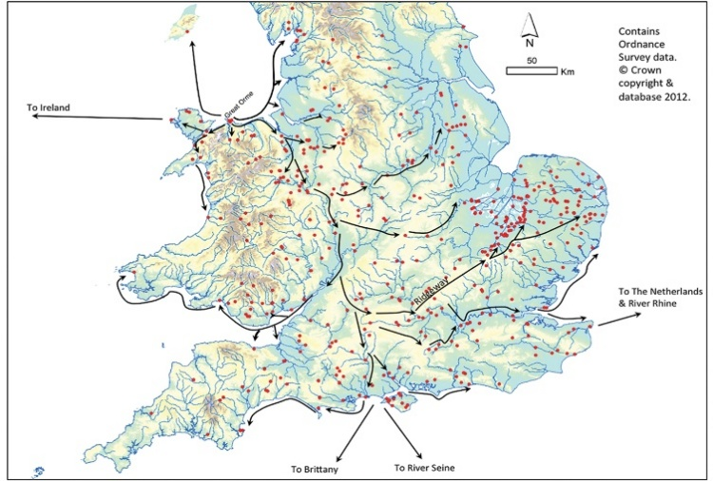
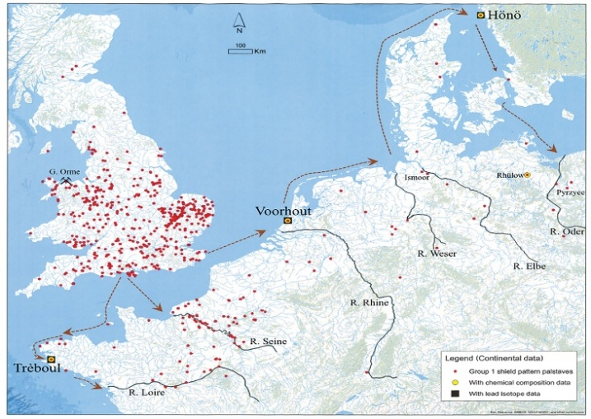
Possible routes of Great Orme shipments across UK Possible routes of Great Orme shipments across Europe
Figure 1: R.A. Williams, Antiquity Journal, 2019

The national and international connections, illustrated in the above images, have opened up new avenues of study on how trade worked during the Bronze age. The scale of copper operations at the Great Orme seems truly remarkable. Professor John Koch makes note that roads as we know them today did not exist until the time of the Roman conquests so transporting quantities of this copper at this scale both domestically and internationally could only be possible by sea trading (The Story of Wales, 2012, 18:00-20:00). This is supported by research that suggests that tin was transported by river and sea during the Bronze Age from Britain to the Mediterranean (Durham University, 2025). There has been much academic debate about where the tin was sourced that was essential to the manufacture of bronze (Williams et al., 2025). A bronze age shipwreck recovered from the Mediterranean contained bronze artefacts which contained tin that could be traced back to Southwest Britain and this supports the idea of a much more extensive trade network than previously thought for metal products in which Britain played an important part.
Willaims has theorized that contrary to previous assumptions that the mine was a smaller scale, seasonally worked mine, the mine was instead a full-time operation with a “Golden Age” period lasting between 1,600 to 1,400BC with production level being estimated around 232 to 830 tonnes, which would roughly translate into about 1–4 tonnes per year (Williams and Le Carlier De Veslud, 2019, p.1189). This theory of a “Golden Age” describes a picture in which the Great Orme mine was an important part of a Europe wide chain of operations and trade where copper material from Wales and tin materials from Cornwall were used across Europe as far as the Levant to the east, Spain to the west and Sweden to the north (Williams et al., 2025). The question remains of how such international trade impacted the local community considering that during this time period Britain was a pre-monetary economy thought to be characterised by gift exchange (Brück, 2023, p.392). Evidence for such links with far off destinations is not apparent in the archaeological record of the Great Orme as yet, although excavations are still ongoing.
The discovery and exploitation of copper at the Great Orme created profound transformations in Bronze Age Britain. From the estimated peak of production at around 1600 to 1400 BC, the Great Orme became the core resource of Britain’s copper supply and a key part of expansive trade networks that linked Wales to Europe. Today, the Great Orme stands as a compelling archaeological record by showcasing the dynamic interplay between natural resource availability, human ingenuity and technological evolution. The site remains emblematic of how resource-driven developments shaped prehistoric communities and shaped Britain’s integration into the broader European Bronze Age.

Image Source
https://www.cambridge.org/core/journals/antiquity/article/boom-and-bust-in-bronze-age-britain-major-copper-production-from-the-great-orme-mine-and-european-trade-c-16001400-bc/356E30145B1F6597D8AAA0DDBE69BD51

Bibliography
Williams, R.A. and Le Carlier De Veslud, C. (2019) ‘Boom and bust in Bronze Age Britain: major copper production from the Great Orme mine and European trade. 1600–1400 BC’, Antiquity, 93(371), pp. 1178–1196. Available at: https://doi.org/10.15184/aqy.2019.130.
The Story of Wales (2012). BBC. Available at: https://www.youtube.com/watch?v=RQiMYiawRUM.
Brück, J. (2023) ‘Magic money: commodities and exchange in Bronze Age Europe’, World Archaeology, 55(4). Available at: https://www.tandfonline.com/doi/full/10.1080/00438243.2024.2425276 (Accessed: 12 August 2025).
Durham University (2025) Bronze-age Britain traded tin with the Mediterranean, shows new study – settling a two-century debate - Durham University, Durham University. Available at: https://www.durham.ac.uk/research/current/thought-leadership/2025/05/bronze-age-britain-traded-tin-with-the-mediterranean-shows-new-study--settling-a-two-century-debate/ (Accessed: 12 August 2025).
James, S. (2014) Sian James - Archaeologist, LinkedIn. Available at: https://uk.linkedin.com/in/sian-james-a3a59332 (Accessed: 9 August 2025).
James, S. (2016) ‘Digging into the darkness: the experience of copper mining in the Great Orme, North Wales’, in R. Hensey and M. Dowd (eds) The Archaeology of Darkness. Oxford: Oxbow Books, pp. 75–84. Available at: https://d1wqtxts1xzle7.cloudfront.net/91828874/Compressed_2016_The_Archaeology_of_Darkness-libre.pdf?1664653149=&response-content-disposition=inline%3B+filename%3DThe_Archaeology_of_Darkness_edited_by_M.pdf&Expires=1749649932&Signature=EjI3SnRgp8IbDWQjwg2s2TRa6H34sHNyt1wBppJssNg7CQ4nyI4Y6XNro-bETYY~49nD6xtqxGbRTeolMtbVcyDrmjjf0vhfL0Jcb41wWfZXoHEuihE1FyfqZ3eDbLEMCUY7pa~pFuueaztbvY2D17kFL-6fExeDPDi0uUqWPkoZ8FIQU~mFXgjyOE88NUOiHJ4Nm~4a4i1lEIrfjpNUYi2UgMN3GlefSlc~MwkmbVDr0DD2xwSDX6TIQQGYf1TdhvMUtE1KQOWC2TgDKEtO4l1VBu~oh~0TiC-XtlNZBsCQ57F6Rg1dg1hrCOF9lIVz5PeSFNOltutIAKniGqeCeQ__&Key-Pair-Id=APKAJLOHF5GGSLRBV4ZA#page=89 (Accessed: 4 June 2025).
Lewis, A. (1990) ‘Underground exploration of the Great Orme Copper Mines’, in S. Crew and P. Crew (eds) Early Mining in the British Isles. Porthmadog: Snowdonia Press, pp. 5–10.
Williams, R.A. et al. (2025) ‘From Land’s End to the Levant: did Britain’s tin sources transform the Bronze Age in Europe and the Mediterranean?’, Antiquity, 99(405), pp. 708–726. Available at: https://doi.org/10.15184/aqy.2025.41.
Williams, R.A. and Le Carlier De Veslud, C. (2019) ‘Boom and bust in Bronze Age Britain: major copper production from the Great Orme mine and European trade. 1600–1400 BC’, Antiquity, 93(371), pp. 1178–1196. Available at: https://doi.org/10.15184/aqy.2019.130.

