WORKSHEET 5 – TESTING (Treasure Hunt)

For this worksheet, there are several possible approaches to the problem.
Create your own test set to show the strengths and/or limitations of your solution. Use as many of the boxes below as you need.

Test: Enter the correct coordinates for the treasure

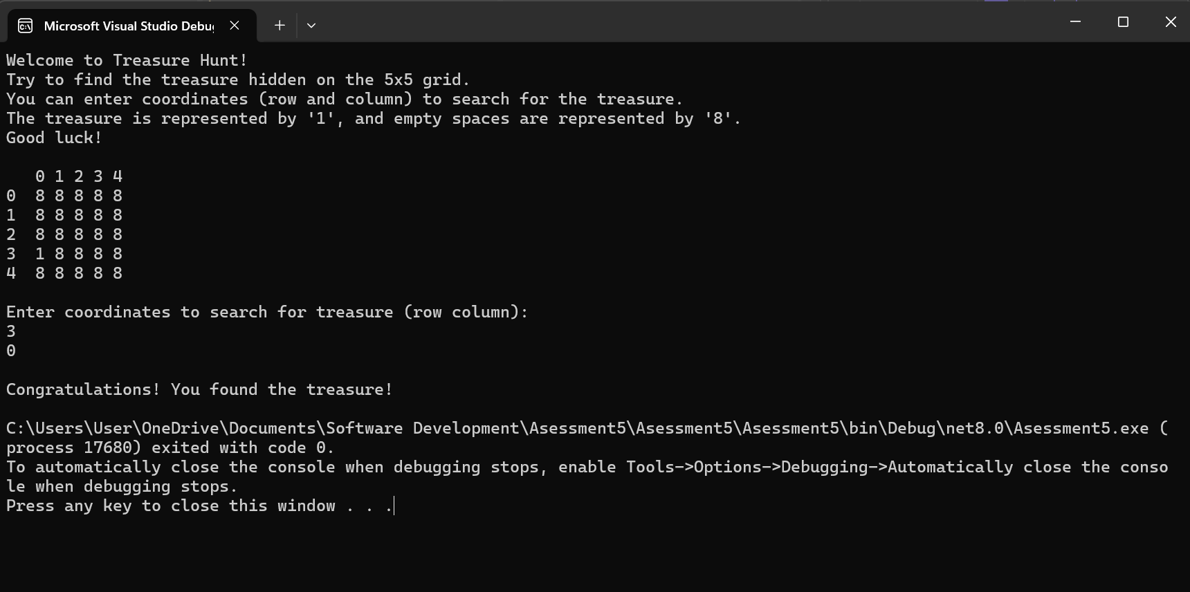
Result: Did the programme behave as expected ie syntactically and logically correct?
YES/NO (delete as appropriate)
If NO, what went wrong?
Yes it worked

Test: Enter the incorrect coordinates for the treasure

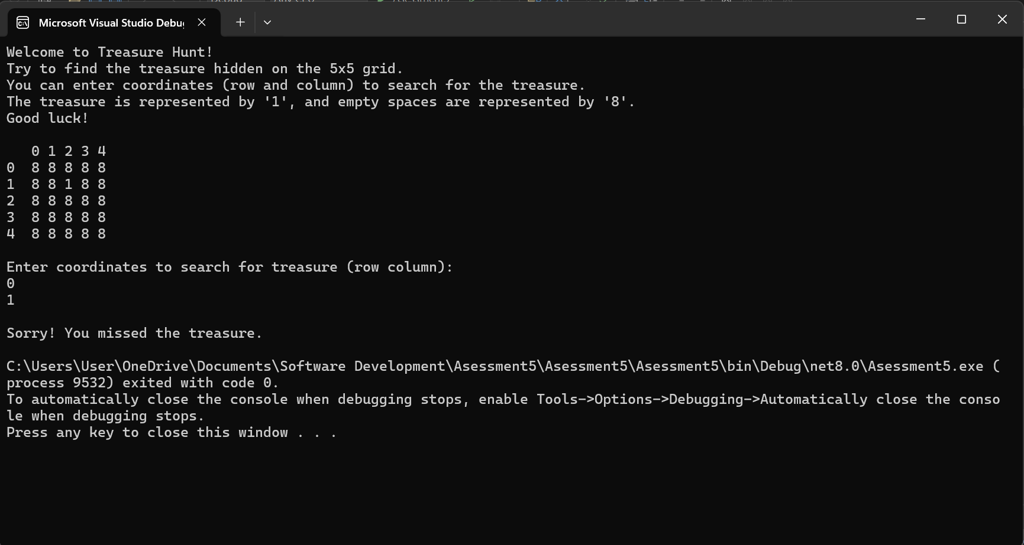
Result: Did the programme behave as expected ie syntactically and logically correct?
YES/NO (delete as appropriate)
If NO, what went wrong?

Test: Enter 3 numbers

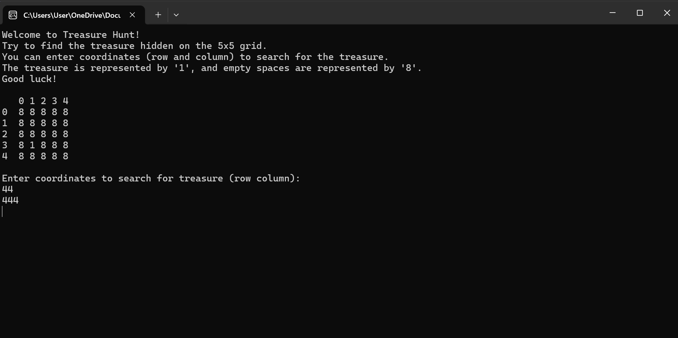
Result: Did the programme behave as expected ie syntactically and logically correct?
YES/NO (delete as appropriate)
If NO, what went wrong?
No error message, but the game just doesn’t respond

Test: Enter 2 coordinates that don’t exist in the game

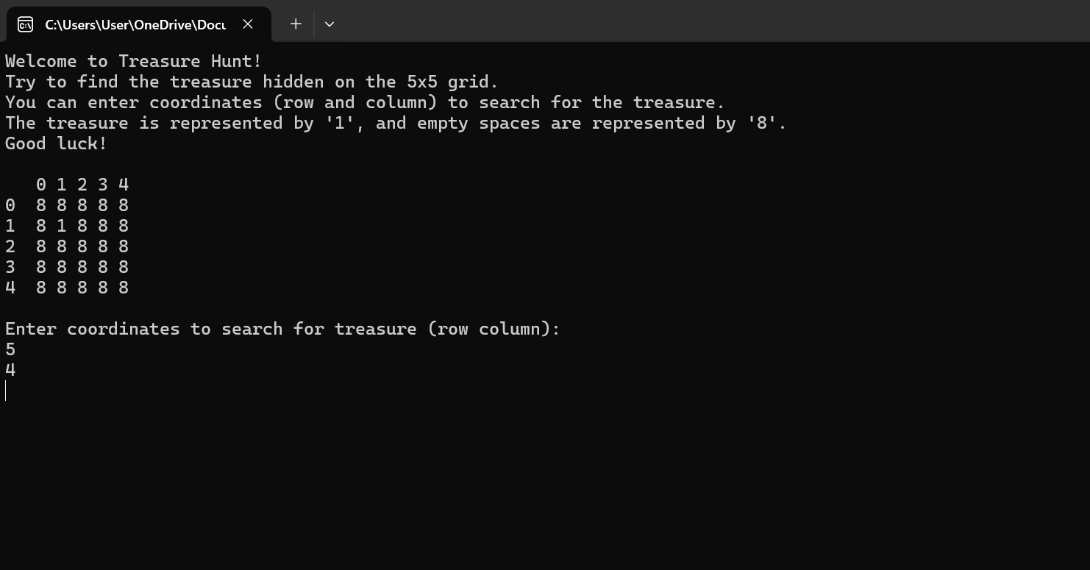
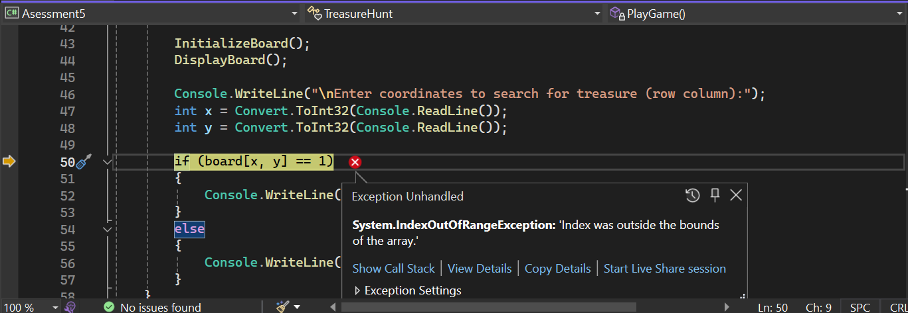
Result: Did the programme behave as expected ie syntactically and logically correct?
YES/NO (delete as appropriate)
If NO, what went wrong?
Error showing that the number that was input is out of the number range

Test: Enter any letters into the coordinates

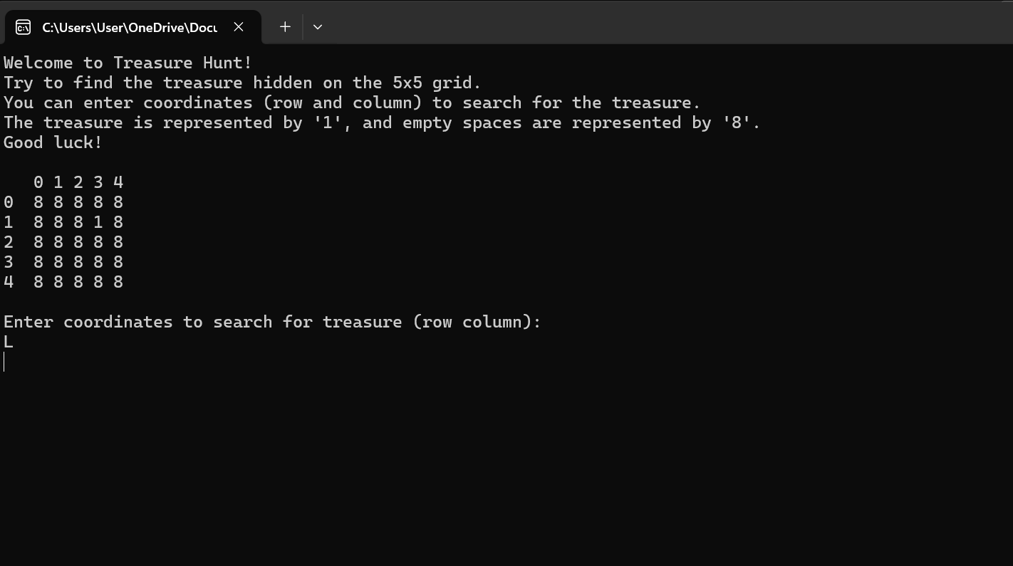
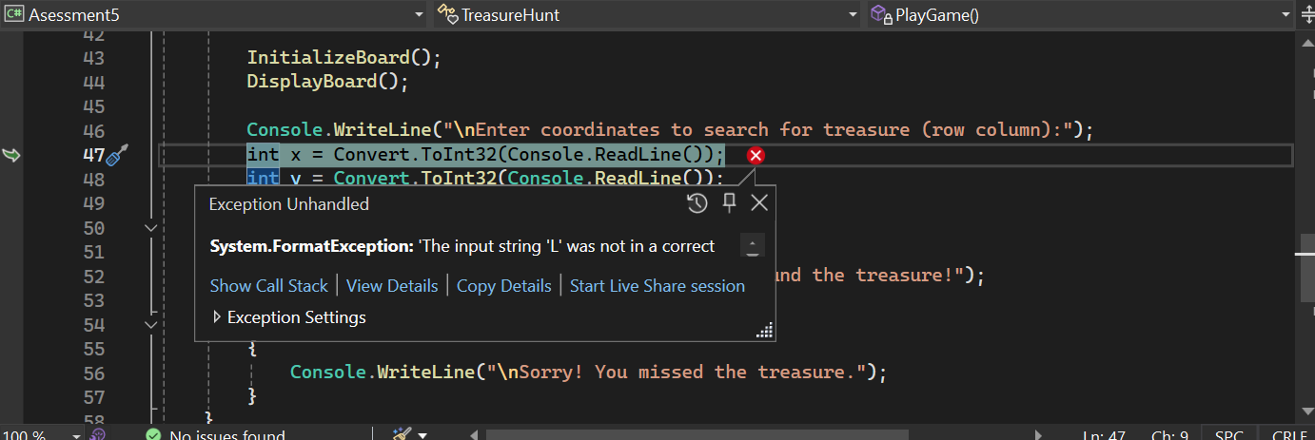
Result: Did the programme behave as expected ie syntactically and logically correct?
YES/NO (delete as appropriate)
If NO, what went wrong?
Error showing that you can only insert 1 integer into the coordinates

Final code:
class TreasureHunt
{
static int[,] board = new int[5, 5]; // The game board

// Function to initialize the game board
static void InitializeBoard()
{
Random rand = new Random();
int treasureX = rand.Next(0, 5);
int treasureY = rand.Next(0, 5);
board[treasureX, treasureY] = 1; // Placing the treasure
}

// Function to display the game board
static void DisplayBoard()
{
Console.WriteLine(" 0 1 2 3 4");
for (int i = 0; i < 5; i++)
{
Console.Write(i + " ");
for (int j = 0; j < 5; j++)
{
if (board[i, j] == 0)
Console.Write("8 ");
else
Console.Write("1 ");
}
Console.WriteLine();
}
}

// Function to play the game
static void PlayGame()
{
Console.WriteLine("Welcome to Treasure Hunt!");
Console.WriteLine("Try to find the treasure hidden on the 5x5 grid.");
Console.WriteLine("You can enter coordinates (row and column) to search for the treasure.");
Console.WriteLine("The treasure is represented by '1', and empty spaces are represented by '8'.");
Console.WriteLine("Good luck!\n");

InitializeBoard();
DisplayBoard();

Console.WriteLine("\nEnter coordinates to search for treasure (row column):");
int x = Convert.ToInt32(Console.ReadLine());
int y = Convert.ToInt32(Console.ReadLine());

if (board[x, y] == 1)
{
Console.WriteLine("\nCongratulations! You found the treasure!");
}
else
{
Console.WriteLine("\nSorry! You missed the treasure.");
}
}

static void Main(string[] args)
{
PlayGame();
}
}

