DS 1

My Screenshots/Photos

Screenshot/Photo 1
This is my first screenshot.
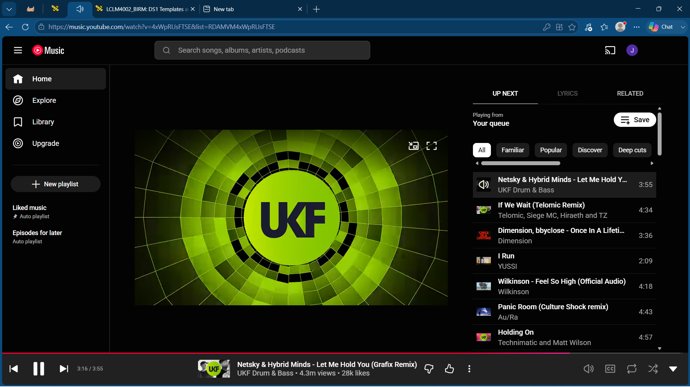
The image above shows the current song I am listening to using the internet browser, Microsoft Edge to access the website, YouTube.

Screenshot/Photo 2
This is my second screenshot
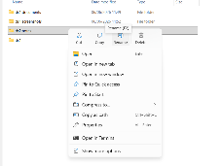
The image above shows that I am using editing on word to rename an incorrectly named folder. ds2 should be ds1.

Screenshot/Photo 3
This is my third screenshot
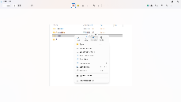
The image above shows me using the sniping tool to crop the image in my second screenshot to the size I wanted.

Screenshot/Photo 4
This is my final screenshot
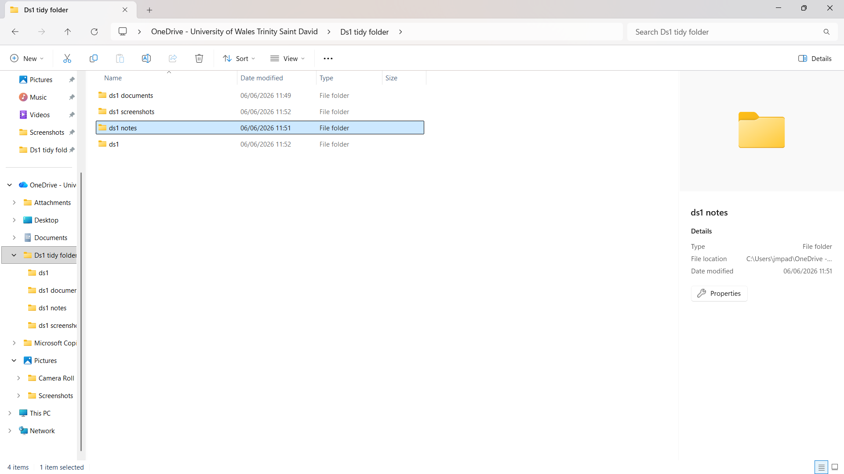
The image above shows that I am capable of turning a messy folder in my one drive, into a tidy one that makes sense to my coursework.

My Short Reflection

I use digital tools to assist in my everyday life, an example of this is my coursework in ds1 as it is digital skills. I feel confident when I am screenshotting images and editing them, I have done this a lot, and I find it simple and easy. I want to improve my PowerPoint skills as I’m not very good at using PowerPoint. I often use these tools, in my coursework so I need to improve on them to pass. I sometimes feel nervous about giving presentations as I am shy about speaking in front of class sometimes. I hope this module will help me improve on all my digital skills. Digital skills are important for me because I need them in everyday life and it is important to my development in the business industry.

