

Programme Name: Master of Business Administration
Module Name and Code: Marketing Management – LCMB7024

Facebook Home Hub: A Smart Home Integration Platform Enhancing Social Connectivity and Automation

Lecturer’s Name: Dr Haoran Liu

Student’s Name: Kazi Shahariar

Student ID: 2427254

Word Count: 2,438 words

Submission Date: 28th April 2025
Table of Contents
Introduction 3
Brand Extension 4
Description of the Proposed New Brand Extension 4
How It Aligns with the Existing Brand Values and Market Position 4
How It Adds Value to the Brand, Fills a Market Gap, or Meets an Emerging Need 4
STP for the New Brand Extension 5
1. Segmentation 5
2. Targeting 6
3. Positioning 6
Customer Personal Profile 7
Marketing Mix Strategy for Facebook HomeHub 8
1. Product 8
2. Price 8
3. Promotion 9
4. Place 9
5. Process 9
6. People 10
7. Physical Evidence 10
Conclusion 11
Reference 12

Introduction
Mark Zuckerberg established Facebook as the worldwide social networking pioneer when he founded it in 2004. Facebook emerged as a student-oriented service for college connexions yet grew to become one of the world's largest social media companies supporting more than 2.8 billion users each month worldwide. The company manages Facebook as its core product and operates Messenger as its primary service along with Instagram and WhatsApp provides advertising solutions and develops VR technology. Facebook delivers its identity through a mission to establish connexions based on communication and community that let people maintain relationships with friends and family and the globe at large (Buil, De Chernatony and Hem, 2022). Facebook's organisational growth has enabled the company to develop its operations toward augmented reality (AR) and virtual reality (VR) alongside smart device production. The continuous dedication of Facebook to remain innovative and valuable has driven the company toward digital commerce and gaming as well as enterprise solutions development. This document investigates the capabilities of Facebook HomeHub which represents a new smart home integration platform through which users can combine home management with Messenger functionality (Buil, De Chernatony and Hem, 2022). This report investigates the potential scope of Facebook HomeHub by evaluating its technology integration with Facebook’s existing user base to move into smart home solutions as the company builds its market presence in connected living technology. The service evaluation investigates customer requirements together with brand compatibility for Facebook’s system.

Brand Extension

Description of the Proposed New Brand Extension
HomeHub by Facebook operates as a smart home integration platform which delivers improved home automation usability via Facebook social systems. Users can manipulate home devices through Facebook Messenger or Facebook applications using integrated Facebook Messenger and smart home technologies. The system gives homeowners control over their environment through spoken commands or chatting through the interface and delivers automatic notifications showing home security alerts and delivery information (Arthanat, Wilcox and Macuch, 2023). Facebook HomeHub combines intelligent home automation with social functionalities to enable users to maintain social connexions when operating their domestic environment. Users leverage Messenger to transfer home preferences such as playlists and lighting choices with relatives through the platform and work together with loved ones regarding collective household requirements. Facebook HomeHub expands user interaction with smart homes by introducing social cooperation through community-based operations.

How It Aligns with the Existing Brand Values and Market Position
The foundation of Facebook’s brand values modernly exists within community development and accessible human connection (Bridges, Keller and Sood, 2020). Facebook HomeHub functions by the company's core values by offering an interface which lets users join forces with their living areas through technology while enabling easy relationships between family members. The platform fits within Facebook's broader strategy for expanding into smart technologies after its Oculus VR venture and AR features across Messenger and Instagram.

How It Adds Value to the Brand, Fills a Market Gap, or Meets an Emerging Need
Facebook HomeHub provides Facebook with substantial value through its entry into the expanding smart home market where Statista (2023) estimates the market will reach $53.45 billion by 2026. Connected home businesses grow fast because customers use smart technologies for their convenience needs alongside safety benefits and energy cost reductions. Many advanced home automation systems currently fail to provide an intuitive connection between user social activities and device control (Martinez, Polo and De Chernatony, 2020). The social aspects of Facebook together with its expansive user network enable Facebook HomeHub to deliver an integrated smart home solution that strengthens social interactions. Users can operate their devices and receive alerts through an established platform which they already use daily to extend Facebook's presence in their everyday life patterns. As an emerging solution, Facebook HomeHub addresses the market demand for user-friendly home automation platforms which unite practical functionality with existing social interaction capabilities.

STP for the New Brand Extension
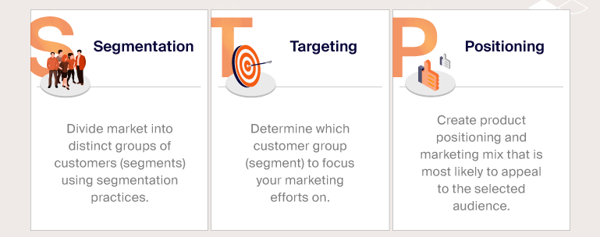
Figure 1: STP for the New Brand Extension
Source: (Park and McCarthy, 2023)

1. Segmentation
Market segmentation based on demographic, regional, psychographic, and behavioural characteristics is crucial for the successful deployment of Facebook HomeHub. Different portions show user platform interactions and how it meet their demands.

Demographic Segmentation: Since middle- and high-income people between 25 and 45 utilise smart home devices, Facebook HomeHub targets them. People between 25 and 45 like smart homes for their simplicity of use, security, and energy efficiency. 39% of 25-44-year-olds are interested in purchasing smart home gadgets due to their increased technology usage (Al-Fuqaha et al., 2021).

Geographic Segmentation: Facebook HomeHub will launch in contemporary cities across North America, Europe, and Asia, including IT hubs in San Francisco, Berlin, and Tokyo (Martínez and De Chernatony, 2024). These places have many inventive technology users, therefore smart device adoption peaks there. Due to reliable internet access and many networked devices, the targeted markets are ideal for product launches.

Psychographic Segmentation: The offering will target innovative technology-based market segment members and those seeking efficiency gains via technology (Martínez and De Chernatony, 2024). These customers require smart home solutions to automate and regulate their equipment. Facebook HomeHub is for users who want software that works with Facebook and Messenger and want an easy home connection.

Behavioural Segmentation: Three customer groups are homeowners, renters, and shared householders. Smart device users enjoy solutions that combine social media and smart device management, therefore Facebook HomeHub targets them (Park and McCarthy, 2023). Facebook HomeHub allows tenants, particularly in cities, to monitor and operate home gadgets using their present platforms, eliminating the need for separate applications or systems. Facebook HomeHub helps shared houses increase cooperation and user experience by distributing smart home controls across inhabitants.

2. Targeting
Per its segmentation approach, Facebook HomeHub will target numerous categories that match its product features and capabilities. Our solution targets high-tech millennials and Gen Xers aged 25–45 who utilise technology to manage their homes and work as professionals while raising young families and buying smart home features. 45% of millennials consider buying devices with smart home connectivity, making this product ideal for this market (Park and McCarthy, 2023). Secondary target customers include urban renters and shared houses that desire simple, adaptable automated solutions. These consumers frequent Facebook and are interested in home improvement ideas. Facebook HomeHub's built-in social tool and complete home management features allow young professionals and small families in metropolitan regions to buy the product by leveraging private security and energy-saving features.

3. Positioning
Facebook HomeHub positions itself as an upscale device which integrates smart home systems with social media features from Facebook. Customers will find Facebook HomeHub presents the simplest method to handle their smart home environment through its integrated system that serves controls through Messenger and Facebook apps.
The positioning message for Facebook HomeHub declares:
“People who combine technological expertise with the importance of secure convenience can integrate Facebook HomeHub to experience unified smart home management via social connectivity. Facebook HomeHub allows users to manage their home devices together with real-time alerts by integrating effortlessly into the Facebook platform which users access daily.”
Facebook HomeHub uses Messenger for total social networking, allowing users to share control settings and quick notifications while communicating in real-time (Vorderer, Krömer and Schneider, 2021). Facebook HomeHub prioritises home management via social engagement by helping users create unique experiences beyond Google Home and Amazon Alexa. Facebook HomeHub provides a safe, personalised home control platform using social media, messaging, and community elements. Due to its full range of innovative features, which incorporate social capabilities into every element, the product is unique in its business.

Customer Personal Profile

Psychographic Profile
- Values: Innovation, convenience, technology integration
- Attitudes: Strong belief in using technology to improve daily life and productivity
- Lifestyle: Active, tech-savvy, enjoys a connected home experience
- Buying Behavior: Prefers premium, smart home devices and seeks seamless integration with existing digital ecosystems
- Aspirations: Aspires to enhance home convenience and security, balancing professional success with personal well-being

Description
Emily Harris is a marketing manager in San Francisco who makes $85,000 a year and is 32 years old. Being a tech-savvy professional, she looks for creative technologies to simplify her everyday chores—especially those about her house. Emily belongs to the millennial generation, which values smart homes and technology. 38% of millennials are probably going to buy smart home appliances. Emily is a fantastic fit for Facebook HomeHub because her taste for luxury goods fits her goal for flawless home automation and social connectedness. Convenience and security drive her; she makes sure her living area is not only practical but also linked to her social network. Emily's way of life relies on work-life balance, hence she looks for technologies like Facebook and Messenger that fit her current digital ecology.

Marketing Mix Strategy for Facebook HomeHub
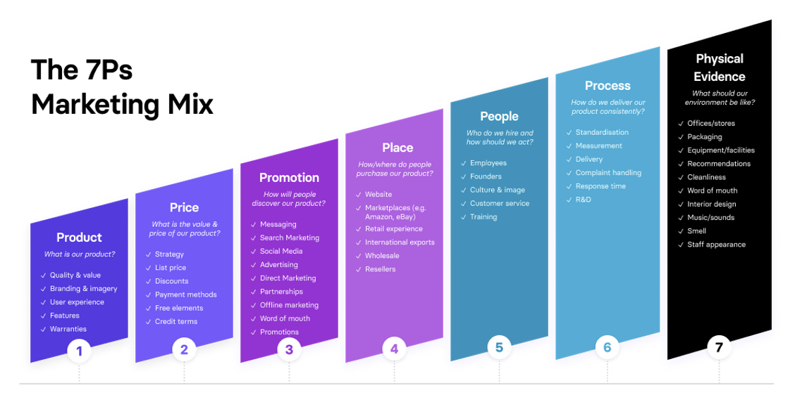
Figure 2: Marketing Mix Strategy
Source: (Han et al., 2019)

1. Product
Through its unified platform, Facebook HomeHub integrates Facebook social networking into smart home technologies. The software leverages Facebook Messenger and Facebook to manage home lights, heating, security, and electrical equipment. Voice control, event-based automation, and real-time notifications increase user experience. Messenger lets users share smart home setups and domestic experiences with friends and family, adding social aspects for the smart home (Park, McCarthy and Milberg, 2022). When combined with Facebook HomeHub, the offering goes beyond smart home management. This solution connects home management and community engagement to provide homeowners with a more dynamic home control experience. Facebook HomeHub tackles the growing market for smart home devices by adding social capabilities while remaining competitive at $200 to $300 (Statista, 2023). The industry is expected to reach $53.45 billion by 2026.

2. Price
High-performance smart home features will establish Facebook HomeHub as a premium product. Users who want a linked smart home system and utilise Facebook goods might choose Facebook HomeHub for $200–$300 (Park, McCarthy and Milberg, 2022). Its pricing is comparable to Google Nest and Amazon Alexa devices in the smart home market. As a major social tool provider, Facebook HomeHub has an advantage since users would pay more for things that match their social network interests. Subscriptions should provide specialised home automation routines and security monitoring to increase customer loyalty and income streams. Statista found that subscription-based tech services are rising, giving Facebook a chance to create this market strategy with home-related services.

3. Promotion
Facebook plans to use its active platforms as part of the promotion strategy to build awareness about Facebook HomeHub. The platform's large user base exceeding 2.8 billion enables the company to capitalise on an enormous built-in promotional marketing base for its products. Social media marketing strategies will direct Facebook HomeHub promotion efforts to Facebook, Instagram, and Messenger platforms to access technical consumers who already use these platforms. The promotional marketing initiatives will show Facebook HomeHub capabilities through interactive advertisements and video demonstrations about messenger-based smart home automation (Han et al., 2019). The campaign depends heavily on influencers as essential business partners. Technology influencers together with home improvement vloggers will display the user-friendly nature of Facebook HomeHub in their day-to-day activities. Facebook will host live product demonstrations alongside workshops and Q&A sessions enabling users to experience Facebook HomeHub directly which builds trust as well as excitement.

4. Place
The new HomeHub product Facebook can be purchased through Facebook's electronic storefront as well as Amazon online. People who depend on Facebook platforms will find the product readily available through both Facebook e-commerce and Amazon (Han et al., 2019). Major retail stores including Best Buy and Fry's Electronics will offer Facebook HomeHub for purchase as well as provide test opportunities for potential customers. Facebook HomeHub offers dual distribution through smart home retailers and complete integration with Google Home and Amazon Alexa platforms to provide customers with effortless interconnectivity with other smart home systems.

5. Process
Facebook has designed the buying and operating processes of Facebook HomeHub to be easy for users to understand. Facebook operates product sales through its platform and allows consumers to buy it from their partner retail locations with the added benefits of seeing and experiencing the product in person. Users who purchase the product will immediately set up their Facebook connection to Messenger followed by device synchronisation enabling them to control their environment instantly (Al-Fuqaha et al., 2021). Configuration steps will guide users through an intuitive setup process that the Facebook Help Centre guides users through with Messenger bot assistance to regulate their hardware technicalities. Through AI integration the platform will automatically learn user preferences to keep operations personal and easy to handle over time.

6. People
The Facebook HomeHub customer service staff stands essential to guarantee customers' seamless experience when using the platform. These support representatives will deliver technical help through live chat combined with both Facebook Messenger and email services (Al-Fuqaha et al., 2021). Users can get individual guidance through the service for addressing their device issues learning how to set up their equipment and receiving recommendations about product features. Early adopter communities need brand ambassadors for the successful adoption of the product. These product ambassadors will use their presence at tech events and virtual gatherings along with their influencer activity to directly engage customers so they can both answer queries and show off how the product functions.

7. Physical Evidence
Facebook HomeHub presents physical evidence through its premium and ergonomic design complemented by high-quality packaging which shows its high-end status. The product will use sustainable durable materials during manufacturing to achieve both durability and sustainability in performance (Park and McCarthy, 2023). Visitors at retail stores will discover Facebook HomeHub demonstrations that show how customers can handle the product and witness its relationship with Facebook platforms. The packaging of Facebook HomeHub will showcase three key selling features such as Messenger integration together with customizable automation and security features to help customers appreciate the product's worth before buying it.

Conclusion
As Facebook HomeHub enters the market it opens strategic prospects for Facebook to move into the smart home market expected to surpass $53.45 billion by 2026 (Statista, 2023). Facebook HomeHub builds upon its Facebook user community to deliver home automation solutions, which do not exist in comparable services from Amazon Alexa and Google Nest. The merger of Messenger for home system controls with social network updates in Facebook HomeHub establishes an interactive smart living system that emphasises community interaction. The rising need for the combination of smart home functionality with social technology demands led to this product extension (Martínez and De Chernatony, 2024). The existing Facebook infrastructure combined with its familiar user base enables Facebook HomeHub to quickly find market success since members already rely on Facebook for daily communication. Facebook needs to advance its brand awareness using strategic marketing activities and stakeholder alliances plus physical and virtual showroom initiatives. Facebook's skills in enhancing personalization and community connection will transform Facebook HomeHub into an indispensable network management tool for consumers who want a standard-setting experience in connected home technologies and social networking.

Reference
Al-Fuqaha, A. et al. (2021) 'Internet of Things: A survey on enabling technologies, protocols, and applications,' IEEE Communications Surveys & Tutorials, 17(4), pp. 2347–2376. https://doi.org/10.1109/comst.2015.2444095.
Arthanat, S., Wilcox, J. and Macuch, M. (2023) 'Profiles and predictors of smart home technology adoption by older adults,' OTJR: Occupational Therapy Journal of Research, 39(4), pp. 247–256. https://doi.org/10.1177/1539449218813906.
Bridges, S., Keller, K.L. and Sood, S. (2020) 'Communication strategies for brand extensions: Enhancing perceived fit by establishing explanatory links,' Journal of Advertising, 29(4), pp. 1–11. https://doi.org/10.1080/00913367.2000.10673620.
Buil, I., De Chernatony, L. and Hem, L.E. (2022) 'Brand extension strategies: perceived fit, brand type, and culture influences,' European Journal of Marketing, 43(11/12), pp. 1300–1324. https://doi.org/10.1108/03090560910989902.
Han, J. et al. (2019) 'Smart home occupant identification via sensor fusion across On-Object devices,' ACM Transactions on Sensor Networks, 14(3–4), pp. 1–22. https://doi.org/10.1145/3218584.
Martínez, E. and De Chernatony, L. (2024) 'The effect of brand extension strategies upon brand image,' Journal of Consumer Marketing, 21(1), pp. 39–50. https://doi.org/10.1108/07363760410513950.
Martinez, E., Polo, Y. and De Chernatony, L. (2020) 'Effect of brand extension strategies on brand image,' International Marketing Review, 25(1), pp. 107–137. https://doi.org/10.1108/02651330810851908.
Park, C.W. and McCarthy, M.S. (2023) 'The effects of direct and associative brand extension strategies on consumer response to brand,' Advances in Consumer Research, 20(1), pp. 28–33. https://dialnet.unirioja.es/servlet/articulo?codigo=340903.
Park, C.W., McCarthy, M.S. and Milberg, S.J. (2022) 'The effects of direct and associative brand extension strategies on consumer response to brand extensions,' ACR North American Advances [Preprint]. https://www.acrwebsite.org/volumes/7415/volumes/v20/NA-20.
Vorderer, P., Krömer, N. and Schneider, F.M. (2021) 'Permanently online – Permanently connected: Explorations into university students’ use of social media and mobile smart devices,' Computers in Human Behavior, 63, pp. 694–703. https://doi.org/10.1016/j.chb.2016.05.085.

