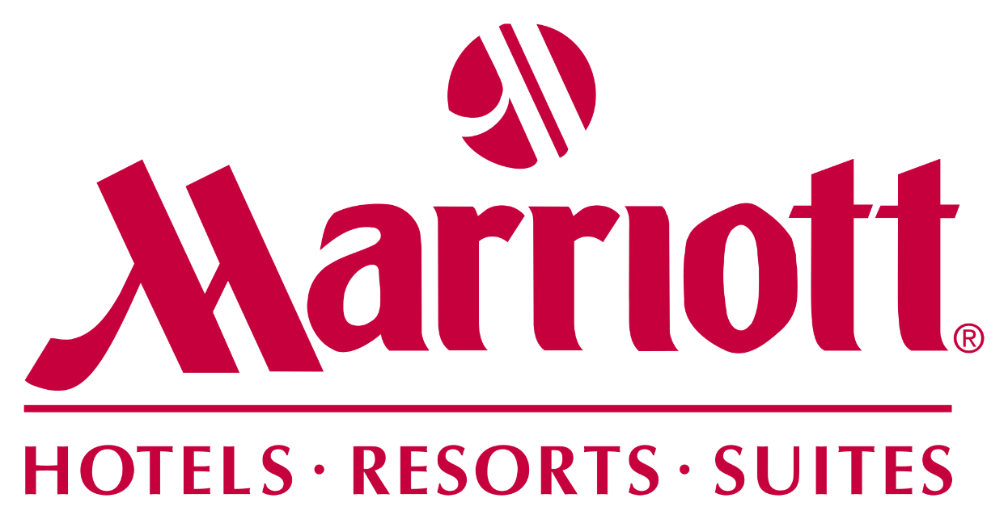

Strategic Audit and Analysis of Marriott in the context of covid-19 Pandemic

BMBM6016, Strategic Marketing
Junjie Li (2105553)
March 18, 2022

Executive summary
While the sudden outbreak of covid-19 affects almost every industry to a different extent, the hotel industry is the one under the most negative hit. With the covid-19 continuing to impact the hotel industry, leading hotel brands, such as Marriott should be the first ones that adapt quickly through strategic re-orientation to mitigate the operational and financial risks brought by pandemics. The present report sheds light on the competitive environment of Marriott in the covid-19 time through a critical and comprehensive audit in different levels, macro, micro, and internal levels. Different strategic management tools are used to facilitate analysis. The report identifies influential factors at the macro-level (such as travel restriction, data technologies, etc.) and micro-level (such as increased power of buyers, less threat of substitutes, etc.) The resources and capabilities of Marriot are presented in its broadest portfolio and widest presence across markets, allowing it to hedge the unprecedented market risks. Recommendations such as cross-portfolio communication, creative offerings to stimulate demands are promoted for Marriot to navigate risks under the ongoing covid-19.

Content page
Executive summary
1. Introduction 1
2. Main body 3
2.1 Macro-environment audit 3
2.2 Micro-environment audit 4
2.3 Internal environment audit 6
2.3.1 Financial analysis of Marriott 6
2.3.2 Resources and competencies of Marriott 7
2.3.3 Competitive situation of Marriott 8
3. Recommendations 10
4. Conclusion 12
References 13

1. Introduction
Covid-19, an infectious disease causes, outbroke on a global scale in 2019 and has continued to impact us (WHO, 2021). A plethora of measures have been introduced by governments across markets to suppress the negative impacts of the covid-19 pandemic, such as the imposition of a series of requirements on inbound travel, the restriction on outbound travel, the public social distancing concern, etc. (McKinsey, 2020) (see Figure 1) Under these measures, the time, economic and safety costs for travel has been unprecedentedly high, bringing the people-intensive hotel industry to a standstill. Especially, with the World Health Organization classifying the covid-19 outbreak as a global pandemic, business for hoteliers fell off with occupancy rates plummeting to just 20 % and room rates plummeting nearly 30 % (Anguera-Torrell, Aznar-Alarcón and Vives-Perez, 2021). The uncertain situation facing the hotel industry require incumbents make active answer through strategic adjustment to navigate the continuous risks resulting from covid-19.
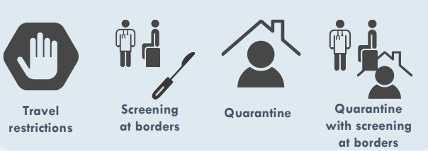
Figure 1. Travel measures under covid-19
Source: (Burns et al., 2021)
Marriott is a worldwide franchiser, licensor, and operator of residential, hotels, and timeshare properties under a wide range of brands (as in Figure 1). Due to covid-19, Marriott reported a revenue per room (RevPAR) 60% down (Marriott, 2021). Marriott has taken substantial measures to mitigate all negative impacts of covid-19. The report affords a critical and comprehensive audit of Marriott from both external and internal perspectives in the ongoing covid-19 context, with an overate aim to proposal some actionable recommendations to help Marriott effectively negative the ongoing covid-19.
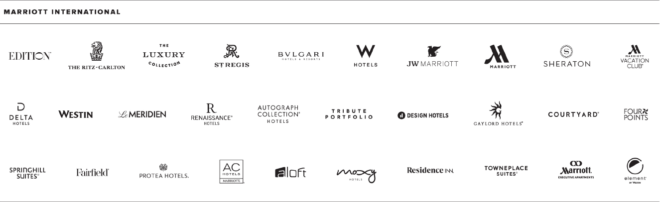
Figure 2: Brands under Marriott International
Source: (Marriott, 2021)
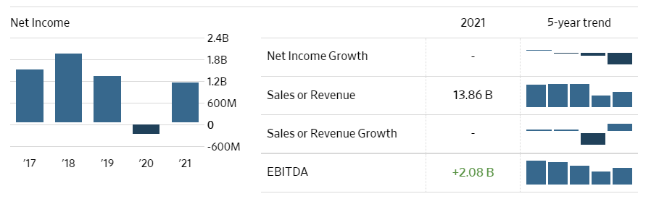
Figure 3: Financial highlights of Marriott
Source: (Wall Street Journal, 2022)

Main body
The section will utilize a portfolio of strategic management techniques to critically and comprehensively audit the internal and external environment facing Marriott. It will start with a macro-environment audit using PESTEL, micro-environment audit using Porter’s five forces, internal environment audit using SWOT, and VIROFramework.

Macro-environment audit
PESTEL, which stands for political, economic, social, technological, environmental, and legal, is a management technique frequently used by strategists to access the major factors in the macro level which are beyond their control but have significant implications on business operations (Ansoff et al., 2018). Given the fact that there are a wide spectrum of macro factors impacting Marriot under the covid-19 context, the report hights the political factors and economic, and technological factors which have the greatest relevancy to Marriot’s strategic management

In terms of political factors , countries, such as China, have not yet opened their borders to tourists from other places due to their stringent stance in covid-19 control, resulting in lower-than-previous demands in hotels within in these countries and also resulting in loss of tourists in some reopened travel hotspots in other countries ( Asian people have been perceived as the biggest sources of tourists in global tourism) (Bloomberg, 2022). Different legal regulations have been issued to ensure safer guest accommodation under covid-19. For instance, encourage not to take guests who test positive for covid-19, provides adequate ventilation and clean to prevent covid-19, etc.

In terms of economic factors, the covid-19 has resulted in the severe contraction of the global economy. Specifically, the global economy shrank by 5.2% in 2021 (with developed economies shrank 7% and emerging economies shrank 2.5%), representing the biggest recession since World War II (World Bank, 2022). However, the global economy is expected to grow at 4.9% in 2022 due to accelerating policy support and vaccination program, amid continued covid-19 flare-ups (International Monetary Fund, 2022). Therefore, the hotel sector may experience a gradual recovery from the pandemic crisis in the coming future.

In terms of technology, social media marketing: social media has gained traction in the usage rate, especially in the young tech-savvy generations, and become ubiquitous in acquiring and disseminating information, they are proving to be valuable marketing channels for the hotel industry, which previously relied on TV commercials and magazines for marketing (Chan and Guillet, 2011). Service personalization has been enabled by data technologies, specifically big data enables values hidden in massive data to be discovered. The preferences and patterns of individual consumers can be understood. Based on this, more personalized accommodation experiences and more targeted personalized marketing communication plans can be developed and delivered (Pan and Yang, 2017). It is also noticeable that robotic maids, predictive maintenance based on big data analytics, contactless communication, and smart sensors based on the Internet of things are increasingly being used by leading and pioneering hotel brands to ensure a safe and superior customer experience under the covid-19 context. (EHL Insights, 2021).

It has been evident that there are both unsized opportunities such as the further integration of technologies to prevent covid-19 and address customer concern in the covid-19 context, and some ongoing threats brought by travel restrictions and accompanying costs.

Micro-environment audit
The micro-level audit is performed using Porter’s five force analysis. The model draws upon industrial organization economics to derive five major forces that determine the overall attractiveness and competitiveness of a specific industry (Deepak and Jeyakumar, 2019). Attention will be paid to only relevant points here.
Table 2: Porter’s five forces analysis
Source: own summary
Factors | Implications
Threats of substitutes | - Moderate  - The sharing accommodation provided by Airbnb continues to threaten the traditional hotel industry due to its heterogeneity in services (Airbnb offerings are more localized and diversified in size, types, locations, etc.) (Zervas, Proserpio, and Byers, 2017). However, over the long term, the peer-to-peer accommodation offered by Airbnb will still pose a significant threat to the whole traditional hotel industry. So far, it has 247 active guests during 2020 with more than 7.4 million different types of rooms available (Hospitality Net, 2020).
Bargaining power of customers | - Relatively high  - The hotel industry has been highly concentrated and the outbreak of covid-19 has accelerated the inequality between supply and demand (Kim, Han, and Ariza-Montes, 2021), as there are no costs for customers to switch between brands, the customers are endowed with more bargaining power. The pressure from the customer side has resulted in all major hotel chains trying to lower the prices of their offerings to snatch customers from each other.
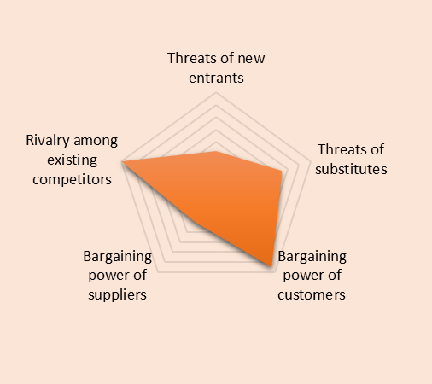
Figure 3. Porter’s five forces highlight the hotel industry
Source: own summary
The overview of the whole industry indicates the overall attractiveness of the whole industry is relatively low as the covid-19 pandemic has turned the hotel industry into a buyer’s market where suppliers exceed demands and consumers have bargaining power over suppliers in price negotiation. The buyer market of the hotel industry also indicates the higher competition among existing rivalries, as they all face the revenue pressure under the sluggish industry prospect reserved from covid-19. Therefore, the major implication for Marriot is to secure its bargaining power against customers and stand out in the fierce competition.

2.3 Internal environment audit

2.3.1 Financial analysis of Marriott
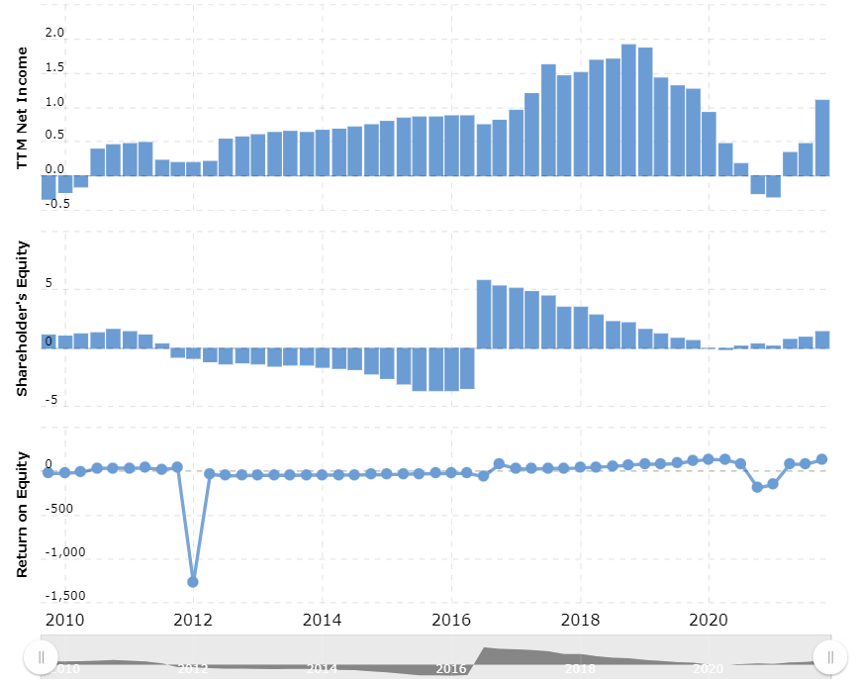
Figure 4. Key financial ratios of Marriott
Source: (MacroTrends, 2022)
Covid-19 has negatively impacted world travel since the beginning of 2020. Marriott’s revenue and return on equity have experienced negative growth first time in the past 10 years after 2012. 25% of its 7600 properties around the world under Marriott were closed in 2020, the ratio decreased to 6% in 2021 (Marriott, 2021). Besides, covid-19 also resulted in significantly high cancellations by travelers and historically low new room additions. Although Marriott has taken substantial measures to mitigate all financial and operational difficulties brought by covid-19, such as reducing cash outlays, implementing a multi-pronged platform to remain clean, initiating above-property restructuring, etc. the negative impacts are still hard to be counteracted by these measures (Marriott, 2021). In the midst of this challenging time, Marriott should revise its current strategy to navigate the future volatilities and uncertainties in the hotel industry due to covid-19.

Resources and competencies of Marriott
VRIO stands for value, rarity, imitability, and organized to exploit, which is used here to evaluate the competitive resources and capabilities of Marriot. The framework has its origin in the resource-based view, holding the idea that resources and competencies owned by the company provide them a basis for strategic sustainable competitive advantage development (Ansoff et al., 2018). The above audit on the macro and microenvironment has helped identify some external influential factors that have operational implications on Marriot, the internal audit on resources and competencies can help Marriot for the further strategic development in the context of covid-19.
Table 3: VRIO analysis of Marriott
Source: Own analysis
Resources/  Competences | Valuable? | Rare? | Inimitable? | Exploited? | Competitive advantage
Brand reputation | Yes | Yes | No | Yes | Temporary competitive advantage
Geographical presence | Yes | No | No | Yes | Competitive parity
Well-diversified portfolio | Yes | Yes | Yes | Yes | Competitive advantage
Experienced and capable employees | Yes | Yes | No | Yes | Temporary competitive advantage
Innovative hospitality technology | Yes | Yes | Yes | Yes | Competitive advantage

The competitive advantage of Marriot drives by its well-diversified brand portfolio. Marriott has 21 distinct brands and businesses (Marriott, 2021). Different brands under Marriott have different market position targeting different market segments (The Economic Times, 2022)The network of brands allows Marriott to effectively leverage economies of scale and capitalize on profitable opportunities (Travel Pulse, 2022). Another competitive advantage of Marriot lies in its innovative hospitality technology. Marriott mobile app provides more interaction-less experiences through mobile check-in, keyless open, and mobile requests at any time for anything (Marriott, 2021). Marriot has pioneered use internet of things to innovate guest experiences by driving connection and convenience (Digital Journal, 2022). Meanwhile, Marriott has attempted to unleash the power of big data analytics technology to understand guest patterns and preferences to personalize and optimize services (Middletown Press, 2022). However, the competitive advantages of Marriott have not actively been exploited during the covid-19 crisis. For instance, Marriott does not explore the new use of these technologies to prevent covid-19 infection and deliver virus-free accommodation services, which can be an opportunity to seize in the future.

Competitive situation of Marriott
After the internal and external environmental audit of Marriot, SWOT, which stands for strengths, weaknesses, opportunities, and threats is used to identify and synthesize all factors that could impact the strategic development of Marriot. The part focus on the opportunities and threats presented in the internal and external environment where Marriott operates.
- In terms of opportunities, Cutting edge technologies in the hotel industry have brought more methods for hotel incumbents to turn crisis into challenges. The deeper integration of the hotel service delivery and a wide spectrum of technologies unleash the new potential of how value can be created in the future (Goryushkina et al., 2018). For instance, the internet of things enables hotels to build automation to improve cost efficiency and delivery contact-free services. The artificial intelligence-enabled robots can replace humans to reduce people’s intensity in the hotels and perform basic tasks, such as answering inquiries, amenities delivery, check-in, and out (Parmar et al., 2019). While Marriott has already a pioneer in technology integration into hotel service delivery, it should be more innovative in actively using a wide spectrum of technologies to address the pain points of traveling during covid-19.
- In terms of threats, Covid-19 will continue to impact the hotel industry negatively as it directly results in declined tourists’ arrivals in the major markets Marriott operates to an extent that nobody can predict (McKinsey, 2020). The covid-19 will directly impact the revenue generated from the managed and franchised hotels, but also influence the financing and solvency issues for operation.Covid-19 also leads to the additional expenditure in maintenance, which has not been fully reimbursed by revenues. The uncertain and unpredictable situation of the covid-19 in the future and other possible crises highlights the importance of hotel layers to actively navigate the crisis to capture value, rather than just passively comply with regulations. At the same time, the hotel industry has been highly competitive, Marriot has to compete with leading brands (such as Hilton, Jin Jiang, Radisson, etc.) and regional hotel chains, and independent local hotels, sharing and rental accommodations. The current situation, where demands have been much lower than supplies due to covid-19, significantly intensified the competition.
The SWOT analysis thereby identifies the covid-19 as both threats and opportunities for Marriott. On the one hand, the uncertainties of covid-19 will bring more operational pressure for Marriott; on the other hand, the active and practice responses of Marriott, through measures such as creative marketing, technology utilization can also help Marriott to generate revenues and navigate the covid-19 challenges

Recommendations
Based on the above audit on the internal environment and external environment facing the organization, some recommendations are provided as follows:
- Given a wide range of portfolio brands under Marriott as its sustainable competitive advantage, Marriott needs to implement more effective and frequent communications mechanisms, either through seminars, emails, meetings, or phone calls, or even setting up a new covid-19 advisory group, to provide its owners and franchisee with updated real-time information regarding the covid-19 situation, and regarding steps should be taken to support operations (such as hotel cleanliness procedures, etc.)
- The marketing teams of Marriott should also focus on stimulating demands from the guest side by creative offerings during the covid-19, enabled by a hygiene hotel environment. Given people’s lust for wonder has been accelerated as they have been quarantined themselves for so long, Marriott can offer some leisure or business travel packages with minimized interaction or supervised interaction to avoid the spread of covid-19 within Marriott. Local social media tools, such as WeChat in China, Facebook in the US, Kakao in South Korea, should be utilized to initiate marketing communications with the local guests and travelers. Also, highly personalized accommodation services, such as preferred type of room, the plan of travel route, etc. can be developed based on big data analytics of customer previous consumption patterns to promote demands, especially Marriott has a widely diversified portfolio of brands with different offerings and its integration of technological advancements as its competitive advantage.
- Cleanness and safety would be important to guests, new technologies can be introduced to promote guest experiences. For instance, the mobile application of Marriot can be added with more functions to facilitate with contact-less check-in, check-out, room services, entertainment, and other services. Also, some cleaning technologies can be enhanced, such as electrostatic sprayers with hospital-grade disinfectant for sanitization, or the internet of things to enhance touch-less control of equipment, etc.
- All employees need to receive the covid-19 awareness training, such as hygiene portal housekeeping. Also, they need to be more prepared for all kinds of situations brought by covid-19 to help guests at anything for problems
- The corporate and regional team of Marriot should be on standby 24/7 to support the hotels with updated covid-19 travel information acquired from local and regional authorities. This relevant information should be communicated to employees through emails, mobile notifications, etc. so that they can better plan their trips.

Conclusion
The present report shed light on the strategic management issue of Marriott hotel under the covid-19 context. The covid-19 has hit severely on the people-intensive hotel industry through governmental responses such as travel restrictions and social distancing. At the crossroad of unprecedented changes, some adjustment on strategies is required to better navigate the ongoing covid-19. The audit of Marriott’s external environment indicates macro-level factors such as stringent covid-19 regulations, the economic recession, the sharing economy, the data legal regulation will continue to negatively impact Marriot, but emerging opportunities can be found in the hotel-related technologies, hotel sustainability, etc. The micro-level industrial indicates the low attractiveness of the industry as it is a typical buyer market with shrank demand under covid-19. The internal analysis indicates the strength of Marriot in its brand portfolios (as its sustainable competitive advantage), geographical positions, and well-trained employees, but threats in its unsatisfactory financial performance and highly standardized services. Based on the environment audit, recommendations including marketing communication across brands, employee covid-19 awareness training, contact-less technology introduction, etc.

References
Anguera-Torrell, O., Aznar-Alarcón, J. P. and Vives-Perez, J. (2021) ‘COVID-19: Hotel industry response to the pandemic evolution and the public sector economic measures’, Tourism Recreation Research, 46(2), pp. 148–157.
Ansoff, H. I. et al. (2018) Implanting strategic management. Springer.
Burns, J. et al. (2021) ‘International travel-related control measures to contain the COVID-19 pandemic: a rapid review’, Cochrane Database of Systematic Reviews, 2021(3). doi: 10.1002/14651858.CD013717.pub2.
Chan, N. L. and Guillet, B. D. (2011) ‘Investigation of social media marketing: how does the hotel industry in Hong Kong perform in marketing on social media websites?’, Journal of Travel & Tourism Marketing, 28(4), pp. 345–368.
Deepak, R. K. A. and Jeyakumar, S. (2019) Marketing management. Educreation Publishing.
Digital Journal (2022) Chain Hotel Market Is Going to Boom : Marriott International, Hyatt Hotels, Radisson Hotel Group - Digital Journal. Available at: https://www.digitaljournal.com/pr/chain-hotel-market-is-going-to-boom-marriott-international-hyatt-hotels-radisson-hotel-group (Accessed: 7 March 2022).
EHL Insights (2021) How technology is improving COVID-affected customer experience. Available at: https://hospitalityinsights.ehl.edu/covid-affected-customer-experience (Accessed: 15 March 2022).
Goryushkina, N. E. et al. (2018) ‘The world hotel market: current state and development trends’, International Journal of Mechanical Engineering and Technology, 9(13), pp. 618–627.
Hospitality Net (2020) How big of a threat to the hospitality industry, if at all, is Airbnb’s upcoming IPO? . Available at: https://www.hospitalitynet.org/opinion/4101840.html (Accessed: 18 March 2022).
Hotel Management (2022) Marriott charts solvency plans amid COVID-19 pandemic . Available at: https://www.hotelmanagement.net/operate/marriott-outlines-plans-for-staying-solvent-a-pandemic (Accessed: 7 March 2022).
International Monetary Fund (2022) World Economic Outlook, October 2021: Recovery During A Pandemic. Available at: https://www.imf.org/en/Publications/WEO/Issues/2021/10/12/world-economic-outlook-october-2021 (Accessed: 6 March 2022).
Kim, J. J., Han, H. and Ariza-Montes, A. (2021) ‘The impact of hotel attributes, well-being perception, and attitudes on brand loyalty: Examining the moderating role of COVID-19 pandemic’, Journal of Retailing and Consumer Services, 62, p. 102634.
Koo, G., Lee, N. and Kwon, O. (2019) ‘Combining object detection and causality mining for efficient development of augmented reality-based on-the-job training systems in hotel management’, New Review of Hypermedia and Multimedia, 25(3), pp. 112–136.
MacroTrends (2022) Marriott Net Income 2010-2021 | MAR | MacroTrends. Available at: https://www.macrotrends.net/stocks/charts/MAR/marriott/net-income (Accessed: 6 March 2022).
Marriott (2021) Marriott International Annual Report 20202.
McKinsey (2020) COVID-19’s effect on the hotel industry |. Available at: https://www.mckinsey.com/industries/travel-logistics-and-infrastructure/our-insights/hospitality-and-covid-19-how-long-until-no-vacancy-for-us-hotels (Accessed: 7 March 2022).
Middletown Press (2022) Chamber on the Move: Two new businesses coming to Middletown. Available at: https://www.middletownpress.com/opinion/article/Chamber-on-the-Move-Two-new-businesses-coming-to-16978395.php (Accessed: 7 March 2022).
Nyangwe, S. and Buhalis, D. (2018) ‘Branding transformation through social media and co-creation: lessons from marriott international’, in Information and communication technologies in tourism 2018. Springer, pp. 257–269.
Pan, B. and Yang, Y. (2017) ‘Forecasting destination weekly hotel occupancy with big data’, Journal of Travel Research, 56(7), pp. 957–970.
Parmar, S. et al. (2019) ‘Smart hotel using intelligent chatbot: A review’, International Journal of Scientific Research in Computer Science, Engineering and Information Technology, 5(2), pp. 823–829.
The Economic Times (2022) JW Marriott: Marriott International launches JW Marriott Bengaluru Prestige Golfshire Resort & Spa . Available at: https://economictimes.indiatimes.com/industry/services/hotels-/-restaurants/marriott-international-launches-jw-marriott-bengaluru-prestige-golfshire-resort-spa/articleshow/90045369.cms (Accessed: 7 March 2022).
The Times (2022) Marriott Bonvoy Brilliant Amex Review — Premium Benefits for Frequent Travelers | NextAdvisor with TIME. Available at: https://time.com/nextadvisor/credit-cards/reviews/marriott-bonvoy-brilliant-amex-card/ (Accessed: 7 March 2022).
Travel Pulse (2022) Marriott To Expand Its Reach in the Asia Pacific Region . Available at: https://www.travelpulse.com/news/hotels-and-resorts/marriott-to-expand-its-reach-in-the-asia-pacific-region.html (Accessed: 7 March 2022).
Wall Street Journal (2022) MAR | Marriott International Inc. Financial Statements . Available at: https://www.wsj.com/market-data/quotes/MAR/financials (Accessed: 6 March 2022).
WHO (2021) Coronavirus. Available at: https://www.who.int/health-topics/coronavirus#tab=tab_1 (Accessed: 15 March 2022).
Zervas, G., Proserpio, D. and Byers, J. W. (2017) ‘The rise of the sharing economy: Estimating the impact of Airbnb on the hotel industry’, Journal of marketing research, 54(5), pp. 687–705.

