Bakshi Rashid 2236979
Assignment 2

Q2. What impact can the challenges of operational policing have on individual and group wellbeing? Why is it important to manage mental wellbeing in policing? Your answer must be based on academic research rather than personal experience.
In this essay, I will write how the challenge of operational policing impacts the wellbeing of individuals and teams. I will also mention why it is extremely important to manage mental wellbeing as a police officer and the effects of not doing so.
Mental wellbeing is defined as a way an individual copes and responds well with natural life stress, is a productive individual, forms and manages positive relationships and bonds and can manage a good work/life balance (BBC News 2023).
The role of police officers contains numerous challenges, stress and risk due to the daily activities officers are exposed to and asked to carry out. The daily activities can range from sudden deaths to car crashes to domestic incidents and during these incidents police officers may be assaulted and even injured whilst working demanding shifts.
Some of the challenges involved in policing is that police officers are likely to experience 400-600 traumatic incidents across their careers whilst a member of the public would experience 3-4. (Avon and Somerset Police Federation 2021). These traumatic incidents can be dealing with violent and aggressive offenders or incidents involving serious injuries/abuse, death or victims disclosing horrific crimes. Although some officers may not be affected by attending traumatic and stressful incidents immediately, constant exposure to these incidents/calls can lead to a police officer struggling with their mental health if they don’t receive the support they need. (Porter and Lee 2023).
Another challenge of operational policing is officers are being deployed single crewed to resource the call demand however this leaves single crewed officers outnumbered, assaulted more often and with higher individual workloads and higher levels of stress due to the increase in individual work (Police Federation 2021). Other challenges involved in policing is the increase in public and media scrutiny across recent times, there are many media outlets who rightfully write about all the wrongdoings of police officers however not many will write about the operational challenges and struggles of police officers (PMAC).
Whilst attending calls, officers must deal with being verbally and racially abused as well as being assaulted whilst on duty, assaults on police officers are on the rise and we can see this as in the year ending March 2023, around 110 assaults per day were recorded in England and Wales (Police Federation 2023). The effects of being assaulted can affect officers’ mental health, esteem and confidence in their work life and their personal life which can affect relationships with family, friends and even colleagues. Attending calls after being assaulted can lead to officers feeling nervous/stressed about being assaulted again which is why it’s important for officers to manage their mental wellbeing and utilise support if they are struggling.
Other officers may not have any issues dealing with traumatic incidents however they may struggle with the high number of personal workloads leaving them stressed, potentially working from home to resolve incidents and bring down their workloads or staying on later than the allocated hours to resolve incidents, complete the relevant paperwork.
Individual stress from operational policing can impact an individual’s wellbeing as a high level of stress can cause physical and mental problems (World Health Organisation 2023) impacting police officers health. The longer officers neglect their health, physical and mental problems can develop and worsen. Officers neglecting or ignoring their mental health can lead to further physical or mental health issues later down the line which shows the importance of managing mental wellbeing in policing (Mulligan 2022).
The challenges of operational policing may impact individuals so much so that they end up taking time off the job. The year 2021 showed that nearly 10,000 police officers nationally took time off due to stress, depression, anxiety and post-traumatic stress disorder. With officers having time off due to job related stress this effects the whole force as officers left on teams must attend more calls to help vulnerable people and at times there may not be enough officers to resource the calls leaving the public at risk. The officers remaining in the teams deal with increased workloads due to attending more calls and take on the workload of the officer taking time off due to job related stress, this affects the groups wellbeing as it leaves the officers remaining on the team burnt out, fatigued and overworked which impacts their own wellbeing (Avon and Somerset Police Federation 2021).
For other officers the impact of operational policing may be too much, which leads to some officers resigning from the job due to high levels of stress which may impact their physical and mental health and it may even impact their work life balance as relationships with family members and friends become effected. The graph below shows that the number of police officers leaving in recent years has never been higher (Gilder, Symonds and Agerholm 2023).
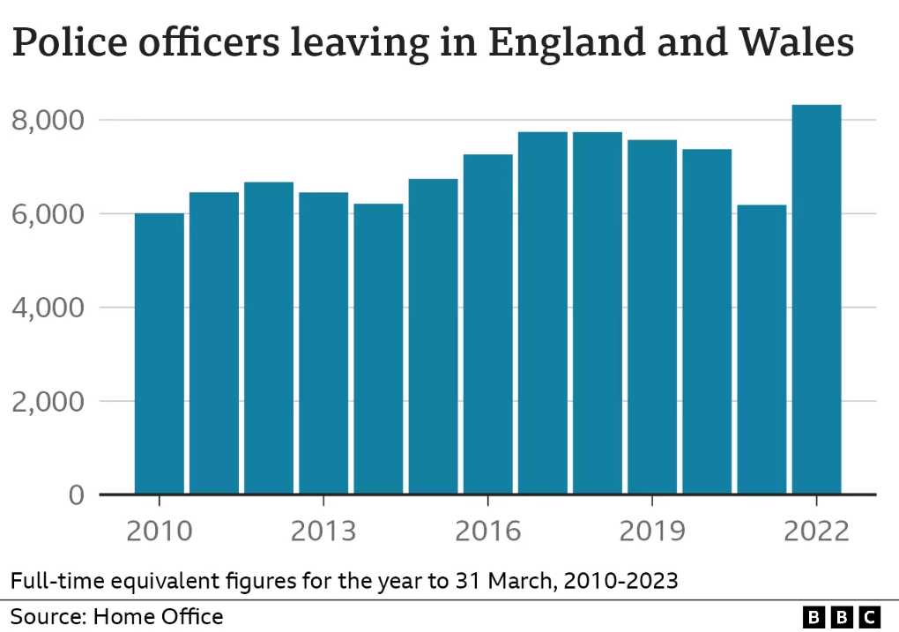

However, even though plenty officers have resigned, more officers have been recruited to replace them. The graph below shows that there is has never been more police officers in England and Wales than in 2023 when a record was set (Gilder, Symonds and Agerholm 2023).
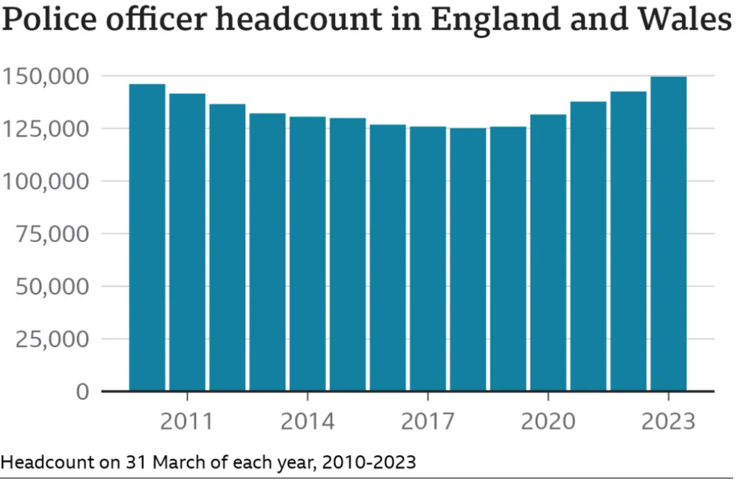

A recent challenge in operational policing is that although there may be more police officers than there has ever been in England and Wales, a lot of the officers managing the frontline are inexperienced and the numbers of police officers hasn’t kept up with the growing population, this suggests that there is a need for more police officers to keep the public safe as with a higher population, there are more reports of crime (Gilder, Symonds and Agerholm 2023).
Looking at police officers’ personal point of view from the Police Federation of England and Wales Pay and Morale Survey 2023.
Once again referring to the survey, 82% of police officers who completed the survey stated that they had experienced feelings of stress, low mood, anxiety or other problems with their mental health and wellbeing over recent times. Due to the stress involved in the job, 92% stated that they feel they aren’t paid fairly and 81% stated that officers pay was a negative impact on their morale. 86% stated that they don’t feel there are enough officers to meet the demands of certain units and because of the lack of officers, 64% said workload numbers were too high and 39% stated that high workload numbers had an impact on their mental health and wellbeing due to not being able to progress cases due to the lack of time across shifts. The survey also revealed 22% of officers who completed the survey expressed intentions to resign soon.
(Leicestershire Police Federation 2024).
Other challenges of operational policing are the morale surrounding shift work. 85% stated that operational police teams had low morale and 73% stated that there were poor mental health and wellbeing issues within policing which were also significant factors for officers who are thinking of resigning (Leicestershire Police Federation 2024).
Mental health is an important part of a person’s wellbeing, the mental health aspect effects how a person operates psychologically, emotionally and socially amongst others. A role of a police officer requires the officer to be emotionally aware and be socially active whilst dealing with members of the public as officers will deal with people at their lowest, attend emotional incidents such as fatal car crashes, other deaths and incidents where people have been assaulted and injured which requires compassion and understanding (Plumptre 2024). If officers are struggling with their mental wellbeing, they won’t be able to carry out their role effectively, which is why it’s important to manage mental wellbeing.
Theres no denying that stress and operational challenges will always be a part of a police officer’s job however officers can use coping skills to manage the challenges. To manage mental wellbeing and relieve the stress from operational policing, it’s important to have a good work/life balance. Officers whilst off duty should partake in regular exercise as exercise benefits physical and mental health.
The physical benefits are that exercise reduces the risk of heart disease, high blood pressure, diabetes, obesity and cancer and being a police officer is a physically demanding job due to the weight of the uniform officer’s wear as well as officers having to use force and run after people in certain situations. Issues with physical health significantly increases the risk of developing a mental health problem which shows the important of managing physical health as it has a knock-on effect to a person’s mental wellbeing (health direct).
Mental health benefits from exercise are that it can reduce any stress built from shift and reduce symptoms and help recovery of mental health conditions like depression, anxiety and exercise (health direct).
Another challenge of operational policing is that the role of a police officer also contains unpredictable working hours, officers work dayshifts, afternoons and nightshifts and working hours can range from 9 hour to 12 hour shifts and this excludes officers staying on late to finish off paperwork from the incidents which they attend throughout the shift. It’s important for officers to manage their sleep so they can ensure that they get as much of it as possible, as sleep is another way to manage mental wellbeing. Sleep allows the body and mind to recharge and helps people regulate their emotions and manage the physical and psychological effects of stress. Sleep also helps a person in their ability to recognise danger and threats which is important for a police officer as without enough sleep the brain can’t function properly (Peters and Bryan 2024).
Due to the challenges of operational policing and the impact it can have on officers/staff struggling to cope, each police force offers internal support to their police officers and staff struggling to manage their mental wellbeing. The support available may be the Trauma Risk Management (TRIM) system which was introduced to locate officers who attend traumatic incidents and offer them support in a way which they would like, or the TRIM system is also available to officers for self-referral, or officers can refer colleagues if they notice colleagues are struggling with their mental wellbeing. Other forms of support can be Operation Hampshire, which is a 7-point plan for officers who have been assaulted on duty. Operation Hampshire provides a strategy to support the officer by considering the physical and mental impact on them and then reacting to the officers’ needs (Oscar Kilo).
To conclude this essay, I have utilised research to write about the challenges involved in operational policing. I have mentioned the impact challenges in operational policing has on officers individually and the impact across teams as well as the knock-on effect (impact) on other teams within the force. Finally, I mentioned the importance of managing mental wellbeing in policing as well as the options available to police officers to manage the stress and challenges involved within the job.
Total words: 1802

Q4. Why is a partnership approach the most effective way to reach groups or communities who are less willing to engage with police? You should consider why certain groups are reluctant to engage with police, and the ways engagement can be achieved. Your answer should be based on academic research, although you may make reference to relevant case studies.

In this essay, I will write about how a partnership approach is the most effective way to reach and build bonds/relationships with groups or communities who are less willing to engage with the police and list the ways in which engagement with these groups/communities can be achieved. Within this essay I will also write about the importance of the public engaging with the police as well as the different types of engagement.
Different types of engagement which the police can carry out are as follows:
- Democratic mandate – This type of engagement is when the public can question and better understand the legitimacy of police actions and to hold the police to account for the effectiveness and quality of their services.
- Intermediate strategic – This includes engagement in policy, planning and critical incidents. Engaging communities at this level enables greater understanding of how policing may affect individuals and communities.
- Neighbourhood policing – This type of engagement focuses on securing community participation in relation to local priorities and problems.
(College of Policing 2013)
Community engagement is the process where residents in certain areas build positive relationships with police officers or police community support officers who work in that area. Community engagement can range from a simple interaction to information about crimes within an area being provided to police. Community engagement with residents may be a one off or may be repeated depending on the information being provided to police (College of Policing 2013).
The importance of public/community engagement within policing can’t be underestimated as without the support of the communities, police forces wouldn’t have any reports of crime to deal with or have any information/intelligence which would assist police in investigations, police wouldn’t be able to solve any crimes due to victims or witnesses not coming forward or supporting police due to the lack of trust/belief, therefore without community engagement/support police forces would struggle to do much (College of Policing 2013).
Relations between police and many Black Asian Minority Ethnic (BAME) communities in England and Wales have been strained for a long time due to incidents such as the murder of George Floyd. The murder of George Floyd outraged the black community in the United Kingdom which led to numerous protests across cities in England and Wales and although the incident happened in America, black communities share the opinion that similar incidents happen in the UK as well (Jouavel 2020). This is shown through the death of Chris Kaba where he was shot dead by a police officer who has now been charged for his death, the death once again sparked protests about the treatment of black people by police (Warren 2023) which is why the black community may be less willing to engage with police.
Official stats show that Police in England and Wales were more likely use force against a black and brown person compared to a white person, adding onto this a survey conducted in 2020 shows that two thirds of black and ethnic minority people feel there is a bias against them from police and although not every person from the BAME community share the same opinion, if people feel that there is a bias against them, they are less likely to engage with the police (BBC News 2020).
24.4% of people from BAME backgrounds forces and 28.4 of people who identify as Gay, Bisexual or Lesbian don’t see themselves represented by their police forces which is why certain groups/communities might not engage with police due to the feeling of their background/culture potentially being misunderstood as they aren’t being represented by officers of the same background (Caruthers 2023). Police forces will use a partnership approach through places of worship and community clubs as they are actively looking for people from diverse backgrounds to join their forces to represent the diverse communities within the UK as having the correct balance allows police forces to maintain a good relationship with the communities in which they work in (Smith 2022).
In certain communities’ children from a young age are encouraged to ring police should they be in any trouble or feel they need help but a child from a BAME background (Black, Asian or Minority Ethnic) will be taught to not trust police due to previous bad experiences published in the news, (Wood 2020). If a child is taught not to trust police, then they will grow up with that mindset as well as speak negative of the police to family and friends which will influence the mindset of others and prevent certain communities from engaging with the police.
The same is shown through LGBTQ+ groups as failings in previous infamous investigations involving LGBTQ+ people have caused them to lose trust in the police. In addition to this numerous police forces within the United Kingdom were found to be institutionally racist and homophobic, this only pushes people from diverse backgrounds away and leaves a negative thought of the police which is why certain communities like BAME or LGBTQ+ are less willing to engage with the police (Jessup 2023).
Negative pre-existing thoughts of police exists through a person, family or friends having negative interactions with police officers. Police forces must engage with local communities as this is an effective way to build and even restore relationships with certain groups/communities who may have a negative image of the police and may be reluctant to talk to police.
There are numerous ways which police forces can engage with certain communities through a partnership approach. Partnership approaches can be the police working alongside external agencies or even internal partners like police community support officers, local communities, youth clubs, schools, universities and places of worship or even individuals/groups who are influential in their communities. Partnership approaches are built usually with a goal in mind, the goal can be to help young offenders, reduce criminality in certain areas such as drug dealing or build/restore relationships with certain communities (College of Policing 2023). A partnership approach is an effective way to reach certain communities/groups because police forces cannot deal with some incidents all on their own. Police forces rely on partner agencies to use their expertise and skills in a specific department to engage with different types of people that may not be willing to engage with police (Farrell 2024). A partnership approach provides early risk identification, improved and accurate information sharing, joint decision making and coordinated action, all of which benefits victims and vulnerable people (College of Policing 2018).
Police forces will host events where there is a defined reason for engagement, such as police forces will utilise a partnership approach where police community support officers will work alongside local youth clubs, schools or places of worship within communities to encourage the local community to attend and get an insight into what policing is and how police can help, this build a transparent relationship with communities who may already have negative ideas of the police. This helps massively as if people attend, they can explain to any family or friends who may have preconceived ideas what police do and how the forces are there to help which is an effective way to get the message across and to encourage communities/groups to start engaging with the police. These events can also help police forces develop a better understanding of the community’s needs and help better the relationship between the police and the communities which they police as they notice that their police force is making attempts to improve the relationship (College of Policing 2021).
Certain groups such as victims of domestic abuse may be less willing to engage with police due to the possible implications it may have on their life such as the financial implications, custody over children, having a place to stay or the reaction from their partners therefore police forces have a public protection partnership approach where police can refer individuals who may be affected by domestic abuse to these partner agencies like Women’s aid, through a partnership approach individuals may engage more and provide information which can be shared with the police, assess the risk and then safeguard individuals from that risk (College of Policing 2023).
Youths who involve themselves with criminality or youths who have been exploited or groomed by criminal groups/gangs will be less likely to engage with a police officer due to the potential consequences talking to police could have on them, their family or friends. Police utilising a partnership approach with Youth Justice Services or Youth Offending Services is an effective way to safeguard a young person to move them away from any criminality they may be involved in and promote positive outcomes such as providing them with job or educational opportunities and stop children entering or re-entering the justice system. To make the partnership approach as effective as possible, Youth Justice Services will have a police officer working alongside them in a permanent role. The role of the Youth Justice Service police officer is to keep communication between police forces and Youth Justice Services effective, making sure relevant information and intelligence is provided to police forces from Youth Justice Services and vice versa so appropriate measures can be put in (NPCC 2023).
Utilising internal partnerships, a police community support officer is an effective resource. Part of their job is to engage and build relationships with communities which is an effective way to reach certain communities and groups as PCSOs have the time to build relationships with communities, speak and listen to their problems within the communities and they can gain information from the public to assist with tackling criminality. PCSOs also work with religious leaders and can help police forces understand as to why certain communities/groups won’t engage with the police which can help police forces reach certain groups/communities (BBC News 2012).
Police forces working with partner agencies such as Women’s aid, Youth Justice Services, Multi-agency risk assessment conference (MARAC) and Multi-agency safeguarding hub (MASH) are effective as partner agencies can allocate social/support workers to engage with individuals who require extra support/guidance. As social/support workers can engage with individuals often over a long period of time they can build a rapport with these individuals and the individuals are more likely to engage with support workers.
In conclusion, I have written about the reasons as to why certain groups/communities like the BAME and LGBTQ+ communities may be reluctant to engage with police due to the lack of trust in police because of previous infamous incidents. I have also written about the reasons why certain groups such as victims of domestic abuse as well as youths being exploited by criminal gangs may be reluctant to engage with police due to possible implications or consequences and finally, I have mentioned how police forces utilising a partnership approach is the most effective way to reach the groups/communities who are less likely to engage with police.
Total Words: 1800

Bibliography:
Adam Mulligan. (2022). 5 Dangers of Ignoring Mental Health Problems. [Online]. Psychreg. Last Updated: August 15 2023. Available at: https://www.psychreg.org/dangers-ignoring-mental-health-problems/ [Accessed 8 September 2024].
Avon & Somerset Police Federation. (2021). Capture Data On Traumatic Incidents. [Online]. Avon & Somerset Police Federation. Last Updated: September 15 2021. Available at: https://www.polfed.org/avonsom/news/news-articles/capture-data-on-traumatic-incidents/ [Accessed 8 September 2024].
BBC. (2023). Improving mental well-being and resilience. [Online]. BBC. Last Updated: December 2 2023. Available at: https://www.bbc.co.uk/safety/health/improving-mental-wellbeing [Accessed 8 September 2024].
BBC News. (2012). What is the role of police community support officers?. [Online]. BBC News. Last Updated: April 13 2012. Available at: https://www.bbc.co.uk/news/uk-17702622 [Accessed 8 September 2024].
BBC News. (2020). Ethnic minorities feel UK police are racially biased, report says. [Online]. BBC News. Last Updated: August 20 2020. Available at: https://www.bbc.co.uk/news/uk-53843240 [Accessed 8 September 2024].
Chris Wood. (2020). Police diversity: 'Why join a force of people you mistrust?'. [Online]. BBC News. Last Updated: August 23 2020. Available at: https://www.bbc.co.uk/news/uk-wales-53836048 [Accessed 8 September 2024].
Chris Farrell. (2024). Policing & Partnership Working – Why is this important. [Online]. Careers in Blue. Last Updated: September 5 2024. Available at: https://careersinblue.co.uk/partnership-working-why-is-this-important/ [Accessed 8 September 2024].
Cody Normitta Porter & Rory Lee. (2023). The policing culture: an exploration into the mental health of former British police officers. [Online]. Springer Link. Last Updated: March 9 2023. Available at: https://link.springer.com/article/10.1007/s12144-023-04365-y#:~:text=This%20research%20explored%20th [Accessed 8 September 2024].
College of Policing. (2015). Partnership working and multi-agency responses/mechanisms. [Online]. College of Policing. Last Updated: September 6 2018. Available at: https://www.college.police.uk/app/major-investigation-and-public-protection/domestic-abuse/partnersh [Accessed 8 September 2024].
College of Policing. (2021). Engaging communities. [Online]. College of Policing. Last Updated: January 11 2021. Available at: https://www.college.police.uk/guidance/neighbourhood-policing/engaging-communities [Accessed 8 September 2024].
College of Policing. (2013). Engagement. [Online]. College of Policing. Last Updated: October 23 2013. Available at: https://www.college.police.uk/app/engagement-and-communication/engagement [Accessed 8 September 2024].
College of Policing. (2020). Partnership working. [Online]. College of Policing. Last Updated: May 15 2023. Available at: https://www.college.police.uk/app/major-investigation-and-public-protection/hate-crime/partnership-w [Accessed 8 September 2024].
Elena Carruthers. (2023). Diversity in policing 2023: Do constabularies truly represent the communities they serve?. [Online]. The University of Law. Last Updated: September 29 2023. Available at: https://www.law.ac.uk/resources/blog/diversity-in-policing/ [Accessed 8 September 2024]
Elizabeth Plumptre. (2024). The Importance of Mental Health. [Online]. verywellmind. Last Updated: May 5 2024. Available at: https://www.verywellmind.com/the-importance-of-mental-health-for-wellbeing-5207938 [Accessed 8 September 2024].
healthdirect. (unknown). Exercise and mental health. [Online]. healthdirect. Last Updated: unknown. Available at: https://www.healthdirect.gov.au/exercise-and-mental-health#:~:text=If%20you%20exercise%20regularly%2 [Accessed 8 September 2024].
Jamie Hailstone. (2018). The Thin Blue Line – mental health in the police force. [Online]. SHP. Last Updated: January 24 2018. Available at: https://www.shponline.co.uk/culture-and-behaviours/thin-blue-line-mental-health-police-force/ [Accessed 8 September 2024].
Jess Warren (2023). Chris Kaba: Met Police officer to be charged with murder. [Online]. BBC News. Last Updated: September 20 2023. Available at: https://www.bbc.co.uk/news/uk-england-66865099 [Accessed 8 September 2024].
Lizzie Dearden. (2017). Police morale falling as officers feel undervalued and overworked, survey reveals. [Online]. Independent. Last Updated: August 30 2017. Available at: https://www.independent.co.uk/news/uk/home-news/police-morale-low-uk-britain-federation-survey-pay-o [Accessed 8 September 2024].
Levi Jouavel (2020). George Floyd death: Why US protests resonate in the UK. [Online]. BBC News. Last Updated: June 2 2020. Available at: https://www.bbc.co.uk/news/newsbeat-52877803 [Accessed 8 September 2024].
Lucy Gilder, Tom Symonds & Harriet Agerholm. (2023). How did the government meet its police pledge?. [Online]. BBC News. Last Updated: April 26 2023. Available at: https://www.bbc.co.uk/news/65377091 [Accessed 8 September 2024].
Lucy Bryan and Brandon Peters. (2024). Why Do We Need Sleep?. [Online]. SleepDoctor. Last Updated: April 5 2024. Available at: https://www.sleepfoundation.org/how-sleep-works/why-do-we-need-sleep [Accessed 8 September 2024].
Mental Health Foundation. (unknown). Physical health and mental health. [Online]. Mental Health Foundation. Last Updated: unknown. Available at: https://www.mentalhealth.org.uk/explore-mental-health/a-z-topics/physical-health-and-mental-health [Accessed 8 September 2024].
Sandra Smith. (2022). How a diverse workforce supports fair and effective policing. [Online]. College of Policing. Last Updated: June 1 2022. Available at: https://www.college.police.uk/article/how-diverse-workforce-supports-fair-and-effective-policing [Accessed 8 September 2024].
Sonja Jessup. (2023). The uneasy relationship between the police and Pride. [Online]. BBC News. Last Updated: 1 July 2023. Available at: https://www.bbc.co.uk/news/uk-england-london-66067990 [Accessed 23 April 2024].
Police Federation. (2023). The unacceptable reality of police officer assaults cries for urgent change. [Online]. Police Federation. Last Updated: October 26 2023. Available at: https://www.polfed.org/news/blogs/2023/the-unacceptable-reality-of-police-officer-assaults-cries-for [Accessed 8 September 2024].
Police Federation. (2024). Challenges faced by police demand urgent attention and reform. [Online]. Police Federation. Last Updated: January 11 2024. Available at: https://www.polfed.org/news/latest-news/2024/challenges-faced-by-police-demand-urgent-attention-and- [Accessed 8 September 2024].
Police Federation. (2019). Government must face facts - extreme stress in policing is real. [Online]. Police Federation. Last Updated: February 13 2019. Available at: https://www.polfed.org/news/latest-news/2019/government-must-face-facts-extreme-stress-in-policing-i [Accessed 8 September 2024].
Police Federation. (2021). Safe Crewing Policy. [Online]. Police Federation. Last Updated: 2021. Available at: https://www.polfed.org/media/17200/safe-crewing-policy-document-approved.pdf#:~:text=Single%20crewin [Accessed 8 September 2024].
Police Federation. (2024). Pay and Morale Survey reveals how police officers are struggling. [Online]. Police Federation. Last Updated: March 20 2024. Available at: https://www.polfed.org/leics/news/2024/pay-and-morale-survey-reveals-how-police-officers-are-struggl [Accessed 8 September 2024].
PMAC. (unknown). Stress in the Police. [Online]. PMAC. Last Updated: unknown. Available at: https://pmac.uk/resources/stress-management/stress-in-the-police/#:~:text=For%20police%20officers%2C [Accessed 8 September 2024].
Oscar Kilo. (unknown). Operation Hampshire. [Online]. Oscar Kilo. Last Updated: unknown. Available at: https://www.oscarkilo.org.uk/services/operation-hampshire#:~:text=Operation%20Hampshire%20provides%2 [Accessed 8 September 2024].
World Health Organisation. (2023). Stress. [Online]. World Health Organisation. Last Updated: February 21 2023. Available at: https://www.who.int/news-room/questions-and-answers/item/stress [Accessed 8 September 2024].

