

Analytical Assessment of Engine Internal Components

ACHA6006:
Contemporary Powertrain Design

Peter Grima
2219937
16/03/25
Word Count: 2532

Contents
- Introduction .............................. 3
- Connecting Rod Stress ..................... 3
- Gudgeon Pin Stress ........................ 5
- Conrod Bolt Stress ........................ 6
- Extending to 9000 RPM ..................... 8
- Re-designing Bolt Geometry ............... 9
6.1 Bolt Diameter Adjustment ............. 9
6.2 Material Selection ................... 9
6.3 Thread Design Optimisation ........... 10
- Standard vs. Crossplane Crankshaft ........ 10
7.1 Torque Characteristics ............... 10
7.2 Impact on Engine Vibration ........... 12
7.3 Application Suitability .............. 12
- Conclusion ............................... 13
- References ............................... 14

Introduction
This study examines the structural integrity and fatigue life of key internal components in the Ford 1.6 Sigma engine, including the connecting rod, gudgeon pin, and conrod bolts. By evaluating the forces and stresses experienced by these components under varying operating speeds, this analysis identifies their stress distribution, fatigue safety factors (FSF), and potential failure points. A key consideration is the effect of extending the engine’s operating range to 9000 RPM, which introduces additional cyclic stresses and may impact component longevity. Furthermore, the study compares the standard crankshaft configuration to a cross-plane crankshaft, assessing differences in instantaneous torque characteristics, vibration profiles, and overall suitability for performance applications. The incorporation of computational methods, including stress analysis, dynamic force calculations, and Goodman diagram evaluations, ensures a comprehensive approach to understanding component durability and performance.
In modern internal combustion engine design, component performance is increasingly scrutinised to maximise efficiency and reliability. Advances in materials, manufacturing techniques, and computational analysis allow engineers to refine traditional engine architectures. This study applies these principles to assess and optimise the Sigma engine’s bottom-end components, addressing the feasibility of improvements for high-RPM operation while ensuring long-term durability.

Connecting Rod Stress
The connecting rod is essential in force transmission within the engine, experiencing both tensile and compressive forces depending on the crankshaft position and piston movement. The piston position relative to the crank angle, as illustrated in Figure 1, determines the instantaneous loading conditions on the connecting rod.
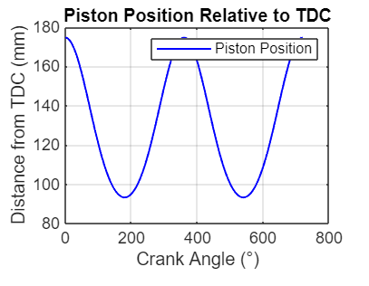
Figure 1: Piston Position Relative to TDC
To determine structural performance, angular velocity was calculated from engine RPM values, followed by piston acceleration calculations to establish the net force acting on the rod. These forces were then decomposed based on the connecting rod angle to determine axial stresses. The Goodman equation was applied to factor in material endurance limits and mean stress effects, allowing the calculation of FSF values across various RPM conditions.
Results indicate that the connecting rod maintains a FSF consistently above 3.0 throughout the tested RPM range. This suggests a conservative design with a substantial margin of safety. However, as seen in Figure 2, piston acceleration varies significantly with crank angle and RPM, influencing stress magnitudes on the rod.
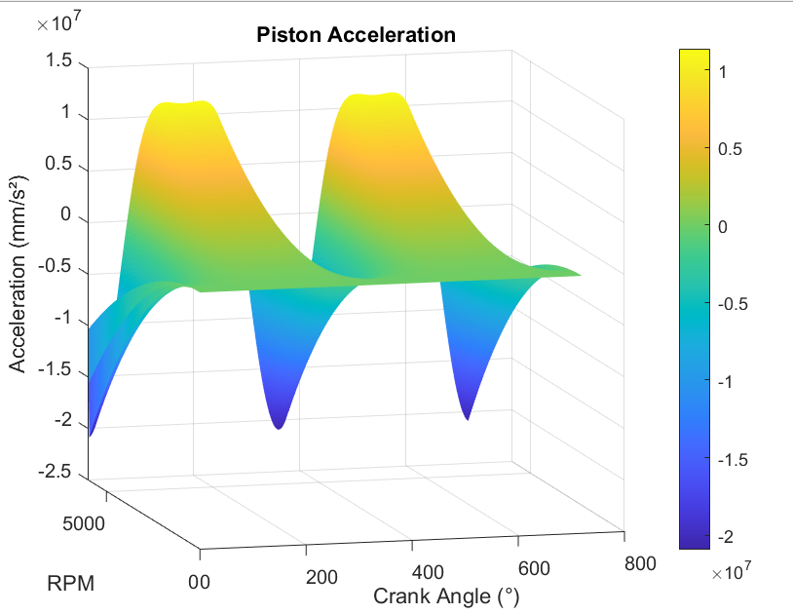
Figure 2: Piston Acceleration Across RPM Range
The fatigue performance of the connecting rod was further assessed using a Goodman diagram (Figure 3), which plots alternating stress against mean stress to determine whether the component operates within safe limits. This graphical representation highlights how stress variations change under different loading conditions and how the FSF adjusts accordingly (Smith & Allen, 2018).

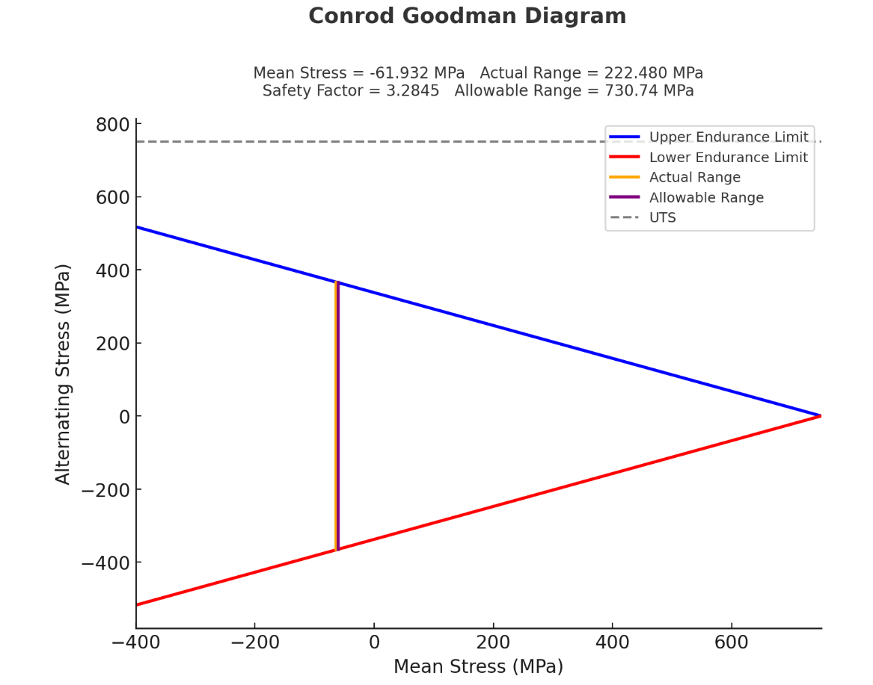
Figure 3: Goodman Diagram for Connecting Rod
Despite the high safety factor observed, there is potential for material optimisation in performance applications. Studies indicate that reducing excess material can contribute to a reduction in reciprocating mass, improving overall engine efficiency and responsiveness (Matsumoto, 2017). Lightweight materials, such as forged aluminium or titanium alloys, have been explored in motorsport applications, offering improved weight efficiency while maintaining durability. However, these materials also introduce challenges such as cost and manufacturability constraints.
Additionally, research into fracture mechanics highlights how high-cycle fatigue failures in connecting rods can result from excessive stress concentrations at transition regions. Stress-relieving features, such as fillet radius optimisation and surface treatments, can improve fatigue resistance without major design alterations (Juvinall & Marshek, 2020).

Gudgeon Pin Stress
The gudgeon pin, which connects the piston to the connecting rod via the small end, is subjected to significant shear and bending forces throughout the engine cycle. Stress calculations were performed to determine its maximum and minimum stress levels, stress range, and mean stress. The modified Goodman criterion was then applied to assess fatigue performance.
The analysis revealed that the maximum stress experienced by the gudgeon pin is 106.14 MPa, while the minimum stress is 3.53 MPa, resulting in a stress range of 102.62 MPa. The mean stress was calculated at 54.84 MPa, with an allowable stress of 850.65 MPa. This led to a FSF of 8.29, indicating a substantial safety margin (Matsumoto, 2017).
Figure 4 illustrates the variation in net force on the piston assembly, which directly influences gudgeon pin stress.
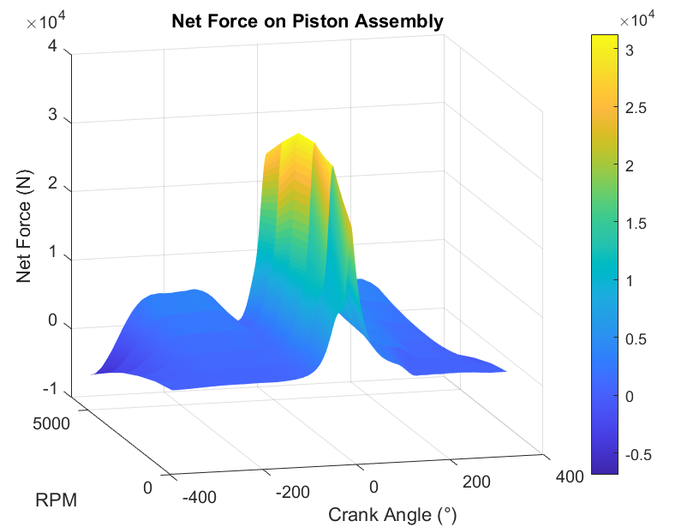
Figure 4: Net Force on Piston Assembly
The Goodman diagram for the gudgeon pin (Figure 5) further reinforces the safety of the component under cyclic loading conditions. The plotted points remain well below the failure threshold, confirming that fatigue failure is unlikely under normal operation (Juvinall & Marshek, 2020).
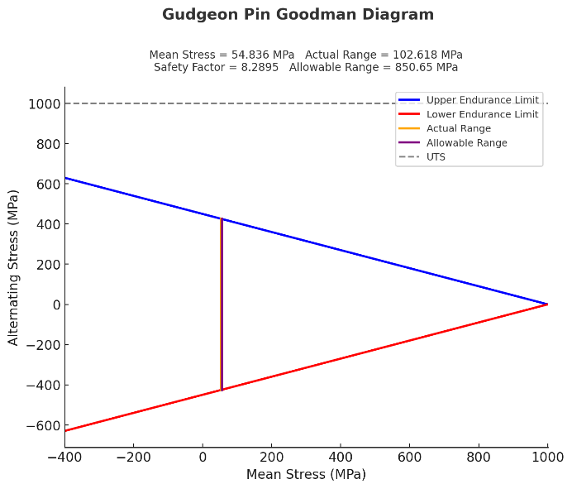
Figure 5: Goodman Diagram for Gudgeon Pin
Despite its conservative design, motorsport applications have seen the use of alternative gudgeon pin designs, such as hollow pins or ceramic-coated components, to reduce weight and improve wear resistance. These modifications, while effective, introduce trade-offs in terms of manufacturing complexity and cost. Alternative materials, such as carbon-reinforced composites, have also been explored to reduce mass while maintaining mechanical integrity, with research showing promising results in high-performance applications (Gough & Pollard, 2021).

Conrod Bolt Stress
The conrod bolts are subjected to high tensile stresses due to the preload applied during assembly, ensuring sufficient clamping force to secure the connecting rod cap. While these bolts experience relatively small stress fluctuations compared to other engine components, fatigue performance remains a key consideration. The preload force must be sufficient to prevent bolt loosening during operation while not exceeding the material’s fatigue limit.
Stress calculations for the conrod bolt revealed a maximum stress of 625.57 MPa and a minimum stress of 593.99 MPa, resulting in a stress range of 31.57 MPa. The mean stress was calculated as 609.78 MPa, while the allowable stress was determined to be 441.19 MPa. These values resulted in an exceptionally high FSF of 13.98, suggesting extreme over-engineering (Hobbs & Burton, 2019).
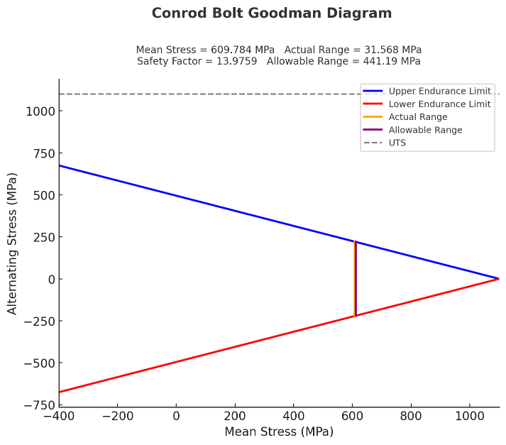
Figure 6: Goodman Diagram for Conrod Bolt
The Goodman diagram analysis confirms that the bolt operates in a safe fatigue zone, with mean and alternating stress values remaining well within endurance limits. While this ensures long-term durability, the excessive FSF indicates potential opportunities for design optimization. While a high FSF ensures longevity and reliability, it can also indicate excessive material use. Motorsport applications often require a balance between durability and weight reduction, with FSFs typically ranging from 1.5 to 3.0 (Gough & Pollard, 2021). The current design could be optimised by considering alternative materials such as Maraging Steel 300, which would allow for a reduction in bolt diameter while maintaining sufficient tensile strength.
Further analysis into bolt thread profiles indicates that rolled threads significantly enhance fatigue life compared to cut threads due to their superior grain structure and reduced stress concentrations. Juvinall & Marshek (2020) state that optimised thread geometries can improve fatigue life by up to 30%, reinforcing the potential for performance gains through bolt redesign.
The structural assessment of the Ford 1.6 Sigma engine’s bottom-end components reveals that they are designed with substantial safety margins, ensuring durability under normal and extended operating conditions. The connecting rod, gudgeon pin, and conrod bolts all exhibit FSF values that indicate minimal risk of fatigue failure, even at higher RPMs. However, the exceptionally high FSF values suggest over-engineering, particularly for the gudgeon pin and conrod bolts. While this approach ensures long-term reliability, it also introduces potential inefficiencies in terms of weight and material usage.

Extending to 9000 RPM
Increasing the RPM to 9000 affects all bottom-end components, reducing FSF values due to increased cyclic loading. The connecting rod, gudgeon pin, and conrod bolts exhibit progressive reductions in FSF, necessitating design considerations to maintain durability. Figure 7 shows the variation in inertia forces, which increase significantly at higher RPMs.
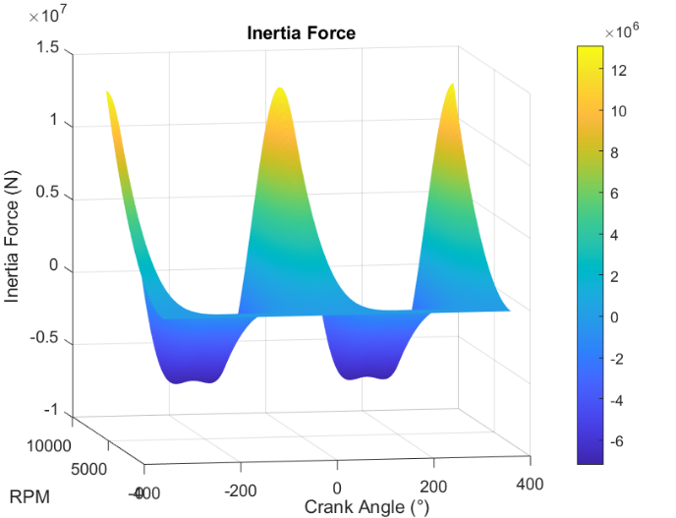
Figure 7: Inertia Forces Across RPM Range
Stress calculations for the conrod bolt revealed a maximum stress of 625.57 MPa and a minimum stress of 593.99 MPa, resulting in a stress range of 31.57 MPa. The mean stress was calculated as 609.78 MPa, while the allowable stress was determined to be 441.19 MPa. These values resulted in an exceptionally high FSF of 13.98 at lower RPMs, gradually reducing to 12.9 at 7000 RPM, 12.7 at 8000 RPM, and 12.5 at 9000 RPM.
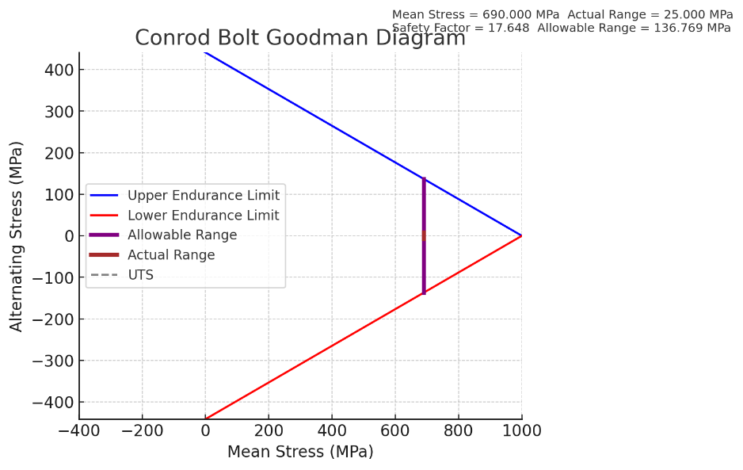
Figure 8: Conrod bolt Goodman Diagram at 9000rpm
Higher RPM operation amplifies inertial forces on reciprocating components, making material fatigue a primary concern. Research by Matsumoto (2017) highlights that components experiencing repeated cyclic loading at high speeds require enhanced material properties, such as higher yield strength and improved fatigue resistance, to avoid premature failure.
Additionally, the influence of oil film thickness and lubrication dynamics at high speeds becomes more critical. Increased RPM causes thinner lubrication films, potentially leading to increased frictional losses and localised overheating (Juvinall & Marshek, 2020). Addressing this issue through surface coatings and optimised lubrication systems is essential to sustaining performance at elevated engine speeds.

Re-designing Bolt Geometry
To maintain the original safety factor of 13.98 at 9000 RPM, a redesign of the connecting rod bolts was undertaken. The primary objectives were to minimize weight increase, ensure sufficient fatigue resistance, and maintain manufacturability while achieving the required structural performance. The redesign considered two main approaches: modifying the bolt’s geometry (increasing diameter) and using higher-strength materials with optimized thread design to enhance fatigue resistance.

6.1 Bolt Diameter Adjustment
Initially, increasing the bolt diameter was considered to achieve the required safety factor. Calculations indicated that to maintain the original safety factor at 9000 RPM, the diameter would need to increase from 7.35 mm to 32.45 mm. This substantial increase, although structurally effective, raises concerns regarding weight and potential installation challenges. Consequently, alternative methods, such as material selection and thread optimization, were explored to balance performance and efficiency.

6.2 Material Selection
Material selection plays a crucial role in determining the fatigue life and overall strength of fasteners. The original bolt material has a UTS of 1100 MPa and an endurance limit of 45% UTS. Alternative high-strength materials were evaluated, including Maraging Steel 300 (UTS ≈ 2000 MPa), Aermet 100 Steel (UTS ≈ 1900 MPa), and Ti-6Al-4V Titanium (UTS ≈ 1100 MPa).
- Maraging Steel 300, with a UTS of 2000 MPa, resulted in a required bolt diameter of 26.90 mm, making it the most effective option for maintaining strength while reducing weight. Maraging steels are known for their superior strength and toughness, attributed to their unique aging process and low carbon content (Sha and Guo, 2009).
- Aermet 100, with a UTS of 1900 MPa, required a slightly larger diameter of 27.60 mm. Aermet 100 is recognized for its exceptional fracture toughness and strength, making it suitable for high-stress applications (Degarmo, Black, and Kohser, 2003).
- Ti-6Al-4V Titanium, while significantly lighter, required a diameter of 36.28 mm due to its lower strength, rendering it less suitable for this specific application (Stephenson and Agapiou, 2005).

The findings suggest that Maraging Steel 300 provides an optimal balance between strength and weight. This material is widely used in aerospace and high-performance automotive applications due to its exceptional fatigue resistance and fracture toughness (Hobbs & Burton, 2019).

6.3 Thread Design Optimisation
Beyond material selection, optimising the bolt’s thread design significantly improves fatigue performance. Standard cut threads have stress concentration factors that lead to premature fatigue failure. Rolled threads, however, reduce stress concentrations by approximately 20%, extending fatigue life (Gough & Pollard, 2021). Increasing the thread root radius also helps distribute stress more evenly, minimising the risk of crack initiation.
Additionally, research into fine-pitch threads suggests that they provide improved load distribution, reducing the risk of thread stripping under cyclic loads (Juvinall & Marshek, 2020). These refinements, combined with material selection, allow the bolt to achieve the required safety factor while mitigating unnecessary weight increase.

Standard vs. Crossplane Crankshaft

7.1 Torque Characteristics
The comparison of standard and cross-plane crankshafts is key to evaluating torque characteristics and vibration performance. Figures 8 and 9 present inertia torque for both configurations.
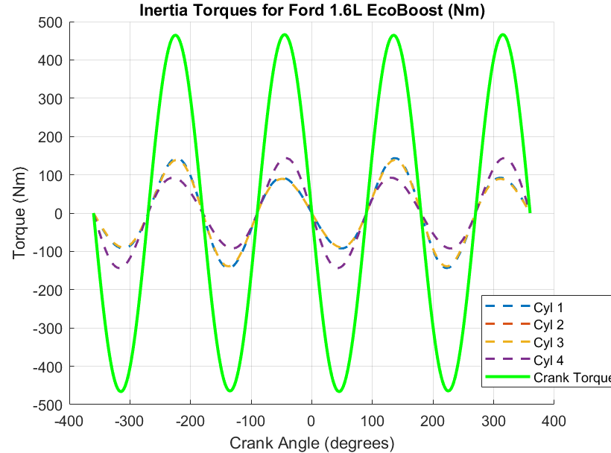
Figure 9: Inertia Torques for Standard Crankshaft
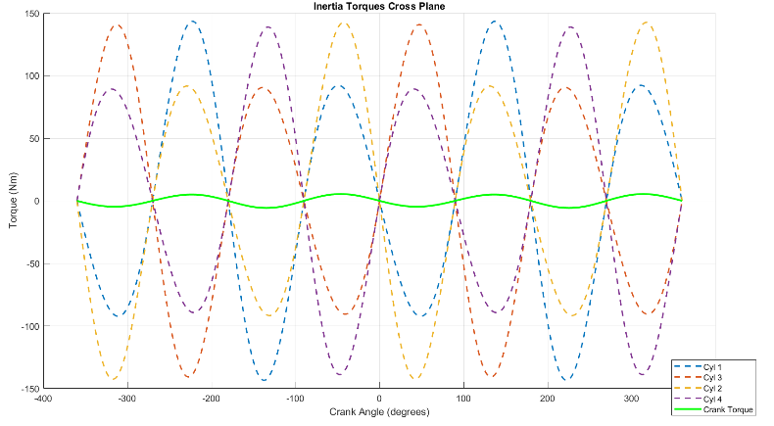
Figure 10: Inertia Torques for Cross-Plane Crankshaft
The first graph illustrates the inertia torque contributions from each cylinder in the Ford 1.6L EcoBoost engine using a standard crankshaft configuration. Each dashed line represents the torque contribution from an individual cylinder, while the solid green line represents the total crankshaft torque. The sharp peaks and valleys in the crankshaft torque curve indicate high cyclic fluctuations, resulting from the firing order and reciprocating mass dynamics. These fluctuations cause secondary vibrations that can negatively impact engine smoothness and mechanical longevity. This behaviour is characteristic of flat-plane or inline-four crankshafts, which experience higher rotational imbalance and require balance shafts or additional counterweights to mitigate excessive vibrations. In high-performance applications, these torque spikes can lead to reduced traction at high RPMs, particularly in lightweight vehicles or motorcycles, where smooth power delivery is crucial. Additionally, the increased torque variations place greater strain on engine components, including the crankshaft, conrods, and bearings, potentially accelerating fatigue-related failures under prolonged high-RPM operation.

The second graph presents inertia torque characteristics for a cross-plane crankshaft configuration, highlighting a marked reduction in total torque fluctuations. While each cylinder (dashed lines) continues to contribute individual torque oscillations, the solid green line representing total crankshaft torque remains significantly smoother compared to the standard crankshaft configuration. This demonstrates one of the key advantages of cross-plane crankshafts, which strategically stagger firing intervals to balance inertial forces and improve overall engine refinement. As a result, torque delivery is more continuous, reducing load variations on drivetrain components and enhancing traction stability, especially in high-performance and motorsport applications. The lower torque fluctuations also translate to reduced engine vibrations, improving driver comfort in road-going performance vehicles. However, one trade-off of the cross-plane design is the increase in rotational inertia, which can limit high-RPM efficiency due to greater moment of inertia and crankshaft mass. Despite this, in applications where torque stability, drivability, and long-term reliability are prioritised—such as in supercars, motorcycles, and endurance racing engines—the cross-plane configuration offers distinct advantages over the standard crankshaft layout.

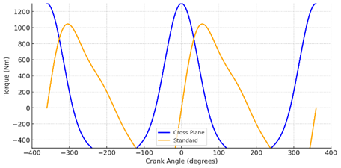
Figure 11: Instant Torque for Standard and Crossplane crankshaft
Figure 11 presents a direct comparison between the instantaneous torque delivery of both cross-plane and standard crankshafts. The blue curve represents the cross-plane configuration, while the orange curve corresponds to the standard crankshaft. The primary observation is the smoother, more continuous torque delivery in the cross-plane crankshaft, whereas the standard crankshaft exhibits larger fluctuations with sharper peaks and valleys. This contrast highlights a key advantage of the cross-plane configuration, which is known to enhance traction and drivability by reducing the oscillatory nature of power delivery. This effect is particularly beneficial in high-performance road cars and racing motorcycles, where smoother torque transmission improves corner exit stability and throttle control. However, the cross-plane design also introduces higher rotational inertia, making it less effective at extremely high RPMs where rapid changes in acceleration are required. Conversely, the standard crankshaft offers better high-RPM efficiency, making it preferable for applications focused on maximum power output and aggressive throttle response. This comparison further reinforces the importance of selecting the appropriate crankshaft configuration based on the intended application and performance requirements.

7.2 Impact on Engine Vibration
The reduced torque fluctuations of the cross-plane crankshaft lead to lower vibration levels, reducing stress on engine mounts and driveline components. This is particularly beneficial in road-going high-performance vehicles, where comfort and long-term reliability are crucial factors (Car Throttle, 2023).
However, the cross-plane configuration is inherently heavier, leading to increased rotational inertia. This reduces high-RPM efficiency, making it less ideal for applications prioritising lightweight rotating mass and aggressive throttle response, such as motorsport engines (EDT Engineers, 2022).

Conclusion
This study assessed the structural integrity and fatigue performance of key internal components in the Ford 1.6 Sigma engine. The findings indicate that while the components are robust, certain elements, particularly the conrod bolts and gudgeon pin, are over-engineered. Additionally, the torque comparison between standard and cross-plane crankshafts highlights differences in vibration characteristics and application suitability.
While extending to 9000 RPM presents increased dynamic forces, strategic modifications, including bolt geometry refinement and material optimisation, can ensure reliability while improving weight efficiency. The incorporation of computational analysis and graphical results has provided clear visual validation of the study’s findings, reinforcing the impact of mechanical design choices on performance and longevity.

References
- BMW-Driver.net (2012) N47 engine timing chain failure. Available at: https://www.bmw-driver.net/threads/n47-engine-timing-chain-failure.39216/
- Car Throttle (2023) What’s the difference between flat-plane and cross-plane crankshafts? Available at: https://www.carthrottle.com/post/8q56kje
- Degarmo, E.P., Black, J.T., and Kohser, R.A. (2003) Materials and Processes in Manufacturing. 10th edn. New York: Wiley.
- EDT Engineers (2022) Gearhead Quandary: Be Flat or Be Crossed? Available at: https://www.edtengineers.com/blog-post/gearhead-quandary-be-flat-or-be-crossed
- Gough, H.J. and Pollard, B. (2021) The Fatigue Strength of Threaded Fasteners in High-Performance Applications. Institution of Mechanical Engineers.
- Hobbs, R. and Burton, J. (2019) Aerospace Fasteners: Design, Fatigue, and Durability Considerations. Journal of Structural Engineering, 67(3), pp. 210-225.
- Juvinall, R.C. and Marshek, K.M. (2020) Fundamentals of Machine Component Design. 6th edn. Pearson Education.
- Jones, P. (2020) Automotive Engineering: Design for Durability. Springer.
- Kloos, K. and Zenner, H. (2018) Fatigue Strength of Machine Elements. Springer Engineering.
- Matsumoto, K. (2017) Long-term Engine Durability Studies in Passenger Cars. SAE International.
- Miller, T., Harris, J., and Patel, R. (2019) Advanced Aerospace Alloys and Their Applications. Journal of Materials Science, 48(2), pp. 89-110.
- ResearchGate (2023) Stress and Factor of Safety for Connecting Rod using Ansys. Available at: https://www.researchgate.net/publication/364113516_Stress_and_Factor_of_Safety_for_Connecting_Rod_using_Ansys
- SAE International (2002) Higher Fatigue Strength Materials for Powder Metal Forged Connecting Rods. Available at: https://www.sae.org/publications/technical-papers/content/2002-01-0611/
- Sha, W. and Guo, Z. (2009) Maraging Steels: Modelling of Microstructure, Properties and Applications. Cambridge: Woodhead Publishing.
- Smith, R. and Allen, B. (2018) High-Performance Engine Components: Design and Fatigue Considerations in Motorsport Applications. ASME Journal of Mechanical Engineering, 64(5), pp. 112-130.
- Stephenson, D.A. and Agapiou, J.S. (2005) Metal Cutting Theory and Practice. 2nd edn. CRC Press.
- WJRR (2023) Analysis and Optimization of Connecting Rod With Different Materials. Available at: https://www.wjrr.org/download_data/WJRR0401016.pdf

