

University of Wales Trinity Saint David

MODULE NAME: INTERNATIONAL BUSINESS COMMUNICATIONS
ASSIGNMENT TITLE: COMPONENT 2
MODULE PRACTICAL: INDIVIDUAL PRESENTATION
MODULE CODE: LCBB6001
MODULE LEADER: AFZAL MUNNA
STUDENT NAME: ANGELA MURESAN
STUDENT ID: 2131060
DATA:13.12.2024

Table of Contents
Slide 1: Cover Page 3
Slide 2: Outline of The Presentation 3
Slide 3: Define Culture 4
Slide 4: Various Elements of Culture 5
Slide 5: Theoretical Underpinning about Cultural Impact 6
Slide 6: Cultural Elements and Barriers in Relation to China 7
Slide 7: Barriers in China to Overcome 8
Slide 8: Negotiation Strategies for a Successful Deal 9
Slide 9: Conclusion 10
Slide 10: Reference List 11
Slide 11: Thank You!! 12

Slide 1: Cover Page
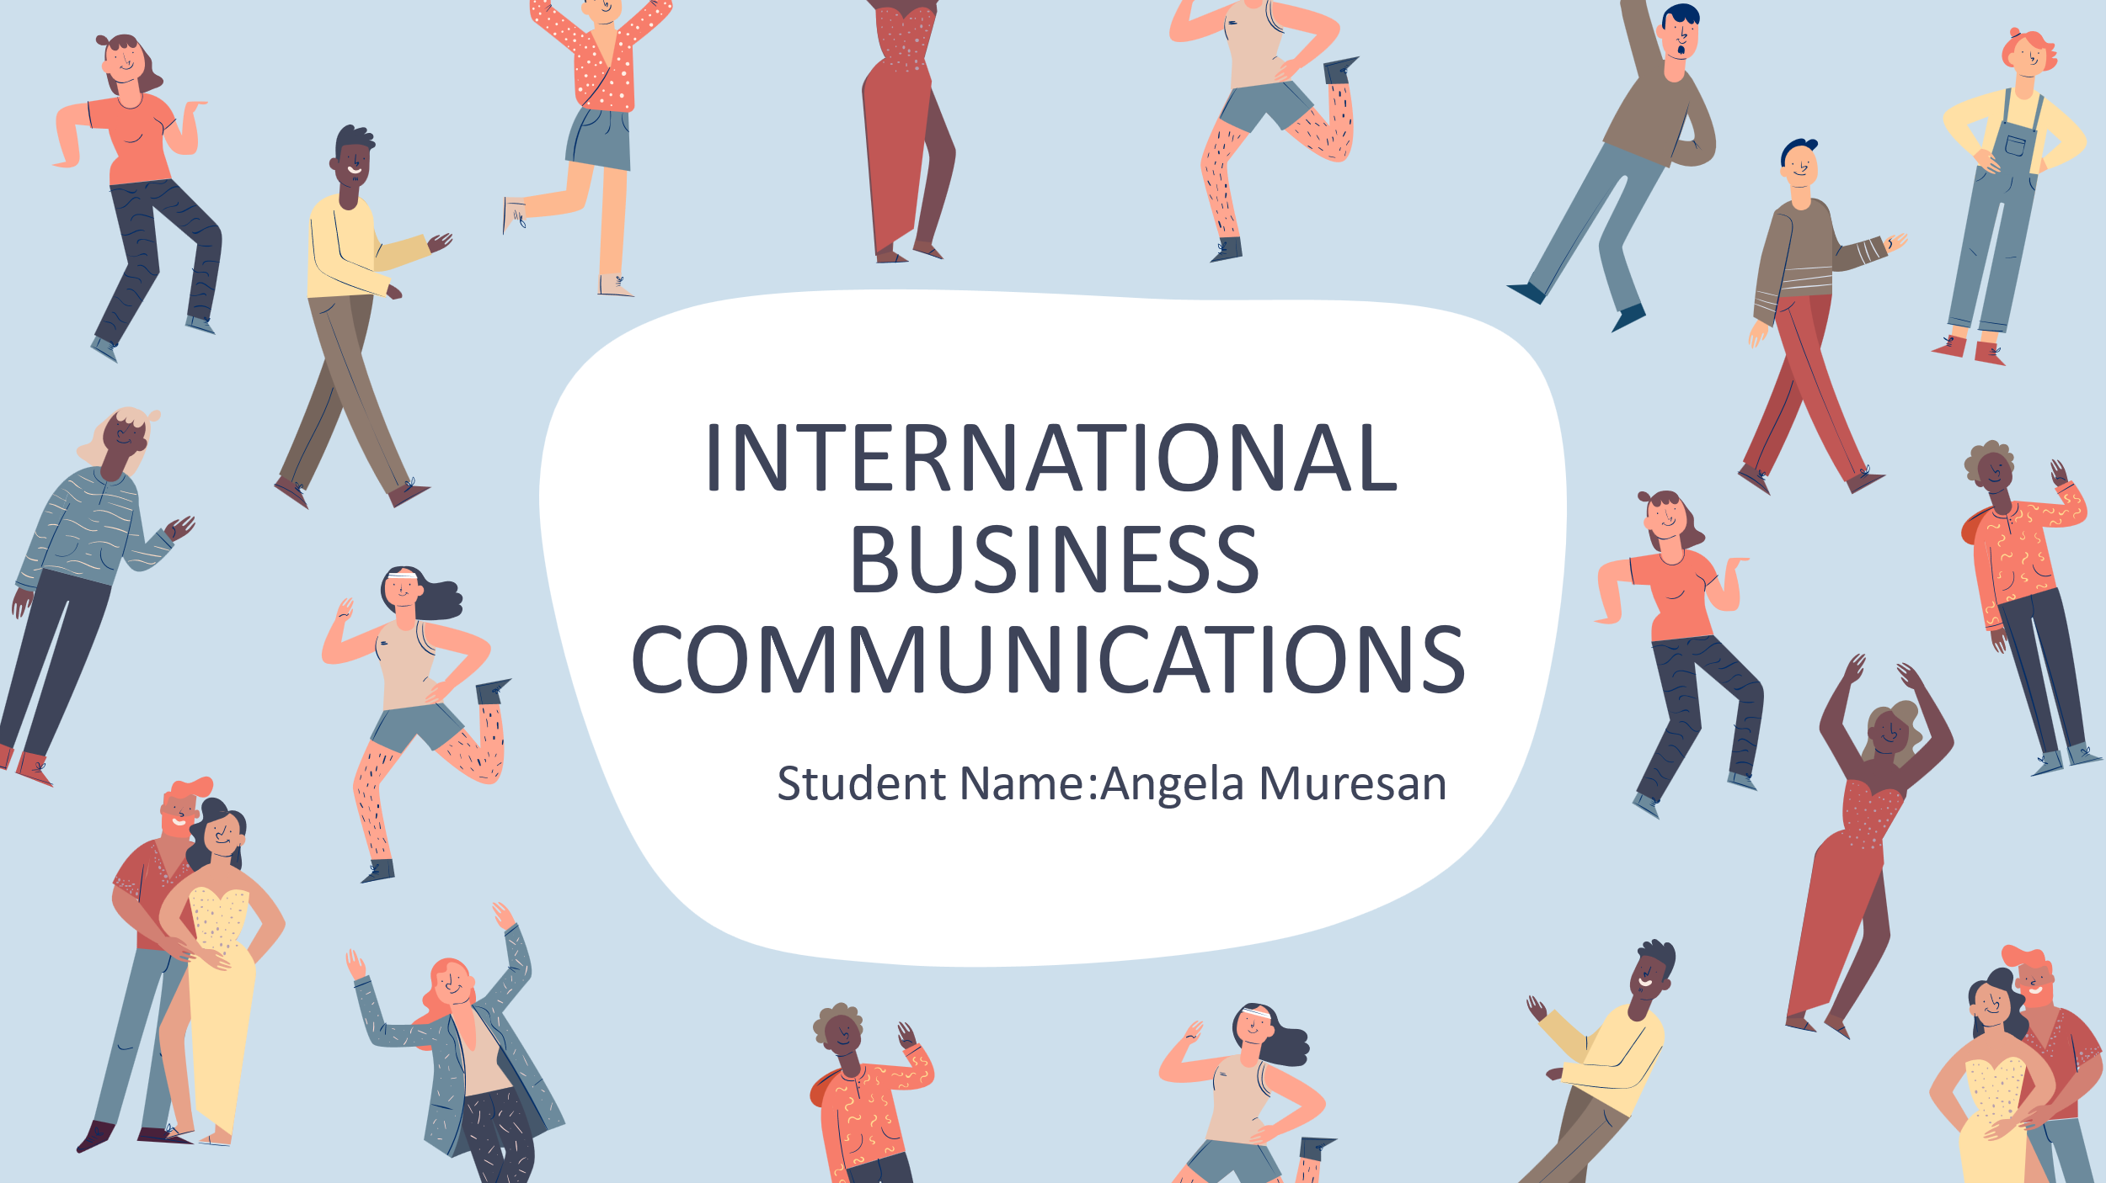

Slide 2: Outline of The Presentation
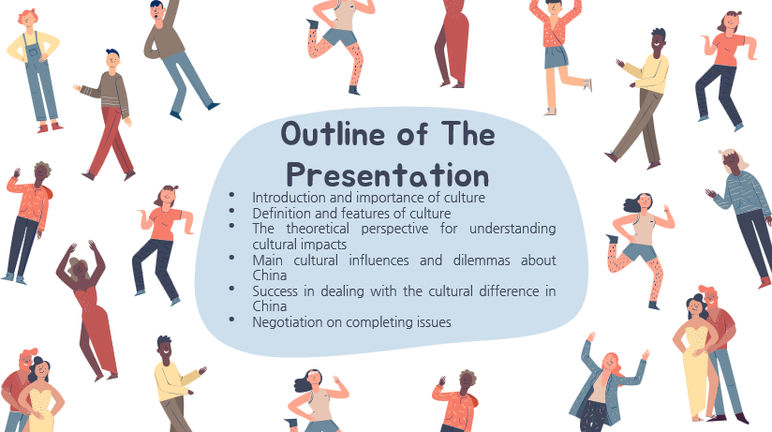
- Introduction and importance of culture
- Definition and features of culture
- The theoretical perspective for understanding cultural impacts
- Main cultural influences and dilemmas about China
- Success in dealing with the cultural difference in China
- Negotiation on completing issues
SN
This presentation will focus on how Tesco engages in cross-cultural negotiations with a potential Chinese partner. In this presentation, it will define culture and its elements. It will also explain cultural impact theories, and discuss some of the specific barriers that exist in China. Practical strategies on how to overcome these barriers in order to have a good partnership will also be outlined here.

Slide 3: Define Culture
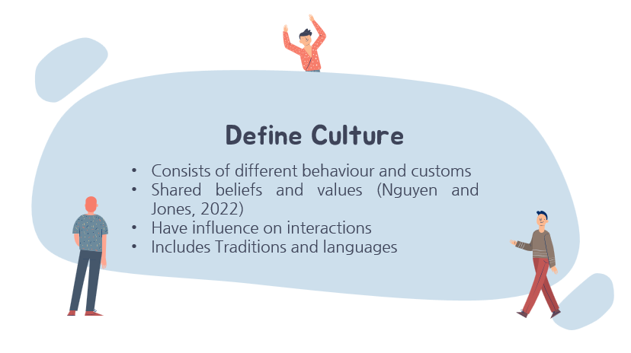
- Consists of different behaviour and customs
- Shared beliefs and values (Nguyen and Jones, 2022)
- Have influence on interactions
- Includes Traditions and languages
SN
Culture is the set of traditional and perceived ways by a group of people (Nguyen and Jones, 2022). It influences how people interact, communicate, and perceive. Language, norms, and customs are all part of it. Culture is passed from one generation to another. This defines who a person is and gives one a sense of belonging.

Slide 4: Various Elements of Culture
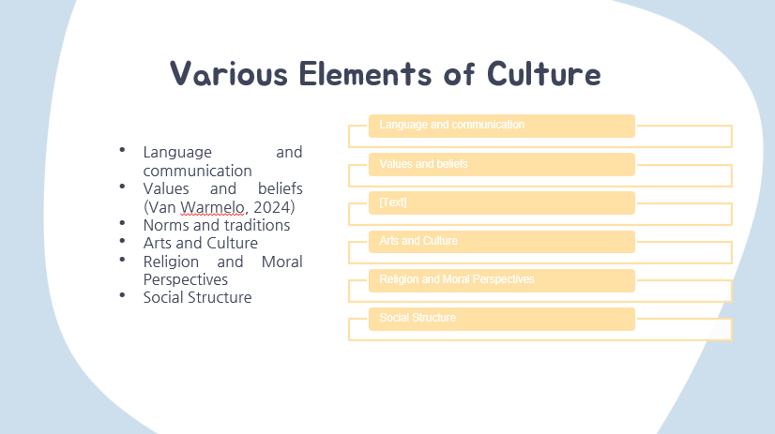
- Language and communication
- Values and beliefs (Van Warmelo, 2024)
- Norms and traditions
- Arts and Culture
- Religion and Moral Perspectives
- Social Structure
SN
Culture comprises many things that define a community of people (Van Warmelo, 2024). Language is the tool for communication and speech. Values and beliefs determine actions and attitudes. The notion of norms is what is expected in social behaviour, while customs cement one's identity. Art, music, and tradition voice values; religion tends to inform moral attitudes. A social structure puts all the roles in place within a community, thus giving a distinct cultural experience.

Slide 5: Theoretical Underpinning about Cultural Impact
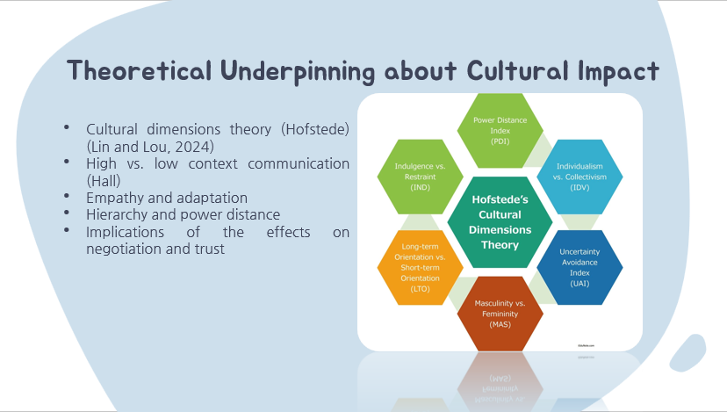
- Cultural dimensions theory (Hofstede) (Lin and Lou, 2024)
- High vs. low context communication (Hall)
- Empathy and adaptation
- Hierarchy and power distance
- Implications of the effects on negotiation and trust
SN
Some theories that explain the influence of culture are illustrated by Hofstede's Cultural Dimensions Theory, which enables a clearer understanding of cross-cultural negotiation (Lin and Lou, 2024). It identifies dimensions such as individualism vs. collectivism, power distance, and uncertainty avoidance, which differ in cultures and impact communication. For example, China scores much higher in the dimension of power distance, structures are meant to be hierarchical and based on respect. Thus, UK culture falls on the lower scale of power distance where equality is the prime focus. Hall's high vs. low-context communication model also comes into play here as well (Levitt, 2022). The communication system of China happens to be more subtly based on non-verbal cues, whereas the UK takes a more direct approach. In order to appreciate these differences which will help to create empathy and flexibility about an issue, highly important for effective negotiation and building trust.

Slide 6: Cultural Elements and Barriers in Relation to China
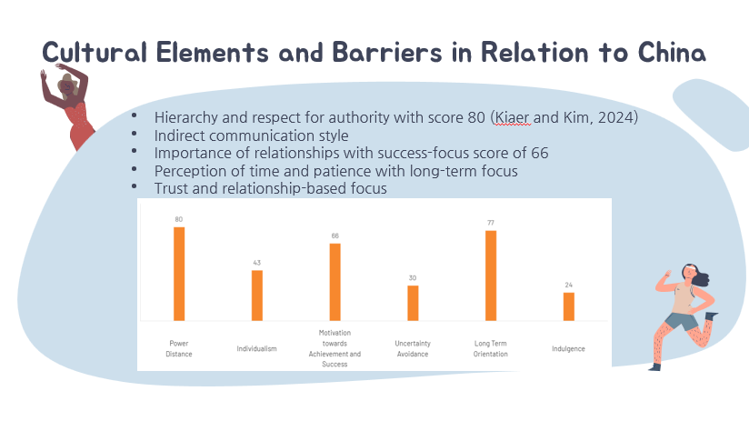
- Hierarchy and respect for authority with score 80 (Kiaer and Kim, 2024)
- Indirect communication style
- Importance of relationships with success-focus score of 66
- Perception of time and patience with long-term focus
- Trust and relationship-based focus
SN
The business culture of China is not like that of the UK. Thus, negotiation approaches will be affected. Hierarchy is repeated with a focus on authority, communication being more indirect than direct, and non-verbal clues and subtle nuances over confrontation head-on (Kiaer and Kim, 2024). Relationship building is very important in building trust, so acceptance into a circle of people as opposed to the task or outcome. Time pressure is present but Chinese culture is time-sensitive, favouring patience and long-term planning, favouring patience and long-term planning, whereas quicker expectations are present in the UK. The concept of “face” has to be preserved, and conflict must be avoided (theculturefactor.com, 2024). All these present a set of requirements for smooth exchange to take place. All these stipulations dictate the nature of the negotiation environment that needs to be tolerated in order to seek mutual understanding and respect.

Slide 7: Barriers in China to Overcome
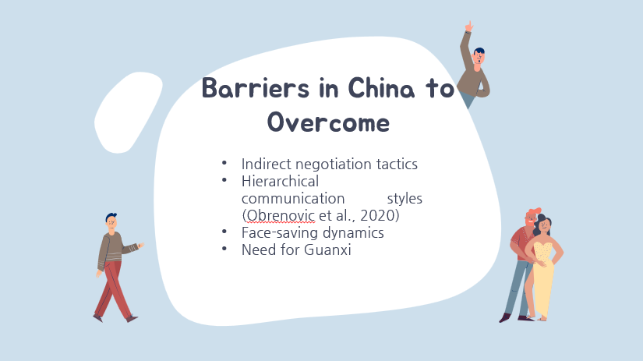
- Indirect negotiation tactics
- Hierarchical communication styles (Obrenovic et al., 2020)
- Face-saving dynamics
- Need for Guanxi
SN
Tesco has to encounter various hurdles when negotiating in China. First of all, most businesses in China operate within a rather rigid hierarchical structure, which will influence the decision-making and communication process (Obrenovic et al., 2020). The indirect method of negotiation means sometimes reading between the lines, which tends to be opposite to Tesco's direct way. Building up trust relationships, or Guanxi, is central for trust but rather a time-consuming process requiring effort. Finally, face-saving practices sometimes mean that Tesco should not be able to confront partners openly since it would harm their trust and reputation and thus is detrimental to its negotiation process.

Slide 8: Negotiation Strategies for a Successful Deal
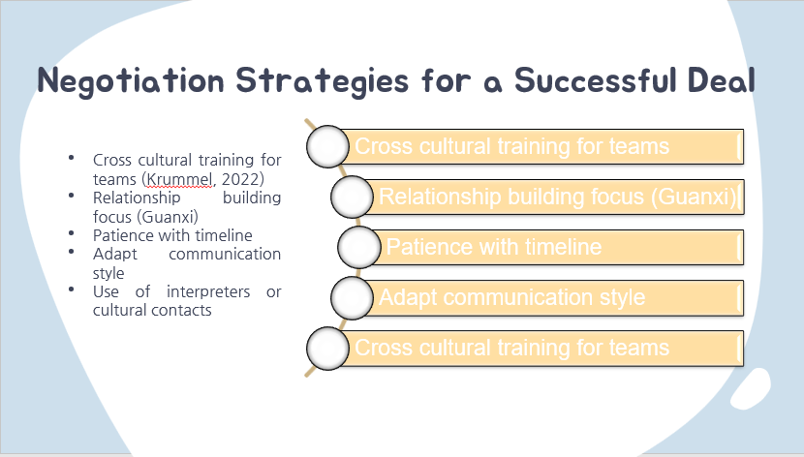
- Cross cultural training for teams (Krummel, 2022)
- Relationship building focus (Guanxi)
- Patience with timeline
- Adapt communication style
- Use of interpreters or cultural contacts
SN
To secure a successful partnership, Tesco should adopt several strategies (Krummel, 2022). Providing cross-cultural training will equip teams to understand Chinese norms. Building solid Guanxi through relationship-oriented activities, like casual get-togethers is key to trust. Tesco will have to endure long timelines; China operates on the long term. Communication has to be toned down to an indirect nature rather than direct confrontation and maintaining harmony. Employment of an interpreter or cultural liaison can close these language and cultural gaps, making communication smoother and clearer, allowing mutual understanding.

Slide 9: Conclusion

- Cultural consciousness is imperative
- Methods create great partnership
- Flexibility guarantees enduring success
SN
In conclusion, it has been found that it has been only through such understanding and cultural respect that Tesco will manage to do well in partnering with any Chinese firm. Tesco has been needed to strategize and lay emphasis on relationships to cope with cultural barriers and achieve sustainable, solid cooperation. Long-term collaboration in negotiation has to be flexible as well.

Slide 10: Reference List
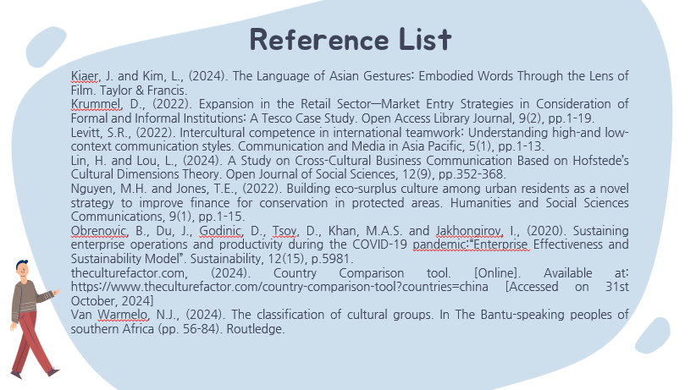
Kiaer, J. and Kim, L., (2024). The Language of Asian Gestures: Embodied Words Through the Lens of Film. Taylor & Francis.
Krummel, D., (2022). Expansion in the Retail Sector—Market Entry Strategies in Consideration of Formal and Informal Institutions: A Tesco Case Study. Open Access Library Journal, 9(2), pp.1-19.
Levitt, S.R., (2022). Intercultural competence in international teamwork: Understanding high-and low-context communication styles. Communication and Media in Asia Pacific, 5(1), pp.1-13.
Lin, H. and Lou, L., (2024). A Study on Cross-Cultural Business Communication Based on Hofstede’s Cultural Dimensions Theory. Open Journal of Social Sciences, 12(9), pp.352-368.
Nguyen, M.H. and Jones, T.E., (2022). Building eco-surplus culture among urban residents as a novel strategy to improve finance for conservation in protected areas. Humanities and Social Sciences Communications, 9(1), pp.1-15.
Obrenovic, B., Du, J., Godinic, D., Tsoy, D., Khan, M.A.S. and Jakhongirov, I., (2020). Sustaining enterprise operations and productivity during the COVID-19 pandemic:“Enterprise Effectiveness and Sustainability Model”. Sustainability, 12(15), p.5981.
theculturefactor.com, (2024). Country Comparison tool. [Online]. Available at: https://www.theculturefactor.com/country-comparison-tool?countries=china [Accessed on 31st October, 2024]
Van Warmelo, N.J., (2024). The classification of cultural groups. In The Bantu-speaking peoples of southern Africa (pp. 56-84). Routledge.

Slide 11: Thank You!!


