
HTML & CSS Web development
ACCA4023

20 July 2026
from: Abu bakr siddeeq (2435732)
LECTURER: Dr. Shah Room

Contents
Introduction 2
Requirements 3
Purpose: 3
Subject matter 3
Intended audience 3
Implementation 4
Screenshots of the Webpages 4
Homepage 4
Courses Page 5
Contact page 6
Validation 7
HTML Validation 7
CSS Validation 7
Evaluation 8
Website usability 8
Website accessibility: 9
Search engine optimisation 9
Part B: My website evaluation 10
Usefulness (Usability and Utility) 10
Search Engine Optimisation (SEO) 11
Accessibility 11
Part C: 2 live website comparisons 11
References: 13
Appendix 15
Homepage 15
Courses page 16
Contact page 18
CSS stylesheet code 19

Introduction
In this report, the design, development and evaluation of the website ”Islamic education” that I have created will be presented. It will explain the purpose, requirements, who it is intended for and the implementation process that lead to the creation of the website. It will feature topics related to the website ranging from the purpose of the website to its implementation and evaluation
The report begins with discussing the requirements, purpose, subject matter and who the website is intended for.
Then it goes on to the implementation process, where screenshots of the website will be taken and validation of the HTML and CSS scripts will be performed to show if there are any errors within the scripts. And if they were, were they corrected? And if they were, how were they corrected?
This will be followed by an evaluation report which is divided into 3 parts. Part A will be discussing research on website usability, accessibility and search engine optimisation(SEO). Part B will be an evaluation of these 3 topics in my website. And Part C will be providing a comparison between 2 live websites in terms of usability, accessibility and SEO.
Throughout this report, readers will gain a clear understanding of of how the website, was planned, executed and tested to meet the requirements and needs of the user.

Requirements

Purpose:
The purpose of the Islamic Education website is to provide accessible Islamic learning for anyone interested in studying Islam. It supports learners who wish to recite the Holy Qur’an in its original revealed language or improve their existing recitation. It also helps users who want to learn Arabic so they can understand Qur’anic meanings more deeply and read Hadith in the language spoken by the Prophet Muhammad ﷺ. In addition, the website offers learning in other important Islamic sciences such as Sīrah, Spirituality, and Fiqh. Courses are also available for young learners, helping to nurture them into confident, aspiring individuals who are guided by faith, knowledge, and understanding.

Subject matter
The subject matter of the Islamic Education website is to provide Islamic Educational courses and classes for passionate users seeking to learn different fields of Islam. The website showcases a range pf Islamic content related to Islamic sciences such as Qur’an recitation, Arabic language, Hadith, Sirah, Spirituality, Fiqh. Each topic is presented in a simple way that makes it easy to navigate for a beginner as well for continued learners.
The website also features a dedicated section for children’s Islamic studies, offering age‑appropriate learning designed to nurture young individuals through faith, knowledge, and good character.
In addition to educational content, the website includes essential features such as a homepage, a courses page, and a contact page. These pages work together to provide a simple user experience, understand the purpose of the site, and reach out for further information if needed.

Intended audience
The intended audience of this website includes learners seeking to learn and gain a better and deeper understanding of Islam. There is no specific age, as it can range from young aspiring learners aged 5-6 years old to senior individuals enthusiastic to study and deepen their connection with the faith through understanding and learning about various topics of Islam.
Overall, the website aims to support anyone seeking clear, easy-to-understand Islamic education, regardless of age, background, or previous experience.

Implementation

Screenshots of the Webpages

Homepage
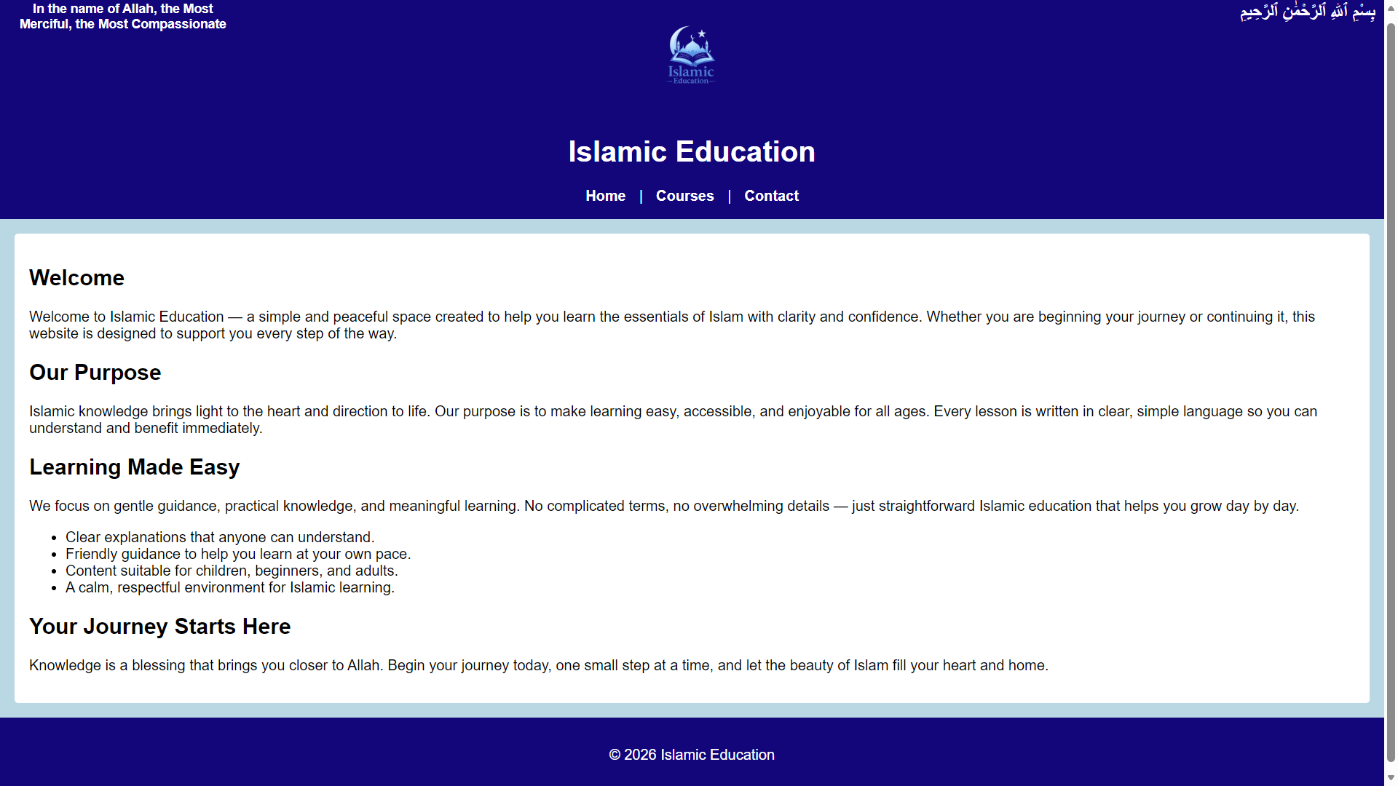

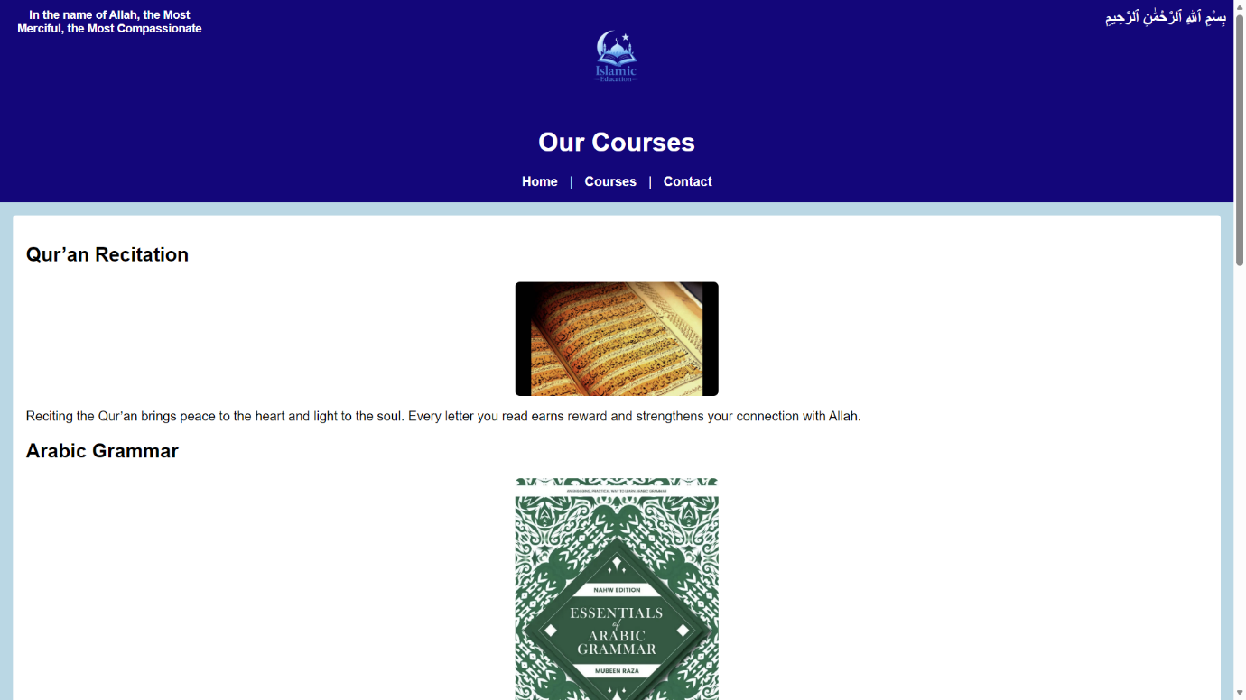
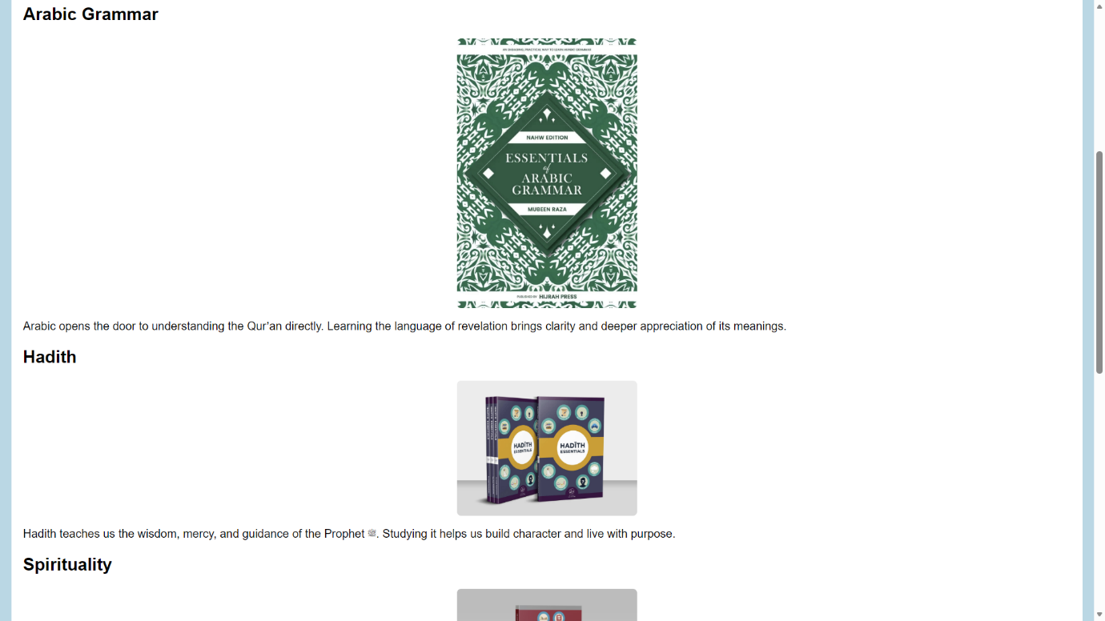
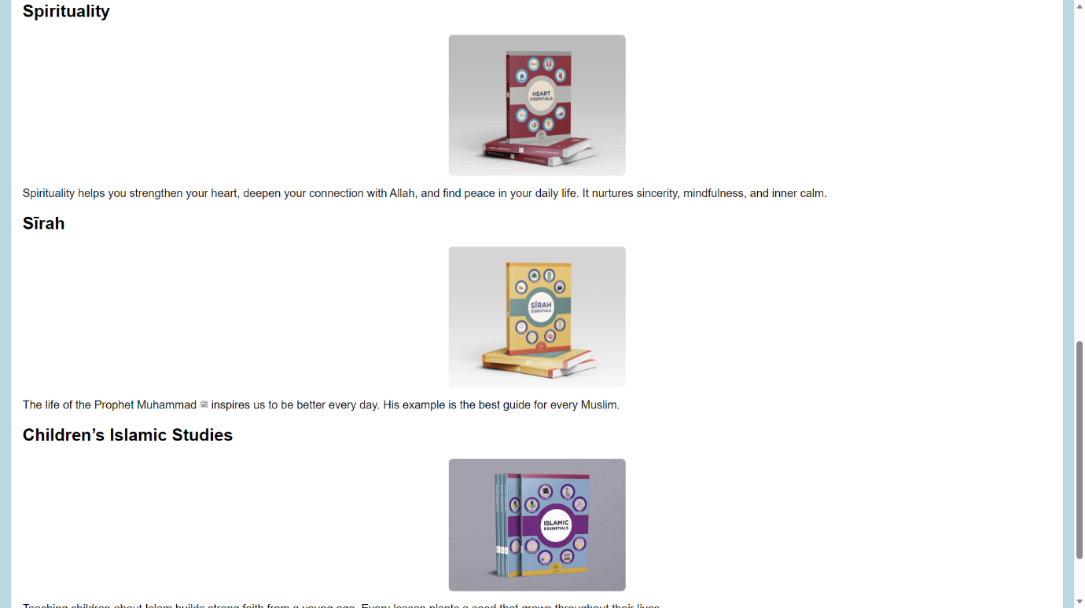
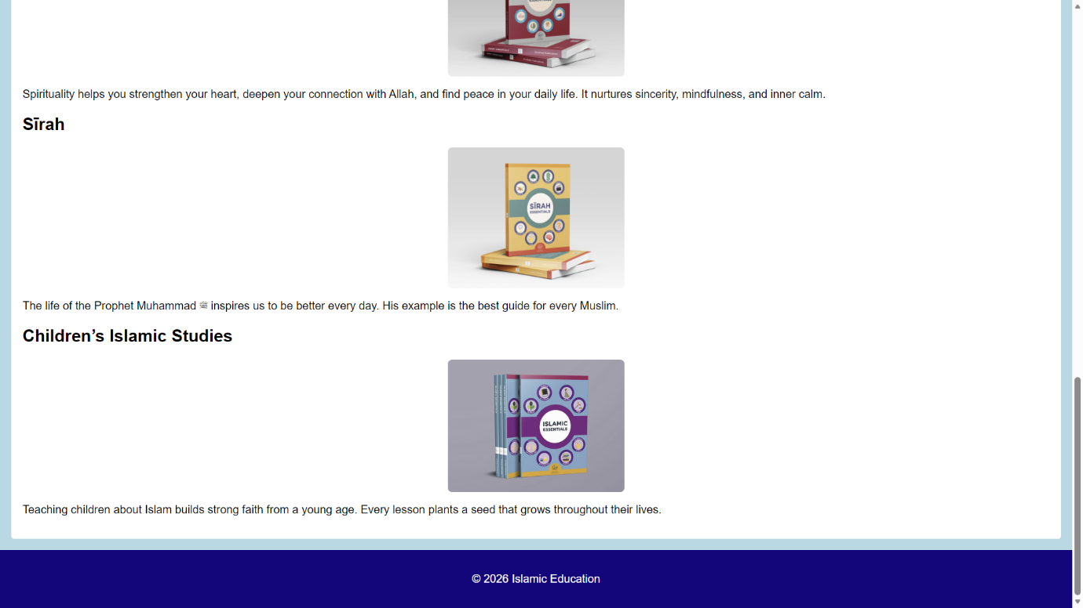
Courses Page

Contact page
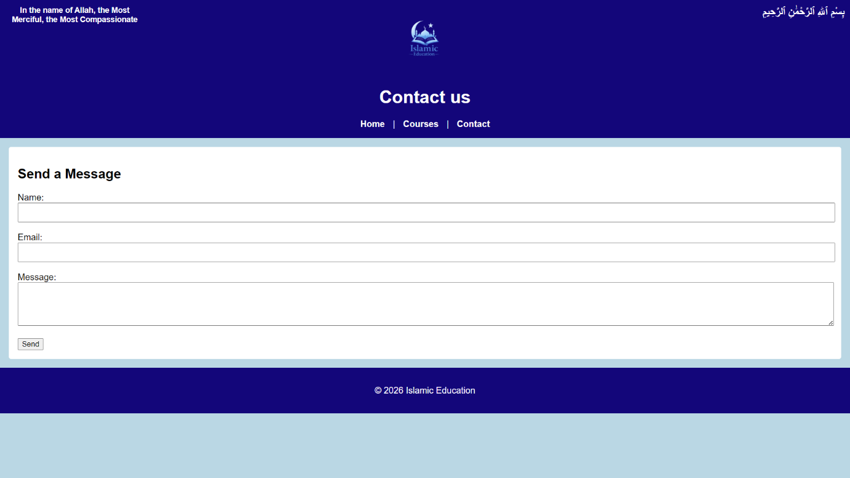

Validation

HTML Validation
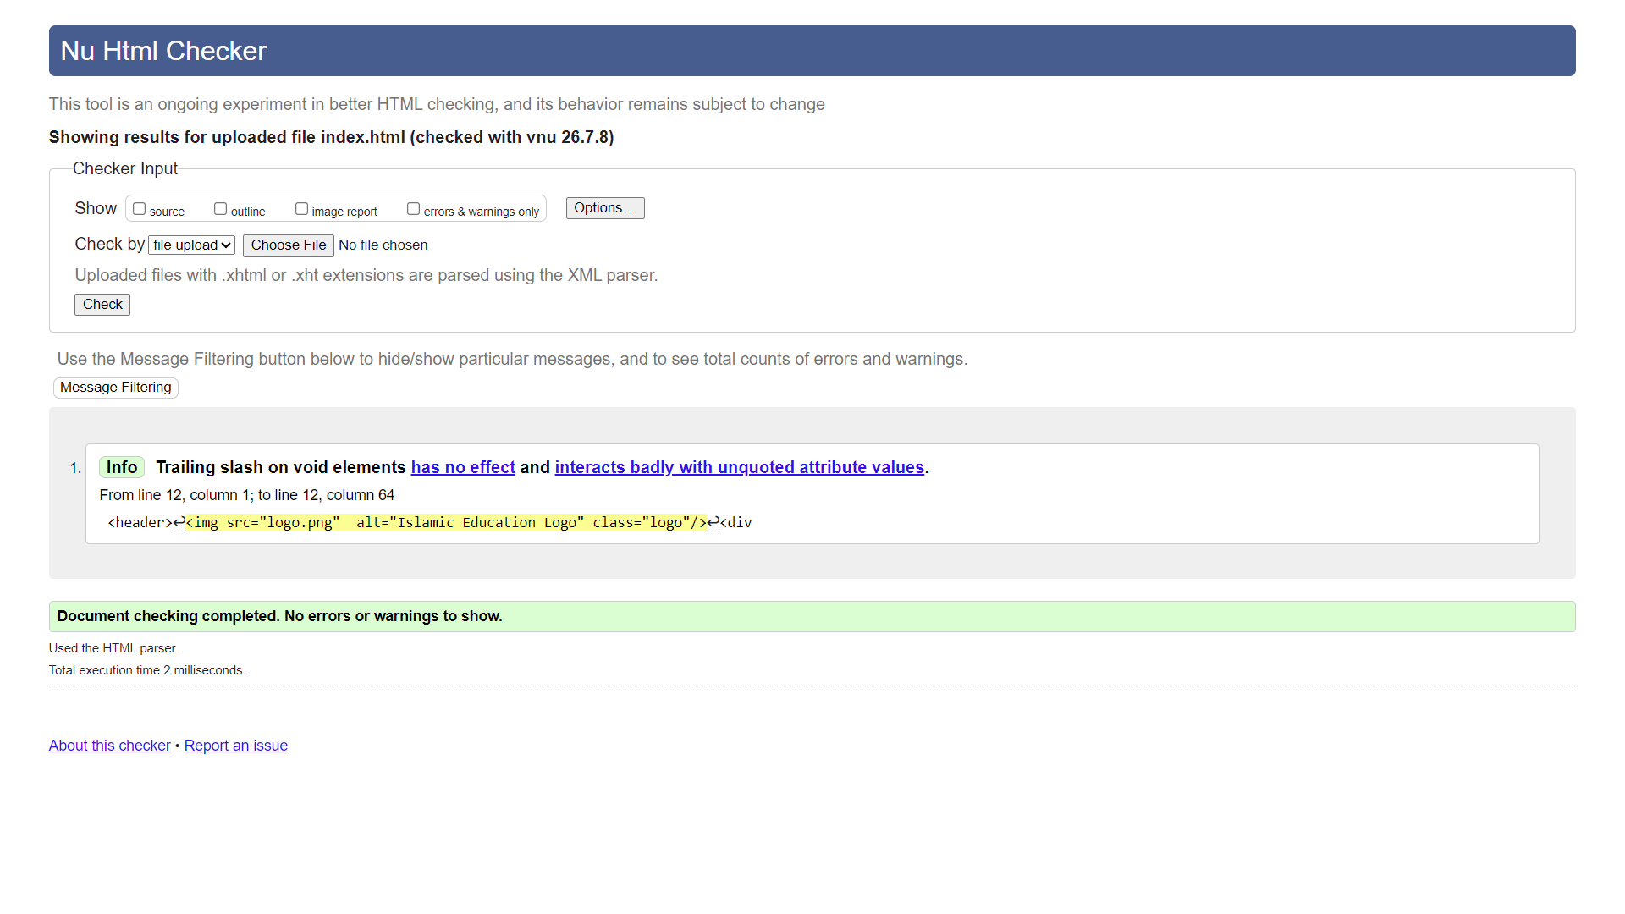

CSS Validation
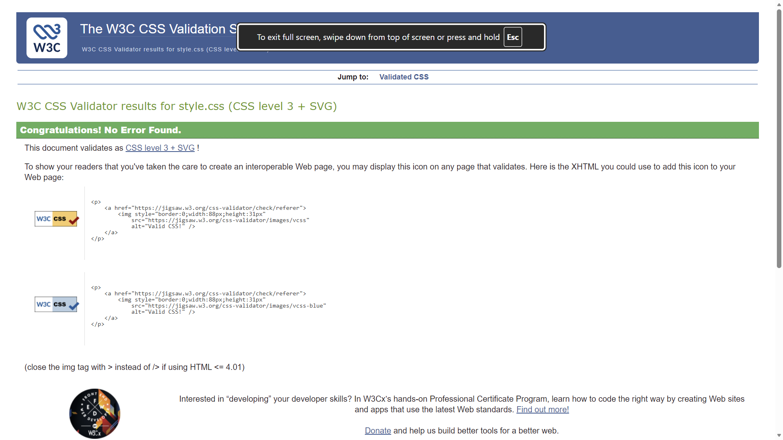

Evaluation

Website usability
Website usability is an important element when evaluating a website. Website usability refers to how easy and efficient a site is for user to use, ranging from navigating within it to achieving their intended purpose of visiting that site[1].
Several aspects are taken into account to assess the strength of usability of a website for users. Availability, clarity, credibility and relevance are amongst some of the things taken into consideration when assessing a website's usability[1].
In order to evaluate web usability, one of the most effective ways Web usability is evaluated is by it being tested by real users[2]. This is an effective way to identify potential issues related to the site, whether the site meets its intended purpose and gives insight into how the users interact with the site[2].
In testing a website's usability, questionnaires are amongst the most frequently used methods for usability evaluation tool, as it is easier and cheaper than other approaches to gather feedback from users[3].
System Usability Scale(SUS) is one of the questionnaires testers can use to test website usability. It comprises a 10-point questionnaire with responses ranging from 1-5. With 1 being in complete agreement with the statement and 5 in complete disagreement. The even-numbered statements are positive statements, and the odd-numbered statements are negative statements to help balance the responses[3]. To calculate a SUS score, convert each item’s response into a value between 0–4 (odd items: response minus 1; even items: 5 minus response). Add all ten values, then multiply the total by 2.5. The final SUS score ranges from 0 to 100[3]. If the overall score is over 70%, it means experience is positive but possesses minor issues[4].
An example of SUS being used can be taken from the following example;
SIMPONIK was developed to help with online learning during COVID-19 and to handle many guest visits at the Polytechnic. In order to improve its website services and user experience, the websites usability needed to be evaluated. The method used to evaluate it was SUS, and its questionnaire was distributed to 100 participants. The SUS score was over 76%, which meant according to the SUS method, the website is deemed acceptable by users. The report also found that improvements were needed in terms of practicality and ease of using and accessing the Simponik website[5].

Website accessibility:
Website accessibility refers to making a website accessible to as many people as possible [6]. Website accessibility is developed so that people with disabilities can use it. It helps them perceive, understand, navigate and interact with the website[7]. Website accessibility benefits everyone, not just people with disabilities. It also helps users on mobile devices, older users with changing abilities, and people in situations where certain actions—like listening to audio—are not possible[7].
Web Content Accessibility Guidelines(WCAG) are a set of rules that have been made to make creating websites for people with disabilities easier[9]. It gives a criterion of success that developers can apply to removes barriers for people with disabilities[9]. There are 4 main principles that the WCAG focuses on. They are being perceivable, operable, understandable and robust[9].
Different methods are used to evaluate the accessibility of websites. One method is by using automated accessibility testing, which uses software tools which check for WCAG errors within web pages. Automated scans are able to detect missing alt on images, incorrect headings, poor colour contrast ratios, missing form labels, etc[10]. They only account for roughly 30-50% of WCAG problems and require human judgement, so human judgement is just as important[10]. Another method that is essential in evaluating accessibility is manual expert testing where humans check those aspect where tools cannot detect such as visual design checks, keyboard-only navigation, etc[11].
An example of a website accessibility evaluation is as follows:
University websites contain many types of information, so they must be accessible and compatible for all users. A study was done to assess the accessibility of the top 25 QS-ranked world universities and the top 25 QS-ranked Indian universities using WCAG 2.2. The automated tool “SortSite” was used to check accessibility, usability, browser compatibility, and SEO issues.
From the study, it was found that many of the websites were not presentable, understandable, interactive, or user-friendly. In terms of browser compatibility, Indian universities were shown to have greater issues with compatibility. Firefox is the most incapable browser, and Microsoft Edge being the most[12].

Search engine optimisation
Search engine optimisation(SEO) is the process of improving the visibility of a website and enhancing its ranking on search engine results to increase its online presence[13]. In simple terms, it's about getting found when someone searches for that which your site is offering[14]. The more a site has SEO, the more possibilities it has for visibility through the search engine, leading to a greater chance that its pages will be accessed by interested users. There are 3 key steps SEO works to understand site content and ensure that it appears in relevant searches. They are: Crawling, indexing and ranking[15].
In crawling, search engines use crawlers to scan websites by following links between the pages. The more clear and updated the website structure is, the easier it is for these bots to discover your site[15]. After crawling, search engines analyse your pages and store them in their index, and after being placed in their index, search engines rank pages based on relevance, quality and user experience[15]. SEO plays a heavy role in website development. Firstly, developers must ensure that their site is crawlable and indexable by creating a clean HTML structure and avoiding broken links and crawl errors. Google’s developer guide emphasises that if your page cannot be understood by Google, you may lose traffic[16]. Also, it gives guidelines to developers to ensure the security of the webpages as well as reliability in their loading.
Evaluating a website’s SEO can be done using evaluation tools that check crawlability and indexability. They check for crawl errors as well as how many pages are indexed compared to how many are excluded. Evaluation tools such as Google Search Console can be used. This is essential as it gives you an idea as to how Google actually sees your site[17]. Also, content quality is evaluated for search engines[18], so things like the depth and relevance of a website are analysed and evaluated.
Part B: My website evaluation

Usefulness (Usability and Utility)
To evaluate my website usability, I used the SUS method for evaluation. There were positives within the website and its content, as well as areas in which improvements could be made. In terms of strengths, ease of use, the intended purpose of the website and confidence were the strong points of the website. In order to improve the website in the future, more information and details within the web pages are essential. There should be additional links within the website for the courses page to make enrolment for courses much easier. Adding videos and a library section will give more purpose and reason for people to visit the website. The overall score of the website through SUS evaluation method is 67.5, which is ok but can be better.

Search Engine Optimisation (SEO)
In my website, there are multiple SEO techniques that were used to improve the visibility of the site in the search engine results.
Firstly, words that have relation and links with the word “Islamic education” were consistent throughout the site to allow search engines to understand the purpose of the site. E.g., homepage- using words like Islamic education and having links to courses, courses page including topics with specific keywords such as Qur’an recitation, Arabic language, Sirah, etc.
Secondly, each page’s title is clear and easily understandable. This makes it easy for the search engine to understand what each page is about. E.g., Homepage- overview of what the website is about, courses page- informs what courses are available, etc. This will help increase click rates and allow Google to index pages correctly.
Also, the website HTML is simple and correct, which allows search engines to crawl through the pages easily e.g., correct use of <header>, <nav>, <main>, etc.

Accessibility
When testing the accessibility of my website, I used contrastchecker.com to check the colour contrast, and it passed the accessibility test. Also to evaluate the accessibility of my site, without touching the mouse, I kept on clicking the tab icon to test if it moves logically and all the links and buttons could be reached, which it can do so without confusing its user. Zoom testing was also done to check sites responsiveness, and there were no concerns about accessibility or visibility of the web pages and their content. The website passes basic accessibility guidelines for the website to be perceivable, operable, understandable and robust.
Part C: 2 live website comparisons

Area | Website 1 | Website 2
Weblink of the Website | https://www.bbc.co.uk/news | https://www.theguardian.com/uk
Usability | The BBC website is easy to navigate and offers a wide range of content. Its layout is clear, and important sections like the latest news are highlighted well. However, new users may need time to learn how to find specific information. Overall, it meets its purpose and provides a good user experience. The SUS test score of 70/100 indicates above-average usability. | The Guardian website is easier to navigate than the BBC site, with simple layouts and seamless movement between topics. Although the homepage contains a lot of information, reducing the amount of content could improve clarity and user comfort. Overall, the usability is positive, and the site effectively supports users in finding what they need. The Guardian scored 72.5/100 in the SUS test, indicating strong usability.
Accessibility | Using the WAVE evaluation tool, the BBC homepage showed 30 errors, all caused by the same issue: a broken ARIA reference where aria-describedby or aria-labelledby points to a missing target. Positively, the site had no contrast errors and included 139 accessibility features. The Accessibility Impact (AIM) score was 6.1/10, which is well above the average score of 5. | Using the WAVE evaluation tool, the site’s homepage showed 3 errors, two of which were duplicate issues and one unique issue, all against WCAG 2.1 guidelines. Two errors were caused by a form control having more than one label, and one was due to an empty button with no value. The site also had 36 contrast errors. On the positive side, WAVE detected 123 accessibility features, including 100 instances of alt text. The site achieved an AIM score of 5.5, which is just over average.
SEO | The website’s SEO elements were well‑implemented. The title tag was short and clear, and the meta description gave a concise overview of the content. Images included appropriate alt attributes that accurately described what they showed without keyword‑stuffing. The site has a canonical tag and 2-3 alternatives, if the first link does not work. The heading structure was organised correctly, with one <h1> on the main page and multiple <h2> and <h3> tags used to break content into logical sections. Overall, the site followed good on‑page SEO practices. | The SEO evaluation of theguardian.com/uk showed a short and clear title tag. The meta description was brief and could do with more detail. The page included a canonical tag. The heading structure lacked an <h1> but used several <h2>, <h3>, and <h4> tags. Image alt attributes were inconsistent, with one incorrect, one missing, and others not descriptive enough. Overall, it was ok but there are several areas that need improvement.
Mobile Friendliness | The website was tested on a mobile device and displayed well. The layout adapted smoothly to the screen, text remained clear and readable, and the site never felt cramped. Navigation was easy, links and icons were simple to tap, searching for topics was straightforward, and pages loaded quickly. Zooming did not reduce quality, touch responsiveness was good, and dark mode was supported. Overall, the mobile experience was positive with no issues found. | The website adapted smoothly to mobile devices. The layout was simple, uncluttered, and easy to read, with clear text that remained sharp when zooming. Navigation was effortless, and links and icons were easy to tap. Searching for topics was straightforward, pages loaded quickly, and touch response was reliable. The site also supported both dark and light mode. Overall, the mobile experience was positive with no issues found.
Conclusion | Overall, while both websites performed well across usability, accessibility, SEO, and mobile responsiveness, the BBC website showed stronger consistency and fewer issues than The Guardian. BBC offered clearer structure, more reliable alt attributes, better‑organised headings, and fewer accessibility errors. The Guardian was usable and mobile‑friendly but had more accessibility problems and weaker SEO elements. Therefore, BBC delivered a more polished and effective experience overall.

References:
[1] A. Mika, Ramotion, “Website Usability 101: Definition, Principles and Methods | Ramotion Branding Agency,” Web Design, UI/UX, Branding, and App Development Blog, Apr. 17, 2023. https://www.ramotion.com/blog/website-usability/ (accessed July 12, 2026).
[2]A. Krysiak, “Website Usability: The Ultimate Guide for 2024,” survicate.com. https://survicate.com/blog/website-usability/ (accessed July 12, 2026).
[3]N. S. Aziz, N. S. Sulaiman, W. N. I. T. M. Hassan, N. L. Zakaria, and A. Yaacob, “A Review of Website Measurement for Website Usability Evaluation,” Journal of Physics: Conference Series, vol. 1874, no. 1, p. 012045, May 2021, doi: 10.1088/1742-6596/1874/1/012045.
[4]P. Burgess, “SUS (System Usability Scale): How to Use It, Score It, and Interpret It,” UXResearchBlog, Dec. 12, 2025. https://www.uxresearchblog.com/post/sus-system-usability-scale-how-to-use-it-score-it-and-interpret-it (accessed July 12, 2026).
[5]D. Saputra, E. Ardiyan Syah, and F. Darnis, “Usability Testing on the Simponik Website using the System Usability Scale (SUS),” Sinkron, vol. 7, no. 4, pp. 2584–2592, Nov. 2022, doi: 10.33395/sinkron.v7i4.11916.
[6]GOV.UK, “Make Your Public Sector Website or App Accessible,” GOV.UK, May 09, 2018. https://www.gov.uk/guidance/accessibility-requirements-for-public-sector-websites-and-apps (accessed July 12, 2026).
[7]W3C, “Introduction to Web Accessibility,” Web Accessibility Initiative (WAI), Mar. 07, 2024. https://www.w3.org/WAI/fundamentals/accessibility-intro/ (accessed July 13, 2026).
[8]“What is accessibility? - Learn web development | MDN,” MDN Web Docs, Dec. 19, 2024. https://developer.mozilla.org/en-US/docs/Learn_web_development/Core/Accessibility/What_is_accessibility (accessed July 13, 2026).
[9]K. Rivenburgh, “WCAG 101: Understanding the Web Content Accessibility Guidelines | WCAG,” WCAG, Jan. 12, 2021. https://www.wcag.com/resource/what-is-wcag/ (accessed July 14, 2026).
[10]AccessiGuard Team, “How to Do a Website Accessibility Audit in 2026: A Step-by-Step Guide,” Accessiguard.app, Feb. 13, 2026. https://www.accessiguard.app/blog/how-to-do-website-accessibility-audit? (accessed July 14, 2026).
[11]T. A. Guide, “Accessibility Audit Guide 2026 - Complete WCAG 2.2 Website Audit Process,” TheWCAG - An accessibility Guide, 2026. https://www.thewcag.com/accessibility-audit-guide?utm_source=copilot.com (accessed July 14, 2026).
[12]K. Krittika and S. R. Shimray, “Accessibility evaluation of top 25 QS-ranked world universities and top 25 QS-ranked Indian universities using WCAG 2.2: a comparative study,” Universal Access in the Information Society, May 2025, doi: 10.1007/s10209-025-01218-2.
[13]S. Berry, “What Is SEO?,” SEO.com, July 28, 2025. https://www.seo.com/basics/glossary/seo/ (accessed July 18, 2026).
[14]V. Pavlik, C. Skopec, and F. Ali, “What is SEO? A complete guide to search engine optimization,” Semrush Blog, Jan. 22, 2020. https://www.semrush.com/blog/what-is-seo/?msockid=2974079427f262371e8511fb26d563f7 (accessed July 18, 2026).
[15]M. Ellis, “What Is SEO?,” MOZ, 2023. https://moz.com/learn/seo/what-is-seo (accessed July 18, 2026).
[16]“SEO Guide for Web Developers | Google Search Central | Documentation,” Google for Developers. https://developers.google.com/search/docs/fundamentals/get-started-developers (accessed July 18, 2026).
[17]SEO Scout Editorial Team, “How to Do an SEO Site Audit — Step-by-Step Complete Guide,” SEO Scout, Feb. 15, 2026. https://seoscout.co/learn/site-audits (accessed July 18, 2026).
[1]“SEO audits: How to conduct one that drives traffic growth [+ checklist],” HubSpot, Apr. 28, 2026. https://blog.hubspot.com/marketing/seo-audit?https://blog.hubspot.com/marketing/seo-audit? (accessed July 19, 2026).

Appendix

Homepage
<!DOCTYPE html>
<html lang="en">
<head>
<meta charset="UTF-8">
<title>Islamic Education - Home</title>
<meta name="viewport" content="width=device-width, initial-scale=1">
<link rel="stylesheet" href="style.css">
</head>

<body>
<header>
<img src="logo.png" alt="Islamic Education Logo" class="logo"/>
<div class="bismillah-en">In the name of Allah, the Most Merciful, the Most Compassionate</div>
<div class="bismillah">بِسْمِ ٱللّٰهِ ٱلرَّحْمَٰنِ ٱلرَّحِيمِ</div>
<h1>Islamic Education</h1>
<nav>
<a href="index.html">Home</a> |
<a href="courses.html">Courses</a> |
<a href="contact.html">Contact</a>
</nav>
</header>

<main>
<h2>Welcome</h2>
<p>Welcome to Islamic Education — a simple and peaceful space created to help you learn the essentials of Islam with clarity and confidence. Whether you are beginning your journey or continuing it, this website is designed to support you every step of the way.</p>

<h2>Our Purpose</h2>
<p>Islamic knowledge brings light to the heart and direction to life. Our purpose is to make learning easy, accessible, and enjoyable for all ages. Every lesson is written in clear, simple language so you can understand and benefit immediately.</p>

<h2>Learning Made Easy</h2>
<p>We focus on gentle guidance, practical knowledge, and meaningful learning. No complicated terms, no overwhelming details — just straightforward Islamic education that helps you grow day by day.</p>

<ul>
<li>Clear explanations that anyone can understand.</li>
<li>Friendly guidance to help you learn at your own pace.</li>
<li>Content suitable for children, beginners, and adults.</li>
<li>A calm, respectful environment for Islamic learning.</li>
</ul>

<h2>Your Journey Starts Here</h2>
<p>Knowledge is a blessing that brings you closer to Allah. Begin your journey today, one small step at a time, and let the beauty of Islam fill your heart and home.</p>
</main>

<footer>
<p>© 2026 Islamic Education</p>
</footer>
</body>
</html>

Courses page
<!DOCTYPE html>
<html lang="en">
<head>
<meta charset="UTF-8">
<title>Islamic Education - Courses</title>
<meta name="viewport" content="width=device-width, initial-scale=1">
<link rel="stylesheet" href="style.css">
</head>

<body>
<header>
<img src="logo.png" alt="Islamic Education Logo" class="logo"/>
<div class="bismillah-en">In the name of Allah, the Most Merciful, the Most Compassionate</div>
<div class="bismillah">بِسْمِ ٱللّٰهِ ٱلرَّحْمَٰنِ ٱلرَّحِيمِ</div>
<h1>Our Courses</h1>

<nav>
<a href="index.html">Home</a> |
<a href="courses.html">Courses</a> |
<a href="contact.html">Contact</a>

</nav>
</header>

<main>

<h2>Qur’an Recitation</h2>
<img src="https://www.al-islam.org/sites/default/files/EMpAvdlHgaY.jpg" alt="Qur'an" class="course-img">
<p>Reciting the Qur’an brings peace to the heart and light to the soul. Every letter you read earns reward and strengthens your connection with Allah.</p>

<h2>Arabic Grammar</h2>
<img src="https://hijrahpress.com/wp-content/uploads/2022/08/NAHW-Cover-600x900.jpg" alt="Arabic Grammar" class="course-img">
<p>Arabic opens the door to understanding the Qur’an directly. Learning the language of revelation brings clarity and deeper appreciation of its meanings.</p>

<h2>Hadith</h2>
<img src="https://as-siraat.org.uk/wp-content/uploads/hadithessentials1.jpg" alt="Hadith" class="course-img">
<p>Hadith teaches us the wisdom, mercy, and guidance of the Prophet ﷺ. Studying it helps us build character and live with purpose.</p>

<h2>Spirituality</h2>
<img src="https://as-siraat.org.uk/wp-content/uploads/Heart-Essential-Book-scaled.jpg" alt="Spirituality" class="course-img">
<p>Spirituality helps you strengthen your heart, deepen your connection with Allah, and find peace in your daily life. It nurtures sincerity, mindfulness, and inner calm.</p>

<h2>Sīrah</h2>
<img src="https://as-siraat.org.uk/wp-content/uploads/Sirah-Essentials-Mockup-scaled.jpg" alt="Seerah" class="course-img">
<p>The life of the Prophet Muhammad ﷺ inspires us to be better every day. His example is the best guide for every Muslim.</p>

<h2>Children’s Islamic Studies</h2>
<img src="https://as-siraat.org.uk/wp-content/uploads/islamic-essentials.jpg" alt="Children Islamic Studies" class="course-img">
<p>Teaching children about Islam builds strong faith from a young age. Every lesson plants a seed that grows throughout their lives.</p>

</main>

<footer>
<p>© 2026 Islamic Education</p>
</footer>
</body>
</html>

Contact page
<!DOCTYPE html>
<html lang="en">
<head>
<meta charset="UTF-8">
<title>Islamic Education - Contact</title>
<meta name="viewport" content="width=device-width, initial-scale=1">
<link rel="stylesheet" href="style.css">
</head>

<body>
<header>
<img src="logo.png" alt="Islamic Education Logo" class="logo"/>
<div class="bismillah-en">In the name of Allah, the Most Merciful, the Most Compassionate</div>
<div class="bismillah">بِسْمِ ٱللّٰهِ ٱلرَّحْمَٰنِ ٱلرَّحِيمِ</div>
<h1>Contact us</h1>
<nav>
<a href="index.html">Home</a> |
<a href="courses.html">Courses</a> |
<a href="contact.html">Contact</a>
</nav>
</header>

<main>
<h2>Send a Message</h2>

<form>
<label>Name:</label><br>
<input type="text"><br><br>

<label>Email:</label><br>
<input type="email"><br><br>

<label>Message:</label><br>
<textarea rows="4"></textarea><br><br>

<button type="submit">Send</button>
</form>
</main>

<footer>
<p>© 2026 Islamic Education</p>
</footer>
</body>
</html>

CSS stylesheet code
<!DOCTYPE html>
<html lang="en">
<head>
<meta charset="UTF-8">
<title>Islamic Education - Contact</title>
<meta name="viewport" content="width=device-width, initial-scale=1">
<link rel="stylesheet" href="style.css">
</head>

<body>
<header>
<img src="logo.png" alt="Islamic Education Logo" class="logo"/>
<div class="bismillah-en">In the name of Allah, the Most Merciful, the Most Compassionate</div>
<div class="bismillah">بِسْمِ ٱللّٰهِ ٱلرَّحْمَٰنِ ٱلرَّحِيمِ</div>
<h1>Contact us</h1>
<nav>
<a href="index.html">Home</a> |
<a href="courses.html">Courses</a> |
<a href="contact.html">Contact</a>
</nav>
</header>

<main>
<h2>Send a Message</h2>

<form>
<label>Name:</label><br>
<input type="text"><br><br>

<label>Email:</label><br>
<input type="email"><br><br>

<label>Message:</label><br>
<textarea rows="4"></textarea><br><br>

<button type="submit">Send</button>
</form>
</main>

<footer>
<p>© 2026 Islamic Education</p>
</footer>
</body>
</html>

