Author: Scott Anthony Witts
Student number: 1701090
Conrod Dynamic Forces Report

Abstract
The report will consider the forces of a connecting rod within a cylinder while increasing and decreasing the size of the internal components and the revolutions per minute (RPM). It was found that if the RPM, crank radius or the piston mass was increased then the maximum tensile force would also increase, if they were decreased then the maximum tensile force would also decrease. Increasing the conrod length would decrease the maximum tensile force and decreasing the length would increase the maximum tensile force.
Contents
TITLE | PAGE
Introduction | 1
Research/literature review | 2
Methodology | 3
Analysis | 4
Conclusion | 9
Recommendation for further studies | 10
References | 11

List of figures
Figure 1: Graph showing oscillations of the force and acceleration from the original specification data at 6200RPM………………………………………………………. Page 4

Figure 2: Graph showing oscillations of the force and acceleration from the original specification data at 3200RPM………………….………………………………...…. Page 4

Figure 3: Graph showing oscillations of the force and acceleration from the original specification data at 800RPM……………………………………………………...… Page 5

Figure 4: Graph showing oscillations of the force and acceleration with an increase to 9000RPM……………………………………….…………………………………….. Page 5

Figure 5: Graph showing oscillations of the force and acceleration with increased conrod length……………….………………………………………………………………… Page 6

Figure 6: Graph showing oscillations of the force and acceleration with reduced conrod length…………………………………………………………………………………. Page 6

Figure 7: Graph showing oscillations of the force and acceleration with increased crank radius…………………………………………………………………………………. Page 7

Figure 8: Graph showing oscillations of the force and acceleration with reduced crank radius………………………………………………...……………………………...... Page 7

Figure 9: Graph showing oscillations of the force and acceleration with increased piston mass………………………………………………………...………………………… Page 8

Figure 10: Graph showing oscillations of the force and acceleration with reduced piston mass……………………………………………………………………………...…… Page 8

Introduction
The following report will be considering the forces of the conrod based on the radius of the crankshaft, length of the conrod, revolutions per minute of the crankshaft (RPM), and the mass of the piston. The report will be evaluating the results when increasing or decreasing the crank radius, conrod length, RPM and the mass of the piston. The results will be illustrated in the form of graphs produced through Microsoft Excel. There will be ten spreadsheets created, four spreadsheets will include the original manufacturer specification data for the crank radius, conrod length and the piston mass.
The four spreadsheets with original specification data will show the manufacturers idle, middle range, maximum limit and exceeding the manufacturers restricted RPM limit being applied to the engine. The other six spreadsheets will have increasing and decreasing alterations made to the crank radius, conrod length and piston mass. Each spreadsheet will produce three graphs showing the effects of the varying alterations using the same formula input on Microsoft Excel, however only the graphs displaying the forces will be relevant and used during the report. The graphs produced with variations will also be compared to the original specification data graphs of the selected vehicle to clearly identify the change in forces acting on the conrod.

Research/literature review
The research into the data required for the selected vehicle, this being a Volkswagen Golf R32 was found from multiple resources. The idle and maximum RPM was found on Autodata, which is a reliable source that provides technical data and information that is provided to them from over 160 manufacturers (Autodata, 2017), it stated that the idle RPM is 720±130 and the maximum RPM being 6200. The conrod length and crank radius were sourced from the specifications of Wossner pistons and conrods, which is an aftermarket performance company that specialise in forged engine components. The website states the conrod length is 164mm, and the stroke being 95.9mm which means that the crank radius would be half the stroke at a measurement of 47.95mm. (Performance Engine Components, 2017). A website which specialises in high tensile forged aluminium pistons, (JE Pistons, 2017) identified the piston mass of the selected vehicle as 328 grams which would be inputted as 0.328kg into the spreadsheet. The website also identified information of the conrod length and stroke are identical to previous research, reinforcing the reliability of the source.

Methodology
The report will be undertaken by using a premade Microsoft Excel spreadsheet (ConrodAssignment1.xlsx), the spreadsheet will include the required formulas for the report although the data input of the selected vehicle would require further research to retrieve the data for the crank radius, conrod length, maximum RPM and the mass of the piston. The spreadsheet will produce three graphs which include the height the conrod travels, the velocity the conrod travels and the force and acceleration of the conrod simultaneously. Each graph would require a chart title, Y axis title, X axis title and adjustments to the dimensions of the graphs.
The write up for the report will be produced using Microsoft Word, using a Times New Roman font through out with a font size of twelve. The analysis will be tackled by retrieving the figures from the spreadsheets and examining the graphs whilst comparing the alterations to the standard specification graphs, explaining the results relating to the forces and the reasoning behind each result. The purpose of the conrod dynamic forces report is to show how the conrod reacts when there is an increase and decrease of force applied. The aim of the report is to provide an understanding of what can affect the force on the conrod, what can cause an exceeded limit of force and result in catastrophic damage to the conrod and engine components.
Analysis
The first spreadsheet was produced using the original specification data of the Volkswagen Golf R32 at 6200RPM, the result shows that the maximum tensile force of the conrod is 8545.734 Newtons (N) this would be rounded to the nearest figure and claimed as 8546N. The maximum tensile force is reached as the conrod goes down the cylinder towards bottom dead centre (BDC), as shown on the graph produced showing an increase in force in the negative Y axis. The conrod travels three full cycles over the 0.0288 seconds / 28.8 milliseconds (ms) timescale on the X axis.
Fig 1:
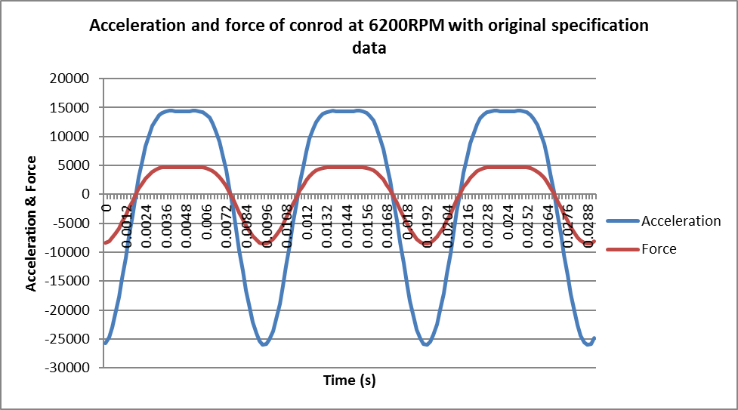

The second spreadsheet was produced also using the original specification data at 3200RPM, the result shows that the maximum tensile force is 2281N which is significantly lower than the tensile force found at 6200RPM, this is due to the crank turning at almost half the speed resulting in a decrease in the tensile force. The maximum tensile force is also reached at BDC, however the graph shows a smother reading due to the conrod completing only one and a half cycles over the 28.8ms period.
Fig 2:
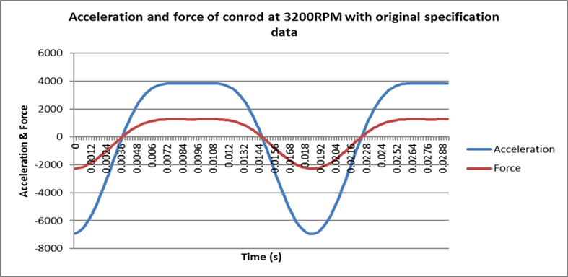

The third spreadsheet was produced using the original specification data again but at an idle speed of 800RPM, the result shows that the maximum tensile force is 161N and achieved at BDC which again has substantially decreased from the force produced at 3200RPM. The graph has a smoother waveform again as the conrod only travels half a cycle over the 28.8ms timescale displayed on the X axis.
Fig 3:
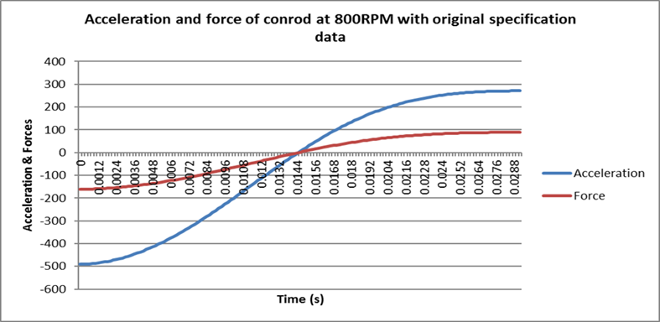
The fourth spreadsheet was produced using the original specification data but with an extreme increase up to 9000RPM which is 2800RPM above the safe limit for the engine. This alteration increased the maximum tensile force to a colossal figure of 17968N, again the maximum was achieved at BDC. This figure is over double the force given at the maximum RPM and would have a very high chance of causing catastrophic damage to the engine and its components. The conrod now travels four and a half times over the 28.8ms period, and the graphs waveform now looks relatively aggressive.
Fig 4:
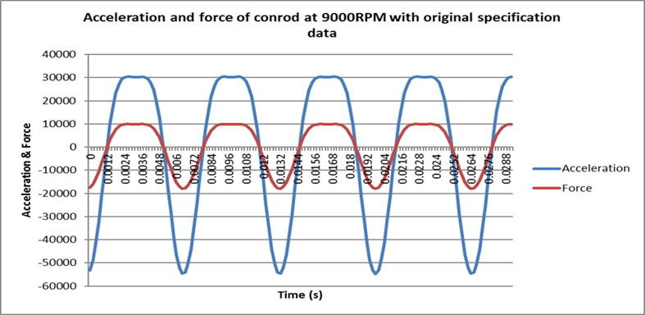

The fifth spreadsheet was produced at 6200RPM with an increase to the conrod length, the length was increased from 164mm to 194mm. The result of this action decreased the maximum tensile force by 298N from the original 8546N to 8248N. The graph looks very similar to the original specification graph and the conrod still completes three cycles over the 28.8ms, however the acceleration of the conrod has increased marginally at top dead centre (TDC) and developed a smoother curve at the peak of the waveform in the positive Y axis as the piston reaches TDC.
Fig 5:
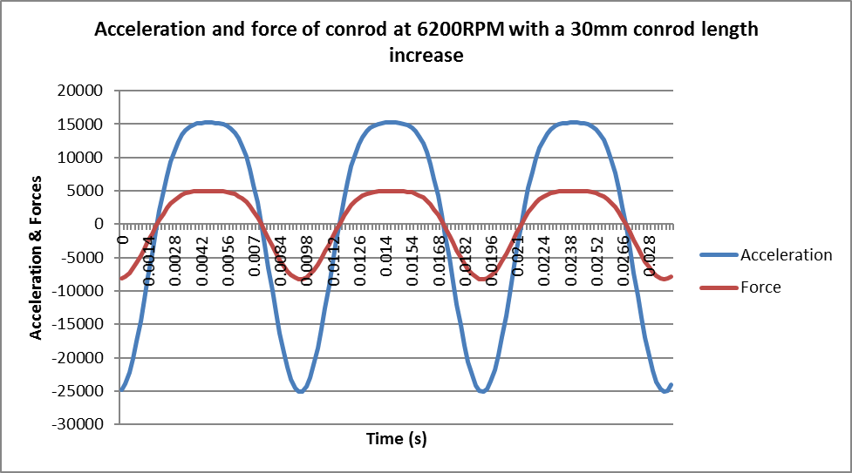
The sixth spreadsheet was produced at 6200RPM with a decrease to the conrod length, the length was decreased from 164mm to 134mm. The result of this increased the maximum tensile force by 432N from the original 8546N to 8978N. The change is more defined compared to the increase to the conrod length due to the dip at the peaks of the acceleration and force waveforms and there is an increase to the force and acceleration at BDC. The conrod still completes three cycles in the 28.8ms period due to no change being made to the RPM
Fig 6:
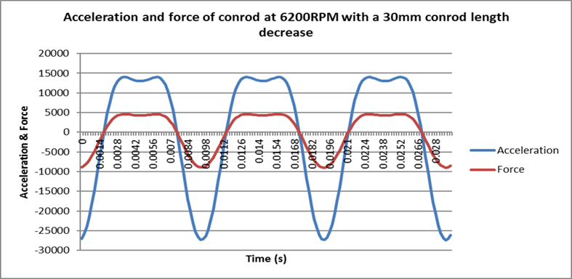

The seventh spreadsheet was produced at 6200RPM with an increase to the crank radius from 47.95mm to 57.95mm. The effect of this increased the maximum tensile force by 2268N up to 10814N which is reached in the negative Y axis. The acceleration increased in the positive and negative axis of the graph, this is due to the RPM being the same but the conrod must travel an extra 20mm due to the crank radius increasing by 10mm.There is a dip at the peak of both waveforms as there was with the decrease to the conrod length. There is no change to the waveform distance in the X axis as there is still 3 complete cycles over the 28.8ms time due to no change being made to the RPM.
Fig 7:
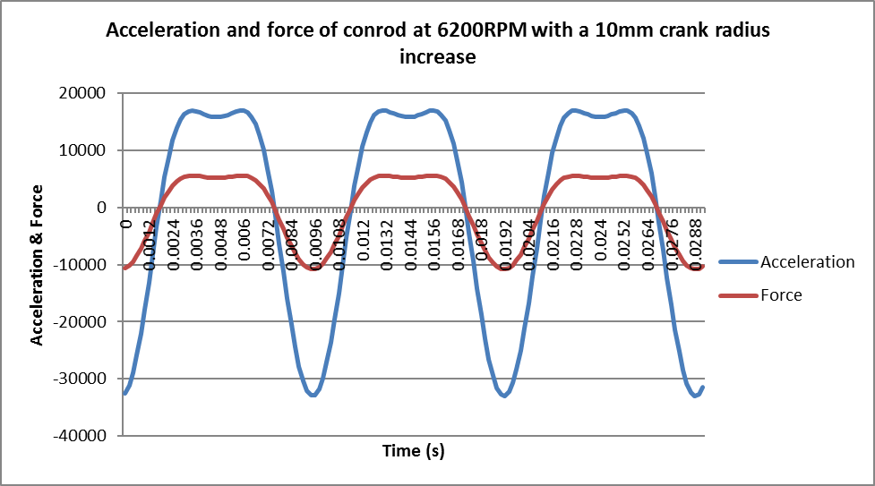

The eighth spreadsheet was produced at 6200RPM with a decrease to the crank radius from 47.95mm to 37.95mm. This decreased the maximum tensile force from the standard specification by 2100N and down to 6445N. The acceleration of the conrod has also decreased due to the reduced crank radius. There is still 3 full cycles over the 28.8ms period due to no change being made to the RPM.
Fig 8:
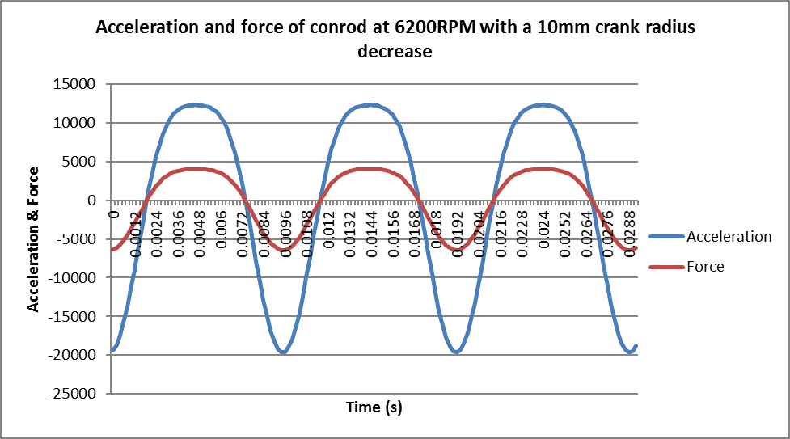

The ninth spreadsheet was produced at 6200RPM with an increase to the piston mass from 0.328kg to 0.656kg resulting in a piston with double the mass compared to the standard specification piston mass. The result of increasing the piston mass by 50% increased the maximum tensile force by 50% also from 8546N to 17092N, but the alteration had no effect on the acceleration. There is still 3 completed cycles over the 28.8ms due to no change being made to the RPM.
Fig 9:
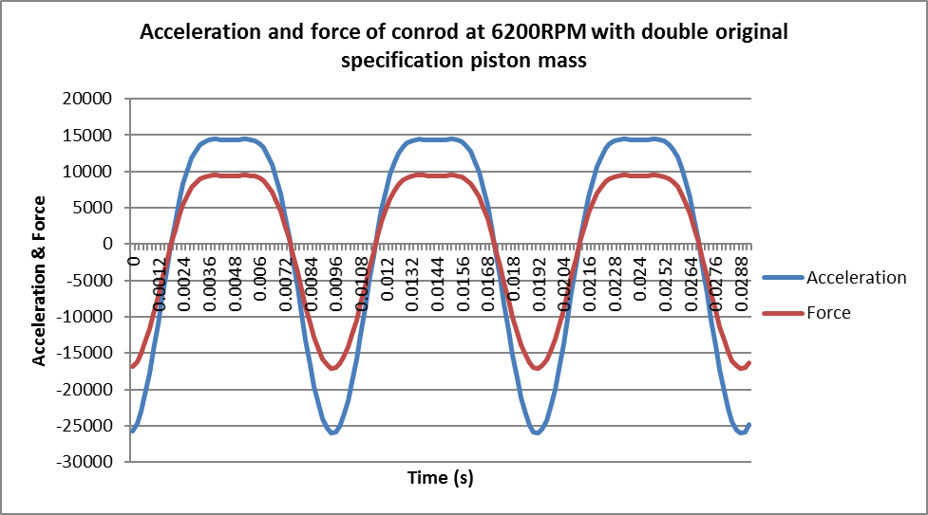

The tenth spreadsheet was produced at 6200RPM with a reduced piston mass from the standard 0.328kg to 0.164kg which is half the standard piston mass. The result of decreasing the piston mass decreased the maximum tensile force from 8546N to 4273N which shows that decreasing the piston mass by 50% also decreases the maximum tensile force by 50%, but the alteration had no effect on the acceleration. There is still 3 complete cycles over the 28.8ms period due to no change being made to the RPM.
Fig 10:
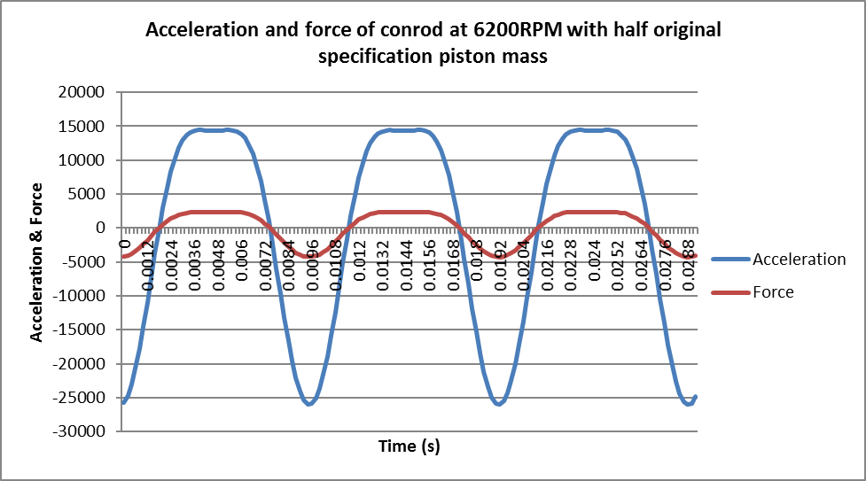

Conclusion
Based on the first four spreadsheets it is shown that the force and acceleration will increase when the RPM is increased, and decrease as the RPM is decreased. Increasing the conrod length reduces the force of the conrod, and decreasing the conrod length increases the force. Increasing the crank radius raises the acceleration and the force of the conrod, and decreasing the crank radius lowers the acceleration and force of the conrod. The higher the piston mass the higher the tensile force will be, and the lower the piston mass the lower the tensile force will be. The maximum tensile force is always found in the negative Y axis, this is because as the piston is at TDC and is displayed in the positive Y axis it is under compression as the air and fuel mixture is under a controlled burn forcing the piston and conrod down the cylinder. When the conrod is at BDC, there is more tensile force required to push the piston and conrod up the cylinder where there is a build-up of pressure between the piston and the top of the cylinder.

Recommendation for further studies
If this report was to be repeated the research would be more reliable if the measurements of the components were taken personally by the researcher to retrieve live data measurements which would be more reliable and would guarantee more accurate results.

References

Http: 1. (2017) Autodata, [Online]. Available: https://workshop.autodata-group.com/vehicle/component/td, [2017, December, 6th].
Http: 2. (2017) JE Pistons, [Online]. Available: http://www.jepistons.com/Catalogs/Sport-Compact/VW-Audi/32l_24v.aspx, [2017, December, 7th]
Http: 3. (2017) Performance Engine Components, [Online]. Available: http://www.steelconrods.co.uk/product_info.php?cPath=22_47_154&products_id=399, [2017, December, 7th]

