My Screenshots/Photos
- Please add 4–6 screenshots or photos of your digital life.
- You can use your phone or laptop.
- For each screenshot, write one or two sentences explaining what it shows.

Screenshot/Photo 1
Laptop

I use my laptop to communicate with my team and business partners but also to complete my other daily tasks like paying my bills, checking my emails and write documents. This device is my main digital device which I’m using.

Screenshot/Photo 2
iPhone
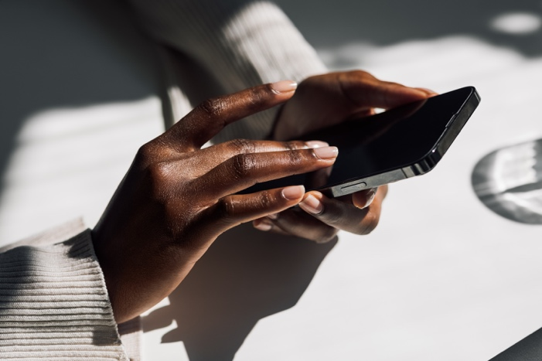
My second device is my IPhone. I’m using this device for everyday communication – emails, social media, whatsapp, telegram and many more. The biggest challenge is to keep it up and running so I always have my power bank with me.

Screenshot/Photo 3
Bank card

Another digital device which I’m using is my contactless bank card. It helps me to pay small payments like coffee, etc plus gives me an access to travel features like Tube or train.

Screenshot/Photo 4
Smartwatch
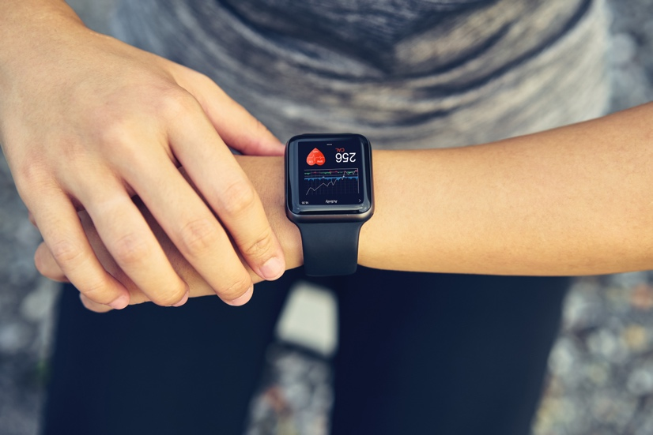
Here is my smart watch, which helps me to control my health parameters. I’m using this device to measure my heartbeat, number of steps and see the progress of my sports activity.

Screenshot/Photo 5
Ovolu digital business card
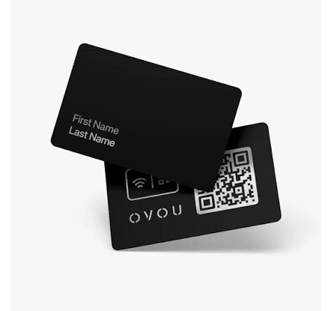
Another digital device is my Ovolu business card – NFC technology which allows me to share my contact details with my business partners without giving them a paper business card. Simply tap the card to someone's phone, and my details pop up on their phone..

Screenshot/Photo 6
Tablet
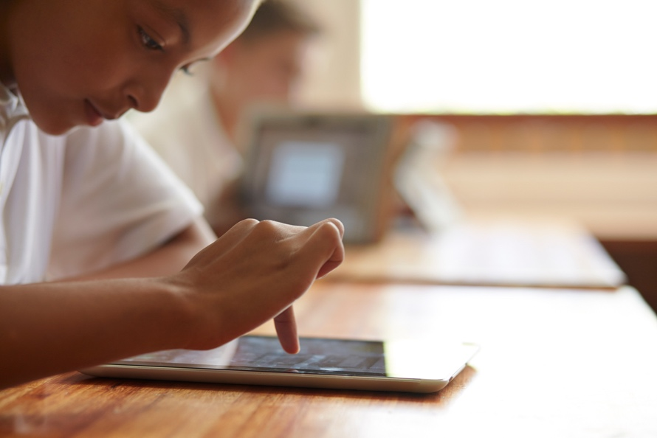
The tablet is another digital device which I’m using mostly for business presentations. Is handy and very useful for a meetings outside of the office. I use it also for checking my post and making a notes with digital pencil.

My Short Reflection
- Write 5–8 simple sentences about your digital life.
- You can use the sentence starters below if helpful.
We live in digital era. This means we are surrounded by devices and technology, so naturally we are users of vices, users or more precisely, consumers. In my case I use digital tools to speed up my business tasks but also manage my personal stuff – bills, hobby’s and everything that is related to the past, , and future.
Digital skills are very important to me because my business life and my career are attached to technology, so if I want to be competitive and deliver more projects, close more deals, I must stay on top with the the latest features.
I hope this module helps me to improve my digital skills and gives me more practical skills on how to use it in an effective way.
In my digital skill I would like to improve my knowledge and expertise with devices powered by sophisticated software like mobile phones, tablets – more applications create more options to make my life easier.

Sentence starters
- I use digital tools to …
- I feel confident when I …
- I want to improve …
- I often use these tools: …
- I sometimes feel nervous about …
- I hope this module will help me …
- Digital skills are important for me because …
You can write more if you want.

Submission Checklist
Before you submit, please check:
​​​ ☒ I added 4–6 screenshots
☒ I wrote short sentences for each screenshot
☒ I wrote my short reflection
☒ My work is my own
☒ My file opens correctly
​​☒ My file opens correctly

