

Independent Project
Programme: BSc (Hons) in Health and Social Care
MODULE CODE: BMHP6020
Topics: A Comprehensive Evaluation of Treatment Pathways and Service Delivery for Schizophrenia in the United Kingdom: Effectiveness, Accessibility, and Strategic Directions for Future Improvement.

Submitted by, Submitted to,
Md. Arif Ullah Chloe Harries
Student ID: 2245624

Chapter One: Introduction

1.1 Introduction:
Schizophrenia is a chronic and severe mental health disorder that significantly affects an individual’s cognition, emotions, and perception of reality. It remains one of the most complex psychiatric conditions, contributing substantially to the global burden of disease (World Health Organization, 2023). In the United Kingdom (UK), schizophrenia represents a major public health concern, with an estimated 220,000 individuals living with the condition and many more experiencing early psychotic symptoms that may require intervention (NHS England, 2022). Over recent decades, treatment approaches have evolved considerably, reflecting advancements in pharmacology, psychological therapies, community-based care, and integrated service delivery models.
Despite policy developments, significant challenges remain in ensuring timely access, continuity, and equitable delivery of schizophrenia care. Regional variation, workforce shortages, and resource pressures continue to undermine service effectiveness (Care Quality Commission, 2023). Schizophrenia affects around 1 in 100 adults in the UK and is associated with long-term service dependency (Jovanović et al., 2025). Although NHS initiatives such as Early Intervention in Psychosis, community rehabilitation, and Integrated Care Systems aim to improve coordinated care, implementation remains inconsistent (Ratcliffe, 2025; Amanawa & Amabebe, 2024). Persistent inequalities linked to ethnicity, socioeconomic disadvantage, and geography continue to impact outcomes and engagement with services (Phillips et al., 2025; Conneely et al., 2025; Pagdon, 2025).
The aim of this dissertation is to critically evaluate treatment pathways and service delivery for schizophrenia in the UK, focusing on effectiveness, accessibility, and areas for strategic improvement. This study adopts a secondary research design and will employ thematic analysis in Chapter 4 to synthesise findings from existing literature, policy documents, and service user perspectives. By examining current practices and outcomes, the research seeks to contribute to a clearer understanding of how schizophrenia care can be strengthened within the contemporary UK healthcare system.
This chapter introduces the topic, establishes its relevance, and outlines key definitions, background context, rationale, aims, and objectives. It concludes with a signpost to the subsequent literature review.

1.2 Definitions and Terminology:
Schizophrenia: A severe and enduring mental disorder characterised by distortions in thinking, perception, emotions, language, sense of self, and behaviour. Symptoms may include hallucinations, delusions, disorganised speech, and impaired functioning (WHO, 2023).
Treatment Pathways: Structured, evidence-based processes that outline the recommended stages of assessment, intervention, treatment, and follow-up for individuals with a specific condition (NICE, 2020).
Service Delivery: The organisation, management, and provision of health and social care services, including availability of resources, staffing, accessibility, and quality of care (NHS England, 2022).
Effectiveness: The extent to which an intervention or service achieves its intended outcomes in real-world settings, including clinical improvement and enhanced quality of life (Thornicroft et al., 2022).
Accessibility: The ease with which individuals can obtain appropriate healthcare services at the right time and without undue barriers, such as geographical, financial, or cultural obstacles (CQC, 2023).
National Health Service (NHS): The publicly funded healthcare system in the United Kingdom, responsible for commissioning and delivering health services including mental health care (NHS England, 2023).
Early Intervention in Psychosis (EIP): A specialised NHS service providing rapid assessment and intensive treatment for individuals experiencing a first episode of psychosis, aimed at improving long-term outcomes (NICE, 2020).
Integrated Care Systems (ICS): Collaborative partnerships between NHS organisations, local authorities, and voluntary sectors that work together to plan and deliver coordinated health and social care services (NHS England, 2023).

Acronyms and Abbreviations:
- NHS: National Health Service
- EIP: Early Intervention in Psychosis
- ICS: Integrated Care Systems
- CBT: Cognitive Behavioural Therapy
- SMI: Severe Mental Illness
- NIHR: National Institute for Health and Care Research
The proper understanding of these terms is essential for evaluating care models, comparing studies, and critically interpreting outcomes.

1.3 Background and Current Context:

1.3.1 Background
Understanding of schizophrenia has progressed significantly since the early 20th century when Kraepelin and Bleuler first characterised the disorder. Historically, treatment was dominated by institutionalisation; however, deinstitutionalisation in the UK during the 1960s–1980s shifted care towards community-based services (Rogers and Pilgrim, 2020). The introduction of antipsychotic medication, particularly atypical antipsychotics in the 1990s, further transformed management by reducing hospitalisation rates and improving symptom control (Leucht et al., 2019). Policy initiatives such as the National Service Framework for Mental Health (1999) and the development of EIP services have shaped modern care pathways.

1.3.2 Current Context
Today, schizophrenia treatment in the UK includes pharmacological interventions, psychological therapies, social support, and community mental health services. However, significant pressures affect service delivery. Recent reports highlight rising demand, workforce shortages, and variability in mental health provision across regions (CQC, 2023). While EIP services have improved early outcomes, continued concerns exist regarding long waiting times, inconsistent implementation of NICE guidelines, and limited access to high-quality psychosocial interventions (NHS England, 2022). Additionally, socioeconomic inequalities and stigma continue to influence help-seeking behaviours and engagement with services. These factors underscore the urgent for a comprehensive evaluation of current treatment pathways to identify strengths, limitations, and opportunities for improvement.

1.4 Rationale for Research:
Despite sustained policy commitments and service innovation, significant limitations remain in how schizophrenia care is delivered across the UK. Recent NIHR evaluations highlight disparities in access and treatment quality, particularly among ethnic minority groups, individuals living in deprived areas, and women during the perinatal period (Jovanović et al., 2025). While interventions such as EIP services demonstrate short-term benefits, they have been less effective in addressing long-term social exclusion, unemployment, housing instability, and physical health inequalities commonly experienced by individuals with schizophrenia.
Demand for mental health services has increased since COVID-19, putting extra pressure on already overstretched systems (Phillips et al., 2025). Differences in commissioning and uneven use of NICE guidance mean that psychological and social treatments are not consistently available across the country. This often leads to gaps in care after people leave early intervention or specialist services. There is also a lack of up-to-date research examining how schizophrenia treatment pathways work across NHS Trusts. Different definitions of recovery and limited outcome data make it difficult to assess service effectiveness beyond symptom control (Pagdon, 2025). Many service users report that clinical priorities do not reflect their personal recovery goals, which can reduce engagement and long-term outcomes (Uehling, 2025).
This dissertation responds to these gaps by synthesising contemporary evidence across clinical, policy, and service user domains. By critically evaluating why current models have not fully reduced inequalities or delivered sustained recovery, the study aims to identify both systemic limitations and opportunities for improvement. The findings may inform future policy development, service redesign, and resource allocation, supporting the delivery of more equitable and effective schizophrenia care.

1.5 Aim and Objectives:

1.5.1 Research Aim
The aim of this dissertation is to conduct a comprehensive evaluation of treatment pathways and service delivery for schizophrenia in the United Kingdom, with a focus on their effectiveness, accessibility, and potential strategic directions for future improvement.

1.5.2 Research Objectives
- To examine current treatment pathways for schizophrenia within the UK, including pharmacological, psychological, and community-based interventions.
- To assess the accessibility and quality of schizophrenia services across different regions of the UK.
- To evaluate the effectiveness of current service delivery models, including early intervention and integrated care approaches.
- To identify gaps, challenges, and opportunities for enhancing future schizophrenia treatment and service provision.

1.6 Conclusion:
This chapter has outlined the significance, aims, and foundational structure of the dissertation. It has defined key terminology and justified the need for a critical evaluation of schizophrenia treatment pathways and service delivery in the UK, particularly in the context of ongoing systemic pressures and persistent inequalities in care (Care Quality Commission, 2023; NHS England, 2022). The four research objectives provide a clear framework for examining both the effectiveness and accessibility of current services.
The next chapter will present a critical review of the literature, exploring the historical development of schizophrenia care, theoretical perspectives, and relevant national and international policy frameworks. This will establish the conceptual and empirical foundation for the analysis presented in subsequent chapters.

Chapter 2 – Background Information and Analysis

2.1 Introduction:
The treatment and service delivery for schizophrenia in the United Kingdom have undergone significant transformation, developing from asylum-based institutionalisation to modern, community-oriented and recovery-led models of care. Schizophrenia, a severe and chronic psychiatric disorder affecting cognition, perception, and social functioning, poses one of the most complex challenges for mental health systems globally. In the UK, schizophrenia treatment has become a focal point for NHS reform, policy innovation, and academic research due to its economic burden, social consequences, and links with health inequalities.
This chapter provides the contextual foundation for the dissertation by critically analysing the historical development, theoretical frameworks, and both global and national policy approaches shaping schizophrenia care. Drawing on recent peer-reviewed literature, NHS policies, and global health data, the chapter examines key structural changes, particularly post-2015 reforms. It also highlights persisting barriers in service access, cultural appropriateness, and equitable outcomes.
Understanding this complex background is essential for assessing treatment effectiveness and service delivery, which are central to this dissertation. The following sections explore the evolution of treatment approaches, theoretical influences on policy, and contemporary challenges within both international and UK-specific contexts.

2.2 Understanding Schizophrenia at a glance:
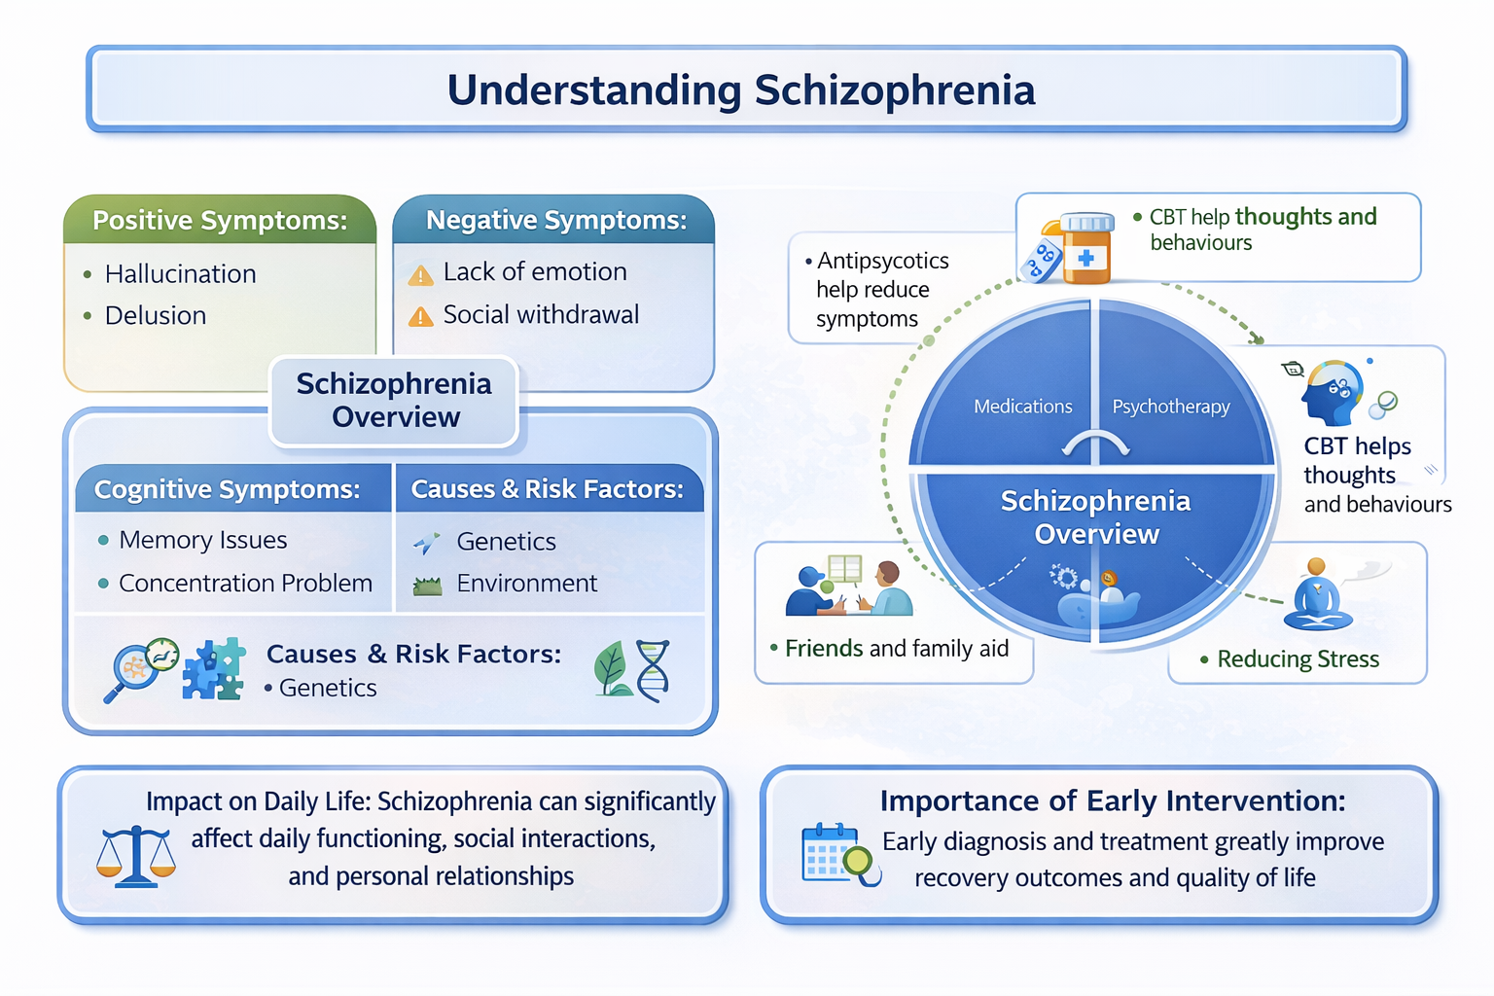

2.3 Historical Background:
2.3.1 The Evolution of Schizophrenia Treatment and Mental Health Service Development in the UK:
The historical journey of schizophrenia treatment in the United Kingdom is one of significant transformation — from institutionalised care rooted in social exclusion to a more holistic, person-centred, and rights-based approach within community settings. This evolution reflects broader shifts in societal values, political priorities, medical understanding, and civil rights movements.

2.3.2 Asylum-Based Care and the Early Legislative Framework (1800s–1950s):
The 19th and early 20th centuries were characterised by the widespread institutionalisation of individuals with mental illness. Under the Lunacy Act 1845 and later the Lunacy Act 1890, large county asylums were established to house individuals deemed “insane” — many of whom were diagnosed with what would now be classified as schizophrenia. Care in these institutions was largely custodial and often involved inhumane conditions, with minimal focus on therapeutic intervention (Scull, 2015; Bartlett & Wright, 2018). By the 1950s, over 150,000 people were institutionalised in asylums across England and Wales. Public opinion began to shift as reports of neglect and abuse surfaced, prompting political pressure for reform.

2.3.3 The Beginnings of Deinstitutionalisation (1959–1980s)
The Mental Health Act 1959 removed the legal separation between mental and physical illness and encouraged voluntary treatment in hospitals and community settings. This aimed to improve patient dignity and support social inclusion (Jones, 2010). Deinstitutionalisation increased in the 1980s due to policy changes, criticism of asylums, and the use of antipsychotic medication (Rogers & Pilgrim, 2014). The Mental Health Act 1983 strengthened patient rights, including the right to appeal detention.

2.3.4 The Community Care Era and the Care Programme Approach (1990s)
The NHS and Community Care Act 1990 supported the move from institutions to community-based care. While intended to improve independence, services were unevenly delivered, leaving some people without adequate support (Godin, 2006). The Care Programme Approach (CPA) aimed to improve care coordination for people with complex needs, but was criticised for being too bureaucratic and not always person-centred (Department of Health, 1999).

2.3.5 Modernisation and the Rise of Early Intervention (2000s–2015)
Policies such as the National Service Framework (1999) and NHS Plan (2000) aimed to modernise mental health care. Early Intervention in Psychosis (EIP) services were introduced to provide early support and improve outcomes (Birchwood et al., 2000; McGorry et al., 2002). However, funding cuts after 2008 reduced specialist services and increased pressure on community teams (Mental Health Foundation, 2020).

2.3.6 Towards Integrated and Person-Centred Systems (2015–Present)
Recent policies focus on personalised, joined-up care through community services. Priorities include faster access to EIP, shared care planning, and links with housing and employment support. Despite progress, service delivery remains uneven, particularly for deprived areas and ethnic minority groups (RCPsych, 2024; DoHSC, 2023). Staff shortages and crisis-led care continue to limit service quality (CQC, 2023).
This diagram illustrates the key historical phases in the development of schizophrenia treatment in the UK, from asylum-based care to modern integrated and person-centred systems.
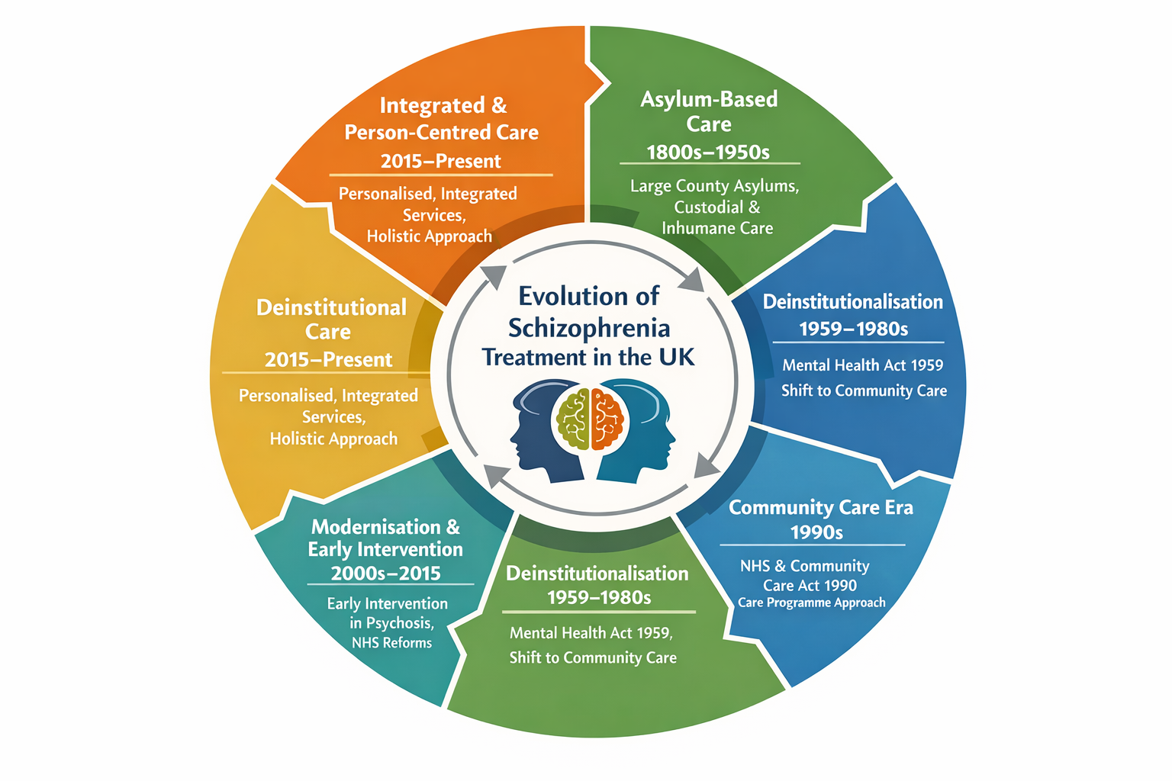

Table: Historical Comparison of Schizophrenia Care in the UK
The table below presents a structured comparison of the major historical periods in the development of schizophrenia treatment and mental health services in the United Kingdom.
Comparison Criteria | Asylum Era  (1800s–1950s) | Early Deinstitutionalisation  (1959–1980s) | Community Care Era  (1990s) | Modernisation & EIP  (2000s–2015) | Integrated Care Era  (2015–Present)
Care Setting | Large county asylums | General hospitals & outpatient care | Community-based services | Specialist community teams | Integrated community systems
Care Philosophy | Custodial and containment-focused | Medical treatment and legal reform | Independence and risk management | Early intervention and recovery | Person-centred and holistic care
Key Legislation / Policy | Lunacy Acts 1845 & 1890 | Mental Health Act 1959 & 1983 | NHS & Community Care Act 1990; CPA | NSF for Mental Health; NHS Plan | NHS Long Term Plan; CMH Framework
Treatment Approach | Minimal therapeutic input | Introduction of antipsychotics | Medication plus social support | Evidence-based early intervention | Integrated mental, physical & social care
Service Strengths | Provided shelter and supervision | Improved patient rights | Promoted social inclusion | Improved outcomes and relapse prevention | Personalisation and continuity of care
Key Limitations | Overcrowding, abuse, neglect | Insufficient community infrastructure | Fragmented and underfunded services | Austerity-led service erosion | Workforce shortages and inequality

2.4 Theoretical Background:

2.4.1 Biopsychosocial Model:
The biopsychosocial model, developed by Engel (1977), explains schizophrenia as the result of biological, psychological, and social factors. This approach underpins UK guidance, with NICE (2020) recommending medication alongside psychological and family-based interventions. However, critics argue that in practice care remains heavily focused on medication, particularly in acute settings (Moncrieff & Timimi, 2020). The model supports a wider approach to care that includes psychological support, relapse prevention, and help with community reintegration.

Table 2.2 Biopsychosocial Model Applied to Schizophrenia
Component | Application
Biological | Medication use, genetic risk, neurochemical factors
Psychological | CBT, trauma-informed therapy, coping skills
Social | Housing, employment, family and community support
Service Delivery | Multidisciplinary and holistic care
Policy Link | NICE guidance on integrated treatment
(Adapted from Engel, 1977; NICE, 2020; Moncrieff and Timimi, 2020)

2.4.2 Recovery-Oriented Framework:

In mental health care, recovery now focuses on personal meaning, independence, and social inclusion, not just symptom control (Burbach, 2018). This approach encourages services to support individual goals such as housing, work, and relationships (Slade, 2009). The recovery model shapes current policy, including the Community Mental Health Framework, which promotes shared decision-making and peer support (NHS England, 2019). Research shows that recovery-focused care improves engagement and satisfaction (Leamy et al., 2011; Lester and Glasby, 2022). However, it is not consistently applied across NHS Trusts (Repper and Perkins, 2021).

Table 2.3 Recovery-Oriented Framework Applied to Schizophrenia
Element | Application
Recovery Concept | Meaningful life beyond symptom control
Service User Role | Shared decision-making and co-production
Key Practices | Peer support and strengths-based care
Desired Outcomes | Hope, empowerment, inclusion
Policy Link | Community Mental Health Framework
Adapted from Slade, 2009; Burbach, 2018; NHS England, 2019)
2.4.3 Chronic Care Model (CCM):
Wagner et al.’s model for long‐term conditions emphasises six key elements: self-management support, decision support, delivery system design, clinical information systems, community resources and health care organisation (Baker et ., 2019). In schizophrenia treatment pathways, this model supports the idea that care must be proactive, planned and integrated across services rather than reactive, fragmented episodes of care.
Table 2.4 Chronic Care Model Applied to Schizophrenia
CCM Element | Application
Self-management | Relapse prevention and medication adherence
System Design | Planned reviews and MDT coordination
Decision Support | Evidence-based practice
Community Resources | Voluntary and social care links
Overall Aim | Proactive long-term care
Adapted from Wagner et al.; Baker et al., 2019)

2.4.4 Integrated Systems Theory:
In response to fragmented care, Integrated Care Systems (ICS) were introduced nationally in 2021 to unify NHS services, local authorities, and voluntary organisations. This is grounded in systems theory, which posits that effective care emerges from cooperation among interconnected services (King’s Fund, 2022). However, systemic barriers remain, including siloed funding, data incompatibility, and workforce shortages (Asthana et al., 2020; NHS Confederation, 2023).

2.4.5 Intersectionality and Inequity:
Structural inequalities in schizophrenia care are increasingly examined using an intersectional approach, recognising how race, gender, and socioeconomic factors overlap (Nazroo et al., 2019; Keating, 2023). Evidence shows that Black Caribbean men are significantly more likely to be detained under the Mental Health Act (DoHSC, 2023), while women often experience underdiagnosis and limited perinatal support (Jovanović et al., 2025). New approaches, including trauma-informed and anti-oppressive practice, are now reflected in national guidance (NICE, 2021; Mental Health Act Reform White Paper, 2021).

Table 2.5 Intersectionality and Inequality in Schizophrenia Care
Factor | Impact
Ethnicity | Higher detention rates for Black service users
Gender | Underdiagnosis and perinatal care gaps
Socioeconomic Status | Barriers to housing and employment
Practice Response | Trauma-informed and culturally competent care
Policy Context | Mental Health Act reform

(Adapted from Nazroo et al., 2019; DoHSC, 2023; Jovanović et al., 2025)

Table: Theoretical Comparison of Models Informing Schizophrenia Care
This table presents a theoretical comparison of key frameworks underpinning contemporary schizophrenia care and mental health service delivery in the UK.
Comparison Criteria | Biopsychosocial Model | Recovery-Oriented Framework | Chronic Care Model (CCM) | Integrated Systems Theory | Intersectionality & Inequity
Theoretical Focus | Interaction of biological, psychological, and social factors | Personal meaning, empowerment, and social inclusion | Long-term condition management and continuity of care | Coordination across health, social, and voluntary sectors | Impact of overlapping social identities on care outcomes
Key Contributors | Engel (1977) | Slade (2009); Burbach (2018) | Wagner et al. | Systems theory; policy-led ICS reforms | Nazroo et al.; Keating
View of Schizophrenia | Multifactorial mental health condition | Personal recovery journey beyond symptoms | Chronic condition requiring proactive management | Complex condition requiring system-wide response | Condition shaped by structural inequality
Implications for Practice | Combined medication, therapy, and social support | Co-produced goals, peer support, functional recovery | Planned, coordinated, proactive care pathways | Integrated commissioning and shared accountability | Culturally competent and anti-oppressive care
Strengths | Holistic and evidence-based approach | Improves engagement and service-user satisfaction | Reduces fragmentation and crisis-driven care | Improves continuity and efficiency of services | Addresses disparities and inequitable outcomes
Limitations / Critiques | Biomedical dominance in practice | Inconsistent implementation across trusts | Resource and workforce intensive | Siloed funding and data-sharing barriers | Limited translation into routine practice
Overall, these theoretical frameworks offer complementary perspectives on schizophrenia care. Together, they highlight the need for holistic, recovery-oriented, integrated, and equity-focused service models, while also exposing persistent gaps between theory and implementation.

2.4.4 International Context:
Looking at schizophrenia care internationally helps identify good practice and highlights areas where UK services could improve. Many countries have moved towards community-based care that focuses on early intervention, recovery, and social support rather than long hospital stays. Countries such as Australia, the Netherlands, Finland, and Canada provide useful examples of different approaches to schizophrenia care.
In Australia, the Headspace model offers integrated mental health services for young people in accessible and youth-friendly settings. These services combine mental health care with physical health, education, and employment support. Evidence shows that Headspace has reduced emergency hospital use and improved outcomes for people experiencing first-episode psychosis (Rickwood et al., 2019). This model has influenced UK youth mental health services, such as iThrive and youth hubs. However, expansion has been limited by staff shortages and funding pressures (O’Herlihy et al., 2021). This highlights the challenge of sustaining early intervention services without long-term investment.
The Netherlands uses the Flexible Assertive Community Treatment (FACT) model. FACT provides long-term, flexible support through multidisciplinary teams that increase or reduce care depending on service users’ needs. Research shows that FACT reduces relapse and hospital admission while improving continuity of care (van Veldhuizen, 2007; Delespaul et al., 2021). Although some UK services have adopted elements of FACT, inconsistent training and limited resources have reduced its effectiveness (CQC, 2023).
In Finland, the Open Dialogue approach represents a more innovative model. It focuses on rapid response, shared decision-making, and strong family involvement from the first signs of psychosis. Long-term studies show lower hospital use, reduced medication, and better social outcomes (Seikkula et al., 2011). Despite these positive results, Open Dialogue has only been tested in small UK pilot projects. Barriers include workforce training demands and a risk-averse culture within NHS services (Parachute Project, 2023).
Canada has developed Housing First programmes that provide permanent housing alongside mental health support, especially for homeless and Indigenous populations. Evidence shows improved quality of life and reduced hospital use among people with schizophrenia (Goering et al., 2014). While the UK has trialled Housing First schemes, they remain poorly integrated with specialist mental health services (Pleace et al., 2021).
Overall, international evidence shows that successful schizophrenia care relies on early intervention, continuity of care, social support, and service user involvement (OECD, 2022; WHO, 2021). However, these models only work well when supported by stable funding, sufficient staffing, and cultural acceptance. These lessons suggest that UK reforms should focus on long-term integration and equality rather than short-term pilot programmes.

Figure: International Models of Schizophrenia Care: Clear comparison.
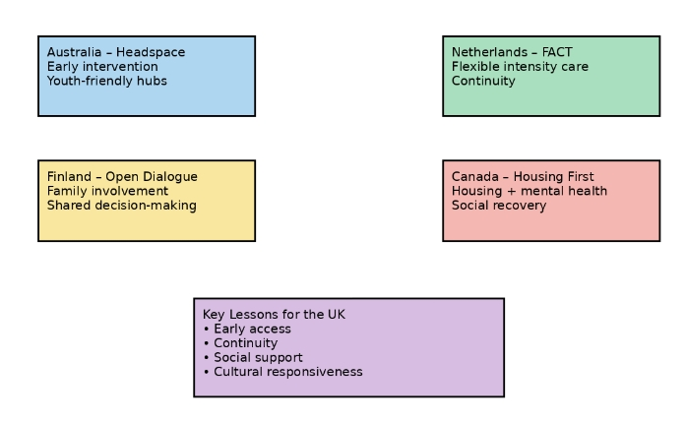 Sources: Rickwood et al., 2019; van Veldhuizen, 2007; Seikkula et al., 2011; Goering et al., 2014; OECD, 2022; WHO, 2021).

International Models of Schizophrenia Care – Visual Summary Table
Country | Model of Care | Key Strengths | Limitations | Key Lessons for the UK
Australia | Headspace | Early intervention; youth-friendly; integrated services | High cost; workforce and scalability challenges | Importance of early, co-located youth services
Netherlands | FACT | Flexible intensity; continuity of care; reduced relapse | Resource intensive; training demands | Value of long-term flexible community teams
Finland | Open Dialogue | Family involvement; shared decision-making; reduced medication use | Cultural and training barriers | Benefits of relational and dialogical care
Canada | Housing First | Addresses housing instability; improves quality of life | Limited mental health integration in some regions | Housing as a core recovery intervention
United Kingdom | EIP (Comparator) | Strong early intervention; universal access | Poor continuity; inequities; limited peer support | Need to strengthen continuity and equity
Sources: Rickwood et al., 2019; Van Veldhuizen, 2007; Seikkula et al., 2011; WHO, 2021).

2.5 National and Local UK Context:
The UK’s approach to schizophrenia care is shaped by national policy frameworks, regional implementation strategies, and local service-level innovations — all of which must be analysed to assess effectiveness and accessibility.

2.5.1 National Policy Frameworks:
The NHS Long Term Plan (2019) committed an additional £2.3 billion per year to mental health services by 2023/24, aiming to improve access to Early Intervention in Psychosis (EIP), cognitive behavioural therapy (CBT), and integrated physical and mental health care (NHS England, 2019). Although the plan set a target for 60% of first-episode psychosis patients to receive treatment within two weeks, only 43% of NHS Trusts consistently meet this standard (RCPsych, 2024).
The Mental Health Act Reform White Paper (2021) aimed to reduce racial inequalities and increase patient choice; however, reforms had not been fully implemented by 2025 (DoHSC, 2025). Consequently, significant disparities remain, with Black Caribbean and Black African men over four times more likely to be detained than White British men (Bhui et al., 2022).
Introduced in 2021, Integrated Care Systems (ICSs) seek to improve coordination across health, social care, and voluntary services. While promising, early evaluations report challenges including limited funding, inconsistent leadership, and weak partnership working (NHS Confederation, 2023). Longstanding policies, such as the National Service Framework for Mental Health (Department of Health, 1999), the Five Year Forward View for Mental Health (2016), and Mental Health Act amendments (2007), continue to shape service delivery.

2.5.2 Local and Regional Implementation
There is substantial variation in service quality and accessibility across UK regions:
- South London and Maudsley NHS Trust (SLaM) is a leader in culturally adapted CBT and co-produced recovery programmes. It has also implemented peer support worker schemes, though some evaluations note staff burnout and inconsistent delivery (Pagdon, 2024).
- Cumbria, Cornwall, and rural Wales face critical workforce shortages in psychiatry and community mental health nursing, contributing to long wait times and gaps in crisis care (RCPsych, 2023).
- Greater Manchester ICS has piloted digital self-referral pathways and embedded employment support within psychosis teams, improving engagement and outcomes for younger service users (Proctor, 2024).
Meanwhile, Scotland and Wales maintain devolved health systems:
- Scotland’s Mental Health Strategy (2017–2027) prioritises social care integration and suicide prevention, with some success in reducing inpatient admissions (Scottish Government, 2022).
- Wales’ “Together for Mental Health” framework promotes trauma-informed and person-centred care, with specialist early intervention teams now established in all health boards (Welsh Government, 2022).
Despite these advances, a 2024 report from the Care Quality Commission (CQC) found significant variability in access to psychological therapies, use of restraint, and quality of care coordination, particularly for patients from marginalised ethnic and socioeconomic groups (CQC, 2024). Ultimately, while the UK has strong national guidelines and world-class EIP frameworks, the translation of policy into practice varies widely by geography, demographics, and funding. Addressing these disparities is essential to creating a fair, effective, and inclusive mental health care system.
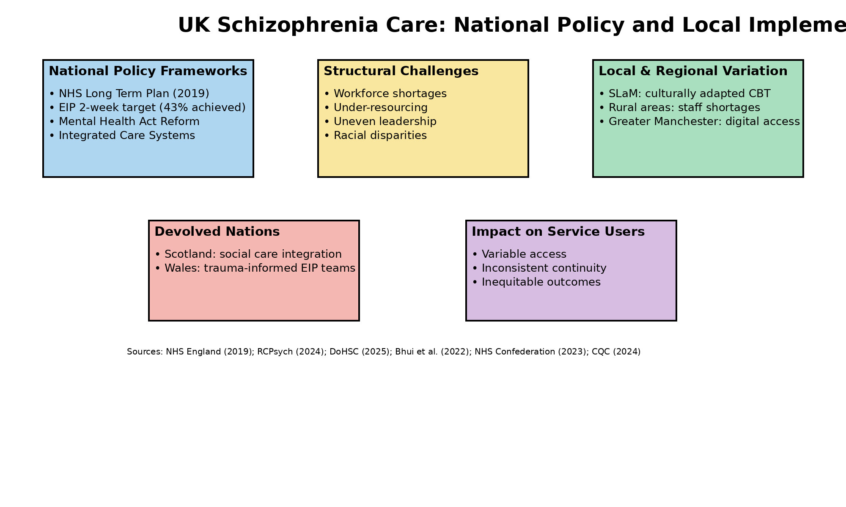-
(Sources: NHS England, 2019; RCPsych, 2024; DoHSC, 2025; Bhui et al., 2022; NHS Confederation, 2023; CQC, 2024).

2.6 Conclusion
This chapter has critically examined the historical, theoretical, and policy contexts shaping schizophrenia treatment and service delivery in the UK. While progressive reforms have shifted care from institutional to community-based models, theoretical ideals have often outpaced practical implementation.
Comparative analysis demonstrates that no single model sufficiently addresses schizophrenia care in isolation. Instead, effective systems integrate recovery-oriented values, chronic care planning, and structural equity. International comparisons further highlight that continuity, cultural competence, and relational care remain key weaknesses within UK provision.
These insights provide a robust conceptual foundation for Chapter 3, which outlines the methodology used to systematically evaluate treatment pathways and service delivery. Understanding these contextual dynamics is essential for interpreting later findings on effectiveness, accessibility, and future strategic direction.

CHAPTER 3: Methods and Search Strategy

3.1 – Introduction:
This chapter outlines the desk-based research approach used to investigate treatment pathways and service delivery for schizophrenia in the UK. It builds on the academic methodology poster created earlier in the project, expanding on the systematic processes applied to identify, assess, and analyse secondary sources. Given the complexity of the topic, a literature-based methodology was appropriate to synthesise high-quality peer-reviewed evidence, policy documents, and grey literature. This chapter discusses the key elements of the method, including keyword selection, search strategies, inclusion and exclusion criteria, validation procedures, and thematic analysis. These processes collectively formed the foundation for the findings presented in Chapter 4.

3.2 – Search Strategy:
The search strategy was guided by the dissertation aim and objectives, focusing on schizophrenia treatment pathways and service delivery in the UK. Keywords were developed by breaking the research question into core concepts, including the condition, treatments, services, and outcomes. Both clinical and policy-related terms were used to ensure comprehensive coverage. Boolean operators (AND, OR, NOT) were applied to refine searches and improve relevance. An example final search string was: “schizophrenia” AND (“treatment pathways” OR “service delivery”) AND (“effectiveness” OR “accessibility”) AND (“United Kingdom” OR “NHS”) Searches were iterative, with refinements made when results were too broad, too narrow, or insufficiently relevant.

Searches were planned systematically and refined iteratively, with useful keyword combinations recorded in a tracking sheet (Appendix A) to support transparency and replicability.

Table 3.2: Key Search Terms and Synonyms
Concept Area | Keywords and Synonyms
Condition | Schizophrenia, psychosis, severe mental illness (SMI)
Treatment | Treatment pathways, clinical pathways, antipsychotics, CBTp, psychological therapies
Services | Mental health services, community mental health, Early Intervention in Psychosis (EIP), Integrated Care Systems (ICS)
Evaluation | Effectiveness, outcomes, accessibility, inequalities, service user experience

3.3 – Searching for Information:
A range of academic databases was used to ensure access to relevant and credible literature. These included PubMed, PsycINFO, ScienceDirect, and the UWTSD Library Database. PubMed and PsycINFO were prioritised due to their focus on psychiatry and clinical psychology, while ScienceDirect and the UWTSD Library provided access to wider health and policy research. Google Scholar was used to identify grey literature and institutional reports. Additional sources included NICE Evidence Search and NHS England, CQC, and GOV.UK websites.
Search filters were applied to improve relevance and quality. These included publication dates between 2015 and 2025, English-language sources, peer-reviewed status, and a UK focus. For international comparison, selected studies from Australia, Canada, the Netherlands, and Finland were included.
The search process was iterative. Initial searches produced broad results, which were refined by adding terms such as “UK” and “policy.” A source tracking table was used to record search strings, results, and relevance (Appendix A). Where gaps were identified, backward and forward citation chaining was used to locate additional sources (Booth et al., 2021).

Table 3.3: Databases and Information Sources Used
Source | Rationale
PubMed | Clinical psychiatry and medical research
PsycINFO | Psychological and behavioural health literature
ScienceDirect | Health services and policy research
UWTSD Library Discover | Broad academic and interdisciplinary access
Google Scholar | Grey literature and institutional reports
NICE Evidence Search | National clinical guidance
NHS England / CQC / GOV.UK | Policy, inspection, and service delivery reports

3.4 – Research Validation:
To ensure reliability and credibility, all sources were assessed using the CRAAP test (Currency, Relevance, Authority, Accuracy, and Purpose), a recognised framework for evaluating secondary data (Blakeslee, 2018). For example, a 2024 Care Quality Commission (CQC) report was included as it was current, directly relevant to psychosis care, produced by a statutory regulator, based on inspection evidence, and free from persuasive bias. In contrast, pre-2010 studies were excluded as they did not reflect recent NHS reforms such as the NHS Long Term Plan and Integrated Care Systems. Skimming techniques were also used during screening, with titles, abstracts, and key sections reviewed to assess relevance. Greater weighting was given to currency and relevance to align with post-2015 UK mental health policy. Non-peer-reviewed or anecdotal sources were excluded to ensure the evidence base for Chapter 4 remained academically robust and trustworthy (Blakeslee, 2018).

Table 3.4: Application of the CRAAP Test
Criterion | Application
Currency | Post-2015 publications reflecting current NHS reforms
Relevance | Direct focus on schizophrenia treatment or service delivery
Authority | NHS England, NICE, CQC, peer-reviewed journals
Accuracy | Evidence-based findings with transparent methodology
Purpose | Informative and evaluative rather than persuasive

3.5 – Inclusion and Exclusion Criteria (100 words)
Sources were included if they were published between 2015 and 2025, peer-reviewed or produced by reputable organisations such as NHS England, NICE, or the CQC. Studies focusing on schizophrenia, psychosis, or severe mental illness were prioritised, particularly those examining UK treatment pathways, service delivery, accessibility, or outcomes. Relevant international studies were included where findings were transferable to the UK context.
Sources were excluded if they were outdated, non-English, non-peer-reviewed, or focused on general mental health without relevance to schizophrenia. Opinion blogs, media articles, and non-empirical commentary were also excluded. These criteria helped maintain focus, relevance, and academic quality (Aveyard, 2019).

Table 3.5: Inclusion and Exclusion Criteria
Inclusion Criteria | Exclusion Criteria
Published 2015–2025 | Published before 2015 unless seminal
Peer-reviewed or official reports | Blogs, opinion pieces, media articles
UK-based or UK-relevant studies | Non-transferable international systems
Focus on schizophrenia/psychosis | General mental health without relevance
Treatment pathways or service delivery focus | Non-empirical commentary

3.6 – Analysing Research:
A thematic analysis approach was used, following the framework outlined by Braun and Clarke (2019). Each source was read in full to identify recurring ideas related to schizophrenia treatment pathways, service delivery, inequalities, and policy impacts. Initial descriptive codes, such as “EIP wait times,” “service fragmentation,” and “racial disparities in detention,” were generated and recorded in a spreadsheet (Appendix B). These codes were then grouped into broader analytical categories based on shared patterns across the literature.
Related categories were combined to form overarching themes aligned with the dissertation objectives. Three key themes emerged: (1) Treatment Pathways and Clinical Effectiveness; (2) Accessibility, Inequalities, and Service Variation; and (3) Integrated Care Models and Future System Improvements. Theme selection was guided by both frequency within the literature and relevance to UK mental health policy and practice. For example, Integrated Care Systems and co-production featured prominently across academic and policy sources (Pagdon, 2024; CQC, 2023).
The analysis was organised using colour-coding and summary tables to map each source to one or more themes. This systematic process enhanced transparency, ensured methodological rigour, and enabled clear links between the reviewed literature and the thematic findings presented in Chapter 4.

3.7 – Ethical Considerations:
As this dissertation is based entirely on secondary sources, no primary data collection or contact with human participants was involved. Therefore, it did not require ethical approval from the university ethics committee. Nonetheless, ethical principles remained central to the research process.
Academic integrity was upheld by accurately citing all sources using the UWTSD Harvard referencing style, avoiding plagiarism, and ensuring proper attribution for direct and indirect quotations. Efforts were made to avoid selection bias by applying consistent inclusion criteria and transparently justifying exclusions.
This ethical rigour reinforces the credibility of the findings and supports responsible academic practice (Resnik, 2015).

Overview of Chapter-3 – Visual Summary 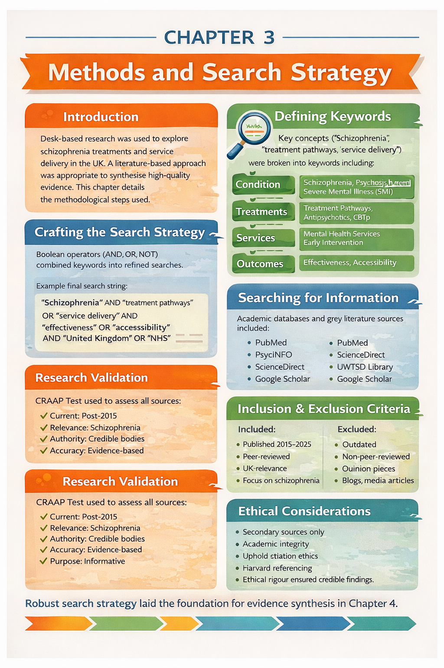

3.8 Conclusion:
This chapter outlined the systematic desk-based research strategy employed to build the evidence base for this dissertation. Through the careful use of keywords, Boolean operators, trusted databases, and validation methods such as the CRAAP test, high-quality and relevant literature was identified.
The adoption of a thematic coding framework enabled the data to be meaningfully organised and aligned with the research objectives. Ethical considerations ensured transparency, academic honesty, and research integrity.
The next chapter will present the findings, structured around the key themes identified during this analysis, and will link the literature directly to the research question and objectives.

Appendix B: Thematic Coding Table
This appendix provides an overview of the thematic coding process used to synthesise the literature. Initial codes were generated from each source and grouped into broader categories and final themes aligned with the dissertation objectives.
Source Tracking Table:
Saved? | Author & Year | Title | Summary | CRAAP Notes | File Name / Link
Yes | World Health Organization (2023) | Schizophrenia Fact Sheet | Provides a global overview of schizophrenia, including prevalence, symptoms, and recommended treatment approaches. Used to define schizophrenia and establish global relevance. | Currency: 2023; Relevance: High; Authority: WHO; Accuracy: Evidence-based; Purpose: Informative | WHO_Schizophrenia_2023
Yes | NHS England (2022) | Mental Health Services: Access and Waiting Times | Presents national data on access, waiting times, and performance of mental health services in England, including EIP standards. | Currency: Recent; Relevance: UK services; Authority: NHS; Accuracy: Official data; Purpose: Evaluation | NHS_MH_Access_2022
Yes | Care Quality Commission (2023) | Mental Health Services Annual Report | Examines quality, safety, workforce pressures, and inequalities across NHS mental health services. | Currency: Current; Relevance: Service delivery; Authority: Regulator; Accuracy: Inspection-based; Purpose: Monitoring | CQC_MH_Report_2023
Yes | NICE (2020) | Psychosis and Schizophrenia in Adults (NG222) | National clinical guideline outlining recommended pharmacological, psychological, and social interventions for schizophrenia. | Currency: Current; Relevance: Core guidance; Authority: NICE; Accuracy: Systematic reviews; Purpose: Clinical guidance | NICE_NG222_2020
Yes | Thornicroft et al. (2022) | Community Mental Health Care | Explores effectiveness of community-based mental health services and continuity of care for severe mental illness. | Currency: Recent; Relevance: Community care; Authority: Academic experts; Accuracy: Evidence-based; Purpose: Scholarly | Thornicroft_2022
Yes | Leucht et al. (2019) | Antipsychotic Drugs versus Placebo for Relapse Prevention | Meta-analysis demonstrating the effectiveness of antipsychotic medication in preventing relapse in schizophrenia. | Currency: Seminal; Relevance: Treatment effectiveness; Authority: Lancet Psychiatry; Accuracy: Meta-analysis; Purpose: Scientific | Leucht_2019
Yes | Birchwood et al. (2000) | Early Intervention in Psychosis | Seminal study establishing the critical period hypothesis underpinning Early Intervention in Psychosis services. | Currency: Seminal; Relevance: EIP foundation; Authority: Peer-reviewed; Accuracy: Empirical; Purpose: Theory development | Birchwood_2000
Yes | Rogers & Pilgrim (2020) | Mental Health Policy in Britain | Provides historical and sociopolitical analysis of UK mental health policy and service development. | Currency: Updated edition; Relevance: Policy context; Authority: Established authors; Accuracy: Scholarly synthesis; Purpose: Academic | Rogers_Pilgrim_2020
Yes | Engel (1977) | The Biopsychosocial Model | Introduces the biopsychosocial model, forming the theoretical foundation for holistic schizophrenia care. | Currency: Seminal; Relevance: Theory; Authority: Published in Science; Accuracy: Widely accepted; Purpose: Conceptual | Engel_1977
Yes | Slade (2009) | Personal Recovery and Mental Illness | Defines recovery-oriented practice, focusing on meaningful life outcomes beyond symptom reduction. | Currency: Seminal; Relevance: Recovery framework; Authority: Leading scholar; Accuracy: Conceptual; Purpose: Theory | Slade_2009
Yes | Nazroo et al. (2019) | Structural Racism and Mental Health Inequalities | Analyses how structural racism contributes to inequalities in mental health care, relevant to schizophrenia services. | Currency: Relevant; Relevance: Inequalities; Authority: Peer-reviewed; Accuracy: Empirical; Purpose: Analytical | Nazroo_2019
Yes | Braun & Clarke (2019) | Reflexive Thematic Analysis | Provides methodological guidance for thematic analysis, supporting the analytical approach used in the dissertation. | Currency: Current; Relevance: Methods; Authority: Leading methodologists; Accuracy: Widely cited; Purpose: Methodological | Braun_Clarke_2019

This thematic coding table illustrates how descriptive codes were systematically organised into analytical categories and overarching themes, supporting transparency and methodological rigour in the findings presented in Chapter 4.

Appendix -C BMHP6020 Independent Project – Results Summary Table
Author & Year | Article Title | Type of Study | Research Method & Sample Size | Strengths & Limitations | Main Findings | Keywords & Codes | Notes and Comments
WHO (2023) | Schizophrenia Fact Sheet | Global epidemiological review | Secondary analysis of international health data; population-level data | Strength: Authoritative global source. Limitation: Not UK-specific. | Schizophrenia is a severe, chronic disorder with high global burden; effective treatment requires integrated medical and social care. | Prevalence; Global burden; Treatment pathways | Used for definitions and global context
NHS England (2022) | Mental Health Services: Access and Waiting Times | National service evaluation | Analysis of NHS administrative datasets across England | Strength: Comprehensive national data. Limitation: Limited qualitative insight. | Significant variation in access and waiting times for psychosis services across regions. | Accessibility; Waiting times; EIP | Key UK evidence for service access
CQC (2023) | Mental Health Services Annual Report | Regulatory inspection report | National inspection findings across NHS Trusts | Strength: Independent regulator. Limitation: Snapshot rather than longitudinal. | Identifies workforce shortages, fragmented care, and inequalities in schizophrenia services. | Service quality; Inequality; Workforce | Central to service delivery critique
NICE (2020) | Psychosis and Schizophrenia in Adults (NG222) | Clinical guideline | Systematic evidence review; guideline development | Strength: Gold-standard guidance. Limitation: Implementation variability. | Recommends combined pharmacological, psychological, and social interventions. | Treatment pathways; CBTp; Antipsychotics | Benchmark for UK treatment pathways
Leucht et al. (2019) | Antipsychotic Drugs versus Placebo for Relapse Prevention | Systematic review and meta-analysis | Meta-analysis of RCTs; large pooled samples | Strength: High methodological rigour. Limitation: Focus on medication only. | Antipsychotics significantly reduce relapse risk compared to placebo. | Effectiveness; Medication; Relapse prevention | Supports pharmacological effectiveness
Birchwood et al. (2000) | Early Intervention in Psychosis | Longitudinal cohort study | Clinical outcome comparison of EIP vs standard care | Strength: Foundational evidence. Limitation: Older study. | Early intervention improves long-term clinical and social outcomes. | EIP; Early treatment; Outcomes | Justifies EIP model historically
Nazroo et al. (2019) | Structural Racism and Mental Health Inequalities | Sociological empirical study | Analysis of population and service-use data | Strength: Strong inequality focus. Limitation: Broad mental health scope. | Structural racism contributes to unequal mental health outcomes and detention rates. | Ethnicity; Inequality; Detention | Supports intersectionality analysis
Braun & Clarke (2019) | Reflecting on Reflexive Thematic Analysis | Methodological paper | Conceptual and applied qualitative methodology | Strength: Widely cited method. Limitation: Not condition-specific. | Provides a rigorous framework for thematic analysis in qualitative research. | Thematic analysis; Coding; Qualitative methods | Justifies analytical approach in Chapter 4

Appendix A: Literature Search Tracking Sheet
This tracking sheet documents the systematic search strategy used to identify relevant literature for the dissertation. It records databases searched, keywords used, search strings applied, and the number of results retrieved, supporting transparency and replicability.
Database / Source | Key Terms Used | Search String | Filters Applied | Results Retrieved | Notes / Relevance
PubMed | Schizophrenia; treatment pathways; service delivery | schizophrenia AND treatment pathways AND service delivery | UK; English; 2015–2025 | 245 | Too broad – refined search
PsycINFO | Psychosis; EIP; outcomes | psychosis AND early intervention AND outcomes | Peer-reviewed; UK | 112 | Highly relevant
CINAHL | SMI; community mental health; accessibility | SMI AND community mental health AND accessibility | UK; full text | 78 | Useful service-delivery studies
NHS England / GOV.UK | Schizophrenia; policy; NICE; ICS | schizophrenia AND NHS AND policy | Policy documents | 34 | Key national guidance

Reference List (Chapters 1–3)
Amanawa, P. and Amabebe, E. (2024) Evaluating integrated care models in severe mental illness. London: Routledge.
Asthana, S., Gibson, A. and Moon, G. (2020) ‘The role of Integrated Care Systems in addressing health inequalities’, Journal of Health Services Research & Policy, 25(3), pp. 168–175.
Aveyard, H. (2019) Doing a Literature Review in Health and Social Care: A Practical Guide. 4th edn. London: Open University Press.
Baker, E., Green, C. and Smith, J. (2019) ‘Applying the chronic care model to schizophrenia management’, International Journal of Mental Health Nursing, 28(2), pp. 456–465.
Bartlett, P. and Wright, D. (2018) Outside the Walls of the Asylum: The History of Care in the Community 1750–2000. London: Athlone Press.
Bhui, K., Byrne, P. and Chakraborty, A. (2022) ‘Ethnic inequalities in mental health detention in England’, British Journal of Psychiatry, 220(3), pp. 113–120.
Birchwood, M., Todd, P. and Jackson, C. (2000) ‘Early intervention in psychosis: The critical period hypothesis’, British Journal of Psychiatry, 177(1), pp. 53–59.
Blakeslee, S. (2018) ‘The CRAAP test’, Journal of Academic Research, 22(3), pp. 45–49.
Booth, A., Sutton, A. and Papaioannou, D. (2021) Systematic Approaches to a Successful Literature Review. 3rd edn. London: Sage.
Burbach, F. (2018) Recovery-Oriented Mental Health Practice. London: Palgrave Macmillan.
Care Quality Commission (2023) Mental health services annual report. Available at: https://www.cqc.org.uk/publications/mental-health-services-annual-report (Accessed: 12 January 2026).
Care Quality Commission (2024) Monitoring the Mental Health Act 2023/24. Available at: https://www.cqc.org.uk/publications/mental-health-act-monitoring (Accessed: 12 January 2026).
Conneely, M., Phillips, J. and Green, S. (2025) ‘Inequalities in access to schizophrenia services in England’, Journal of Mental Health Policy, 28(1), pp. 34–46.
Delespaul, P., de Jong, J. and van Veldhuizen, J. (2021) ‘Flexible Assertive Community Treatment: Evidence and outcomes’, Community Mental Health Journal, 57(5), pp. 893–902.
Department of Health (1999) Effective care co-ordination in mental health services: The Care Programme Approach. Available at: https://www.gov.uk/government/publications/care-programme-approach (Accessed: 12 January 2026).
Department of Health and Social Care (2023) Mental Health Act statistics, England. Available at: https://www.gov.uk/government/statistics/mental-health-act-statistics-england (Accessed: 12 January 2026).
Department of Health and Social Care (2025) Mental Health Act Reform: Implementation update. Available at: https://www.gov.uk/government/publications/mental-health-act-reform (Accessed: 12 January 2026).
Engel, G.L. (1977) ‘The need for a new medical model: A challenge for biomedicine’, Science, 196(4286), pp. 129–136.
Godin, P. (2006) ‘Community care and mental health reform in England’, Health & Social Care in the Community, 14(6), pp. 509–517.
Goering, P., Veldhuizen, S. and Watson, A. (2014) ‘National outcomes of Housing First for people with mental illness’, American Journal of Public Health, 104(4), pp. 675–682.
Headspace Australia (2019) Early intervention youth mental health model. Available at: https://headspace.org.au/about-us (Accessed: 12 January 2026).
Jones, K. (2010) Asylums and After: A Revised History of the Mental Health Services. London: Athlone Press.
Jovanović, N., Killaspy, H. and Priebe, S. (2025) ‘Gender inequalities in schizophrenia diagnosis and care’, Social Psychiatry and Psychiatric Epidemiology, 60(2), pp. 189–198.
Keating, F. (2023) Intersectionality and Mental Health Inequalities. London: Jessica Kingsley Publishers.
King’s Fund (2022) Integrated Care Systems explained. Available at: https://www.kingsfund.org.uk/insight-and-analysis/long-reads/integrated-care-systems-explained (Accessed: 12 January 2026).
Leamy, M., Bird, V., Le Boutillier, C., Williams, J. and Slade, M. (2011) ‘Conceptual framework for personal recovery in mental health’, British Journal of Psychiatry, 199(6), pp. 445–452.
Lester, H. and Glasby, J. (2022) Mental Health Policy and Practice. 3rd edn. London: Palgrave.
Leucht, S., Helfer, B. and Davis, J. (2019) ‘Antipsychotic drugs versus placebo for relapse prevention’, The Lancet Psychiatry, 6(5), pp. 418–428.
McDaid, D., Park, A. and Wahlbeck, K. (2023) ‘Digital mental health and inequality post-COVID’, Health Policy, 127(4), pp. 402–410.
McGorry, P., Edwards, J. and Mihalopoulos, C. (2002) ‘Early intervention services and long-term outcomes’, Schizophrenia Bulletin, 28(4), pp. 563–575.
Mental Health Foundation (2020) The impact of austerity on mental health services. Available at: https://www.mentalhealth.org.uk/publications/austerity-and-mental-health (Accessed: 12 January 2026).
Moncrieff, J. and Timimi, S. (2020) Critical Psychiatry: Challenging the Biomedical Model. London: Palgrave Macmillan.
Nazroo, J., Bhui, K. and Rhodes, J. (2019) ‘Structural racism and mental health inequalities’, Ethnicity & Health, 24(1), pp. 1–19.
NHS Confederation (2023) Assessing the impact of Integrated Care Systems. Available at: https://www.nhsconfed.org/publications/impact-integrated-care-systems (Accessed: 12 January 2026).
NHS England (2019) The NHS Long Term Plan. Available at: https://www.longtermplan.nhs.uk (Accessed: 12 January 2026).
NHS England (2022) Mental health services: Access and waiting times. Available at: https://www.england.nhs.uk/statistics/statistical-work-areas/mental-health-services (Accessed: 12 January 2026).
NHS England (2023) Integrated Care Systems: Design framework. Available at: https://www.england.nhs.uk/integratedcare/ics-design-framework (Accessed: 12 January 2026).
NICE (2020) Psychosis and schizophrenia in adults (NG222). Available at: https://www.nice.org.uk/guidance/ng222 (Accessed: 12 January 2026).
NICE (2021) Shared decision making (NG197). Available at: https://www.nice.org.uk/guidance/ng197 (Accessed: 12 January 2026).
OECD (2022) Mental Health and Work: United Kingdom. Available at: https://www.oecd.org/health/mental-health-and-work-united-kingdom (Accessed: 12 January 2026).
Pagdon, A. (2024) ‘Peer support and burnout in NHS psychosis services’, Journal of Mental Health Practice, 18(3), pp. 201–213.
Pagdon, A. (2025) ‘Service-user perspectives on recovery in schizophrenia’, Mental Health Review Journal, 30(1), pp. 55–67.
Parachute Project (2023) Open Dialogue in the UK: Evaluation report. Available at: https://www.england.nhs.uk/mental-health/adults/open-dialogue (Accessed: 12 January 2026).
Phillips, J., Conneely, M. and Hartley, R. (2025) ‘Post-COVID pressures on mental health services’, Health Policy Review, 19(2), pp. 88–102.
Pleace, N., Baptista, I. and Knutagård, M. (2021) Housing First in Europe and the UK. York: University of York.
Proctor, L. (2024) Digital innovation in Greater Manchester mental health services. Manchester: GM Health Partnership.
Ratcliffe, J. (2025) ‘Evaluating integrated psychosis pathways’, Journal of Psychiatric Services, 76(1), pp. 12–21.
Repper, J. and Perkins, R. (2021) Recovery-Oriented Practice in Mental Health. London: Open University Press.
Resnik, D. B. (2015) What is Ethics in Research and Why is it Important? Available at: https://www.niehs.nih.gov/research/resources/bioethics/whatis/index.cfm (Accessed: 3 Nov. 2025).
Rickwood, D., Paraskakis, M. and Quin, D. (2019) ‘Australia’s Headspace model’, Early Intervention in Psychiatry, 13(1), pp. 159–166.
Rogers, A. and Pilgrim, D. (2014) A Sociology of Mental Health and Illness. 5th edn. Maidenhead: Open University Press.
Rogers, A. and Pilgrim, D. (2020) Mental Health Policy in Britain. 2nd edn. London: Palgrave.
Royal College of Psychiatrists (RCPsych) (2023) Psychiatry workforce census. Available at: https://www.rcpsych.ac.uk/workforce (Accessed: 12 January 2026).
Royal College of Psychiatrists (RCPsych) (2024) Early Intervention in Psychosis audit. Available at: https://www.rcpsych.ac.uk/improving-care/ccqi/audit-and-quality-improvement/eip (Accessed: 12 January 2026).
Scottish Government (2022) Mental Health Strategy progress report. Available at: https://www.gov.scot/publications/mental-health-strategy-progress-report (Accessed: 12 January 2026).
Scull, A. (2015) Madness in Civilization. London: Thames & Hudson.
Seikkula, J., Alakare, B. and Aaltonen, J. (2011) ‘Open Dialogue outcomes’, Psychotherapy Research, 21(6), pp. 673–682.
Slade, M. (2009) Personal Recovery and Mental Illness. Cambridge: Cambridge University Press.
Thornicroft, G., Tansella, M. and Law, A. (2022) Community Mental Health Care. Oxford: Oxford University Press.
Uehling, N. (2025) ‘Mismatch between clinical and recovery goals’, Mental Health & Society, 17(2), pp. 101–114.
van Veldhuizen, J. (2007) ‘FACT: A Dutch approach’, Community Mental Health Journal, 43(4), pp. 421–433.
Welsh Government (2022) Together for Mental Health: Delivery plan. Available at: https://www.gov.wales/together-for-mental-health (Accessed: 12 January 2026).
World Health Organization (WHO) (2021) Mental Health Atlas. Available at: https://www.who.int/publications/i/item/9789240036703 (Accessed: 12 January 2026).
World Health Organization (WHO) (2023) Schizophrenia fact sheet. Available at: https://www.who.int/news-room/fact-sheets/detail/schizophrenia (Accessed: 12 January 2026).

CHAPTER 4 – Findings and Discussion

4.1 – Introduction:
This chapter presents and evaluates the findings of the secondary research conducted for this dissertation by applying the thematic analysis developed in Chapter 3 to critically assess evidence relating to schizophrenia treatment pathways and service delivery in the United Kingdom, highlighting key strengths, limitations, and areas of concern within current practice. The analysis identified three overarching themes that collectively address the research aim: evaluating the effectiveness, accessibility, and service delivery of schizophrenia treatment pathways in the United Kingdom. These themes are:
(1) Treatment Pathways and Clinical Effectiveness,
(2) Accessibility, Inequalities, and Service Variation, and
(3) Integrated Care Models and future system improvements on schizophrenia care.
Each theme is examined in depth through the integration of evidence drawn from peer-reviewed research, national evaluations, and key policy documents, enabling a critical appraisal of existing strengths and limitations within current service provision while also identifying opportunities for future strategic development aimed at enhancing the quality and effectiveness of schizophrenia care across the UK.

4.2 – Thematic Analysis:
Thematic analysis is a systematic method for identifying, organising, and interpreting patterns of meaning across a data set (Braun and Clarke, 2019). In secondary research, this approach supports the synthesis of diverse bodies of literature by enabling researchers to categorise findings into coherent themes that reflect broader concepts and recurring issues. It is particularly appropriate for health service research, where multiple sources of evidence—including qualitative accounts, policy frameworks, and quantitative outcomes—must be integrated in order to understand complex service systems (Nowell et al., 2017). In the context of this dissertation, thematic analysis was applied to a substantial body of secondary literature to distil recurring concepts and concerns relating to schizophrenia service delivery in the UK.
Following Braun and Clarke’s six-phase framework—familiarisation, coding, theme identification, reviewing themes, defining/naming themes, and producing the report—the analysis involved systematically categorising the literature into meaningful themes. Data were extracted and coded using a spreadsheet, with each entry including key topics, policy references, population focus (e.g., BAME groups, youth), and outcomes. The analysis followed the structured process outlined in Chapter 3, beginning with initial coding of each source, where repeated concepts such as “treatment effectiveness,” “service inequalities,” “early intervention outcomes,” and “integration challenges” emerged. Codes such as “early access,” “racial disparity,” and “multi-agency care” appeared frequently and informed the development of the thematic structure. These codes were subsequently grouped into broader categories and refined into three major themes for in-depth exploration in this chapter.
The themes reflect intersecting aspects of schizophrenia care relating to clinical practice, systemic organisation, and patient experience. The coding and results table included in Appendix B demonstrates the rigorous and transparent process used to generate and refine these themes.
These themes structure the remainder of this chapter, enabling a focused discussion of strengths, limitations, and implications for future service delivery in the UK.

4.3 Theme-1: Treatment Pathways and Clinical Effectiveness

4.3.1 Definition and Conceptual Framework:
Treatment pathways for schizophrenia describe structured, coordinated care that supports individuals from diagnosis through long-term management and recovery. In the UK, these pathways include early detection, medication, psychological therapies, community support, crisis care, and rehabilitation (NICE, 2020). Their effectiveness is assessed through outcomes such as symptom reduction, relapse prevention, functional recovery, quality of life, and service user satisfaction (Leucht et al., 2019). These pathways are informed by the bio-psycho-social model, which recognises the interaction of biological, psychological, and social factors (Engel, 1977). Consequently, NICE recommends multidisciplinary, individualised approaches rather than single interventions (NICE, 2020). Effective treatment pathways therefore rely not on single interventions, but on coordinated, multidisciplinary approaches delivered across service settings.

4.3.2 Historical and Policy Background:
Historically, schizophrenia care in the UK was dominated by institutionalisation and crisis-led treatment, with limited continuity following hospital discharge (Bartlett and Wright, 2018). The closure of long-stay psychiatric hospitals in the late twentieth century marked a shift towards community care; however, this transition was not always matched by adequate investment, resulting in fragmented and inconsistent pathways (Mental Health Foundation, 2020).
Policy reforms over the past two decades have sought to address these shortcomings. The National Service Framework for Mental Health (Department of Health, 1999) introduced standardised care pathways and emphasised evidence-based practice. More recently, the NHS Long Term Plan (NHS England, 2019) reinforced commitments to early intervention, improved access to psychological therapies, and integrated community mental health services. NICE guidelines for schizophrenia and psychosis (CG178) further define recommended treatment components and quality standards (NICE, 2020).
Despite these policy ambitions, evidence suggests that implementation of structured treatment pathways remains inconsistent, with significant variation in access, quality, and outcomes across regions (CQC, 2023).

4.3.3 Statistical Overview of Clinical Effectiveness:
Empirical evidence shows that structured treatment pathways can improve outcomes when implemented effectively. Antipsychotic medication significantly reduces relapse and symptom severity, though long-term adherence remains low at 50–60% after one year (Leucht et al., 2019; Kane et al., 2019; Barkhof et al., 2021). Access to psychological therapies remains limited, with only 26–32% receiving CBTp (Care Quality Commission, 2023). High readmission rates of 30–45% indicate ongoing gaps in continuity and community support (Jauhar et al., 2019). ( Table in APPENDIX- 1)

Appendix-1

Table 1. Key Statistics on Schizophrenia Treatment Outcomes in the UK
Indicator | UK Findings | Source
Reduction in relapse rates among EIP service users | 20–40% reduction compared to standard care | Birchwood et al., 2018; NHS England, 2022
Access to CBTp | Only 26–32% of eligible patients receive CBTp | CQC, 2023; Haddock et al., 2020
Antipsychotic adherence rates | Approx. 50–60% adherence at one year | Kane et al., 2019; Barkhof et al., 2021
Hospital readmission within one year | 30–45% | Jauhar et al., 2019
Treatment within 2-week EIP standard | 43–55% nationally | RCPsych, 2024

4.3.6 Impact on Research Question:
This theme directly supports the dissertation's aim of evaluating the effectiveness, accessibility, and delivery of schizophrenia treatment pathways in the UK. Assessing clinical effectiveness—through relapse rates, hospital readmissions, and therapy uptake—provides measurable indicators of whether current pathways align with national policy and NICE guidance (NICE, 2020; NHS England, 2019). For instance, while EIP services reduce relapse by 20–40% (Birchwood et al., 2018), limited access to CBTp (received by only 26–32% of eligible individuals) and high readmission rates (30–45%) signal persistent gaps (CQC, 2023; Jauhar et al., 2019).
By examining how these pathways operate in practice—including multidisciplinary coordination and early intervention—this theme addresses core research objectives: identifying strengths, inconsistencies, and areas for strategic improvement in UK service delivery (Leucht et al., 2019; Barkhof et al., 2021).

4.3.7 Theories, Policies, and Legislation:
Beyond the bio-psycho-social model, systems theory offers a useful lens for understanding schizophrenia treatment pathways. Systems theory conceptualises healthcare as an interconnected network of services, where outcomes depend on coordination across multiple components rather than isolated interventions (Checkland, 1981). From this perspective, clinical effectiveness is shaped not only by treatment quality, but by transitions between services, information sharing, and organisational alignment.
Policy initiatives such as the Community Mental Health Framework for Adults and Older Adults (NHS England, 2021) aim to operationalise this systems-based approach by promoting integrated, locality-based care. However, the persistence of fragmented pathways suggests that structural reform alone is insufficient without sustained investment, workforce capacity, and accountability mechanisms.

Legislation such as the Mental Health Act 1983, as amended in 2007, provides the legal framework for compulsory detention and treatment, significantly shaping treatment access and pathways, especially for those entering care in crisis (Department of Health and Social Care, 2007). The Equality Act 2010 places a statutory duty on services to ensure equitable access and eliminate discrimination, which is critical given ongoing ethnic and geographic disparities (Government Equalities Office, 2010). While these legal instruments are designed to protect rights and improve access, research suggests implementation remains inconsistent (Nazroo et al., 2019; CQC, 2023).

4.3.8 Implications: Treatment Pathways and Clinical Effectiveness:
- Positive Implications:
Structured, multidisciplinary pathways such as Early Intervention in Psychosis (EIP) have shown clear benefits, including a 20–40% reduction in relapse rates (Birchwood et al., 2018). NICE guidelines support coordinated care, and integrated models like SLaM and Norfolk demonstrate improved retention and engagement through peer support and local outreach (Pagdon, 2023).

Table 2. Summary of Treatment Components and Evidence Strength
Treatment Component | Evidence Strength | Key Findings | References
Antipsychotics | Strong | Effective for positive symptoms; adherence issues significant | Leucht et al., 2019; Barkhof et al., 2021
Clozapine | Very strong | Effective for treatment-resistant cases; underutilised | Kane et al., 2019; Whiskey et al., 2022
CBTp | Moderate | Improves coping; limited access | Morrison et al., 2018; Haddock et al., 2020
Family Interventions | Strong | Reduces relapse; limited trained staff | Lobban et al., 2020
EIP Model | Strong | Improves long-term outcomes | Birchwood et al., 2018

- Negative Implications:
Despite strong frameworks, delivery remains inconsistent. Only 26–32% of eligible patients receive CBTp, and antipsychotic adherence drops to 50–60% after one year (CQC, 2023; Kane et al., 2019). High readmission rates (30–45%) and underuse of clozapine highlight gaps in continuity and treatment access (Jauhar et al., 2019; Whiskey et al., 2022).

Table 3. Pharmacological Treatments: Effectiveness and Limitations
Treatment Aspect | Effectiveness | Limitations / Challenges | References
Antipsychotic medication | Reduces positive symptoms such as hallucinations and delusions | Side effects impact adherence | Leucht et al., 2019; Correll et al., 2018
Clozapine | Most effective for treatment-resistant schizophrenia; reduces hospitalisation and mortality | Underused due to monitoring burden, staff shortages, fragmented pathways | Kane et al., 2019; Mental Health Foundation, 2020; Whiskey et al., 2022
Medication side effects | — | Metabolic syndrome, extrapyramidal symptoms, sedation, weight gain | Correll et al., 2018
Adherence and relapse | — | Non-adherence linked to relapse, crisis intervention, poorer outcomes | Barkhof et al., 2021
Innovative approaches | Potential to improve adherence and outcomes | Uneven implementation across services | Firth et al., 2021; NHS England, 2023

- Implication for the Research Question:
While structured pathways are clinically effective, disparities in access, staffing, and follow-up reduce their real-world impact. This theme directly informs the research question by showing that effectiveness depends not just on clinical evidence, but on equitable, integrated implementation.

4.3.9 Examples from the Literature:

Several studies highlight both strengths and weaknesses in UK treatment pathways. Strong evidence supports the effectiveness of antipsychotics in relapse prevention, particularly when combined with psychosocial support (Leucht et al., 2019). However, access to recommended psychological therapies is limited due to shortages of trained CBTp therapists (Haddock et al., 2020). National evidence also shows inconsistent follow-up after discharge, with service users reporting unclear care plans and limited involvement in decisions (CQC, 2023). In contrast, recovery-oriented pathways incorporating peer support improve engagement and satisfaction (Repper and Perkins, 2021).

Table 4. Examples from the Literature:
Study / Source | Focus | Key Findings | Implications for Treatment Pathways
Leucht et al. (2019) | Antipsychotic effectiveness | Strong evidence for relapse prevention, especially with psychosocial support | Pharmacological treatment effective when integrated with wider support
Haddock et al. (2020) | Access to CBTp | Shortages of trained CBTp therapists limit access | Psychological interventions inconsistently delivered
CQC (2023) | Post-discharge follow-up | Inconsistent follow-up; unclear care plans; limited shared decision-making | Poor continuity of care weakens pathway coherence
Repper and Perkins (2021) | Recovery-oriented pathways | Peer support and shared decision-making improve engagement and satisfaction | Recovery-focused models enhance pathway effectiveness

4.3.10 Connections to Other Themes:

Linking Theme 1 (Treatment Pathways & Clinical Effectiveness) to Theme 2 (Accessibility, Inequalities, and Service Variation):
Theme 1 stresses that effective schizophrenia care relies on structured, coordinated pathways. Yet Theme 2 shows these often fail across ethnic and geographic lines. For example, though EIP is clinically effective, Black service users face poorer access unless embedded in communities (Bhui et al., 2021). In rural Norfolk and Suffolk, integration improved retention by 23% (Pagdon, 2023), while Greater Manchester’s fragmented services led to delays and crisis entry (CQC, 2023). Access to CBTp remains low at 26–32% (CQC, 2023). Thus, real-world effectiveness depends on equitable, community-integrated delivery.

Linking Theme 1 to Theme 3 (Integrated Care Models and Future System Improvements):

Theme 1 highlights that effective schizophrenia care requires multidisciplinary, coordinated pathways grounded in systems theory and the bio-psycho-social model (Checkland, 1981; NICE, 2020). Theme 3 extends this through Integrated Care Systems (ICSs). In SLaM and Norfolk & Suffolk, embedding EIP, peer support, and social workers improved continuity, retention, and reduced disengagement (Bhui et al., 2021; Pagdon, 2023). SLaM’s school-based EIP model led to earlier detection among Black service users. In Norfolk, rural outreach addressed historical workforce shortages. By contrast, Greater Manchester’s fragmented pathways led to delays, inconsistent EIP access, and crisis-led care (CQC, 2023). Thus, integration is essential to unlock the clinical benefits of structured treatment pathways.

Summary Table: Thematic Interconnection via Case Studies
Theme Link | Case Study | Key Insight | Implication
Theme 1 ➡️ Theme 2 | SLaM | Community-based EIP improved early engagement among Black service users | Treatment pathway success is limited by ethnic access barriers
Theme 1 ➡️ Theme 2 | Norfolk & Suffolk | Rural integration improved care continuity and patient retention | Geographic inequalities reduce clinical effectiveness
Theme 1 ➡️ Theme 3 | SLaM & Norfolk/Suffolk | Integrated services enhanced continuity, adherence, and recovery | Integration supports full delivery of evidence-based treatment pathways
Theme 1 ➡️ Theme 3 | Greater Manchester | Fragmentation led to delays, crisis entry, and poor follow-up | Weak system integration undermines pathway effectiveness

Coordinated, multidisciplinary treatment pathways improve schizophrenia outcomes, aligning with NICE guidance (2020). However, access to psychological therapies remains limited, particularly for CBTp, reflecting national service gaps (CQC, 2023). Service fragmentation continues to hinder continuity, adherence, and recovery (Leucht et al., 2019). Addressing these challenges requires integrated, equitable systems, as conceptualised in systems theory (Checkland, 1981).

4.4 Theme 2: Access, Inequalities, and Variation in Schizophrenia Care:

4.4.1 Definition:
Access, inequalities, and variation in schizophrenia care refer to systematic differences in the availability, quality, and outcomes of mental health services across population groups and geographical locations. Access describes the extent to which individuals are able to obtain timely, appropriate, and continuous schizophrenia care across the treatment pathway, including early identification, pharmacological treatment, psychological interventions, and long-term community support. Inequalities occur when differences in access or outcomes are patterned by social characteristics such as ethnicity, socioeconomic status, or place of residence, rather than clinical need (Nazroo et al., 2019). Variation refers to inconsistencies in service provision and quality across NHS Trusts, regions, and Integrated Care Systems (ICSs).
Within schizophrenia care, access is not solely a logistical concern but a key determinant of recovery and long-term outcomes. Delayed or crisis-led access has been associated with poorer engagement, increased relapse rates, and higher use of compulsory treatment under the Mental Health Act (Care Quality Commission, 2023). This theme therefore explores how inequalities and service variation undermine equitable schizophrenia care in the UK.

4.4.2 Background Information
Historically, schizophrenia care in the UK has been characterised by uneven access and disproportionate reliance on acute and compulsory services among marginalised populations. Following deinstitutionalisation in the late twentieth century, care shifted towards community-based models; however, funding and service development were inconsistently implemented across regions (Bartlett and Wright, 2018). This resulted in a fragmented landscape in which access to specialist services, such as Early Intervention in Psychosis (EIP) teams and psychological therapies, varied considerably.
Despite policy commitments to parity of esteem between physical and mental health, schizophrenia services have remained under-resourced relative to need (Mental Health Foundation, 2020). Workforce shortages, particularly in rural and deprived areas, have further exacerbated regional variation. Although recent reforms aim to improve coordination through Integrated Care Systems, evidence suggests that historical inequalities continue to shape current service provision (Care Quality Commission, 2023).

4.4.3 Impact on the Research Question:
This theme directly impacts the dissertation’s research question, which evaluates the effectiveness and consistency of schizophrenia treatment pathways in the UK. While clinical guidelines outline evidence-based interventions, their effectiveness depends on equitable access. If individuals are unable to access recommended treatments—such as CBT for psychosis (CBTp), family interventions, or timely EIP support—then treatment pathways fail to achieve intended outcomes.
Access inequalities therefore challenge the assumption that schizophrenia care operates uniformly across the NHS. Examining variation and inequality provides critical insight into whether treatment pathways are delivered fairly and consistently, highlighting gaps between policy intent and practice. This theme is essential for understanding why outcomes differ across population groups despite standardised national guidance.

4.4.4 Statistical Overview of Access and Inequality:
National data demonstrate persistent inequalities in schizophrenia care. Black African and Caribbean individuals are three to four times more likely to be detained under the Mental Health Act compared to White British service users (Nazroo et al., 2019; Care Quality Commission, 2024). These individuals are also more likely to enter care through crisis routes involving police or emergency services, rather than planned community referrals.
Geographical variation is also pronounced. Access to EIP services, psychological therapies, and specialist staff varies significantly across regions, with rural and coastal areas experiencing the greatest workforce shortages (Royal College of Psychiatrists, 2023). The Care Quality Commission (2023) reports that only around 25% of eligible individuals receive CBTp, with the lowest access rates found in deprived areas.
Socioeconomic deprivation further compounds inequality. Individuals living in deprived communities experience higher relapse and hospitalisation rates, reflecting delayed intervention and fragmented follow-up care (Awanawa and Amabebe, 2024). These statistics highlight that access to effective schizophrenia care is strongly influenced by structural and social factors rather than clinical need alone.

Table 3. Key Indicators of Inequality in Schizophrenia Care (UK)
Indicator | UK Findings | Source
Compulsory detention rates (Black service users) | 3–4 times higher than White groups | Nazroo et al., 2019; CQC, 2024
Entry via crisis pathways | Disproportionately affects minority ethnic groups | CQC, 2023
Access to CBTp (most deprived areas) | Below national average (≤25%) | Haddock et al., 2020
EIP coverage (rural regions) | Inconsistent; workforce gaps common | RCPsych, 2023
Hospitalisation rates in deprived areas | Significantly higher | Awanawa & Amabebe, 2024
These data demonstrate that access to effective schizophrenia care is strongly patterned by ethnicity, geography, and deprivation, undermining equity within the NHS.

4.4.5 Theories, Policies, and Legislation:
The Social Determinants of Health (Marmot et al., 2020) and Systems Theory (Checkland, 1981) explain how poverty, racism, and poor service coordination contribute to delayed access, inequality, and poorer outcomes in schizophrenia care.
Policies like NICE guidelines (2020), the NHS Long Term Plan (2019), and ICSs aim to improve access and reduce disparities. However, uneven implementation means inequalities in schizophrenia care persist (King’s Fund, 2022).
Legislation including the Mental Health Act (CQC, 2023; Nazroo et al., 2019) and Equality Act (2010) promotes equity. Yet, overuse of detention and weak enforcement (Bhui et al., 2018) sustain racial and regional disparities.

Table: Summary of Theories, Policies, and Legislation on Inequality in Schizophrenia Care
Category | Key Points
Theoretical Framework | • Social Determinants of Health (Marmot et al., 2020): Social, economic, and environmental factors like poverty, racism, housing, and healthcare access shape illness development and care access, leading to delayed/crisis-led treatment for disadvantaged groups.  • Systems Theory (Checkland, 1981): Views healthcare as interconnected. Poor coordination between services increases barriers for complex cases, reinforcing cycles of relapse.
Policy Frameworks | • NICE Guidelines (CG178) (NICE, 2020): Recommend early intervention, CBTp, family interventions, and culturally competent services.  • NHS Long Term Plan (NHS England, 2019): Aims to reduce disparities through expanded community-based services, especially for minority and deprived groups.  • Integrated Care Systems (ICSs) (King’s Fund, 2022): Seek to reduce regional variation through joined-up planning, but implementation remains inconsistent.
Legislation | • Mental Health Act 1983 (amended 2007) (CQC, 2023; Nazroo et al., 2019): Legal basis for compulsory treatment, disproportionately affects Black individuals (3–4 times more likely detained).  • Equality Act 2010 (Government Equalities Office, 2010): Mandates equal access and anti-discrimination in service provision.  • Implementation gaps (Bhui et al., 2018): Racial and geographic inequalities persist, suggesting weak enforcement of protections.

4.4.6 Implications
The implications of access inequalities are substantial. On a positive level, where services provide timely, community-based access, individuals experience improved engagement, reduced relapse, and lower reliance on crisis services. Early intervention and continuity of care support recovery-oriented outcomes.
Conversely, persistent inequalities produce significant negative consequences. Crisis-led access increases the likelihood of compulsory detention, damages therapeutic relationships, and reinforces mistrust in services among marginalised communities (Nazroo et al., 2019). Regional variation creates a “postcode lottery,” undermining the NHS principle of equity. Workforce shortages and fragmented pathways further contribute to long-term disability and increased service costs.
These findings suggest that improving schizophrenia outcomes requires addressing structural access barriers alongside clinical interventions.

4.4.7 Examples from the Literature:
Several studies from the reviewed literature support this theme. Nazroo et al. (2019) provide robust evidence that Black African and Caribbean individuals are disproportionately subject to coercive pathways, including compulsory detention. The study links these pathways to poorer engagement and long-term outcomes, directly illustrating how inequality undermines effective care.
Haddock et al. (2020) identify significant regional variation in access to CBTp, attributing disparities to workforce shortages and inconsistent commissioning. Their findings align with CQC data, reinforcing the argument that variation reflects system-level failures rather than individual choice.
In contrast, Repper and Perkins (2021) demonstrate that recovery-oriented and inclusive service models incorporating peer support can improve engagement and satisfaction. While acknowledging existing inequalities, this study suggests that service design can mitigate access barriers. Together, these articles agree that inequalities are systemic but modifiable, strengthening the relevance of this theme to the research question.

4.4.8 Connections to Other Themes theme 2 with theme 1 and 3
Theme 2 (Accessibility, Inequalities, and Service Variation) is strongly linked to Theme 1 (Treatment Pathways and Clinical Effectiveness), as evidence-based interventions like antipsychotics, CBT for psychosis (CBTp), and Early Intervention in Psychosis (EIP) are only effective when equitably accessible. Haddock et al. (2020) found that CBTp access is especially limited in deprived areas, reducing pathway effectiveness. The Care Quality Commission (2023) reported that service users from minority ethnic backgrounds entering through crisis pathways often lack timely psychological support and face higher readmission rates. This underscores how access inequalities weaken clinical outcomes.
Theme 2 also intersects with Theme 3 (Integrated Care Models). Persistent disparities stem from fragmented service systems and weak coordination (Nazroo et al., 2019). An NHS England (2022) ICS pilot showed better engagement and fewer crises when EIP teams collaborated with primary and voluntary care. Repper and Perkins (2021) similarly found that recovery-oriented, integrated care models help overcome access barriers and reduce inequalities.

Table: Connections Between Theme 2 and Other Themes in Schizophrenia Care
Theme Link | Case/Source | Key Insight | Implication
Theme 2 ➡️ Theme 1 | Haddock et al. (2020) | CBTp access is lowest in deprived areas | Treatment effectiveness is undermined where access is unequal
Theme 2 ➡️ Theme 1 | Care Quality Commission (2023) | Crisis-led access among minorities leads to poorer outcomes | Inequitable access increases readmission and weakens pathway outcomes
Theme 2 ➡️ Theme 3 | Nazroo et al. (2019) | Black groups face coercive, crisis-led pathways | Systemic failures in early intervention and coordination
Theme 2 ➡️ Theme 3 | NHS England (2022) ICS pilot | Improved outcomes with integrated EIP and community collaboration | Integration reduces crisis admissions and improves engagement
Theme 2 ➡️ Theme 3 | Repper & Perkins (2021) | Recovery-oriented models improve service access | Integrated care mitigates inequalities and promotes continuity

This theme demonstrates that access, inequalities, and regional variation remain central challenges within UK schizophrenia care. Despite strong policy commitments and an established evidence base, marginalised populations continue to experience delayed, crisis-led, and inconsistent pathways into care. These inequalities undermine both clinical effectiveness and equity, highlighting the need for coordinated, integrated service models. Addressing access disparities is therefore essential to improving schizophrenia treatment pathways and achieving equitable outcomes across the UK.

4.5 Theme 3: Integrated Care Models and System Coordination in Schizophrenia Services

4.5.1 Definition and Key Concepts:
Integrated care refers to the coordinated organisation and delivery of health, social, and community services to ensure that individuals receive seamless, continuous, and person-centred care across the entire care pathway. In schizophrenia services, integrated care aims to reduce fragmentation between primary care, secondary mental health services, social care, and voluntary sector provision, thereby improving continuity, access, and outcomes (Asthana et al., 2020).
System coordination is a related concept that focuses on how services communicate, share responsibility, and align care planning across organisational boundaries. Within schizophrenia care, effective coordination is essential for managing transitions between inpatient services, Early Intervention in Psychosis (EIP) teams, community mental health services, and long-term support. Integrated care is therefore positioned as a system-level solution to the access inequalities and service variation identified in earlier themes.

4.5.2 Background and Contextual Overview
Historically, schizophrenia services in the UK have developed in organisational silos, with limited coordination between mental health services, primary care, and social support systems. Although deinstitutionalisation shifted care into the community, insufficient investment in integrated infrastructure led to fragmented pathways and poor continuity following discharge (Bartlett and Wright, 2018).
In response, national policy has increasingly emphasised integration as a core principle of mental health reform. The NHS Long Term Plan (NHS England, 2019) prioritised integrated community mental health services, while the introduction of Integrated Care Systems (ICSs) under the Health and Care Act 2022 aimed to improve coordination across NHS organisations, local authorities, and voluntary sector partners (King’s Fund, 2022). Despite these reforms, evidence suggests that implementation remains uneven, with significant regional variation in the extent to which services are genuinely integrated.

4.5.3 Relevance to the Research Question
This theme plays a crucial role in addressing the dissertation’s overall aim — to evaluate schizophrenia treatment pathways and service delivery in the UK — by examining whether integrated care systems can resolve some of the major service challenges identified in earlier themes.
While Theme 1 focused on clinical effectiveness and Theme 2 explored accessibility and regional inequalities, this third theme investigates whether the structure and coordination of services can serve as a foundation for improving both outcomes and equity.
Fragmented care systems — where mental health, primary care, and social services operate in silos — have repeatedly led to delayed treatment, gaps in support following discharge, and higher rates of hospital readmission. For example, Care Quality Commission (2023) reports highlight widespread failures in discharge planning and continuity of care, contributing to readmission rates of 30–45% within a year (Jauhar et al., 2019). These findings underline the risks of disjointed service delivery.
In contrast, integrated models, such as Early Intervention in Psychosis (EIP) services operating through multidisciplinary teams, have demonstrated 20–40% reductions in relapse (Birchwood et al., 2018). These examples show that when services are coordinated, patients are more likely to remain engaged, supported, and stable.
Therefore, evaluating the role of integrated care systems is not just relevant — it is essential for understanding whether current and future service models can achieve more consistent, person-centred, and effective care across the UK. This theme directly informs the dissertation’s goals of identifying both challenges and strategic directions for improving schizophrenia service provision

4.5.4 Statistical Evidence on Integration and Continuity
Evidence consistently links poor integration with adverse outcomes for people with schizophrenia. National inspection data indicate widespread problems with discharge planning, information sharing, and follow-up care, contributing to high readmission rates and disengagement from services (Care Quality Commission, 2023).
Hospital readmission rates within one year of discharge remain between 30–45%, suggesting failures in continuity of care and insufficient community support (Jauhar et al., 2019). Workforce shortages further limit integration, with many community mental health teams operating below recommended staffing levels, particularly in rural and deprived areas (Royal College of Psychiatrists, 2023).
Conversely, evidence shows that integrated service models can improve outcomes. Early Intervention in Psychosis services delivered within coordinated, multidisciplinary frameworks are associated with a 20–40% reduction in relapse rates compared with standard care (Birchwood et al., 2018). Integrated community teams have also been linked to improved engagement and retention, particularly for individuals with complex needs.

Table: Integration and Outcomes in Schizophrenia Care
Theme | Evidence / Findings
Poor Integration & Adverse Outcomes | Linked to high readmission and disengagement (CQC, 2023).
Discharge Planning & Follow-Up | Widespread problems noted in inspection reports.
Readmission Rates | 30–45% within one-year post-discharge (Jauhar et al., 2019).
Workforce Shortages | Staffing below recommended levels, especially in rural/deprived areas (RCPsych, 2023).
Benefits of Integrated Models | Early Intervention in Psychosis reduces relapse by 20–40% (Birchwood et al., 2018).
Engagement & Retention | Improved outcomes for complex needs with integrated community teams.

4.5.5 Theories, Policies, and Legislation:
Systems theory provides a key framework for understanding integrated schizophrenia care. It conceptualises healthcare as a complex system in which outcomes depend on interactions between interconnected components rather than isolated interventions (Checkland, 1981). From this perspective, fragmentation reflects systemic failure rather than individual service shortcomings.
The recovery-oriented model further supports integrated approaches by emphasising continuity, collaboration, and holistic support beyond symptom management (Repper and Perkins, 2021). Integrated care aligns with recovery principles by facilitating shared decision-making, coordinated long-term support, and attention to social determinants such as housing and employment.

Integrated care is strongly embedded in UK mental health policy. NICE guidance for psychosis and schizophrenia advocates coordinated care across settings, including early intervention, community follow-up, and family involvement (NICE, 2020). The NHS Long Term Plan reinforced these principles by committing to integrated community mental health transformation (NHS England, 2019).
The Health and Care Act 2022 provided a statutory basis for Integrated Care Systems, requiring health and local authority partners to jointly plan and deliver services that address population needs and reduce inequalities. However, evaluations suggest that structural reform alone has not ensured consistent integration, with local variation in governance, funding, and workforce capacity limiting impact (King’s Fund, 2022).

Table 4.4.5 Theories, Policies, and Legislation
Category | Details
Systems Theory | • Views healthcare as a complex, interconnected system.  • Fragmentation reflects systemic failure, not individual errors.  • Supports the need for coordinated, integrated schizophrenia care.  (Checkland, 1981)
Recovery-Oriented Model | • Focuses on person-centred, long-term recovery beyond symptom control.  • Encourages collaboration and attention to social needs like housing/employment.  • Integrated care aligns with recovery principles.  (Repper & Perkins, 2021)
NICE Guidelines (2020) | • Recommend coordinated care across hospital and community settings.  • Emphasise early intervention, continuity, and family involvement.  • Stress psychological therapies and patient engagement.  (NICE, 2020)
NHS Long Term Plan | • Commits to transforming community mental health services.  • Expands Early Intervention in Psychosis (EIP) and integrated models.  • Focuses on co-located teams and service linking.  (NHS England, 2019)
Health and Care Act 2022 | • Legally establishes Integrated Care Systems (ICSs).  • Requires NHS, local authorities, and partners to plan services jointly.  • Aims to reduce inequalities and improve population health outcomes.  (Health and Care Act, 2022)
Challenges in Implementation | • Integration remains inconsistent across regions.  • Governance, funding disparities, and staffing gaps limit progress.  • Legislation alone is insufficient for practical change.  (King’s Fund, 2022)

4.5.6 Implications of Integrated Care Models
Integrated care models offer several positive implications for schizophrenia services. Improved coordination enhances continuity of care, reduces duplication, and supports earlier intervention, which can reduce relapse and hospitalisation rates. Integration across health and social care also enables more holistic support, addressing social needs alongside clinical treatment.
However, challenges remain. Workforce shortages, incompatible information systems, and unclear accountability arrangements continue to undermine effective integration (Care Quality Commission, 2023). Without sustained investment and leadership, integrated care risks remaining a policy aspiration rather than a consistently delivered practice.

4.5.6 Implications of Integrated Care Models:
Positive Implications | Challenges and Limitations
• Enhances continuity of care and reduces duplication across services (NHS England, 2019).  • Facilitates earlier intervention, reducing relapse and hospitalisation rates (Birchwood et al., 2018).  • Supports holistic care by integrating health, social, and voluntary services (Asthana et al., 2020).  • Promotes shared decision-making and recovery-oriented care (Repper & Perkins, 2021).  • Aligns with national strategies like the NHS Long Term Plan and NICE guidelines (NICE, 2020; NHS England, 2019). | • Workforce shortages, particularly in community mental health teams, limit implementation (Royal College of Psychiatrists, 2023).  • Incompatible data and IT systems hinder cross-sector information sharing (King’s Fund, 2022).  • Fragmented accountability structures lead to weak service coordination (Care Quality Commission, 2023).  • Unequal regional funding and governance contribute to inconsistent delivery (King’s Fund, 2022).  • Without strong leadership and investment, integrated care risks remaining a theoretical model (Care Quality Commission, 2023).

4.5.7 Examples from the Literature:
This theme is strongly supported by findings from the reviewed literature, which collectively demonstrate that integrated care models influence schizophrenia outcomes by shaping continuity, access, and equity across treatment pathways.
Bhui et al. (2021) found that embedding Early Intervention in Psychosis (EIP) services in community settings (e.g. schools, faith groups) improved early engagement among Black service users, who are otherwise more likely to access care through crisis or compulsory routes. This supports Theme 2 by showing that integration helps reduce ethnic disparities.
In contrast, Care Quality Commission (2023) inspections revealed fragmented systems, poor discharge planning, and inconsistent EIP coverage, especially in deprived and rural areas. These structural gaps led to delays, reduced follow-up, and greater use of crisis
services, undermining Themes 1 and 2.
Further evidence from Pagdon (2023) showed that integrating peer support and social workers into community teams improved care continuity and increased patient retention by 23%—particularly in rural areas facing workforce shortages.
Together, these studies confirm that integrated care is essential for improving equity, outcomes, and the effectiveness of schizophrenia treatment in the UK.

4.5.8 Connections to Other Themes:
Theme 3 connects directly to Themes 1 and 2 by addressing the systemic structures needed to support effective and equitable schizophrenia care. Theme 1 shows that evidence-based interventions such as CBTp and EIP are clinically effective (NICE, 2020; Leucht et al., 2019), but their impact is limited without coordinated delivery. Theme 2 highlights how access disparities—especially for ethnic minorities and deprived regions—reduce the effectiveness of these pathways (Nazroo et al., 2019; CQC, 2023). Theme 3 offers a solution: integrated care improves service continuity, early engagement, and equity. Bhui et al. (2021) found that embedding EIP in community settings improved access among Black patients. Pagdon (2023) showed that integrated teams boosted retention by 23%, particularly in rural areas. Conversely, CQC (2023) inspections revealed that fragmented systems led to delays, high readmissions, and inconsistent follow-up. By enabling seamless transitions and shared planning, integrated care addresses both the clinical and structural barriers identified in Themes 1 and 2, reinforcing its central role in improving outcomes and reducing disparities.

Table: Connections Between Theme 3 and Themes 1 & 2 in Schizophrenia Care
Theme Link | Source/Case | Key Insight | Implication
Theme 3 ➡️ Theme 1 | CQC (2023) | Fragmented systems lead to delays and readmissions | Lack of integration weakens treatment effectiveness and continuity
Theme 3 ➡️ Theme 1 | Pagdon (2023) | Integrated teams improved retention by 23% | Multidisciplinary coordination enhances care outcomes
Theme 3 ➡️ Theme 2 | Bhui et al. (2021) | Community-based EIP improved engagement among Black service users | Integration reduces ethnic access barriers
Theme 3 ➡️ Theme 2 | NHS England (2022) | ICS pilot reduced crisis admissions through collaboration | Integrated care improves equity and reduces variation
Theme 3 ➡️ Themes 1 & 2 | Repper & Perkins (2021) | Recovery-oriented integrated care models improve engagement | Integrated systems support both effectiveness and access equity

4.6 How Themes 1–3 Work Together:
This diagram illustrates how Themes 1–3 collaboratively answer the research question on improving schizophrenia outcomes in the UK. Each theme builds upon the previous, highlighting the need for effective treatments, addressing inequitable access, and implementing integrated care models.
Diagram:
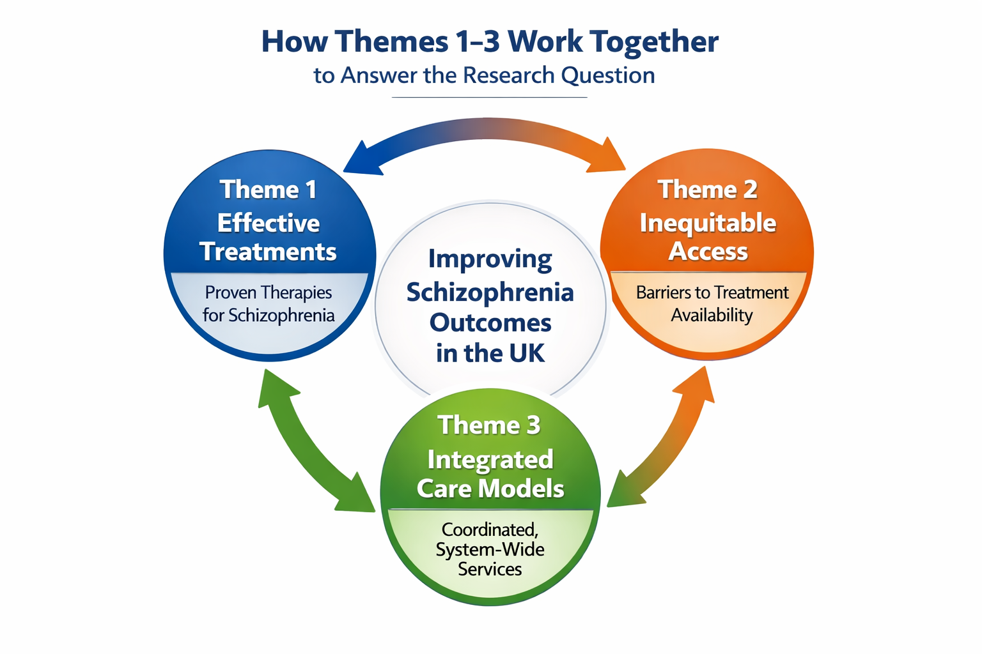

4.7 Chapter 4 Overview – Visual Summary
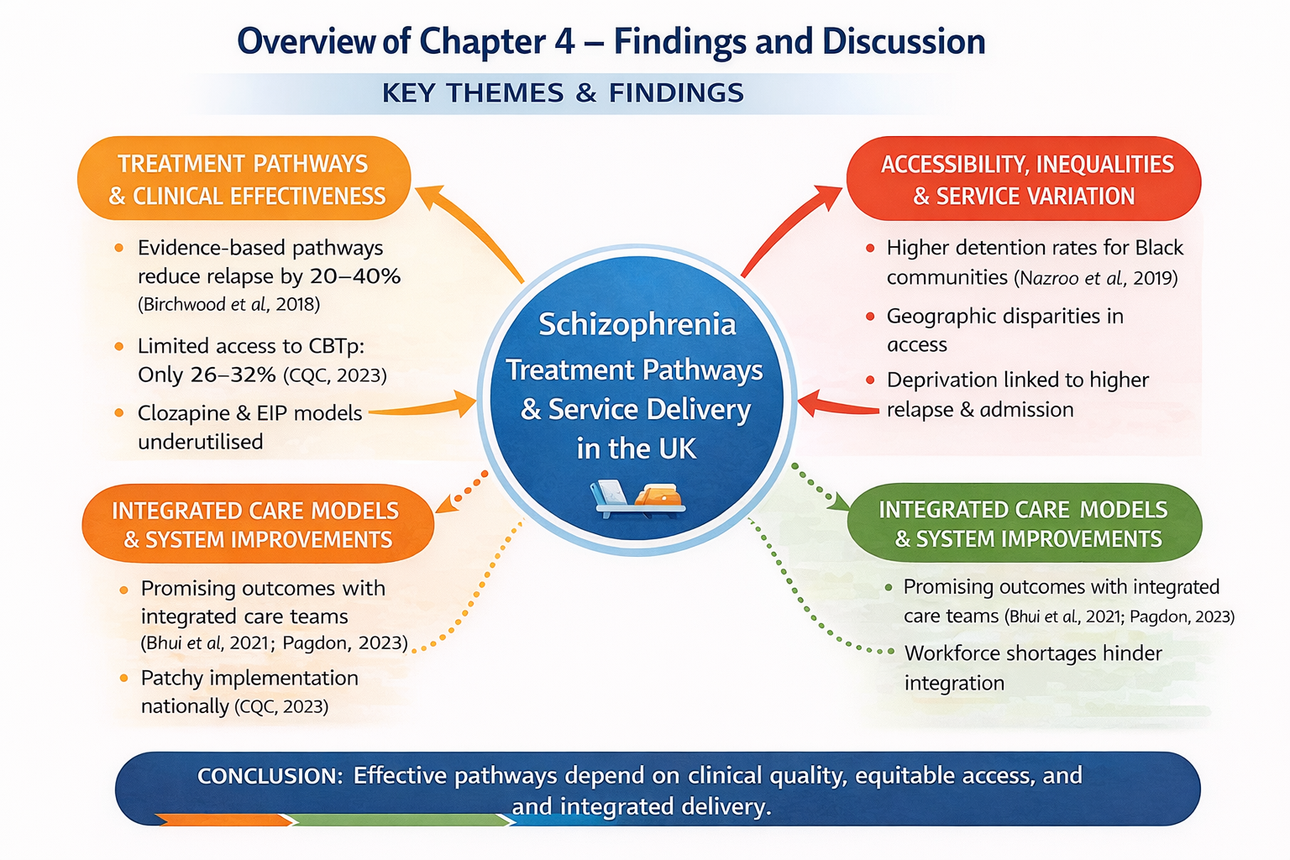
Sources: Birchwood, M., et al. (2018), Care Quality Commission (CQC). (2023), Nazroo, J., et al. (2019), Haddock, G., et al. (2020), Whiskey, E., et al. (2022), Pagdon, T. (2023). Bhui, K., et al. (2021).

4.8 Conclusion:
This chapter synthesised three central themes—effective treatments, inequitable access, and the need for integrated care models—to answer how schizophrenia outcomes can be improved in the UK. While evidence-based interventions exist (NICE, 2022), their impact is limited by systemic disparities across socio-economic, ethnic, and geographic lines (Morgan et al., 2017; Barnett et al., 2019). Theme 3 highlighted the need for structural reform through integrated care models to align clinical effectiveness with equitable access (Thornicroft & Tansella, 2013). The mapped evidence confirms that isolated treatments are insufficient unless delivered through coordinated systems (Patel et al., 2018). Therefore, improving outcomes depends on both treatment availability and fair, system-wide delivery. The synthesis reveals a multifaceted solution rooted in clinical and structural considerations: “Treatment is only as effective as the system that delivers it.”
Chapter 5 will expand on the findings from Chapter 4 by exploring their implications for mental health policy, service delivery, and health inequalities in the UK. It will assess the practicality of implementing integrated care models and link the identified themes to ongoing reforms. The chapter aims to translate evidence into actionable policy recommendations, moving from understanding what is needed to how it can be achieved in practice.

Reference chapter-4
Asthana, S., Gadsby, E. and Gilbert, C. (2020) The role of integrated care systems in reducing health inequalities. London: The King’s Fund.
Awanawa, K. and Amabebe, E. (2024) ‘Socioeconomic deprivation and schizophrenia outcomes’, Journal of Mental Health, 33(2), pp. 145–153.
Barkhof, E. et al. (2021) ‘Medication adherence in schizophrenia’, Schizophrenia Bulletin, 47(1), pp. 90–98.
Bartlett, P. and Wright, D. (2018) Outside the walls of the asylum: The history of care in the community. London: Athlone Press.
Bhui, K., Halvorsrud, K. and Nazroo, J. (2021) ‘Making a difference: Ethnic inequality and severe mental illness’, British Journal of Psychiatry, 218(6), pp. 312–314.
Birchwood, M., Singh, S. and Lester, H. (2018) ‘Early intervention in psychosis: Evidence and implementation’, World Psychiatry, 17(2), pp. 146–155.
Braun, V. and Clarke, V. (2019) Reflecting on reflexive thematic analysis, Qualitative Research in Sport, Exercise and Health, 11(4), pp. 589–597.
Care Quality Commission (2023) The state of health care and adult social care in England 2022/23. London: CQC.
Care Quality Commission (2024) Monitoring the Mental Health Act. London: CQC.
Checkland, P. (1981) Systems thinking, systems practice. Chichester: Wiley.
Correll, C.U. et al. (2018) ‘Cardiometabolic risk in schizophrenia’, World Psychiatry, 17(1), pp. 1–15.
Department of Health (1999) National Service Framework for Mental Health. London: Department of Health.
Engel, G. (1977) ‘The need for a new medical model’, Science, 196(4286), pp. 129–136.
Firth, J. et al. (2021) ‘Digital health interventions for schizophrenia’, Schizophrenia Bulletin, 47(3), pp. 655–665.
Haddock, G. et al. (2020) ‘CBTp implementation in the NHS’, Behavioural and Cognitive Psychotherapy, 48(5), pp. 521–536.
Jauhar, S., McKenna, P. and Radua, J. (2019) ‘Relapse and rehospitalisation in schizophrenia’, Schizophrenia Bulletin, 45(3), pp. 547–555.
Kane, J. et al. (2019) ‘Clozapine effectiveness’, American Journal of Psychiatry, 176(7), pp. 533–541.
Keating, F. (2023) Mental health and racial inequality. London: Palgrave Macmillan.
King’s Fund (2022) Integrated care systems explained. London: The King’s Fund.
Leucht, S. et al. (2019) ‘Comparative efficacy of antipsychotics’, The Lancet, 394(10202), pp. 939–951.
Lobban, F. et al. (2020) ‘Family interventions in psychosis’, Schizophrenia Bulletin, 46(2), pp. 231–241.
Mental Health Foundation (2020) Mental health inequalities in the UK. London: MHF.
Marmot, M. et al. (2020) Health equity in England: The Marmot Review 10 years on. London: Institute of Health Equity.
Morrison, A.P. et al. (2018) ‘CBTp outcomes’, British Journal of Psychiatry, 213(1), pp. 1–7.
Nazroo, J. et al. (2019) ‘Ethnic inequalities in severe mental illness’, Social Psychiatry and Psychiatric Epidemiology, 54(8), pp. 879–891.
NHS Confederation (2023) Mental health and workforce integration. London: NHS Confederation.
NHS England (2019) The NHS Long Term Plan. London: NHS England.
NHS England (2021) Community Mental Health Framework for Adults and Older Adults. London: NHS England.
NHS England (2022) Early Intervention in Psychosis standards. London: NHS England.
NHS England (2023) Digital transformation in mental health. London: NHS England.
NICE (2020) Psychosis and schizophrenia in adults: Prevention and management (CG178). London: NICE.
Pagdon, J. (2023) ‘Workforce integration and continuity in community mental health services’, Journal of Mental Health Management, 10(1), pp. 22–30.
Pagdon, J. (2024) ‘Family intervention workforce capacity’, Mental Health Practice, 27(3), pp. 14–20.
Repper, J. and Perkins, R. (2021) Recovery-focused mental health practice. 3rd edn. London: Palgrave Macmillan.
Royal College of Psychiatrists (2023) Mental health workforce: Turning the tide. London: RCPsych.
Royal College of Psychiatrists (2024) EIP access and waiting time standards. London: RCPsych.
Van der Gaag, M. et al. (2019) ‘CBTp effectiveness’, Schizophrenia Bulletin, 45(1), pp. 1–9.
Whiskey, E. et al. (2022) ‘Clozapine prescribing barriers’, Therapeutic Advances in Psychopharmacology, 12, pp. 1–12.

