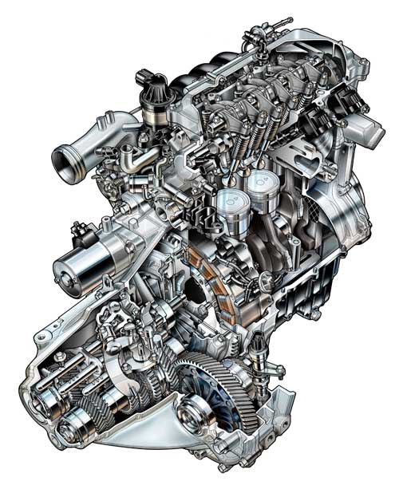
CONROD DYNAMIC FORCES REPORT

Analytical Methods & study skills
Alexander Wright (1701086)
2018
Abstract
Connecting rods can experience large tensile forces while under engine operating conditions. There are a number of main factors and engine specific dimensions that can vastly affect the amount of force. If excessive tensile forces are placed upon the connecting rod, ultimately this can lead to complete breakage which can cause complete engine failure. The following report will look into these forces, utilising specific engine data to determine the peak forces under different engine operating speeds, conrod dimensions and piston weights; all of which directly affect the tensile forces experienced.
Contents
Page Number:
1. Abstract
2. Introduction >
3. >
4. Engine specifications
5. Graph report & analysis >
6. >
7. >
8. > Summary/conclusion
9. Bibliography

Introduction to Connecting Rods
A four stroke piston engine, while producing rotational motion; does not directly produce a turning force. This is because most the most commonly used style of internal combustion engine is the reciprocating type; whereby pistons are used to transfer the chemical energy generated by the combustion process into mechanical energy. The crankshaft, the primary mechanical component in the reciprocating piston engine; functions as the component that transfers the reciprocating motion produced by the pistons into a rotational motion that can be used to drive the road wheels. To transfer the energy from the pistons to the crankshaft, a rigid member known as a ‘conrod’ / connecting rod is used. A conrod is typically constructed from tough, durable metals such as steel (typically used in mass production engines), aluminium alloys (which can reduce weight at the expense of durability) or even titanium in some high end applications such as motorsport derived engines, where the benefits of the reduced weight and high strength can be critical to the engine design and demands experienced when used for racing purposes.
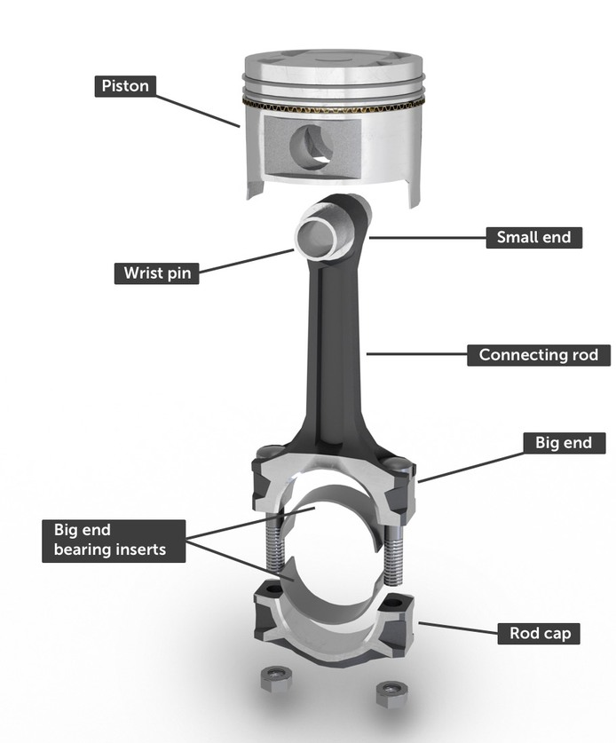

Fig 1.
Figure 1 illustrates the main components that make up the connecting rod assembly. Among these components, the bearing inserts are a vital component that allows a thin film of oil to sit between them and the big end bearing journals on the crankshaft. This allows the vital lubrication of the moving components and prevents wear, which can ultimately prevent bottom end engine failure.
In most engine applications, to split the big end and the rod cap to allow removal and re-fitment of the rods themselves, rather than cutting the part (which can remove vital material from the big end, affecting both the dimensions and strength), it is instead ‘fracture split’, which is a method which utilises large weighs being rapidly applied to a striker cap, which creates a clean fracture in the big end along a guided line.
“Being one of the most integral parts in an internal combustion engines design, the connecting rod must be able to withstand tremendous loads and transmit a great deal of power.
The various forces acting on the connecting rod are as follows: 1. Forces on the piston due to gas pressure and inertia of the reciprocating parts. 2. Force due to inertia of the connecting or inertia bending forces. 3. Force due to friction of the piston rings and of the piston, and 4. Forces due to friction of the piston pin bearing and crank pin bearing.”
G. Naga Malleshwara Rao (2013) ‘Design Optimization and Analysis of a Connecting Rod using ANSYS’ International Journal of Science and Research (IJSR), India Online ISSN: 2319-7064. Available at: https://www.ijsr.net/archive/v2i7/MDIwMTMxMjg=.pdf (Accessed 3rd December 2018)
As stated in the Technical report referenced above, there are a number of forces that are experienced by a connecting rod. Out of these forces experienced, the largest 2 are forces on the piston due to gas pressure and inertia of the reciprocating parts & . force due to inertia of the connecting or inertia bending forces. Frictional forces do not play a large roll in the forces experienced by a connecting rod / piston assembly due to the significant lubrication of vital engine components that greatly reduces these forces.
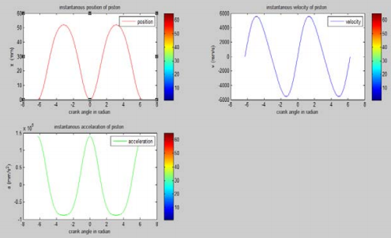

Fig 2: H. Nigus. (2015) ‘Kinematics and Load Formulation of Engine Crank Mechanism,’ Mechanics, Materials Science. Available at: https://hal.archives-ouvertes.fr/hal-01305936/document. (Accessed 3rd December 2018)
Figure 2 shows an example of the Kinematics experienced by the piston within an internal combustion engine during operation. The graphs, which illustrate the piston position, velocity & acceleration respectively; show the changes as the piston travels both up & down the cylinder. While these graphs show piston kinematics, it delivers an accurate representation of the position, velocity & acceleration of the connecting rods that can be expected in the graphs produced from the conrod dynamic forces calculations.
Throughout the rev range, the connecting rods will experience large changes in both tensile and compressive forces. The following graphs will illustrate the resultant forces at different points in the rev range all the way up to the limiter / redline.

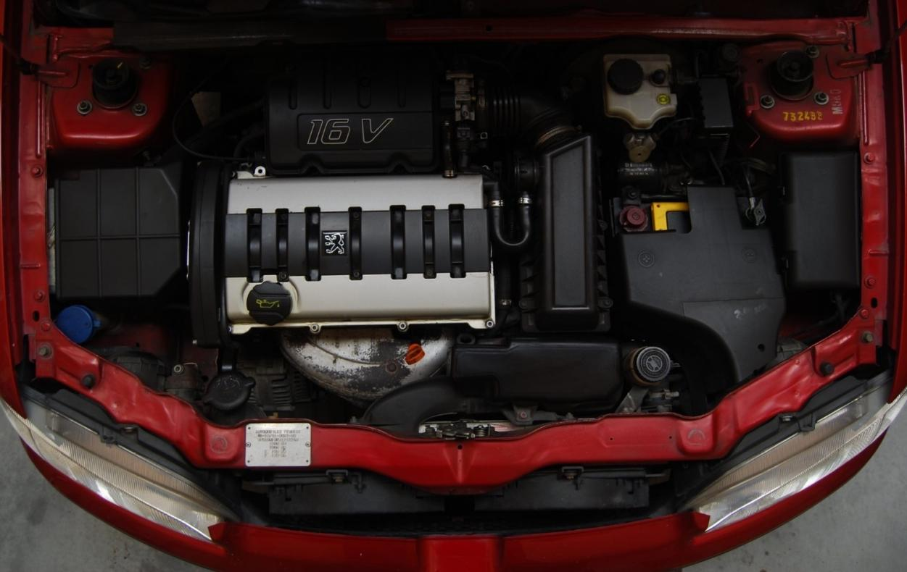
Engine:

Fig 3. TU5J4 shown in a Peugeot 106 GTI
Figure 3 Image Source: http://www.aussiefrogs.com/forum/peugeot-forum/126702-106-gti-new-zealand.html
PSA TU5J4 1.6L, 16V
Engine Type – Number of Cylinders: Inline – 4
Engine Code: TU5J4 (NFX)
Fuel Type: Petrol
Fuel system: Multi point fuel injection
Displacement: 1587 cm³ / 96.8 cu-in
Bore x Stroke: 78.5mm x 82mm
Valve-train: DOHC 16 valve (4 per cylinder)
Aspiration: Naturally Aspirated
Compression Ratio: 10.8:1
Maximum Power Output: 120PS / 118bhp @6600rpm
Maximum Torque: 145Nm / 106ft-lb @5200rpm
Maximum Revolutions per-minute (rpm): 7500
Vehicular Applications: Peugeot 106 (GTI & S2 Rallye), Citroen Saxo (VTS 16V)
Conrod Length: 139.00mm
Small End Diameter: 18.00mm
Small End Width: 20.00mm
Big End Diameter: 48.6mm
Big End Width: 23.8mm
Crank Radius: 41mm
Piston Mass: 0.30kg
Graph Report
*All force figures in Newtons (N)*

Fig 4. 1000rpm (Idle)
Figure 4: While at around a regular idle speed of 1000rpm, the forces exerted on the connecting rod are very low, peaking at just over 174N. The low engine rpm results in a low acceleration figure, as the frequency of strokes are low over a fixed period of time compared to a higher crankshaft rotational speed.
Max tensile force on rod @ 1000rpm |  | 174.5981

The effects of a much higher rpm will be depicted in the following graphs, showing much higher resultant forces.
Fig 5. 2500rpm
Figure 5: With only a 1500rpm increase (A regular cruising engine speed, 2500), the tensile forces exerted on the connecting rod are significantly higher, peaking at 1091N, over five times higher than the peak tensile force at idle. The higher rpm figure also means that the forces are being exerted over a much shorter time period, for example the peak is delivered for only around a number of thousandths per second, as the waveform becomes very sharp at the peak.
Max tensile force on rod @ 2500rpm |  | 1091.287
Fig 6. 5000rpm
Max tensile force on rod @ 5000rpm |  | 4360.292
Fig 7. 7500rpm (Rev Limiter)
Max tensile force on rod @ 7500rpm |  | 9792.475

As shown in Figures 6 & 7; with increasing engine speeds, the forces start to significantly rise, showing a peak of 4360 when at 5000 rpm. This rises to 9792 once at the 7500rpm rev limiter implemented by the engine management system.
(It is to note that a rev limiter is put in place in engines to prevent complete failure due to the mechanical components being pushed too far in terms of their speed which can result in excessive forces on components, especially on vital internals such as the connecting rods).
The peak force & acceleration of the conrod at this engine speed is very high, also peaking very sharply. Observations over the different points in the rev range illustrated by the graphs show how the peaks become sharper as the engine speed rises.
Following on from the graphs produced for the standard engine measurements and data, analysis can be performed with different sets of figures to look at the effects of weight and length changes. With the engine using a set of lightweight forged pistons (weight down from 0.3kg to 0.26), the following graph was produced at 5000rpm, (figure 8).

Fig 8. 5000rpm (lightweight 0.26kg forged pistons)
Max tensile force on rod |  | 3778.92

With just a small mass decrease on the piston (down 0.04kg), the force on the connecting rod has reduced by around 600N at the same rpm. Lightening the pistons within the engine can significantly reduce the stress & strain on the connecting rod as shown above. This weight reduction can also allow the engine to reach a higher rpm before the connecting rods begin to suffer excess strain and result in breakage (along with supporting engine modifications to allow it to rev higher while remaining safe).

Another aspect to consider is the stroke length of the engine; another figure that affects the force. The standard TU5J4 engine has a bore of 78.5mm, with a 82mm stroke (41mm crank radius), giving a 1587 cubic capacity. The following graph (Figure 9) shows the force when at 5000rpm using a longer stroke ZRP Crankshaft which takes the J4 engine up to around 1.8L up from 1.6. The long stroke crank increases the stroke to 92.5mm, thus taking the capacity up to 1790cc. This crankshaft is ideal in a motorsport application, delivering higher torque and power figures, however it is best used with a set of high strength forged pistons and connecting rods as the forces are larger (as demonstrated in Fig 9). The force has increased from 4360 N up to 5061 with the larger stroke length.

Fig 9. 5000rpm (longer stroke)
Max tensile force on rod @ 5000rpm |  | 5061.886

Summary
Overall, the data analysed has shown massive variations in the connecting rod forces. The biggest factor that changed these results was the overall engine rpm, with figures at the rev limiter being significantly higher than at lower rpm figures. One interesting piece of evidence to note is in Fig 8, whereby a lighter piston mass can substantially reduce the forces. In addition to this, to look at the effects or a larger crank radius; the longer 92.5mm stroke crankshaft was used as an off the shelf example, increasing the forces at the same rpm significantly.
All this data collected highlights the necessity in looking at force data when building a performance engine. If using the standard connecting rods while increasing the stroke, the conrods could break to the excess stress and strain placed upon them. This is why it is critical to be fitting stronger components when changing bottom end components and dimensions to improve engine performance.

Bibliography
Image sources:
https://www.picswe.com/pics/engine-cutaway-93.html
https://www.howacarworks.com/pistons
http://www.aussiefrogs.com/forum/peugeot-forum/126702-106-gti-new-zealand.html
References:
G. Naga Malleshwara Rao (2013) ‘Design Optimization and Analysis of a Connecting Rod using ANSYS’ International Journal of Science and Research (IJSR), India Online ISSN: 2319-7064. Available at: https://www.ijsr.net/archive/v2i7/MDIwMTMxMjg=.pdf (Accessed 3rd December 2018)
H. Nigus. (2015) ‘Kinematics and Load Formulation of Engine Crank Mechanism,’ Mechanics, Materials Science. Available at: https://hal.archives-ouvertes.fr/hal-01305936/document. (Accessed 3rd December 2018)

