Understanding and Engaging in the Customer Experience
BMSW5103
Student name:
Eleonora Mariana Filip
Student number: 1807163
Lecturer: Dr.Kenny Tang

Contents
INTRODUCTION 3
COMPANY BACKGROUND 3
TESCO PLC Ltd.: 3
CUSTOMER VALUE 4
1. Factors affecting customer value: 5
SERVICE QUALITY 13
1. SERVQUAL Model: 14
2. Gap Model of Service Quality: 17
CONCLUSION 20
REFERENCES 21

INTRODUCTION
Customer experience can be defined as the outcome of a customer’s interaction with any company or organisation over a period of time (Šambronská, 2013). It is a very subjective matter and is influenced by many factors which contribute to the perceived value of the product for customers. In the following project report, an attempt has been made to identify the factors which impact the potential of maximising the customer value for TESCO. The following project report aims to evaluate the effectiveness of quality systems of TESCO in meeting the customer requirements.

COMPANY BACKGROUND

TESCO PLC Ltd.:
TESCO, one of the leading grocery retailer in United Kingdom, was founded in the year 1919 by Jack Cohen. The company has a huge chain of supermarket stores in not just UK but in more than 7 countries. It is also one of the largest food retailer in the world. Initially, the company was started with a small grocery store but over the years, the operations of TESCO has expanded to a variety of product ranges and even services. The company is the leader in the supermarket retail industry in UK with a market share of approximately 27% which is much higher when compared with any of its competitors (Chowdhury, 2016). Company majorly faces competition from other grocery retail stores such as Sainsbury’s ,LIDL ...The annual revenue of the company in the year 2019 was estimated at $75.6B and the number of employees were more than 4,60,000. TESCO had 6800 shops worldwide in the year 2019 which accounts for the widely spread operations of the supermarket giant. The company offers a wide range of products to its customers varying from household products to daily food essentials.

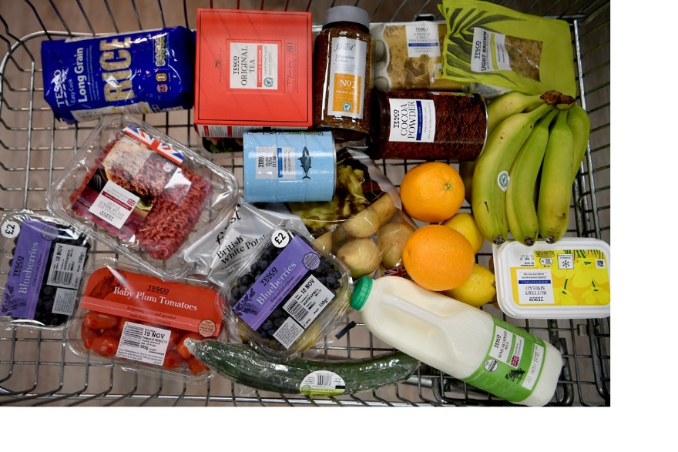
Source: https://www.tescoplc.com/sustainability/sourcing/top-20/

The stores of the company are estimated to serve about more than million customers per week which makes it imperative for the company to understand the importance of customer relationship management and maximise the potential value of its products and services for the customers. Customer relationship management can be defined as the management approach at interacting with current and potential customers of a business with an aim of obtaining long-term sales growth. Customer relationship management aims to develop long-term positive relations with the customers which helps a company to maintain its competitive position in the industry and increase the value of customer satisfaction. Customer experience can be defined as the perceived result of the experience of a customer with an interaction with any brand. A detailed analysis of customer value and experience is being done in the following sections of the report.

CUSTOMER VALUE
Customer value can be defined as a concept which is used to determine the sum total of all the benefits as perceived by the customer upon consumption of a product or service. It is a term used to determine the worth of a product or service for any customer. Customer value is the outcome of customer experience. Over the years, business environment has changed completely with the number of people being involved in the manufacturing or service sector ever-increasing. This change or trend in business environment has increased the importance of customer value as a concept for business managers and organisations in effectively shaping the nature of their operations and financial performance of the company (Peeroo, Samy and Jones, 2016). An organisation’s value perception usually becomes least important in determining the sales of a product or service and this is where customer value dominates in influencing operations in every industry whatsoever. Arguably. It is imperative for the management of TESCO Ltd. to understand that customer value is a very subjective matter and can only be influenced, never controlled. Identifying what drives a customer is important for comprehension of the customer value.

1. Factors affecting customer value:
Products:
Product specification and description is one of the most important determinant of customer value. A product which is being offered by any company or organisation should be in compliance and similarity with the customer requirements and needs. Identifying the needs of the customer and creating a product which has the potential to fulfil and satisfy customer needs is an important task which adds to the customer value. Identical products may have different perceived value for different groups of customer so it becomes necessary for a business organisation to determine the target group or potential customers to clearly establish the customer expectation from a product.
The vast range of product being offered by the company is the testimony to the fact that customer value is an important criterion in taking management decisions by the company (Vu, 2016). The company recently launched a new range of organic food items with an objective of catering to the changing needs of healthy food items with high nutritional contents of customers as more and more people are becoming aware of the health issues and concerns.

Source: https://www.tesco.com/groceries/en-GB/products/252380883
Ranking:
According to me, I will rank TESCO 9/10 for its products which are according to the specification and customer requirement such as organic food products. I will give 8/10 to Sainsbury’s and 8/10 to Aldi because they are also offering products as per market demand.
Price:
Price can be defined as the amount which a customer has to pay in order to avail any service or consume any product. It is another dimension which has an important role to play in maximising customer value of products (Ihtiyar and Ahmad, 2012). If the price of a product is higher than the perceived value of benefits for any consumer, it negatively affects the customer value and if the price of a product is less than the perceived value of benefits for the consumer, customer value increases massively. Price-optimisation tools are used by management to determine the relative demand at different price levels and a level where maximisation of organisational goal is possible is selected as the market price.
To increase the position of price dimension in company’s favour, TESCO frequently makes use of various tools for sales promotion such as cash discounts, buy one get other at 50% discount etcetera to increase the price value embedded in the products for the customer. The policies which are being adopted by the company for pricing of the products clearly states out the mission of the company to ensure that no one can beat it when it comes to monetary value of products. As per my personal opinion, the price-value associated with the products is very high as most of the products have a lot to offer as compared to the price which is further reduced with the help of promotion tools. However, the company has recently increased the prices for a lot of its products which is affecting the customer value negatively and the management of the company has to take steps to control the damage being caused to customer value and experience as a result of price hikes.
ITEMS | TESCO | SAINSBURY’S | ALDI
Semi-skimmed Milk (4 pints) | £1.10 | £1.10 | £1.09
Soft-white Farmhouse Bread (800g) | £1.55 | £1.45 | £0.72
Orange-juice (1litre) | £1.29 | £1.40 | £0.76
Fusilli (500g) | £0.59 | £0.60 | £0.47
Medium-free range British Eggs (6) | £0.90 | £1.10 | £0.79
Toilet Roll (4 pack, 2 ply) | £2.65 | £2 | £1.59
Butter (500g) | £1.90 | £2.20 | £0.76
Total | £9.98 | £9.85 | £6.18
(Source:https://www.lovemoney.com/news/86638/tesco-metro-sainsburys-local-aldi-convenience-store-essentials)
Ranking:
I will give 8/10 to both TESCO and Sainsbury’s and 10/10 to Aldi for prices as per my experience. I think that products of TESCO and Sainsbury’s are overpriced when compared to competitors such as Aldi.

Quality:
Offering a wide range of products and offering a wide range of quality products are two different things which define the importance of quality of a product or service in influencing the customer value. Quality can be defined as the features or characteristics of a product or service which differentiates it from the other products or services being offered in the market. Goods of high quality often help in maximising the customer value and undermine the importance and influence of other dimensions such as price ( Bhardwaj, 2012). Quality is a relative concept and hence it is difficult to define a fixed standard or benchmark which could have the potential to meet any demand or situation. It is important for product managers to ensure that best efforts are being put to increase the quality of the product while considering the other factors or dimensions of customer value.
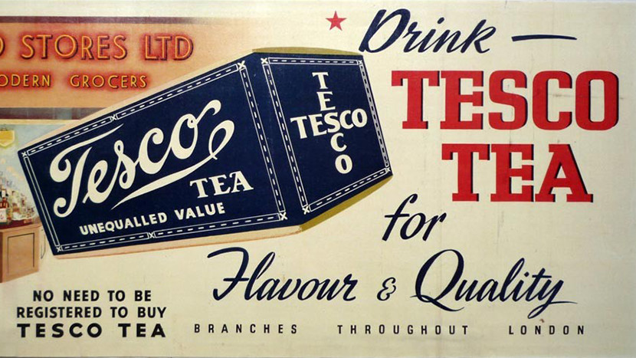
TESCO is a company which strongly emphasize the need to deliver the products of best quality to the customer for increasing the customer satisfaction and value. Approaches such as six sigma and total quality management are being followed to the quality requirements of the customers
Ranking:
I have always liked the quality of products at TESCO so I will give 9/10 to TESCO for quality and to Sainsbury’s I will give 9/10 also and to Aldi I will give 8/10 because sometimes I was not satisfied with the quality of their products.
Brands:
Brand can be defined as anything such as logo, name or design which helps in differentiating the goods of a particular seller or manufacturer from other goods in the market. Value of a brand also has a major impact on the overall customer experience and satisfaction. Customers are likely to associate themselves with a brand which has a high value and the mere association with a highly-valued brand gives them an immense amount of satisfaction and increases the richness of their experience (Siami and Gorji, 201)Customer relationships with particulars brand is a testimony of the impact brand value has on development of customer relationships and influencing customer value. Brand helps a firm to differentiate itself from its rivals or competitors.
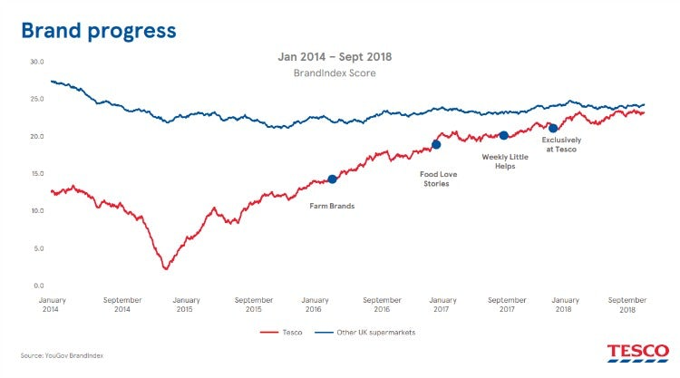
Source: https://www.marketingweek.com/tesco-shifts-marketing-focus-to-value/
TESCO is one of the highest valued brand in the United Kingdom and also stands strongly in the worldwide group of highest-valued brands. It can be observed from the above graph that the management of the company has shifted their focus towards building a brand of great value in the past few years which has also changed the customer satisfaction levels. A brand which has a high-value is able to gain the trust of the customer and having a positive customer attitude helps significantly in subconsciously improving the quality of customer experience and the perceived value by the customers. I think it can be concluded that brand value is one of the important factor which can have an impact on maximising customer value.
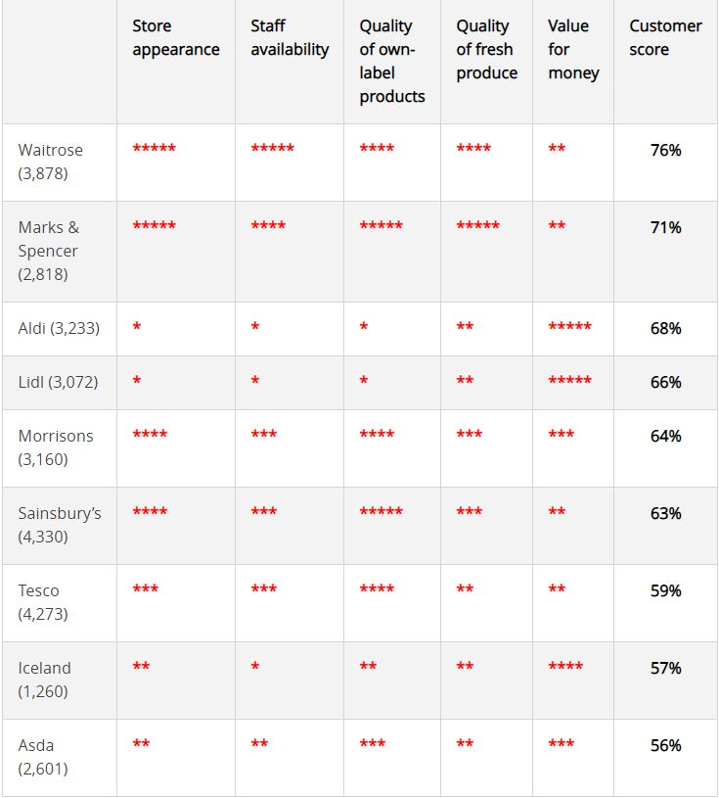
(Source: https://www.which.co.uk/news/2019/02/best-and-worst-supermarkets-for-2019/)
Ranking:
I will give 8/10 rating to TESCO for brand value as there is a scope of improvement. I will give 9/10 to Sainsbury’s and 10/10 to Aldi because both the companies are taking necessary steps for establishing a strong brand.
Value-adding services:
Value-adding services as the name suggests are services which are being offered by companies or business organisations with the objective of increasing the worth and benefits of using a product or availing any service. Value-adding services have the objective of providing additional value and benefit to the customer other than the benefits associated with the product (Vorasaiharit and Thawesaengskulthai, 2016). These are services which are not the core competency of the organisation but an additional provision for increasing the customer satisfaction and enhancing consumer experience. For example, after sales services, home-delivery, online shopping .Understanding the importance of providing services which adds to the value of a product is necessary for managers to enhance the customer experience and satisfaction.
TESCO has been making changes in its policies and started offering additional services which are very impactful in increasing the overall customer satisfaction and experience. The company has recently launched an online platform where customers can shop very conveniently by the help of few clicks. The company website is a very efficiently designed platform where the customer can shop without any complexities and it adds to the overall value of the products.
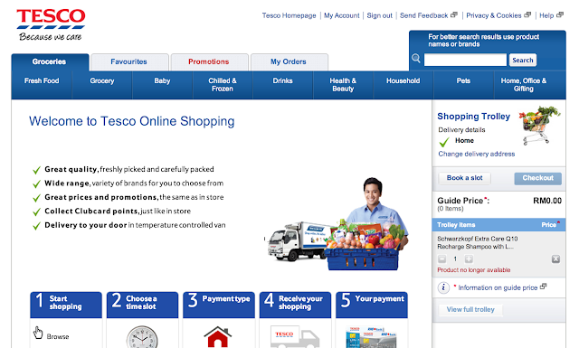
Source: https://www.carolinemayling.com/2013/08/tesco-malaysia-online-shopping.html
Ranking:
Because of TESCO’s online shopping facility, I will give 9/10 to TESCO for value-added services and 8/10 to Sainsbury’s and 9/10 to Aldi because it is also developing such services.
Customer-relationship:
Customer-relationship can be defined as the connection between the customers and the company. Managers of business organisations are taking measures to develop a long-term relationship with the customers to obtain stable future-sales. Many a times, a customer is influenced to buy the product of any particular brand or company on the basis of his prior experience and the relationship which has been developed with the company (Dinçer, Yüksel and Pınarbaşı, 2019).
TESCO implemented a loyalty card program to enable the customers to avail discounts when they shop for multiple times with the company. Loyalty card program help TESCO to also obtain important data regarding the demographics of its customers which helps in further strategy formulations. The loyalty card program increases the perceived value of products for the customers of TESCO as the customer gets entitled to a discount in future on the purchase of products from the same brand.As per my opinion, along with loyalty card program, the management of the company should take measures to strengthen the position of survey and feedback channels of the company which could result in better grievance handling and increase the satisfaction level of customer and build long-term relationships.
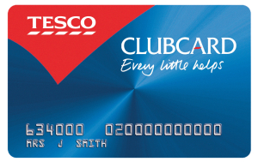
Source: https://eternalsunshineoftheismind.wordpress.com/2013/03/05/tesco-the-crm-champion/
Ranking:
Based on my personal experience, I think TESCO is taking some serious steps for CRM such as club cards which are better than any of its competitors. Hence, I will give 9/10 to TESCO and 8/10 Aldi and 7/10 To Sainsbury’s.
SUMMARY TABLE:
DIMENSION | TESCO | ALDI | SAINSBURY’S
Product | 9 | 8 | 8
Price | 8 | 10 | 7
Quality | 9 | 8 | 9
Brand | 8 | 10 | 9
Value-added services | 9 | 9 | 8
CRM | 9 | 8 | 7
Total | 50/60 | 53/60 | 48/60

On the basis of this table, there is a scope of improvement in the customer value for TESCO in many dimensions such as price-value and brand-value.

SERVICE QUALITY
Service quality can be referred as the capacity of a business organisation to fulfil the requirements and needs of the customer in an effective and efficient manner which paves way for business growth and long-term customer satisfaction. Service quality is predominantly linked with the level of customer satisfaction (Mukerjee, 2013). Different level of quality of services generate different perceived value of products for customer and influence the customer satisfaction. From the context of TESCO ltd, the impact of dimensions of service quality and the effectiveness of the company in meeting the requirements of the company can be better understood with the help of two models – SERVQUAL and the Gap Model of Service Quality. SERVQUAL is a measure which helps in evaluation of different dimensions of service quality and Gap Model of Service Quality helps in analysing the effectiveness of an organisation in meeting the customer requirements.
SERVQUAL MODEL:
SERVQUAL is a model which is used to determine the level and quality of service which is being offered by a company on the basis of measurement of five dimensions of service which are reliability, tangibility, assurance, empathy and responsiveness (Razak, Nirwanto and Triatmanto, 2016). The managers of TESCO understand the relevance and application of this model in ensuring high level of customer satisfaction which is desirable by every manager and business organisation. Under this model, emphasis is laid on development of quality systems particularly in the discipline of product quality. This model puts forward the argument that an increase in the quality which is being provided in five dimensions of service results into a better customer satisfaction and experience.

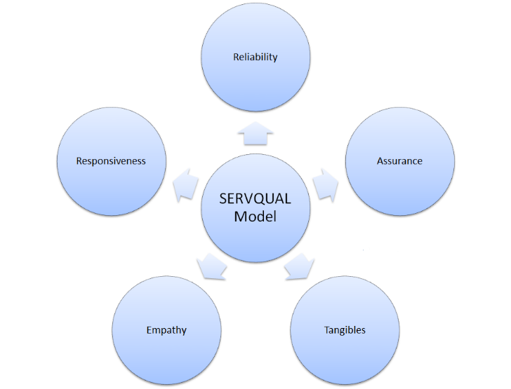
Source: https://www.marketingstudyguide.com/understanding-the-servqual-model/
Reliability – First Dimension of Service Quality
Reliability can be defined as the extent to which a company is accurate and honest in its business activities. It is very important for any business organisation to make sure that the customers trust the products which are being offered by the company. It determines the extent to which a company delivers what it promises (Mollah and Sharif, 2014). As per my opinion, the products which are being offered by the company TESCO are highly reliable with the specification and product description being labelled on the packaging. Reliability is the most important dimension of service quality which influences the attitude of a customer towards any product or service which is being offered in the marketplace. I believe that the strategies which are being adopted by the managers of TESCO Ltd. are highly effective in adding reliability as a result of which quality of service improves remarkably.
Ranking:
According to my personal experience, I will give 9/10 to TESCO and 8/10 to Sainsbury’s and 7/10 to Aldi. Services of TESCO are very reliable to me.
Assurance – Second Dimension of Service Quality
Assurance as a dimension of service quality refers to the communication of expertise to customers of a business. Even if the products which are being offered by a company or an organisation are of the best quality possible, it is very important to make customers aware about the expertise which is being and assure them with the quality levels. It showcases the ability and capacity of the organisation and has a lot to deal with transmission of trust into the potential customers. To assure the customers of the quality of products which are being offered by TESCO, the company has launched an entire range of products which are available exclusively at TESCO. The company is taking measures to increase customer’s trust and confidence in the department which connects the company to customer which is Marketing Department.
Ranking:
I will give 9/10 to TESCO for assurance and 8/10 to both Sainsbury’s and Aldi because TESCO assures the customers through ethical sourcing and information of the services which it is providing.
Tangibility – Third Dimension of Service Quality
In most situations, customers of any business organisation evaluate the services which are being offered with the help of comparing the tangibles associated with that service. Hence, it is important for any company to make sure that tangibility of any service is also being taken care of. In the context of TESCO, tangibility refers to the physical and tangible elements included in the company stores and outlets (Younus, Rasheed and Zia, 2015). According to me, the management of TESCO has communicated very effectively with the customer in many disciplines of service quality and the overall presentation models used by the companies improves the tangibility as a dimension of service quality.
Ranking:
I will give 8/10 to TESCO since low tangibility and 9/10 to both Sainsbury’s and Aldi because of high tangibility and strong brand emphasis. I think there is a scope of improvement in the store and outlet details and elements in TESCO.
Empathy – Fourth Dimension of Service Quality
Empathy as a dimension of service quality involves providing personalised care and attention to the needs of the customer by a company or an organisation. It is the responsibility of the business organisations to satisfy the needs and requirements of the customer and empathy suggests that personalised attention to individual customer requirement is an important determinant of service quality (Yi and Gong, 2013). In this context, TESCO is offering a wide range of products which are being designed according to the needs and requirements of the customer such as organic food items with high nutritional content. The company has launched many variants in each product segment which could cater to the need of individual customers.
Ranking:
TESCO is matching its service with customer requirements and hence, I will give 9/10 to TESCO and 8/10 to Sainsbury’s and 9/10 to Aldi.
Responsiveness – Fifth Dimension of Service Quality
Responsiveness can be defined as the willingness and desire of a business organisation to help and solve the problems of the customers promptly and as quickly as possible. It is measured with the help of duration of time which is required by a company in addressing to any problem or suggestion of its customers (Peeroo, Samy and Jones, 2015). It is one of the most important determinant of the quality of service and has a great potential of increasing the customer satisfaction. From the context of TESCO, it has been observed that the management has made arrangements which helps the company in responding to the complaints and feedbacks of the customers promptly. It has designed a platform for customers to give suggestions and feedbacks on the company website which is a very effective way of increasing the responsiveness.
Ranking:
I had a good experience of help and customer complaint redressal with TESCO hence I will give 10/10 to TESCO for responsiveness and 9/10 to Sainsbury’s and only 8/10 to Aldi because of slow-responsiveness.
SUMMARY TABLE:
DIMENSION | TESCO | ALDI | SAINSBURY’S
Reliability | 9 | 7 | 8
Assurance | 9 | 8 | 8
Tangibility | 8 | 9 | 9
Empathy | 9 | 9 | 8
Responsiveness | 10 | 8 | 9
Total | 45/50 | 41/50 | 42/50

On the basis of above table, it can be said that TESCO is providing a high quality of service with respect to every dimension of service quality and this has helped the company to influence satisfaction level of the customers. TESCO is a better brand in terms of service quality than its competitors such as Sainsbury’s and Aldi.

2. Gap Model of Service Quality:
The Gap Model of Service Quality is a framework which is being used by the business managers to understand customer satisfaction in a better manner. Under this model, five gaps have been identified which may exist in terms of customer satisfaction and the prime objective of any organisation should be to address these gaps and try to mitigate them in order to improve customer value. It is an important tool to measure the effectiveness of organisation in meeting the customer requirements (Peppers and Rogers, 2016). The model puts forward the argument that customer satisfaction is predominantly influenced by the perception. Customer satisfaction is a phenomenon where a customer perceives the value of products or services as meeting the expectations which he had in mind prior to interaction with the product. Any space between the perceived value and customer expectation can be categorised in the following five gaps of customer service:
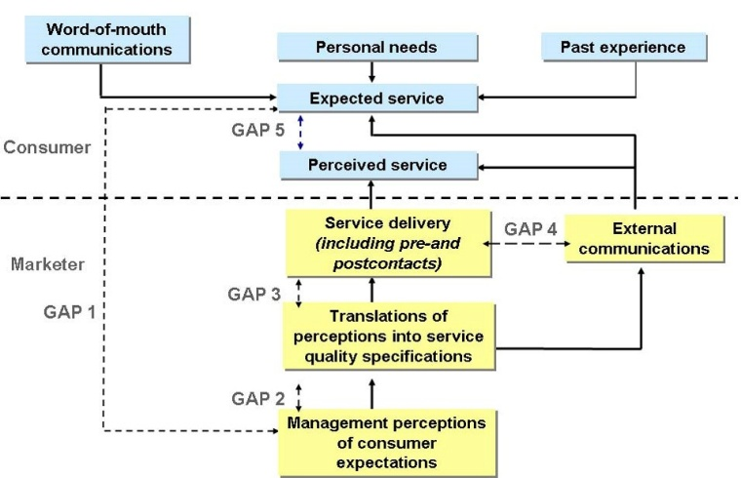
Source: https://en.wikipedia.org/wiki/SERVQUAL
GAP 1 - The Knowledge Gap:
Knowledge Gap can be defined as the gap between customer expectations of a product or service and the actual product or service (Jain, Aagja and Bagdare, 2017). This gap signifies the different between the management perception of what customers want and the actual demands and requirements of the customers. It may arise due to a number of reason which contribute to the lack of knowledge of management such as ineffective market survey, inability to listen to customer grievances.
Ranking:
I will give 9/10 to TESCO for the knowledge gap since the management is able to provide products which cater to the needs of customers for example the company launched an entire range of organic food items with high nutritional content to address the customer requirement of healthy food items. I will rate 8/10 to both Sainsbury’s and Aldi.
GAP 2 - The Policy Gap:
The policy gap can be defined as the gap which arises out of the ability of translating the management understanding of customer needs and requirements into a successful deliver of product or service (Stein and Ramaseshan, 2016). Policy gap don’t arise due to a difference in management perception of customer needs but because of lack of the ability of conversion of that understanding into the product. In the context of TESCO, the management of the company was aware about the customer need of cosmetic products and the company launched a range of beauty and cosmetic products but the quality expectations of customer could not be met.
Ranking:
I will give 9/10 to TESCO regarding policy gap and I will give 8/10 to Sainsbury’s and Aldi.
due to scope of improvement in their policies and customer requirements.
GAP 3 - The Delivery Gap:
The delivery gap arises out of the difference in the policies and expectation of service delivery and the actual delivery of service which may be due to a number of factors such as poor employee training, lack of measures to ensure expected delivery standards etcetera. TESCO has recently launched a new sales platform for online sales where customers can easily shop by being at home with a few clicks and the company was not able to deliver the products at the time which was expected or promised due to bulk orders which resulted into a delivery gap (Bagdare and Jain, 2013). The management of TESCO is assigning delivery slots and asking customer for delivery preferences to ensure mitigation of delivery gap.
Ranking:
I will give 8/10 to TESCO because of glitches in online delivery and 9/10 to Sainsbury’s and 8/10 also to Aldi because of small delivery gap which I think exists in their services.
GAP 4 - The Communication Gap:
Communication gap arises due to a difference in what is being promised to the customers through different mediums and channels of marketing and what actually gets delivered to the customers (Rawson, Duncan and Jones, 2013). Generally, companies put a lot of efforts in designing their marketing campaigns which sometimes lead to a unconscious overpromising which in future becomes the reason for the dissatisfaction of customers. TESCO is making sure that the marketing campaigns of the company are in close stimulation with the actual benefits and advantages of the product and there is no scope for any communication gap to exist. The company is also providing product brochures on various platforms to ensure proper information about the product is being conveyed to the customers.
Ranking:
I will give 10/10 to TESCO for effective communication and 8/10 to Aldi for sometimes misleading advertisements and 9/10 to Sainsbury’s.
GAP 5 - Customer Gap:
Customer gap is a gap in service quality which arises out of a difference in customer expectations and customer perceptions related to a product or service (Klaus and Maklan, 2013). Expectations of a customer is highly influenced by various factors such as online advertising, word of mouth, background of customer etcetera. On the contrary, customer perception is highly personalized and subjective in nature and is essentially based on the interaction of the customer with the product. TESCO has provided the provision of returning the orders and products if the customers are not satisfied and the company is also taking frequent surveys to identify any such gap if it exists at all.
Ranking:
As a customer of TESCO, I think my expectations are being met by TESCO and I will give a 9/10 to TESCO and 8/10 to both Sainsbury’s and Aldi because of low quality of service and products which I have experienced in the past.
SUMMARY TABLE:
GAP | TESCO | ALDI | SAINSBURY’S
The Knowledge Gap | 9 | 8 | 8
The Policy Gap | 9 | 8 | 8
The Delivery Gap | 8 | 8 | 9
The Communication Gap | 10 | 8 | 9
The Customer Gap | 9 | 8 | 8
Total | 45/50 | 40/50 | 42/50

CONCLUSION
It can be concluded from the above report that customer experience and value is an important determinant of the customer satisfaction which helps in further determination of a company’s performance. Factors such as product specifications, price, brand have the potential to impact the perceived value for customers (Lemon and Verhoef, 2016). It has been observed that TESCO is taking measures to increase the favourability of factors which impact customer value. At last it can be concluded from the SERVQUAL model and the Gap Model of Service Quality that the management of TESCO is effectively managing the quality systems to meet the requirements and expectations of the customers.

REFERENCES
Books and Journals:Bagdare, S. and Jain, R., 2013. Measuring retail customer experience. International Journal of Retail & Distribution Management.
Chowdhury, B.N., 2016. A critical analysis of customer loyalty and customer satisfaction-a case study on Tesco Club Card (Doctoral dissertation, University of East London).
Dinçer, H., Yüksel, S. and Pınarbaşı, F., 2019. SERVQUAL-based evaluation of service quality of energy companies in Turkey: strategic policies for sustainable economic development. In The circular economy and its implications on sustainability and the green supply chain (pp. 142-167). IGI Global.
Ihtiyar, A. and Ahmad, F.S., 2012. Measurement of perceived service quality in the food retail industry of Turkey. International Business Management. 6(2). pp.249-255.
Jain, R., Aagja, J. and Bagdare, S., 2017. Customer experience–a review and research agenda. Journal of Service Theory and Practice.
Klaus, P.P. and Maklan, S., 2013. Towards a better measure of customer experience. International Journal of Market Research. 55(2). pp.227-246.
lal Bhardwaj, N., 2012. Consumer buying behaviour toward carbon labelling (FMCG) in Tesco supermarket. International Journal of Data and Network Security. 1(2). pp.1-11.
Lemon, K.N. and Verhoef, P.C., 2016. Understanding customer experience throughout the customer journey. Journal of marketing. 80(6). pp.69-96.
Mollah, A.S. and Sharif, A., 2014. The impact of relationship marketing on customer loyalty at Tesco Plc, UK. European Journal of Business and Management. 6(3). pp.21-55.
Mukerjee, K., 2013. Customer‐oriented organizations: a framework for innovation. Journal of Business Strategy.
Peeroo, S., Samy, M. and Jones, B., 2015, December. Customer engagement manifestations on Facebook pages of Tesco and Walmart. In 2015 International conference on computing, communication and security (ICCCS) (pp. 1-8). IEEE.
Peeroo, S., Samy, M. and Jones, B., 2016, September. Generating Customer Engagement and Customer Enragement on Facebook Pages of Tesco and Walmart. In Conference on e-Business, e-Services and e-Society (pp. 146-156). Springer, Cham.
Peppers, D. and Rogers, M., 2016. Managing customer experience and relationships: A strategic framework. John Wiley & Sons.
Rawson, A., Duncan, E. and Jones, C., 2013. The truth about customer experience. Harvard Business Review. 91(9). pp.90-98.
Razak, I., Nirwanto, N. and Triatmanto, B., 2016. The impact of product quality and price on customer satisfaction with the mediator of customer value. Journal of Marketing and Consumer Research. 30(1). pp.59-68.
Šambronská, K., 2013. GAP model as one possibility of evaluating hotel service quality. Prace Naukowe University Ekonomicznego we Wrocławiu. (303). pp.247-254.
Siami, S. and Gorji, M., 2012. The measurement of service quality by using SERVQUAL and quality gap model. Indian Journal of Science and Technology. 5(1). pp.1956-1960.
Stein, A. and Ramaseshan, B., 2016. Towards the identification of customer experience touch point elements. Journal of Retailing and Consumer Services. 30. pp.8-19.
Vorasaiharit, N. and Thawesaengskulthai, N., 2016, January. Integration of SERVQUAL model with quality function deployment to enhance library’s service quality. In International Conference on Engineering Technologies and Big Data Analytics (ETBDA’2016) (pp. 78-84).
Vu, M., 2016. IS THE BALANCED SCORECARD USEFUL IN A COMPETITIVE INDUSTRY?: Using Tesco PLC as a case study in the UK grocery retail industry.
Yi, Y. and Gong, T., 2013. Customer value co-creation behaviour: Scale development and validation. Journal of Business research. 66(9). pp.1279-1284.
Younus, S., Rasheed, F. and Zia, A., 2015. Identifying the factors affecting customer purchase intention. Global Journal of Management and Business Research.
Online
Addressing the sustainability challenges in our top 20 products and ingredients. 2020. [Online] Available thru<https://www.tescoplc.com/sustainability/sourcing/top-20/>
TESCO list of organic items. 2019. [Online] Available thru<https://www.tesco.com/groceries/en-GB/products/252380883 >
TESCO’s history. 2020. [Online] Available thru<http://www.tescobengaluru.com/about-us/tescos-history/>
Understanding the SERVQUAL Model. 2015. [Online] Available thru< https://www.marketingstudyguide.com/understanding-the-servqual-model>
SERVQUAL. 2020. [Online] Available thru< https://en.wikipedia.org/wiki/SERVQUAL/>
Is Lidl really cheaper than TESCO, Aldi and Sainsbury’s. 2019. [Online] Available thru< https://www.which.co.uk/news/2019/02/best-and-worst-supermarkets-for-2019/>

