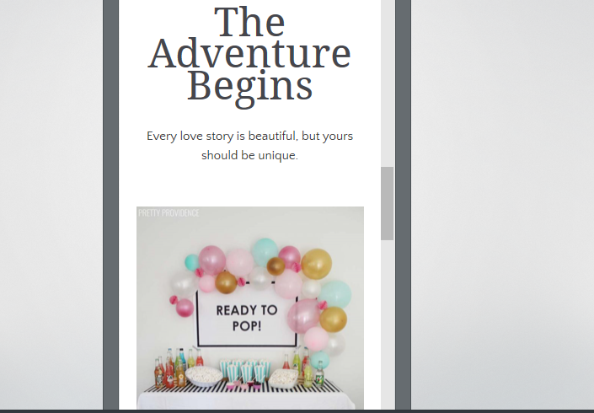

About my site I was trying to use the same pictures from my poster, to use light colour and some pictures that can show to my customers about my offers and I add a bit about me I use one of my picture I think that its can be useful because when I am searching for some service I wish to saw person who will organize like that I can understand a bit about person first impression its good. Use on website pictures or video from previous event its will be much helpful for customer to choose a right event planner. Website its not perfect its just first probation and describe about my future business during the period when business grow up you can add more and more and make a website more interesting and attractive for customers. Also, they can add comment about impressions or just ask about something that they want to know. On present website are one of first step were people are looking for different things, having on social media some samples about your service can help you a lot. I use also use pictures from different events and express like that what kind of services I have , on fundal page I choose something with flowers , and things that help me for work and show that everything its done by me not prepared by someone else, handmade all the time are required from customers and its shows your imaginations and unique style , people should find a website useful and interesting so explore a website they can imagine how the event will be , beside the pictures must contain some planification or examples for one or another event and its suppose to be on main page so people are getting interested and they scrolling down for more information and until end they will decide to ask some questions. And preparing new parties after you can add more information and make your site more attractive. Prepare a good website you can have more view and put on top of the list , also should be some staff that can show to people how performing you are and how do you like to do that you are doing. Colourful website its all-time attractive, when you design your site you have to do like how do you want to see this as a customer , you have to be a customer who looking for organize an event yes different people different opinion but you can do better day by day. So this one its just a start and future a website will develop together with my business.
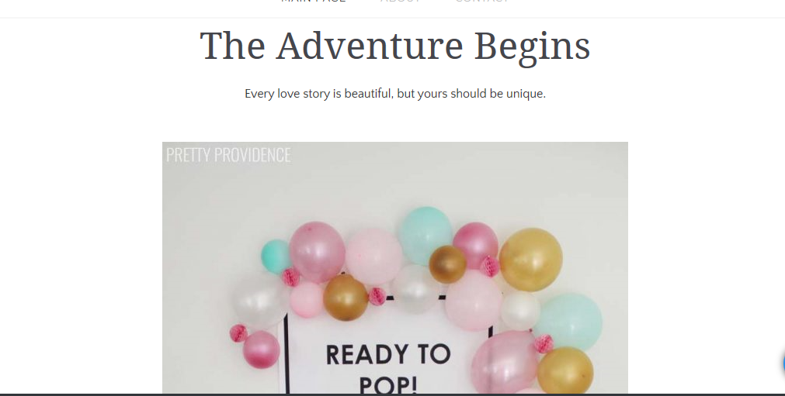
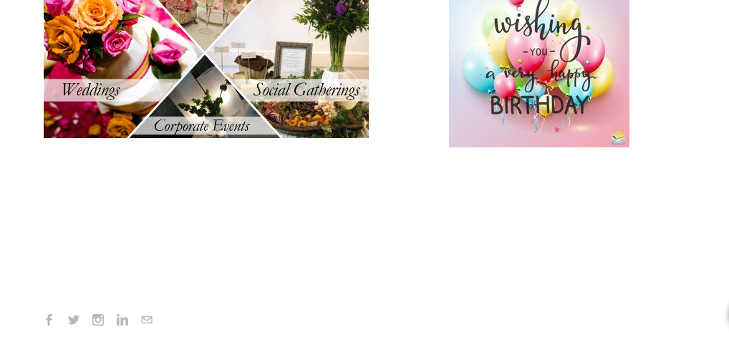

My email : 19008789@gmail.com
Password : Student20

