Name: Chris Morris
Student number: P149915
Module title: Network and Data Centre Management
Module component: Assignment 1
Module code: ACCA6001
Lecturer: Carlene Campbell
Abstract
When creating a network data centre several decisions need to be made based on a set of criteria. After being built, the network can grow further with enough scaliblity and implement features such as Machine2Machine Communication. It is important that enough planning and teamwork is present throughout.
Introduction
The objective is to create an enterprise network encompassing five campuses and include features such as server farms and core switches to help the network function at a consistent level.
This created data centre will then be used to touch upon one of the preselected topics given for this task, which in this case has been chosen to be Machine2Machine Communication.
Content
Task 1
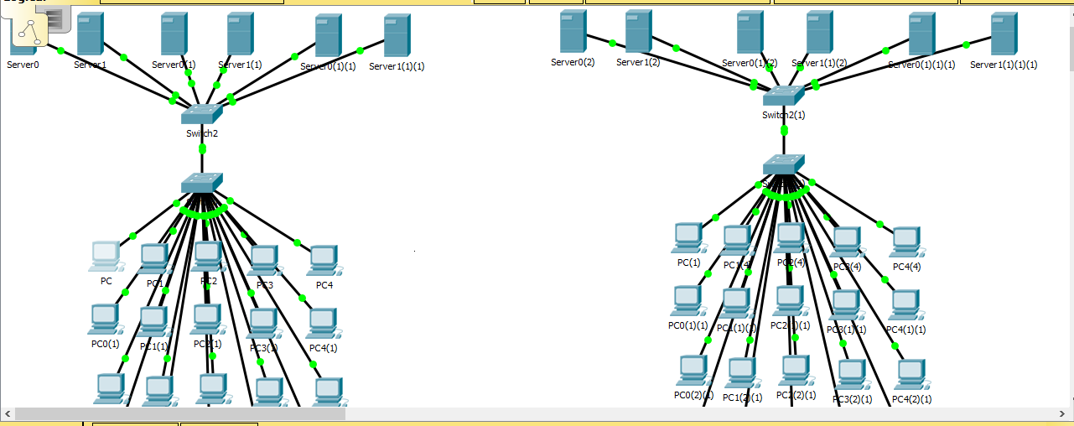
A network was created that encompassed five campuses; Carmarthen, Lampeter, London, Malaysia, and Swansea. Each campus was given twenty PC’s as a rough estimation. This was judged to be an amount that was too many but enough to provide enough infrastructure to potential build upon.
The PC’s were then equipped to a central switch tasked with providing a gateway from them to any servers. There were three main servers (Extranet, Internet, and Intranet), each of which was provided with a backup.
An extranet server will help handle any information that relates to outside organisations. Internet will allow for access to the namesake application, helping a business achieve its business targets.
Lastly, Intranet servers tend to be a mixture between the two (based on one’s objectives), granted to only authorised personnel. Therefore, it is important to reflect on which server is required for the correct instance. [1]
The network was planned with this layout because it would allow for clear separation of each campus and make future expansion easier. Also, having backup switches and servers will prove helpful in the case of a network disaster as it will result in less delay.
The locations are placed in alphabetical order for simple clarification. The author believes that this layout will is beneficial to help guide users who are unfamiliar and provide a platform which can easily be scaled up in future.
When a network data centre is created, several questions need to be posed to ensure it meets criteria [2], such as how much it can be scaled up in future and how it effects current equipment and infrastructure. Therefore, communication and co-operation is required between the engineers who programme the data centre and the administrators who control it.
Each device was given a unique IP address for simple identification. The assumption was that having static IP addresses would be safer due to giving the centre more control over them. Each device was configured with an address beginning with 192.168, a familiar and consistent scheme.
Each location was given a different last portion of the network address to differentiate between them. Any remaining host addresses in a location can be applied later to future scaliblity and additional devices.
The security measures implemented include encrypted passwords to allow only authorised personnel to access the centre configuration. The passwords were kept the same throughout for simplicity and to strengthen the accessibility for those who have been granted access.
Lastly, in terms of storage each location has been provided cloud storage. The main reasons for this are to save costs and provide a remote location away from the network to help protect storage in the case of a malfunction.
Task 2
Machine2Machine Communication a process utilised by both wired and wireless networks where data can be sent and devices can confer with each other to help accomplish tasks such as the separation of data. [3] [4]
The overall of a Machine2Machine infrastructure [5] [6] is for device involved in the process to collaborate on how to control all the data it receives and choose one device to be the “intelligent device”, which acts as the main gateway and controls the data packets. Data can either be sent downlink when being sent or uplink if being received.
Data is retrieved and analysed through aa process named telemetry (the way in which data is exported to the devices in the first place) and the results are laid out ready for analysis, similar to the three-handshake process commonly used in computer networking.
Machine2Machine is a very similar process to that of Internet of Things (IoT), the structure which allows devices to easily connect to the Internet. However, the main difference is that M2M does the same primarily for wireless sensors and is regarded as a more specific concept while IoT is a broad scheme for linking networks.
The areas in which Machine2Machine can excel in include [7] monitoring a network and reporting any issues while using as little storage as possible. It can also assist with only activating devices when it needs to in order to preserve data and store data for departments (e.g. manufacturers).
There are several advantages of machine-to-machine [8], specifically the fact that communication becomes easier as devices are linked together, allowing them to cope with growing demand [9] and work in a more logical way.
This streamline has the aforementioned resulting effect of cutting costs, having a greater control over scalability in the process. However, the drawbacks [10] include how expensive they are to implement in the first place and provide less flexibility as they provide predetermined guidelines.
In terms of the network composed in Task 1, Machine2Machine could be implemented to make the business goals easier to achieve (specifically with the servers).
M2M can also help divide data into three main categories [11]; Internet data, any hardware such as sensors that are linked together, and lastly any data that requires approval and translation into an acceptable data format.
An example of a paper that analyses Machine2Machine is from Kalyani, Gaur, Priya, Vijay, and Vats. [11] This paper, published in the International Engineering and IT journal in 2015, analyses M2M, including the features and how important it could prove in the future.
The overall conclusion is that Internet access is growing in demand to this day and therefore M2M will serve as an important element of linking networks together, as will IoT.
This paper is useful because it helps provide indication as to how the network created in Task 1 can grow in future. For example, it could expand with a higher amount of devices as supply grows and include features such as VoIP (Voice over Internet Protocol).
Conclusion
Overall, a network was created to demonstrate understanding of how a network data centre functions and the features that are included it in such as cloud storage and the creation of an IP addressing scheme if necessary.
Also, Machine2Machine communication (which allows devices to operate in a smarter fashion) was discussed, including the positives of cutting costs but the drawbacks of less flexibility.
When building a data centre, one must consider factors such as scaliblity and security in order to maximise future growth and keep protection consistent. Therefore, prior planning is important to the process.
References
[1] Verisign, “Guide to Securing Intranet and Extranet Servers.”
[2] A. Greenberg, D. A. Maltz, and J. R. Hamilton, “VL2: A Scalable and Flexible Data Center Network,” 2009.
[3] B. Van Lier, “Can Machines Communicate? - The Internet of Things and Interoperability of Information,” Eng. Manag. Res., vol. 2, no. 1, pp. 55–66, 2013.
[4] D. Barretto, C. Miranda, and W. Holland, “Internet of Things.” 2015.
[5] P. K. Verma et al., “Machine-to-Machine (M2M) communications: A survey,” Journal of Network and Computer Applications, vol. 66, no. May, pp. 83–105, 2016.
[6] R. Prasad, S. K. Prasad, and C. Engineering, “The next Wireless Generation 5G : Technologies and Applications,” International Journal of Research and Engineering, vol. 03, no. 11, pp. 22–25, 2016.
[7] TEC, “Machine-to-Machine Communication (M2M),” 2011.
[8] C. Mobile, “The benefits of M2M – a clever connectivity management platform,” 2017.
[9] I. Raritan, “An Introduction to Data Centre management,” 2010.
[10] A. Ghosh, P. K. Gajar, and S. Rai, “Bring Your Own Device (Byod): Security Risks and Mitigating Strategies,” J. Glob. Res. Comput. Sci., vol. 4, no. 4, pp. 62–70, 2013.
[11] V. L. Kalyani, P. Gaur, S. Priya, V. Vijay, L. Kalyani, and S. P. Vats, “IoT : ’ Machine to Machine ’ Application A Future Vision,” Journal of Management Engineering and Information Technology, no. 4, pp. 2394–8124, 2015.

marking criteria and Student FEEDBACK

This section details the assessment criteria. The extent to which these are demonstrated by you determines your mark. The marks available for each criterion are shown. Lecturers will use the space provided to comment on the achievement of the task(s), including those areas in which you have performed well and areas that would benefit from development/improvement.

Common Assessment Criteria Applied (Assignment 1) | Marks available | Marks  awarded
1. Research-informed Literature
Extent of research and/or own reading, selection of credible sources, application of appropriate referencing conventions.
You have provided evidence of your research reading. You have use suitable references (Grade mark: 53.33%) | 15 | 8
2. Knowledge and Understanding of Subject
Extent of knowledge and understanding of concepts and underlying principles associated with the discipline.
You have demonstrated understanding of the underlying concepts and principles. (Grade mark: 53.33%) | 15 | 8
3. Analysis
Analysis, evaluation and synthesis; logic, argument and judgement; analytical reflection; organisation of ideas and evidence
You have discuss your research aspect but this area need some more improvement with more detailed discussions. You have discuss and explain your design implementation. (Grade mark: 53.33%) | 30 | 16
4. Practical Application and Deployment
Deployment of methods, materials, tools and techniques; application of concepts; formulation of innovative and creative solutions to solve problems.
You have implemented working network for all campuses. However, they are isolated from each other. You need to show how they are interconnected and what technologies you would use to interconnect them. (Grade mark: 46.67%) | 30 | 14
5. Skills for Professional Practice
Attributes in professional practice: individual and collaborative working; deployment of appropriate media; presentation and organisation.
Your work require some formatting to look more presentable and professional. It would be good to put spaces between each headings or a new page. (Grade mark: 50.00%) | 10 | 5

Assignment Mark (Assessment marks are subject to ratification at the Exam Board. These comments and marks are to give feedback on module work and are for guidance only until they are confirmed. ) | Late Submission Penalties (tick if appropriate) |  | 51%
 | Up to four weeks late |  | 51%
 | First Attempt? |  | 51%

