
“A child’s experience between the ages of 0 – 5 years will affect the rest of their lives”

Introduction:In this poster I will explain how a child’s experience between the ages of 0-5 years will affect the rest of their lives using and bringing informations based on Piaget’s theory of cognitive development and Vygostky’s theory of social constructivism. Also, in this poster, I will give an example of how a parent can support their child’s development using Erik Erickson’s theory about child development.
Piaget’s theory of cognitive development
Piaget(2015) said that rather than trying to explain individual differences ( why some children are more intelligent than others), Piaget was intested in how intelligence itself changes as children grow. He called this ‘genetic epistemology’’.
According to Piaget(2015), cognitive development occurs through the interaction of innate capacities with environmental events and progresses through a series of hierarchical, qualitatively different, stages.The age between 0-5 years has 2 stages of cognitive development: sensorimotor(0-2 years) and pre-operational(2-7 years).
The sensorimotor stage: As Piaget(2015) explained this stage last for about the first two years of life. Babies experience the world primarily through their feelings ("sensori") and through actions ("motor"). This was from the observation of his own children.
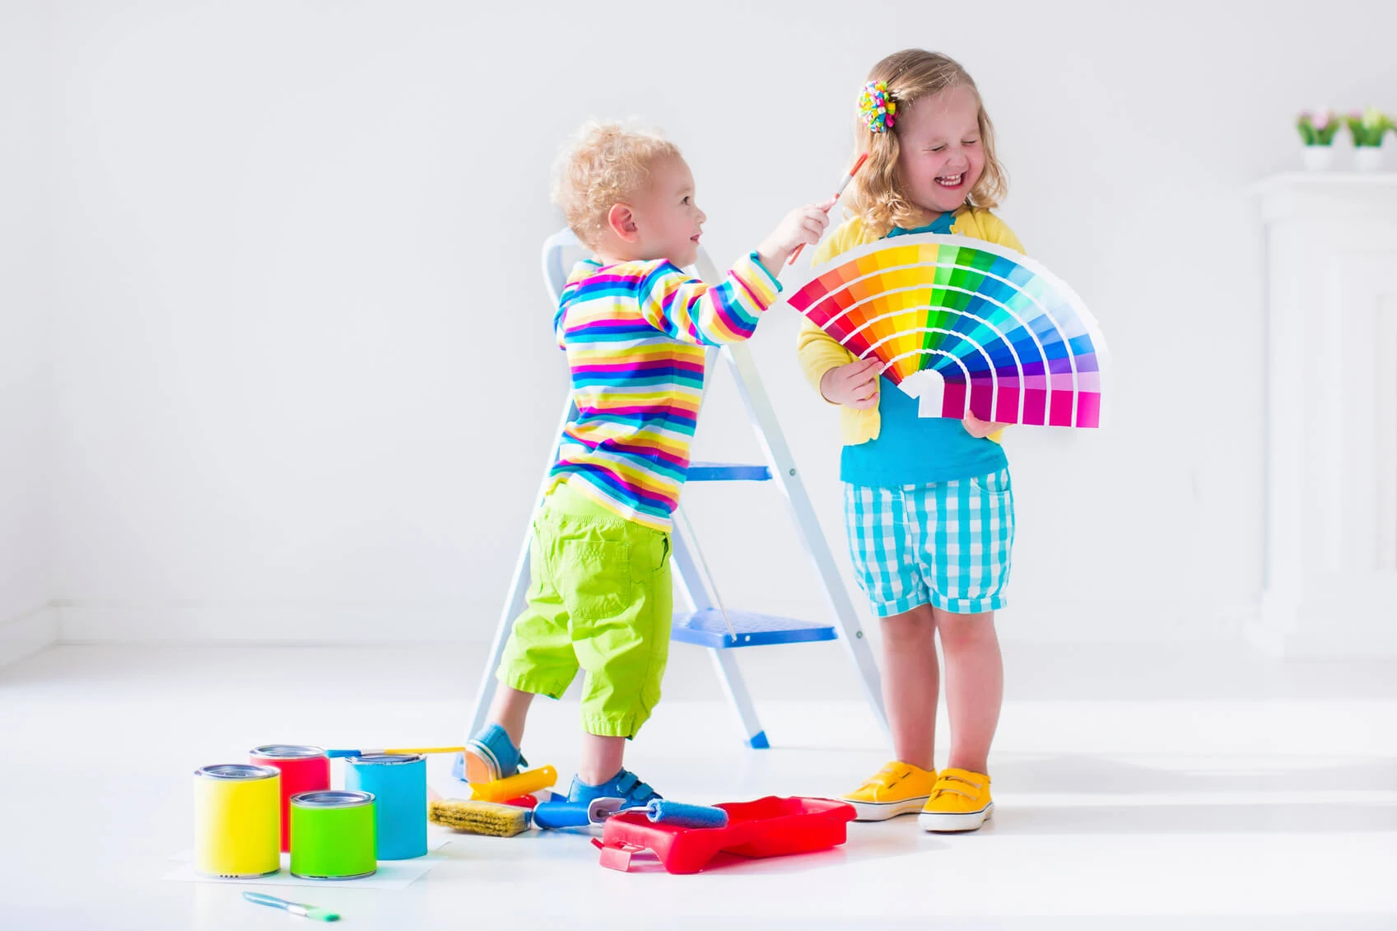
During the sensorimotor stage, a range of cognitive abilities develop. These include: Object Persistence; Self- knowledge Late resemblance and representative sports. They are associated with the emergence of a common symbolic function, the ability to mentally represent the world. The key to success at this stage is the stability of the object - knowing that the object still exists, even if it is hidden. This requires the ability to create a mental picture of the goal. Towards the end of this phase, a typical symbolic function begins to emerge when children show in their play that they can use one object to represent another. Language is beginning to emerge because they understand that words can be used to refer to objects and feelings. Priority Stage: Toddlers and young children acquire the ability to represent the world through language and mental images. At this stage, young children can think about things symbolically. It is the ability to create something, like a word or an object, that has meaning other than itself. Piaget(2015) said that the pre-operational stage is the continued development and use of internal images, symbols and language, especially important for the child’s developing sense of self-awareness.Thinking is still intuitive (based on subjective judgements about situations) and egocentric (centred on the child's own view of the world).
Vygotsky’s theory of social constructivism:
Language is the basis for Vygotsky's ideas on social interaction. Speech development takes place in three stages: external, irritable, and internal speech. External or social discourse occurs three years from birth. Infants use language to communicate their feelings, express their feelings, and share simple words. They use language to express their needs and also respond to the words of their parents. You can begin to see the social impact on behaviour at this stage based on the responses to their requests. Although infants use language to control their needs, people around them express their approval or disapproval based on their behavior. This leads to a person's cognitive development. The next stage, irritating speech, occurs between the ages of three and seven. When they begin to rationalize their actions or behaviour internally, children begin to talk to each other. This internal speech helps them control their reasoning and organize their thoughts. They continue to define meaning by the reactions of others, further aligning cultural beliefs with their own cognitive development. Vygotsky thought that without language, we would be limited to a more primitive function. Language is ultimately a tool for communicating the behaviour we desire and therefore enabling the development of society and its culture.

How a parent can support his child’s development:
The role that a parent should have regarding the child’s development is to provide encouragement, emotionally support, shelter, food and safety. In my opinion, these are the key needs for a child to have a healthy social life. Erikson explain in his theory how important and crucial is the parent role in a child development. From birth to age one years, he named this ‘trust versus mistrust’ stage. During this phase, if children are consistently provided all their basic needs such as food, clean diapers, warmth, and loving affection and soothing from caregivers, they will learn that they can trust other people in their environment to love them and to take care of them, and they will believe the world is good. Between the age of one-three years, is the period when the child starts to develop knowledge about things and they feel like they know everything and wants to be independent. As Erikson shows and explains, in this stage the parents should be very supportive and let the child be independent as he feels, encouraging the child without shaming or ridiculing the child. The third stage, initiative versus guilt, spans ages three to six years. When children develop initiative, they continue to develop their self-concept and gain a desire to try new things and to learn new things while being responsible for their actions to some extent. If caregivers continue to give children a safe space to experiment and appropriate stimuli to learn, the children will continue to find their purpose. However, if caregivers try to create too many strict boundaries around what children can do and to force too much responsibility on kids, children will feel extreme guilt for their inability to complete tasks perfectly.

Andreea Catalina Paun
1919504

Annotated bibliography
Angela Oswalt(2021) Child and Adolescent development: Overview Erik Erikson and child development. Available at: https://www.gulfbend.org/poc/view_doc.php?type=doc&id=7927 (Accessed: 27 February 2021)
This source is about Erik Erikson’s theory about human stages development from birth to death by dividing them in several age periods. Erikson's theory describes what types of stimulation children need at each stage in order to master the stage and become active and well-adjusted members of society, as well as the types of problems and developmental delays that can arise if this stimulation is not provided. The source that I used is credible and reliable, because it provides sources for supporting ideas and they’re reliable. All the information written there are having the purpose to inform people. Also, a date of publication as well as author and publisher name appear in the source. To create the poster I used this source firstly by reading the information and paying attention on specific ideas that I needed. Then, I gathered every information that was linked with what is my poster about and my opinions as well creating solid arguments on how a parent can support his child’s development, how crucial is the parent role in a children life and what advantages and disadvantages a parent can bring according to their way of education.
Dr. Saul McLeord(2020) Piaget's Theory and Stages of Cognitive Development. Available at: https://www.simplypsychology.org/piaget.html (Accessed: 24 February 2021)
In this source is shown and explained the stages between 0-7 years based on Piaget’s theory of cognitive development, how children react to different kind of things and how they urnderstand. In the first stage, sensorimotor stage, it’s about cognitive abilities and how they develop and last from 0-2 years. The second stage is the pre-operational stage developed by children using internal images, symbols and language, helping the child develop his sense of self-awareness. In this source appears the name of the author, year of publication that is also updated and all the references used, making the source credible and reliable. I’ve used this source by reading and trying to understang the theoru of cognitive development for children so I can have ideas on how to explain and how to put all the informations in my poster.
Dr.Serhat Kurt(2020) Lev Vygotsky – Sociocultural Theory of Cognitive Development. Available at: https://educationaltechnology.net/lev-vygotsky-sociocultural-theory-of-cognitive-development/ (Accessed:1March 2021)
In this source is explained based on Erikson theory about child development about how parents can facilitate the development of a child's mechanism for dealing with stress and novelty in their environment. With repeated positive experiences, a trust and relationship is formed between the child and the parent, as a result of which the child eventually has to internalize that trust and then their education is generalized. This sensitive support for new experiences promotes the child's continued participation in learning activities with his parents. Also, is explained how crucial is the role of the parents in their child life and how the child can be affected if he is not living in a healthy environment socially and emotionally. By having an author, a date of publication and all the sources used for the source, we can confidently say that the source is credible and reliable. I used this source specifically for the part in my poster where I had to write about one practical example on how a parent can support their child’s development. All the informations that I needed I have found them in this source and helped understand and have a perception regarding the child development and the parents role in it.
First Discoverers(2020) Child Development Theories: Lev Vygotsky. Available at: https://www.firstdiscoverers.co.uk/lev-vygotsky-child-development-theories/ (Accessed:1March 2021)
This source is about, according to Vygostky, how social interaction is a big factor in a child development and how he acquire behaviour and cognitive processes relevant to his own society. In this source we can see that the informations are having the purpose to educate schools, references are shown withing the source along with a date of publication making the source reliable.
Parent Line(2021) Worried about your child’s development? Here’s five places where you can get support. Available at: https://www.parentline.org.au/worried-about-your-childs-development-heres-five-places-where-you-can-get-support/ (Accessed: 4March2021)
This source was used by me for design my poster using the image from this site.
Rachel G. and Francesca N.(2015) Psychology: The science of mind and behaviour. Hodder Education Group
This source is about Piaget’s theory of cognitive development and how every stage in a child life intelligence changes his grow, how social interaction and environmental events can affect the child. The source is credible as you can find informations on the internet about the authors. I used this source to make myself understand better how social life can impact a child and his ability to understand and see things from his own perception.
Reload Digital(2016) Don’t Stunt Your Child’s Development! Listen to the Science Behind Nursery Decoration. Available at: https://www.vinylimpression.co.uk/blogs/blog/don-t-stunt-your-child-s-development-listen-to-the-science-behind-nursery-decoration (Accessed:4March 2021)
This source was used to take the image from the site and post it to my poster. The source is reliable by having author name, date of publication and sources shown on the site.
Sherrie Campbell(2017) 10 Things Our Children Need From Us As Their Parents. Available at: https://www.huffpost.com/entry/10-things-our-children-ne_b_10250988 (Accessed:4 March 2021)
Source used for taking the image and using for my own poster purpose design. An credible and reliable source with an author name and date of publication, as well as references shown on the site.
Paraphrasing tool site:
https://myassignmenthelp.com/paraphrasing-tool.php

