Student Name: Silviu Cilica  Student ID: 2225055  Module Title: Foreign Languages & Cultural Awareness  Module Code: BMIH5003  Lecturer: Heidi Prosser  Date: 09.02.2024 | 
ASSIGNMENT 1: PORTFOLIO
(4 Components)

Component 1: Professional Reflection (500 words +/- 10%)

Weighting: 25%
Cross-cultural communication is essential in the hospitality industry, where there are constant changes that help to promote client satisfaction. This reflective essay aims at discussing an event I witnessed while undertaking Level 4 internship with Gregs, my preferred fast-food centre. To be more specific, the occurrence occurred during breakfast service. By making use of scholarly sources that would serve as a source of ideas, this event explores the complexities surrounding adopting multiple dietary preferences such as halal dining practices.
A cultural misunderstanding occurred between a Middle Eastern client and an F&B staff member during one of the hustling morning hours at Greg’s. Since the consumer followed some strict halal dietary rules, he was unable to communicate his requirements properly before professionals from food and beverage department. As a result of the staff’s ignorance regarding halal, they intentionally provided breakfast that did not include ingredients prescribed by the Islamic diet. Andriyani et al. (2019) conducted the study that stresses cross-cultural misunderstanding in tourism sector. This situation is the incarnation of those results. In most of the cases, Middle Eastern guests usually face difficulties when trying to communicate their halal diet restrictions. This emphasizes the importance of cultural intelligence in hospitality workers.
This scene inclined me to consider the statements by Grobelna (2015) relating to intercultural barriers present within hospitality industry. Having an advanced strategy is essential for meeting special dietary needs of people with different specifications such as halal meal preferences. Language training sessions must make emphasis on language skills as a well-grounded knowledge of cultural specifics, especially culinary ones. I understand how essential it is to gain a deeper understanding of what are the halal dietary practices and an insight into Middle Eastern cultural customs for me not adopt any misconceptions such as those which have been created previously. In order to consider this, it is crucial that focused training sessions be incorporated—perhaps influenced by Ruiz-Bejarano’s (2017) analysis of Islamophobia as a possible hindrance against international halal trade. Hospitality professionals can create an equal work environment that respects the dietary needs of a diverse group of customers by advocating in-depth understanding concerning halal standards.
In summary, the events at Gregs revealed challenges involved in satisfying halal dietary requirements within a multicultural environment. It may become clear in the future how vital ongoing education and training are to ensure that people working at food and beverage enterprises have enough knowledge, skill set as well as understanding of such cases. If these approaches are adopted, the hospitality industry might improve its effectiveness to provide a welcoming and culturally sensitive environment for all guests.

References:
Andriyani, A., Djatmika, D., Sumarlam, S. and Rahayu, E., 2019. Learning from face-threatening acts by tourism workers in Bali: The impacts of cross-cultural misunderstanding. Journal of Social Studies Education Research, 10(3), pp.64-81.
Grobelna, A., 2015. Intercultural challenges facing the hospitality industry. Implications for education and hospitality management. Journal of Intercultural Management, 7(3), pp.101-117.
Ruiz-Bejarano, B., 2017. Islamophobia as a deterrent to halal global trade. Islamophobia Studies Journal.

Component 2: Training Plan (500 words +/- 10%)

Weighting: 25%

Identified cultural misunderstanding (in a few words) :
The episode at Greg’s involved an Eastern purchaser who follows halal eating regulations and could not state his specifications in a clear enough manner to communicate them effectively with the Food & Beverage (F&B) personnel member. However, with the lack of halal knowledge and an accent issue, it was not possible to meet his expectations. It emerges that this shows the need of receiving specialised training to raise cultural competence in hotel staff members (Andriyani et al., 2019).

Training plan (Why/What//Who/Where/When):
Cultural competence is very important to this industry because it promises the guests with an enjoyable and dignified journey. The cultural misunderstanding that was evident in Gregs showed why personnel were required to go through specialized training so as they could understand different taste preferences and the complications of halal dining (Andriyani et al., 2019). To create an environment that is embracing and does not disregard customers’ origins, the hotel has invested in this training. This should result in more pleasant experiences and a higher proportion of repeat business.
There are three main components to the training plan:
- Cultural Awareness programme aims to assist employees in understanding cultural aspects, especially dietary patterns as it related to halal diets. The training programme will make employees aware of halal processes and become more mindful when interacting with consumers on a daily basis. Grobelna (2015) notes that after this session, participants would be able to identify and appreciate several cultural standards and traits.
- The language training sessions are a reaction to the problems that arise due to different languages. The objects of these classes will be the commonest expressions and words relating to dietary needs. Employees will attend basic language training to be able to communicate better with diverse guests. It is the purpose of increasing communication effectiveness by fully comprehending guests’ wants and needs (Grobelna, 2015).
- To ensure that employees are appropriately trained in halal standards and certification, the hotel will partner with respected certifying agencies. Thanks to this feature, staff members should be able better identify and cater the needs of customers who have halal diets. Knowledge of the importance of halal certifications is necessary since staff can give informed opinions regarding menu items to guests with certain dietary restrictions (Ruiz-Bejerano, 2017).
This training program must be accomplished by all hotel staff—those in the kitchen and front desk, as well management employees—due to their reasons for visitor contacts. An inclusive approach guarantees that all team members possess the needed level of knowledge to competently address different cultural and food habits. Different departments should communicate with each other because guests need to experience consistent and culturally sensitive services.
The onsite training sessions will be conducted at the current facilities of this hotel. Various interactive workshops and guest speaker sessions can likewise be conducted in areas that foster experiential learning and participation. This strategy enables the practical application of knowledge in a familiar environment, reinforcing cultural competency capabilities retention and execution.
It is going to take six weeks in implementing progressive the training plan. We will arrange appointments during off-peak hours in order not to interfere with your daily routine much. During the training process, progress will systematically be measured by continuous scenario-based assessments and feedback mechanisms (Grobelna, 2015).
References:
Andriyani, A., Djatmika, D., Sumarlam, S. and Rahayu, E., 2019. Learning from face-threatening acts by tourism workers in Bali: The impacts of cross-cultural misunderstanding. Journal of Social Studies Education Research, 10(3), pp.64-81.
Grobelna, A., 2015. Intercultural challenges facing the hospitality industry. Implications for education and hospitality management. Journal of Intercultural Management, 7(3), pp.101-117.
Ruiz-Bejarano, B., 2017. Islamophobia as a deterrent to halal global trade. Islamophobia Studies Journal.

Component 3: Student Self-Reflection (500 words +/- 10%)

Weighting: 25%
The theoretical positioning of Chen et al., (2012) on the role played by culture in hotel management provides basis for pursuing my study into cultural consciousness and hospitality. Initially, my knowledge was based on academic approaches emphasizing cultural understanding an enhancing visitor experiences (Chen et al., 2012).
It was during my Level 4 placement at Gregs where I was able to practice cultural competency from firsthand experience. The formative experience that contributed to my development and impacted on Kolb’s reflective model can be seen in the cultural miscommunication between a Middle Eastern customer, along with an employee of food and beverage department where they could not synchronise (Chen et al., 2012).
Assuming the role of a cultural observer, I have been able to see the real life implications of not looking at everything else from an intercultural perspective using Kolb’s method. This meeting drove home the need for practical skills that go beyond theoretical knowledge and limit one’s point of view through factual experience (Kolb, 2007).
Reflective observation allowed me to see that cultural competency is not only a theory, but something one should always be conscious of and think about. This knowledge made me pay more attention to the difference between theory and practice, as well as I joined cultural subtleties in my research (Kolb, 2005).
The application of theoretical frameworks, such as those offered by Chen et al., into practice presents an important aspect of abstract conceptualization. Chen et al. paved the way towards a new perspective on cultural consciousness which could be utilized in the hospitality industry (Chen et al., 2012).
Through the process of active experimentation, I managed to develop a strategy for practice-application that would narrow down theory and practice practices. As a means for hotel employees to translate their theoretical knowledge into action, Chen et al. (2012) recommended that they should engage in an organized cyclic training programme which encourages active experimentation.
Over time, I began to see cultural awareness for what it really is: far more than just a mere intellectual concept that has no practical relevance. Thus, when knowledge was being gained on a continual basis due to the allowance for iterative learning by Kolb’s methodology itself (Kolb, 2007), I constantly wished only that my approach could become one better.
This learning opportunity enabled the learner to understand that cultural awareness is a journey in which experiences play an important role; therefore, it was not a static talent. This understanding is fundamental in creating a harmonious environment that promotes pleasant guest experiences, minimising confusion as well as developing an all round hospitality climate (Kolb 2005).
It was not until I tried to apply these teachings that the importance of a continuing process learning and adjustments came into being for me as applied it towards my personal development. It has not only made me more appreciative of cultural competence but also inspires my desire to contribute, as better I can in the endeavour find viable answers for increasing those aspects required to create awareness on culture sensitivity in service delivery field.
Finally, taking Kolb’s reflective model as a source for my reflections shows light on how I develop culturally aware consciousness over time within the hotel industry. This event has made my interest in cultural competency large, and now I am eager to create programs that will help hotel owners become more aware of national differences.

References:
Chen, R.X., Cheung, C. and Law, R., 2012. A review of the literature on culture in hotel management research: What is the future?. International Journal of Hospitality Management, 31(1), pp.52-65.
Kolb, D.A., 2007. The Kolb learning style inventory. Boston, MA: Hay Resources Direct.
Kolb, D.A., 2005. David A. Kolb on experiential learning.

Component 4: Training Presentation (6 Slides)

Weighting: 25%

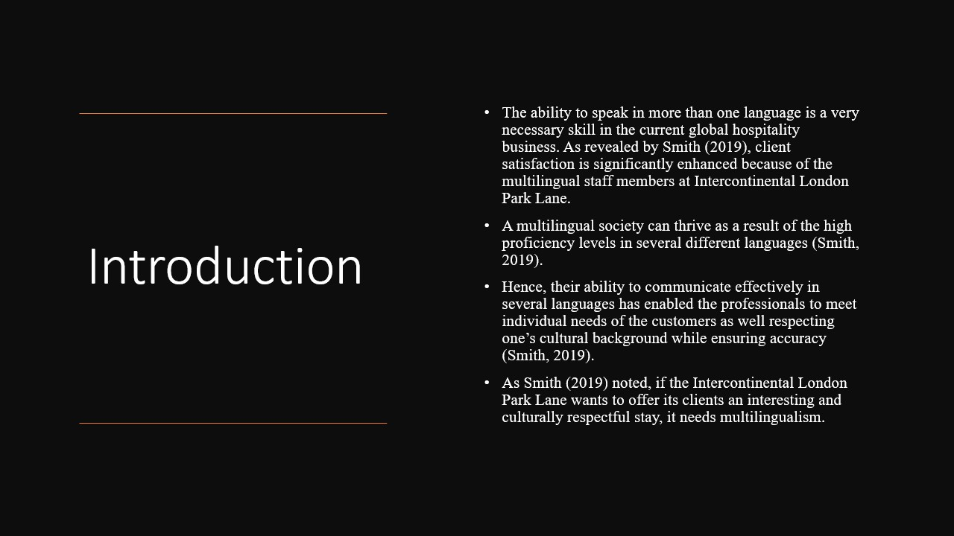
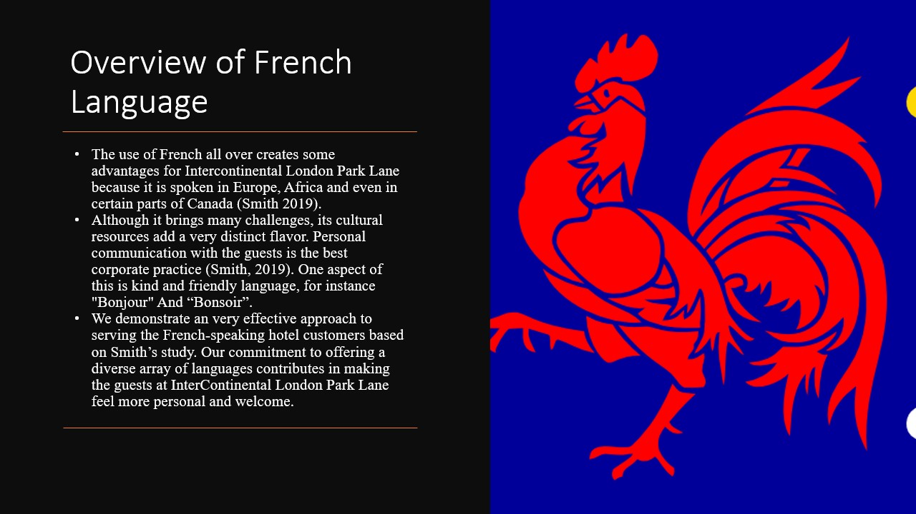
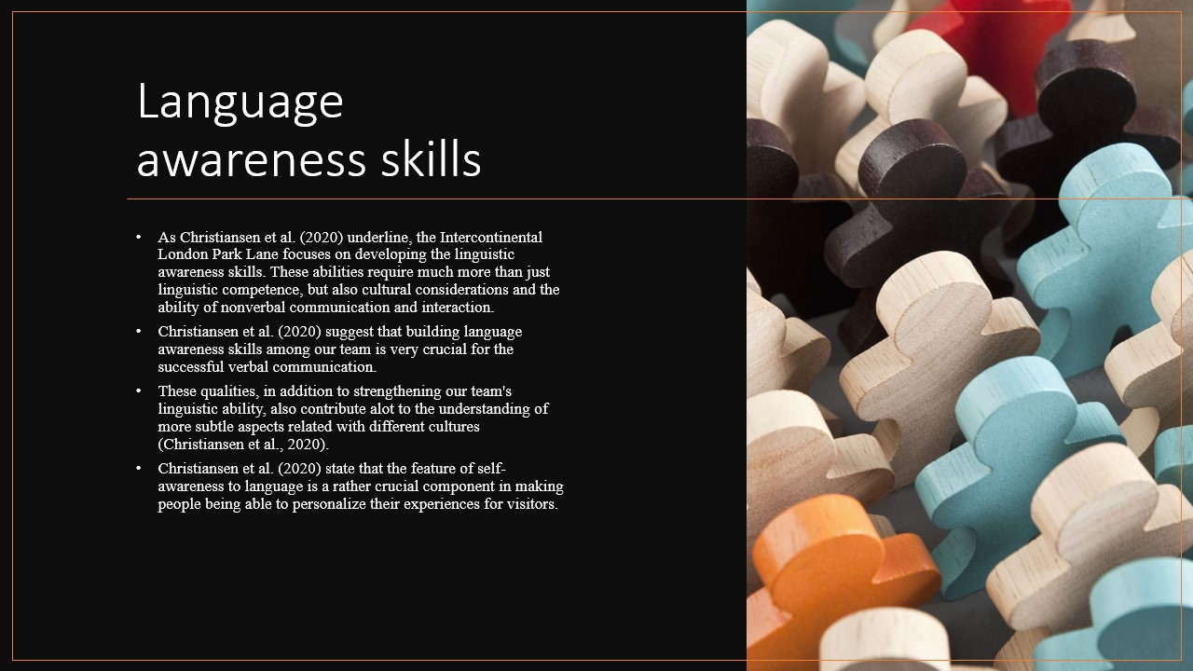
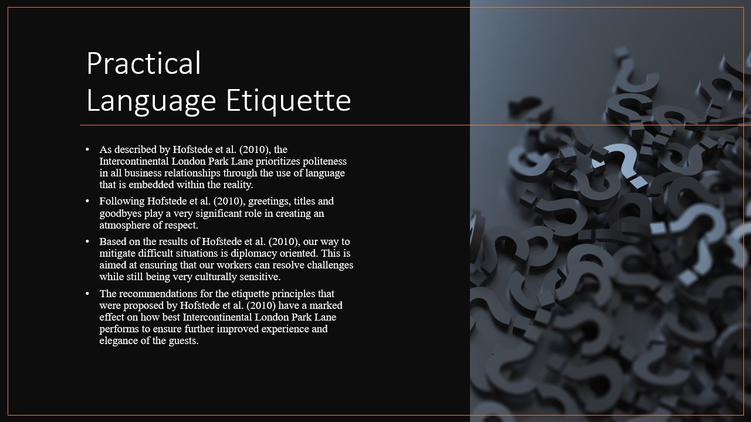
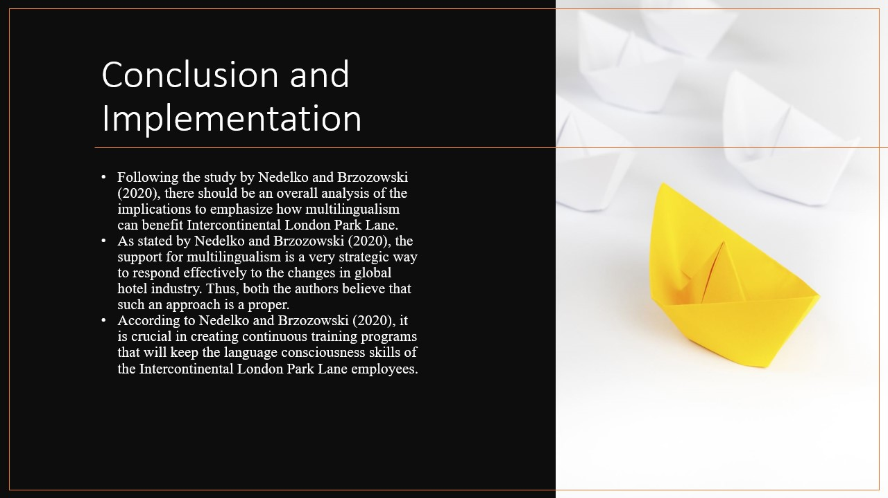
References (no screenshots):
Christiansen, B., Branch, J.D., & Karmowska, J. (2020). "Cultural Factors and Performance in 21st Century Businesses." Hershey: IGI Global.
Hofstede, G., Hofstede, G.J., & Minkov, M. (2010). "Cultures and Organizations: Software of the Mind." New York: McGraw-Hill.
Nedelko, Z., & Brzozowski, M. (eds). (2020). "Recent advances in the roles of cultural and personal values in organizational behavior" in Ordóñez de Pablo, P. Advances in Human Resources Management and Organizational Development Book Series. Hershey: IGI Global.
Smith, J. (2019). "The Beauty of Learning French." Language Journal, 42(3), 210-225.

