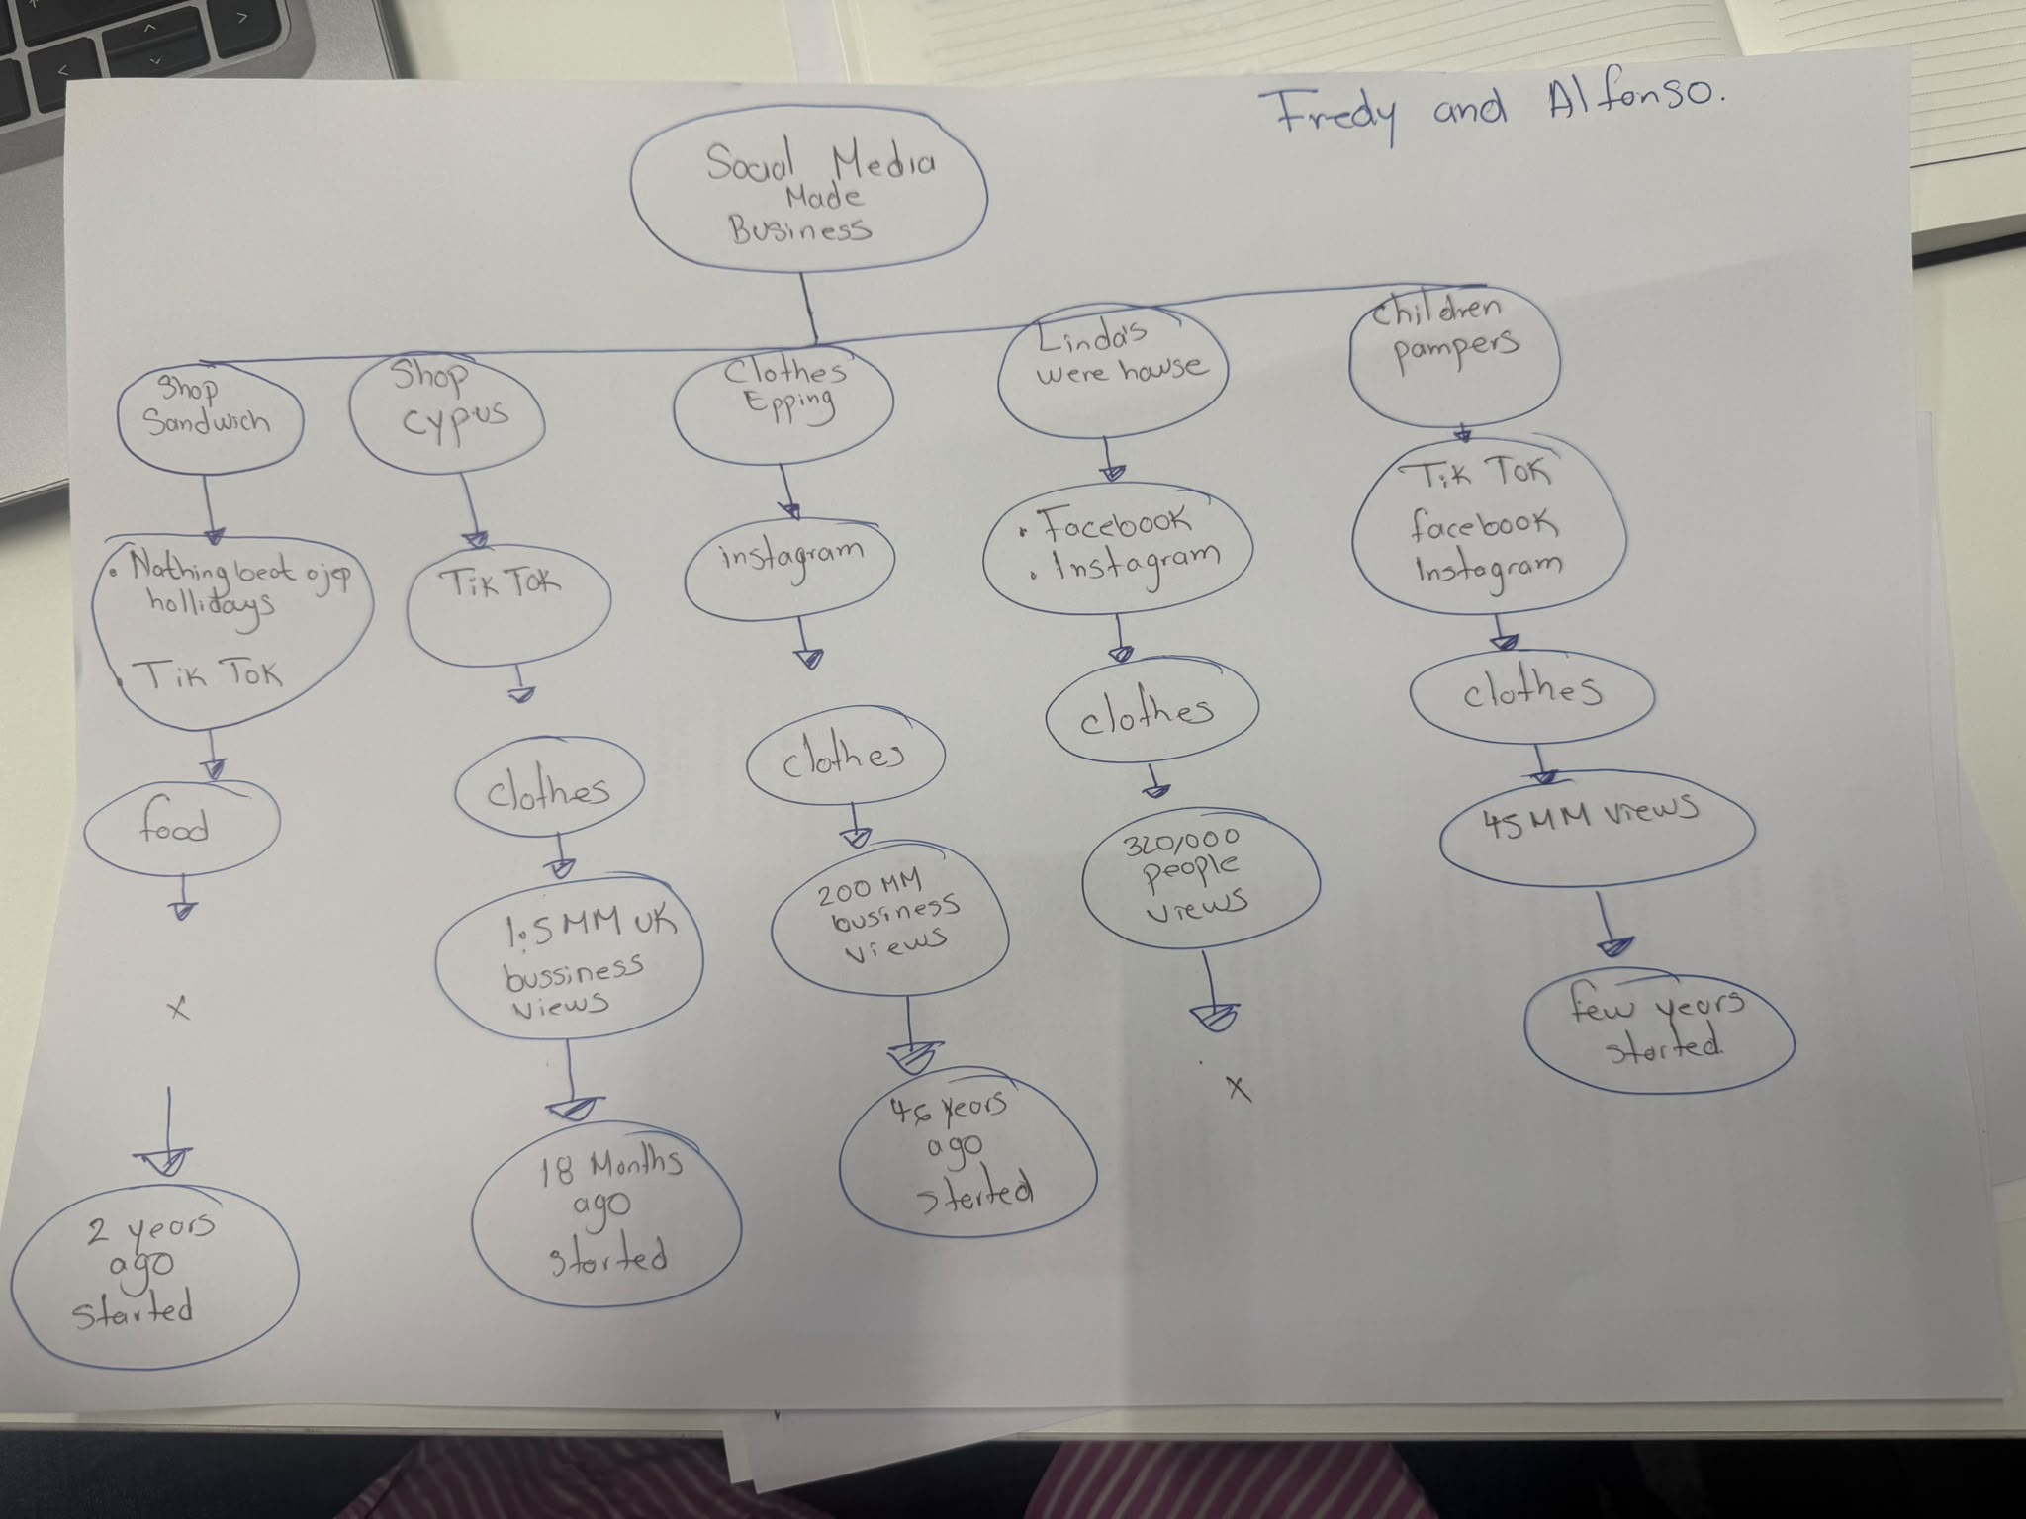

Part 2
- What is the main idea of the whole text?
The main idea is that social media platforms such as Instagram and TikTok can help small businesses rise up so much and attract a lot of attention just by posting and reaching more customers. The article explains how online videos can help them reach more customers and gain more sales from this.

- What is one key point that supports the main idea, and which specific example from the text shows this?

One key point that supports this idea is that through these online videos you can reach customers from further away, for example a customer drove 3 hours to try the chicken burger at Honywood Sandwich Shop in Basildon after an online video was posted about it.

- What is a different key point that supports the main idea, and which specific example from the text shows this?

Another key point that supports the main idea is that social media can help reach the number of customers they can get and gain more sales. For example, Linda Hunter changed her clothing business to an online shop after posting it online and getting more sales now she sends clothes to customers all over the world.

- Which part of the text do you think is most important, and why?

I think the most important part of the text is the fact that social media can help businesses gain such numbers of customers and sales just by posting online. This shows, that businesses can move away from traditional advertising and rely more on social media.

Reflection
- What did you find difficult in this assessment, and why was it difficult?

What I found most difficult in this assessment is finding out the main idea from the article as well as finding the most relevant examples because of how many businesses and examples the text included.

- What helped you with this difficulty, and how did it help you?
What helped me with this difficulty was taking notes and the most relevant information and from there breaking it down into what the main idea of the article was and with this I can break down and organise to see what examples best match this.

