Changemakers Building your Personal Brand for Sustainable

Module code: BMHP5015
Assignment Title: E-Portfolio Evidence of Learning
Lecture name: Dr Tayo Korede
Student name: Annelis-Daniela Raportoru
Student id: 1912628

Table of Contents
Personal statement for applying for a postgraduate degree 3
Pitch for broadcasting a documentary on the vulnerable aged population 4
CV for healthcare professional 6

Personal statement for applying for a postgraduate degree
Right now, I have been studying the Business administration in nursing but I have the desire of pursuing for the MBA Healthcare Management where in future I could perform the role of nurse in any of the reputed organization and assists the service users. The academic knowledge and brief time experience gained during the academic curriculum of my Health and Social Care bachelor's degree have fuelled my interest in studying further in the field. I think it will enable me to gain more knowledge and help me contribute a lot in the professional field. More knowledge through the master’s program in the health and social care sector will guide me through my career path for which I have the passion to contribute more from a personal and professional prospect. I want to take admission in the Anglia Ruskin University for the MBA (Master of Business Administration) Healthcare Management in the next year. Looking back at my academic scores and reflecting on the feedbacks that I have received from my tutor; I believe that the university should grant my admission.
My role will be to assist the service users with the help of the talented and organized employees so that they meet the expectations of the users and properly carry out their job roles. I would like to see me in the position of Assistant HR manager in the health care organization where I would be leading the members and training them on how to perform with the use of upgraded tools. Together with some of my fellow classmates who joined, me in these noble activities, worked dedicatedly and became more committed to participating in the broader role of contributing more to the upliftment of such vulnerable sections of society.
I learned and gained several experiences that include time management skills, and scheduling different tasks based on priorities both in professional and personal domains. Team management activities include discussion through fruitful communication (Heide et al., 2018). It is needed for the formulation of functional strategies to performing shoulder to shoulder for any noble societal cause has been a great strength for me. I realized the significance of team mission, vision, and goals by working in the camp. I understood that the patience level has significance while listening to the problem of people, their life stories, and suffering as it helped to formulate further activities for them.
In my study in the undergraduate program, I have developed the necessary skills through the curriculum that has enhanced my capabilities in academic and professional fields. The lessons I have learned from the bachelor's degree will work as a platform for further studies in the Master's academic program. The knowledge I learned such as theoretical knowledge in health and social science with practical exposure while participating in the voluntary camp. I already have the skills of writing academic papers including the research-based paper by data analysis. The data analysis skill will enable me to perform further research in the health and social care domain to help me identify the area of attention for the development of vulnerable sections of society. The exposure to real-life experience gained through my BSc (H) in health and social care will be enriched after joining the master's program by utilizing the skills and abilities to engage and helping the individuals and communities requiring the help and guidance for countering the health and social issues they are facing. My knowledge of psychological, biological, and structural determinants of society and health affecting the healthy behaviours, and health beliefs in the context of diverse unhealthy habits of alcoholism, body dysmorphia, obesity, self-harm, and drug addiction will be boosted while studying master's curriculum. I will be able to utilize the theoretical as well as practical knowledge of the latest practices in the field of health and social care.
The realization to pursue a master’s degree in the field of Health and Social Care will make me more efficient in taking in understanding the broader scenarios of various socio-economic problems. The academic curriculum learned from the master’s curriculum surely enables me to take strategic decisions for many people suffering from poor health due to lifestyle problems. It will make me efficient enough in understanding socio-cultural attitudes toward the vulnerable sections of the society suffering worse due to the wrong set of cultural and economic barriers. The skills gained through the master’s curriculum will give me enough confidence to contribute to society from my personal mission and goal to do something out of any organizational capacity also.

Pitch for broadcasting a documentary on the vulnerable aged population
My decision to write this pitch has been decided by collaborative discussion in a meeting organized by the social and health care professionals. I am writing this pitch in favour of the vulnerable elderly sections of our society who have limited options available to overcome their vulnerabilities. In order to raise awareness among many people, I have my trust in your channel that can bring justice to the issue on which I am going to elaborate in here for your channel to show the documentary.
BBC news is a very prominent channel having a reach to millions of viewers sitting across various parts of the world. Your channel is famous for raising awareness to the general public on different emerging issues impacting everyday lives has made me think of choosing your channel to present an appeal for showing a documentary on the wider determinants of health among the most vulnerable sections of society, especially the aged people. I am a student of health and exceptional care that has experienced the on-going crisis those people have been facing. Their sufferings and the determinant factors hampering the health and social wellbeing in the improvement of those people will shake the conscience of any human being. It has been a need of the hour for raising awareness on the issue to grab the attention of the local governments, and other bodies responsible for monitoring the social and health care issues. Being a prominent channel socially responsible for raising awareness I have my best hope on your channel’s capability to create a documentary on the vulnerable sections of the society.
Our professional community is ready to help your channel for preparing the documentary for the noble purpose. I know many persons suffering from tough conditions, social discrimination because of their identity, and poor health. Once your channel BBC news agrees to shoot the documentary, I will lend my helping hand along with my other peers working in the same profession by providing all kinds of the necessary information, taking the crewmembers to the sufferer people, and other kinds of necessary helps as required from your end. As we already, know how creative documentaries your channel prepares to depict in a lively manner. My professional friends and I would expect your channel to bring a humanistic touch while broadcasting the documentary to be impactful and leave a long-term effect in the minds of millions of viewers. I know the creative team of your TV channel will do all their best to highlight the discrimination the elderly people face every day affecting their psychological state of well-being. The attitudes of the society toward the elderly people are affecting the social and economic aspects of well-being causing deprivation to the respectful sections of the society (Kang and Kim, 2022). Elderly people view television channels for a longer period as you have known about the fact. Your TV channel will make them feel stronger, optimistic, and compassionate and show them a new path to fruitfully living their time by contributing to the society with the rich experience, and expertise they have achieved over the years by proving the statement of "Old is gold.” The differentiated ability they have earned, can be leveraged by many employers through designing flexible shift, flexible job roles for older people to help them be major stakeholders in the development of our society. These views can bring change to the employers' minds to help them realize the potential hidden among the aged people while watching the documentary on your TV channel.
The existing social stigma about elderly people will be reduced once your TV channel’s documentary is broadcasted. I would also urge you to broadcast the documentary in prime time to attract the attention of the younger audience and a few repeated broadcasts will enhance the reach to the millions of viewers watching the program at various times. I along with the other professional member of the health and social care professional, vulnerable people would expect you to approve the documentary to be prepared and broadcasted as early as possible that will make an impact on the younger people removing the societal barriers for the aged people face from the society.
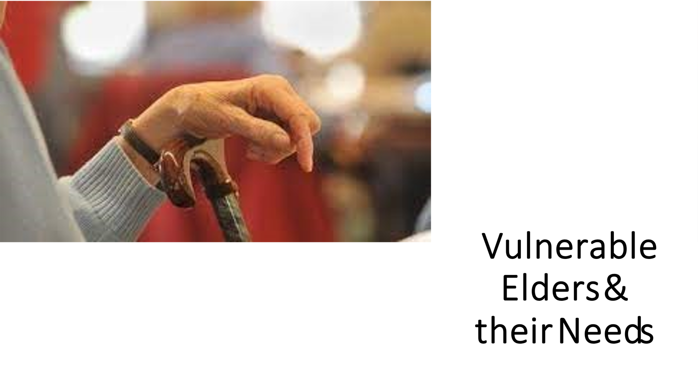
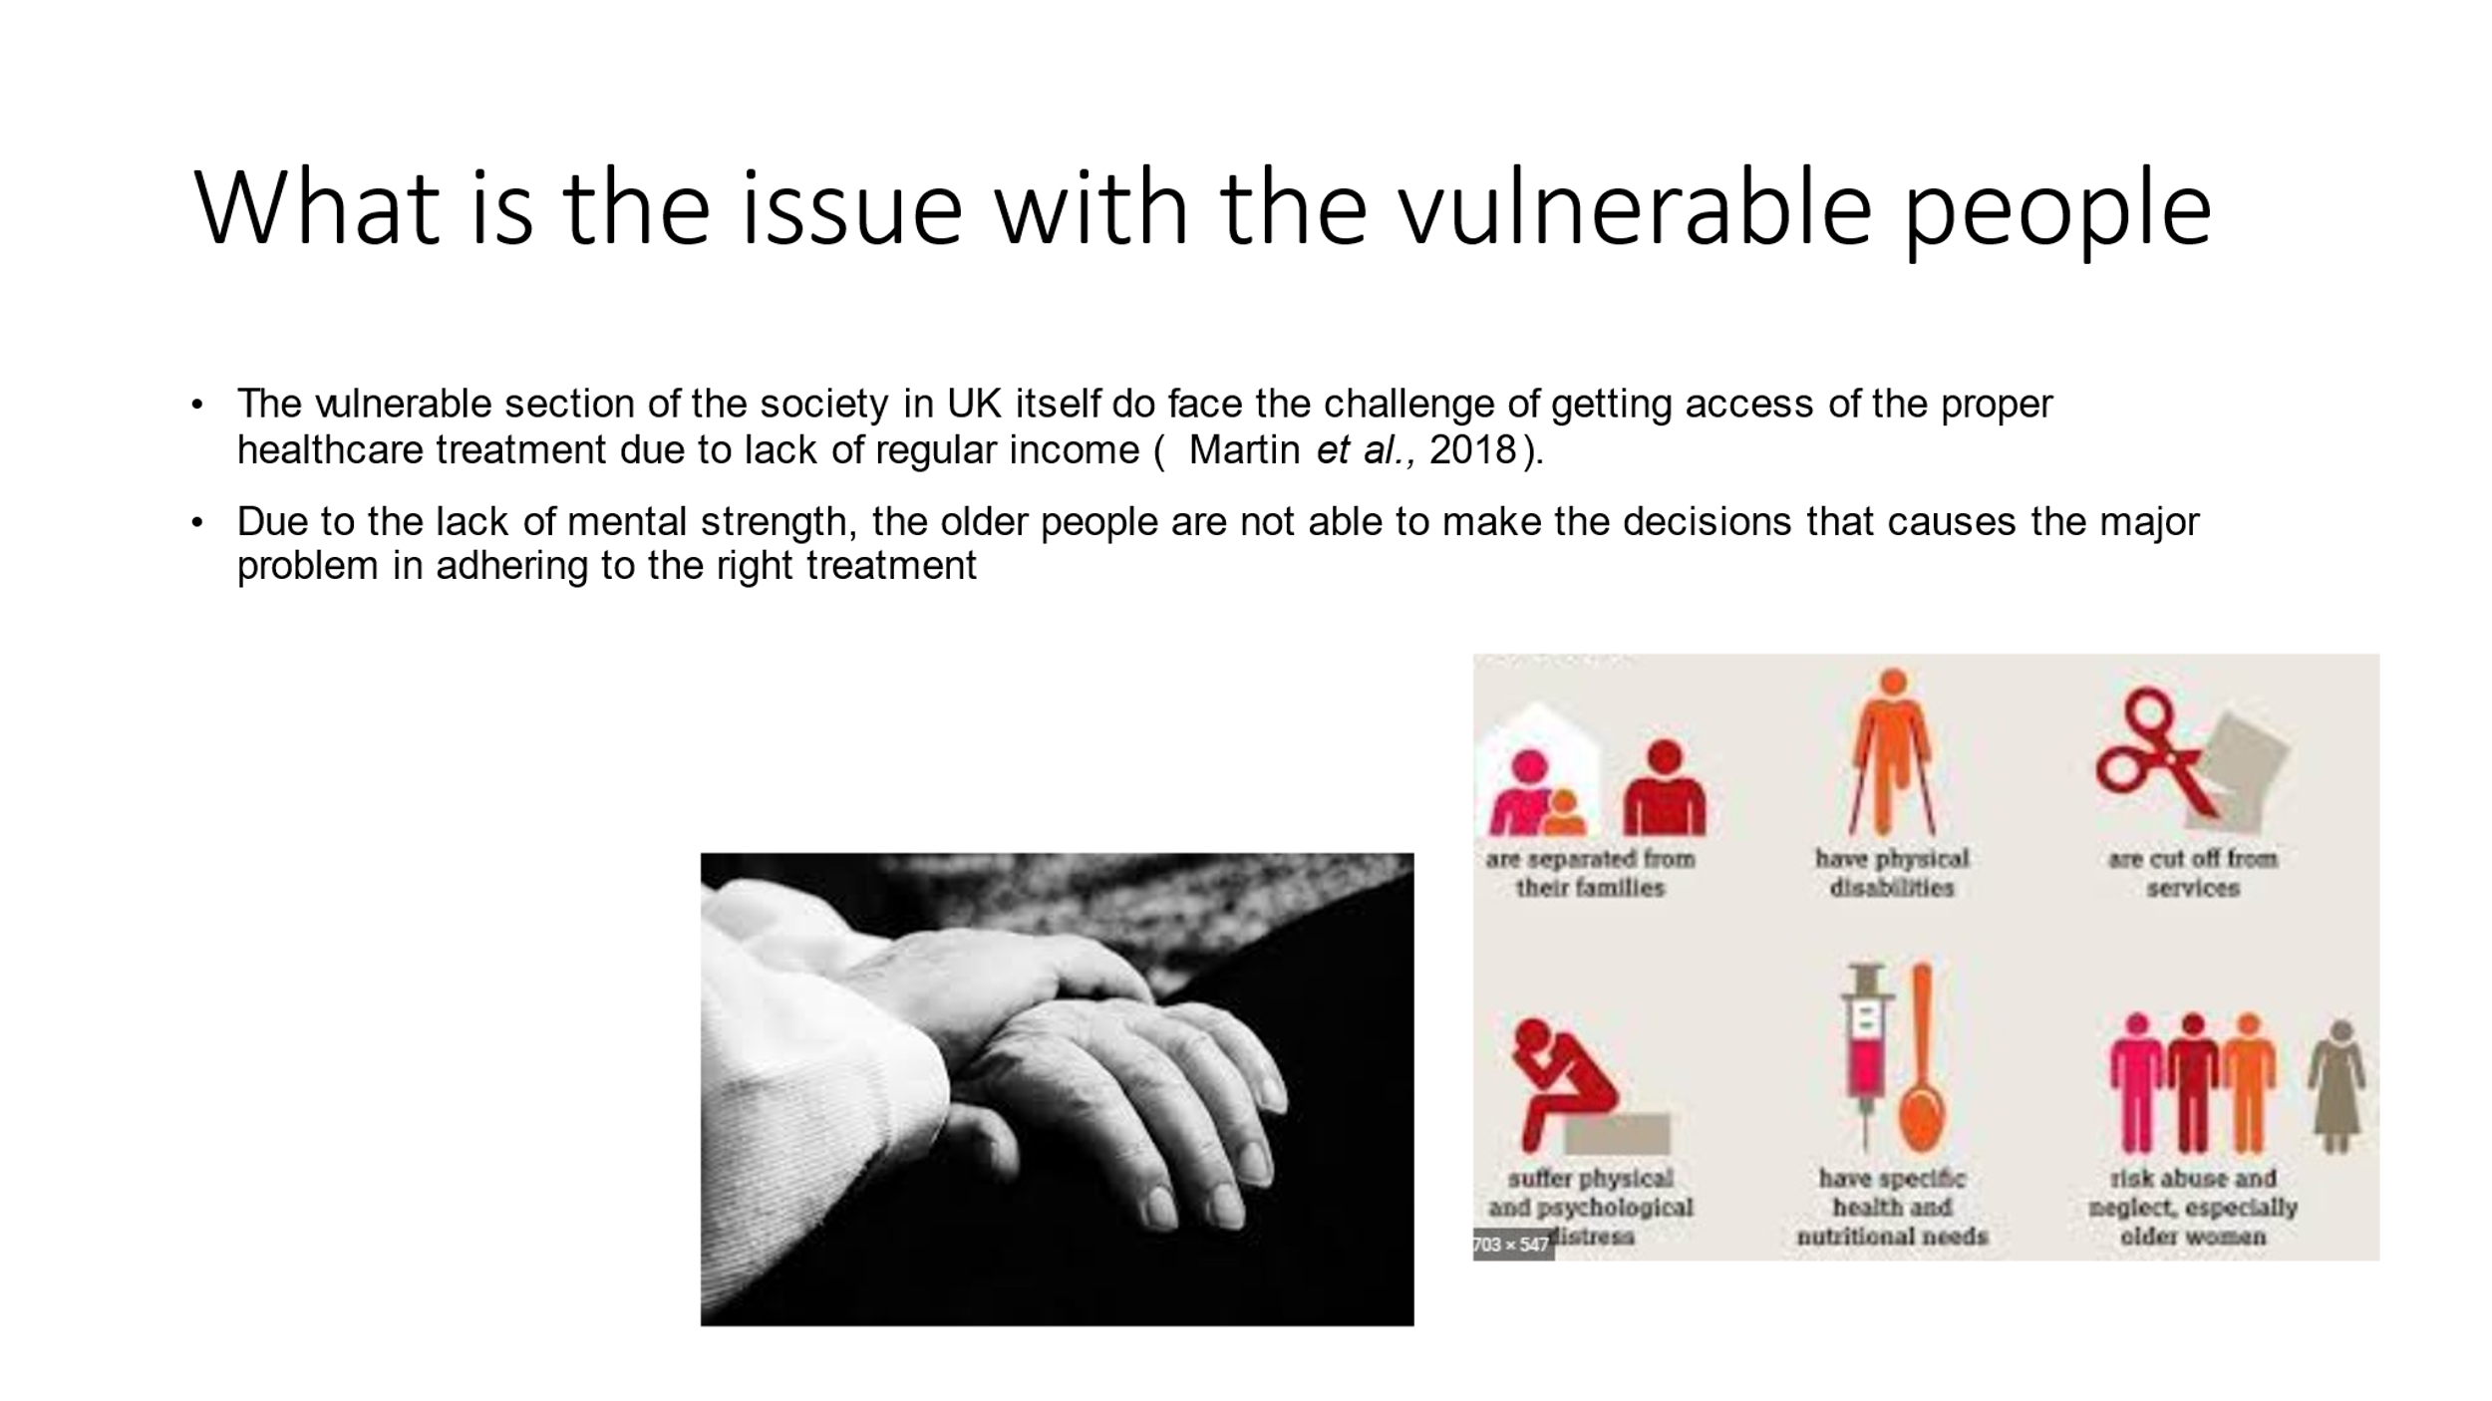
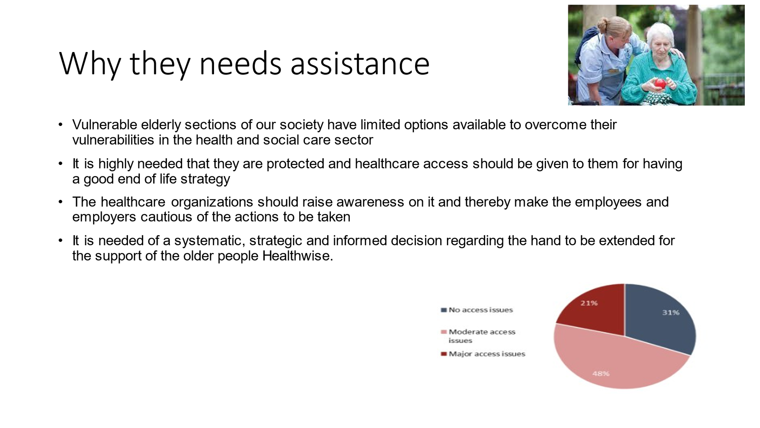
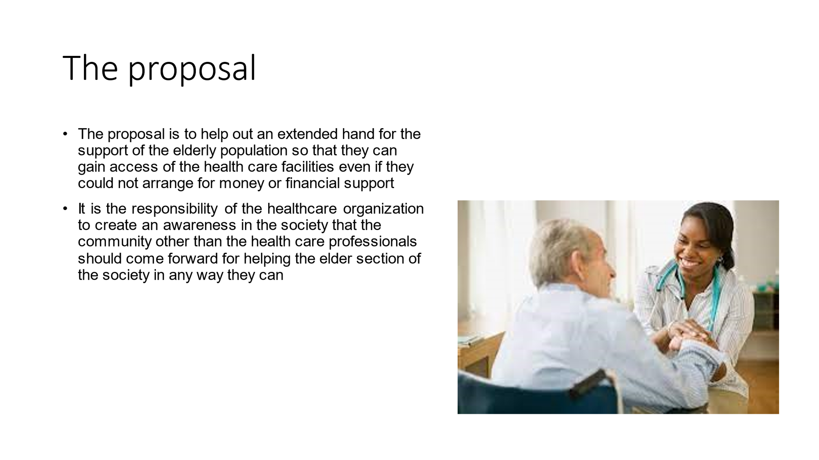
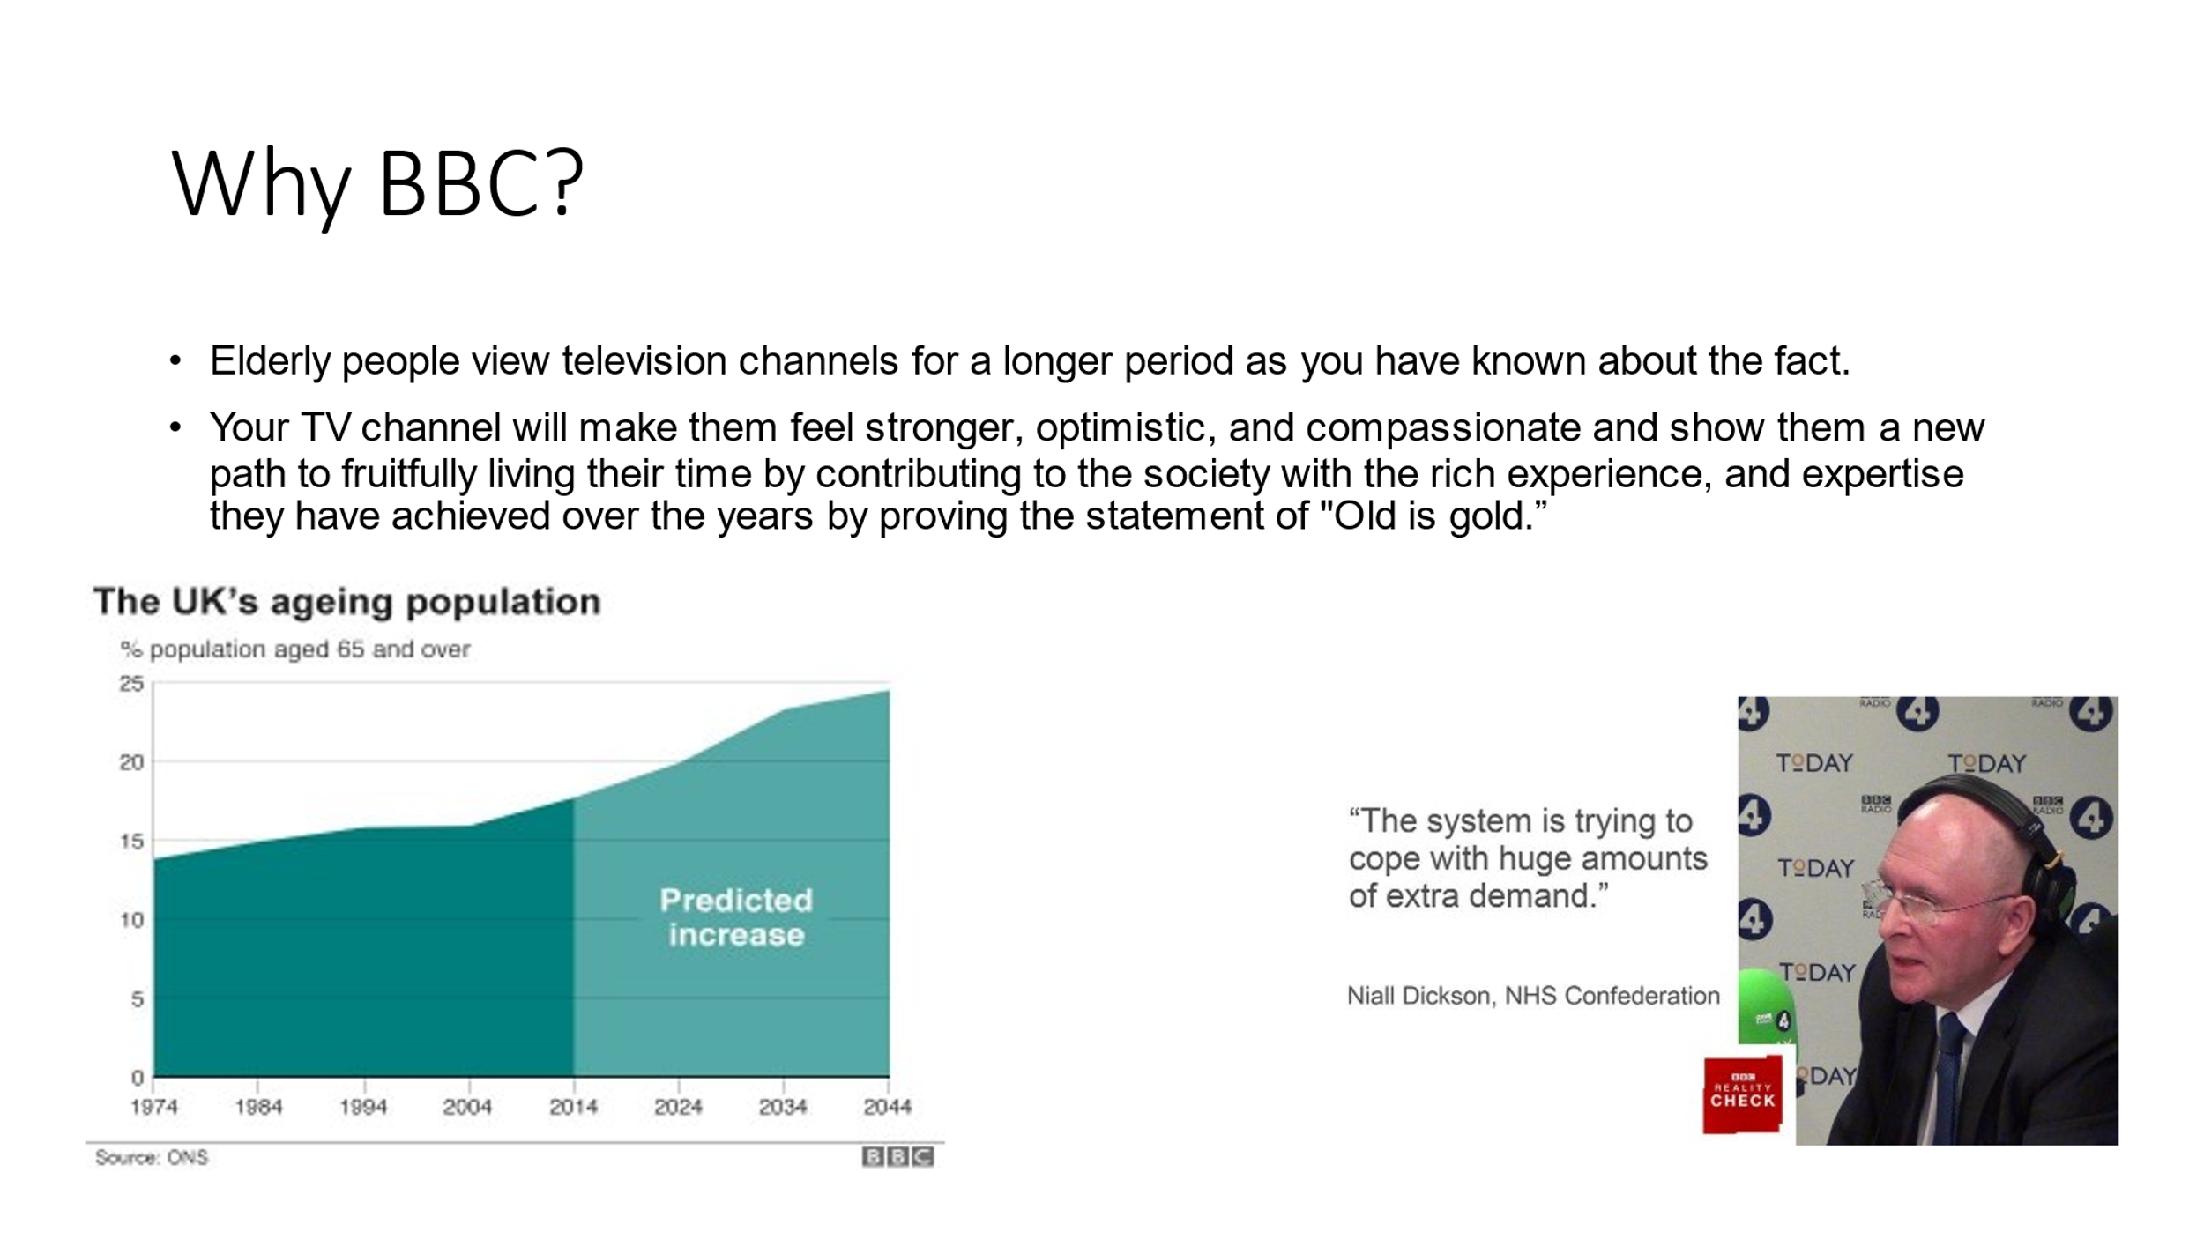

CV for healthcare professional
Name: Annelis-Daniela Raportoru

Contact details: 07471501436
Email address: annelis_daniela@yahoo.com

"A fresh graduate willing to gain real-life exposure to health and social care professionals to bridge the gap between the academic and practical knowledge to contribute responsibly in the society for removing the inequality, wider determinants of health and social wellbeing. I am willing to look for the position of Human Resource Assistant in the health care organization in future.
PERSONAL PROFILE

Skilled in problem solving of any complex situations in workplace.

As a continuous learner, who is passionate about excelling in the professional field and compassionate toward the people suffering from various lifestyle-related health issues. I want to take a major role in removing the social stigma, and disparity toward the vulnerable sections of the society having no way to uplift themselves from their miserable conditions. I am determined and focused to do the best for my job role while willing to give extra effort voluntarily to assess the problems of people coming to my organization, engaging them enthusiastically to come out of their misery. My dealings with the people coming into my organization to seek help will be assisted by my earnest effort as designated in the organization I will be working. The people with whom I will be dealing feel comfortable and find me as one of their own.

Leadership skills as well as qualities to encourage the employees by proportioned.

My Key Skills and Competencies

- Good listener and compassionate while listening to the case history of the people whom I deal with.
- A good and enthusiastic coordinator among cross-departmental activities to facilitate and expedite the common goals of all the concerned departments serving the betterment of the people
- Habitually use the analytical and reasoning to get in-depth of any complex situation brewing up in the workplace. The skill is helpful in resolving the problem in the advanced stage to avoid any workplace conflicts with others, especially while working in an organization set up for a common purpose.
- Competent in socializing with new people, coming to take healthcare services to deliver better services after knowing the root cause of those problems. The skill facilitates my understanding and decision-making on the course of action necessary for them.
- Expert in time management by prioritizing the tasks needed urgent actions based on requirements for the personal and professional objectives.
- Critical thinker who can distinguish between opinions and customs based on analysing to take the best suitable decision.
- Emotionally strong and intelligent enough to maintain the balance between professional life and personal life
- Competent in leadership skills by applying the humanistic approach to lead others with empathy for the success of organizational objectives
Educational Qualification
- Studying the degree of Business Administration (B.A.) in University of Wales
- Diploma in Computer Degree
- Completed Higher Education in 2006

I gained work experience during my undergraduate study program when I joined a volunteering camp for the enhancement of the people of vulnerable sections of society. The place was the best opportunity for professionally displaying my competencies while I was studying the health and social care issue academically. I had gained the experience of utilizing my academic knowledge under the guidance of senior and experienced professionals. The experiences gained in that camp helped me understand the real-life social determinants acting as a barrier to the improvement of the most vulnerable section of society. The stories of the suffering of the aged people and social attitudes towards them obstructing the employment, financial security, job promotion, and employment opportunities have made me rethink working in a different approach as I worked there in that way. I wanted to work for the people suffering for several reasons to help them come out of the vulnerable situations more passionately with compassion and that zeal still exists in me to perform better professionally. At the initial entry-level stage, I have the necessary competencies and 2-month-long professional exposure on which I will be gaining increased knowledge by working under an organizational setup. I would utilize the previous knowledge by blending it with the newer experience I will have in my organization.

Reference List
Heide, M., von Platen, S., Simonsson, C. and Falkheimer, J., 2018. Expanding the scope of strategic communication: Towards a holistic understanding of organizational complexity. International Journal of Strategic Communication, 12(4), pp.452-468.
Kang, H. and Kim, H., 2022. Ageism and Psychological Well-Being Among Older Adults: A Systematic Review. Gerontology and Geriatric Medicine, 8, p.23337214221087023.

