PLC’s and Control

PLC Controlled Conveyor Sorting System

Gower College Swansea
PLC’s



APPENDIX GA36b

LEVEL 5 ASSESSMENT SPECIFICATION

Student name: | Nariman Ramadhan | Student ID number: | Ram20849142
Programme: | HND in Electrical and Electronic Engineering
Module: | PLC’s and Control
Module code: | GOEE5002 | Contribution to Overall Module Assessment (%): | 50%
Lecturer: | Brian Lewis | Internal Verifier: | Dr Rabya Kadhim
Assignment Title: | PLC Assignment 1 | Word count (or equivalent):
Submission deadline: |  | Return date of provisional marks & written feedback:
Submission method: | All written assessments, where practical and possible, must be submitted via Turnitin unless otherwise instructed by the Lecturer. (Please DO NOT put this assessment specification into Turnitin or it will match many similarities with other students’ submissions.)  Alternative submission method (if applicable):  Late submission of the assessment will result in a late penalty mark. Penalties for late submission: Up to one week late, maximum mark of 40%. Over one week late, 0%. Only the Extenuating Circumstances Panel may approve a change to submission dates.
Academic honesty / referencing: | Academic honesty is required. In the main body of your submission you must give credit to authors on whose research and ideas your work is based. Append to your submission a reference list that indicates the books, articles, etc. that you have used, cited or quoted in order to complete this assessment.

Module Learning Outcomes
(from module syllabus)
- Produce a detailed specification for a feedback control system.

- Write software code for, and properly document, a given control application.

- Design and document the hardware and software required for fault diagnostics, operator controls, and safe operation.

Contents
PLC Controlled Conveyor Sorting System 0
Contribution to Overall Module Assessment (%): 1
1. Introduction 3
2. System specifications 3
Functional requirements 3
Input and Output Specifications 4
Assumption and limitation 4
3. System design 5
HMI 5
System flowchart 6
4. Program Implementation 7
5. Testing and Validation 12
Test Environment 12
Test method 12
6. Evaluation and Discussion 12
7. Conclusion 13
References 13

Introduction
Industrial automation is essential in modern manufacturing, enhancing productivity, consistency and safety. A key technology in this field is the Programmable Logic Controller (PLC), which offer dependable and flexible control of industrial processes. Conveyor-based sorting systems are a common PLC application, particularly in material handling environments where items must be detected, classified and sorted effectively. (Hui, 2018)

This project presents the design and simulation of an automated conveyor sorting system using Siemens TIA Portal. Cylindrical objects travelling along a conveyor are identified and their size determined according to sensor detection time. They are then directed into separate bins using pneumatic actuators. The system also includes inductor lights and a Human-Machine Interface (HMI) to enable both automatic and manual operation.

The aim of this assignment is to design, develop and validate a fully operational PLC-controlled aborting system that satisfies the specific requirements. The entire system is created and tested using simulation tools within TIA Portal, allowing performance verification without physical hardware.

System specifications

System overview
The system comprises a motor-drive conveyor, two detection sensors, three pneumatic pushers for sorting, indicator lamps, and an HMI. Cylindrical items move along the conveyor and are detected in sequence by the sensor. The time between sensor signals is used to determine the size category, after which the item is detected into the appropriate collection bin.

Control is achieved using programmed in Siemens TIA Portal and verified through simulation. The HMI enables operators, monitoring and manual control of the system. (Phys, 2021)

Functional requirements

The system is designed to meet the following functional requirements:
- Start-up operation: the system starts only when the green start push button is pressed and held for 3 seconds. During this period, the green indicator lamp flashes. After 3 second, the green lamp remains ON continuously and the conveyor motor starts running.
- Stop operation: when the red stop push button is pressed, the conveyor motor stops immediately, and the red indicator lamp turns ON to indicate the stopped state.
- Object detection and classification: two sensors are positioned along the conveyor belt. The time taken for an object to travel between sensor 1 and sensor 2 is measured. Based on this measured time, the object is classified into one of three predefined size categories.
- Sorting operation: according to the classification result, a pneumatic pusher diverts the object into Bin 1, Bin 2 or Bin 3 at the correct position along the conveyor.
- Idel mode: if no object is detected for 30 second while the system is running, the conveyor stops automatically to save energy and prevent unnecessary operation.
- Human-Machine-Interface (HMI):
the HMI allows the operator to:
- Start and stop the system
- Manually activate sorting actuators
- monitor system state
- display counter for each sorting bin

Input and Output Specifications

Inputs
- Start push button
- Stop push button
- Sensor 1 (object detection)
- Sensor 2 (object detection)
Outputs
- Conveyor motor
- Green indicator lamp
- Red indicator lamp
- Pneumatic pusher for Bin 1
- Pneumatic pusher for Bin 2
- Pneumatic pusher for Bin 3

Internal variable
- System state (stopped, start-up, running, Idle)
- Timers for start delay, idle timeout, and sensor time measurement
- Object classification variable
- Counter for each sorted object in each Bin

Assumption and limitation
The system is implemented and tested using simulation within Siemens TIA Portal. Therefore, physical construction such as sensor noise, mechanical delays, and pneumatic pressure variations is not considered. However, the control logic is designed in a way that allows direct implementation on real hardware with minimal modifications.

System design
the system is implemented using a Siemens S7-1200 PLC (CPU1215c DC/DC/Rly)
integrated with a
kTP700 Basic DP HMI panel. The hardware setup consists of:
- Conveyor belt driven by a DC motor
- Two optical sensors positioned along the conveyor
- Three pneumatic actuators for sorting
- Indicator lamps (green and red)
- HMI for operation interaction
The PLC performs all control logic, timing, classification and counting operations while the HMI provides monitoring and manual control functional.
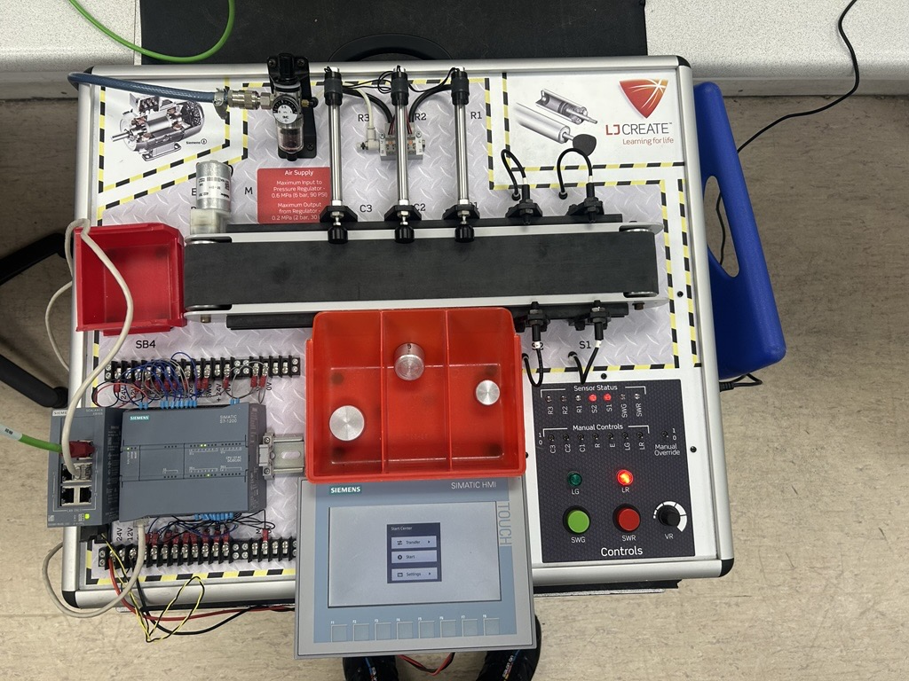

HMI

The figure shows the main HMI root screen developed for the conveyor sorting system using a Siemens KTP700 Basic DP panel. The interface provides operator control and system monitoring functions. It includes Start and Stop push buttons for system operation, manual control buttons for Actuator A, Actuator B, and Actuator C, and a reset button for clearing object counters.
The HMI is connected to the PLC via configured tags, allowing real-time communication between the operator interface and the control program. Status feedback is visually represented to indicate system operation conditions. The layout was designed to be simple and intuitive, ensuring ease of use and minimizing operator error.
The HMI enhances usability by providing direct interaction with the system without requiring modifications to the PLC program.
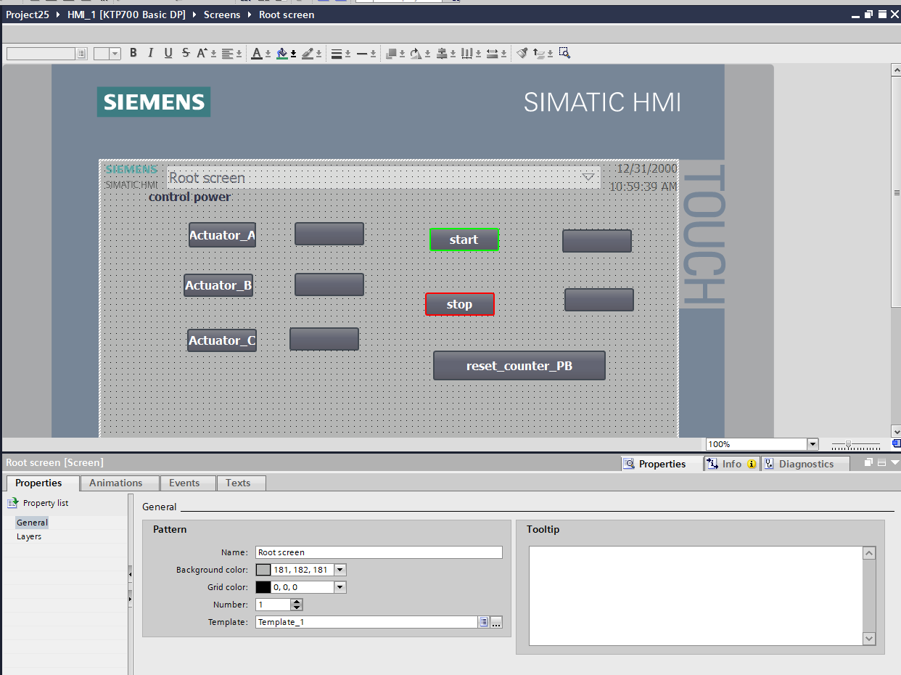

System flowchart
start-up control, object detection, classification, sorting actuation, and idle timeout management. The control logic begins with system initialisation, followed by a hold-to-start verification stage. Once running, the system continuously monitors sensors, calculates object travel time, classifies object size using defined time windows, and activates the corresponding actuator. After sorting, the system returns to the running loop unless a stop command or idle timeout condition occurs.
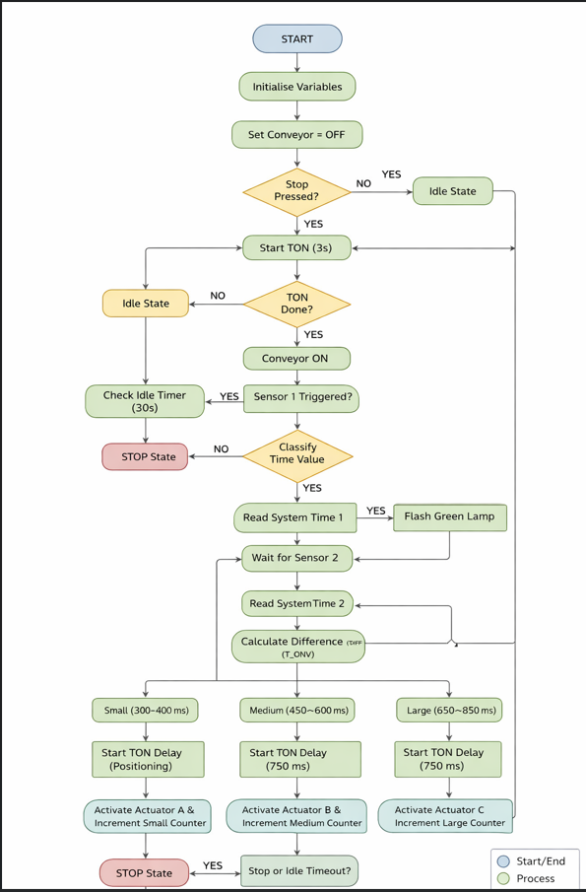

Program Implementation

Start/stop and conveyor enable logic (OB1 - network 1)

This network implements the hold-to start control logic for the conveyor system. The green Start button activates a TON timer set to 3 second, ensuring the button must be held before enabling the conveyor. The stop button has priority and immediately disables the conveyor when pressed. The network also integrates HMI start/stop commands and controls the conveyor enable output signal
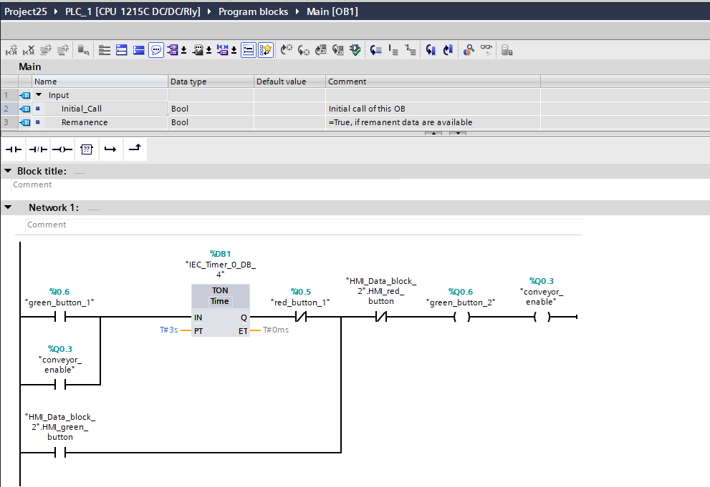

Green lamp flashing logic (OB1-network 2)

This network controls the flashing behaviour of the green indictor lamp during system operation. A 1 Hz clock pulse signal is combined with the start condition to generate the blinking effect. Ones the conveyor id enabled, the green lamp output is activated, providing visual feedback that the system is running.
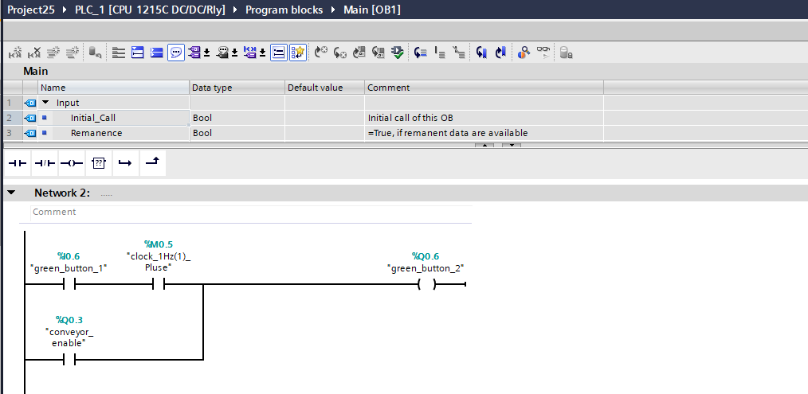

Sensor time measurement logic (OB1-network 3)

This network capture and calculate the travel time of an object between sensor 1 and sensor 2
the red-sys-T instruction reads the system clock at each sensor tigger, storing the timestamps in a data block. The T-DIFF function then computes the time difference between the two readings, producing the object travel time used for size classification.
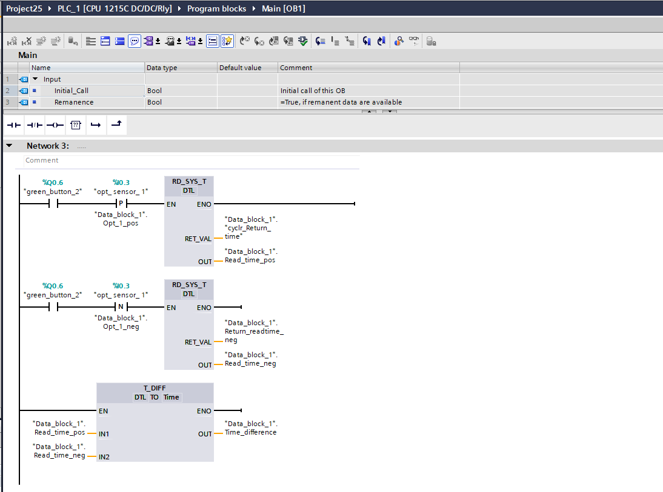

Small object classification and sorting logic (OB1-natwork 4)

This network preforms classification and sorting for small object. The measured travel time is converted to an integer and evaluated using the IN-RANGE instruction (300_400 ms). If the value falls within this range, a positioning delay (TON) is applied, followed by a 750 ms pulse (TP) to activate actuator A. the corresponding CTU counter increments to record the sorted small object.
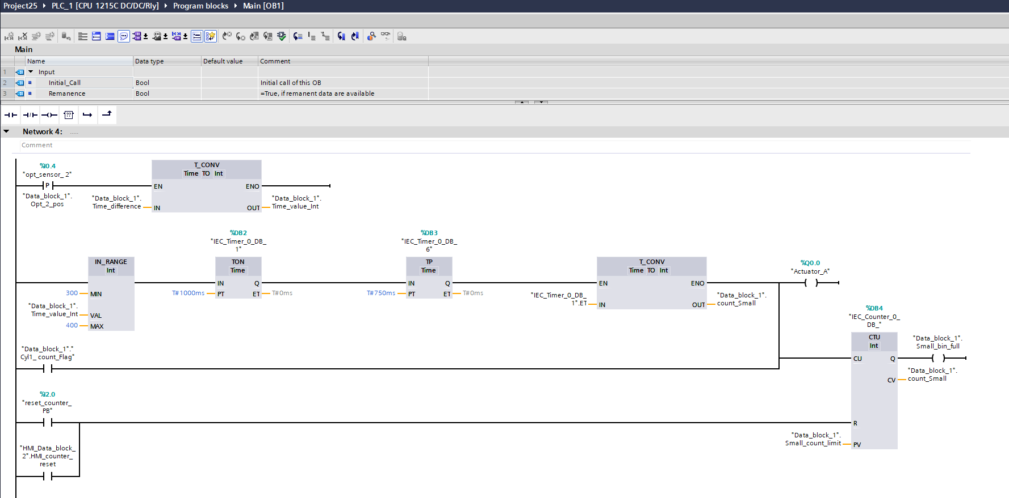

Medium object classification and sorting logic (OB1- network 5)

This network handles the classification and sorting logic for medium-size objects. The calculated travel time is converted to an integer and evaluated using the IN_RANGE instruction (450-600 ms). When the condition is satisfied, a positioning delay (TON) is applied, followed by 750 ms pulse (TP) to activate the corresponding actuator. The CTU counter increments to record each sorted medium object
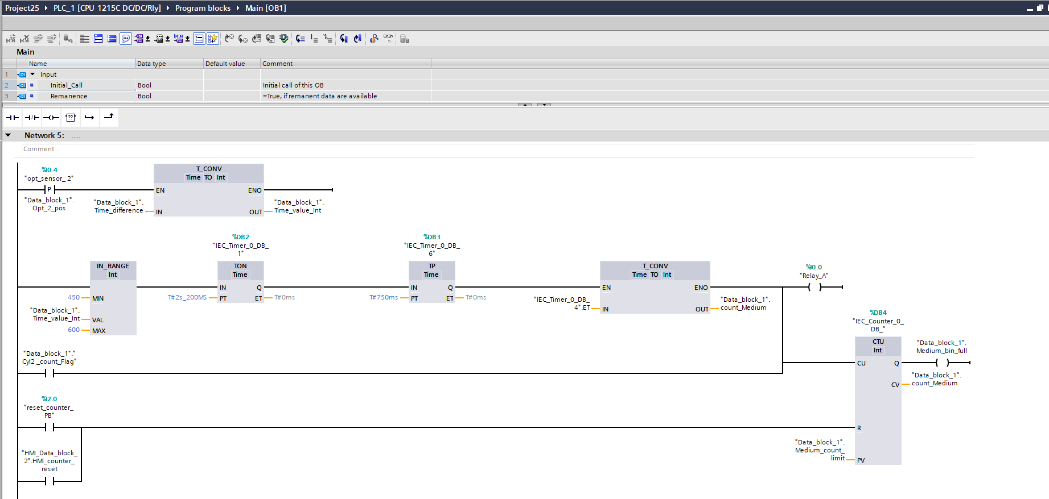

Large object classification and sorting logic (OB1-network 6)

This network preforms classification and sorting for large objects. The calculated time inverted to an integer and checked using the IN_RANGE instruction (650-850 ms). If the value is within this range, a positioning delay (TON) is applied before generating a 750 ms pulse (TP) to activate the corresponding actuator. The CTU counter increments to record each sorted large object and monitors the Bin capacity limit.
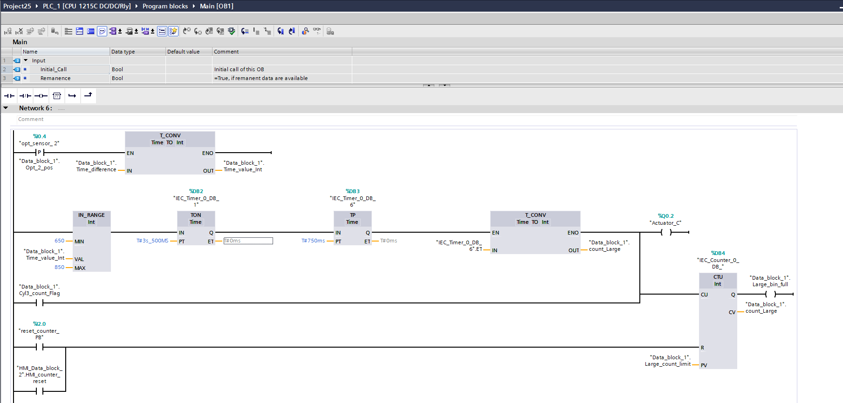

Idle timeout and indicator control logic (OB1-network 7-8)

These networks implement the 30-seconds idle timeout and indicator control logic. A TON timer motions system activate and disable the conveyor if no object is detected within the specified period. The logic also manages red and green indicator outputs to reflect system status, ensuring clear visual feedback during normal operation and stop condition.
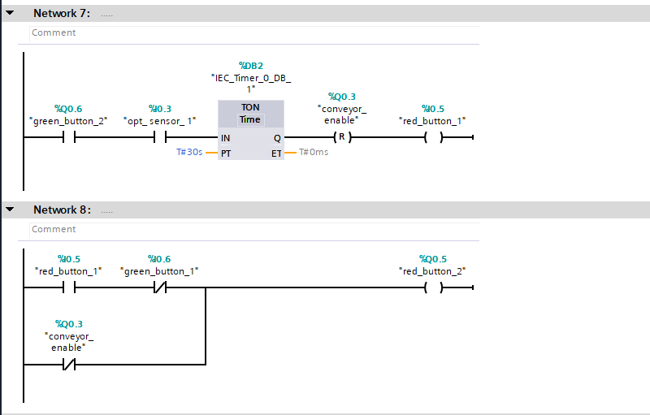

Start-up initialisation routine (OB1-network 1)

This start-up network runs ones when the PLC transition to RUN mode. It initialises key time-related variable in the data block using system time instructions, ensuring the program start from a known and consistent state after a restart. This improves reliability and prevents in correct timing values during the first scan cycle.
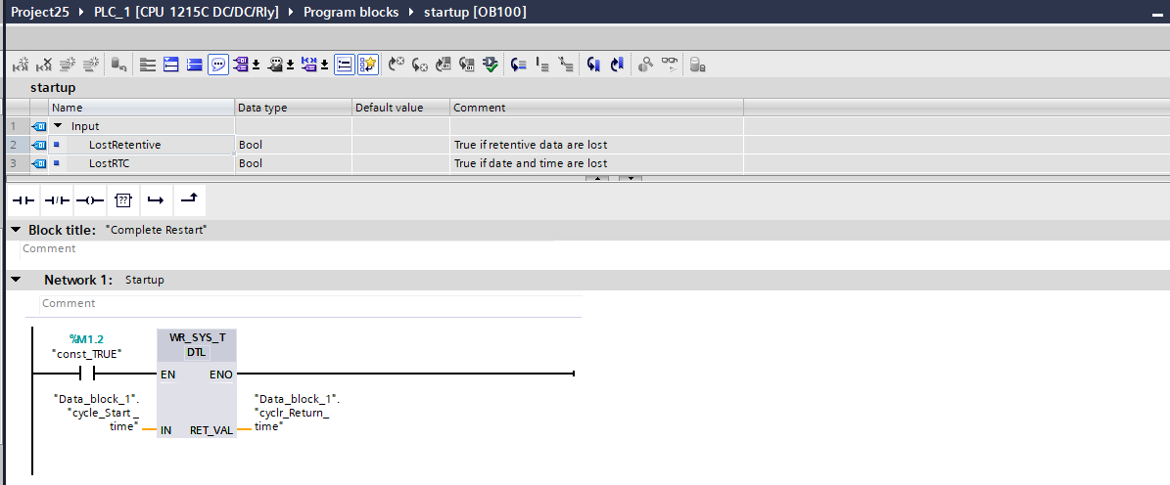

Testing and Validation

Test Environment
All functional tests were carried out in Siemens TIA Portal using a software-in-the-loop simulation environment. Simulation- based verification is widely used to validate PLC logic before hardware commissioning, enabling repeatable tasting of timing, sequencing and I/O behaviour without physical risk

The PLC platform used was a SIMATIC S7-1200 (CPU 1215C DC/DC/Rly), with a SIMATIC HMI KTP700 Basic DP operator panel.

Test method

Testing was carried out as requirement-based validation. Each requirement was mapped to one or more test cases with:
- Input stimulus: button/ sensor events (rising edges, holds, time gaps)
- Expected behaviours: motor/ lamp/ actuator outputs, counters, and statue tags
- Evidence: screenshot of OB1 networks online status, HMI runtime behaviours and key tag values (timers, counters, class selection)

Evaluation and Discussion

The implemented conveyor sorting system successfully fulfilled all specified functional requirements within the TIA Portal simulation environment. The hold-to-start mechanism provided protection against unintended activation, while the stop function demonstrated immediate priority, ensuring safe system behaviour. The use of system time instructions (RD_SYS_T and T_DIFF) enabled accurate travel-time measurement independent of PLC scan cycle variations, improving classification reliability. The defined time windows for small, medium, and large objects produced consistent and repeatable sorting results during testing. The combination of positioning delays (TON) and fixed pulse actuation (TP) ensured precise object diversion without prolonged actuator energisation. Counter functionality operated correctly and integrated effectively with the HMI for monitoring and reset operations. The 30-second idle timeout feature enhanced operational efficiency by automatically stopping the conveyor during inactivity. Although the system performed reliably in simulation, real-world deployment would require consideration of sensor noise, mechanical tolerances, and pneumatic response variations. Overall, the project demonstrates effective integration of sensing, timing logic, decision-making, actuation, and operator interaction within a structured PLC-based industrial automation framework.

Conclusion
This project presented the design, implementation, and validation of a PLC-controlled conveyor sorting system using Siemens TIA Portal. The system successfully integrates time-based object classification, structured ladder logic programming, actuator pulse control, and HMI-based monitoring.
All functional requirements were met, including hold-to-start operation, accurate time-based classification, controlled actuation, counter management, and automatic idle shutdown. The use of system clock instructions and IEC timers ensured reliable and deterministic behaviour.
Although testing was performed in simulation, the control architecture is suitable for deployment in a real industrial environment with minimal modifications. The project demonstrates effective application of PLC programming principles and industrial automation design methodologies.

References
Hui, H. &. (2018). Investigating Current PLC Security Issues Regarding Siemens S7. belfast: queen university belfast .
Phys, P. K. (2021). Development of two-dimensional plotter using. Punjab: Journal of Physics:.

