Using a Research Approach in HR
Research is a study or investigation into a specific issue, problem or concern to increase knowledge by using a number of materials and resources in a systematic way (Anderson 2013). The size of a study can vary due to organisations’ own policies and procedures.
Horn (2009) highlights four methods of research. First is the burning desire strategy formed from a personal interest into a specific area. Next is the replication strategy; reapplying previous research into a new context. In a HR context this means replicating an earlier research project amending to fit within their organisation. Then there’s the practical problem strategy, which is a common method of research. A problem needs to be resolved through a focused project with the issue stemming from an area of concern previously identified. Finally, the convenient strategy is where a professional will choose an area to research because they have access to it.
Examples of a research topic could be sickness absence, mental health in the workplace, staff wellbeing and improvement of staff induction process. Once the topic has been identified there must be consideration of the process. Anderson (2013), created a research roadmap guide listing the different stages required to successfully complete a research project. Appendix 1 demonstrates this.
The two types of data used in research; primary/secondary and qualitative/quantitative (Anderson, 2013).
Primary data is collected during the study and secondary data is information that exists. (Anderson, 2013). Qualitative data is consistently based around words and meanings, whereas quantitative data contains numbers and statistics. (Bryman and Bell, 2015).
Bryman and Bell (2015) state that three basic criteria must be met during the final research design; reliable, replicable and valid.
To ensure that a conclusion is valid it must ensure consistency with the data collected. According to Lesser (2010) organisations can’t see the performance of their workforce without consistent data.
In addition to the above data, Anderson (2013) states the four research strategies HR Professionals follow, all relating to different situations. Firstly, a cross sectional strategy involves the accumulation of data through a survey. A beneficial strategy proving very cost effective, reaching a wide audience. Secondly is a case study. In contrast, this requires detailed research into particular situations. (Anderson, 2013). Data collection could be through observation or interviews (Free Management Library, 2015). Benefits of this result in large volume of qualitative data. However, at times proving difficult to analyse.
Action research is the base of problem-solving and aims to understand/encourage change. An advantageous approach to solve a specific problem by involving others in the research, meaning change to thinking patterns and experiment with new ideas and situations. (V Anderson 2013). The last strategy is comparative. This compares various situations and groups. Similarly, to cross sectional, comparative designs often use surveys and interviews to gather data in multiple settings thus allowing HR professionals to compare and contrast data. A popular data collection method is sampling. Sampling is a cost effective and practical way to speed up data collection. (Creswell, 2007 and Horn, 2012). However, when using the sampling method, it’s important to consider that there’s a reflection on wider groups with no bias in the data. (Bee and Bee, 2005 and Creswell, 2007).
As stated by Anderson (2013) and Bryman and Bell (2015), research projects are usually made up of one or more method of data collection. One approach is surveys where a document is produced with specific and relevant questions (Bryman and Bell, 2015). Surveys are quick, cheap and convenient as respondents can complete it in their own time although, it can prove difficult to gather detailed responses.
Secondly is interviews. Interviews require more preparation. The questions asked during interviews are usually answered with more detail and can follow a structured or unstructured approach, which reflects on the amount of detail and information collected (Horn, 2012).
Another approach is focus groups, used to gather opinions and views. A misconception is that focus groups are only group interviews, however the aim is to assess how groups of individuals understand specific concepts and ideas (Walker 1985).
Lastly, is participant observation where the researcher steps into a social setting for a period of time, monitoring behaviour. It creates real perspective about practical problems and gathering data. Providing the reality of the workplace hasn’t been modified for the purpose of the observer, this method creates a real understanding about working practices of a department within the organisation.
Finally, professionals analyse and conclude, studying the data for themes. Once established, the researcher will draw a conclusion and present. Anderson (2013) advises charts and tables to present data, whereas Bryman and Bell (2015) prefer bullet points.

Appendix
Appendix 1.1 Roadmap
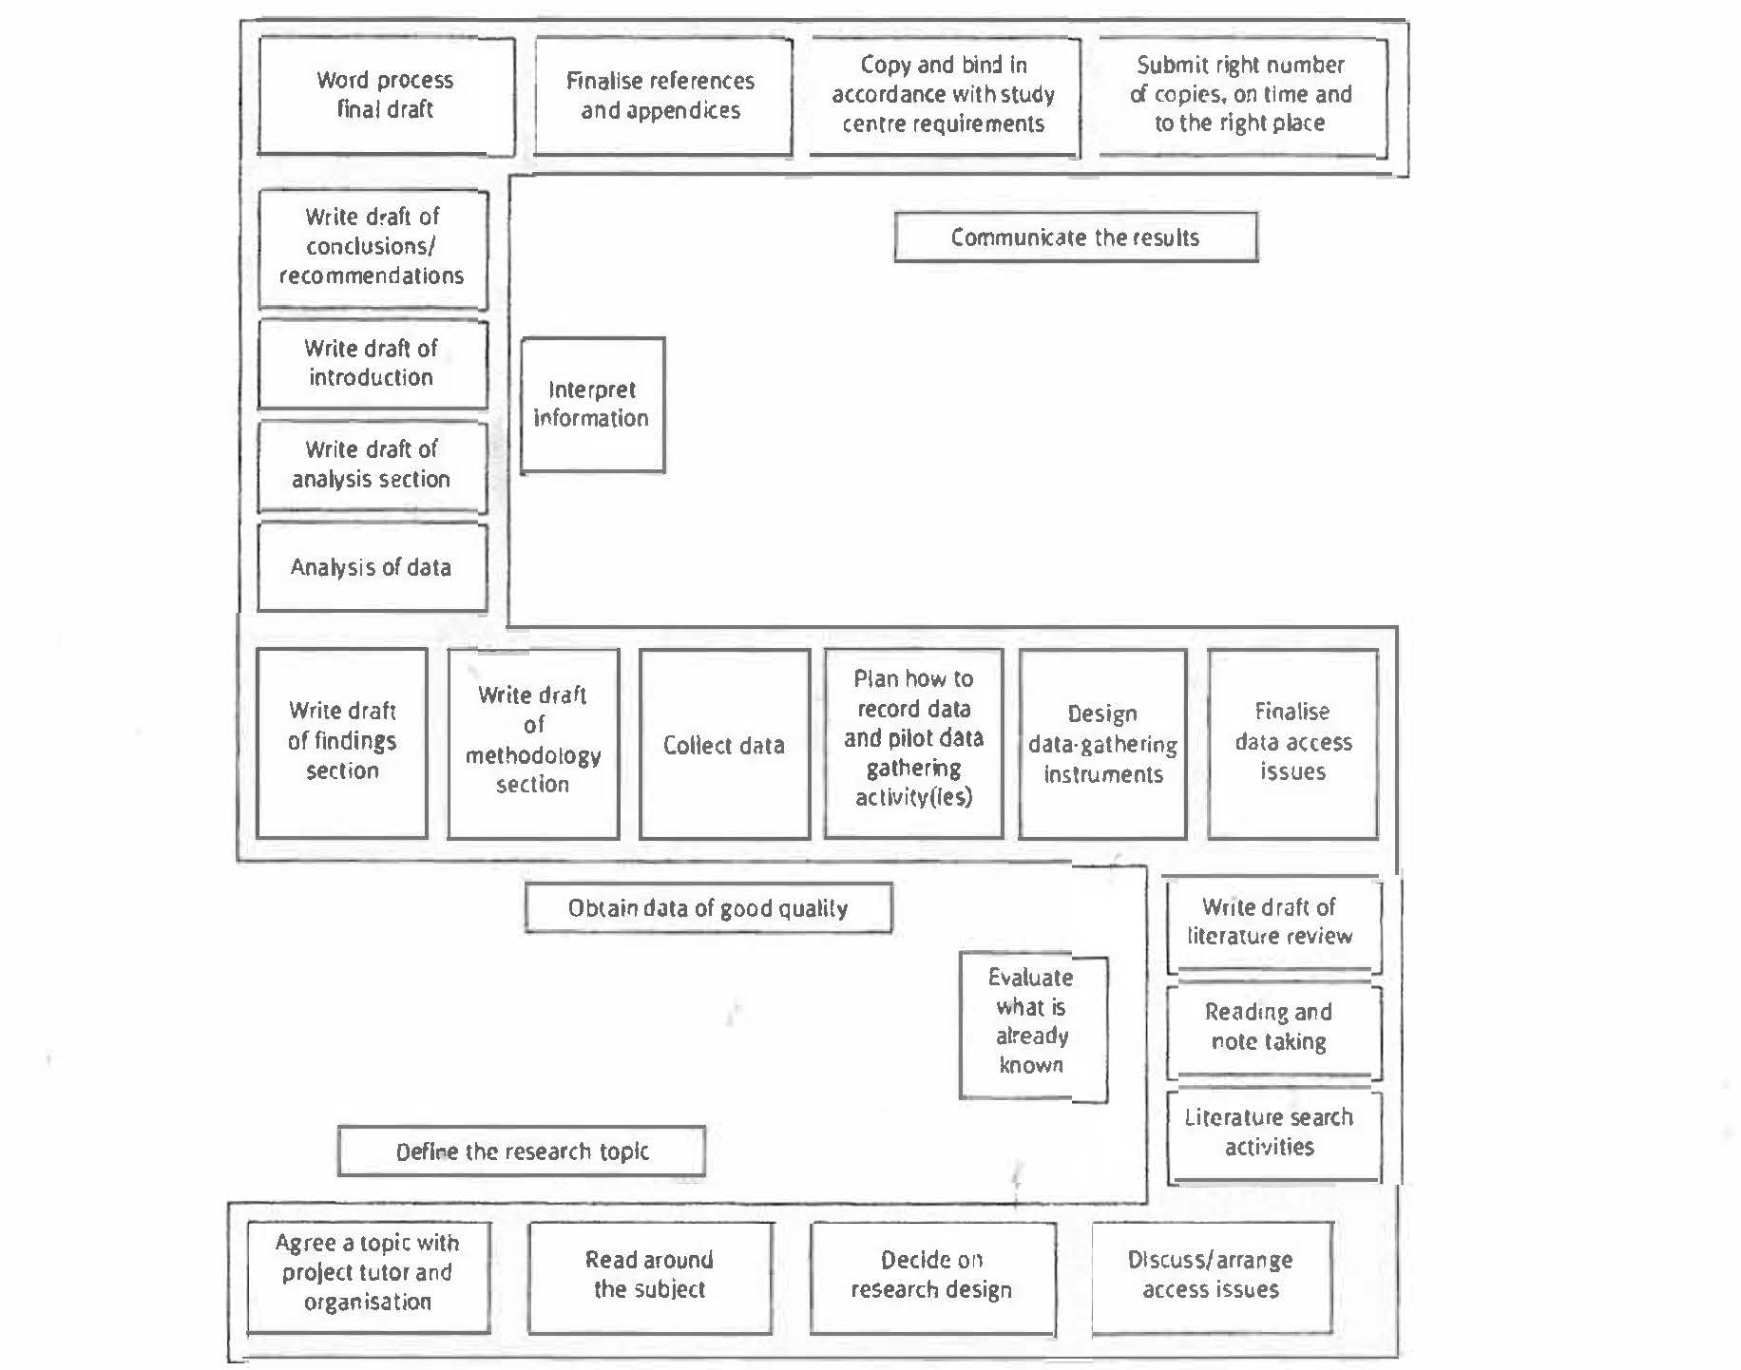

Bibliography
Anderson, V. (2013) Research methods in human resource management. 3rd ed. London: Chartered Institute of Personnel and Development.
Bee, F. and Bee, R. (2005) Managing information and statistics. 2nd ed. London: Chartered Institute of Personnel and Development.
Bryman, A. and Bell, E. (2015) Business research methods. 4th ed. Oxford: Oxford University Press.
Creswell, J. W. (2007) Qualitative inquiry and research design. 2nd ed. London: Sage.
Free Management Library (2015) Basic business research methods [online]. Available at: http://managementheko.org/businessresearch/index.htm. [Accessed 29 October 2018].
Horn, R. (2012) Researching and writing dissertations: a complete guide for business and management students. 2nd ed. London: Chartered Institute of Personnel and Development.
Lesser, E. (2010) HR analytics: go figure. People Management. 20 May 2010. [online]. Available at: https://www.peoplemanagement.co.uk/long-reads/articles/hr-analytics-go-figure. [Accessed 2 November 2018].
Walker, R. (1985) Applied qualitative research. Aldershot: Gower.

