BMIH6007
International Meetings Management
for the
Hotel Industry

CULTURAL INTELLIGENCE IN GLOBAL BUSINESS CONFERENCE
ISTANBUL, TURKEY

Module Lead: Kathryn Flynn

SHABANA BEGUM
2223853@student.uwtsd.ac.uk

Acknowledgments of AI usage:
I acknowledge the use of consensus, ChatGPT to search for types of events and event cycle and check spellings and format. I confirm that I have not presented any AI generated text as my own work. I confirm I have copies of my drafts, notes, and other resources I used before, and after the use of AI tools which I may be asked to provide in evidence.

1. Introduction

Cultural intelligence is very important in today’s business world. Businesses work with people from different countries, backgrounds, and beliefs. If they do not understand different cultures, they may struggle to build relationships or succeed in new markets (Ang and Van Dyne, 2015). Events that promote cultural intelligence help business leaders and professionals improve their understanding of different cultures and how to work together.
The event, “Cultural Intelligence in Global Business,” is designed to teach business leaders, diversity trainers, and global marketing experts how to manage multicultural teams, build inclusive workplaces, and create marketing strategies that respect cultural differences (Cultural Intelligence Center, 2024). The event will take place at Çırağan Palace in Istanbul, Turkey, which is a well-known venue with modern facilities and a strong international business presence (Kempinski, 2025). The event will include masterclasses, panel discussions, interactive exhibits, and networking opportunities to give attendees both knowledge and practical skills.
The international events industry plays a crucial role in business, tourism, and cultural exchange, with the MICE (Meetings, Incentives, Conferences, and Exhibitions) sector significantly contributing to global economic development (Bowdin et al., 2011). Events are no longer just logistical operations but strategic experiences, impacting brand visibility, community engagement, and economic growth.

This report critically evaluates the event cycle, marketing strategies, financial planning, and event design (Bowdin et al., 2011) while integrating key theoretical models such as Goldblatt’s Event Management Theory, Getz’s Experience Model, and the EMBOK framework. The discussion also incorporates sustainability, digital transformation, and accessibility trends that are shaping modern event planning (Getz, 2012; EMBOK, 2025). By applying best practices and case studies from Olympic Games, Glastonbury Festival, and corporate expos, this report provides a structured and evidence-based approach to effective event management. The report will also highlight the importance of inclusivity and accessibility in event management (McKinsey & Company, 2024).

2. The Event Cycle
THE EVENT CYCLE

The event cycle is a method used by event planners to organise an event from start to finish. It includes three main stages: planning, delivery, and evaluation (Bowdin et al., 2011).
1. Planning Phase:
- Conducting a feasibility study to assess market demand, financial viability, and stakeholder engagement (Bladen et al., 2012).
- Establishing SMART objectives (Specific, Measurable, Achievable, Relevant, Time-bound) to align with business and attendee expectations (Lynch, 2009).
- Implementing risk management strategies based on situational analysis (PESTEL: Political, Economic, Social, Technological, Environmental, and Legal factors) (Grant, 2005).
2. Delivery Phase:
- Ensuring smooth logistics, security, and real-time audience engagement (Getz, 2012).
- Incorporating digital technology (AI-driven platforms, hybrid events, mobile applications) to enhance audience experience (Kim & Jang, 2016).
3. Evaluation Phase:
- Using Key Performance Indicators (KPIs) such as attendance rates, financial returns, and social media engagement to measure success (O’Toole, 2006).
- Applying post-event surveys and financial audits to refine future event strategies (Smith, 2016).

By applying the EMBOK Model, which focuses on administration, design, marketing, operations, and risk, event managers can ensure a structured and effective approach to planning (O’Toole, 2025).

2.1 Planning Phase

The planning phase is the most important part of the event cycle because it sets the foundation for the entire event. Without good planning, an event can face many problems such as poor attendance, financial loss, or logistical failures (Kristiansen et al., 2021).
Key steps in the planning phase include:
- Setting objectives: The event must have clear goals. In this case, the main goal is to help businesses improve cultural intelligence (Cultural Intelligence Center, 2024).
- Choosing the venue: Çırağan Palace was chosen because it has good transport links, high-quality facilities, and a strong reputation for hosting international business events (Kempinski, 2025).
- Identifying stakeholders: These include attendees, speakers, sponsors, suppliers, and event staff (Bladen et al., 2012).
- Developing a budget: The event needs to plan for venue costs, speaker fees, catering, marketing, and logistics (ICCA, 2024).
- Creating a marketing plan: This involves using social media, websites, email campaigns, and professional networks to attract attendees (Forbes, 2024).

A feasibility study is also conducted at this stage. This means checking if the event is financially possible, has the right audience, and has enough time to be successfully organised (Lynch, 2009). Risk assessments must also be completed to plan for problems such as low-ticket sales, technical failures, or unexpected costs (UNWTO, 2024).

2.2 Delivery Phase

The delivery phase is when the event actually takes place. This includes:
- Setting up the venue: Ensuring the stage, seating, and technology are ready.
- Managing registrations: Checking tickets, welcoming guests, and providing event materials.
- Coordinating sessions: Making sure speakers, panellists’, and exhibitors are prepared.
- Overseeing logistics: Handling catering, security, and accessibility requirements (Kristiansen et al., 2021).
During this phase, good communication is essential. Event organisers must work closely with venue managers, suppliers, and event staff to ensure everything runs smoothly (M&IT, 2024).

2.3 Evaluation Phase
Once the event is finished, organisers must review how successful it was. The evaluation phase helps measure the event’s impact and identify areas for improvement (Lynch, 2009).

Key evaluation steps include:
- Collecting attendee feedback: Using surveys and interviews to understand their experience.
- Assessing financial performance: Checking if the event stayed within budget.
- Reviewing media coverage: Looking at how much attention the event received online and, in the press, (Quick, 2020).
- Identifying areas for improvement: Finding out what worked well and what could be better for future events.

Event reports help determine the return on investment (ROI) for sponsors and attendees. A well-organised and successful event can increase future sponsorship opportunities and attract more participants in the next edition (Kristiansen et al., 2021).

3. Event Concept

The Cultural Intelligence in Global Business event is designed to be engaging, educational, and interactive. It combines expert-led sessions, real-world case studies, and networking opportunities to ensure that participants gain practical knowledge on managing cultural diversity in global business settings. The event will follow a structured itinerary, with different activities planned throughout the day to keep attendees engaged.
An event concept is the creative vision and thematic structure that defines the purpose, design, and experience of an event (Goldblatt, 2011). It serves as the foundation for planning and delivering an engaging experience.

Key Elements of the Event Concept
1. Theme & Objectives:
- The theme should align with attendee expectations and industry relevance (Getz, 2012).
- Objectives must be SMART (Specific, Measurable, Achievable, Relevant, Time-bound) to ensure success (Lynch, 2009).
2. Target Audience & Stakeholder Engagement:
- Identifying the right demographics and cultural factors that influence attendee expectations (Kim & Jang, 2016).
- Involving sponsors, exhibitors, and partners to enhance event value (Bowdin et al., 2011).
3. Innovative Event Experiences:
- Using digital engagement tools, interactive sessions, and hybrid event features to enhance participation (Smith, 2016).
- Ensuring personalisation through AI-driven event platforms and data analytics (O’Toole, 2011).
The event concept must integrate experience design, logistical planning, and brand positioning to ensure long-term success.

3.1 Event Itinerary

The event will run for two days and will include a mix of masterclasses, panel discussions, interactive exhibits, and networking sessions. Below is an example of the event schedule:

Day 1: Understanding Cultural Intelligence
- 09:00 - 10:00: Registration and Welcome Breakfast
- 10:00 - 11:30: Masterclass: “Cultural Intelligence: The Key to Global Leadership” (Speaker: Dr. Linda Jenkins) (Livermore, 2011).
- 11:30 - 12:00: Coffee Break and Networking
- 12:00 - 13:30: Panel Discussion: “Overcoming Bias in Global Marketing” (Speakers: Sarah Tan and Ahmed Karim) (Kristiansen et al., 2021).
- 13:30 - 14:30: Lunch Break (International Cuisine Experience)
- 14:30 - 16:00: Interactive Exhibit: Case studies from Google and Unilever on inclusive business strategies (Quick, 2020).
- 16:00 - 17:30: Breakout Sessions: Group activities and cultural intelligence workshops

Day 2: Applying Cultural Intelligence in Business
- 09:30 - 10:30: Breakfast and Networking
- 10:30 - 12:00: Case Study Presentations: Real-world business cases on cultural intelligence success stories (Trompenaars and Hampden-Turner, 2012).
- 12:00 - 12:30: Coffee Break
- 12:30 - 14:00: Workshop: “Developing Inclusive Leadership Skills”
- 14:00 - 15:30: Final Panel: “The Future of Cultural Intelligence in Business”
- 15:30 - 16:00: Closing Remarks and Certificate Distribution

3.2 Delegate Experience

The event is designed to be highly interactive to keep attendees engaged. Delegates will:
- Participate in hands-on workshops where they can practice cultural intelligence strategies.
- Network with industry leaders, HR professionals, and business executives.
- Engage with interactive exhibits showcasing real-world business applications of cultural intelligence.

Providing a structured, well-paced itinerary will ensure that attendees stay involved throughout the two days and leave with practical takeaways.

4. Aim, Objectives & Marketing strategies and promotion

4.1 Event Aim

The main aim of the event is to help business professionals develop cultural intelligence to work effectively in diverse global markets.

4.2 SMART Objectives

This event follows the SMART framework to ensure measurable and realistic outcomes:
- Specific: Help attendees develop three practical strategies for managing cultural diversity in business (Ang and Van Dyne, 2015).
- Measurable: At least 80% of attendees should actively engage in workshops and networking activities (Kristiansen et al., 2021).
- Achievable: Delivered through expert-led masterclasses, interactive exhibits, and real-world case studies (Livermore, 2011).
- Relevant: The event addresses major business challenges, such as cross-cultural communication, marketing bias, and leadership in diverse teams (Trompenaars and Hampden-Turner, 2012).
- Time-bound: The event takes place over two days, ensuring focused and impactful learning experiences (Bladen et al., 2012).

By setting these objectives, the event will deliver practical value to attendees, making it a valuable experience for businesses looking to improve their global leadership and inclusivity strategies.

4.3 Marketing Strategies & Promotion
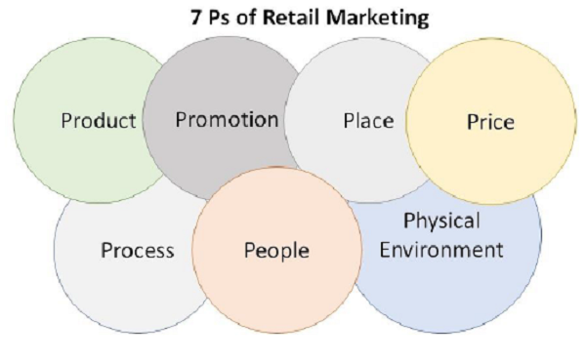
Marketing is critical for attracting attendees, securing sponsorships, and increasing event visibility (Kotler et al., 2008). Effective marketing follows the 7Ps framework (Product, Price, Place, Promotion, People, Process, Physical Evidence) (Bowdin et al., 2011).

Key Marketing Strategies:
1. Target Audience Segmentation: Using Maslow’s Hierarchy of Needs to appeal to different audience demographics (Kim & Jang, 2016).
2. Integrated Marketing Communication (IMC): Combining social media, PR, influencer marketing, and paid advertising to maximise reach (Kotler et al., 2008).
3. Sponsorship & Brand Partnerships: Leveraging corporate sponsors such as Coca-Cola and Google to enhance brand credibility (Goldblatt, 2011).
4. Sustainable Marketing: Promoting eco-friendly practices and carbon-neutral events to align with consumer values (Smith, 2016).
Applying a strategic marketing plan based on audience analytics ensures the event’s commercial success and long-term engagement.

Marketing and Branding for the event:
To attract business leaders and professionals, a strong marketing campaign is necessary. The event promotion strategy will include:
- Social Media Advertising: LinkedIn, Facebook, and Twitter campaigns targeting business communities (Forbes, 2024).
- Email Invitations: Direct invitations to HR professionals, corporate leaders, and business schools.
- Business Partnerships: Collaborating with Google, Unilever, and Coca-Cola, who can promote the event through their channels (Event Industry News, 2024).
A professional event website will provide details about the agenda, speakers, ticket pricing, and sponsorship opportunities (C&IT, 2024).
5. Event Management Considerations
5.1 Operational and Planning Strategies
Efficient operations management ensures seamless execution, security, and attendee experience (Bowdin et al., 2011). The EMBOK Model’s ‘Operations’ pillar provides a structured approach to event logistics (O’Toole, 2011).

EMBOK MODEL

Key Operational Considerations:
1. Venue Selection: Choosing accessible, high-capacity venues that support hybrid event technologies (Kim & Jang, 2016). Çırağan Palace offers grand ballrooms, conference rooms, and outdoor spaces, making it an ideal venue for a professional yet welcoming environment (Kempinski, 2025).
2. Security & Risk Management: Implementing crowd control strategies, cybersecurity for digital events, and emergency response planning (Bladen et al., 2012).
3. Technology Integration: Using RFID tracking, AI-powered chatbots, and virtual event platforms to improve attendee interaction (Smith, 2016). The event will require projectors, sound systems, translation devices, and interactive displays for exhibits (ICCA, 2024).
4. Supply Chain & Vendor Management: Coordinating catering, audiovisual production, and transport logistics to enhance service delivery (O’Toole, 2006).
5. Sustainable Logistics: Incorporating zero-waste catering, renewable energy sources, and digital ticketing to reduce environmental impact (Grant, 2005). Ensuring safe entry procedures, accessibility for attendees with disabilities, and emergency planning (McKinsey & Company, 2024).
Applying EMBOK and risk assessment models ensures a streamlined operational strategy, reducing risks and optimising efficiency. A dedicated event team will handle registration, coordination with suppliers, and on-site problem-solving to ensure smooth delivery (Skift Meetings, 2024).

5.3 Stakeholder Coordination

Stakeholders play a major role in ensuring the event’s success. The key stakeholders involved in this event include:
- Sponsors: Google, Unilever, Coca-Cola: companies with strong diversity and inclusion initiatives (Bowdin, 2006).
- Venue Partner: Çırağan Palace, which provides the necessary event space, catering, and logistical support (Kempinski, 2025).
- Attendees: Business leaders, diversity trainers, and HR professionals (Kristiansen et al., 2021).
- Suppliers: Catering companies, IT providers, and event production teams to ensure high-quality service (Bladen et al., 2012).

Regular communication with all stakeholders will ensure that deadlines, responsibilities, and expectations are clear.

6. Event Budget
Financial planning is crucial for ensuring event sustainability, profitability, and cost efficiency (Bowdin et al., 2011). Budgeting must align with revenue sources, cost controls, and Return on Investment (ROI) goals (Bladen et al., 2012).
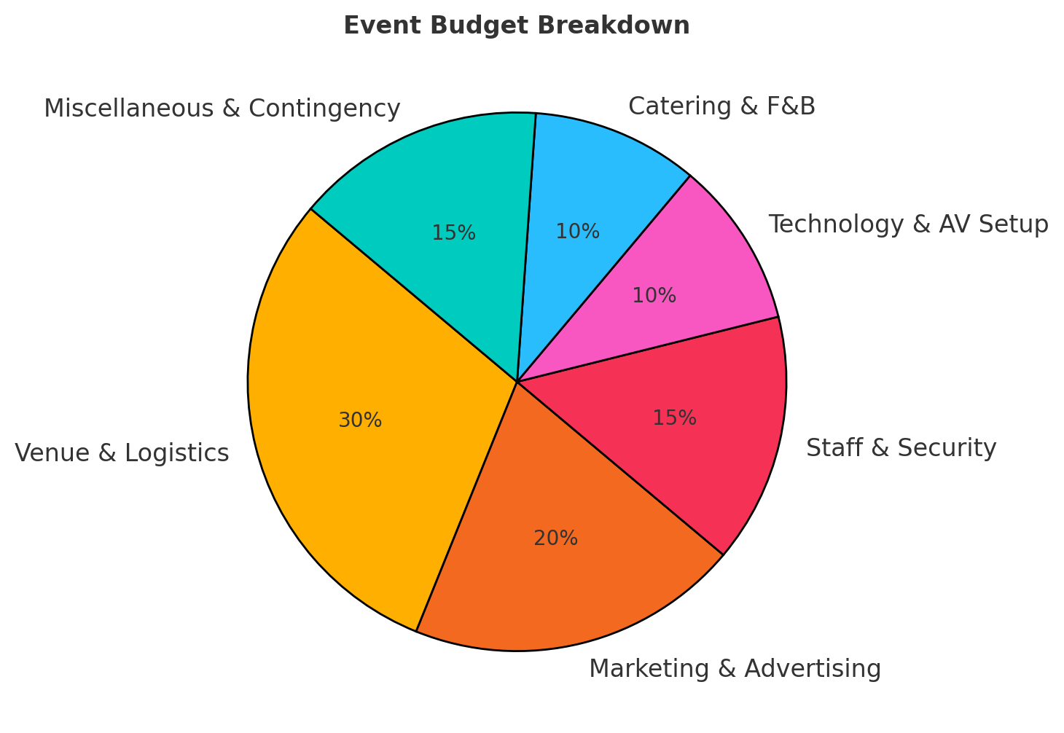
Key Budgeting Components:
1. Revenue Streams:
- Ticket sales (dynamic pricing models).
- Sponsorships & brand partnerships (Olympic Games’ corporate funding model).
- Merchandise and food & beverage sales (Kim & Jang, 2016).
2. Cost Management:
- Venue rental, staffing, marketing, and production costs.
- Contingency reserves for unforeseen expenses (O’Toole, 2006).
3. Break-Even Analysis:
- Identifying cost-revenue balance and implementing cost-reduction strategies (Smith, 2016).
- Using financial planning models from major festivals such as Glastonbury (Bladen et al., 2012).

6.1 Projected Income Sources
The event will generate revenue through:
1. Ticket Sales:
  - VIP Pass (Full Event Access): £500
  - Standard Ticket: £250
  - Student Ticket: £100
2. Sponsorship Deals:
- Corporate sponsorship packages (£5,000 - £50,000) (Bowdin et al., 2011).
3. Exhibition Booth Fees:
- Companies will pay £2,000 - £10,000 for space at the interactive exhibit.
4. Workshop & Certification Fees:
• Attendees can pay extra for certification courses in cultural intelligence (Quick, 2020).

6.2 Breakdown of Expenses
Expense Category | Estimated Cost (£)
Venue Rental | 50,000
Speaker Fees | 20,000
Catering | 15,000
Marketing & Promotion | 10,000
IT & Audio Equipment | 8,000
Staff Salaries | 12,000
Printing & Materials | 5,000
Security & Insurance | 7,000
Miscellaneous Costs | 5,000
Total Expenses | £132,000
By securing strong sponsorships and setting competitive ticket prices, the event aims to cover all costs and generate profit. Financial planning ensures that resources are allocated effectively (Lynch, 2009).

7. Industry Trends, Issues & Impacts
The event industry is evolving, with new trends shaping how conferences and business meetings are planned. To ensure the Cultural Intelligence in Global Business event is successful, it is important to consider current industry trends, challenges, and impacts.

7.1 Latest Industry Trends

Recent trends in event management show a shift toward technology-driven, sustainable, and hybrid events (ICCA, 2024). Key trends include:
- Hybrid Events: Many events now combine in-person and virtual attendance, allowing a global audience to participate (Skift Meetings, 2024).
- AI & Translation Technology: AI-powered tools, such as real-time translation services, make events more accessible for international audiences (Event Industry News, 2024).
- Diversity & Inclusion Focus: Businesses are prioritising inclusive event experiences by ensuring equal participation for all attendees (McKinsey & Company, 2024).

7.2 Challenges & Risks
Despite new opportunities, there are several risks and challenges in organising an international business event. These include:
- Cultural Sensitivity Risks: Discussions about diversity must be handled carefully to avoid misunderstandings or offensive content (Trompenaars and Hampden-Turner, 2012).
- Economic Factors: Inflation and financial instability may impact sponsorship deals and ticket sales (Lynch, 2009).
- Health & Safety Concerns: Post-pandemic event planning must include health regulations, sanitisation, and emergency response plans (Bowdin et al., 2011).
To mitigate these risks, the event team will ensure thorough research, strong risk management, and flexible planning.

8. Situational & Cultural Considerations
Planning an international event requires understanding local culture, regulations, and business expectations. The Cultural Intelligence in Global Business event must align with Turkish cultural norms and business etiquette.

8.1 SWOT Analysis of Event Location
A SWOT analysis helps to assess the strengths, weaknesses, opportunities, and threats of hosting the event at Çırağan Palace, Istanbul.
Factor | Analysis
Strengths | Prestigious venue, historic appeal, strong business connections, easy international access (Kempinski, 2025).
Weaknesses | High cost of luxury venue, potential language barriers for some attendees (Bowdin et al., 2011).
Opportunities | Expanding global partnerships, attracting corporate sponsorships, enhancing cultural intelligence awareness (Kristiansen et al., 2021).
Threats | Political or economic instability, potential travel restrictions, cultural misunderstandings (Lynch, 2009).
8.2 PESTEL Analysis

A PESTEL analysis examines external factors affecting the event:
- Political: Turkey is a business-friendly country but has political tensions that could impact travel (Lynch, 2009).
- Economic: Exchange rates and inflation may affect ticket pricing and sponsorship deals (Bowdin et al., 2011).
- Social: Istanbul is a culturally rich city that supports diverse and inclusive events (Kristiansen et al., 2021).
- Technological: Turkey has strong internet infrastructure and tech-friendly venues (Quick, 2020).
- Environmental: The event will follow sustainability practices, including paperless registration and eco-friendly catering (Bladen et al., 2012).
- Legal: Event organisers must comply with visa policies, data protection laws, and accessibility regulations (Bowdin et al., 2011).

8.3 Ensuring Cultural Inclusivity

Since this event is about cultural intelligence, it is essential to respect and embrace cultural differences. To achieve this:
- Multilingual Support: Providing translation services and bilingual event materials.
- Respect for Local Customs: Following Turkish etiquette in greetings, business interactions, and dress code (Trompenaars and Hampden-Turner, 2012).
- Inclusive Participation: Ensuring equal opportunities for women, underrepresented groups, and differently abled attendees (Kristiansen et al., 2021).

By addressing situational and cultural considerations, the event can create an inclusive and welcoming environment for all participants.

9. Post-Event Evaluation
Evaluating an event is essential to measure its success, financial performance, and overall impact. A post-event review helps organisers identify strengths, weaknesses, and areas for improvement (Bowdin et al., 2011).
Evaluation Framework:
1. Quantitative Metrics:
- Ticket sales, sponsorship ROI, social media engagement (Kotler et al., 2008).
- Event profitability and revenue tracking (O’Toole, 2006).
2. Qualitative Metrics:
- Attendee feedback via surveys, interviews, and Net Promoter Score (NPS) (Kim & Jang, 2016).
- Stakeholder satisfaction reports (Goldblatt, 2011).
By conducting structured post-event analysis, organisations can enhance event strategies and long-term sustainability.

9.1 Success Metrics
The Cultural Intelligence in Global Business event will be evaluated using three key metrics:
1. Attendee Feedback:
• Surveys will be sent to all participants to measure satisfaction levels, key takeaways, and areas for improvement (Lynch, 2009).
• Attendees will rate the usefulness of the masterclasses, networking opportunities, and exhibit sessions (Quick, 2020).
2. Financial Performance:
• Ticket sales, sponsorship income, and overall revenue will be compared to the budgeted expenses (Bladen et al., 2012).
• The aim is to ensure that the event covers costs and generates a positive return on investment (ROI) for sponsors and organisers.
3. Media & Social Engagement:
• Tracking mentions, shares, and interactions on platforms such as LinkedIn, Twitter, and business forums (Kristiansen et al., 2021).
• Measuring the reach of promotional campaigns and event-related articles published online.

9.2 Review of Stakeholder Satisfaction
Key stakeholders, sponsors, guest speakers, and exhibitors—will be given post-event evaluation forms to provide their feedback on event logistics, branding visibility, and networking opportunities (Bowdin et al., 2011).

9.3 Future Event Planning
Using the insights gathered from the evaluation, organisers will create an improvement plan for future editions of the event. This may include:
- Adjusting the event schedule to allow more networking time.
- Expanding hybrid participation options for international attendees.
- Increasing sponsorship opportunities to enhance the quality of exhibits and guest speaker line-ups (Quick, 2020).

By conducting a detailed post-event analysis, organisers can ensure that future events continue to attract high attendance, strong sponsorship, and positive engagement.

Conclusion:
This report has shown how well-planned event management is essential for success. By using Goldblatt’s Event Management Theory, the EMBOK Model, and Getz’s Experience Model, event planners can organise events that are structured, engaging, and financially stable (Goldblatt, 2011; O’Toole, 2011; Getz, 2012).
The findings highlight that careful planning, audience involvement, and new technology are key factors in making an event successful. AI-powered tools, digital ticketing with blockchain, and hybrid event formats are making events more accessible and eco-friendlier (Smith, 2016). Managing the budget well, reducing risks, and reviewing event feedback help organisers make better decisions for future events (Bowdin et al., 2011).
The future of event management is moving towards sustainability, inclusivity, and innovation. More people now expect green events, smart technology, and personalised experiences (Kim & Jang, 2016). Event professionals who keep up with these changes will attract more guests, improve efficiency, and stay ahead in the industry.
In the end, a balanced mix of creativity, planning, and new trends will help create events that people remember. By learning from past events and working closely with stakeholders, organisers can ensure that events are enjoyable, impactful, and beneficial for both businesses and communities.

References
Ang, S. and Van Dyne, L. (2015) Handbook of cultural intelligence: Theory, measurement, and applications. 2nd edn. New York: Routledge.
Bladen, C., Kennell, J., Abson, E., and Wilde, N. (2012) Events management: An introduction. Abingdon: Routledge.
Bowdin, G. A. J. (2006) Events management. 2nd edn. London: Butterworth-Heinemann.
Bowdin, G., Allen, J., O’Toole, W., Harris, R., and McDonnell, I. (2011) Events management. 3rd edn. Oxford: Elsevier.
Cultural Intelligence Center (2024) Research & Training on Cultural Intelligence. Available at: https://culturalq.com
Forbes (2024) Business Events & Diversity Strategies. Available at: https://www.forbes.com/councils/forbescommunicationscouncil/2023/12/27/refreshing-your-corporate-event-strategy-for-2024/
Getz, D. (2012) Event Studies: Theory, Research and Policy for Planned Events. 2nd edn. London: Routledge.
Goldblatt, J. (2011) Special Events: Creating and Sustaining a New World for Celebration. 6th edn. Hoboken, NJ: Wiley.
Grant, R. (2005) Contemporary strategy analysis. 5th edn. Oxford: Blackwell.
ICCA (2024) International Business Events & Industry Trends. Available at: https://www.iccaworld.org
Kempinski (2025) Çırağan Palace Kempinski. Available at: https://www.kempinski.com/en/ciragan-palace
Kim, J. H. and Jang, S. (2016) ‘Memory Retrieval of Cultural Event Experiences: Examining Internal and External Influences’, Journal of Travel Research, 55(3), pp. 322–339.
Kotler, P., Keller, K.L., Brady, M., Goodman, M. and Hansen, T. (2008) Marketing management. Harlow: Pearson Education.
Kristiansen, E., Solem, B. A. A., Dille, T., and Houlihan, B. (2021) ‘Stakeholder management of temporary sport event organisations’, Event Management, 25(6), pp. 619–639. Available at: https://doi.org/10.3727/152599521X16106577965080 .
Livermore, D. (2011) The cultural intelligence difference: Master the one skill you can’t do without in today’s global economy. New York: American Management Association.
Lynch, R. (2009) Strategic management. 5th edn. Harlow: Prentice Hall.
McKinsey & Company (2024) Diversity & Inclusion Research. Available at: https://www.mckinsey.com/business-functions/organization/our-insights
O’Toole, W. (2011) Events Feasibility and Development: From Strategy to Operations. Oxford: Butterworth-Heinemann.
Quick, L. (2020) Managing events: Real challenges, real outcomes. London: Sage.
Skift Meetings (2024) The Future of Hybrid & Digital Events. Available at: https://meetings.skift.com
Smith, B. (2016) ‘Event Technology Trends Shaping the Future of Events’, Social Tables Blog. Available at: https://www.socialtables.com/blog/event-technology/event-technology-trends/
Trompenaars, F. and Hampden-Turner, C. (2012) Riding the waves of culture: Understanding diversity in global business. 3rd edn. New York: McGraw-Hill.
UNWTO (2024) Tourism & Business Travel Reports. Available at: https://www.unwto.org

