Workplace culture and its impact on organisational efficiency

Name: Sara Al Hashidi
Student ID: 1919947
Name of university: University Of Wales Trinity Saint David
Name of lecturer: Olubukola Adegbite
Module code: BMSW5105
Module name: workplace culture and its impact on organisational efficiency
Assignment title: workplace culture and its impact on organisational
efficiency

Table of content
Introduction………….……………………………………………………………..………..1
Definition of organisational and workplace culture………………………..2
The impact of the environmental factors on Primark culture………….3
Explain how does Primark culture promote ethical behaviour among
employees……………………………………………………………………………………...4
Critical appraisal of Primark culture…………………………………………..……5
Recommendation that may enhance Primark culture in the future…6
Conclusion………………………………………………………………………………………7
Reference list………………………………………………………………………………….8

Introduction
Every organisation has a culture that identifies how the process of the work throughout conducting ways in which people expect to be in the workplace and the different attitudes. However, cultures of an organisation may be positive and it can also be negative or a mixture of both sides. If it is negative it can definitely damage the reputation of the organisation and bad practice, and if it is positive it could encourage employees to exceed expectations. It influences the way people behave and how they feel at work, when the workplace culture can not be recognised, the impact of the workplace culture can be identified. However, this report will assess the impact of the environmental factors on Primark culture using Pestel. The report will cover how the Primark culture promote ethical behaviour among employees, it will also provide a critical appraisal of Primark culture to be able to evaluate how culture is maintained in such organisation. In addition to relevant recommendations that can enhance the workplace culture of the organisation in the future. There will be also a brief conclusion that summarises the assignment context and the key point covered in this report.



Definition of organisational and workplace culture
Organisational culture or workplace culture is influential in shaping the company and the way it produce for its customers. Workplace culture is the collection of expectations, values and practises that guides and informs the actions of all the team member within the company (2021). It can also be defined with its shared beliefs, customs, habits and different attitudes, standards and norms of the workplace employees. Workplace culture or organisational culture prescribes the way in which the company interacts with the outside world, as well as how it conducts its business effectively and how it treats its employees (2021). However, organisational culture contributes to the social and psychological environment as it impacts on the overall employee engagement levels and the employee experience. The culture of the organisation indicates the company’s branding and reputation which can lead to an effect on the recruitment effort (2021). The culture of the company determine how the new ideas and innovation develops and how information flows through the hierarchy of the business.

However, every and each company has a unique organisational culture which can be developed over a period of time and evolve in one way or another. Although, when all cultures of the organisations should be having solid foundation, they should be able to change and adapt (2021). This change helps the company to advance and compete in challenging times. It is important for an organisation to change but, it is also hard strategy to improve. There are lots of benefit that identifies the advantage and the importance of organisational culture (2021). It helps the team members to overcome barriers of ambiguity. Team members that is knowledgeable and informed about certain processes are usually more motivated and engaged to compete projects. Having a clear culture in the organisation that unifies and promotes employees organised work structure helps individuals to corporate and work together with purpose more effectively (2021).

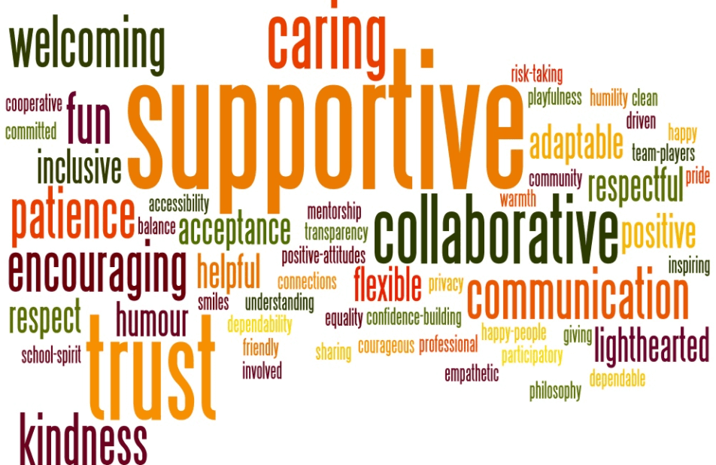
The impact of the environmental factors on Primark culture
Pestel analysis is a tool that is used to assess the factors that could affect the company and try to anticipate the risk raised by these factors. Pestel underlines the key strategies that defines the political, economical, social, technological, environmental and legal premises that could impact on the organisation. However, below is an explanation on the impact of the environmental factors on the culture of Primark company (Talk About,2021).
Political factors | - Political instability; in 2016 united kingdom decided to leave the EU. Brexit has caused a huge impact on the instability in financial markets and business environments dropping well below projected levels.  - Following the collapse of Rana plaza, the factory in Bangladesh where most of the products in Primark is from, there have also been a several new regulations set to prevent that occurring again, all of which have greatly affected Primark (Pest,2021).  - Primark’s revenue from 2007 to 2017: over the past few years the industry has seen fundamental growth, by the overall increase of the revenue of roughly 5.5 billion pounds. In 2017 Primark has generated a revenue around 7.1 billion pounds (2021).  - Employees rights; the conditions of employment and the right of workers might be an area of concerns that occur to the company that impact negatively employees in overseas manufacturing plants result in an extremely damage measures to call for help by attaching messages in sewing of clothes.  - Private limited company; Primark is a Public limited company PLC, therefore they had to institute tax, since their revenue raised considerably they would be expected to pay more tax (Pest,2021).
Economical factors | - Because of Brexit, the value of GPB decreased. However, this benefit Primark, due to the fact that the low exchange means a translation benefits for the organisation.  - Commercial property prices, since the Brexit there have been a rise of the price value (Pest,2021).  - The decision of Primark deciding to remain as a traditional mortal and bricks retailer could impact on the level of potential profit and sales.  - The rent price for Primark raised up by 25 percentage in the last year in high retail shops and shopping centres especially Primark company (Pest,2021).  - The impact also gone high with Primark operating across several jurisdictions results in the trade across the different currencies and the different culture in the market. Therefore, exposing Primark company to significant financial losses may occur if the rates of foreign exchange drop.  - The Primark consumer age range group choose to save as opposed to the stereotypical wasteful spending which associate with many of that age range, due to the economy currently appear and the pound falls on value, this adds up as an advantage that impact the position for the organisation (Pest,2021).
Social factors | - Primark offers clothing for all age ranges and genders, footwear, accessories, lingerie, homeware and cosmetics etc.  - After suffering negative press, Primark company have made their social responsibility increasingly motivated and committed and became a bigger part of the their website responding to key queries that consumer might have (2021).  - Primark has a code of conduct that constitute the value of the company. They have thirteen code of conduct where labour is safeguarded for example, hygienic and working hours are not excessive ,employment can be choosed freely, working conditions are safe (Pest,2021).
Technological factors | - Primark lack of online presence for customers to shop online or via app.  - Recent study shows 53 percentage said they shop online rather than in store.  - 25-34 years old ages shop up to eight times a month hence they are losing out on a lot of profit (2021).  - Social media and blogs are Primark site itself. “Primania” enable customers to be inspired and keep up with upcoming and recent trends.
Environmental factors | - Primark’s annual report shows how they are acting to be environmentally friendly.  - Consumers of Primark are becoming increasingly more interested and aware of the impact on the environment especially with the widely publicised effects of global warming (2021).  - The recent modern age , most people are concerned with the protection of environment and sustainability in regards to producing different methods and materials. Being able to focus more on the effort of recycled materials and sustainable sources for the selection of business funds investing in the society (Pest,2021).
Legal factors | - The new workplace pensions legislation makes it compulsory for companies to contribute three percentage to an employees pension.  - National minimum wage will cost Primark company millions of pounds.  - Gender equality specially gender pay gap regulations 2017, were put into place this year which means that Primark have to adjust their wages (Pest,2021).

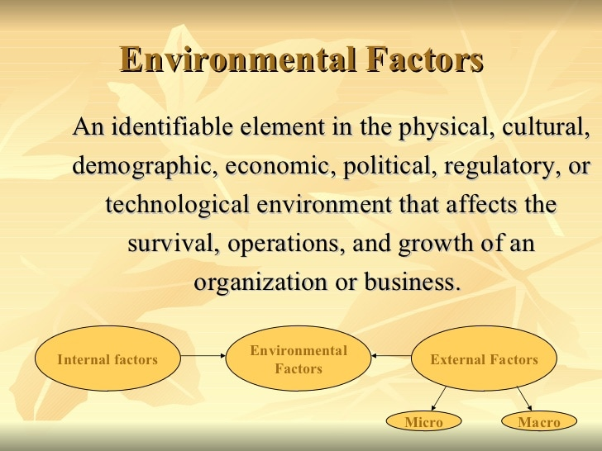
Explain how does Primark culture promote ethical behaviour among employees
Primark sells products at lower rates, this is because the business is different from that of other shops, with no compromise on ethics or social values. They do, however, keep things simple by using less advertising, buying in bulk and having a lower profit margin than other merchants (2021). This means that there is a very little gap between the price they sell things for in their stores and the amount they pay for them when they buy them (Primark values,2021). Primark sources from a variety of nations but, the majority of its products are produced in less economically developed countries such as Pakistan, Bangladesh and India. Primark on the other hand, take in consideration the standards in its supplier chain, which are all outlined in the code of conduct. Primark’s code of conduct is based on international labour norms such as the fair wage and reasonable working hours ( Organisational Cuture,2021). Primark’s code of conduct lays out all of the requirements that factories must achieve before, they may place orders with them. Furthermore, Primark’s ethical trade team which consists of over 80 people depending on their key sourcing countries, monitors and audits all its factories, as well as providing training and support to suppliers and factories to help them meet the company’s code of conducts conditions. The crew is made up of locals who are familiar with the customs, culture and language of these countries. They serve as the company’s on the ground eyes and ears (Organisational Culture,2021).
Every year, Primark conducts approximately 2500 audits every year across its 700 suppliers, these audits can be announced if a new production site is being built, or they can be semi announced unannounced if they have concerns or knowledge about issues within a factory (Organisational Culture,2021). Primark considers people in its supply chain and one of the areas that they have focused on within their program is being able to communicate if any issues arise within factories and ensuring that those workers have a voice, so it is critical that they feel confident and empowered to engage, interact and provide their point of view. Primark has been a member of the ETI (ethical trade initiative) for more than ten years (Primark Values,2021). This is a partnership of companies, non-governmental organizations, and labor unions to develop best practices for supporting factories and promoting workers in global supply chains. Companies who join ETI understand that they have a responsibility, so whatever they make, grow, or generate, they do so responsibly (Primark Values,2021). They have a responsibility to ensure that workers have good working conditions, a safe workplace, are not discriminated against, and are appropriately compensated since they understand that this is what customers demand (Organisational Culture,2021).
However, one of the major obstacles is salaries. Because Primark does not own factories, it does not have control over salary payments. However, the corporation may be able to influence how governments assess the minimum wages in place. Primark shares 98 percent of its manufacturing with other high-street shops, so working together as a collaborative group across brands is the only way they can start to increase pay (Primark Values,2021). One of the company's collaborations is called ACT, which stands for action, cooperation, and transformation, and it involves brands and the global textile union, also known as industrial, working together on three main topics. The first is the establishment of a minimum wage, the second is worker skill training, and the third is purchasing practices (Organisational Culture,2021). The bulk of the workers in many of Primark's factories are women, which is why many of their programs are geared solely toward women. One of these initiatives is health, in which female workers are trained on topics such as health, hygiene, sanitation, and nutrition. They have had an impact with the work that Primark has done, and they will continue to have an impact by growing as a team and working proactively to ensure that progress and improvements continue (Primark Values,2021).

Recommendation that may enhance Primark culture in the future
Fashion retailer Primark playing the sustainability card rights benefits by utilizing the McKinsey’s 7s model framework to enhance its performance and implement successful change management process. It also focus on the seven key elements of the model to ensure that the company’s performance levels are consistently maintained and improved (McKinsey 7S Model,2021). To support the relevant factors and strategies that may enhance Primark’s workplace culture in the future. McKinsey 7s model will help to identify the key elements that the organisation may implement to progress. This model is a tool that analyses the company’s organisational design and the goals that defines how effective the organisation can strive to develop to achieve a successful productive organisation. The framework consist of seven key elements, strategy, structure, system, skill, shared values, staff and style improved (McKinsey 7S Model,2021).
McKinsey 7s model framework
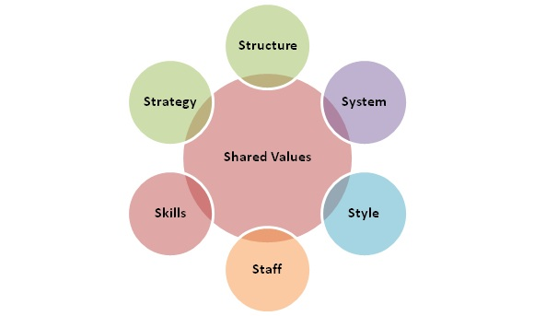

These 7 elements that is identified in McKinsey’s framework model can be classified as being soft or hard elements. The soft elements includes, shared values, skills, style, and staff. The hard elements includes the strategy, structure and the systems improved (McKinsey 7S Model,2021).

The soft elements; of this module such as the shared values, skills, style and staff are less perceptible in nature and are at a high risk and influential by the organisational culture. Therefore, the company is unable to control over them and they are more harder to directly identify or describe. But, this does not mean that it is important as it plays a significant role in improving company performance and organisations success improved (McKinsey 7S Model,2021) .
Shared values;
Core values, this is defined to stimulate and foster a supportive and creative organisational structure that allow the employees to execute formally. As well as promoting and enhancing their motivations and organisational commitment (Statements,2021). The core values at fashion retailer Primark playing the sustainability card right involves, accountability, honesty, quality, creativity, heritage, transparency, and trust.
The business strive to ensure that all its operations and activities are conducted with high ethical and moral standards that declares and measures against international criteria (Statements,2021).
Corporate culture, This encourages an inclusive atmosphere that welcomes diversity in the workplace. The company has production facilities and an international presence, with customers in a variety of nations. They do, however, want to make sure that the organization's culture remains supportive of diversity and that it has internal rules in place to deal with potential discrimination (Statements,2021). Individuals and teams are also given the freedom to flourish independently, which encourages continual creativity and invention. As a result, they are better able to optimize their own personalities and vocations. The company culture is characterized by a supportive leadership that strives to increase job satisfaction and employee motivation by improving accessibility and visibility (McKinsey 7s Framework Of Fashion Retailer Primark Playing the Sustainability Cars right,2021).
Task aligned with values, this ensures that all the roles and tasks are aligned with the core values that the company publish. By reflecting the tactics and strategics with the core values, this enables a reliable and consistent image as well as an honest organisational culture. In the event of the company’s change and promotion, the organisation will make sure to continually maintain the change to all management methods and processes integrate the core values so that they enhance the organisational culture consistently preserved (McKinsey 7s Framework Of Fashion Retailer Primark Playing the Sustainability Cars right,2021).

Skills;
Employee skills, this ensures to hire all employees based on their academic levels and qualifications. As well as recruiting the best professionals and initializing them further to facilitate development and growth.
Employee skills and task requirements, this defines job roles and tasks, training and hiring employees for skill levels in accordance with respect for them. However, the company is being aware that all the employees have the sufficient skills to perform for the identified job role as well as ensuring job requirements are met relating to the values and culture and its strategy and goals (McKinsey 7s Framework Of Fashion Retailer Primark Playing the Sustainability Cars right,2021).
Skill management, this pays attention to enhance the capabilities and skills of the company’s employees. It stick with the regular trainings and workshops that is provided to develop the companies efficiency. They manage externally and internally opportunities for employees to develop and progress personally and professionally (Statements,2021).
Company’s competitive advantage, the human resource is one of the core competitive advantage of Primark company. Job roles requirement and employees skills are developed by providing the competitive benefit to the company and skilled employees that have sufficient trainings can not be imitated. Which then creates non substitutable competency for the company that adds up as an competitive advantage for the future (McKinsey 7s Framework Of Fashion Retailer Primark Playing the Sustainability Cars right,2021).
Style;
Management, leadership style, through this style they involve and engage with employees decision making processes and managerial decisions. Which then allow the leadership to interact regularly with employees and different management teams to identify the potential concerns to resolution, and feedbacks relating to operations within the company. However, through this participation the organisation enhance organisational commitment and increase employee motivation (Statements,2021) .
Effectiveness of leadership style, being able to participate leadership is effective to achieve business goals and vision of the company. Employees become to feel more actively engaged and involved as well as being valued with their overall input, and suggestions being considered (McKinsey 7s Framework Of Fashion Retailer Primark Playing the Sustainability Cars right,2021).
Cooperation and competitive, the cooperation and collaboration support and promote organisational culture enabling the organisation process to function effectively and perform at a high level.
Staff;
Employee skill level and business goals, based on the different employees employed at different job roles and positions, everyone are given a training to familiarize themselves with the company and its values as well for the skill level enhancement. The company is inclusively open that accept and encourage diversity and works with different types of people to attain business goals (McKinsey 7s Framework Of Fashion Retailer Primark Playing the Sustainability Cars right,2021).

The hard elements; consist of the strategy, structure and systems and these are more easier to identify, more perceptible in the nature and can be directly controlled and influenced by the management and the leadership of the organisation (McKinsey 7S Model,2021).
Strategy;
Clearly defined, the overall business strategy and strategic directions in Primark are clearly defined and communicated to all stakeholders and employees. However, this helps the organisation to guide actions, create different types of methods that are aligned with the business strategy and manage performance for the future.
Guiding behaviour for goal attainment, the strategic direction is important as it helps the organisation to guide its employees, stakeholders and staff behaviour towards achieving company goals (Statements,2021).
Competitive pressures, this strategy identifies the competitive pressures by actions and suggestive measures that ensures sustainability of the company by adapting to market changes as well as developing consumer demands and trends (McKinsey 7s Framework Of Fashion Retailer Primark Playing the Sustainability Cars right,2021).
Changing consumer demands, this allow the company to remain competitive and relevant to its aimed target, enable the company to address requested gaps in the consumer market. This then leads the company’s identification of the market activities and product offerings which enhance the company’s leading edge and advantage over other markets (Statements,2021).
Adaptability and flexibility, this is an important aspect of the strategic direction that promote the company’s market innovation and progression change. Flexibility and adaptability helps the organisation to be able to locally and culturally adapt its products through maintaining different countries settlement and regions (McKinsey 7s Framework Of Fashion Retailer Primark Playing the Sustainability Cars right,2021).
Structure;
Organisational hierarchy, this is supported by progressive organisations and learning , with more access to management and a reduced managerial levels , this enable employees to feel more confident and secured and allow them to have higher access to information. However, this increase employees organisational commitment and simplifies decision making process (Statements,2021).
Inter departmental coordination, this allow increased coordination between departments to become more organised and effective. In addition to a smooth work operations and successful company goals.
Internal team dynamics, this ensures employees work effectively with other team members and support towards achieving team objectives along with values (McKinsey 7s Framework Of Fashion Retailer Primark Playing the Sustainability Cars right,2021).
Centralization and decentralization, the company support decentralization decision making, job roles being carried out with responsibility, and setting goals of employees and understanding with the supervisor with mutual coordination. The company is also centralized ensuring that the supervisors observe and approve of the various tactics and efforts that employees decide considering they are aligned with the organisational values and strategies (McKinsey 7s Framework Of Fashion Retailer Primark Playing the Sustainability Cars right,2021).
Communication, this ensure well communication between employees and allow easy flow of information and that no tasks and organisational goals are compromised due to lack of communication (Statements,2021).
Systems;
Organisational system in place, the company has put systems in place to allow the business operation to be managed effectively and to avoid disputes and conflicts. It includes, finance, supply chain management, human resource management, operations, strategic leadership and more.
Defined controls for systems, each of the systems has different methods and tools as controls for goals attainment and evaluating performance (McKinsey 7s Framework Of Fashion Retailer Primark Playing the Sustainability Cars right,2021).
Evaluating and monitoring controls, systems and performance are evaluated and monitored continually to keep the company improve further.
Internal processes for organisational alignment, the company has special process and various methods to keep systems and departments within the organisation more aligned and work towards achieving business objective (Statements,2021).
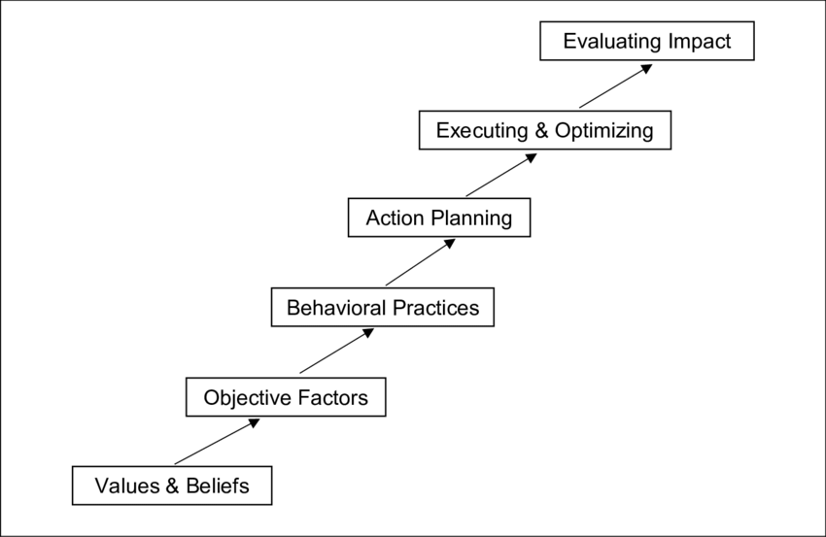

Conclusion

To summarise, an organization's culture is a critical factor that influences the general function of the firm and its future success. A company's structure is dependent on its culture, which allows the organisation to run more effectively and progress by ensuring that employees understand what they are accountable for, their responsibilities, expectations, behaviours, and values, among other things. Primark's key business principle is to think about how it can give its customers good value for money while maintaining and preserving ethical manufacturing standards (Primark Values,2021). This includes paying for independent audits of all of its plants and promoting suppliers who can address problems in a sustainable and productive manner. Primark, on the other hand, wants to show that it is committed to dependable production. This helps to sustain and empathize with its customers by assuring them that the things they buy are ethically created by people who are treated decently (2021).

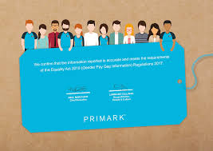

Reference list
- Afribary. 2021. Organisation Behaviour: A Case Study of Primark | Afribary. [online] Available at: <https://afribary.com/works/pkj124> [Accessed 17 November 2021].

- Corporate Finance Institute. 2021. McKinsey 7S Model. [online] Available at: <https://corporatefinanceinstitute.com/resources/knowledge/strategy/mckinsey-7s-model/> [Accessed 16 November 2021].

- Courseworkbox.co.uk. 2021. [online] Available at: <http://www.courseworkbox.co.uk/pdf/primark.pdf> [Accessed 8 November 2021].

- Engage Blog. 2021. Organizational Culture: Definition, Importance, and Development. [online] Available at: <https://www.achievers.com/blog/organizational-culture-definition/> [Accessed 8 November 2021].

- Essay48. 2021. Mckinsey 7s Framework Of Fashion Retailer Primark Playing the Sustainability Card Right. [online] Available at: <https://www.essay48.com/case/49116-Fashion-Retailer-Primark-Playing-the-Sustainability-Card-Right-Mckinsey-7s> [Accessed 16 November 2021].

- Free Essays - PhDessay.com. 2021. PEST Analysis of Primark Stores Ltd - PHDessay.com. [online] Available at: <https://phdessay.com/pest-analysis-of-primark-stores-ltd/> [Accessed 8 November 2021].

- Locusassignments.com. 2021. Unit 1 Assignment on Primark Business Environment – HND Help. [online] Available at: <https://www.locusassignments.com/solution/unit-1-assignment-primark-business-environment> [Accessed 8 November 2021].

- malik, h., malik, h. and profile, V., 2021. Organisational Culture. [online] Hussainrafiq.blogspot.com. Available at: <https://hussainrafiq.blogspot.com/2011/10/organisational-culture.html> [Accessed 17 November 2021].

- Mindtools.com. 2021. The McKinsey 7-S Framework: - Making Every Part of Your Organization Work in Harmony. [online] Available at: <https://www.mindtools.com/pages/article/newSTR_91.htm> [Accessed 16 November 2021].

- Moran, G., Fish, I. and Moran, G., 2021. Primark sets out ‘ambitious’ sustainability strategy. [online] Drapers. Available at: <https://www.drapersonline.com/news/primark-sustainability-strategy> [Accessed 8 November 2021].

- nishahmed1502. 2021. nishahmed1502. [online] Available at: <https://nishahmed1502.wordpress.com/> [Accessed 17 November 2021].

- organisationsandbehaviour. 2021. BEHAVIOUR, STRUCTURES, AND CULTURES.. [online] Available at: <https://organisationsandbehaviour.wordpress.com/2014/10/24/behaviour-structures-and-cultures/> [Accessed 17 November 2021].

- People Insight. 2021. How can we define organisational culture?. [online] Available at: <https://peopleinsight.co.uk/how-can-we-define-organisational-culture/> [Accessed 8 November 2021].

- Statements, M., 2021. Primark Mission Statement. [online] Mission-statement.com. Available at: <https://mission-statement.com/primark/> [Accessed 16 November 2021].

- Talk About. 2021. The future of Primark – will it survive the effects of the pandemic? - Talk About. [online] Available at: <https://talkaboutcommunity.com/2020/07/16/the-future-of-primark-will-it-survive-the-effects-of-the-pandemic/> [Accessed 8 November 2021].

- Ukessays.com. 2021. The Organizations And Behavior Commerce Essay. [online] Available at: <https://www.ukessays.com/essays/commerce/the-organizations-and-behavior-commerce-essay.php> [Accessed 17 November 2021].

- 2021. [online] Available at: <https://www.essaysauce.com/marketing-essays/primark-marketing-analysis-swot-and-pestel/> [Accessed 8 November 2021].

- 2021. [online] Available at: <https://careers.primark.com/our-values> [Accessed 17 November 2021].

