

Prototype Update
User Experience Design

Shannon Cranfield
P149078
Dr Nik Whitehead
M6X01111

Table of Figures
Figure 1: Login Screen 3
Figure 2: Side-Menu 3
Figure 3: Dashboard Screen 3
Figure 4: Modules Screen 4
Figure 5: Timetable Screen 4
Figure 6: Module Topics Screen 4
Figure 7: Chat Screen 1
Figure 8: Menu Screen 1
Figure 9: Menu Food Details 1
Figure 10: Map Screen 2
Figure 11: Library Search Results Screen 2
Figure 12: Email Screen 2
Figure 13 Rolfe’s Reflection Model 9
Figure 14 Elements of User Experience Design 10

Table of Tables
Table 1: User Tasks 5

Table of contents
1. Introduction 1
2. The application 2
2.1. Storyboards 2
2.2. Main Screens 3
3. Collection of Feedback 5
3.1. Process of collection 5
3.2. Results from feedback 6
4. Data 8
5. Reflective Summary 9
6. References 11
Appendix A 12
Appendix B 1
Appendix C 1
Appendix D Email 2
Appendix E Chat 3
Appendix F Library 1
Appendix G Book Computer 1
Appendix H Book Room 1
Appendix I Food Services 1
Appendix J Map – UWTSD 1
Appendix k Map 1
Appendix L Questions 1
Appendix M Settings 1
Appendix N Finance 1

Introduction

A mobile application has been designed for students who attend the University of Wales Trinity Saint David in the Faculty of Architecture, Computing and Engineering. The main aim of this application is to help students with easy access to the information systems that they require on a daily basis while at university. A prototype has been designed for this mobile application. This report provides an analysis of the application prototype, and presents storyboards for the application. The processes used to collect feedback is discussed, and the feedback is analyzed. Additionally, this report investigates how data could be used to influence another version of the app. Finally, a reflective summary of the overall design process is presented next.

The application

  - Storyboards

Ideas drawn from the wireframes previously made have all been implemented in the porotype of the application, no changes were made from the wireframes in the creation of the prototype. Main storyboards of some of the screens of the application have been outlined below. The storyboard molds the foundation for the first version of the prototype which then can be analyzed and improved to form a second version later on in the future. Other screens within the app can be found in Appendix A – N.

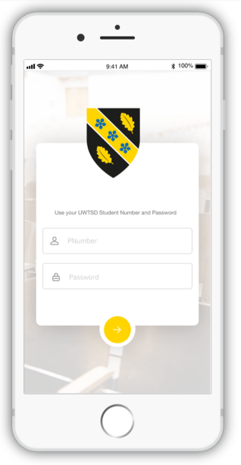
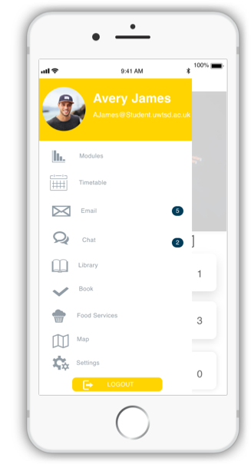
Figure 1: Login Screen
Figure 2: Side-Menu
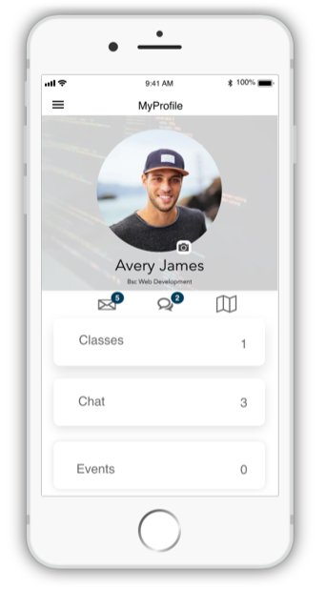
Figure 3: Dashboard Screen

Users can select this hamburger icon to display the different menu, shown in figure 3. This is the main navigation throughout the app.

Each screen in this application has this hamburger icon allowing them to navigate easily within the app.
Once users use their details to log in, the yellow button should be clicked, sending them to the main dashboard screen shown in figure 2.
Each of these menu items will direct users to their corresponding pages.

Users can log out sending them back to the login screen using this button

Once the timetable menu option is selected by users they are directed to this screen. This screen displays the student’s classes.

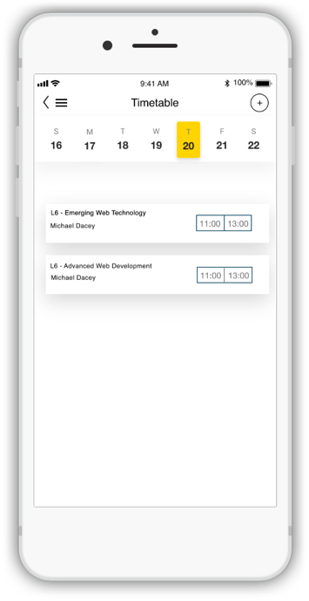

Students can select this + button to add new classes.
This is a slider where students can swipe to select a date retrieving timetable information on specific days.

Users can select to view their modules from the side menu shown in figure 3. Once ‘Modules’ is selected students are directed to this screen. This screen displays the student’s modules

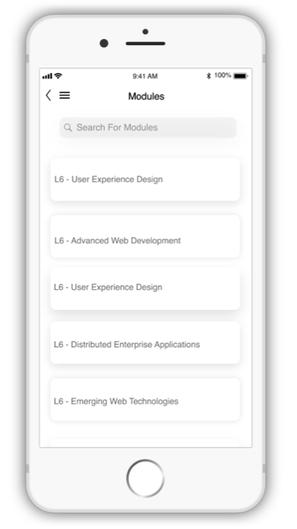
Figure 4: Modules Screen
Students can search for their modules using the search box

Figure 5: Timetable Screen
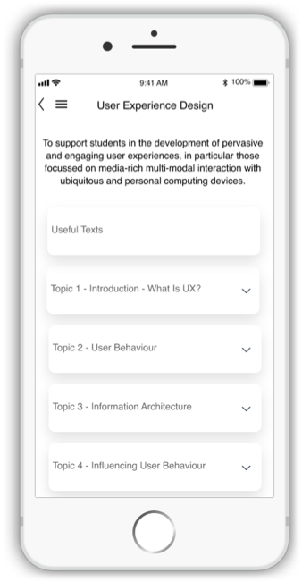
Once users select a module this screen appears displaying the modules topic.

Users can go back to the module page by selecting this button

Once students select a topic, the use of a down arrow is displayed letting students know that they can click this item.

Once they select a topic. Topic resources is then displayed for example PowerPoints and word documents.

Figure 6: Module Topics Screen

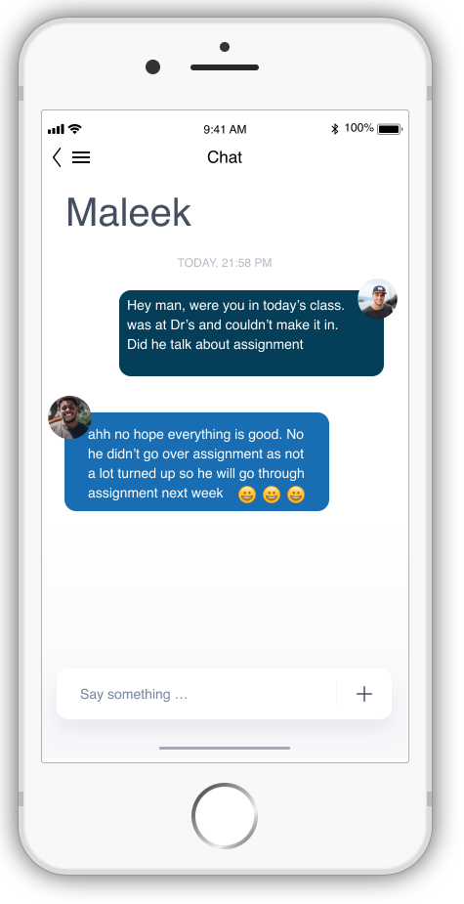
Users can go back to the chat notifications page by selecting this button

Messages that are getting exchanged

Type messages to send to other users

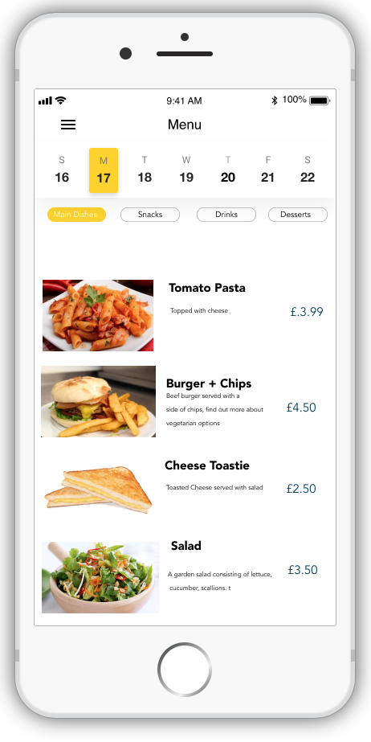

This is a slider where students can swipe to select a date retrieving menu information on specific days.
Figure 7: Chat Screen
Once users select a food details about the food is displayed
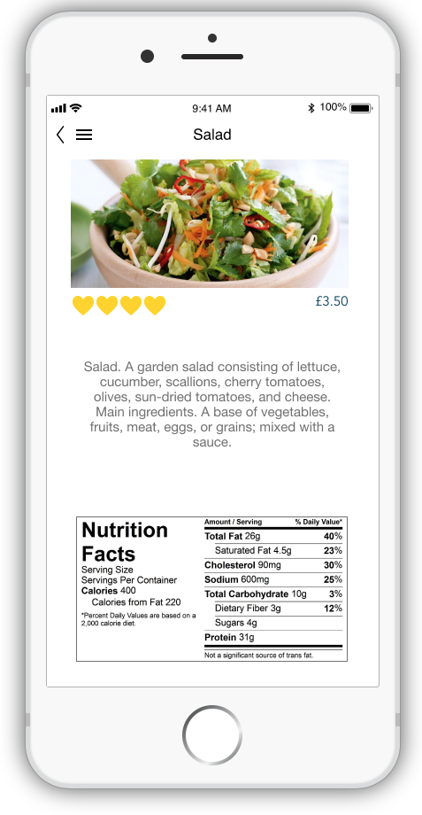
Buttons to select a category of the menu to get displayed

Image of food details

Content details displayed.
Price of food

Rating System: students can rate the food using the hearts

Figure 8: Menu Screen
Description of food

Nutritional facts about food is also displayed

Figure 9: Menu Food Details

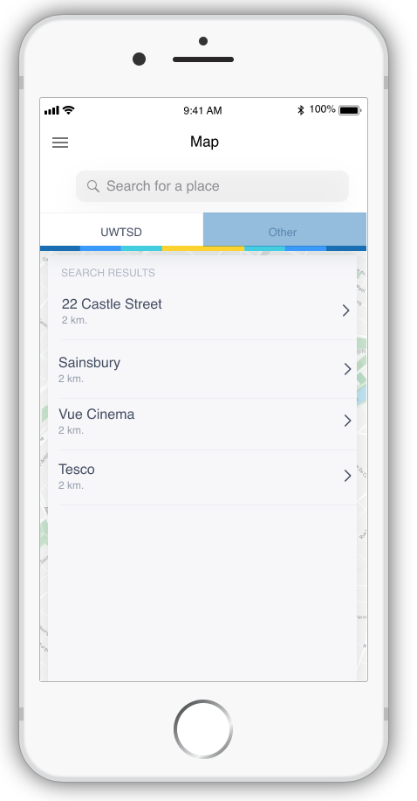
Figure 10: Map Screen
List of recently viewed searched made by student
Search for a venue or room within the grounds of the university this can be seen in Appendix A: Map- UWTSD-Screen
Search for a place outside the university, it automatically uses the UWTSD postcode as the starting point.

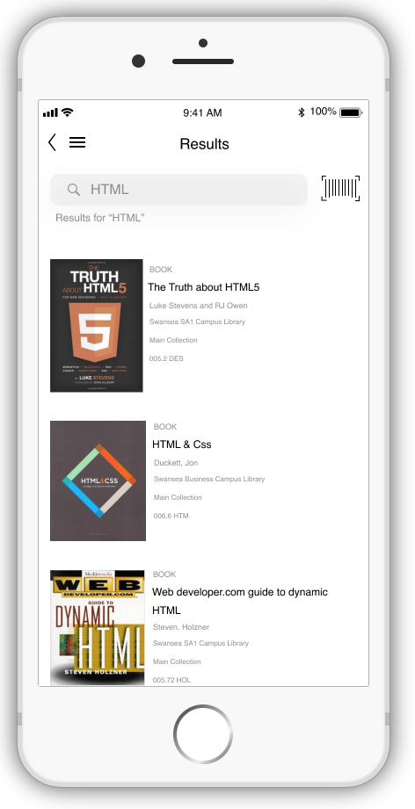

Barcode scanner to scan book

When users select Email In the menu users are directed here to this page.

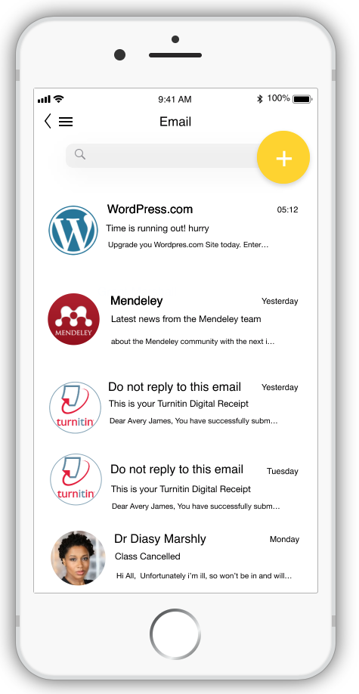
Search results are displayed
- Image of book
- Name book
- Author of book
- Location of book

Students can write a new email here by selecting this button

Figure 11: Library Search Results Screen

Emails displayed here

Figure 12: Email Screen

  - Main Screens
Below is the list of screens and services students will have access to when using the application:

- Login Screen: Users use their student P- number and their student password to log into this application.

- Dashboard: The dashboard is the first screen that users will see once they have logged into the application, this dashboard displays the profile of the student as well as informing students as to what classes they have for that day, events that they have for that day and viewing to see if they have any new emails or new chats. This dashboard acts as an overview of “today’s activity”. Not only does it display but also can direct users to the desired location of the content displayed for example if a user sees they have one new email they can open that email without going to the navigational side bar to open it.

- Modules: Displays the user’s module content, also allowing users to open resources for example PowerPoints, word documents and texts. Arrows are displayed next to module topics to inform users that the button can be expanded to retrieve such data.

- Map: Two map options are available within this application, one being users can locate rooms, toilets, offices and venues etc. by searching for the name, the app within will then guide users to their destination. The second is a regular map, however within this application the starting point will always be set to the UWTSD postcode, users will then be guided to their destination.

- Timetable: The user’s classes is displayed with class name, class location, class time and class lecturer. Users can use a slider situated on the top of the screen to select what date they will like to view their classes; they can also add classes to their schedule by selecting the add icon button.

- Food Services: The app also provides users with information about the day’s food and drink availability. Users can find out what is available on a given day, the price of those products, nutritional facts and details additionally, users can also rate the food, to affect their decisions making on purchasing.

- Booking: Users can book a room on any campus within the app allowing them to have guaranteed access to a specific room without having any room issues. Users can also book a computer to ensure they have space and a computer to work at.

- Questions: Students who are too shy to ask questions out loud in class can use this feature of the app whether in class or outside class also either displaying their name or asking anonymously, they can ask questions directly to the lecturer or to a class forum where other students within the class can answer the questions.

- Email: To save space on downloading many applications, this application integrates the email system implemented into the application, allowing users to access their emails and send emails within the app.

- Chat: A chat system is designed to allow users to talk to students and members of staff.

- Navigation: A hamburger menu is located on every screen allowing easy and quick navigation through the application. A back arrow is situated next to the hamburger where it corresponds to the page. Navigation is like a roadmap, if not easily created for user then users will get lost, in this case users can get lost within the application. Navigation choices were thought through thoroughly as the application has a lot of features and integrations within. Mentioned before a navigational menu icon is displayed on all screens. Moreover, as a back arrow so that users do not struggle working their way around the application.

- Finance: users can view their finances, showing the information about finances and payments.

Collection of Feedback

Mobile testing is a method by which application software developed is tested for usability, functionality and consistency [1] . The development of this mobile application has taken Usability Theory into account when designing it. Usability Theory is a set of ideas that provides insight into how humans interact with technology. It is defined as “the effectiveness, efficiency, and satisfaction with which users can achieve tasks in a particular environment” [2] Feedback on the application has been collected, the process and the results are described below.

  - Process of collection
A task scenario is an action that one needs a participant to take on a tested interface [3]. Task scenarios were written to better understand how real users interact with the mobile application and to improve the application based on these results. The main purpose of a usability test is to improve a design and as such task scenarios were given to five participants who were then observed undertaking the set task scenarios, and feedback was obtained from the participants. Personas, fictional characters created to represent different user types. Personas created previously were used to design the scenario tasks. The session started off by the initial set up of the displaying of the prototype on the participant’s phone. Observations were conducted while all the participants carried out the user tasks and provided feedback to questions discussed during the session. Each of the five participants had 5 tasks to perform shown in table 1.
Table 1: User Tasks
Once the users completed these tasks, users participated in a focus group where 4 questions were discussed as shown below.
- How do you feel about the information architecture and navigation? Does it make sense - Can you find what you are looking for.
- Did you get confused at any point?
- What's your overall impression of the interface?
- Is it stress-free to understand what actions features and objects will perform?
The session then ended with a closing discussion on their final thoughts of the application.

  - Results from feedback
The feedback brought together from those observations sessions were analyzed, and a discussion of some of the feedback will be looked at. Firstly, the feedback from the tasks that the users had to complete will be explored.

Scenario Tasks
- Task 1: Participants completed this task as navigation was clear and simple. Participants followed the navigation leading them to the desired screens they needed to get through to get to the destination for the task. Three out of the five participants knew that they could click on the module which lead them to the topics within that module. However, the other two thought that the screen just stopped and displayed the modules until they accidently pressed on it and it lead them to the next screen leading them to one of the modules topics. Users said that the down arrow used in the topic overview should also be placed in the screen before – the module overview to inform users that it doesn't end their but it goes on and topic resources can be obtained.
- Task 2: Participants were able to locate questions screen however points were made that once users land on this page it’s quite basic and not too easily understandable. Who can see the questions? What questions were raised in what class? How to make secretive? This questions were raised in the session.
- Task 3: Participants completed this task as navigation was clear and simple.
- Task 4: Five out of the five participants could not complete this task as when they selected the book option in the navigation menu they were directed to a book room screen where they can book a room to use. Users was confused leading them not completing this task. Two out of the five participants suggested having two book menu options within the navigation menu one for computer and the second for room however the three other participants opposed and said the navigation menu is already quite full, leading them to suggest have the options made available when they select book on the menu navigation.
- Task 5: All the participants completed this task with ease with one or two confused with wording within completing this task. They stated that they liked the fact that there were two routes in finding this, one way through the navigation menu and the other through the main dashboard. Participants could use functions easily. Additionally participants made comment that terminology used on map pages could improve – “UWTSD”and “other, users didn't understand what other meant or UWTSD until they selected either.

The results from the observations obtained as well as the questions that were given to the test participants will be analyzed next.

Feedback:

- Navigation
Participants thought that the overall navigation through the application was great as a menu icon was displayed on all the pages placed constantly in the same location. Participants thought the hamburger menu allowed them to focus on the main content getting displayed and liked the fact they can call upon it when they choose to rather than it being chucked on the screens. From observations one participant mentioned that they would have preferred the menu to not be hidden away and to rather be exposed on the screen, this same participant suggested that the menu be placed at the bottom of the screen that gets displayed constantly so navigation is not hidden thus allowing for direct access on the other hand this was disputed as it was suggested that the app had a few features and that they all won’t fit at the bottom of the screen. Participants thought that the titles of the screens and navigation was descriptive.

- House style and colour
Additionally, participants thought the University of Wales Trinity Saint David’s house style and ethos was implemented well in the app and that the colour and contrast helps with the interpretation of content, they thought the use of two colours primary being yellow and secondary being blue worked sufficiently. On the food services pages, users thought that the white over the yellow did not work well, therefore suggesting that the font colour be changed.

- Design Layout
The layout of the design was simple and not overloaded. Suggestions were recommended on the dashboard page, stated that maybe the profile image and background image could be made a little smaller making the icons a little bigger.
Participants thought that the design was constant throughout the application making it easy to use. The participants were exhilarated to have features integrated into one app to enhance their university academic experience.

Data

Data needed for services
The application will provide a set of services to students and provide a platform for students to engage with each other and lecturers. The services provided to students will need data in relation to that service to be able to provide the service to students. Some of this data can be automatically gathered via other systems already established at the university while other data will be gathered via student input as students use the mobile application.

Usage Data Tracking
Usage data tracking automatically enables the tracking of usage data which provides a valuable tool for understanding the performance of the application and how popular the different features of the application are [4]. Tracking user data can improve the development of the mobile application and feed into the next version of the application. Data that could be tracked could be
- data about the interaction with the software
- level of student
- location of student
How the user interacts with the different features of the application will provide valuable information for future developments, where popular features can be improved on and unpopular features can either be disregarded or further development to increase usage done on those features.
Users were asked to provide feedback on the user of the application. This information together with the usage data tracking information will be used to improve on the new version of the mobile application. How users experience using an application and how they use the application can be different and hence both of these needs to be taken into account when improving on the development of an application.

Reflective Summary

To reflect on the design of the mobile application Rolfe’s (2001) reflection model was used [5]:
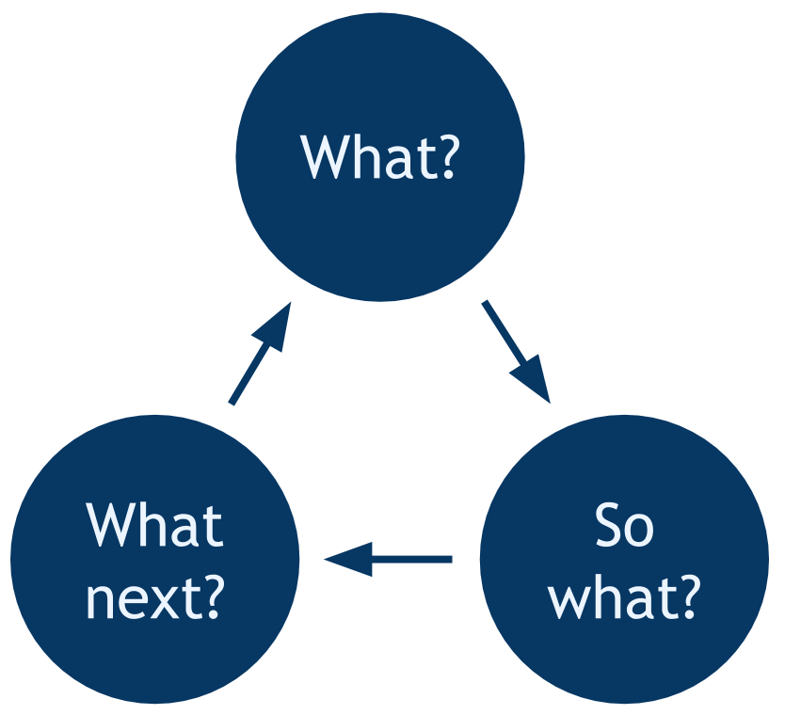
Figure 13 Rolfe’s Reflection Model
What?
The aim of the assignment was to develop a mobile application prototype that helps students at UWTSD to access relevant academic and other student information, easily and efficiently. A prototype was designed based on wireframes tested on users to achieve a more usable mobile application. Task scenarios were given to users to test usability and user experience, the feedback of which was used to improve the design of the mobile application. Negative and positive feedback was provided from the users and this will help with improvements for the second version of the mobile application. The process used was based on usability testing theory to support the design.

So What?
The process implemented generally worked well. Participants found the user scenario tasks easy to follow, however in the testing process, it may have worked better if a system usability questionnaire was used to help with more specific areas for improvement rather than just the 4 questions used in the focus group.

Now what?
The participant feedback will be used to design and develop an improved version of the mobile application. Further usability questionnaires could be used to provide further feedback to influence the design of the new mobile application further.

Designing applications with the user experience in mind and as an explicit outcome means looking beyond the functional and aesthetic aspects of the application [6] and focusing on how the user will experience interacting with the application and whether that will be a successful and positive experience or not. User experience design refers to the design of positive experiences during the use of devices and applications or services. The design of mobile applications places unique requirements on the design of the user experience [7] .

There is an overlap between interaction design and user design, but user design is more than interaction design as it also involves user research (finding out who the users are), creating personas (why and under what conditions would they use the product), performing user testing and usability testing [8].

Some conflict can arise when only focusing on Usability as it focuses on the ease of use whereas the User Experience focuses on a range of aspects of which usability is just one aspect, however ensuring that usability is focused on throughout the design process from wireframes to prototypes to the final deliverable, will ensure that .
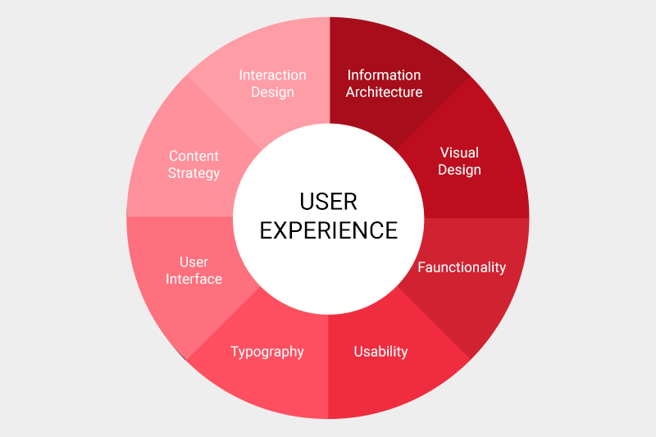
Figure 14 Elements of User Experience Design
Example: The navigation bar was hidden to not clutter the screens but users reported negatively about the bar being hidden.

References

[1] S. Development, “Importance of Mobile App Testing.”
[2] A. Marcus, Design, User Experience and Usability. Springer.
[3] “How to improve your UX designs with Task Analysis | Interaction Design Foundation.” [Online]. Available: https://www.interaction-design.org/literature/article/task-analysis-a-ux-designer-s-best-friend. [Accessed: 17-May-2019].
[4] “What is Usage Data Tracking? – Native Instruments.” [Online]. Available: https://support.native-instruments.com/hc/en-us/articles/209545029-What-is-Usage-Data-Tracking-. [Accessed: 17-May-2019].
[5] Rolfe et al, “Rolfe et al.’s reflective model.”
[6] J. J. Garratt, The Elements of User Experience: User-Centered Design for the Web and Beyond, 1st ed. New Riders, 2002.
[7] “What is Mobile User Experience (UX) Design?” [Online]. Available: https://www.interaction-design.org/literature/topics/mobile-ux-design. [Accessed: 17-May-2019].
[8] “What is Interaction Design? | Interaction Design Foundation.” [Online]. Available: https://www.interaction-design.org/literature/article/what-is-interaction-design. [Accessed: 17-May-2019].

Appendix A
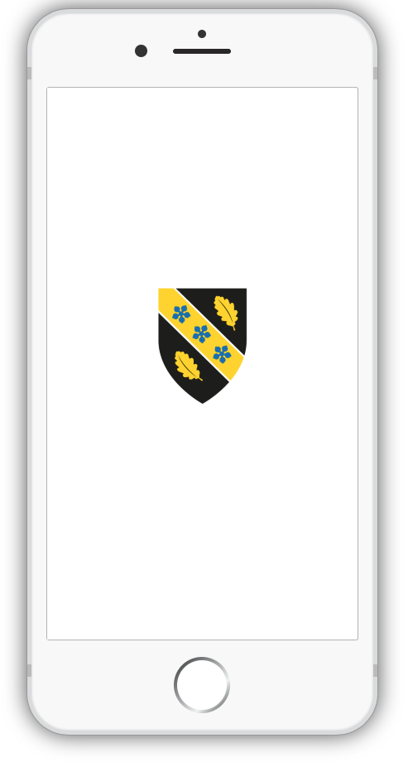

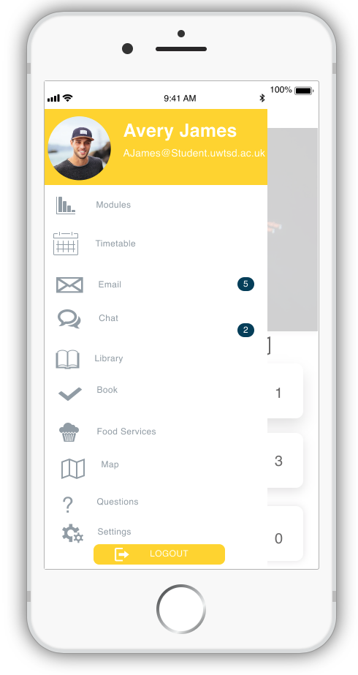

Appendix B

Appendix C

Appendix D Email
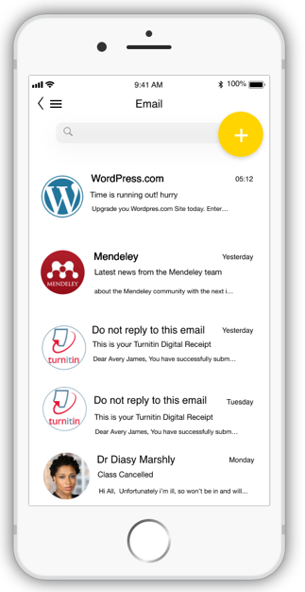

Appendix E Chat
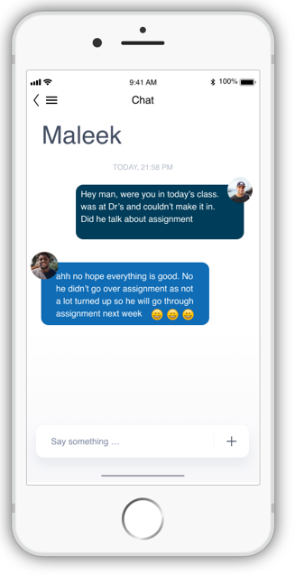
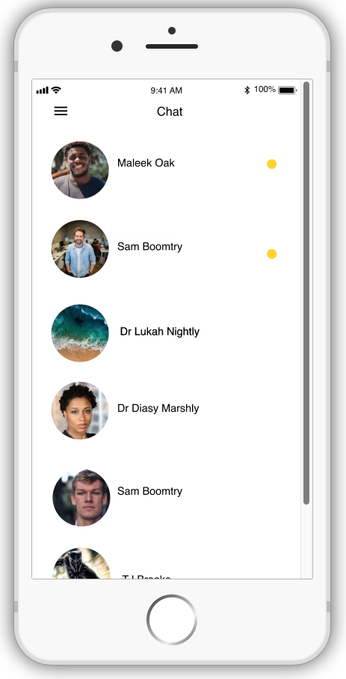

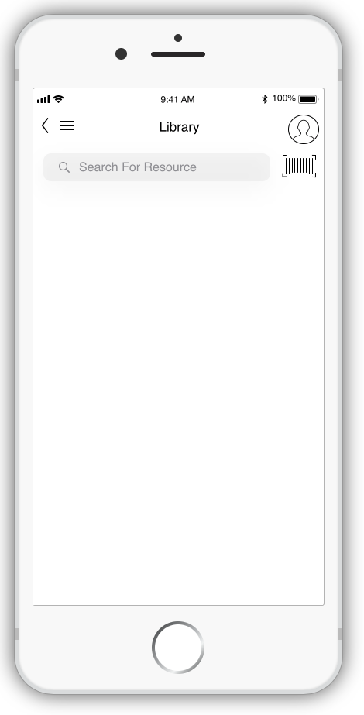
Appendix F Library
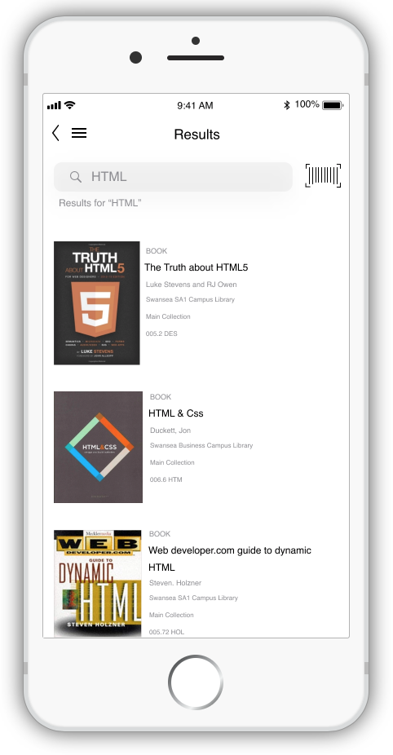

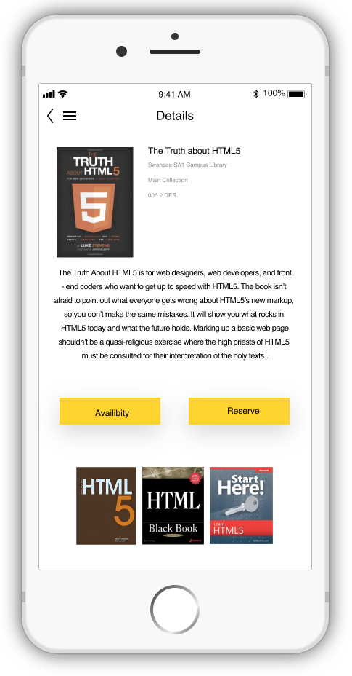
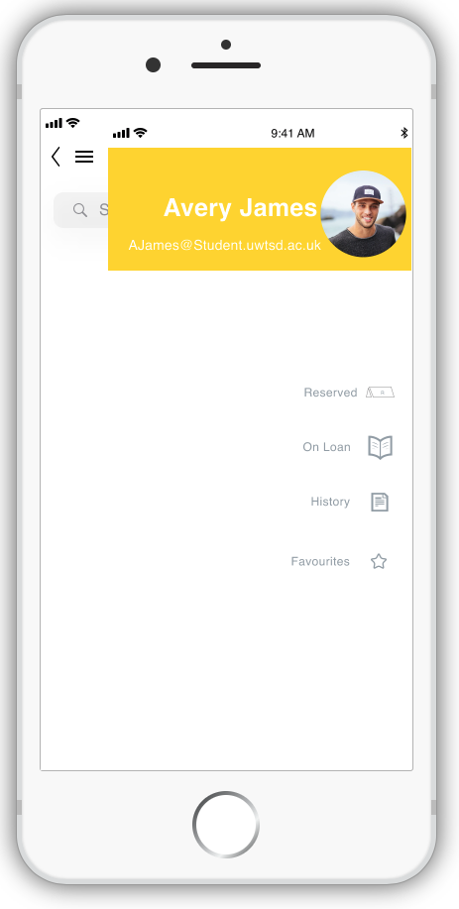

Appendix G Book Computer

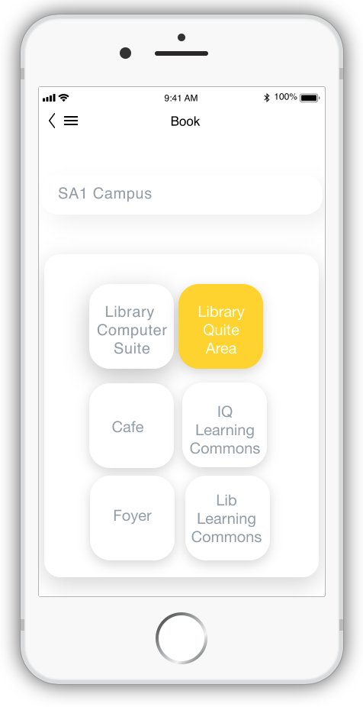
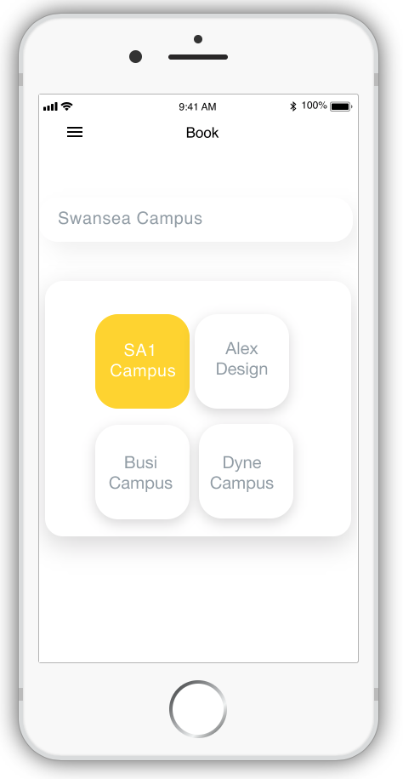
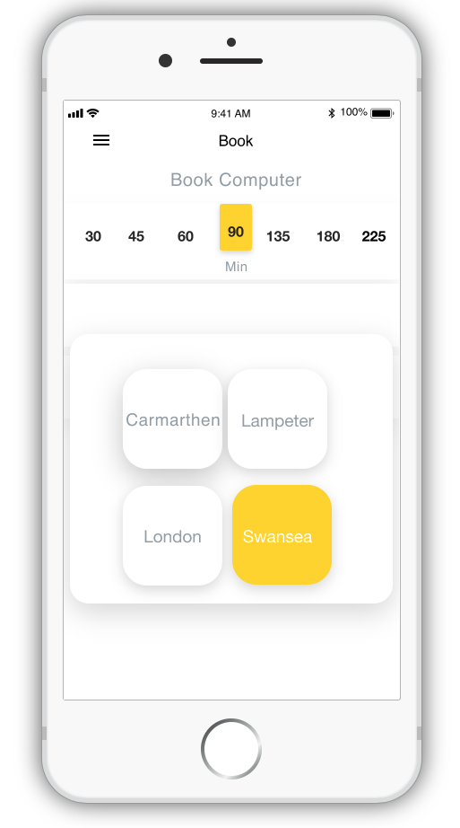
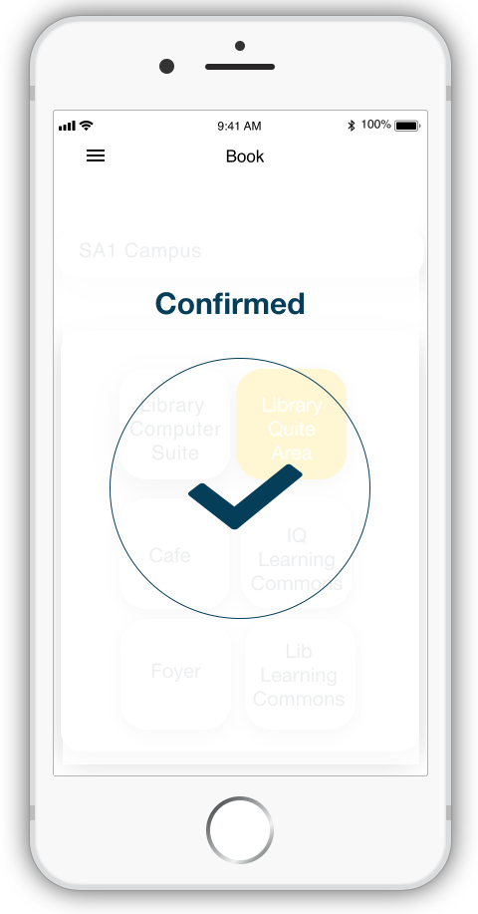

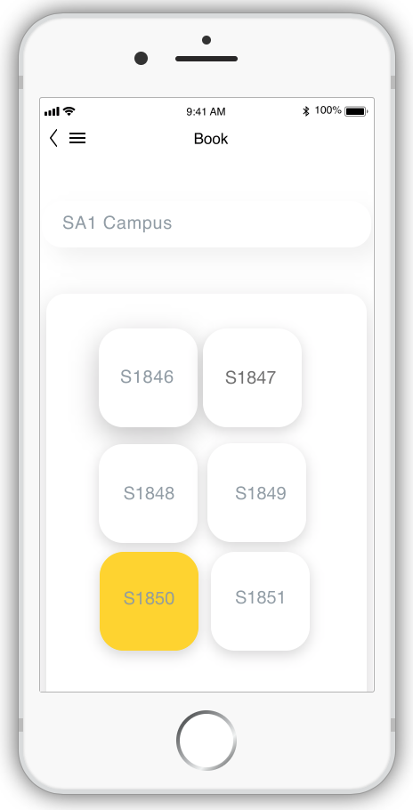

Appendix H Book Room
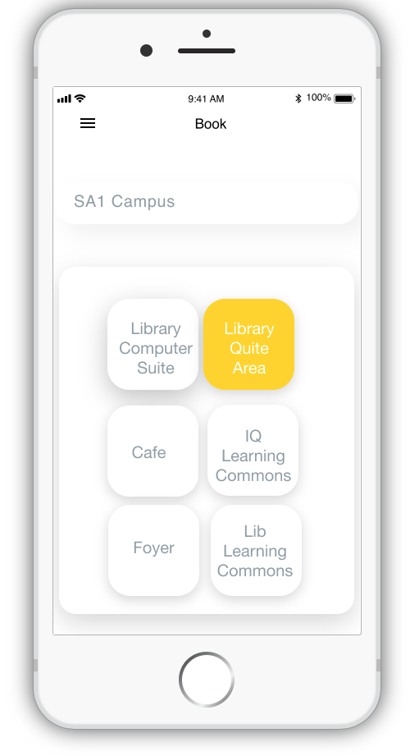
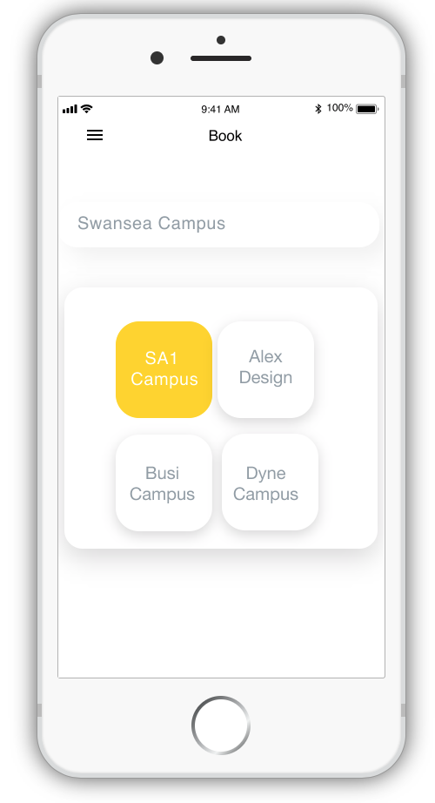
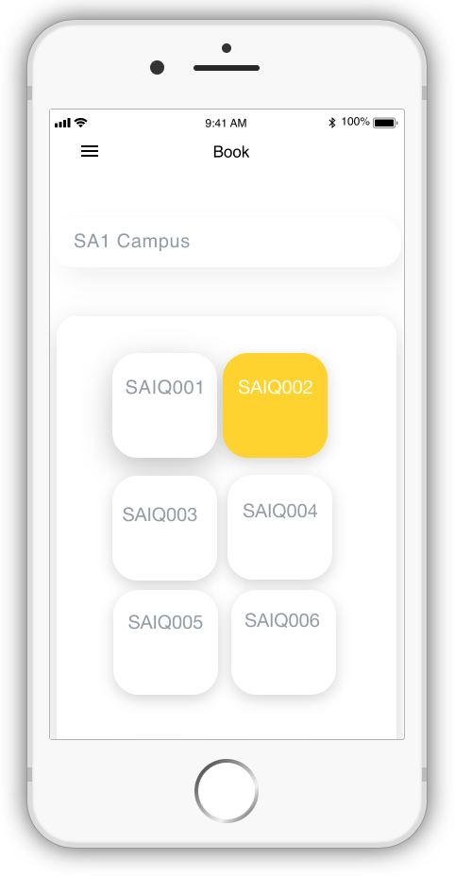
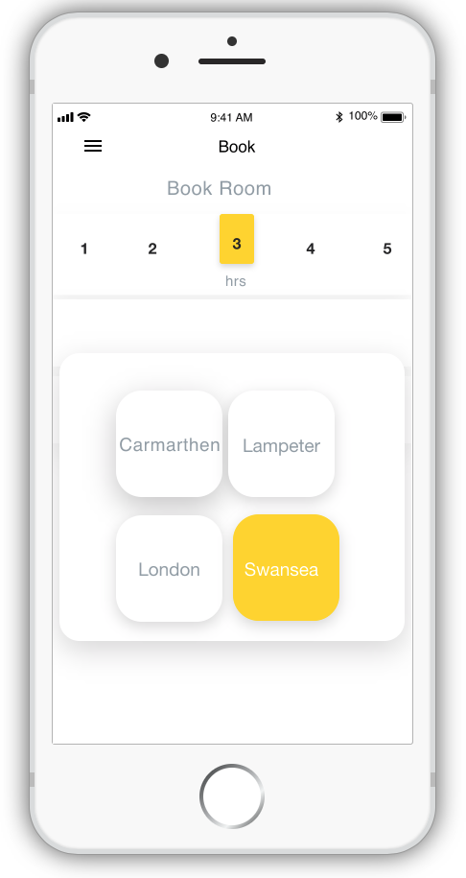

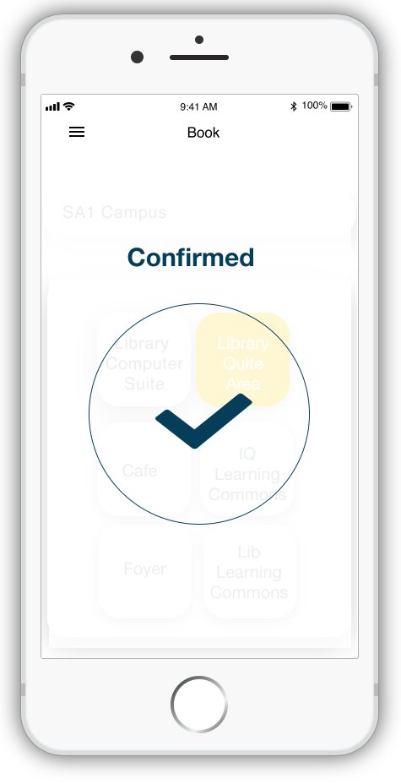

Appendix I Food Services
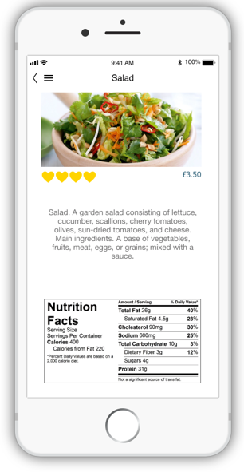
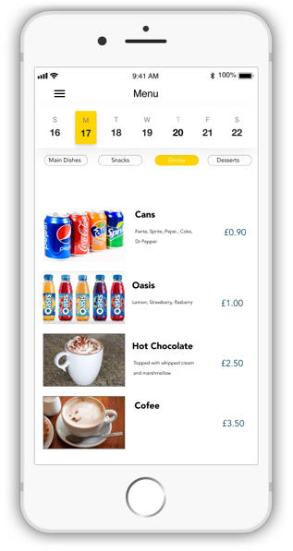
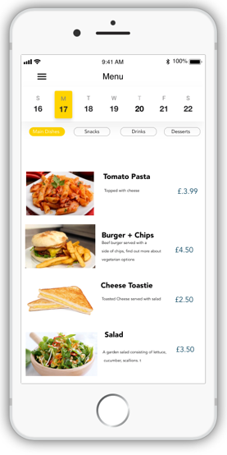

Appendix J Map – UWTSD
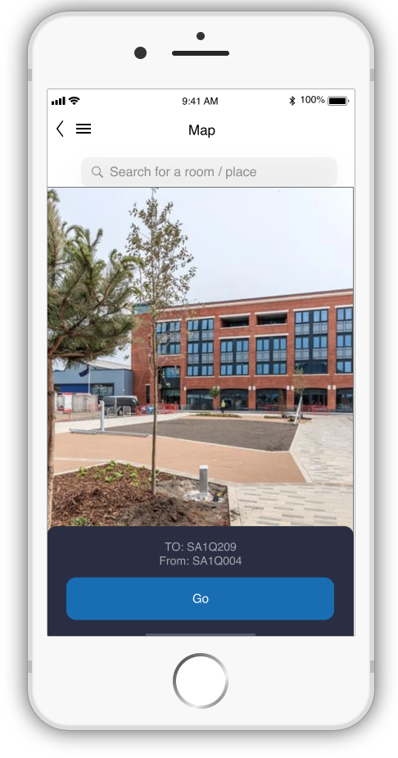
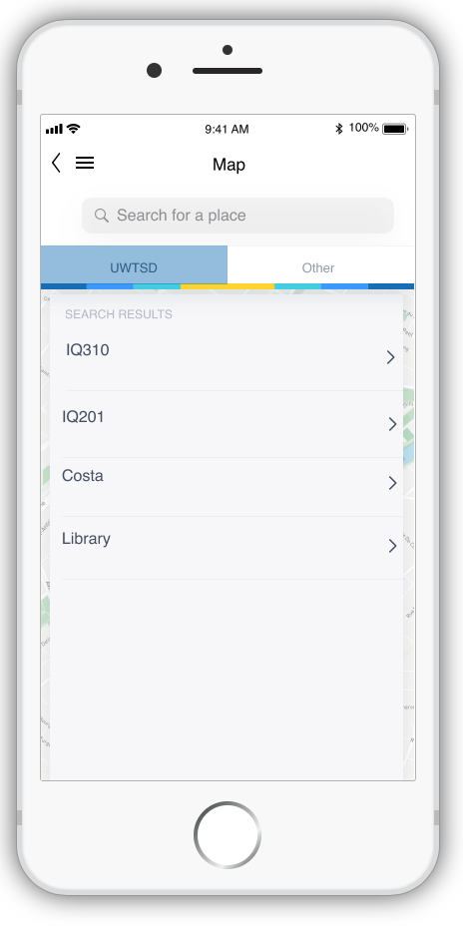

Appendix k Map

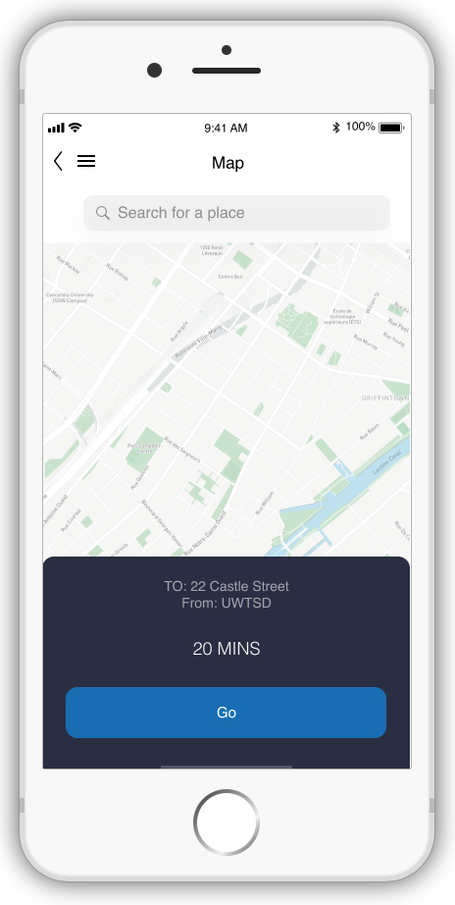
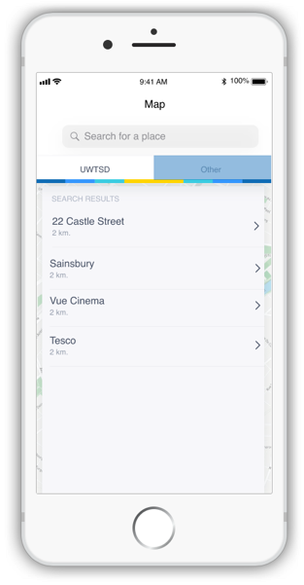

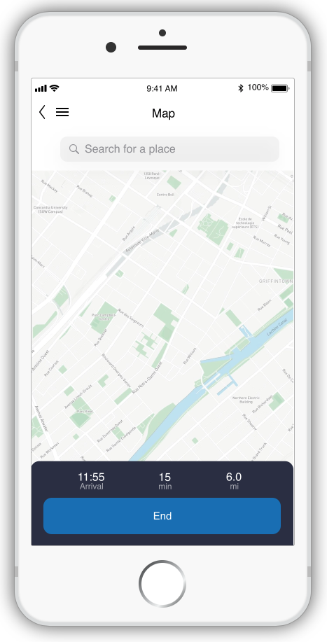

Appendix L Questions
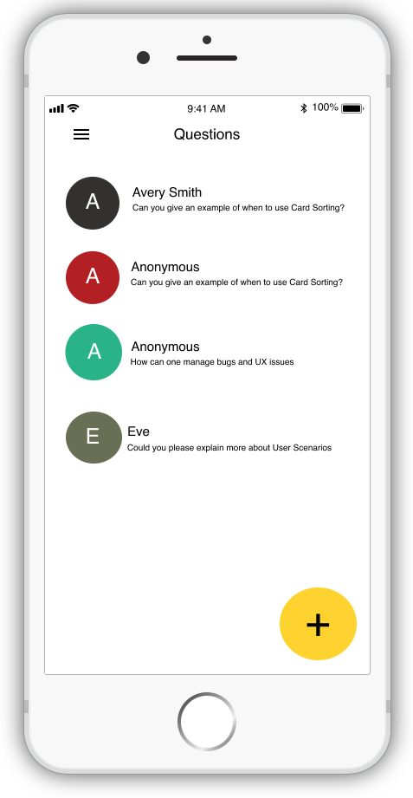

Appendix M Settings

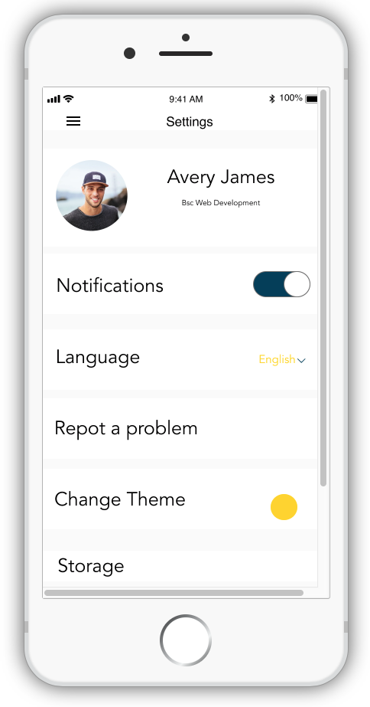

Appendix N Finance
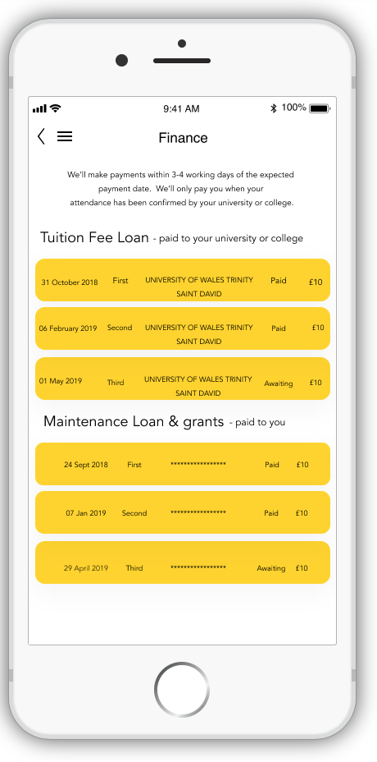

APPENDIX O – DATA REQUIRED FOR THE SERVICES

