

CORY TYZACK
BSc Computing Portfolio
SMART AND CONNECTED DEVICES I
Module Code: ACDA5005
Student ID: 1301015

Contents
Introduction 3
Implementation 3
Log In 3
Data 3
Stats 4
Query 1 4
Query 2 4
Query 3 4
Graphs 4
Basic Graph Searches 4
Advanced Graph Search 5
Future Improvements 5
Screenshots 6
Screenshot 1 (Basic Log In) 6
Screenshot 2 (Advanced Log In) 7
Screenshot 3 (Sessions) 8
Screenshot 4 (Page Session) 8
Screenshot 5 (Display Data Basic) 8
Screenshot 6 (Display Data Advanced) 9
Screenshot 7 (Rainfall on Specific Date Search) 10
Screenshot 8 (Rainfall more than Input) 10
Screenshot 9 (Rainfall Sum Group by sensors) 11
Screenshot 10 (Basic Graph – 1 Variable) 11
Screenshot 11 (Advanced Graph – 2 Variables) 11
Screenshot 12 (Sensor Graph) 12
Screenshot 13 (Date Graph) 12
Screenshot 14 (Rainfall Graph) 13
Screenshot 15 (Sensor and Rainfall Graph) 13
Screenshot 16 (Import Function) 14
Screenshot 17 (Test Plan) 15
Bibliography 16

Introduction
The aim of this assignment was to implement a PHP website with SQL backend database to display and analyse rainfall data captured by 3 sensors. The data was imported from text files into the database from a PHP script using SCANDIR to check if there are any files in the directory, a function to input data into the database and a for loop to go through each text file. This means if more sensors were added in future there would be no need to change any code it would recognise the additional text file. [Screenshot 16]

Implementation
The layout of the website was as followed:
- Index (Homepage)
- Data – Will display the data from the database in a table with filter functionality
- Stats – Used to display data that has been analysed e.g. wettest day, maximum rainfall
- Graph – This will display graph results of data in the table with search feature.
- Login - Login session will be to provide correct permissions to content.

Log In
The basic log in allows the user to access the site with their username and password. The password is stored in plaintext which is very insecure and should never be stored in the database like this. [Screenshot 1] The user can then access the permitted pages/features through the use IF statements with @_SESSION[‘loggedin’] on each page. [Screenshot 3]
The advanced login page uses prepared statements to protect against SQL injection. (Adams, 2020) The use of password_hash and password_verify were also used. [Screenshot 2] These are used to protect a password by using a strong one-way hashing algorithm and then to check the passwords match when logging in. (Php.net, 2020)
The ISSET feature has been used to determine if a variable is declared from user input for validation. If the username and password is incorrect or either field is empty it will display an error and go back to the log in page. [Screenshot 2]

Data
Screenshots 5 and 6 show the basic display of data and then how the filters were implemented to display the data in different formats. An ELSEIF statement is used to filter through the variables to check if any data has been entered. A lot of time was invested in trying to get this to work. I found out through a work colleague that ELSEIF should be structured to check if all values before filtering down into the next IF. [Screenshot 6] An SQL statement is run depending on which variable is set. I have also used date formatting to display the date in a user friendly format. The function used for this is as follows:
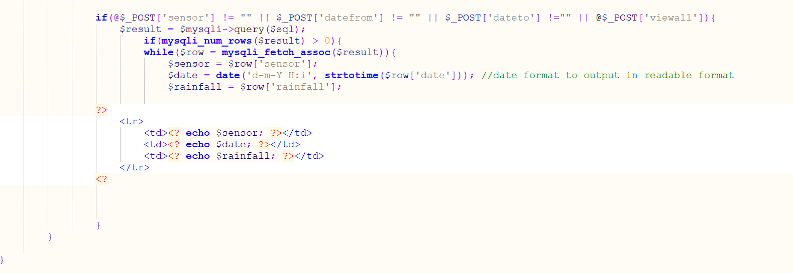
This is used to format the date from the database into a human readable format. (Php.net, 2020) The second part then convert the date time description into a UNIX timestamp. (Php.net, 2020)

Stats

Query 1
The first query implemented to manipulate and present data. [Screenshot 9]
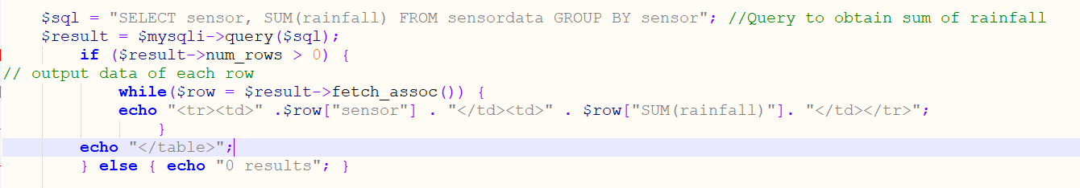
This query sums the total rainfall from the database and groups it by the 3 sensors displaying it in a table. The user can see quickly which area has had the most rainfall since the sensors have been in place. The user can also distinguish which sensor they would need to look into further if there were abnormal amounts of rain to protect against floods etc.

Query 2
The original plan for this query was to implement a more advanced search on the query above. The idea was to group by sensor for each date to show which dates had more rainfall. Instead I created this query which was similar with user input:
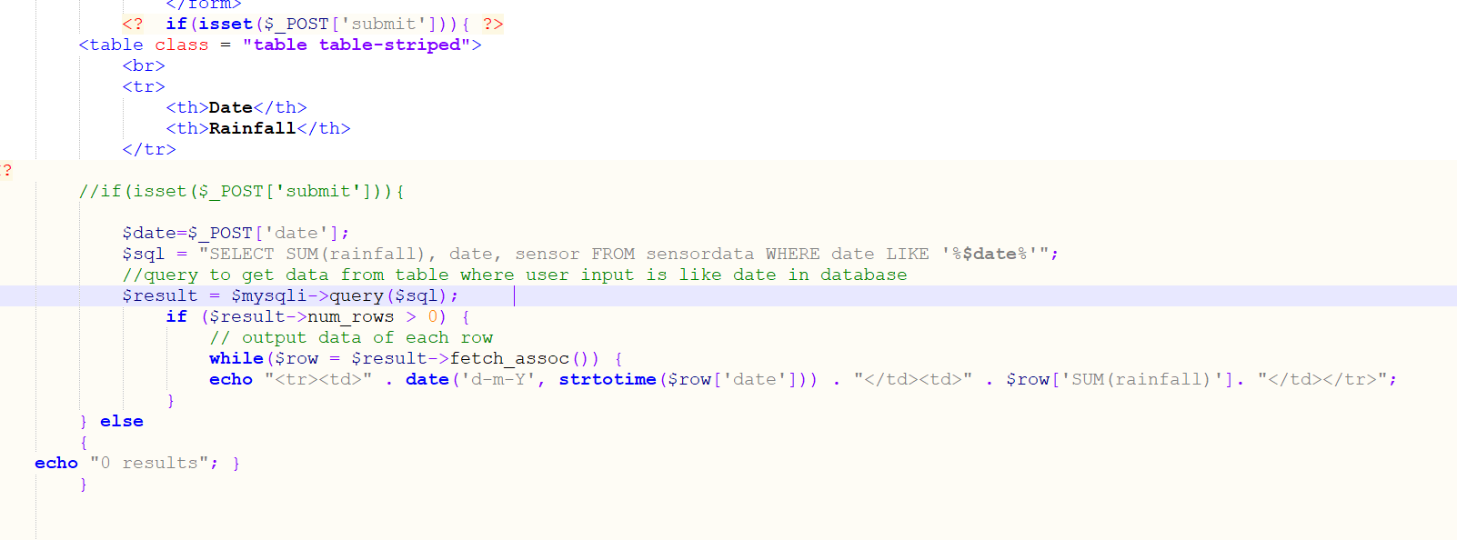
Here the query sums the rainfall on the selected date. This was implemented for the user to check rainfall– if there were storms or establish the wettest day. This query shows the data from all sensors.

Query 3
The third query is another user input query which allows the user to search for data more than a certain amount of rainfall. This again could be used to filter out days where there was little or no rain to analyse the data.
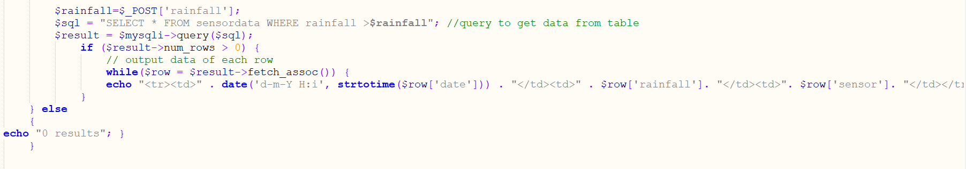

Graphs

Basic Graph Searches
I have implemented 4 graph searches rather than displaying the graphs with no user input. The user can generate a graph by sensor, date, rainfall more than or sensor and rainfall more than. I have based these on my queries which display in tables. I have used the following code to get them to display neatly on the graphs page rather than them opening up in a separate page. I have used the GET feature rather than POST as there is no sensitive data being passed through to the variable. INT is used to show that a number is going to be passed through.
This code uses the image source to get the graph from the page it’s created on. It then takes the variable set from the user input to determine which graph to show. The user is able to get the exact graphs needed with this solution.

Advanced Graph Search
The advanced search gets the input of rainfall and the sensor the user selects. This allows them to get precise data on the dates required. This is obtained using the same method as the screenshot above but uses two GETs to get the result from both user inputs. [Screenshot 15]

Future Improvements
I am happy with the overall layout of the website and the navigation but I would have liked to have invested more time into prepared statements and sanitising any user inputs to prevent SQL injection as security of websites are extremely important. More data validation would also make the website more accessible as users would get precise messages if they weren’t entering correct values etc.
Another improvement I would put in place is to customise the graphs. I would use the date instead of the ID to display the rainfall in each graph. This would give a better representation of the data and make it easier to read.
Another feature I would consider is further searches. Implementing searches such as by sensor, date and rainfall in one would give the user more functionality. This would be implemented through more IF statements.
Another useful improvement would be to use an in depth test plan. This would ensure that testing the website is thorough and all issues are documented. A simple test plan was used this time to test some of features bit by bit. [Screenshot 17]

Screenshots

Screenshot 1 (Basic Log In)
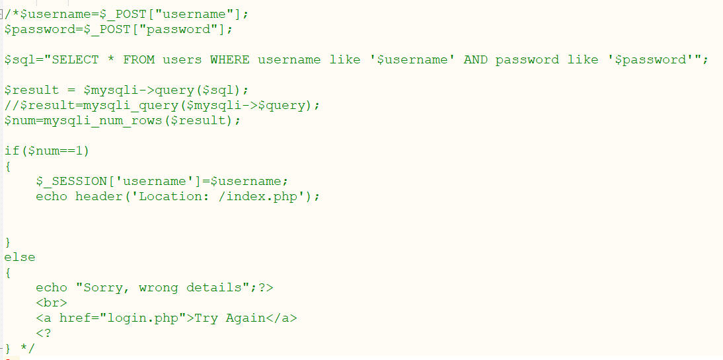

Screenshot 2 (Advanced Log In)
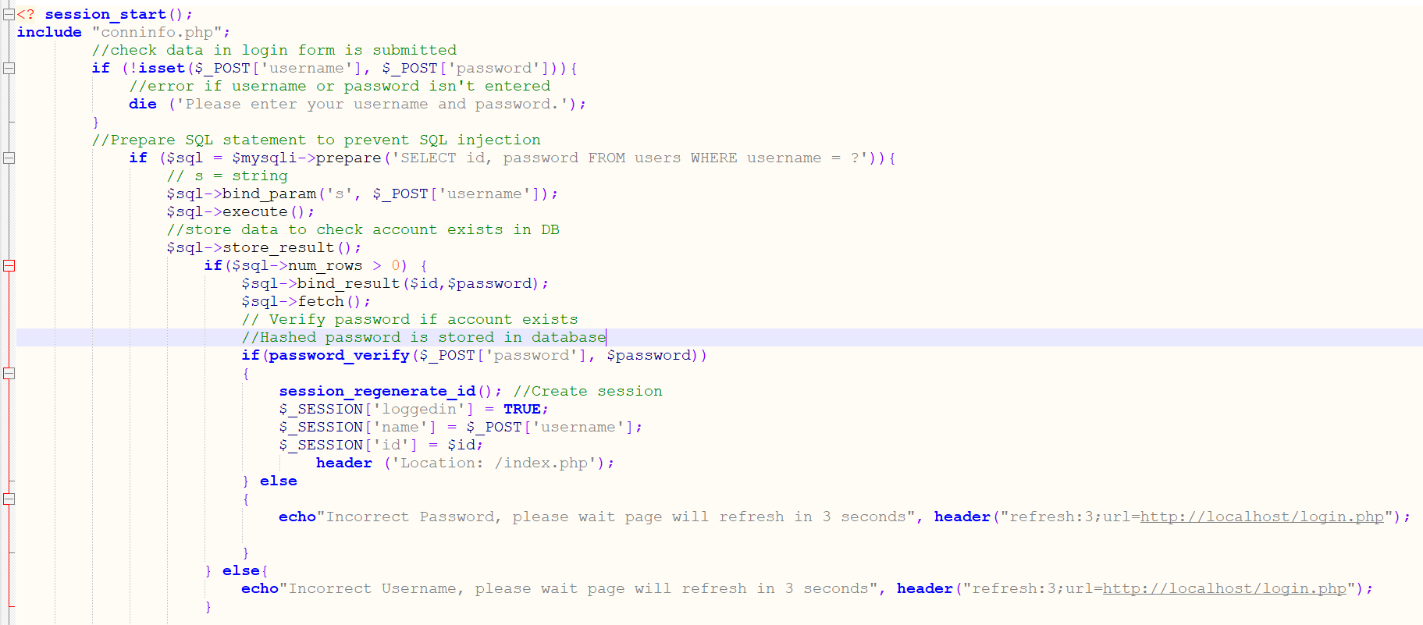

Screenshot 3 (Sessions)
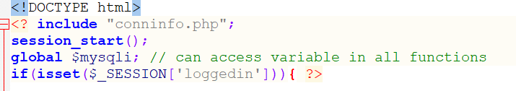
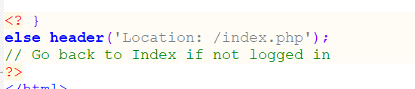

Screenshot 4 (Page Session)
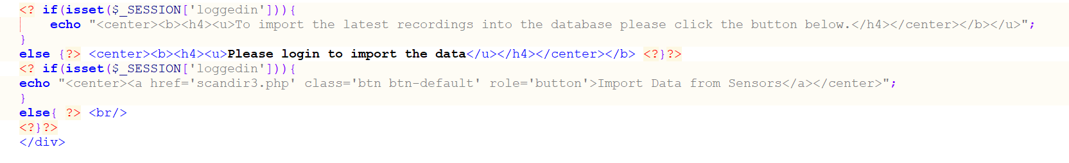

Screenshot 5 (Display Data Basic)
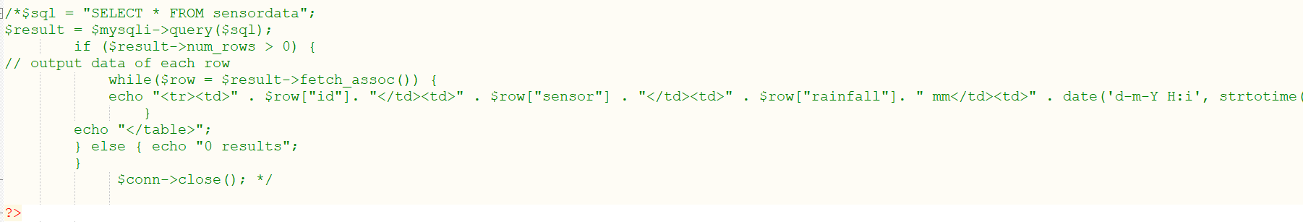

Screenshot 6 (Display Data Advanced)
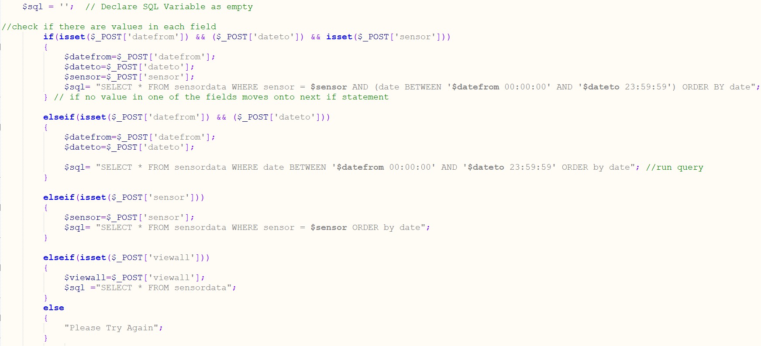

Screenshot 7 (Rainfall on Specific Date Search)

Screenshot 8 (Rainfall more than Input)

Screenshot 9 (Rainfall Sum Group by sensors)

Screenshot 10 (Basic Graph – 1 Variable)

Screenshot 11 (Advanced Graph – 2 Variables)

Screenshot 12 (Sensor Graph)
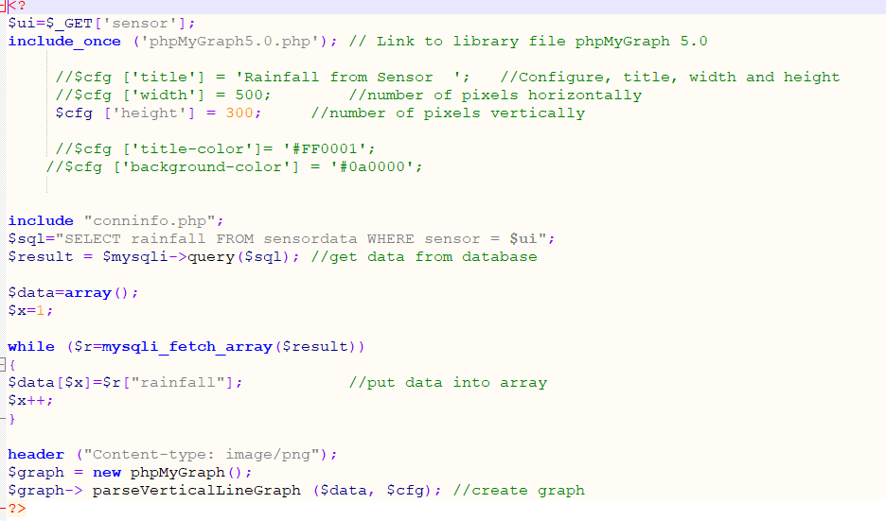

Screenshot 13 (Date Graph)
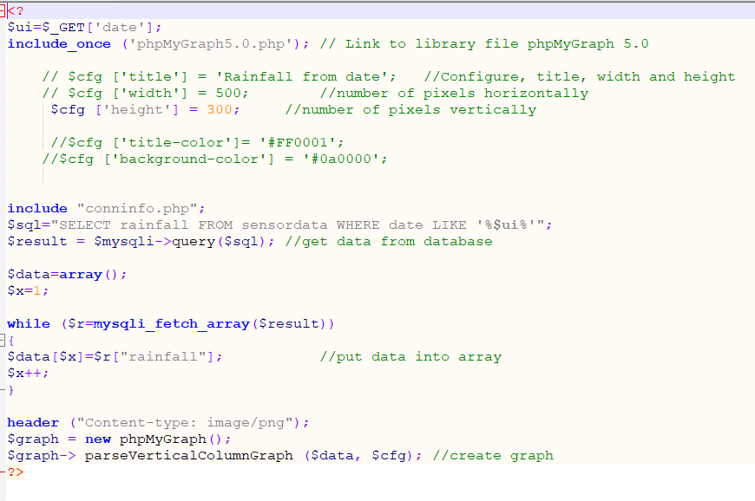

Screenshot 14 (Rainfall Graph)
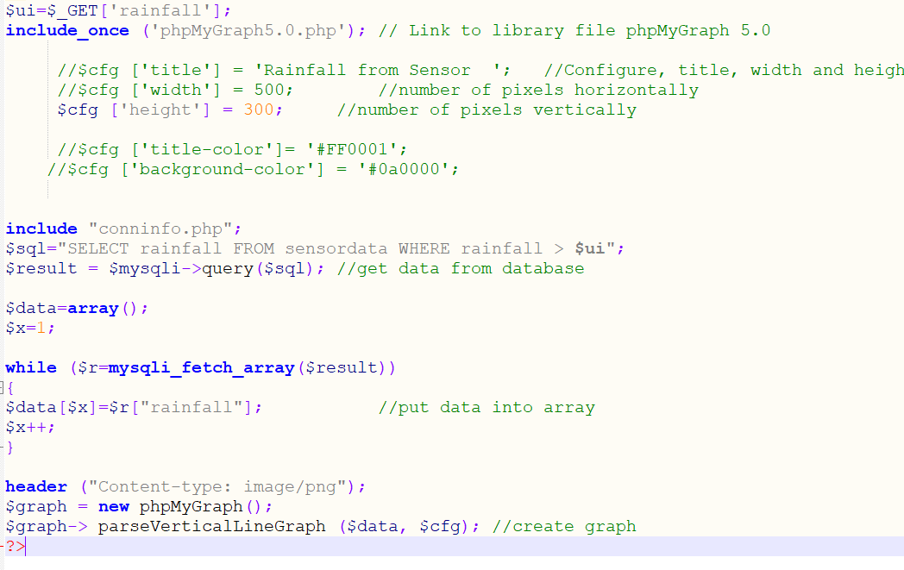

Screenshot 15 (Sensor and Rainfall Graph)
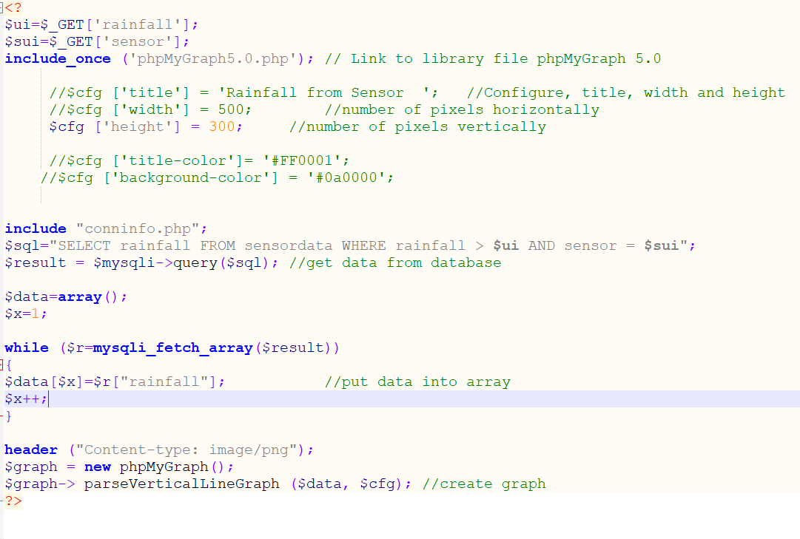

Screenshot 16 (Import Function)
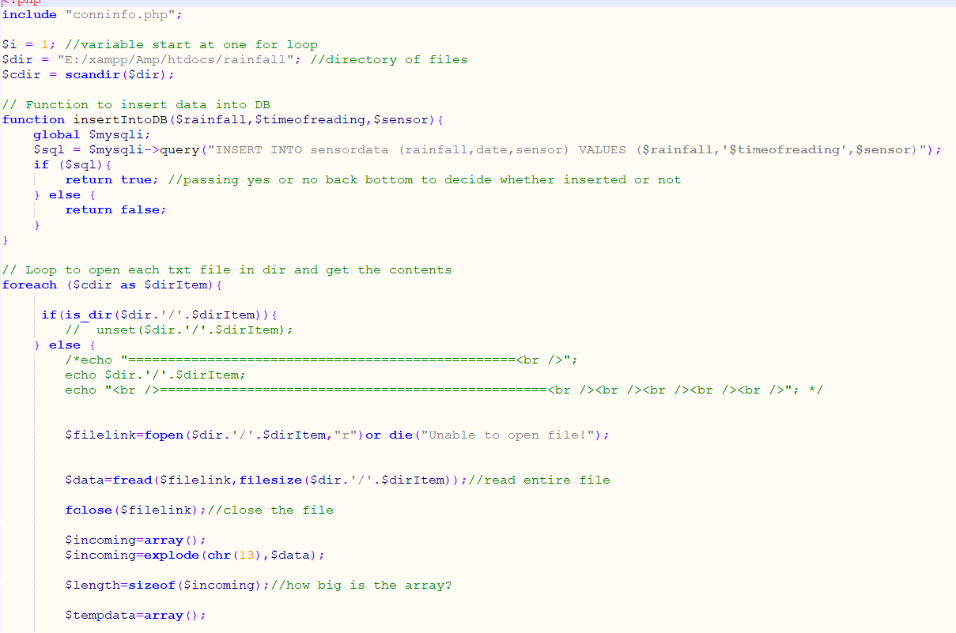
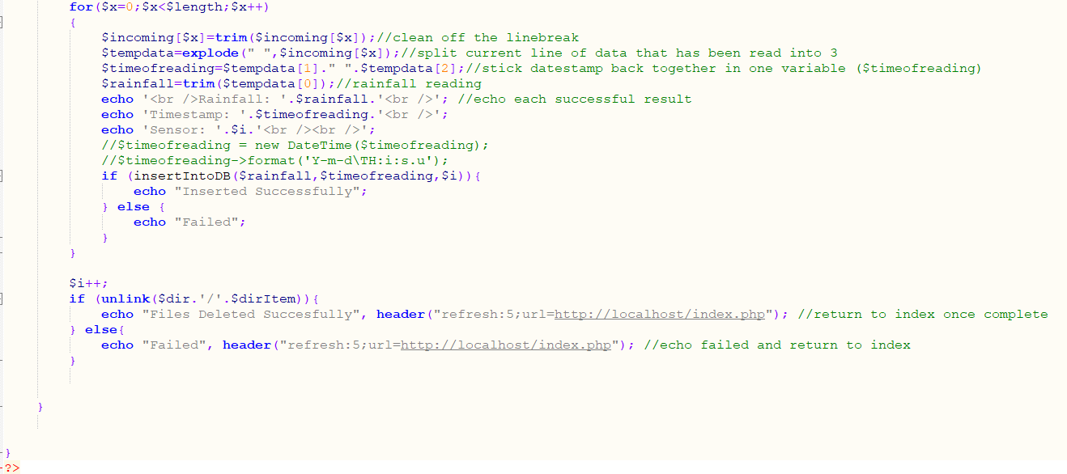

Screenshot 17 (Test Plan)
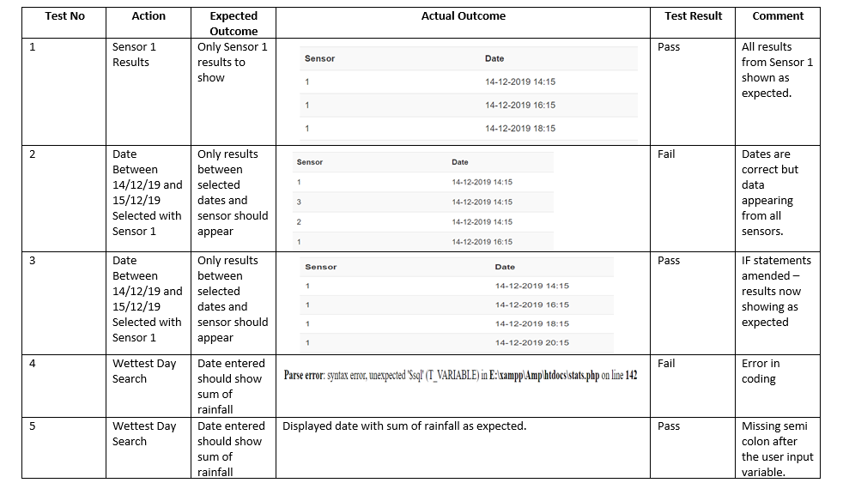

Bibliography
Adams, D. (2020). Secure Login System with PHP and MySQL. [online] CodeShack. Available at: https://codeshack.io/secure-login-system-php-mysql/ [Accessed 21 Feb. 2020].
Php.net. (2020). PHP: date - Manual. [online] Available at: https://www.php.net/manual/en/function.date.php [Accessed 27 Feb. 2020].
Php.net. (2020). PHP: isset - Manual. [online] Available at: https://www.php.net/manual/en/function.isset.php [Accessed 12 Feb. 2020].
Php.net. (2020). PHP: password_hash - Manual. [online] Available at: https://www.php.net/manual/en/function.password-hash.php [Accessed 17 Feb. 2020].
Php.net. (2020). PHP: password_hash - Manual. [online] Available at: https://www.php.net/manual/en/function.password-hash.php [Accessed 22 Feb. 2020].
Php.net. (2020). PHP: strtotime - Manual. [online] Available at: https://www.php.net/manual/en/function.strtotime.php [Accessed 6 Feb. 2020].
Stack Overflow. (2020). Get sum of MySQL column in PHP. [online] Available at: https://stackoverflow.com/questions/5808522/get-sum-of-mysql-column-in-php [Accessed 9 Feb. 2020].
Stack Overflow. (2020). How can i convert a date in php to SQL format ? (and insert it). [online] Available at: https://stackoverflow.com/questions/4791203/how-can-i-convert-a-date-in-php-to-sql-format-and-insert-it [Accessed 7 Feb. 2020].
Stack Overflow. (2020). Search date in database PHP. [online] Available at: https://stackoverflow.com/questions/11123914/search-date-in-database-php [Accessed 6 Feb. 2020].
Tizag.com. (2020). MySQL Tutorial - Sum. [online] Available at: http://www.tizag.com/mysqlTutorial/mysqlsum.php [Accessed 9 Feb. 2020].

